**Question 2:**

**Bisection Method**

One of the simplest root finding methods is Bisection Method, this method is using Bolzano’s theory. This method can be applied to any continuous function and can find the root of the function if the root exists in the interval. The way this method works is it will use the interval given and then halve the interval. After halved the interval, we will have two intervals. The root will exist in one of the intervals. This method will require to choose the right interval again. Choosing the right interval can be check by if ${f(x}_{i}){f(x}_{0}) < 0$ Where $x_{i}$ is the boundaries either left or right boundaries and $x_{0}$ is the middle point we halved. Then this method will repeat until we satisfied.

**Implementation**

1. Choose the boundaries where the root is existed within.
2. Calculate points $x_{0}$ by adding two boundaries then divided by two.
3. After we got two intervals, we need to choose the right interval where ${f(x}_{i})$ and ${ f(x}_{0})$ have different sign.
4. Repeat the process.

**Result**

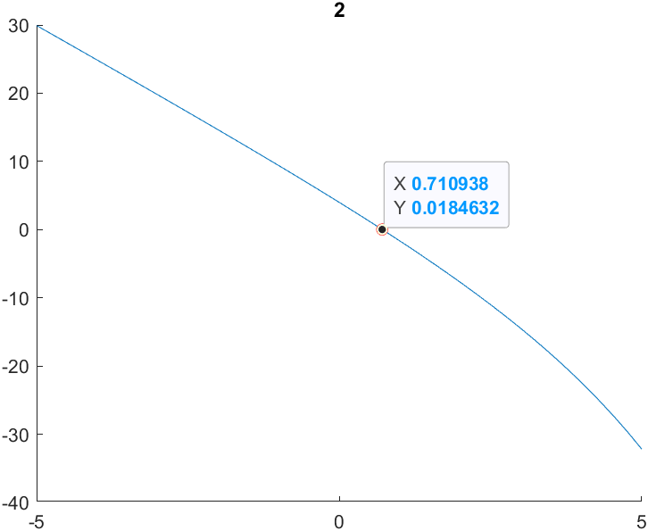

The boundaries cannot be the same point, if the boundaries are the same point then the root of the equation will be that boundaries points (The same point).

We can choose new boundary where $x_{i}=0 and x_{i}=2$. Then we can find the root. The result of the root where the approximate error must fell under 2% is **0.710938**.

**Newton-Raphson method**

Newton-Raphson Method is the root finding method by using the initial guess to find a tangent line to find where it is crossed the x = 0. The new x value will be the point which is crossed x = 0.

The formula to get a new x value is:

$$x_{n+1} = x_{n} - \frac{f(x_{n})}{f'(x_{n})}$$

This method can converge to the root point faster than the bracket method like bisection method. This method may fail sometimes but it may be fixed by choosing new initial point.

**Implementation**

1. Choose a guessing point.
2. Try substitute the value into the derivative function. If the value is equal to zero, the initial must be changed.
3. Finding the new value by using the previous x value.
4. Repeat the process until it close to the root enough.

**Result**

The result of the method after substitute to the function is very close to the root.

The result using this method where approximate error is less than 2% x ≈ **0.714169**

