**PART II**

You are designing a spherical tank (Fig. P5.17) to hold water for a small village in a developing country. The volume of liquid it can hold can be computed as

$$V= πh^{2}\frac{[3R-h]}{3}$$

Where V = volume ($m^{3}$), h = depth of water in tank (m), and R = the tank radius(m).

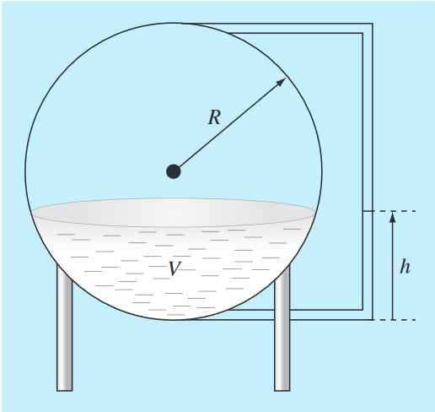

If R 5 3 m, to what depth must the tank be filled so that it holds 30 m3? Use three iterations of the false-position method to determine your answer. Determine the approximate relative error after each iteration. Employ initial guesses of 0 and R.

This problem can be solved by use the convert the equation to a function, the function that is converted is

$$f\left(h\right)= πh^{2}\frac{\left[3R-h\right]}{3}-V$$

We need to find the root of the function; the root of the equation will be the depth of the water that satisfied the equation.

Using Bisection Method, let boundary values be 0 and 3. After created the boundary, we halve the interval to be a new value that we will consider which interval should we use.

By using while loop we can repeatedly halve and choose the interval, the process will continue until we reach the criteria we set which is 1% of error.

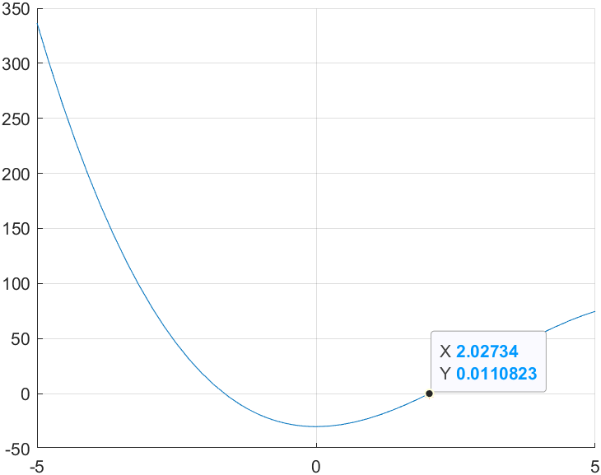

The root of the function is $x≈2.02734$ and $f\left(x\right)≈0.0110823$ which is not accurate, to make the result more accurate, we need to change the criteria to be lower percentage.