# Goal-based Investing without Modern Portfolio Theory

How Investment Managers Can Transcend Roboadvisors

Contents

Goal-based Investing without Modern Portfolio Theory 1

Introduction 1

My Personal Experiences 1

Who this book is for 6

Part 1: Focusing on Investor Goals 6

A Brief History of Modern Portfolio Theory, Goal-Based Investing, and Roboadvisors 6

Investment Narrative 8

The techniques underlying Probabilistic Scenario Optimization 9

Part 2: Building Client Trust through Demonstrating Investment Manager Skill 9

Bayesian Networks Objectively Convey Investment Manager Views 9

Brief history of assessing Probabilistic Forecasts and the use of Bayesian Networks as an investment modeling framework 18

A narrative illustrating how investment managers could add value and act in client’s best interests 18

Part 3: Tailoring Investment Products Based On Client Needs 18

Demonstrate current industry structure versus what it could be 18

Part 4: Mathematical and Technical Appendices 18

Show the mathematical equations underlying the Calculator 18

Demonstrate the Scalability and Asynchronous benefits and System Architecture of the technology 18

## Introduction

### My Personal Experiences

In the course of my dealings with various constituents of the investment management industry, I came to believe the existing system is beyond repair and needs to radically shift its focus from investment products to clients. This sections details my first hand interactions and some of the lessons learned. To be clear, I aim to show the system is beyond repair *not the individuals who work in the industry.* As described in the Acknowledgements section, my interactions with many investment professionals have been both positive and formative, particularly around determining a reasonable basis for an investment. However, I have become convinced that a sufficient number of amoral, confused, and unscrupulous individuals have undermined the integrity of the entire industry. This section demonstrates some of my interactions that led to this view. For those unfamiliar with all of the participants in the industry, the graphic below diagrams the various parties and their relationships.

#### Education

When I graduated from business school during the midst of the Great Recession, it seemed like an exciting time to be entering finance. In business school, I had taken the unusual path of replicating multiple academic papers, and this experience helped land me a position at a large investment consulting firm. Even better, I scored a position building equity risk models whose underlying math had been widely cited in the media as a key contributor to the crisis. I reasoned that the industry would adopt new and better models, and my work could possibly contribute to making the financial system more resilient. I could not have been more naïve.

My experience in business school might have informed me otherwise. I had made a point of learning as much as I could about Modern Portfolio Theory: I read the textbooks and the original papers they cited; I studied for the first CFA exam; and I read the criticisms of the theory. In addition, I had witnessed how dogmatic my professors could be about the underlying assumptions: when I went to office hours to discuss MPT with my corporate finance professor, he asked me to leave.

#### Financial Advisors

I was unfamiliar with the industry when I entered business school. Prior to my acceptance, I had worked as a management consultant making factories more efficient. My experience with stocks had been limited to my own investments, articles on the internet, and a few books. However, I was fascinated with the industry and the idea of influencing which companies would receive capital investments. Almost as soon as school started, all of the students started networking and interviewing for summer internships. I had the misinformed view that financial advisors, or “Private Wealth Managers” when the clients are sufficiently wealthy, advised individuals on their investments. When I went to the recruiting events for Private Wealth Management internships, private wealth managers from each of the major investment banks informed me that their job was to manage the relationship with the client and act as the primary contact between the client and the bank. I had no interest in selling investment products, so I enquired whether internships existed for analyzing individual investments on behalf of clients. They answered, “no.” In fact, only one of the banks even claimed to provide this service.

Later, a managing director from one of the largest wealth managers explained how his bank approached investments for wealthy clients. Clients were lumped into one of five buckets. The bank offered a mix of mutual funds targeted towards each of these buckets. Despite claims of focusing on the individual and a tailored investment experience, wealthy individuals received as much guidance as standard investment products such as target date funds.

However, the Private Wealth Managers at these recruiting events emphasized how well they were doing. Some were managing books of $500 million. As I have since learned, some financial advisors receive about .5% of their client’s assets as a fee each year. The result is that top financial advisors net millions of dollars each year, regardless of how their client’s fare.

At the recruiting events, I asked what qualities distinguished successful private wealth managers. Other than being good with clients, some of the attendees answered that a background in competitive sports correlated with success.

After learning many financial advisors are sales people who hawk commodity investment products to their unsuspecting clients, I decided that I had no interest in applying for any of these internships. Instead, I turned my attention to investment management.

#### Quantitative Investing

I had also already witnessed how religiously some of my classmates had implemented quantitative investment strategies, whose risk measurements relied in MPT, for one of the student investment funds and then panicked as their large holdings in Lehman Brothers and Bear Stearns tanked.

After business school, I built quantitative equity risk models and later sold them. These are large scale statistical models that can forecast the risk for any portfolio of publicly traded stocks. Two central ideas guide their construction. The first is that short-term volatility equals risk, and the second is that volatility today predicts volatility tomorrow. As will be discussed chapter, these models have a history of failure and the assumptions supporting their implementation were disproven decades ago.

Despite the overwhelming evidence against these techniques, the quantitative finance industry, and more recently robo-advisors, have continued implementing them for decades. During business school, I started visiting quantitative firms who claimed their methods were “scientific” and “objective.” After my experiences researching, building, publishing, and selling, I can verify this claim is false. A large number of assumptions are required to determine the stocks underlying the statistical estimates, the methods of determining and calculating risk factors, the statistical weightings given to individual data points, the specific algorithms used for estimation, and so forth. These techniques vary widely between different implementations.

When I started advising clients on how to implement risk models, I saw first-hand how little quantitative firms trusted their outputs. In quantitative investing, a computer attempts to maximize risk-adjusted return. To avoid overly aggressive allocations to individual stocks, industries, or risk factors, the quantitative portfolio manager applies a variety of rigorous constraints that the computer must satisfy when calculating the optimal portfolio. In my dealings with clients, I learned these constraints heavily influenced the final solution such that the portfolio’s performance mirrored an underlying index. Such strategies are known as “closet-indexing” and have a high chance of underperforming the benchmark solely because of the relatively high fees active managers charge.

These “Quants” have reason to distrust the models: when left unchecked, they can cause the manager to hold nonsensical positions. For example, one method of testing risk models is to build a minimum volatility portfolio. This is one of the simplest optimizations a computer can perform: the sole objective is to minimize “risk.” Since optimizers are extremely sensitive to statistical errors, such portfolios can reveal estimation mistakes in the risk models. One particular time, I noticed a small biotech company constituted over 12% of the minimum volatility portfolio. In addition, I knew that this particular firm was the target of a takeover. If the deal failed, then the company’s stock price would decline precipitously. Clearly, this should not be in the portfolio. As it turned out, the researchers who designed the risk model had implemented “robust” statistical methods that dropped outlier moves in prices. When the firm announced it was being acquired, it share price rose abnormally. The algorithm threw out this return as an anomaly. Then, the stock price hovered next to the proposed acquisition price without much fluctuation or correlation to other stocks. The result is this company received a massive overweight in the minimum volatility portfolio. Such effects are also possible from a lack of trading. If a stock does not trade, it has a volatility of zero. Although risk model vendors try to mitigate these statistical anomalies, the risk models cover tens of thousands of stocks. Therefore, problems such as these are much more common than the vendors would like to admit. Consequently, a large amount of human judgment creeps into these so-called “objective” and “scientific” investment funds.

#### Traditional Investment Managers

Despite my negative experience with the religious adherence to MPT in academia and the misguided application of it to investing evidence in Quantitative Investment management, I have also spoken with hundreds of investment managers who had dismissed MPT and quantitative finance in general. To them, investing meant analyzing the prospects of companies both qualitatively and quantitatively. This seemed grounded in reality and made sense. Still, a disconcerting fact loomed over these discussions: the data indicated that both hedge and mutual funds underperform the general stock market after fees. In the 1970s, Burton Malkiel wrote a “Random Walk Down Wall Street” and the first Vanguard funds appeared, which launched these facts into the public domain. Afterwards, study after study confirmed the same results. How could so many intellectually sophisticated individuals, many coming from top business schools such as Harvard, perform so badly?

In the book “The Mark Inside,” XXX describes how con-men ruled the city of Denver in the early 1900s and swindled wealthy individuals out of their savings. The tactics involved gaining the individual’s trust through demonstrating initial, fake results. The mark never understood how the con-man generated the initial extraordinary performance but almost invariably invested in the secondary and tertiary stages in the con. More recently, Bernard Madoff gained investor’s trust through presenting phony performance as well.

During my stint at the investment consulting firm, I began to see evidence, hear anecdotes, and read articles about a similar ruse in the investment world. Large mutual and hedge funds started many portfolios and only continued those that outperformed. Sometimes, they would effectively sell insurance, which pays off a high percentage of the time, and misleads the investor regarding the overall riskiness of the strategy. In quantitative finance, the funds would load up on well-known risk factors. Once a fund could be marketed based on its prior performance, the managers would effectively index it to its benchmark such that they could claim historical long-term outperformance. The industry managed other people’s money for its own benefit, and their underperformance reflected the intent.

In addition, I have visited dozens of traditional investment firms and started noticing patterns of behavior. At some of the best performing firms, the analysts and portfolio managers came across as humble, frank, honest, and deeply knowledgeable. Too many, however, exhibited a religious devotion to the idea that their employees were innately superior to other industry participants. Once I became familiar with the fact that more than 90% of managers underperform index funds, I started asking during these visits: “What do you feel is the competitive advantage of your firm?” A surprising number of fund employees struggled with this question. After a few seconds, many answered “the intelligence of our employees.” In an industry in which almost every firm employs MBAs from the top business schools, I must admit I am still astonished with the unrepentant arrogance and stupidity of this answer.

#### Investment Consultants

“Past performance does not indicate future results.” Although this claim appears on all mutual fund prospectuses and many academic papers show no link between past and future performance, investors still assess a fund’s prospects using its historical performance as the primary metric. A small anecdote on this topic: When I worked at the investment consultant, I worked next to a consultant who interviewed managers. I was struck by how simplistic his questions were: mostly about the manager’s market views and rarely, if ever, any detailed questions regarding his or her largest holdings. In addition, I was responsible for answering detailed client questions regarding our performance attribution software modules. These attempted to determine a manager’s skill at picking stocks, as opposed to betting on a specific economic sector or loading on a well-known “risk factor.” Two completely different methods predominated: Brinson Style Attribution and Factor Analysis. Brinson attribution decomposed historical returns against a benchmark into two buckets: the return generated through stock picking and through allocating to a specific group, usually an economic sector. It was relatively simple to calculate and easily gamed. For example, suppose an investment manager oversaw a fund benchmarked to the S&P 500. If he were to purchase a leverage version of the S&P 500, such as index futures, his allocation to the underlying sectors would match the benchmark. According to Brinson attribution, all of his outperformance would be categorized as stock picking. The other type of performance attribution, Factor attribution, attempted to account for known risk factors, such as leverage. However, both the methods used and the definition of factors varies between software vendors. For example, should factor attribution be performed on a single portfolio versus a benchmark across time or should the portfolio be assessed against the securities in the benchmark at a single time? What is the definition of “leverage”? Each vendor implemented the models differently. As I interacted with more clients, I came to learn that investment managers hate performance attribution. Many of them saw it as arbitrary. Who could blame them?

Despite these drawbacks, I assumed that the investment consultants at my employer implemented these techniques as checks. At one point, my boss and I met with two managing directors from one of the consulting divisions. The aim of the meeting was to determine whether our investment software could represent the attribution results better. Currently, they were simply presented in large tables without much organization. About half an hour into the meeting, one of the managing directors told us that they virtually never used performance attribution. They relied almost exclusively on historical performance and only viewed the attribution analysis if one of their managers was underperforming and they needed to explain the underperformance to a client. These experiences and others later in my career lend credibility to some of the studies and viewpoints this book presents in later chapters.

#### Institutional Investors

Institutional investors such as pension funds, endowments, foundations, and family offices tend to have limited investment staffs. Even the large ones do not typically invest in individual securities. They outsource all of the analysis to investment managers, private equity firms, and venture capitalists. Frequently, they contract consultants to pick these managers and set target allocations to different asset classes as well. Since they own so many securities and lack direct experience with them, they have limited visibility and control over their own portfolios.

In my experience, institutions attempt to mitigate these issues through policies such as not overloading certain risk factors. As explained above, the risk exposures are sufficiently vendor dependent that they are worthless. On one particular visit, I asked the employees of a pension fund how they validated their risk models. To test a risk model, one compares the forecasted and realized volatility. If the model is reasonably accurate, the forecasted and realized volatility should match on average; although, I have seen many cases where vendor estimates are consistently off by a factor of two or three for a specific portfolio. This particular institutional investor, one of the largest in the US, had never verified that their risk models worked. When I asked my question, I received blank stares followed by an incredulous “how can we do that?” On other visits, I learned that the institution had no specific policies regarding risk. In other words, these institutions lacked proper controls over their portfolios. Just invest and hope for the best.

#### Summary

These anecdotal experiences partially led to my belief that the investment management industry need to be designed to serve investor’s best interests. The next chapter shows more formal evidence of how the industry currently lacks the ability to serve clients.

### Who this book is for

* The Target audience for this piece and core ideas behind restoring trust to the investment industry

## Part 1: Focusing on Investor Goals

### A Brief History of Modern Portfolio Theory, Goal-Based Investing, and Roboadvisors

Since Markowitz’s seminal 1952 paper, quantitative investment research has focused on methods to optimize the risk-adjusted return of a portfolio of investments. More recently, Roboadvisors have delivered these techniques to investors via automated web services. These services have focused primarily on reducing investment fees through aggressive pricing of their own services and investing in passive ETFs with the lowest expense ratios. As a benefit of their lower distribution costs and account minimums, Roboadvisors have widened the target audience for investment products, or “democratized” them.

At the same time, Roboadvisors have promoted academic research showing the detrimental effect of fees on investment performance. As a result, traditional investment managers who have historically charged high fees and underperformed their benchmarks have lost significant market share. This impacts financial advisors as well because many of them derive compensation from the investment products they sell to clients. In addition, Roboadvisors offer transparent pricing and suggest their clients only interact with fee-only advisors who do the same. Historically, investment advisors charged these fees over decades and their clients have largely been unaware of the amount they pay. Therefore, the focus on fee-only advisors has the counterintuitive effect of making human advisors less unattractive. Despite rapid growth in the stock market since the financial crises, the number of advisors has declined.

In addition to cost benefits from automating investment decisions, Roboadvisors appear to be an objective way to invest: the decisions are based solely on historical data and the optimization algorithms remove human emotions. Also, the research of Nobel Prize winners Harry Markowitz and Robert Engel backs the algorithms. Lastly, this research forms part of the backbone of Modern Portfolio Theory (MPT), the financial theory taught in business schools and implemented by financial institutions across the world.

Despite these perceived benefits, Roboadvisors implement algorithms whose backing theory and underlying methods are unsound. At least four areas of criticism exist: empirical, behavioral, mathematical, and philosophical. Empirically, the risk algorithms have a history of failing. For example, models based on the underlying algorithms underestimated the probability of the Crash of 1987. According to the models, such a crash had an almost zero possibility of occurrence. Behaviorally, the models rely on MPT, which assumes humans are rational in the aggregate. Starting in the 1970s, behavioral researchers, such as Nobel laureate Daniel Kahneman, have shown the opposite. Most human decisions are based on heuristics instead of rational thought. Without the underlying assumption of rationality, the mathematics underlying the risk models is unsupported. Mathematically, Benoit Mandelbrot, a researcher at IBM whose work formed the basis of Fractal Geometry, demonstrated the “roughness” of financial time series mismatched the “smooth” data from MPT-type models. Philosophically, Roboadvisors rely on work an implicit inductive argument: future volatility will resemble the past. Nobel laureate Robert Engel first introduced algorithms based on this idea in 1982, and RiskMetrics, now MSCI Barra, sold commercial risk models based on his research starting in the early 1990s. Philosophers have challenged the validity of induction since the work of David Hume in 1700s. In the 1930s, Karl Popper argued these methods conflicted with science and sought to purge their use. Since then, Philosophers of Science have largely agreed upon their invalidity.

Advocates for MPT such as Eugene Fama countered that if markets are informationally efficient, then the fund managers should on average perform the same as the overall market less their fees. This is known as the “Efficient Markets” hypothesis, and decades worth of studies show most fund managers underperform their benchmarks. This seems to lend credibility to the idea that markets are informationally efficient and investors are rational in aggregate. However, multiple issues exist with this argument. Thomas Howard responds that the underperformance of investment managers is consistent with them acting in the best interests of their firms rather than their clients. Mutual fund managers are compensated based on the total assets they manage, not their performance. If such managers mirror the performance of the market, known as “closet indexing”, they avoid the reputational risk associated with periods of underperformance. Others, such as Nobel laureate Robert Shiller, assert that the wild swings in prices lack any basis in company fundamentals. Benjamin Graham and Christopher Dodd first propose this idea of the market as manic-depressive in their 1934 classic “Securities Analysis.” Disciples of Benjamin Graham, such as Warren Buffett, assert their own track record serves as evidence against the efficient market hypothesis.

In parallel with the controversy discussed above, Jean Brunel proposed Goal-Based Investing (GBI) as an independent decision framework. It is based on the behavioral psychology research of Daniel Kahneman showing that humans frame monetary decisions based on “mental accounting.” Brunel attempts to align investment decisions with this tendency and buckets them according to three distinct types of goals: 1) 2) 3). This idea represents a subtle shift from MPT: the framework focuses on investor goals instead of the portfolio. The subtle shift in language and thinking suggests how the investment industry can combat the current religious adherence to MPT: focus on the client’s goals. It also implies an ethical adjustment: maximizing risk-adjusted return does not necessarily benefit investors; whereas, ensuring goals are met does. John Kay and Thomas Howard extend this work further: investment risk is not short-term price volatility but the probability of an investor not reaching a goal. This concept establishes the foundation for the remainder of this piece.

**Articulate the position of this piece relative to this background**

This paper breaks from the Markowitz tradition in two respects. First, it focuses on the probability of an investor reaching a financial goal instead of the risk-adjusted return of the portfolio. Second, it attempts to determine an acceptable portfolio for an individual investor rather than the optimal one. The intent behind these differences is both to avoid the problems associated with estimating the risk of an investment portfolio and those concerned with measuring an investor’s risk preferences. Specifically, it makes no assumptions regarding human behavior at either the aggregate or individual level.

**Thesis:** Focusing on the probability of an investor reaching a financial goal rather than the risk-adjusted return of the portfolio results in superior investment portfolios because the portfolios can be tailored to each individual investor so that he or she understands and accepts the result.

### Investment Narrative

How investment managers could add value and act in client’s best interests

Mabel is a single 65-year old retired school teacher who is considering how to invest $400,000. Her pension and social security cover her basic needs, such as housing and groceries. Therefore, her goal for the discretionary portfolio is to enjoy retirement. She intends to spend $60,000 annually for the next ten years on travel, restaurants, remodeling her home, and leasing a luxury car.

Mabel meets with her financial planner, Carla, to determine how to invest the $400,000. Both Carla and Mabel agree that the goal for the portfolio is to match the $60,000 cash flows over the next ten years. Mabel informs Carla that she is only comfortable investing in stocks and bonds because she does not understand other investments. In addition, she does not want more than 75% of the portfolio invested in either stocks or bonds.

Carla has purchased an investment model linking stocks and bonds from an investment bank. She imports this model into the Poppertech Calculator and simulates the performance of various stock and bond portfolios over the next ten years. Each year, a $60,000 withdrawal is subtracted from invested amount. If the portfolio value is insufficient to cover the withdrawal in any year, then the simulation is a failure. If the portfolio value exceeds the required cash flows in each year, then the simulation is a success. The Calculator runs 1,000 simulations and counts the number of successes.

Carla initially runs the simulations for an equal-weighted portfolio with $200,000 invested in both stocks and bonds. Of the 1,000 simulations, only 434 successfully cover the required cash flows. Mabel wonders if a better result is possible. Carla then performs Probabilistic Scenario Optimization using the calculator. Since Mabel specified that no more than 75% of the portfolio be invested in a single asset, Carla sets the Position Size Upper Bound to $300,000, or 75% of $400,000. Additionally, she sets both the Position Size Lower Bound and Interval between Scenarios to $100,000. As a result, the Calculator will run simulations for portfolios consisting of 25%, 50%, and 75% stocks and bonds. Then, it will choose the portfolio with the highest probability of matching the cash flows.

The Calculator runs the simulations for the three portfolios and tabulates the following results:

|  |  |  |
| --- | --- | --- |
| Stocks | Bonds | Probability of Success |
| $100,000 | $300,000 | .201 |
| $200,000 | $200,000 | .434 |
| $300,000 | $100,000 | .501 |

Therefore, investing in 75% stocks seems to be the best choice since it results in the highest probability of success. However, a 50% chance of success seems low to Mabel. She wonders: what would happen if they adjusted the cash flows to be $45,000 per year instead? Also, what if they use a different set of investment forecasts instead of Carla’s chosen model?

The Poppertech Calculator enables Carla and Mabel to iterate over the possibilities until they have analyzed the relevant tradeoffs and concluded on how best to satisfy Mabel’s goals.

### The techniques underlying Probabilistic Scenario Optimization

## Part 2: Building Client Trust through Demonstrating Investment Manager Skill

### Bayesian Networks Objectively Convey Investment Manager Views

Introduction

The purpose of forecasting is to anticipate future events such that reasonable decisions can be made in the present to plan for their possible consequences. The Poppertech Calculator shows how investors can anticipate their ability to reach their individual financial goals given their present decisions regarding investment allocation. Two main types of forecasts exist: deterministic and probabilistic. The Calculator employs both.

Deterministic forecasts consist of certain statements regarding future events:

* “Exxon’s stock will trade between $90 and $100 per share at the end of this year.”
* “Mabel requires $65,000 over the next 10 years.”

In finance, deterministic forecasts are used to both plan and assess the viability of complicated transactions, such as buying a new piece of equipment for a factory.

In contrast, probabilistic forecasts consist of uncertain statements regarding future events:

* “There is a 60% probability of Exxon’s stock trading between $90 and $100.”

Typically, when there is some level of control over an outcome, deterministic forecasts predominate. In the examples above, Mabel has some degree of control over her expenses. Therefore, a deterministic forecast seems appropriate. Correspondingly, the Calculator uses deterministic forecasts for an investor’s required cash flows.

In contrast, probabilistic forecasts predominate when no person or organization controls an outcome. For example, no person or organization controls Exxon’s share price. It is determined by a confluence of factors. Consequently, a probabilistic prediction is more suitable, and the Calculator implements probabilistic investment forecasts.

Deterministic Versus Probabilistic Forecasts

Deterministic forecasts are both easier to understand and more common than probabilistic forecasts. Probabilistic forecasts are difficult to understand in part because the meaning of probability itself is the subject of a contentious debate. When an event has a 50% probability of occurring, does it mean: 1) if the event were replayed a large number of times, we would see that the event occurred half of the time; or 2) the person who is making the forecast is uncertain about whether the event will occur or not? Professional statisticians have debated this question for decades, so it is not surprising that many people find probability to be confusing. In public discourse, weather forecasts are among the few examples probabilistic predictions.

If probabilistic forecasts are both uncommon and complex, then why are they useful? Why do weather forecasters predict a 60% chance of rain? Probability conveys the uncertainty of a forecast. Alternatively, It expresses the confidence of the forecaster. When it is impossible to control an event and knowledge regarding its outcome is necessarily limited, probabilistic forecasts capture these limitations mathematically. Since human knowledge about the future is inherently limited, probabilistic forecasts are much more realistic than deterministic ones.

Therefore, a tradeoff exists: deterministic forecasts are easier to communicate but less realistic than probabilistic forecasts. The Calculator implements deterministic forecasts of the investor’s required cash flows because this facilitates communication between the financial advisor and investor. However, it employs probabilistic forecasts for the investments because the realism of these forecasts is best aligned with the investor’s interests.

#### Understanding the Calculator’s Forecasts for a Single Investment

As discussed above, the required cash flow forecasts are deterministic and standard. They mimic the spreadsheet models that financial advisors currently use to determine cash needs. However, the investment forecasts are probabilistic and are much less common. Therefore, they require further explanation.

An analogy with weather forecasts may aid understanding why the investment forecasts need to be complex and realistic:

*Scenario 1: Suppose you want to know whether to bring an umbrella to work. You check the weather forecast, which says there is a 60% chance of rain. Since rain is likely, you decide to carry an umbrella.*

In Scenario 1, the decision is binary and simple: either bring or do not bring an umbrella. In parallel, the forecast mirrors the decision: a 0% probability of rain indicates it will certainly not rain and no umbrella is required; whereas, a 100% probability of rain indicates it will certainly rain and an umbrella is required. However, a more complex decision would more complex forecasts:

*Scenario 2: A school administrator is deciding whether to cancel school. If there is less than one inch, school should stay open. If there is more three inches, school should be cancelled. If there is one to three inches, the administrator must make a judgment call based on the timing and likelihood of the snow. Since the weatherman forecasts 80% chance of 1-3 inches of snow starting in the early morning, she decides to close school.*

The outcomes in Scenario 2 are complex, and the forecast must match this complexity to be useful. Rather than a simple binary outcome, multiple scenarios are possible. The forecaster must express his confidence regarding intervals of outcomes to aid the administrator’s decision.

Analogous to Scenario 2, investment decisions are both uncertain and complex. Consequently, they need forecasts that adequately match them. The Calculator requires forecasts that area specified similarly to Scenario 2 for the value of a $100 investment after one year. Each forecast consists of four intervals and these are named: “Left Tail,” “Left Normal,” “Right Normal,” and “Right Tail.” These terms have the following definitions:

* “Left Tail”: the bottom outcomes whose combined probability totals 10%
* “Right Tail”: the top outcomes whose combined probability totals 10%
* “Normal”: the middle outcomes whose combined probability totals 80%
  + “Left Normal”: the interval from the “Left Tail” to the most likely outcome
  + “Right Normal”: the interval from the most likely outcome to the “Right Tail”

The Calculator requires inputs from a forecaster to determine each of these intervals. To elicit these inputs, the forecaster should ask the following questions:

* What interval can I say with 80% confidence will contain the value of a $100 investment over one year?
* What do I think the most likely result is?
* What is the worst possible outcome?
* What is the best outcome?

Based on the answers to these questions, there are five inputs to each forecast:

1. The minimum possible outcome (“Minimum”)
   1. Lower bound of the Left Tail
2. The point at the bottom of the 80% confidence interval (“Worst Case”)
   1. The probabilities of the outcomes below this point sum to 10%
   2. Upper bound of the Left Tail
3. The most likely outcome (“Likely”)
   1. The highest point on the Forecast Distribution Graph
   2. Divides the “Normal” region into “Left Normal” and “Right Normal”
4. The point at the top of the top of the 80% confidence interval (“Best Case”)
   1. The probabilities of the outcomes above this point sum to 10%
   2. Lower bond of the Right Tail
5. The maximum possible outcome (“Maximum”)
   1. Upper bound of the Right Tail

The Calculator determines the Forecast Distribution and investment simulations based on these inputs. To derive the Forecast Distribution from the inputs, a method is required for estimating probabilities for points between inputs. Therefore, the Calculator incorporates the following assumptions:

* The Left Tail consists of a triangle whose area equals 10% probability
  + One side spans the interval from the Minimum to the Worst Case inputs along the x-axis
  + One side is vertical at the Worst Case
  + One side connects the previous two segments
* The Right Tail consists of a triangle whose area equals 10% probability
  + One side spans the interval from the Maximum to the Best Case inputs along the x-axis
  + One side is vertical at the Best Case
  + One side connects the previous two segments
* The Left Normal region consists of a trapezoid
  + One side spans the interval from the Worst Case to Likely inputs along the x-axis
  + One side is vertical at the Worst Case and is shared with the Left Tail triangle
  + One side is vertical at the Likely input and is shared with the Right Normal region
  + One side connects the Worst Case and Likely inputs at their maximum height
* The Right Normal region consists of a trapezoid
  + One side spans the interval from the Likely to Best Case inputs along the x-axis
  + One side is vertical at the Best Case and is shared with the Right Tail triangle
  + One side is vertical at the Likely input and is shared with the Left Normal trapezoid
  + One side connects the Likely and Best Case inputs at their maximum height

The Calculator determines the heights in the Forecast Distribution based on these assumptions and the probabilities associated with each region. Please see Appendix 1 for the calculation formulas and mathematical formulation of the Forecast Distribution.

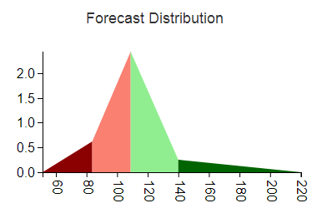

#### Determining Reasonable Values for Forecast Inputs

As described in “Setting Calculator Defaults,” the Calculator sets the default inputs based on historical data. The forecaster then uses these defaults as a baseline when changing the inputs. To help guide these changes, the Calculator displays the Mean, Standard Deviation, Skewness, and Kurtosis of the Forecast Distribution. The Mean measures what the forecaster expects to occur on average. Setting the Mean to be less than the defaults signifies the forecaster expects the investment to perform poorer on average than the historical period. Standard Deviation measures dispersion in future performance. All else equal higher dispersion, or volatility, results in a lower chance the investment will enhance an investor’s ability to reach a goal. Skewness measures asymmetry of future performance. An investment that performs well 99% of the time may still be undesirable if 1% of the time it results in a catastrophic loss, and negative skewness captures such asymmetrical payouts. Finally, Kurtosis measures the weight of the tails, or the possibility of large magnitude payouts in either direction. All else equal, Kurtosis increases the risk of the investor missing the goal. Therefore, Standard Deviation, Skewness, and Kurtosis all relate to risk.

#### Mapping Uniform Random Numbers to Simulations Using the Forecast Distribution

Thus far, the discussion has focused on forecasting investment performance. However, the underlying goal is to simulate investment performance, and subsequently, determine the probability of an investor reaching a cash flow goal based on these simulations. Therefore, a method of converting the forecasts to simulations is required.

Before it is possible to map forecasts to simulations, an intermediate step is required. It is necessary to determine the probability associated with each point on the Forecast Distribution. As shown in the above sections, the Forecast Distribution represents probabilities as areas underneath. Therefore, the Calculator determines the areas underneath and to the left of each point of the Forecast Distribution. This is called the Cumulative Forecast Distribution. Figure XX shows the results graphically. Appendix 2 derives the resulting mathematical formulas.

Next, the Calculator needs random numbers that it will transform to investment simulations using the Cumulative Forecast Distribution. Many computing languages supply pseudo-random numbers on the interval from 0 to 1 such that the probability of drawing any given number is equal. The underlying distribution for such a random number generator is known as the Uniform Distribution.

Since each random number drawn from the Uniform Distribution is on the interval from 0 to 1, each draw shares similar characteristics with a probability. The Cumulative Distribution plots probabilities on its y-axis. Consequently, each “probability” drawn maps to a horizontal line drawn across the y-axis. The intersection of this horizontal line and the Cumulative Distribution determines the investment simulation. The Calculator repeats these draws thousands of times to obtain a representative sample from the Cumulative Distribution. Formally, the general type of mathematical modeling that use numerical approximations is called Numerical Analysis. This can be contrasted with Analytical methods that solve systems of equations deterministically. The specific method employed is called Monte Carlo analysis. Numerical techniques are useful when equations cannot be solved analytically or when the Analytical solutions are extremely complicated. As the next section discusses, the modeling of investment portfolios requires forecasting the connections between investments. This step increases both the complexity of the forecasts and the benefits from using Monte Carlo analysis.

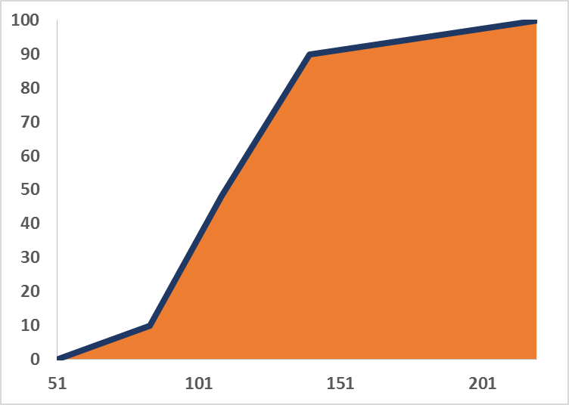

#### Understanding the Forecasts for Multiple Investments

Thus far, the discussion has been focused on forecasting performance of a single investment. However, simulations of investment portfolios are required to calculate the probability of an investor reaching a goal. This adds a layer of complexity because the Calculator needs to account for the relationships between investments as well as their individual performance. These relationships combined with individual performance determine the portfolio’s risk. A contrived example may help illustrate this last point. Suppose that a $100 investment in both Exxon and General Electric and each can only gain $10 or lose $5 in any given year.

* Scenario 1: If both Exxon and GE always increase or decline simultaneously, then the investor would either make $20 or lose $10 per year.
* Scenario 2: If Exxon always increases while GE declines and vice-versa, then the investor would always make $5.

Clearly, Scenario 2 has much lower risk than Scenario 1 and shows why the connections between investments matter.

#### Causal model between investments

The Calculator uses a Bayesian network to relate investments to one another. Figure XX diagrams the relationship between the two potential investments used in the Calculator: stocks and bonds. Bayesian networks are a type of Directed Acyclic Graph. “Directed” means that causal relationships are identified: the performance of stocks affects bonds. Stocks are the “parent” of bonds, and bonds are the “child” of stocks. The arrow in the diagram indicates the causal direction. “Acyclic” means that the causal relationships only flow in one direction; arrows cannot have two heads, and no child of bonds could have an arrow directed towards stocks. As an aside, the Calculator could have just easily assumed the opposite causal direction: bonds affecting stock prices. In finance, US stock prices are a standard causal factor; consequently, the Calculator is follows convention.

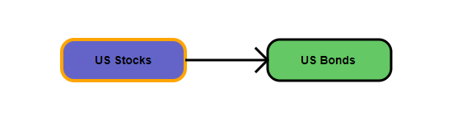

#### Forecasts for Multiple Investments

The Calculator simulates the performance of multiple investments similarly to a Single Investment with a single crucial difference: each Forecast Distribution for the child investment depends on the result of the parent. In particular, different Forecast Distributions are required for outcomes falling in the parent Left Tail, Left Normal, Right Normal, and Right Tail regions. In other words, the child Forecast Distributions are “conditional” upon the parent outcome. Therefore, the forecaster must specify the Minimum, Worst Case, Most Likely, Best Case, and Maximum outcomes for each of the four parent regions, or a total of 20 parameters per child. There is a tradeoff between forecaster time and simulation specificity, and the design of the Calculator attempts to balance this appropriately.

An example may help to illustrate how the Calculator simulates the performance of child variables. Figure YY depicts the network after the user selects bonds as the variable to forecast.

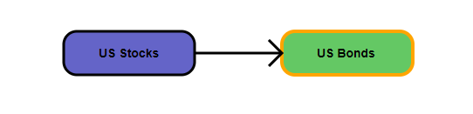

Next, the user selects the parent region. Figure ZZ shows that the user has selected “Stocks Left Tail” as the parent region. Since a different set of forecasts corresponds with each parent region, the forecast inputs and Forecast Distribution change each time the user selects a different value from this dropdown. Figure AA shows the default Forecast Distributions for each parent region.

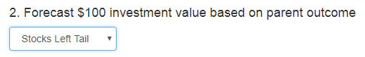

***Forecast Distributions for US Bonds conditional on a US Stock outcome in the a) Left Tail, b) Left Normal, c) Right Normal, d) Right Tail***

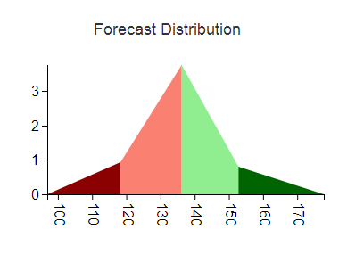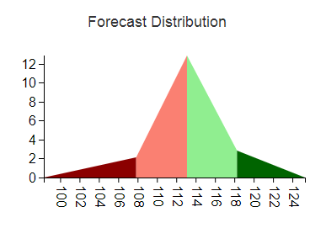

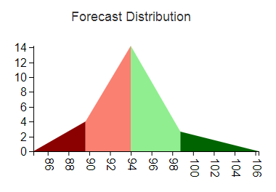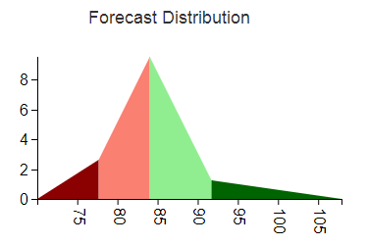

#### Simulating Multiple Investment Outcomes

Simulations for multiple investments parallel the forecasts. First, the Calculator simulates the top level variable using the same steps as described in the section “Mapping Uniform Random Numbers to Simulations Using the Forecast Distribution.” Then, it the appropriate Forecast Distribution for the child based on the outcome. For example, suppose the parent drew an outcome from the Left Tail of its Forecast Distribution. Then, the Calculator would draw the child outcome from Left Tail Forecast Distribution shown in Figure AA. The above steps would be repeated for all of the simulations.

The Calculator shows the simulation results in the “Simulate Investment Results” section. Since all of the draws for the Parent come from the same Forecast Distribution, the Simulation Histogram mirrors the Forecast Distribution and has similar statistical properties. Figure BB illustrates this result.

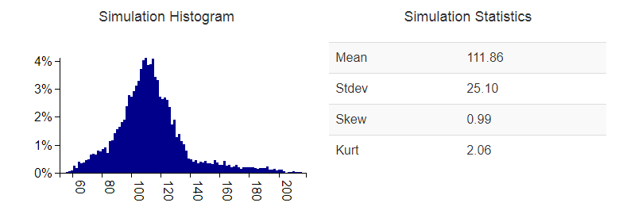

In contrast, the Calculator draws simulations for the child from four different distributions. Consequently, the child Simulation Histogram does not resemble any of the input Forecast Distributions and the statistics are also different. Figure CC demonstrates this.

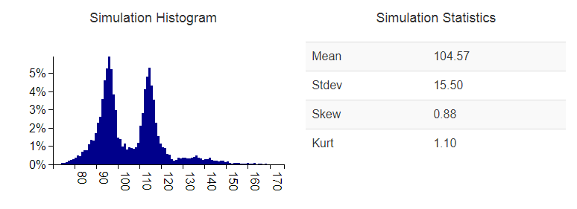

#### Key Benefits and Conclusion

### Brief history of assessing Probabilistic Forecasts and the use of Bayesian Networks as an investment modeling framework

### A narrative illustrating how investment managers could add value and act in client’s best interests

## Part 3: Tailoring Investment Products Based On Client Needs

### Demonstrate current industry structure versus what it could be

## Part 4: Mathematical and Technical Appendices

### Show the mathematical equations underlying the Calculator

### Demonstrate the Scalability and Asynchronous benefits and System Architecture of the technology