

Project Plan

UpliftEd - Online Learning Platform



Version | Date | Author | Changes | State
1.3 | 23/02/2025 | Georgi Ivanov | Finalized document, polished structure, ensured completeness | Finalization

Version history
Version | Date | Author | Changes | State
1.0 | 10/02/2025 | Georgi Ivanov | Document Creation | Draft
1.1 | 18/02/2025 | Georgi Ivanov | Refined research questions, detailed end products, expanded time plan & milestones | Draft
1.2 | 20/02/2025 | Georgi Ivanov | Improved project scope alignment, categorized research questions, added additional milestone details | Reviewed
1.3 | 23/02/2025 | Georgi Ivanov | Finalized document, polished structure, ensured completeness | Finalization

Table of Contents
1. Project Assignment 4
1.1 Context 4
1.2 Goal of the Project 4
1.3 Scope and Preconditions 4
1.4 Strategy 4
1.5 Research Questions 5
1.6 End Products 6
2. Project Organisation 7
2.1 Stakeholders and Team Members 7
2.2 Communication 7
3. Activities and Time Plan 7
3.1 Phases of the Project 7
4. Testing Strategy and Configuration Management 9
4.1 Testing Strategy 9
4.2 Test Environment and Required Resources 9
4.3 Configuration Management 9
5. Finances and Risk 10
5.1 Project Budget 10
5.2 Risk and Mitigation 10
6. Conclusion 11

1. Project Assignment

1.1 Context
UpliftEd™ is a web-based Online Learning Platform designed to facilitate course management, student enrollment, and interactive learning experiences. The platform will serve as a bridge between teachers and students, allowing teachers to create and manage courses while students can enroll, access learning materials, complete assignments, and track progress. The platform will be implemented using Java Spring Boot (backend), React (frontend), and MySQL (database).

1.2 Goal of the Project
- Develop a foundational and user-friendly Online Learning Platform.
- Enable role-based access control with three roles: Students, Teachers and Admins.
- Implement course creation and material upload functionality.
- Provide real-time notifications for assignments and quizzes.
- Ensure secure authentication & authorization using JWT.
- Deploy the platform using CI/CD pipelines for efficiency and scalability.

1.3 Scope and Preconditions

Category | Included (Inside Scope) | Excluded (Outside Scope)
User Management | JWT authentication, user roles (Students & Teachers) | Social networking features (forums, direct messaging)
Course Management | Teachers can create, update, and delete courses | AI-based course recommendations
Lesson & Material Upload | Teachers can upload PDFs, videos, and other resources | Live video lectures or conferencing support
Student Features | Enrollment in courses, tracking progress | Gamification elements (badges, points, leaderboard)
Assignments & Quizzes | Teachers can create quizzes, students can submit answers | Open-ended/essay type question automatic grading (possibly ai-driven)
Notifications | WebSockets for real-time course updates and notifications. | SMS or third-party notification services
Search & Filtering | Courses searchable by category, level, and instructor | Advanced recommendation system
Analytics & Reporting | Basic aggregated data (e.g., number of enrollments per course) | Advanced analytics dashboards with detailed insights
Integrations | Basic file uploads for learning materials | Third-party integrations (Google Classroom, Zoom, etc.)
Platform Support | Web-based application only | Mobile app development
Monetization | None (Free access) | Payment gateways or subscription models
Language Support | English only | Multi-language functionality

1.4 Strategy
- Agile Development using Scrum methodology.
- Sprints of 2-3 weeks with defined milestones.
- Continuous Integration & Deployment (CI/CD) using GitLab.
- Unit and Integration Testing before (almost) every commit.

1.5 Research Questions
1. Authentication & Security
- How can JWT authentication be securely implemented for user login and session management in Spring Boot?
- What are the best practices for role-based access control (RBAC) to manage student, teacher and admin permissions?
- How can password storage and encryption be securely handled using BCrypt and MySQL?
2. Backend Development & Database Design
- What is the best way to design a foundational database schema for managing users, courses, and quizzes?
- How can MySQL indexing and query optimization improve platform performance for large datasets?
- What are the best practices for RESTful API development in a Spring Boot project?
3. Course & Quiz Management
- How can automated quiz scoring and question banks be implemented efficiently in a relational database?
- What techniques ensure data integrity and prevent cheating in online assessments?
4. Real-Time Features & Notifications
- How can WebSockets or polling be used for real-time notifications in Spring Boot?
- How can WebSockets be optimized for scalability to support multiple concurrent users in a learning platform?
5. Testing & Deployment
- How can CI/CD pipelines (GitLab) be set up for automated testing and deployment in a university project?
- What are the best practices for writing unit and integration tests for a Spring Boot REST API?

1.6 End Products
• Deployed Online Learning Platform (Fully functional with student & teacher roles)
• User Authentication System (JWT-based authentication & authorization)
• Course Management System (CRUD operations for courses, materials, and quizzes)
• Quiz & Assessment System (Automated scoring, question bank management)
• File Upload System (Support for PDFs, videos, slides, and documents)
• Real-time Notification System (Assignment, quiz, and course updates via WebSockets)
• REST API Documentation (Swagger UI with request/response details)
• Unit & Integration Test Reports (Test cases, coverage reports, and CI/CD logs)
• CI/CD Pipelines (Automated build, test, and deployment setup via GitLab)
• Admin Management Dashboard (User roles, logs, and platform monitoring)
• Final Project Presentation (Live demo and architecture overview)

PBS
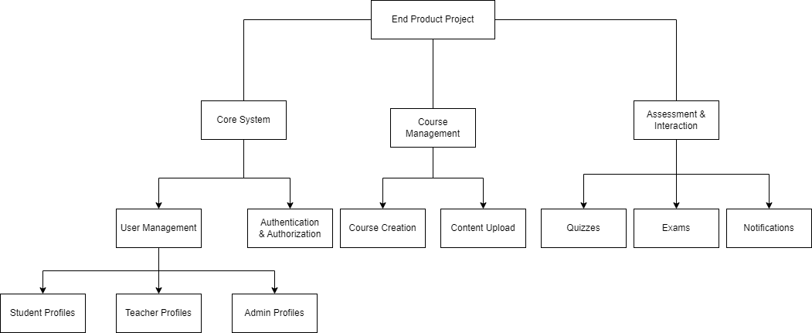

2. Project Organization

2.1 Stakeholders and Team Members
Name | Role | Availability | Contact
Georgi Ivanov | Deveolper | Full-time | 524571@student.fontys.nl
Project Stakeholder | Mentor | Weekly meetings | email

2.2 Communication
- Weekly Stand-ups with the mentor.
- GitLab Issues & Merge Requests for tracking progress.

3. Activities and Time Plan

3.1 Phases of the Project

Phase 1: Setup GitLab, Project Structure, Database Schema
- Create GitLab repository and set up a branching strategy.
- Initialize Spring Boot project and configure dependencies (Spring Security, JPA, MySQL).
- Set up a GitLab CI/CD pipeline for automated testing and deployment.
- Design and implement the database schema, including users, courses, lessons, quizzes, and enrollments.
- Have at least 3 working endpoints in the project’s RESTful services which are at maturity level 2 or higher.
- Set up environment configurations for local development and testing.

Phase 2: Implement Authentication & Authorization (JWT)
- Implement user authentication using JWT, including login, registration, and token validation.
- Create role-based authorization for Students, Teachers and Admins.
- Secure API endpoints using Spring Security.
- Implement password hashing and validation.

Phase 3: Develop Course Management (CRUD)
- Develop endpoints for course creation, updating, deletion, and retrieval.
- Implement database models for courses and lessons.
- Develop a frontend UI for teachers to create and manage courses.
- Ensure students can browse and view courses.

Phase 4: Implement Enrollment, Materials Upload & Quizzes
- Implement a student enrollment system with validation.
- Create functionality for teachers to upload lesson materials (PDFs, videos, assignments).
- Develop a quiz system with automated scoring for multiple-choice questions.
- Implement UI for students to enroll in courses and complete quizzes.

Phase 5: Add WebSockets for Notifications
- Integrate WebSockets to enable real-time notifications.
- Implement a notification system for new assignments and course updates.
- Ensure teachers can send announcements to enrolled students.

Phase 6: Implement Testing & CI/CD Pipeline
- Write unit tests for authentication, course management, and enrollment functionalities.
- Implement integration tests for API endpoints.
- Ensure seamless frontend and backend integration.

Phase 7: Final Debugging, Deployment & Documentation
- Conduct full system testing and resolve major bugs.
- Deploy the application to a cloud-based hosting service.
- Prepare final documentation, including API reference and a user manual.
- Conduct the final presentation and submit all deliverables.

4. Testing Strategy and Configuration Management

4.1 Testing Strategy
- Unit Testing (using JUnit & Mockito).
- Integration Testing for API endpoints.
- UI Testing (using Cypress).
- Test Coverage Goal: 85%+.
- Code Quality Assurance (via SonarQube).

4.2 Test Environment and Required Resources
- DTAP Environment: Development → Testing → Production.
- CI/CD Pipeline for automated deployments.
- GitLab Runner for running tests.

4.3 Configuration Management
- GitLab Repository with branching strategy:
  - main (stable production branch)
  - develop (active development branch)
  - feature/* (individual feature branches)
- Automated Code Review via Pull Requests.

5. Finances and Risk

5.1 Project Budget
- Hosting: Free (Using student cloud resources or local deployment).
- Development Tools: Free (IntelliJ IDEA Community, GitLab, MySQL).

5.2 Risk and Mitigation

Risk | Prevention Activities | Mitigation Activities
Scope Creep | Define clear MVP & deadlines, prioritize core functionalities | Stick to core features, document future enhancements
Tech Issues | Research & prototype before major decisions | Seek guidance from mentor, use well-documented technologies
Time Management | Weekly progress reviews, set clear sprint goals | Adjust workload based on progress, maintain buffer time
Security Risks | Implement authentication best practices, use secure coding | Regular security audits, OWASP guidelines, encrypt sensitive data
Integration Challenges | Choose compatible frameworks, test API early | Use mock testing for early validation, document API contracts
Data Loss | Implement automatic database backups | Maintain version control, use redundant storage options
User Adoption Issues | Conduct user feedback sessions, usability testing | Improve UI/UX based on feedback, provide detailed documentation
Deployment Issues | Use containerized environments (Docker) for consistency | Have rollback plans in place, monitor deployment pipelines
Unforeseen Bugs | Write unit and integration tests | Maintain a dedicated bug-tracking system, prioritize fixes

6. Conclusion
This project plan provides a structured approach for developing the UpliftEd Online Learning Platform while ensuring quality, scalability, and maintainability. The agile methodology, CI/CD integration, and testing strategy will ensure that the project remains on track and delivers a fully functional system by the end of the semester.

