SAP ABAP Asset Management System

1. Introduction
This project is developed using SAP ABAP to manage employee asset allocation within an organization. The system stores employee details, asset details, and allocation information using custom SAP database tables. Smart Forms are used to generate professional allocation documents dynamically.

2. Objectives
- Manage employee information
- Maintain company asset records
- Track asset allocation and return details
- Generate Smart Form output dynamically
- Develop ABAP reports and database integration

3. Technologies Used
- SAP GUI
- ABAP Programming
- SE11 Data Dictionary
- SE38 Reports
- Smart Forms
- Driver Programs

4. Database Tables

4.1 Employee Table - ZEMPLOYEE_DT1
Field Name | Description
EMP_ID | Employee ID
EMP_NAME | Employee Name
DEPARTMENT | Department
PHONE | Phone Number
EMAIL | Email Address
STATUS | Employee Status

Employee Table Screenshot
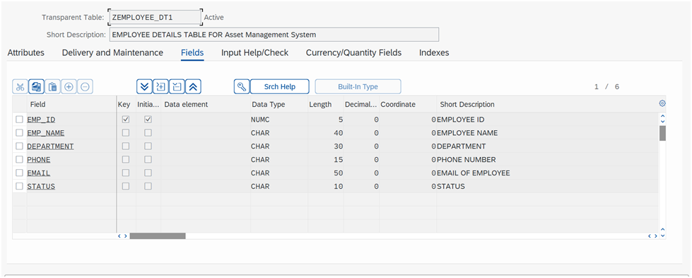

4.2 Asset Table - ZASSET_DT1
Field Name | Description
ASSET_ID | Asset ID
ASSET_NAME | Asset Name
CATEGORY | Asset Category
PURCHASE_DATE | Purchase Date
STATUS | Asset Status
Asset Table Screenshot
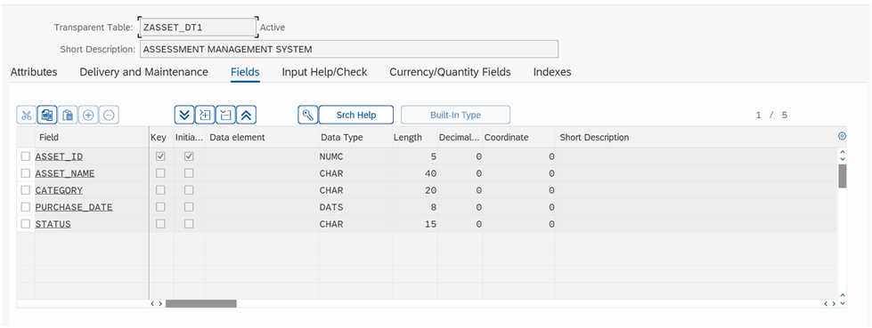

4.3 Allocation Table - ZALLOC_DT1
Field Name | Description
ALLOC_ID | Allocation ID
EMP_ID | Employee ID
ASSET_ID | Asset ID
ALLOC_DATE | Allocation Date
RETURN_DATE | Return Date
STATUS | Allocation Status
Allocation Table Screenshot
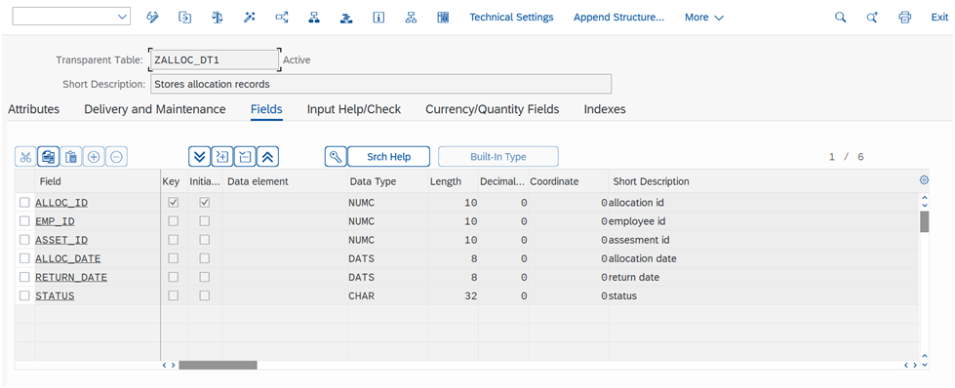

5. Reports Developed
- ZEMPLOYEE_REPORT_DT1
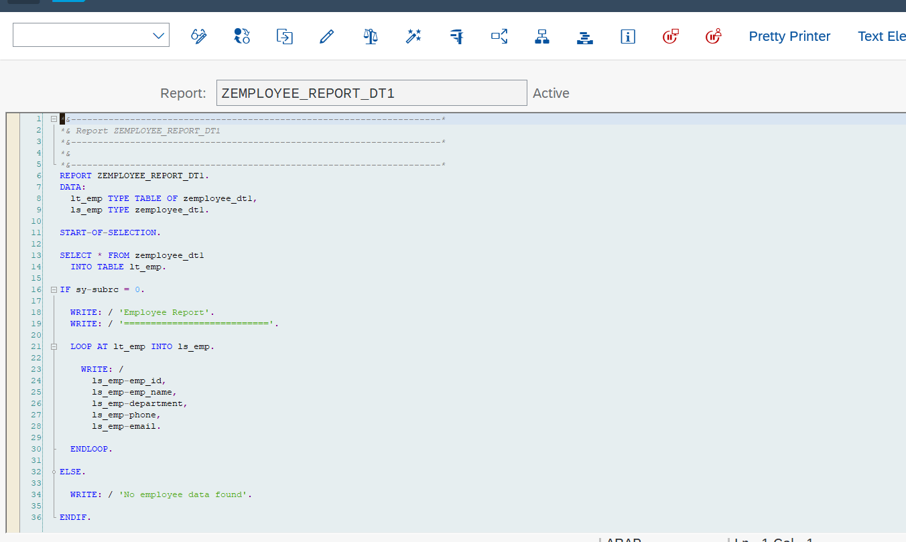
- ZASSET_REPORT_DT1
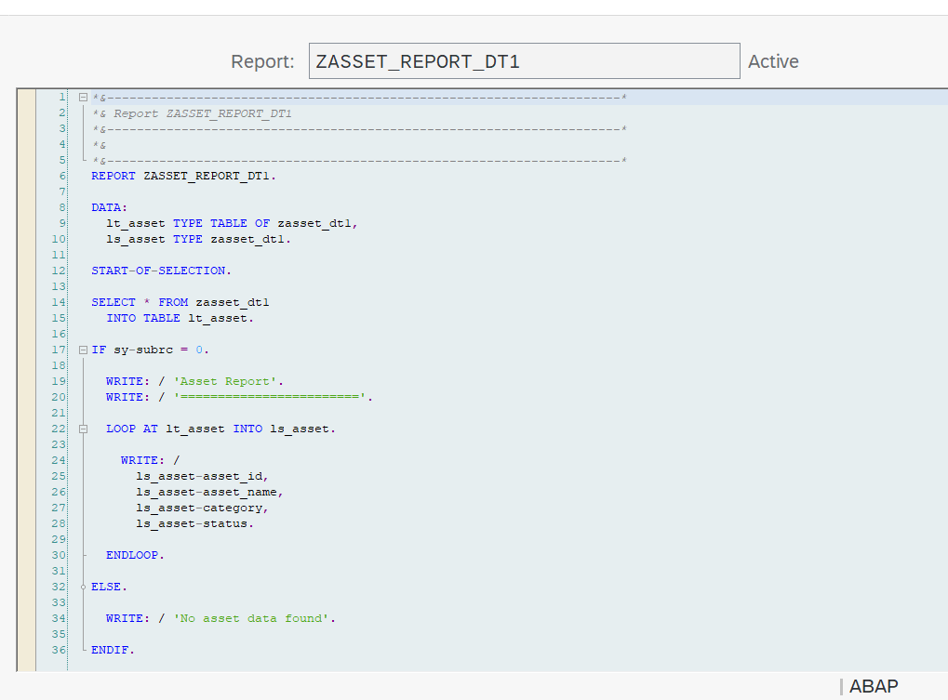

- ZEMPLOYEE_ALV_DT1
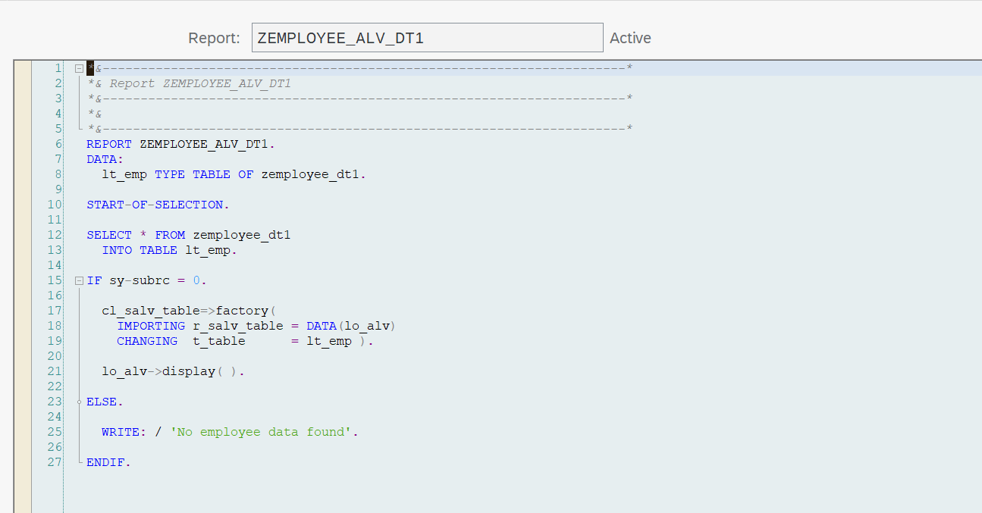

6. Smart Form Development
Smart Forms were developed to generate asset allocation documents dynamically using database-driven values fetched through ABAP driver programs.
- Smart Form Name: ZASSET_FORM_DT1
- Driver Program: ZCALL_SMARTFORM_DT1
- Dynamic Parameters Used
- Database Integration using SELECT SINGLE
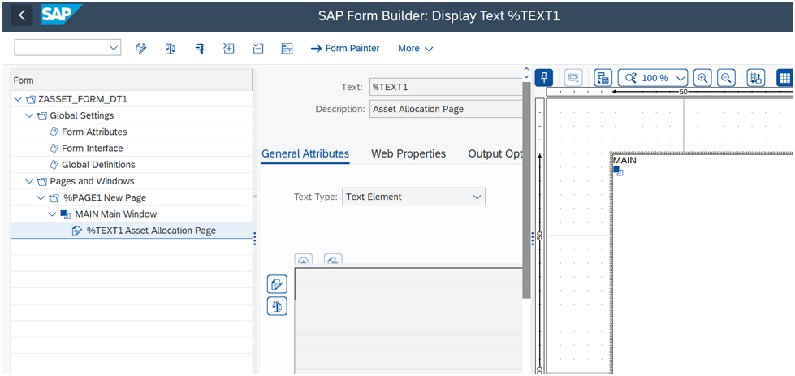
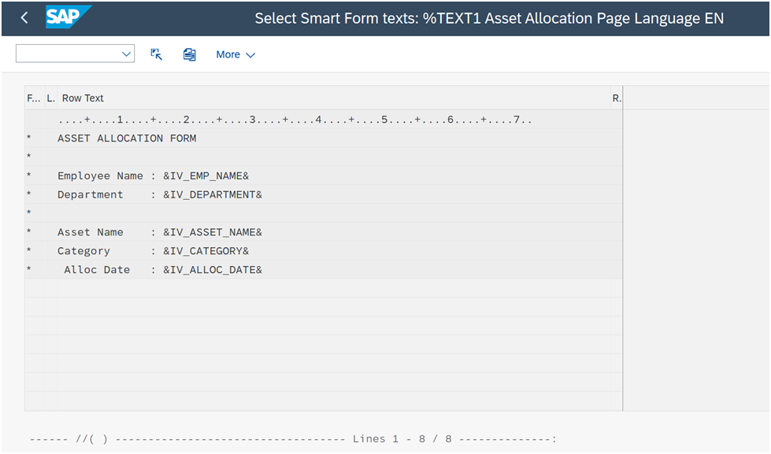
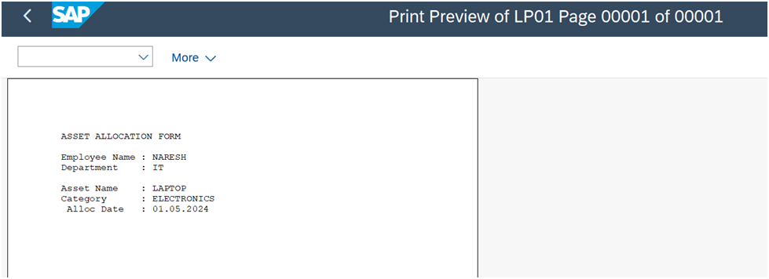

7. Features
- Employee Management
- Asset Management
- Asset Allocation Tracking
- Dynamic Smart Form Generation
- Database Integration
- ABAP Driver Program Execution

8. Conclusion
Successfully developed an SAP ABAP Asset Management System using custom database tables, Smart Forms, reports, and driver programs. The project demonstrates practical SAP ABAP development skills and enterprise workflow integration.

