1. As a tester, you're assigned to test Sign Up / Log In flow on WeTravel platform (https://www.wetravel.com). Please list out all the possibilities after careful review.

**I’ve created mind map. Please find it in the link below**

**https://drive.google.com/file/d/1S9GhLpZYM475u8xfyPFDBNM8UzTJPsi7/view?usp=sharing**

1. We are asking your opinion for what kind of testing you will recommend for Sign Up / Log In flow on WeTravel platform. Please provide the list of various testing types which you will recommend and justify them. Explain with examples about why did you pick those testing types? –

White box testing such as back-end testing, because in Chrome browser’s console I see several errors when clicking on Sign button

1. The error appears because the cancelBubble property of the [Event](https://developer.mozilla.org/en-US/docs/Web/API/Event) interface is deprecated.

2 In Mozilla browser’s console I see this error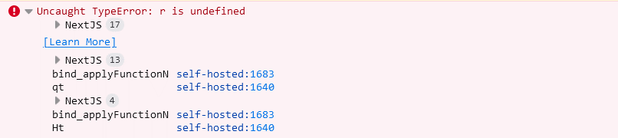

1. Non-functional testing such as cross-browser testing because errors are different for browsers
2. Functional testing such as Happy path testing for “Sign up with Facebook” functionality because during testing I faced several times with the error 