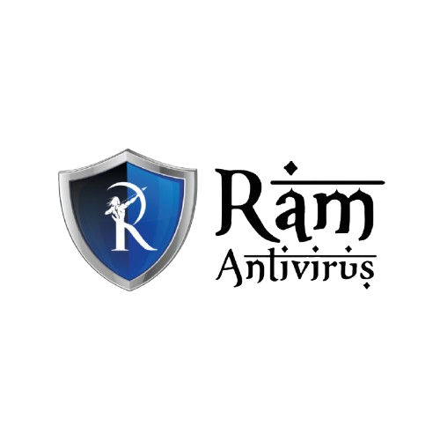

Software Requirements Specification (SRS)
Project: Development of Advanced Cyber Defense for Securing Industrial Infrastructure
Prepared By: Ram Antivirus Security Engineering Team

1. Introduction
1.1 Purpose
This document defines the functional and non-functional requirements for developing an advanced cyber defense system designed to secure industrial infrastructure including SCADA, ICS, and OT environments.
1.2 Scope
The system will monitor industrial networks, detect anomalies and cyber threats, enforce segmentation policies, and provide automated incident response for critical infrastructure environments.
1.3 Definitions
ICS – Industrial Control Systems
SCADA – Supervisory Control and Data Acquisition
OT – Operational Technology

2. Overall Description
The platform is designed as a resilient, real-time industrial cybersecurity solution integrated with Ram Antivirus, supporting critical infrastructure sectors such as power, manufacturing, oil & gas, and transportation.
Major Components:
• Industrial Network Monitoring Layer
• Industrial SIEM Engine
• AI-Based Threat & Anomaly Detection
• Intrusion Prevention & Network Segmentation
• SOAR-Based Incident Response
• Security Operations Dashboard

3. Functional Requirements
3.1 Industrial Network Monitoring
- Continuous monitoring of OT devices and protocols
- Detection of unauthorized device communication
- Protocol inspection (Modbus, DNP3, OPC)
3.2 AI Threat Detection
- Behavioral anomaly detection for ICS systems
- Detection of command manipulation or process tampering
- Risk scoring and threat classification
3.3 Intrusion Prevention & Segmentation
- Network segmentation enforcement
- Real-time threat blocking
- Access control policy management
3.4 Incident Response & Automation
- Automated containment workflows
- SOC alert generation
- Incident logging and forensic data collection

4. Non-Functional Requirements
- High availability for critical infrastructure (99.99% uptime)
- Real-time processing with minimal latency
- Secure encrypted communication
- Role-Based Access Control (RBAC)
- Compliance with industrial security standards (IEC 62443, NIST)

5. Technology Stack (Indicative)
Core Engine: C++ / Rust
Backend: Python / Java
AI/ML: TensorFlow / PyTorch
Data Layer: Elasticsearch / PostgreSQL
Deployment: On-Premise / Hybrid / Secure Cloud
Integration: OT protocol libraries

6. System Architecture Diagram
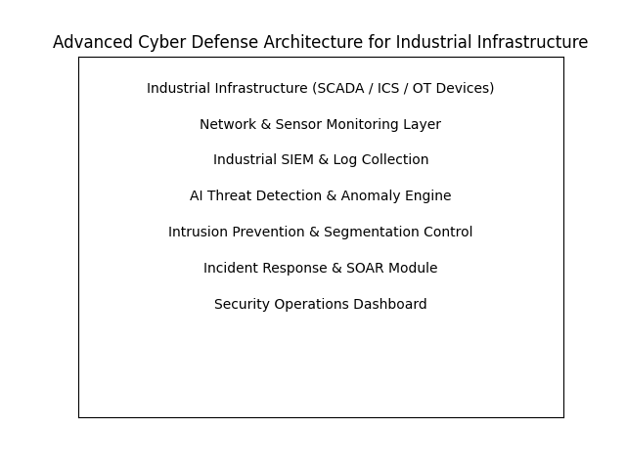

7. Adaptability Statement
The architecture, detection mechanisms, and technology stack described in this document represent a recommended framework. The final implementation may vary depending on industrial sector requirements, regulatory standards, infrastructure constraints, and evolving cyber threats targeting critical systems. The system is designed to remain modular, resilient, and adaptable to diverse industrial operational environments.

