中原大學

資訊工程學系

碩士學位論文

以YOLOv7為基礎之旋轉物件辨識方法

A YOLOv7-based Radian Object Detection

指導教授：蘇志文

研 究 生：林冠良

中華民國 112 年 O 月

**摘要**

近年來，物件偵測技術在空拍影像應用中扮演了越來越重要的角色。然而，現有的物件偵測模型通常只能偵測物件的位置和類別，而無法辨識物件的角度。為了解決這個問題，我們對YOLOv7模型進行了修改，以實現對物件角度的準確偵測。這些修改包括增加了一個旋轉檢測層，用於檢測物件的旋轉角度，並在損失函數中加入了旋轉角度的損失項，以進一步提高模型的準確性。此外，我們還加入了旋轉的NMS，以確保偵測出的物件框框能夠更好地貼合物件。

為了驗證修改後的YOLOv7模型的效果，我們使用了HRSC、DOTA1.0和我們自己的十字路口車流資料集進行了實驗。實驗結果表明，修改後的YOLOv7模型在這些資料集上都取得了不錯的成果，並且在物件角度偵測方面優於現有的物件偵測模型。這驗證了我們的修改可以有效地提高物件偵測模型的準確性，並有望未來在實際應用中發揮更大的作用。

**Abstract**

In recent years, object detection technology has played an increasingly important role in aerial image applications. However, existing object detection models can only detect the position and category of objects, but not the orientation of objects. To address this issue, we modified the YOLOv7 model to achieve accurate detection of object orientation. These modifications included adding a rotation detection layer to detect the rotation angle of objects, and adding a loss term for the rotation angle in the loss function to further improve the model's accuracy. In addition, we also added rotational non-maximum suppression (NMS) to ensure that the detected bounding boxes fit the objects more accurately.

To verify the effectiveness of the modified YOLOv7 model, we conducted experiments using three datasets: HRSC, DOTA1.0, and our own crossroad traffic dataset. The experimental results showed that the modified YOLOv7 model performed better on all three datasets and outperformed existing object detection models in detecting object orientation. This indicates that our modifications can effectively improve the accuracy of object detection models and have the potential to have a greater impact in future practical applications, including traffic management and surveillance in crossroad scenarios.**致謝**

謝謝JackLin.

# 

# 目次

摘要 I

Abstract II

致謝 III

目次 IV

圖目次 VI

表目次 VIII

第一章 緒論 1

1.1 研究動機 1

1.2 論文架構 3

第二章 相關文獻 4

2.1 主流的物體檢測模型 5

2.1.1 二階段物體檢測模型 5

2.1.2 單階段物體檢測模型 7

2.2 無錨框(Anchor-free)物體檢測模型 10

2.3 旋轉邊界框物體檢測模型 14

2.4 基於分類的角度預測方法 17

2.4.1 基於參數迴歸 17

2.4.2 基於角度分類 18

第三章 研究方法 20

3.1 邊界框定義 21

3.1.1 旋轉邊界框之定義 21

3.1.2 旋轉邊界框起點之定義 22

3.2 數據增強 23

3.2.1 馬賽克數據增強(Mosaic Data Augmentation) 23

3.2.2 翻轉數據增強 24

3.2.3 旋轉數據增強 25

3.3 基於YOLOX之遙測空拍無錨框單階段旋轉邊界框物體檢測 26

第四章 實驗結果與分析 30

4.1 實驗環境 30

4.2 實驗資料 30

4.3 實驗結果 34

第五章 結論與未來方向 39

參考文獻 40

Table of Contents

摘要 I

Abstract II

Acknowledgement III

List of Figure V

List of Table VI

Chapter 1 Thesis Format 1

1.1 Add number to table / figure 1

1.1.1 Index number 1

1.1.2 Format of content and title 1

1.2 Add List of Figure / Table 2

Chapter 2 Page index number 3

2.1 How to insert Roman numeral index page number 3

2.1.1 Step 1. Split the page between cover page and pages before content 3

2.1.2 Step 2. Add Roman numeral index page number 4

2.2 Insert Table of Contents 5

2.2.1 How to make class of titles 5

2.2.2 How to show Table of Contents in the thesis file 6

List of Figure

Figure 1 Path to add index number 3

Figure 2 Window when you click "Insert table of figures" 4

Figure 3 Path of "Breaks" 5

Figure 4 Category of "Breaks" 5

Figure 5 How to change the format of page number 6

Figure 6 The window of "Page Number Format" 6

Figure 7 Window of dialog box in "Paragraph" 7

Figure 8 Path to show Navigation Pane 8

Figure 9 Navigation Pane 8

List of Table

Table 1 Format description 3

第一章 緒論

1.1 研究動機

隨著無人機的普遍化，物件辨識也開始大量應用於遙測航拍影像的辨識上，雖然說在前幾年的經驗中，水平邊界框對於密集排列與長寬比變化大的物體辨識上，稍顯無力，使得大部分的研究者開始去研究以旋轉擬合框為基礎的偵測器模型，在本篇論文中，因受到YOLOv7強大的性能啟發，希望能以YOLOv7為基礎，在原本成熟的模型上，以旋轉擬合框加入角度的偵測，去研究如何對空拍影像中的物件進行角度偵測是一個具有重要意義的課題。

針對這個問題，我們對YOLOv7模型進行了修改，以實現對物件角度的準確偵測。我們增加了一個旋轉檢測層，用於檢測物件的旋轉角度，並在損失函數中加入了旋轉角度的損失項，以進一步提高模型的準確性。此外，我們還加入了旋轉的NMS，以確保偵測出的物件框框能夠更好地貼合物件。

為了驗證我們提出的方法的有效性，我們採納了HRSC和DOTA1.0這兩個具有代表性的資料集，同時為了多方驗證，也使用了本實驗室有的十字路口空拍車流資料集進行實驗。實驗結果顯示，我們修改後的YOLOv7模型可以準確地偵測空拍影像中的物件角度，並在各種複雜場景中取得了較好的效果。因此，我們相信我們的研究可以為空拍影像中的物件偵測問題提供一個新的解決方案，有望在未來的實際應用中發揮更大的作用。

1.1.2 Format of content and title

All the format of thesis can take Table 1 for reference.

Table 1 Format description

|  |  |  |
| --- | --- | --- |
| Category | Font size | Format |
| Content | 12 | - |
| Title 1 | 18 | Chapter 1 |
| Title 2 | 16 | 1.1 |
| Title 3 | 14 | 1.2.1 |
| Figure / Table | 12 | As the caption format  (e.g., Figure 1) |

1.2 Add List of Figure / Table

If you want to add list of figure or list of tables, click “References”, “Insert table of figures” at the place you want to add, and choose the caption label that you want to add.

You can take Figure 2 for reference.

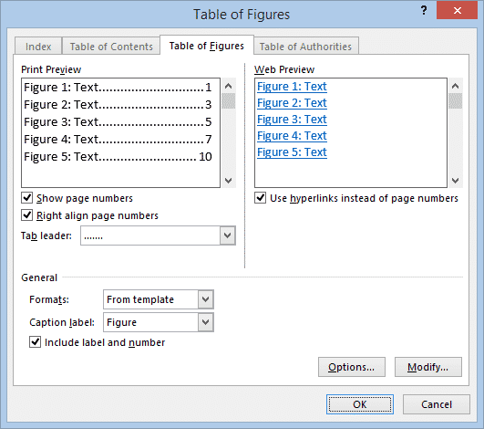

Figure 2 Window when you click "Insert table of figures"

Chapter 2 Page index number

2.1 How to insert Roman numeral index page number

2.1.1 Step 1. Split the page between cover page and pages before content

First, we need to click the page under the cover page and click “Layout”, and then click “Breaks”, choose “Next page”.

You can take Figure 3 and Figure 4 for reference.



Figure 3 Path of "Breaks"



Figure 4 Category of "Breaks"

2.1.2 Step 2. Add Roman numeral index page number

Click “Page Number” below “Insert”, and choose the “Format Page Numbers”, select the Roman numeral numbers in “Number format”.

After you choose the number format, don’t forget to choose “Bottom of Page” when you insert the page numbers.

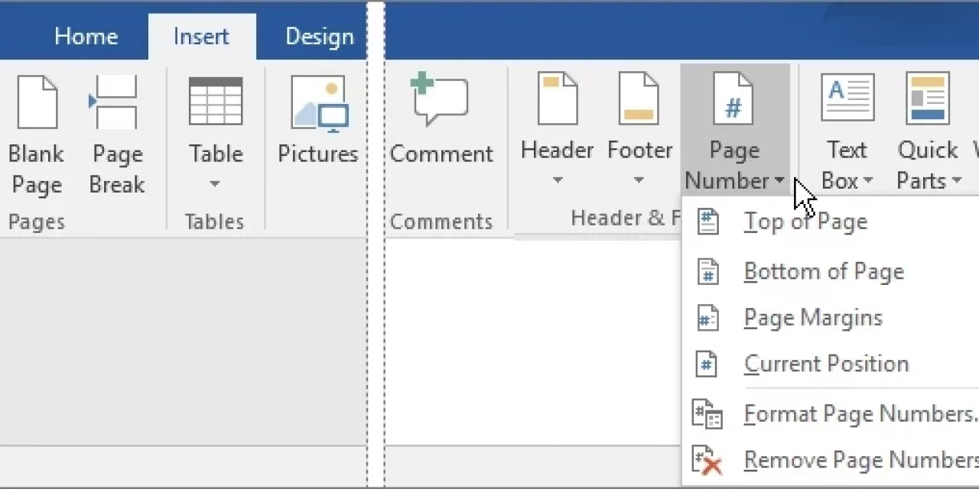

Figure 5 How to change the format of page number

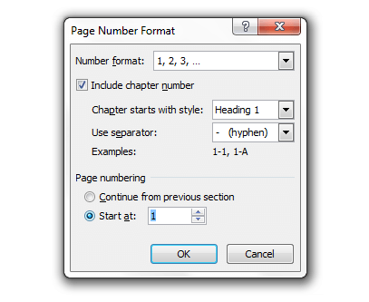

Figure 6 The window of "Page Number Format"

2.2 Insert Table of Contents

2.2.1 How to make class of titles

When you finish editing a title, tap “Home” and then click the dialog box right of “paragraph”, as Figure 7, choose the class of font in the “Outline level” of the window.

Figure 7 Window of dialog box in "Paragraph"

2.2.2 How to show Table of Contents in the thesis file

If you want to show Table of Contents beside the content, click “View” and then choose the “Navigation Pane”, then you can see Table of Contents in your file.

You can take Figure 8 for reference.



Figure 8 Path to show Navigation Pane

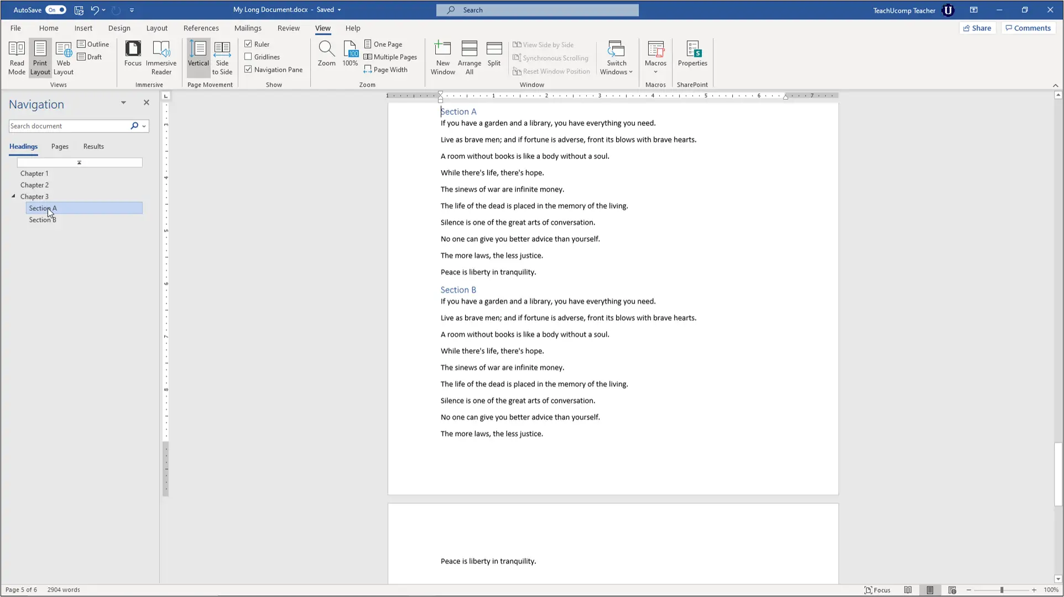

Figure 9 Navigation Pane