中原大學

資訊工程學系

碩士學位論文

以YOLOv7為基礎之具方向性物件辨識方法

A YOLOv7-based Radian Object Detection

指導教授：蘇志文

研 究 生：林冠良

中華民國 112 年 O 月

**摘要**

近幾年來，電腦視覺領域的演算法與模型日新月異，而空拍機的普遍也使得相關技術廣泛被應用於遙測空拍影像之辨識上，領域內目前大致上分為有無錨框兩類偵測器，而旋轉角度偵測方面又再細分為水平邊界框與旋轉擬合框兩類。

在水平邊界框的角度預測上，對於航拍類密集排列、具方向性或長寬比較懸殊之物件辨識上，在以前的經驗上稍顯無力，不過在水平邊界框偵測器經過近幾年相似結構重構以及重參數等不同技術的進步下逐漸成熟，同時也因為本實驗室先前有將領域內知名的YoloV4以及YoloX之水平邊界框偵測器加入角度的偵測能力的先例，雖然分別是以旋轉擬合框以及無錨框的方式來修改模型，不過在2022年中得知YoloV7的發布之後，便想嘗試在進步過後的基礎水平邊界框模型上，繼續嘗試加入角度偵測的功能，在V7參數量少，速度也進步的基礎上建立一個穩定的物件角度偵測器。

為了驗證對於水平邊界框檢測器穩定度的假設性，在加入新的角度偵測頭之後，本論文也利用本身實驗室的十字路口空拍資料以及大型遙測航拍公共資料集DOTA來進行訓練與驗證等工作，透過反覆的實驗以及驗證來佐證所提出的假設。

**Abstract**

Over these years, object detection models in computer vision have been changing and advancing rapidly, and can be roughly categorized into two categories: Anchor-Based and Anchor-Free. In terms of radian detection, it is further divided into two types: horizontal-bounding box and oriented-bounding box.

As for horizontal-bounding box rotation detection, when detecting densely arranged, directional and large aspect ratio objects such as aerial photography is slightly ineffective. But recently, after several bags of goodies improving the performance of horizontal-bounding box detection model, it is now getting more and more mature. Due to the previous experience of our lab implementing radian detection in the well-known YOLOv4, I started to gain interest in doing the same tweaking after knowing the release of a faster and more robust YOLOv7.

This paper...

In order to verify the method proposed in this thesis.

**致謝**

Table of Contents

摘要 I

Abstract II

Acknowledgement III

List of Figure V

List of Table VI

Chapter 1 Thesis Format 1

1.1 Add number to table / figure 1

1.1.1 Index number 1

1.1.2 Format of content and title 1

1.2 Add List of Figure / Table 2

Chapter 2 Page index number 3

2.1 How to insert Roman numeral index page number 3

2.1.1 Step 1. Split the page between cover page and pages before content 3

2.1.2 Step 2. Add Roman numeral index page number 4

2.2 Insert Table of Contents 5

2.2.1 How to make class of titles 5

2.2.2 How to show Table of Contents in the thesis file 6

List of Figure

Figure 1 Path to add index number 3

Figure 2 Window when you click "Insert table of figures" 4

Figure 3 Path of "Breaks" 5

Figure 4 Category of "Breaks" 5

Figure 5 How to change the format of page number 6

Figure 6 The window of "Page Number Format" 6

Figure 7 Window of dialog box in "Paragraph" 7

Figure 8 Path to show Navigation Pane 8

Figure 9 Navigation Pane 8

List of Table

Table 1 Format description 3

第一章 緒論

1.1 研究動機

近幾年來，因為各領域的廣泛運用，物件辨識已成為電腦視覺中最廣為人知的部分，並且伴隨著技術進步以及深度學習的崛起，物件辨識在速度以及準確度上都得到非常可觀的進步，目前大部分物件辨識的偵測器大多也都加入了深度學習作為輔佐，得到蠻成功的成就，而主要在類別上分為兩類：（一）單階段（One-Stage）以及（二）二階段（Two-Stage），後者較早發展，在辨識的過程中，會先擷取出物體的範圍（Region Proposals），再對物體進行分類，分為兩個階段；而單階段則為近幾年來所發展出來，同時對偵測物體進行定位與分類的類型，就精準度而言，後者優於前者，在速度上，則是相反。

同時也因為各領域對於AI的應用的需求導致技術落地化的重要性大幅提升，其中以YOLO系列的單階段物體偵測器最為成功，近年來也不斷推成出新，YOLO是使用人工標註過預先設定好長寬比以及大小的錨框（Anchor），在不同維度大小的特徵圖（Feature Map）去進行回歸預測的偵測器，而這些錨框在不同類型的物件上，也會有不同的標註方式，例如針對物體的旋轉標示而具備方向性或是因物體有深淺度的資訊而以立方體的樣子呈現。

隨著無人機的普遍化，物件辨識也開始大量應用於遙測航拍影像的辨識上，雖然說在前幾年的經驗中，水平邊界框對於密集排列與長寬比變化大的物體辨識上，稍顯無力，使得大部分的研究者開始去研究以旋轉擬合框為基礎的偵測器模型，不過近幾年越來越多輔助的技術開始陸續加入水平邊界框的偵測器中，表現進步也逐漸穩定，已成為成熟的物件偵測器。在本篇論文中，因受到YOLOv7強大的性能啟發，希望能以YOLOv7為基礎，在原本成熟的模型上，再加入角度的偵測，去

1.1.2 Format of content and title

All the format of thesis can take Table 1 for reference.

Table 1 Format description

|  |  |  |
| --- | --- | --- |
| Category | Font size | Format |
| Content | 12 | - |
| Title 1 | 18 | Chapter 1 |
| Title 2 | 16 | 1.1 |
| Title 3 | 14 | 1.2.1 |
| Figure / Table | 12 | As the caption format  (e.g., Figure 1) |

1.2 Add List of Figure / Table

If you want to add list of figure or list of tables, click “References”, “Insert table of figures” at the place you want to add, and choose the caption label that you want to add.

You can take Figure 2 for reference.

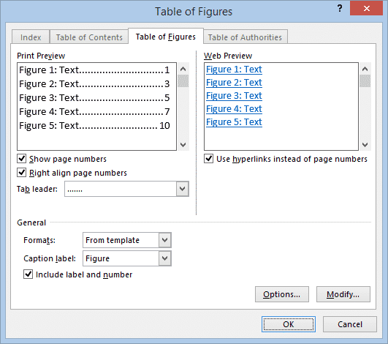

Figure 2 Window when you click "Insert table of figures"

Chapter 2 Page index number

2.1 How to insert Roman numeral index page number

2.1.1 Step 1. Split the page between cover page and pages before content

First, we need to click the page under the cover page and click “Layout”, and then click “Breaks”, choose “Next page”.

You can take Figure 3 and Figure 4 for reference.



Figure 3 Path of "Breaks"



Figure 4 Category of "Breaks"

2.1.2 Step 2. Add Roman numeral index page number

Click “Page Number” below “Insert”, and choose the “Format Page Numbers”, select the Roman numeral numbers in “Number format”.

After you choose the number format, don’t forget to choose “Bottom of Page” when you insert the page numbers.

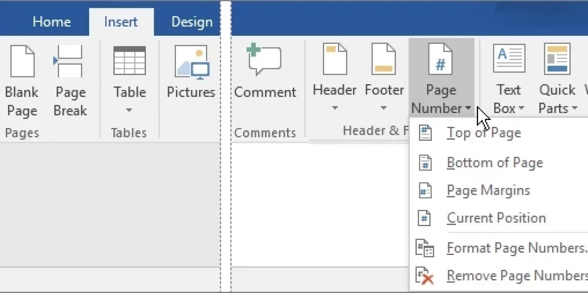

Figure 5 How to change the format of page number

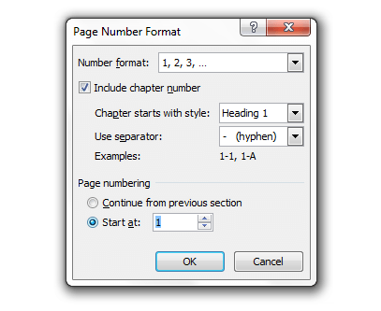

Figure 6 The window of "Page Number Format"

2.2 Insert Table of Contents

2.2.1 How to make class of titles

When you finish editing a title, tap “Home” and then click the dialog box right of “paragraph”, as Figure 7, choose the class of font in the “Outline level” of the window.

Figure 7 Window of dialog box in "Paragraph"

2.2.2 How to show Table of Contents in the thesis file

If you want to show Table of Contents beside the content, click “View” and then choose the “Navigation Pane”, then you can see Table of Contents in your file.

You can take Figure 8 for reference.



Figure 8 Path to show Navigation Pane

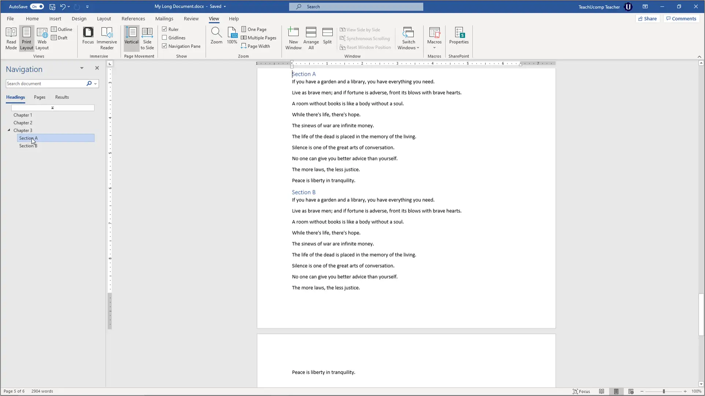

Figure 9 Navigation Pane