中原大學

○○○○學系

○士○○○○

我是一份範本

This is a template of thesis of CYCU

指導教授：○○○

研 究 生：○○○

中華民國 OOO 年 O 月

摘要

民國 42 年由篤信基督、熱心教育人士張靜愚先生、郭克悌先生、賈嘉美牧

師、鈕永健先生、陳維屏先生、瞿荊洲先生及桃園中壢地方士紳吳鴻森先生、

徐崇德先生等會商籌設一所農工學院，期以基督救世愛人的精神，為國家造就

高深科學與工程人才；在歷經多次籌備更名，於民國 44 年 10 月奉教育部核准立案，定名為「私立中原理工學院」，以「篤信力行」為校訓，設物理、化學、化學工程、土木工程等 4 個學系；民國 69 年 8 月 1 日改制為中原大學。

中原大學已走過半個多世紀的歲月，在歷屆董事會支持下，經郭克悌、謝明

山、韓偉、阮大年、尹士豪、張光正、熊慎幹、程萬里、張光正等諸位校長掌

理校務，貢獻良多，厥功甚偉，並分別代表了中原初創、奠基、成長、茁壯、

擴張、拓展及新象等階段。現今擁有理、工、商、法、設計、人文與教育、電

機資訊等 7 個學院、29 個學士班 (含 27 個學系、1 個電資學院學士班、1 個原住民專班)、38 個碩士班、13 個博士班及 19 個碩專班；歷屆畢業校友已達 13萬餘人，在國家重大建設中，竭盡心力貢獻所學，深獲各界讚譽。

瞻望未來，中原除在既有的教育宗旨與理念之精神憲法下，建構「三創教

育」－活用創意、激發創新、迎向創業之特色競爭優勢為標的；揭櫫「全人教

育」、「生命關懷」及「服務學習」為發展目標；積極培育學生品格精進及國際

視野；並以穩健踏實的辦學理念為國內高等教育盡一份心力，全校師生亦在各

項表現中展現傑出優異的成果，屢獲產官學界給予肯定之耀眼成績。本校持續

朝向以具有世界知名度並擁有諸多國內標竿特色之「有信、有望、有愛」的卓

越大學邁進。

Abstract

In 1953, a group of Christian educators and local gentries got together to establish an

agricultural and engineering college in Taiwan to train science and engineering talent in the Christian spirit. After several name changes and long preparations, the Chung Yuan Christian College of Science and Engineering (CYCC) was established in October 1955 upon approval by the Ministry of Education. With "education through honest, diligent pursuit and practical experience" as the school‘s motto, the College was composed of four departments, namely, the departments of physics, chemistry, chemical engineering, and civil engineering. Upgraded to the status of a full university, CYCC was renamed Chung Yuan Christian University (CYCU) on Aug. 1, 1980.

After five decades, CYCU has developed with support from all members of the

Board of Trustees, as well as immense contributions from past presidents and admin-

istrators, Kuo Ke-tee, Hsieh Ming-shan, Han Wei, Yuan Ta-nien, Yin Shiu-hau, Chang

Kwang-cheng , Hsiung Shen-kan, and Cheng Wan-lee who represents stages in CYCU creation, foundation, growth, steadfastness, and expansion. The University enrolls students in seven-granting school and colleges, such as the College of Science, Engineering, Business, Design, Electrical Engineering and Computer Science, Humanities and Education, and the School of Law. The university offers 38 graduate programs and 13 Ph.D. programs in 29 departments. There are more than 120,000 alumni and most of them devote their best to the progress of society.

With a vision for the future, “Integrating,＂“Creativity,＂“Innovation,＂are the competitive advantages of CYCU. By adhering to its educational philosophy and mission,“Holistic Education,＂“Human Concern,＂and “Service Learning＂are the development objectives of CYCU. Furthermore, CYCU has been ranked as the integrated and most prestigious institution of higher education among private universities by Ministry of Education since 1995. Thus, with this responsibility, CYCU devotes to upgrading the level of higher education in Taiwan. Being the leading private university in Taiwan, CYCU intends to raise its reputation in the world; to achieve the goal of being a “faith, hope, and love＂integrated university in Taiwan.

Acknowledgement

中原大學之建校，本基督愛世之忱，以信、以望、以愛，致力於中國之高等

教育，旨在追求真知力行，以傳啟文化、服務人類。

Table of Contents

摘要 I

Abstract II

Acknowledgement III

List of Figure V

List of Table VI

Chapter 1 Thesis Format 1

1.1 Add number to table / figure 1

1.1.1 Index number 1

1.1.2 Format of content and title 1

1.2 Add List of Figure / Table 2

Chapter 2 Page index number 3

2.1 How to insert Roman numeral index page number 3

2.1.1 Step 1. Split the page between cover page and pages before content 3

2.1.2 Step 2. Add Roman numeral index page number 4

2.2 Insert Table of Contents 5

2.2.1 How to make class of titles 5

2.2.2 How to show Table of Contents in the thesis file 6

List of Figure

Figure 1 Path to add index number 3

Figure 2 Window when you click "Insert table of figures" 4

Figure 3 Path of "Breaks" 5

Figure 4 Category of "Breaks" 5

Figure 5 How to change the format of page number 6

Figure 6 The window of "Page Number Format" 6

Figure 7 Window of dialog box in "Paragraph" 7

Figure 8 Path to show Navigation Pane 8

Figure 9 Navigation Pane 8

List of Table

Table 1 Format description 3

Chapter 1 Thesis Format

1.1 Add number to table / figure

1.1.1 Index number

If you want to add index number, at the place that you want to add, click “References” -> “Insert Caption”.

If you have already set the number of contents, you can tick the “Include content number”, and choose the title 1 option.

When you insert the index number, click Tab for once, and then type the illustrate behind, the index number will be added successfully. E.g.: Figure1.1, Table2.1.

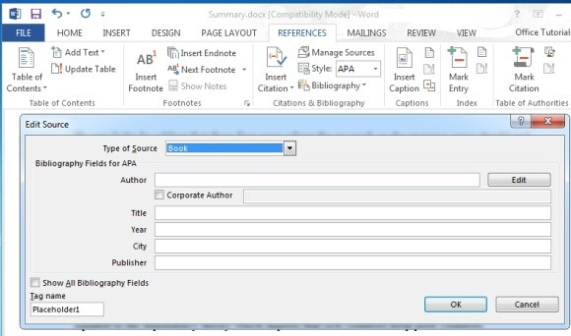

Figure 1 Path to add index number

1.1.2 Format of content and title

All the format of thesis can take Table 1 for reference.

Table 1 Format description

|  |  |  |
| --- | --- | --- |
| Category | Font size | Format |
| Content | 12 | - |
| Title 1 | 18 | Chapter 1 |
| Title 2 | 16 | 1.1 |
| Title 3 | 14 | 1.2.1 |
| Figure / Table | 12 | As the caption format  (e.g., Figure 1) |

1.2 Add List of Figure / Table

If you want to add list of figure or list of tables, click “References”, “Insert table of figures” at the place you want to add, and choose the caption label that you want to add.

You can take Figure 2 for reference.

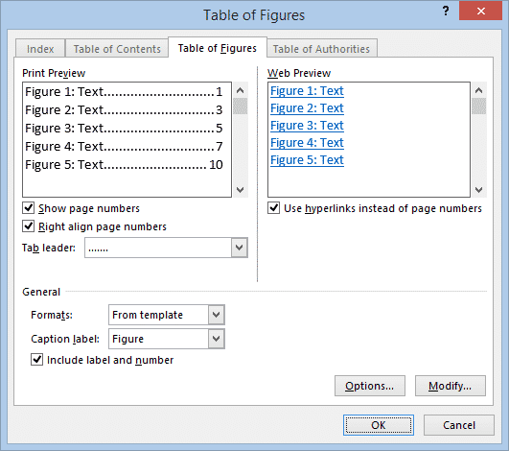

Figure 2 Window when you click "Insert table of figures"

Chapter 2 Page index number

2.1 How to insert Roman numeral index page number

2.1.1 Step 1. Split the page between cover page and pages before content

First, we need to click the page under the cover page and click “Layout”, and then click “Breaks”, choose “Next page”.

You can take Figure 3 and Figure 4 for reference.



Figure 3 Path of "Breaks"



Figure 4 Category of "Breaks"

2.1.2 Step 2. Add Roman numeral index page number

Click “Page Number” below “Insert”, and choose the “Format Page Numbers”, select the Roman numeral numbers in “Number format”.

After you choose the number format, don’t forget to choose “Bottom of Page” when you insert the page numbers.



Figure 5 How to change the format of page number

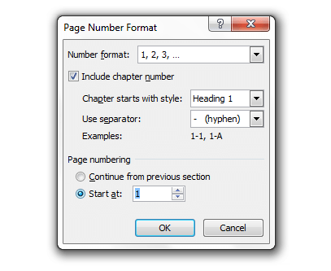

Figure 6 The window of "Page Number Format"

2.2 Insert Table of Contents

2.2.1 How to make class of titles

When you finish editing a title, tap “Home” and then click the dialog box right of “paragraph”, as Figure 7, choose the class of font in the “Outline level” of the window.

Figure 7 Window of dialog box in "Paragraph"

2.2.2 How to show Table of Contents in the thesis file

If you want to show Table of Contents beside the content, click “View” and then choose the “Navigation Pane”, then you can see Table of Contents in your file.

You can take Figure 8 for reference.



Figure 8 Path to show Navigation Pane



Figure 9 Navigation Pane