Interval + voltage motor controller

2020-04-13

This device has the following features:
- Uses modified car windscreen wiper interval relay that can be bought off the shelf or found in scrap cars
- Uses standard 3 or 5A adjustable voltage regulator, which is easy to get and needs only a few extra components
- Controls for interval time and motor voltage

Required materials

- Car interval timer, see first chapter. Found to work are:
- Hella 5WG 003 620-09 or
- Hella 5WG 003 620-091 or
- Hella 5WG 003 620-097
- a capacitor of 4.7 uF, at least 16V
- a resistor of 2.7 kΩ
- some faston flat connectors for the relay pins, unless you choose to directly solder on the relay module pins.
- a potmeter of 25 kΩ linear
- a switch, on/off. A potmeter of 25 kΩ with integrated switch would be great, but usually you can only get logarithmic potmeters with integrated switches.
- knob for potmeter

- LD or LM1084 adjustable regulator
Alternatively take an LD/LM1085 (same but 3A), an LM338 (higher voltage drop), LM350 (higher voltage drop and only 3A). All of these are pin compatible with the well-known LM317 (which is only rated 1.5A, not enough). You need a low-drop regulator if your motor rotates slowly (such a the Mercedes Sprinter motor) and therefore might need all the voltage we can give it. Normally a 3A regulator should be fine.
- heat sink of less than 2°C/W. Take into account that it has to be mounted onto the enclosure.
- TO-220 isolation set
- M3 bolt and nut long enough to fit through the
- 2x 10uF capacitor
- 120 Ω resistor
- a potmeter of 1 kΩ linear
- knob for potmeter

- enclosure
- red and black 4 mm banana plugs for power input (battery and/or other supply)
- some plug to connect the windscreen wiper motor (2 power contacts and 2 switch contacts; 2 separate plugs can be used too)

- solder

Required tools
- Soldering iron for electronics (reduced power, preferably temperature controlled)
- Pliers to strip and cut wire and hold items
- Screw drivers

Build procedure

1. Select car wiper interval timer module

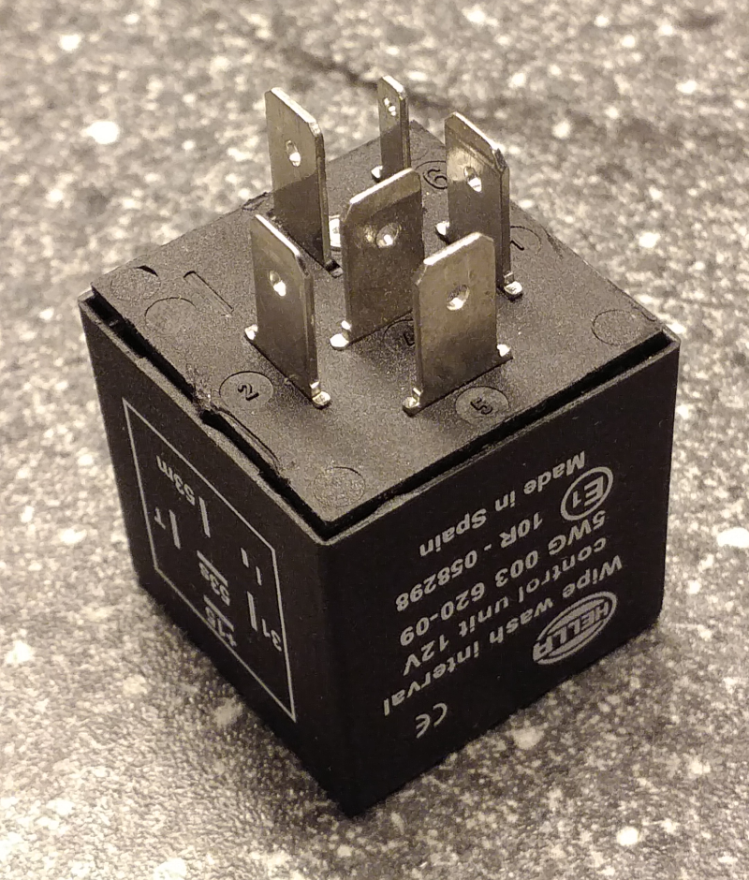
Car interval modules come in many flavors. We are looking for a module with a U641, U642, UU641 or UU642 IC in it. Without opening the device you cannot be certain it is in. We only know new Hella 5WG 003 620-09 modules (sold by number 5WG 003 620-091 and 5WG 003 620-097 as well) have this IC.

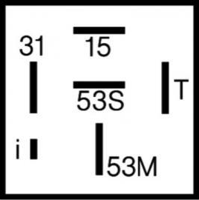
You can get other modules and check if they have this IC inside. We think there is most chance with the modules that have the pinout show in this picture.

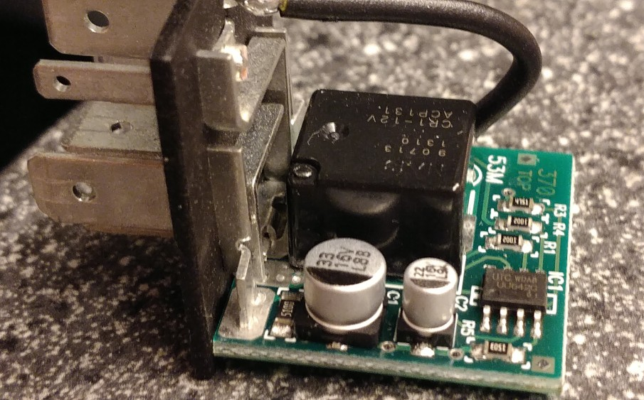

2. Modify car wiper interval timer module
Time: 0:05 to 0:20

We have to modify the interval module to allow for shorter times than are needed on windscreen wipers. In the existing module with a 641 or 642 we have to replace a capacitor and possibly a resistor. Note that your module may look differently. It should have similar components, but older ones may use through hole components instead of surface mount (SMD). After the modification, we can set interval times from 0.7 to 4 seconds. Together with motor speed control, this should give reasonable control over I/E and frequency.

Open the module and locate the 22 uF capacitor. Solder it off in the following way.
First heat one leg with the soldering iron, and while doing so apply a little force on the cap. It should only be rotated a slight bit. Now do the same on the other side. Repeat this several times. Slowly the capacitor will move up, and at some point will come off. If you bend too much at a time, the tracks on the PCB will come off. We need them.
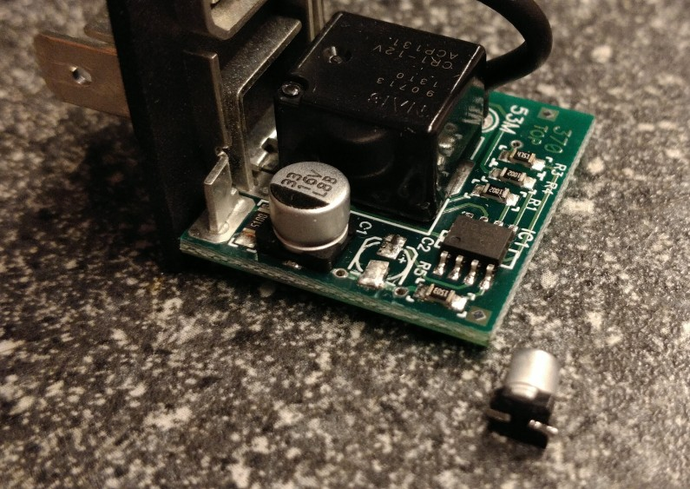
Solder on the 4.7 uF capacitor. Put the negative side of the capacitor on the same side it originally was. See below picture of an example of a modification.

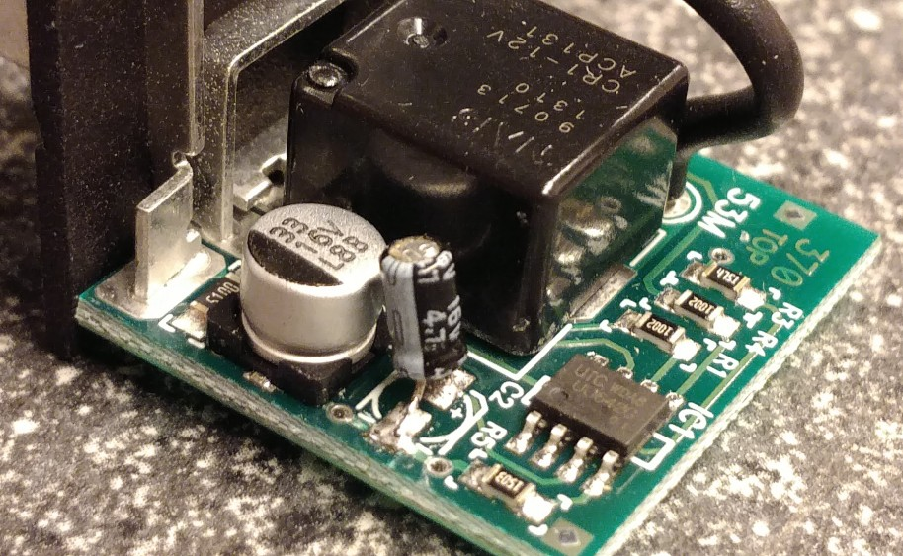
On the board there is also a resistor of of 2.7kΩ or 4.7kΩ. This determines the minimum interval time. On cars with variable timing, a potmeter on the wiper handle is connected in series with this resistor to set the interval time. On cars without, the resistor is fixed to mostly 4.7kΩ, which may be indicated with code 472 or 4751 on the resistor. We want the shortest time possible, so we reduce the resistor to the specified minimum of 2.7kΩ. However, we can also put this resistor outside the module.

To remove the resistor, put enough solder on the soldering iron to touch both sides of the resistor. While touching it, you may need to add some more solder. The resistor will move easily by the touch of the soldering iron after both contacts have reached melting temperature. The solder serves to transport the heat from the iron to the resistor. Watch out not to spread the solder over the PCB.

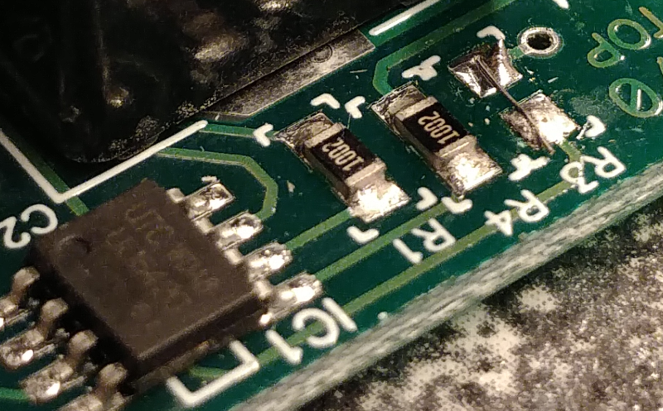
Solder a resistor of 2.7kΩ on the place of the original. You may also replace it with a short, and put the resistor externally in series with the potmeter. This is easier. See picture. Remember to put the resistor in series with the potmeter later!

3. Voltage regulator
This voltage regulator can be used to replace the set of diodes and the 12-pole switch(es). This circuit must come AFTER the interval timer, because the interval timer does not work with low voltages.
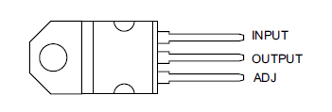
Create the circuit as indicated on the following page. The regulators all have the pinout as indicated in the picture here. Mount the regulator on the heatsink first, this solders easily. Mount it with the TO-220 isolation set, to prevent the heatsink from being connected to the cirrcuit.
You can solder smaller components onto the regulator.
You can increase R1 to 150 Ω for maximum 9.6 V output or 180 Ω for maximum 8.2 V output. This is useful if your motor always turns way too fast on the maximum voltage. The exact voltages may vary because they also depend on the maximum resistance of your potmeter.
Drill holes into the enclosure to hold the connectors, switches and potmeters. Mount them and wire them according to the schematic.

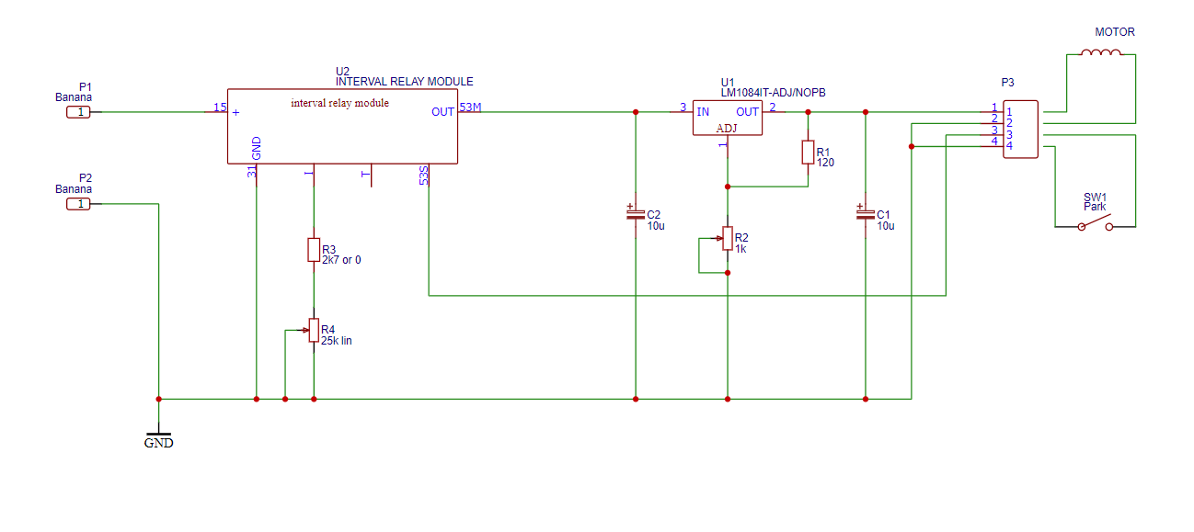

Notes on use
If you use a battery as supply, it is vital that you have a fuse near the battery. This way a short doesn’t create bigger problems such as fire. Use a fuse of 7.5 A (brown) if you have used a 5A regulator, or one of 5A (tan) if you have used a 3A regulator.

Unfortunately it is not directly possible to set I/E ratio or inspiration frequency. Also the interval time is the time from the moment the motor stops, until it starts again, so it’s not possible to set the period or frequency. It’s not even the expiratory time. By measuring the time it takes to do an inspiration and the total period time, these numbers are easy to calculate. Also you will quickly get a feel for it by playing with the controls for some time.

To calculate the I/E and inspiration frequency

1. measure inspiratory time
2. measure period time (time after which a cycle repeats)

I/E = inspiratory time / ( period time - inspiratory time )

Respiratory rate or frequency = 60 / period time

