Christian Abrams

DS 210

**FINAL PROJECT WRITE-UP**

What the Project does:

The project takes a Facebook dataset of social circles that was collected from a survey of participants using the Facebook app ([Link to the dataset](https://snap.stanford.edu/data/ego-Facebook.html)). I used the “facebook_combined.txt” file that listed every edge from the dataset in the format [node, other node its connected to by edge].

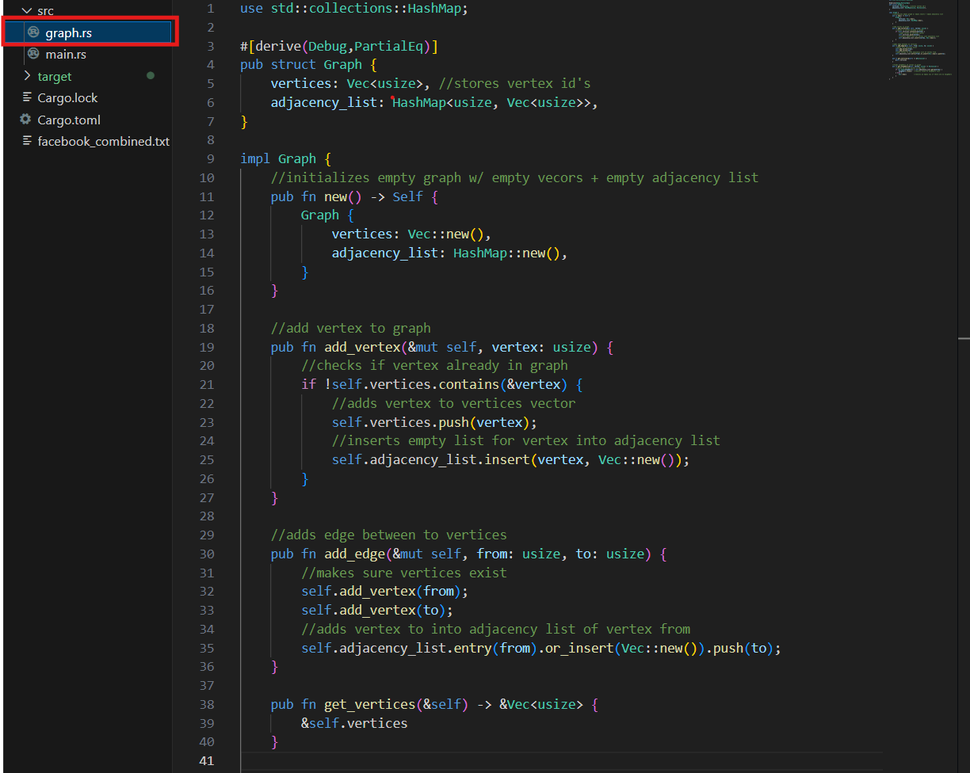

The goal of my project was to calculate the average distance between every single node in the graph. The way it works is by first creating a local graph module that created a graph and all the functions necessary to use it.

­­

The code then uses the “read_graph_from_file” function to read the dataset and implement it into the data type of a graph.

After that the code uses a Breadth First Search to find the distances between every node in the format of a hashmap reading [Node, Distance].

It then uses the BFS to calculate the average distances between every single node in the hashmap.

I have two tests for the code, the first one is the “test_calculate_average_distance” and the second is the “test_bfs_distances”, making sure the calculations for the average distances as well as the BFS were correct, respectively. A screenshot of a computer program

How to run it:

After downloading the zip from github, navigate your terminal and use “cargo run –release.”

What the output looks like:

The output gives the average distance between every node in the dataset.

