Supplementary Material
Madoka Mori-Yoshimura, et al. Efficacy and safety of avalglucosidase alfa in Japanese patients with late-onset and infantile-onset Pompe diseases: a case series from clinical trials. Molecular Genetics and Metabolism.
Contents
Supplementary Table 1. Baseline / change in efficacy parameters (primary and secondary endpoints) from baseline to week 49 in a Japanese patient and overall population from the COMET trial 2
Supplementary Table 2. Baseline / changes in efficacy parameters (secondary endpoints) from baseline to week 25 in Japanese patients and overall population from the Mini-COMET trial 4
Supplementary Fig. 1. Course of ADA titer in Patient 1 5
Supplementary Fig. 2. GMFM-88 total percent score and QMFT total score in (A) Patient 2 (B) Patient 3 (○) and the mean (SD) in the overall population in each cohort () from the Mini-COMET trial. 6

Supplementary Table 1. Baseline / change in efficacy parameters (primary and secondary endpoints) from baseline to week 49 in a Japanese patient and overall population from the COMET trial
 | Patient 1 (Japanese)  (n=1) | Avalglucosidase alfa-arm  (n=51)
Upright FVC%, predicted  Mean baseline (SD)  Mean change from baseline (SE) | 48.04  0.43 | 62.50 (14.4)  2.89 (0.88)
6MWT, m  Mean baseline (SD)  Mean change from baseline (SE) | 365.00  55.00 | 399.30 (110.9)  32.21 (9.93)
6MWT%, predicted  Mean baseline (SD)  Mean change from baseline (SE) | 53.13  8.26 | 57.30 (15.00)  5.02 (1.54)
MIP%, predicted  Mean baseline (SD)  Mean change from baseline (SE) | 28.40  0.12 | 51.74 (24.85)  8.70 (2.09)*
MEP%, predicted  Mean baseline (SD)  Mean change from baseline (SE) | 54.23  15.01 | 59.17 (21.60)  10.89 (2.84)*
HHD, lower extremity  Mean baseline (SD)  Mean change from baseline (SE) | 1140  –91.00 | 1330.45 (625.44)  260.69 (46.07)
QMFT total score / mean (SE)  Mean baseline (SD)  Mean change from baseline (SE) | 35  4.00 | 41.29 (10.15)  3.98 (0.63)
SF-12 PCS score  Mean baseline (SD)  Mean change from baseline (SE) | 48.4  4.68 | 35.95 (7.82)  2.37 (0.99)
SF-12 MCS score  Mean baseline (SD)  Mean change from baseline (SE) | 56.2  0.70 | 48.31 (10.11)  2.88 (1.22)
Abbreviations: 6MWT, 6-min walking test; FVC, forced vital capacity; HHD, hand-held dynamometry; IU, international unit; MCS, mental component summary; MEP, maximal expiratory pressure; MIP, maximal inspiratory pressure; PCS, physical component summary; QMFT, quick motor function test; SD, standard deviation; SE, standard error; SF-12, 12-item short-form health survey.
Note: mean (SD or SE) relate to avalglucosidase alfa-arm (Patient 1 values are actual)
*Two participants with implausibly high MIP% predicted and MEP% predicted values at baseline were excluded from all MIP and MIP analyses.

Supplementary Table 2. Baseline / changes in efficacy parameters (secondary endpoints) from baseline to week 25 in Japanese patients and overall population from the Mini-COMET trial
 | Cohort 1 (20 mg/kg) |  | Cohort 2 (40 mg/kg)
 | Patient 2  (Japanese)  (n=1) | Overall  Population  (n=6) | Patient 3  (Japanese)  (n=1) | Overall  Population  (n=5)
GMFM-88 total percent score  Mean baseline (SD)  Mean change from baseline (SD) | 57.56  2.96 | 54.81 (31.44)  2.62 (9.33) | 96.29  0.83 | 67.43 (33.84)  3.54 (5.46)
QMFT total score  Mean baseline (SD)  Mean change from baseline (SD) | 19  –2 | 23.33 (14.76)  −0.17 (4.45) | 52  2 | 31.20 (19.98)  3.20 (4.55)
Pompe-PEDI functional skills scale: mobility domain  Mean baseline (SD)  Mean change from baseline (SD) | 49.83  0.3 | 66.33 (39.46)  8.50 (13.75) | 37.01  0 | 87.20 (48.32)  5.80 (10.87)
LVM Z-score  Mean baseline (SD)  Mean change from baseline (SD) | –1.4  0.6 | –1.10 (1.07)  –0.60 (2.16)ª | –0.6  –0.1 | 0.13 (2.39)  –0.60 (0.71)^{b}
Abbreviations: GMFM-88, gross motor function measure-88; LVM, left ventricular mass; Pompe-PEDI, Pompe-pediatric evaluation of disability inventory; QMFT, quick motor function test; SD, standard deviation
Note: ªn=5, ^{b}n=2; mean (SD) relate to the overall populations (Patient 2 and 3 values are actual)

Supplementary Fig. 1. Course of ADA titer in Patient 1
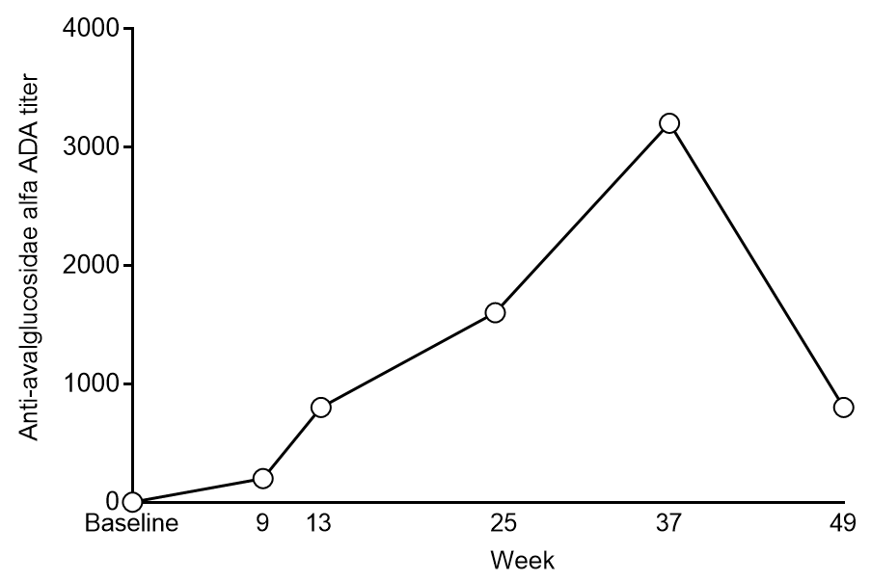

Supplementary Fig. 2. GMFM-88 total percent score and QMFT total score in (A) Patient 2 (B) Patient 3 (¡) and the mean (SD) in the overall population in each cohort (l) from the Mini-COMET trial.

