Soma-workflow in short

The user describes the processing to run in parallel by a graph called a workflow.
A workflow is:
- a set of jobs. A job is mainly described by a program command line
- a set of execution dependencies between jobs.
The workflow describes the parallelism granularity.

A workflow can be:
- submitted to a computing resource
- stopped
- restarted after interruption or errors
The execution state of the workflow is continuously saved in a file (db sqlite).
The execution monitoring can be done using a Python API or a dedicated GUI. The user have access to the job execution status, execution time, exit value and the standard outputs.
The GUI is especially useful to monitor large workflows (eg. filter the display of jobs according to their status).

3 ways of executing workflows:
- multiple core machine
  - 1 job = 1 process
  - the maximum number of jobs running in parallel is a user setting
- cluster in high throughput mode (using DRMAA for example)
  - 1 job = 1 DRMS (Distributed Resource Management System, e.g., torque, LSF...) job
  - the maximum number of jobs waiting in the queues is a user setting
- cluster in low throughput mode (MPI workflow runner --beta--)
  - 1 workflow = 1 DRMS job

What the users like in Soma-workflow ?

The users can control a set of jobs with dependencies with one action (submit, stop, restart).
The users can stop easily the problematic jobs.
In most of the case they can solve the problem without generating a new workflow, they can then restart all the jobs that failed and the following jobs with one action (restart).
The users can directly test Soma-workflow on their own machine and start to save time immediately.

What the users dislike about Soma-workflow ?

- The dependencies: the users want to install a minimum of software on clusters.
- Complicated installation procedure on clusters (compilation of the binding of DRMAA)
- Slowing down and freezing when:
  - workflows contain too many jobs (> 5000)
  - when too many workflows are loaded (eg. more than 5 workflows of 256 jobs)

Users @ NeuroSpin:

Benoit Da Mota (Parietal) pour ses travaux de post doc + travaux en collaboration avec Philippe Pinel, Vincent Frouin, Virgile Fritsch et Mickael Eickenberg
- utilisation quasi quotidienne sur cluster
- Machine Multicoeur + Cluster DSV/CATI + Curie
- Tests réalisés sur Titane, le cluster INRIA et Grille 5000
- des milliers de workflows de tailles variés
- le plus gros workflow: 12000 heures de calculs sur le cluster DSV/CATI
- Publications associées:
  - http://hal.inria.fr/index.php?halsid=riu9mjv3c89fnh9bhdpkpurtd4&view_this_doc=hal-00730385&version=1
  - http://hal.inria.fr/hal-00720265

Clara Fischer (CATI) pour le traitement des images avec Morphologist
- utilisation quasi quotidienne sur cluster
- 11000 images traités avec Morphologist (CATI, imagen, ADNI ...), 1500 avec Freesurfer (~16h de calcul par image)
- utilisation au travers de BrainVisa
- Machine multicoeur + cluster CATI

Joy Sun (CATI) Recherche
- utilisation quasi quotidienne sur cluster
- workflows de 1000 à 4000 jobs, 2h à plus de 6h de calcul par job
- Machine multicoeur + cluster CATI

Thomas Vincent (INRIA MISTIS/Parietal) pour Pyhrf http://pyhrf.org/
- Machine Multicoeur + cluster DSV

Nicolas Souedet (MIRCEN) pour ses travaux de recherche
- utilisation à travers BrainVisa
- Machine mutlicoeur + cluster de Mircen

Solveig Badillo (Parietal) pour ses travaux de thèse
- Machine Multicoeur + cluster DSV
- utilisation de Pyrhf + utilisation directe de Soma-workflow

Moana Reynal (CATI) pour le développement de ses traitements en imagerie nucléaire
- Machine Multicoeur + cluster DSV

Sandrine Lefranc (NAO) pour son stage et ses travaux de thèse
- utilisation à travers BrainVisa
- Machine multicoeur + cluster DSV

Utilisation sur machine multicoeur pour les utilisateurs de Brainvisa: Denis Rivière, David Germanaud, Chantal Ginisty, Jessica Dubois ...

Utilisateurs passés ou occasionnels

Yannick Schwartz (Parietal), machine multicoeur + cluster DSV
Anne Laure Fouque pour ses travaux de thèse, cluster DSV
Delphine Larivière pour son stage (Vincent Frouin), machine multicoeur + cluster DSV
Antonio Moreno, au travers BrainVisa, machine multicoeur + cluster DSV

Future développer Jinpeng ingénieur (Edouard Duchesnay Brainomics)

Licence

The licence is now CeCILL 2: “The principal difference [with BSD] is in the strong obligation of citation which is in CeCILL-B (article 5.3.4)” http://www.cecill.info/faq.en.html.

Web page

Otherwise, the web page is up to date for the current release (2.4)
The source code of the web page is in the brainvisa repository:
brainvisa/communication/web/trunk/gas/soma/soma-workflow/source
The web page is generated using sphinx http://sphinx-doc.org/.

Distribution/Installation

Soma-workflow is now distributed on PyPI.
However, for now, if the user wants to use soma-workflow on a cluster with DRMAA, he has to upload the sources from svn and compile with bv_maker http://www.brainvisa.info/doc/soma-workflow-2.4/sphinx/install_config.html#id21.

The DRMAA scheduler is the only component of soma-workflow which needs to be compiled (c.f. architecture section). They are currently two things to compile:
- a C++ library called libsomadrmaajobs which uses libdrmaa (external)
- a SIP binding of libsomadrmaajobs: soma.workflow.somadrmaajobssip

bv_maker (brainvisa-cmake: customized cmake for the Brainvisa project) was created to compile the multiple project of Brainvisa. However, soma-workflow does not have dependencies on the other projects of Brainvisa and is used without Brainvisa in many cases (c.f. users section). Using bv_maker is thus a bit overkill and confusing for the people who only need Soma-workflow. For the same reasons (and also to release Soma-workflow independently of Brainvisa), Soma-workflow should be an external dependency of Brainvisa (like IPython, PyQt, numpy, matplotlib... and many others).
Two actions could be done to simplify the compilation process:
- Remove the need to compile anything. The DRMAA scheduler is the only component of Soma-workflow which needs to be compiled (c.f. architecture section). Using ctype as Python binding for DRMAA would make Soma-workflow a pure Python program. The brainvisa-cmake CMakeLists could then be removed and setuptools would be all we need (Download, build, install, upgrade, and uninstall Python packages -- easily! https://pypi.python.org/pypi/setuptools).
- Replace the bv_maker compilation by a more standard compilation process: using regular cmake CMakeLists or even makefiles (since the compiled part is the DRMAA scheduler which is supposed to be used only on cluster i.e. Linux).

Sources

The sources are now on svn bioproj.
Change to git - github would open the project for contributions (either internal to NS and external). This can be done easily using svn2git https://github.com/nirvdrum/svn2git#readme or git-svn.

Documentation

The documentation is up to date for the current release (2.4).
The source code of the documentation is in soma-workflow source code in the “doc/source” directory. The documentation is generated using sphinx http://sphinx-doc.org/.

Architecture

General architecture and dependencies:
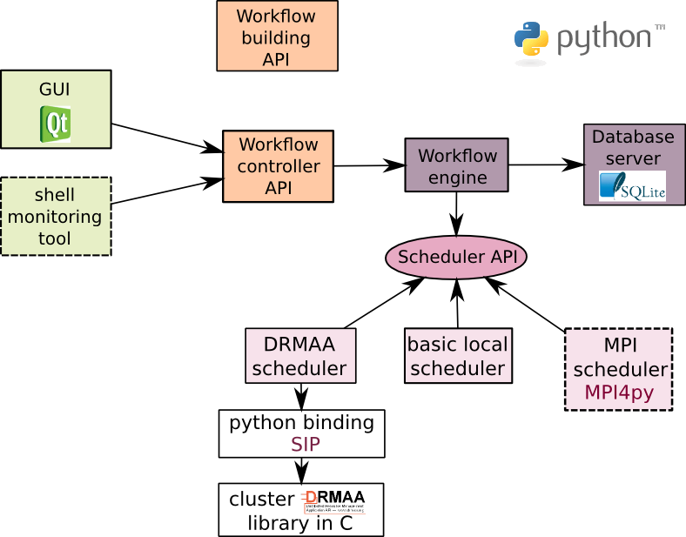

- Orange boxes: external API. These APIs must be very stable since they are used by client code.
- Green boxes: monitoring tools. They are/must be built on top of the workflow controller API.
- Dotted line boxes: not released
- the workflow engine component roll out the workflow, submit the jobs to the scheduler and save the execution status in the database server.
- the database server writes and reads the execution status into a sqlite file. Sqlite file accept limited concurrency access. We thus added a lock system (simple threading.rlock) in the database server to deal with higher level of concurrency to allow multiple processes to be writing to the same database at the same time.
- Several schedulers are available. They all implement the Scheduler API (4 python function: job_submission, get_job_status, get_job_exit_info, kill_job), thus one can add its own implementation of the scheduler.
  - the basic local scheduler is used to submit jobs on multi core machine
  - the DRMAA scheduler can be used to submit jobs on clusters in “high throughput mode” (1 workflow job = 1 cluster job). This scheduler requires an implementation of DRMAA v1.
  - the MPI scheduler can be used to submit jobs on clusters in “low throughput mode” (1 workflow = 1 cluster job). This scheduler requires MPI4py.
Only a subpart of the components are needed to run soma-workflow depending on the execution mode used. The execution mode determines also the way components are divided into processes. In the following figures the gray shapes represent the different processes.

one process mode:

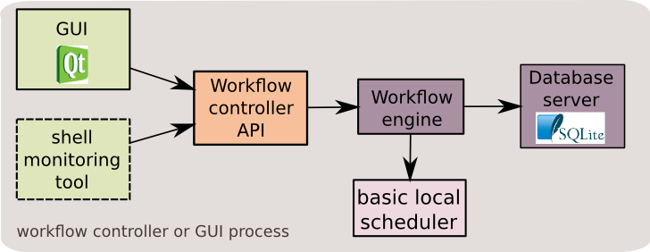

In this mode, the components share a single process. This is the case when soma-workflow is used to run workflows on the local multiple core machine (in this case the basic local scheduler is used). This mode can be used on the cluster too with the Drmaa scheduler for example. http://www.brainvisa.info/doc/soma-workflow-2.4/sphinx/install_config.html#mono-process-application-on-clusters

client-server mode:
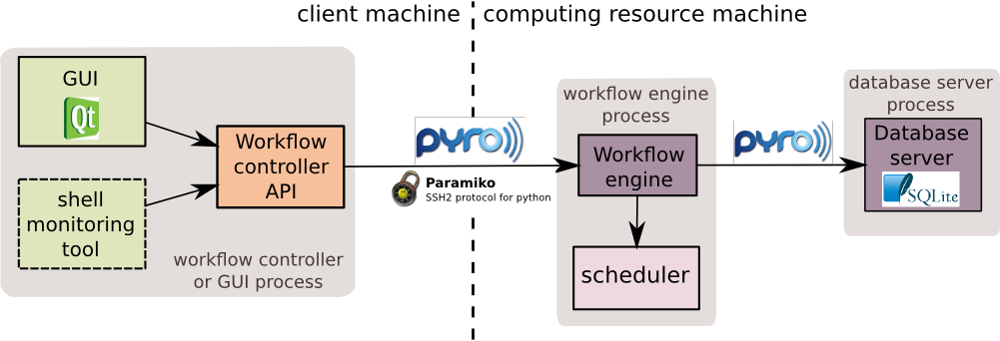

This mode involves three kinds of processes: the workflow controller process, the workflow engine process and the database server process. Only one database server must exist, but several workflow controller and workflow engine process can exist at the same time.
The interprocess communication is done with Pyro and Paramiko.
The communication between the remote machines (the client machine and the computing resource machine) requires the creation of a ssh tunnel (created with Paramiko). However, for some computing resources, the construction of such tunnel is forbidden.
This client server mode can be used on a single machine too, in these case paramiko is not required.
Depending on the scheduler used (DRMAA or local basic) the computing resource machine can be the master of a cluster or a multiple core machine.
C.f. appendix 1 for a complete example.

Low throughput cluster mode

The only way to use soma-workflow in low throughput mode on a cluster (1 workflow = 1 job on the cluster) is now to use the MPI scheduler.

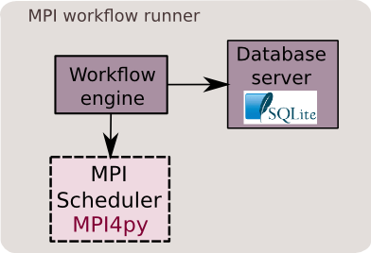

A major difference with the other ways of using soma-workflow is that the workflow can not be submitted using the submit_workflow function of the workflow controller API. The MPI workflow engine has to be submitted to the cluster using the cluster submission command (qsub for example). It is submitted as a regular MPI job which take the workflow file as an input. As every other MPI job, you need to specify the number of core/node you want to use. Thus the job will run on one or several execution node(s). During the execution, the database server in the MPI job will write the workflow execution status in the database file at regular time interval. The workflow execution can be thus monitored using, for example, the one process mode on the master of the cluster.

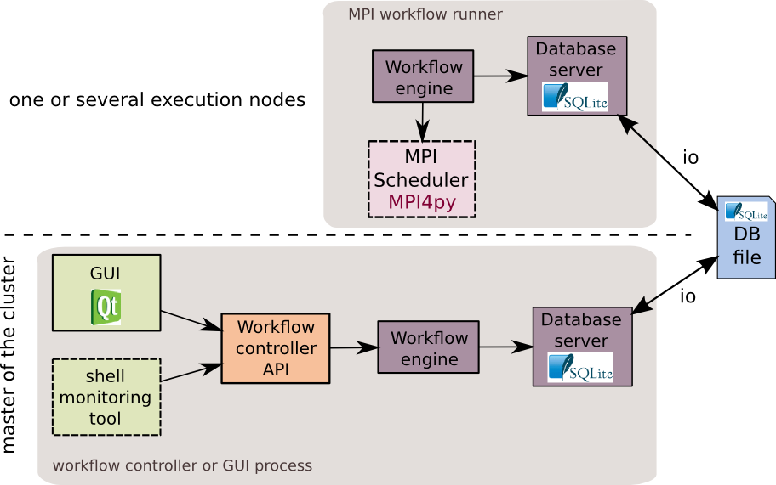

Dependencies and their potential drawbacks

As shown in the diagrams, the dependencies of soma-workflow change depending on the mode/configuration which is used. For now the minimal dependencies are Python and SQLite.

Python all the code is written in python.

SQLite
SQLite is a dependency of soma-workflow (always requested). However, the used module (sqlite3) is part of the Python standard library. It is used to store the submitted workflows and their execution status.
Drawback: SQlite accepts limited concurrency access. Thus if more than 2 or 3 soma-workflow database server objects access to the file, a “database is locked” error can be thrown and the database servers can fail.
Note that SQLite could be replaced by any library which can save the workflow information into a file and accept concurrent access (MongoDB ?).

Qt and PyQt/PySide
Qt and PyQt/PySide are dependencies of the GUI. PyQt and PySide are Python bindings of Qt.
Only one of the two Python binding is required.

DRMAA library:
The DRMAA library is a dependency of the DRMAA scheduler used to execute workflows in high throughput mode (1 workflow job = 1 cluster job).
DRMAA http://www.drmaa.org/ is a standard of the Open Grid Forum. DRMAA is an API specification developed for several languages (C, Java, Python).
To use DRMAA on a cluster you need to find an implementation of DRMAA for the DRMS (Distributed Resource Management System) of the cluster (example Torque/PBS, LSF, SGE...). The available implementations of DRMAA are mainly in C. Some DRMS have build in implementation of the DRMAA library (Sun Grid Engine and Torque). For the other systems you need to find side implementations (example: http://apps.man.poznan.pl/trac/pbs-drmaa) which have uneven quality and can request patches.
Risk: you may not find a working implementation of DRMAA for your DRMS.
With DRMAA you can submit and stop jobs and get back the job status from the DRMS.
A limitation of DRMAA is that you need to do everything in a single DRMAA session. That is, when you open a DRMAA session, submit a job through DRMAA and then close the DRMAA session, you can not stop nor check the status of the job anymore (opening a new DRMAA session for example).

SIP
SIP is a dependency of the DRMAA scheduler.
SIP is used to create a Python binding on top of the DRMAA library which is in C.
To do: SIP should be replaced by ctypes:
- ctypes is in the Python standard library (it would remove a dependency)
- No need to compile => soma-workflow would never need to be compiled whatever mode/configuration is chosen

Pyro
Pyro is required in the client-server mode only. Pyro is a network library used for the interprocess communication (between the workflow controller and the workflow engine, and between the workflow engine and the database server).
Pyro is very convenient and makes the network communication nearly transparent: the objects can talk to each other over the network using normal Python method call.
Drawback: Pyro throws “connection closed errors” at regular time interval. Each time the error is thrown, Soma-workflow GUI invites the user to reconnect. However, some weeks the error is thrown non-stop, making the use of soma-workflow over the network very difficult (the one process mode can still be used in this case). The error is more frequent when the submitted workflow is large (>4000 jobs). Since, several week can pass without this error, a link between the error and the network condition might be suspected.
To do: We only used Pyro 3.10, however there are many newer available versions http://pythonhosted.org/Pyro4. Changing to the most recent may solve the disconnection problem.

Paramiko
Paramiko is required in the client-server mode, if the workflow controller process runs on a different machine than the workflow engine process. If all the processes run on a single machine, Pyro is enough.
Paramiko is an implementation of the SSH2 in Python. It is used to connect from the client machine to the computing resource machine, and to create a ssh tunnel between the machines (in which the communication is done with Pyro).

MPI4py
MPI4py provides bindings for the Message Passing Interface (MPI) http://code.google.com/p/mpi4py/.
MPI4py is a dependency of the MPI scheduler.

Weakness in the code

File transfers are not used and not satisfying.
GUI works fine but should be separated in several files and cleaned up.

Appendix 1

client-server mode example

1.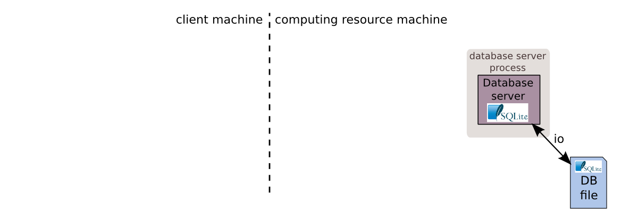
In the client-server mode a database server process must run as an unique server on the computing resource machine. The database server is registered into an Pyro name server.

2.
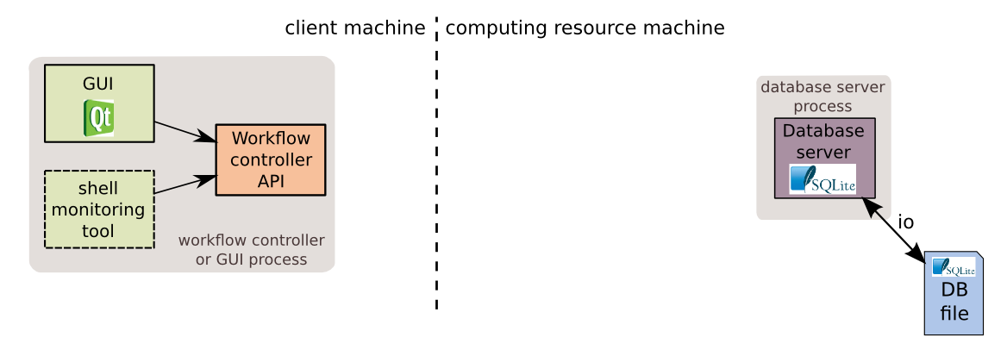

When the user starts the GUI and adds a connection to the remote machine or create a WorkflowController object ...
3.
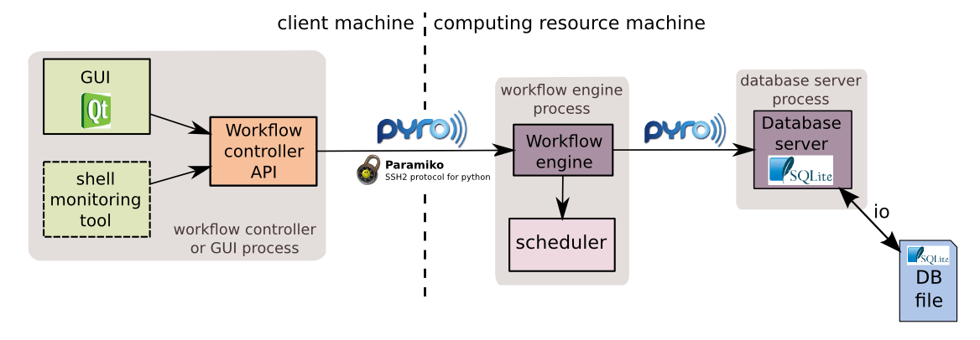

… a workflow engine process is always created. The communication between the process is done through a ssh tunnel using Pyro. The workflow engine process find the database server process using the Pyro name server. These two processes communicates using through Pyro.
The user can submit a workflow using the GUI or the WorkflowController object directly. The workflow is sent to the workflow engine which roll out the workflow.

4.
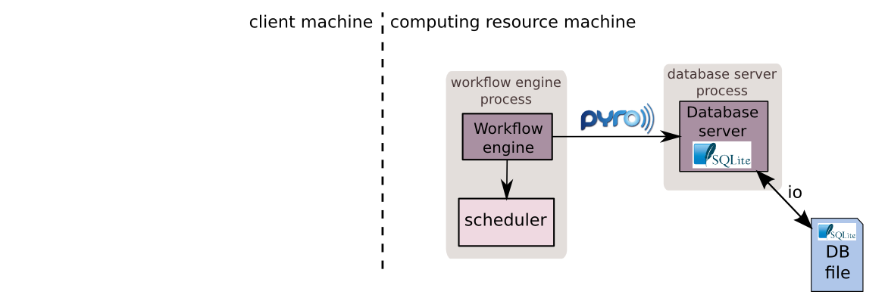

While the workflow is running by the workflow engine. The user can close the GUI/workflowController process. The workflow will keep on running on the computing resource.

5.
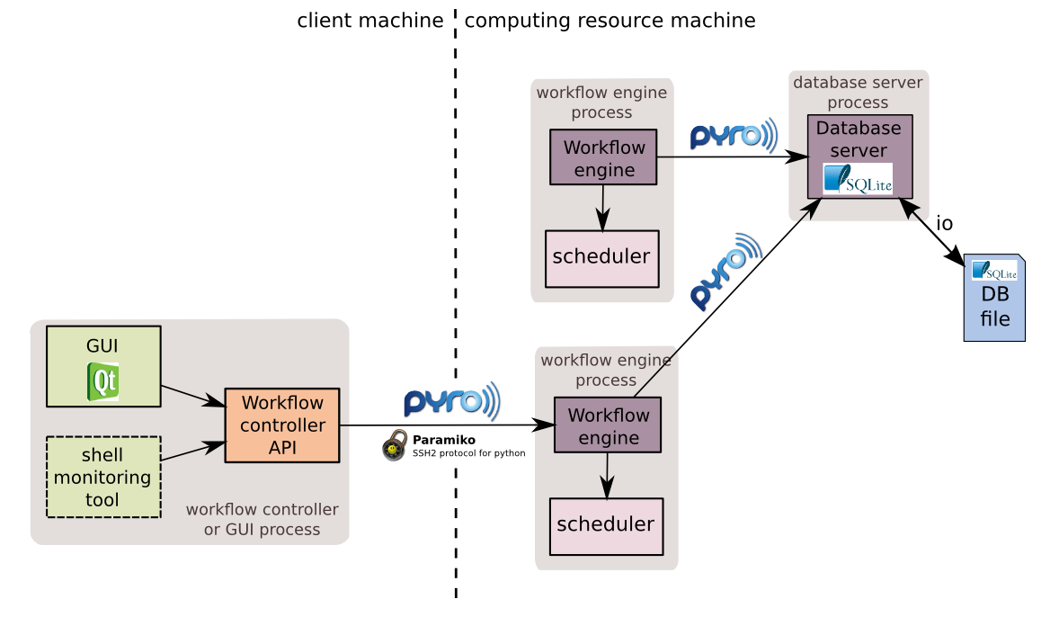

If the user opens a GUI or create a WorkflowController object a new workflow engine is created. The status of the workflow can be checked through the new workflow engine. The user can stop the workflow. The user can also run other workflows which will be executed by the new workflow engine process.
6.
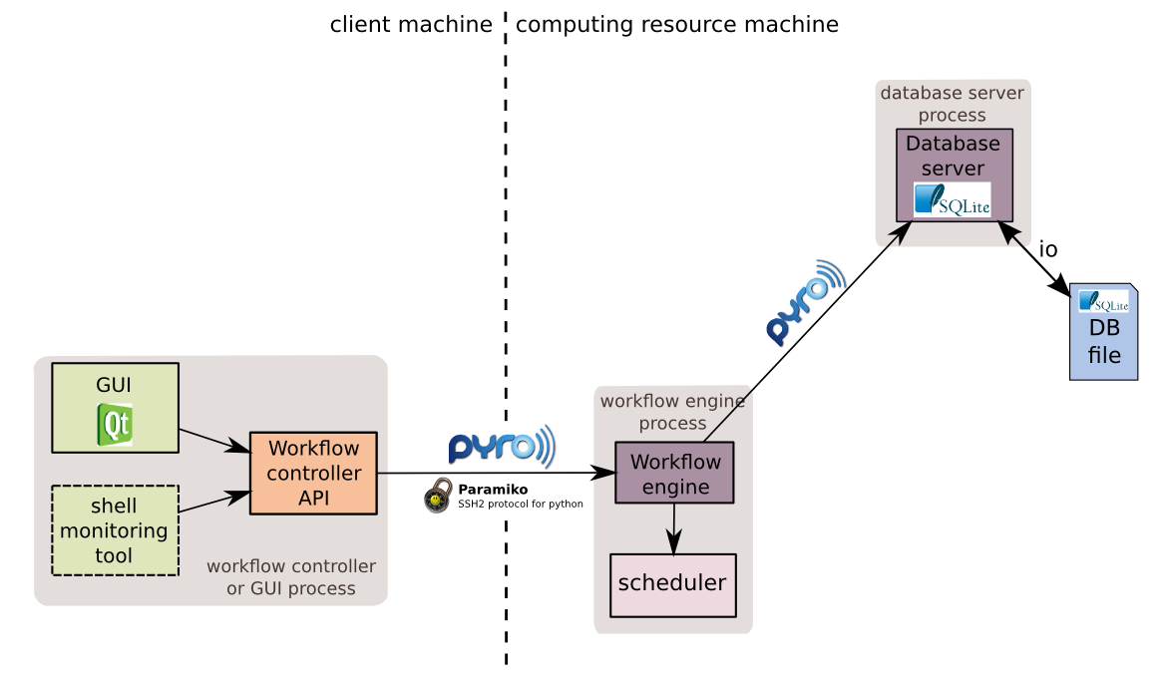
Once the workflow is done the first workflow engine process stop automatically.

