
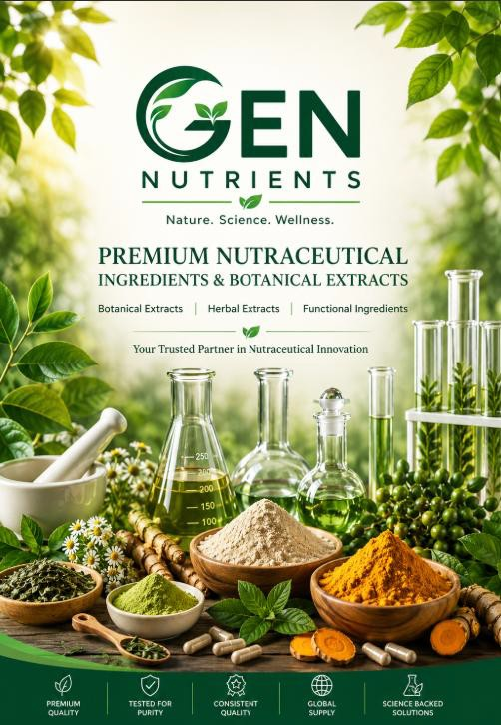

Gen Nutrients | New Jersey 07850 | Phone: 6032342174 |Email: sales@gennutrients.com |




At Gen Nutrients, we believe exceptional health products begin with exceptional ingredients.

As a trusted ingredient partner, we supply premium nutraceutical ingredients, botanical extracts, and functional raw materials to customers across the global health and wellness industry. Our commitment to quality, transparency, and customer satisfaction enables us to provide reliable ingredient solutions that support product innovation and market growth.

We are dedicated to building lasting partnerships through consistent quality, responsive service, and a customer-centric approach that delivers value at every stage of the supply chain.

WHY GEN NUTRIENTS
✔ Premium Quality Ingredients
Carefully sourced and tested to ensure consistent quality and performance.
✔ Comprehensive Documentation
We provide COA, Specifications, MSDS, TDS, and regulatory documents to support compliance and manufacturing needs.
✔ Flexible MOQ (Low Minimum Order Quantity)
We support startups, small businesses, and large manufacturers with flexible ordering options.
✔ Reliable Supply Chain
Consistent sourcing and timely delivery to ensure uninterrupted production.
✔ Customer-Focused Support
Dedicated support from inquiry to delivery for a smooth sourcing experience.
✔ Competitive Pricing
High-quality ingredients offered at cost-effective and market-competitive pricing.
✔ Trust & Transparency
Clear communication, honest sourcing practices, and reliable business relationships.
✔ Global Sourcing Network
Access to a wide range of nutraceutical, botanical, and functional ingredients from trusted suppliers worldwide.

Our Promise
Quality You Trust. Service You Deserve.

Gen Nutrients | New Jersey 07850 | Phone: 6032342174 |Email: sales@gennutrients.com |




Manufacturing process

Raw Material Sourcing Pulverization Extraction
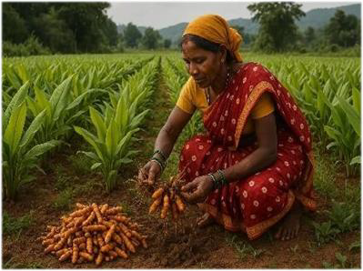
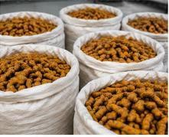
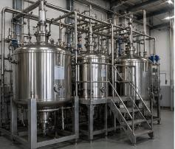

Purification Testing Packaging
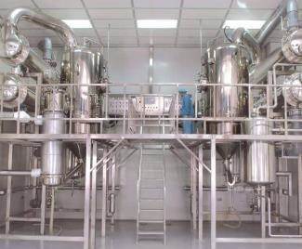
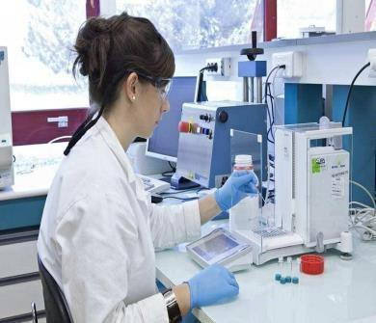
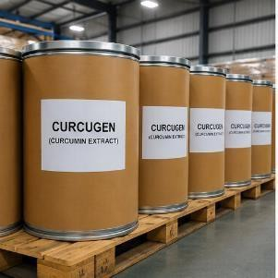

Documentation Global Distribution



Gen Nutrients | New Jersey 07850 | Phone: 6032342174 |Email: sales@gennutrients.com |




OUR PRODUCT RANGE
Gen Nutrients offers a wide range of nutraceutical ingredients, including:
- Botanical Extracts
- Standardized Herbal Extracts
- Nutraceutical Raw Materials
- Specialty Nutrients
- Vitamins & Minerals
- Functional Ingredients
We also provide customized ingredient solutions based on client requirements and specifications

QUALITY ASSURANCE
All products are supported with:
- Certificate of Analysis (COA)
- Technical Data Sheet (TDS)
- Material Safety Data Sheet (MSDS)
- Specification Sheets
- Quality and regulatory documentation
We ensure strict quality checks at every stage from sourcing to final delivery.

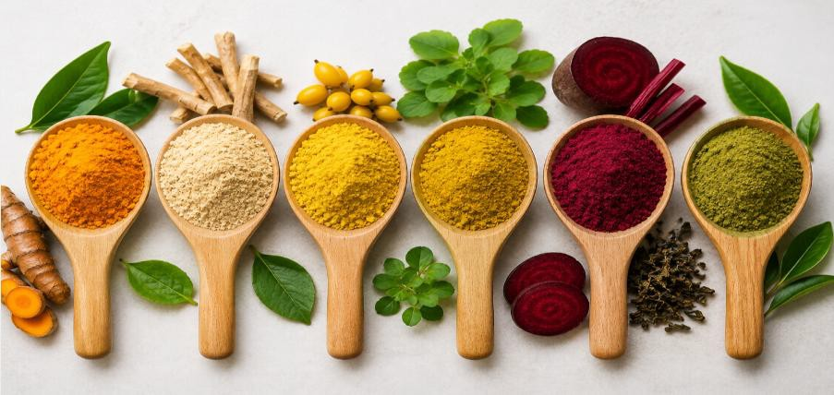

Gen Nutrients | New Jersey 07850 | Phone: 6032342174 |Email: sales@gennutrients.com |


OUR CORE PRODUCTS

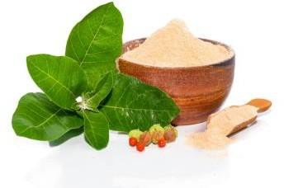 | Ashwagandha Extract  Botanical Name: Withania somnifera  Standardization: Up to 10% Withanolides (HPLC)  Primary Use: Stress Management & Adaptogenic Support
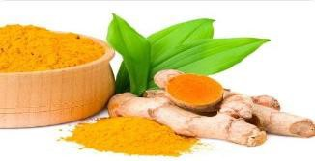 | Curcumin Extract    Botanical Name: Curcuma longa Standardization: Up to 95% Curcuminoids (HPLC) Primary Use: Joint Health & Antioxidant Support
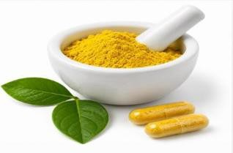 | Berberine HCl  Botanical Name: Berberis aristata Standardization: 97%–98% Berberine HCl (HPLC) Primary Use: Metabolic Wellness Support
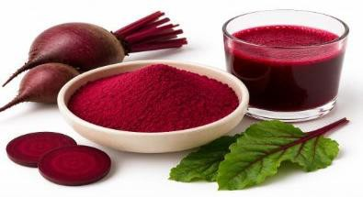 | Beetroot Extract  Botanical Name: Beta vulgaris  Standardization: Natural Nitrates / Betanin  Primary Use: Sports Performance & Endurance Support
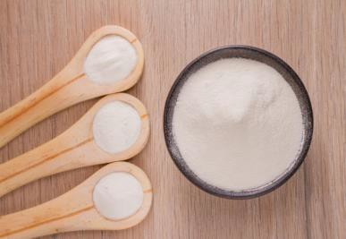 | Collagen Peptides  Source: Marine or Bovine Collagen  Standardization: ≥90% Protein  Primary Use: Skin, Beauty & Joint Health

Gen Nutrients | New Jersey 07850 | Phone: 6032342174 |Email: sales@gennutrients.com |



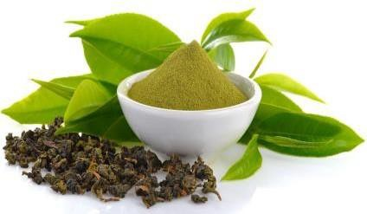 | Green Tea Extract  Botanical Name: Camellia sinensis Standardization: Up to 50% EGCG / Polyphenols Primary Use: Weight Management Support
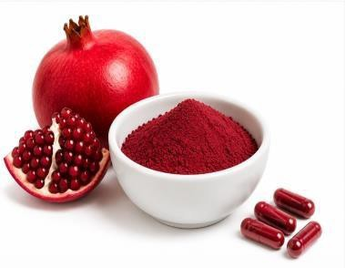 | Pomegranate Extract    Botanical Name: Punica granatum Standardization: Up to 40% Ellagic Acid Primary Use: Antioxidant Support
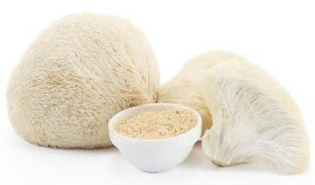 | Lion's Mane Extract  Botanical Name: Hericium erinaceus Standardization: 30% Polysaccharides Primary Use: Cognitive Health Support
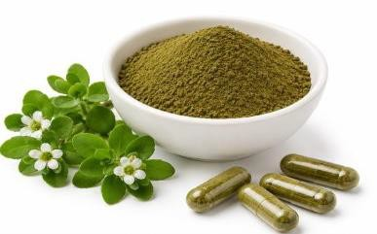 | Bacopa Extract  Botanical Name: Bacopa monnieri Standardization: Up to 50% Bacosides Primary Use: Memory & Cognitive Support
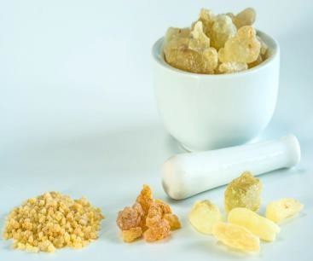 | Boswellia Extract  Botanical Name: Boswellia serrata Standardization: Up to 65% Boswellic Acids Primary Use: Joint Comfort & Mobility Support

Gen Nutrients | New Jersey 07850 | Phone: 6032342174 |Email: sales@gennutrients.com |




Additional botanical extracts, nutraceutical ingredients, and customized specifications available upon request.

Product | Botanical Name | Standardization
Dandelion Extract | Taraxacum officinale | 5%–10% Flavonoids
Moringa Extract | Moringa oleifera | 10%–20% Saponins
Spirulina Powder | Arthrospira platensis | 60%–70% Protein
Garcinia Extract | Garcinia cambogia | 50%–60% HCA (Hydroxycitric Acid)
Milk Thistle Extract | Silybum marianum | 80% Silymarin
Ginseng Extract | Panax ginseng | 10%–80% Ginsenosides
Fenugreek Extract | Trigonella foenum-graecum | 50% Saponins
Green Coffee Bean Extract | Coffea arabica | 45%–50% Chlorogenic Acids
Piperine Extract | Piper nigrum | 95% Piperine

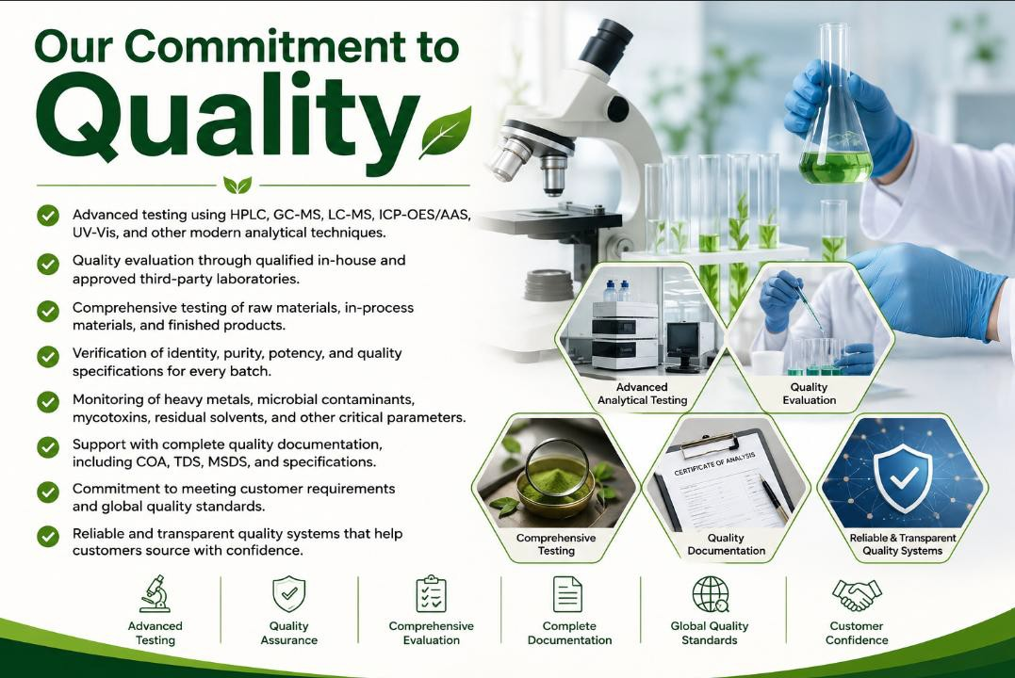
Gen Nutrients | New Jersey 07850 | Phone: 6032342174 |Email: sales@gennutrients.com |




Contact Us
Partner With Gen Nutrients
Premium Nutraceutical Ingredients & Botanical Extracts
• □ Email: sales@gennutrients.com

Website: www.gennutrients.com

Phone: +1 603-234-2174
• Location: New Jersey, United States

We welcome inquiries from nutraceutical brands, manufacturers, distributors, and formulators worldwide.
Get in touch with us to discuss your ingredient requirements and partnership opportunities

Gen Nutrients | New Jersey 07850 | Phone: 6032342174 |Email: sales@gennutrients.com |

