━━━━━━━━━━━━━━━━━━━━━━━━━━━━━━━━━━━━━━━━━━━━━━━━━━━━━━━━━━━━━━━━━━━━━━
BLACKSITE GRC Platform · THKR-BSV-001

Admin System Settings
Roles: Admin
Version: 1.0 | Date: 2026-03-01 | Classification: INTERNAL USE ONLY
━━━━━━━━━━━━━━━━━━━━━━━━━━━━━━━━━━━━━━━━━━━━━━━━━━━━━━━━━━━━━━━━━━━━━━

Overview
System-wide configuration is managed through the Admin System Settings page. Settings include: chat enable/disable, autofail configuration, RSS feed source management, and data ingestion. These settings take effect immediately without a service restart.

Prerequisites
- Admin account.

Procedure

Step 1: System settings page
Navigate to /admin/system-settings. The settings page shows key-value pairs for all configurable settings. Current values and descriptions are shown. Click the toggle or edit field for each setting and save.
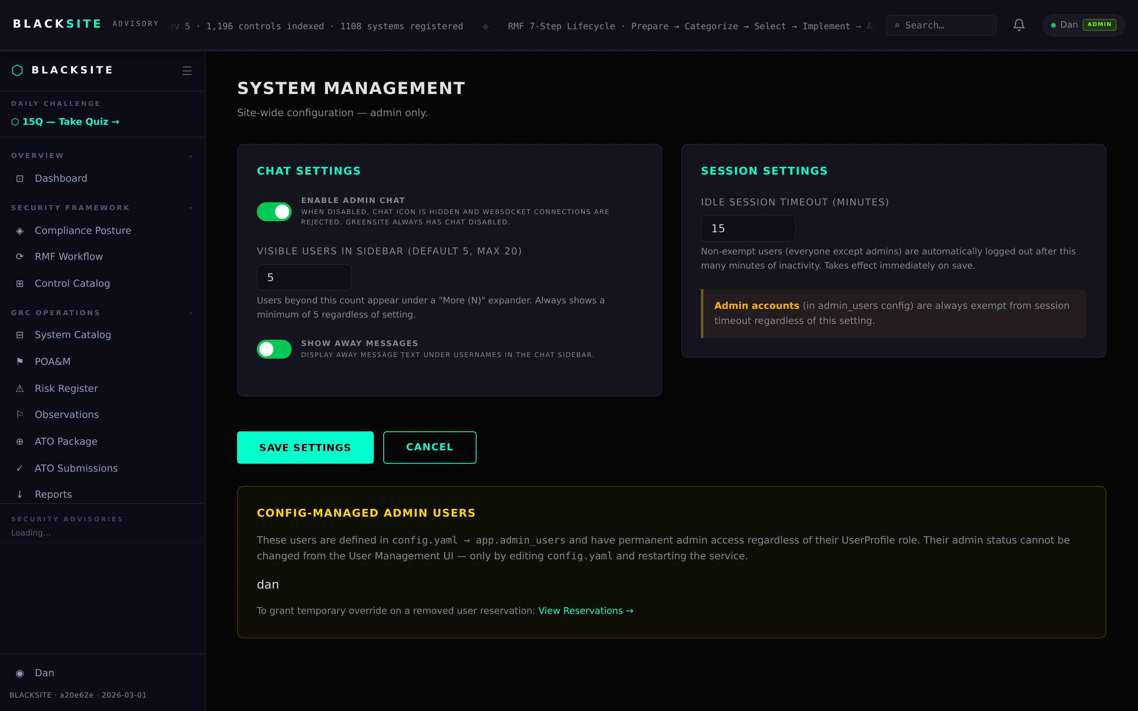
Figure 1: System settings page

Step 2: RSS feed source management
Navigate to /admin/feeds. The 15 curated feed sources are listed with title, URL, and category. Admins can add new feed sources or remove existing ones. Changes affect all users' subscription options.
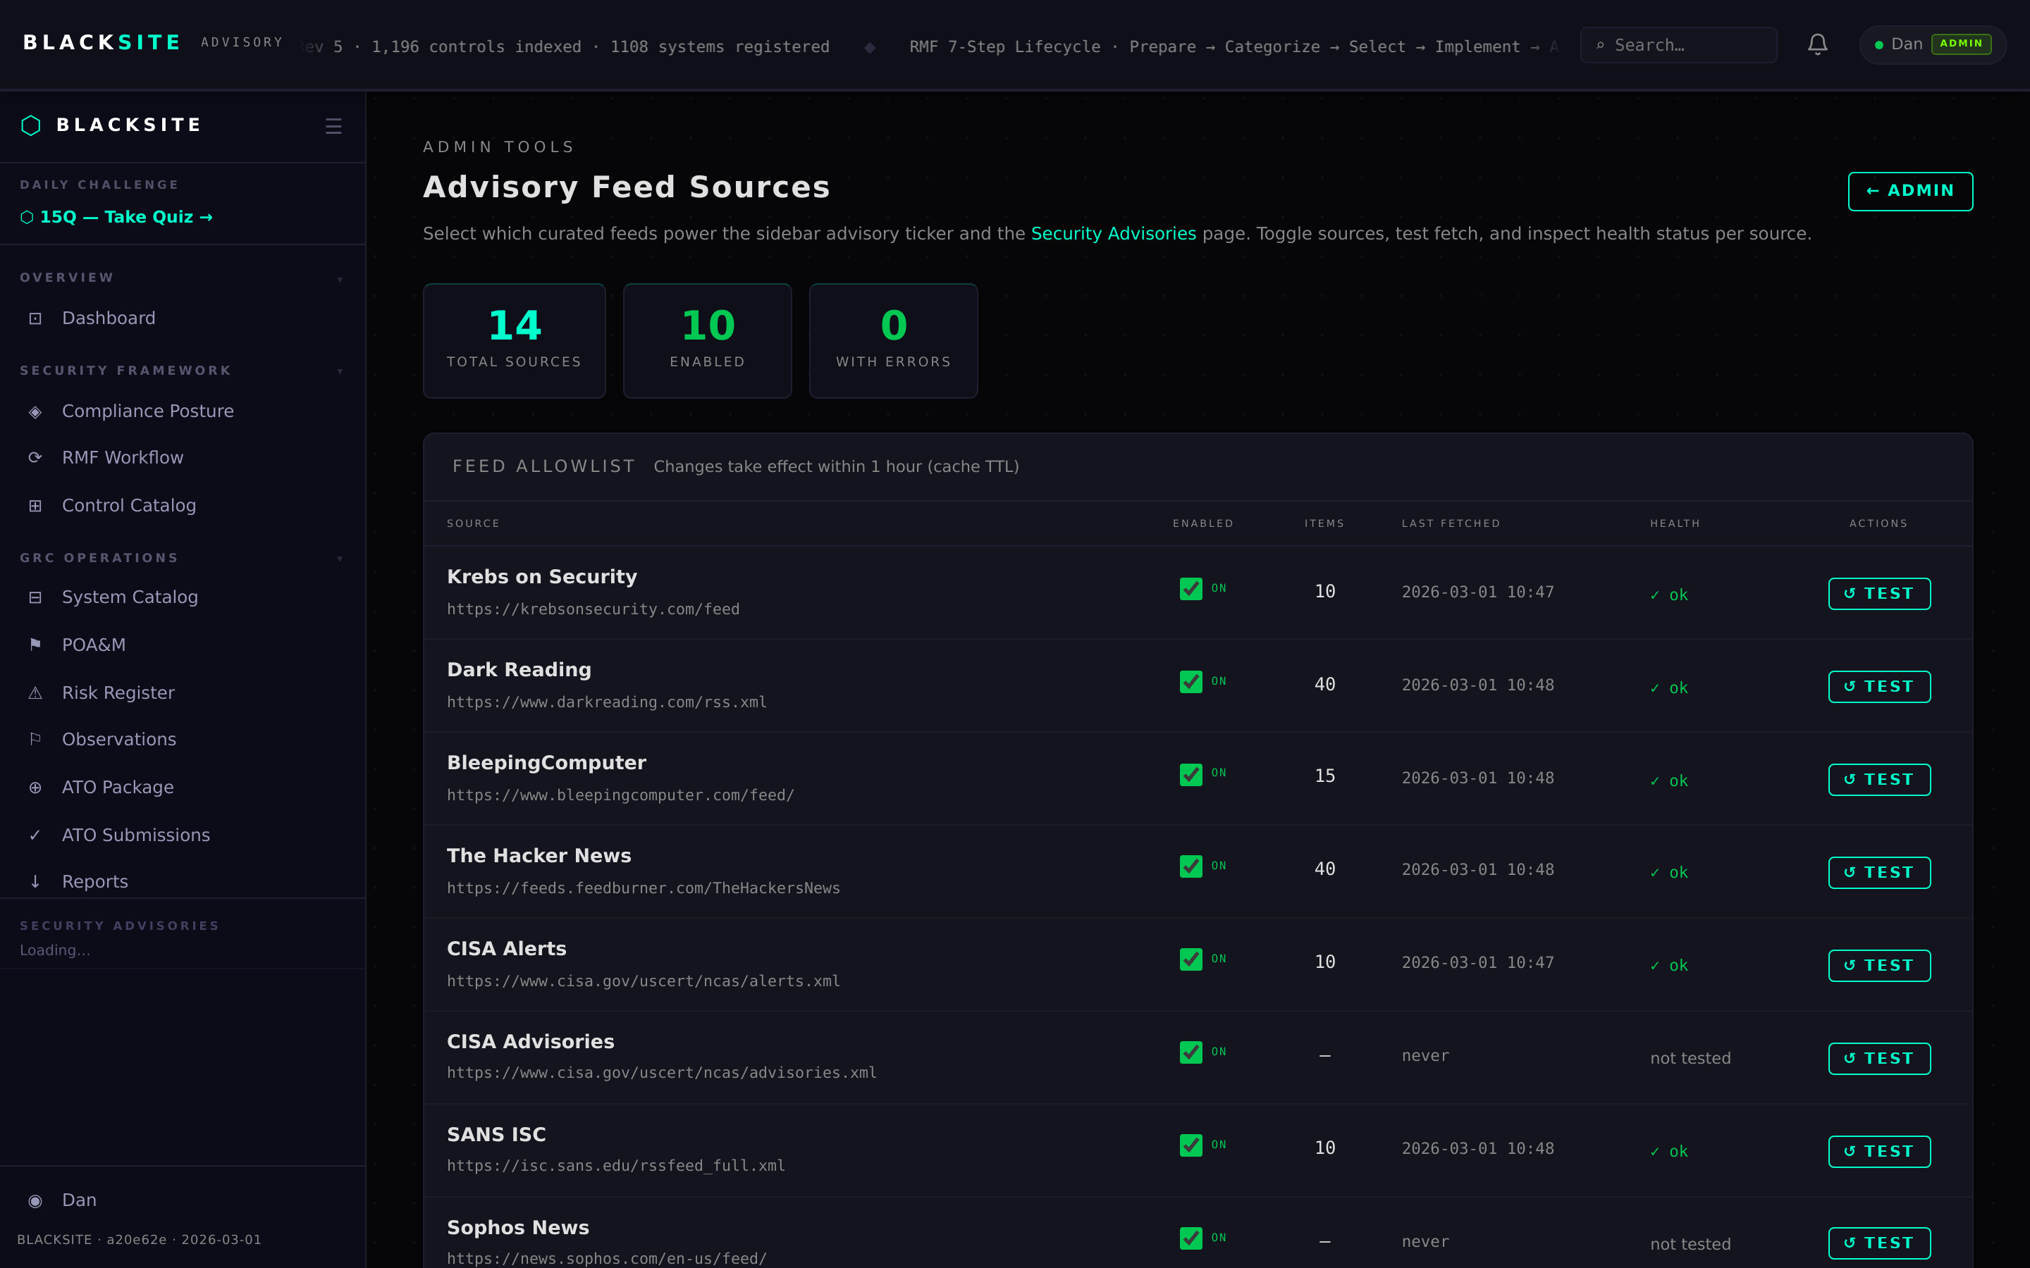
Figure 2: RSS feed source management

Step 3: Autofail configuration
Navigate to /admin/autofail. Configure the autofail threshold: minimum quiz score and minimum combined score required to pass assessments. ISSOs below threshold are automatically flagged in the ISSM dashboard.
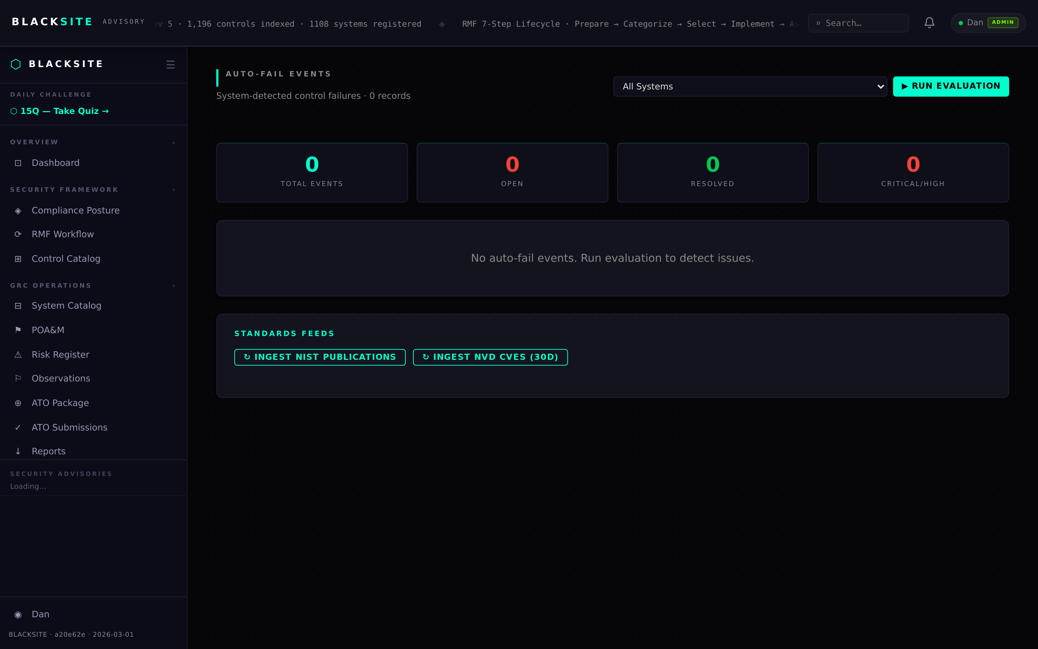
Figure 3: Autofail configuration

Step 4: Data ingestion
Navigate to /admin/ingest. Upload a CSV, XLSX, or JSON file to bulk-import users or systems. Download the template first. A preview step shows parsed rows before committing. Ingestion logs appear in the audit trail.
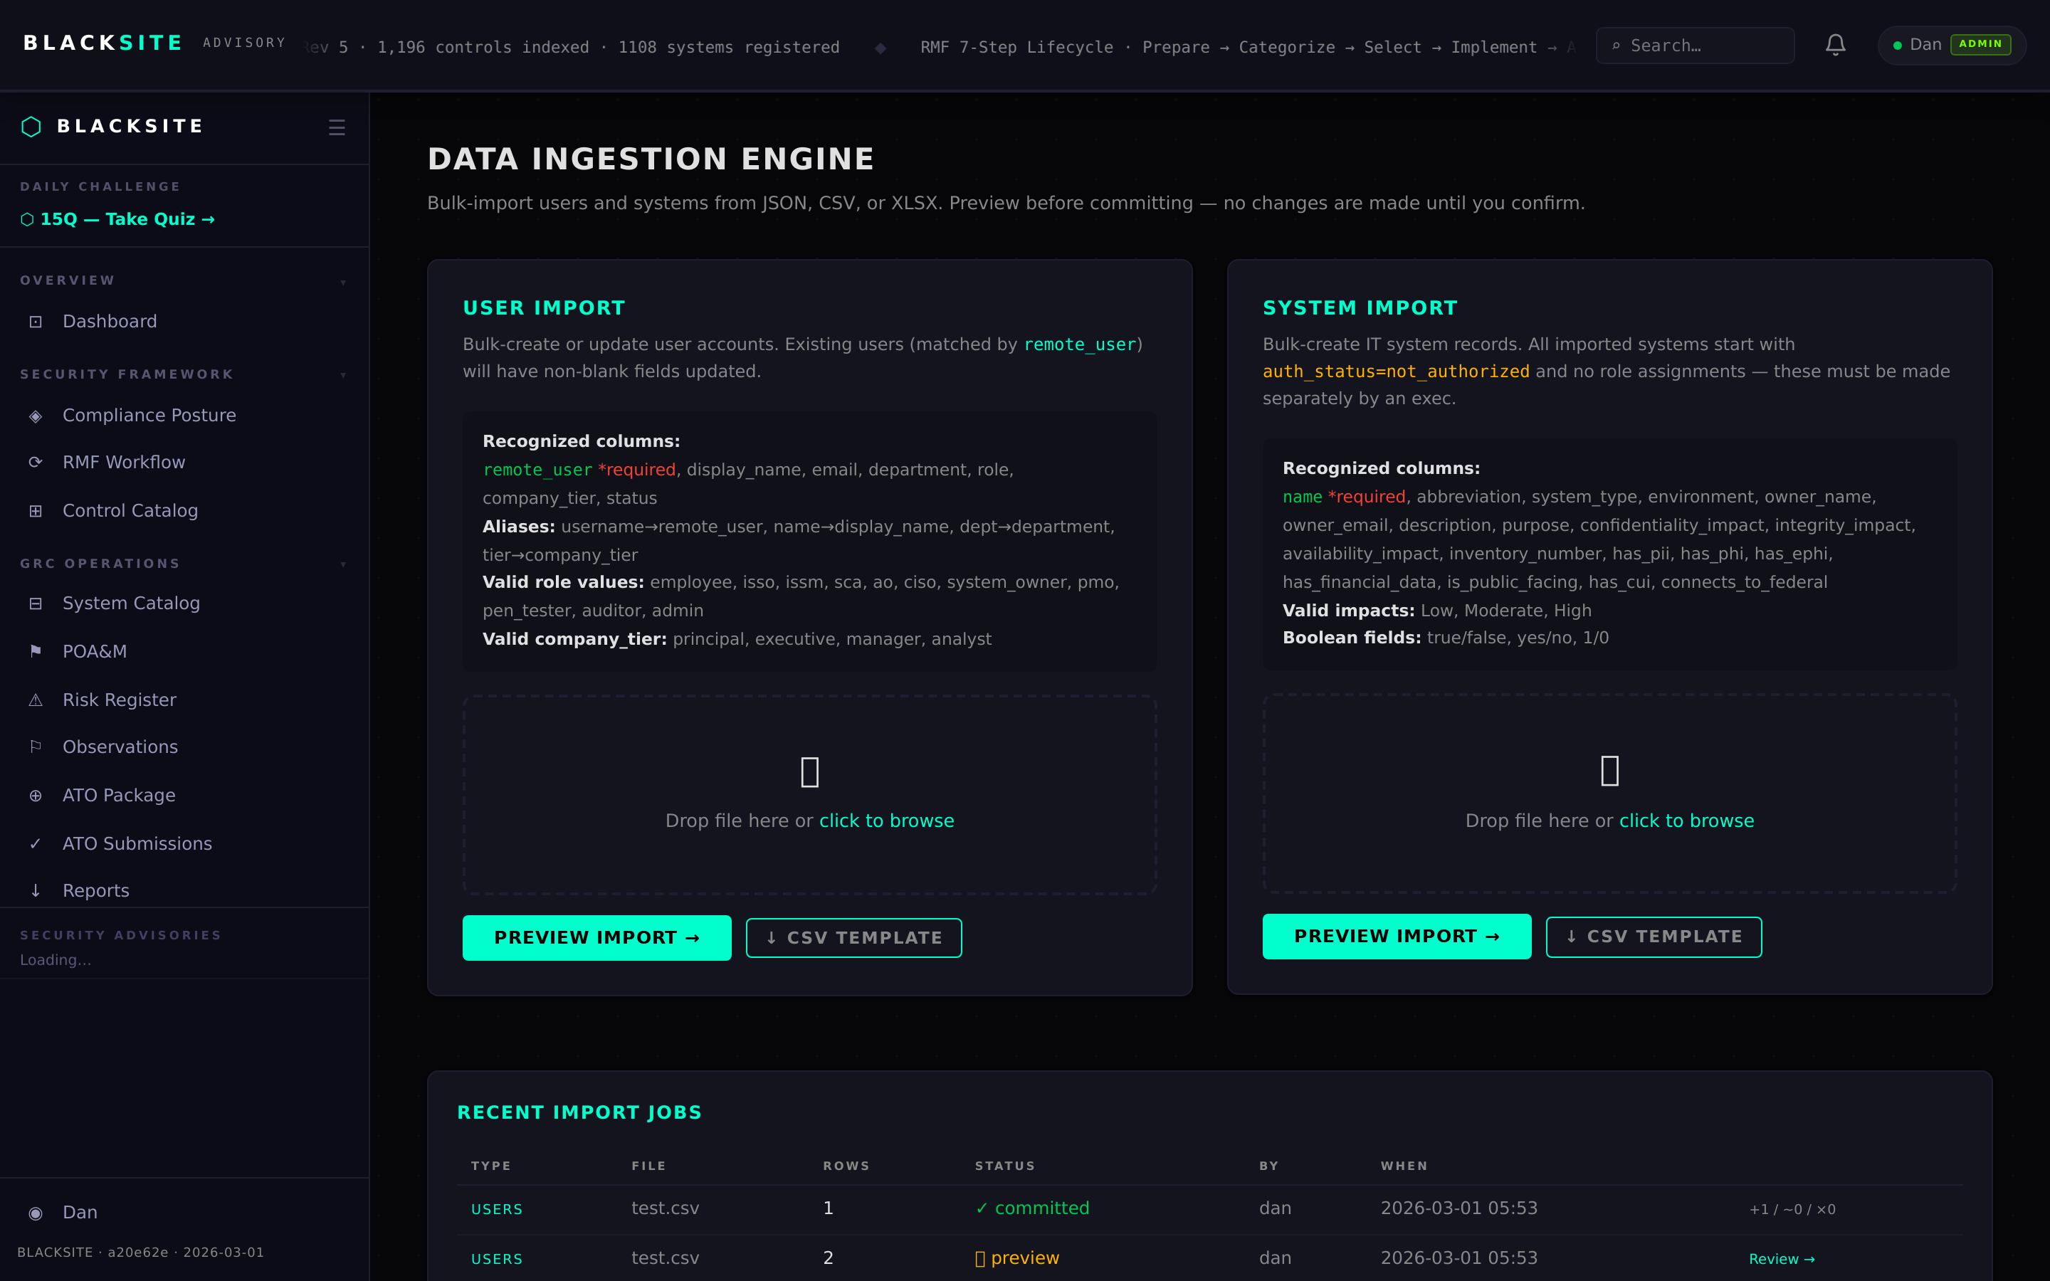
Figure 4: Data ingestion

Common Issues and Resolutions
Symptom | Resolution
Settings not taking effect | Settings are cached in memory for 5 minutes. Wait and retry, or restart the service.
Ingest preview shows 0 rows | Verify the file format matches the template. The first row must be a header row matching expected column names.

