━━━━━━━━━━━━━━━━━━━━━━━━━━━━━━━━━━━━━━━━━━━━━━━━━━━━━━━━━━━━━━━━━━━━━━
BLACKSITE GRC Platform · THKR-BSV-001

Assessment Package Upload
Roles: ISSO, SCA, Admin
Version: 1.0 | Date: 2026-03-01 | Classification: INTERNAL USE ONLY
━━━━━━━━━━━━━━━━━━━━━━━━━━━━━━━━━━━━━━━━━━━━━━━━━━━━━━━━━━━━━━━━━━━━━━

Overview
ISSOs submit assessment packages (SSP, supporting evidence, test results) for SCA review. The upload form accepts PDF and DOCX files up to 20 MB. The AI-assisted assessor automatically scores control narratives and flags gaps. SCAs then review the automated findings and provide their professional judgment.

Prerequisites
- Assessment package prepared as a single PDF or DOCX file (max 20 MB).
- System record exists and ISSO is assigned.

Procedure

Step 1: Navigate to the upload form
Navigate to /upload. Select the target system from the dropdown. Choose the assessment file using the file picker. Only PDF and DOCX are accepted. Click Upload Assessment.
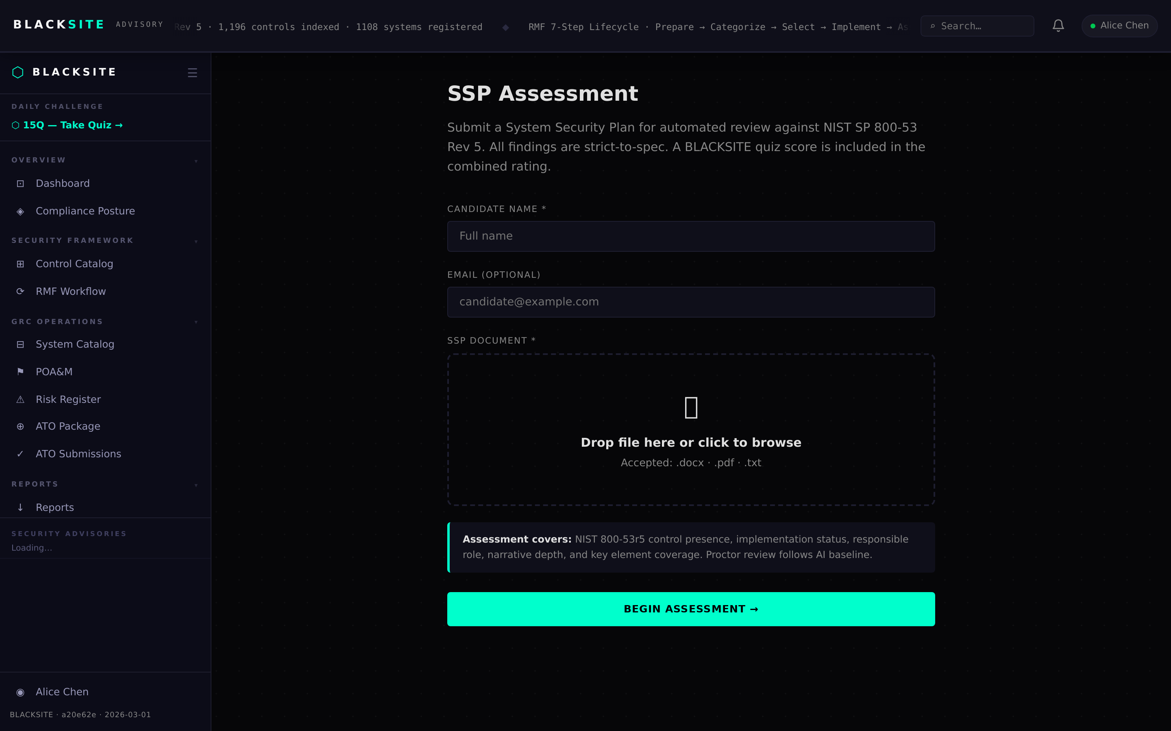
Figure 1: Navigate to the upload form

Step 2: Monitor processing
After upload, a background task parses the document, extracts control narratives, and scores each control (0–5 scale). Processing typically takes 30–90 seconds depending on document size. The admin assessments list at /admin shows the current status (Pending → Processing → Complete).
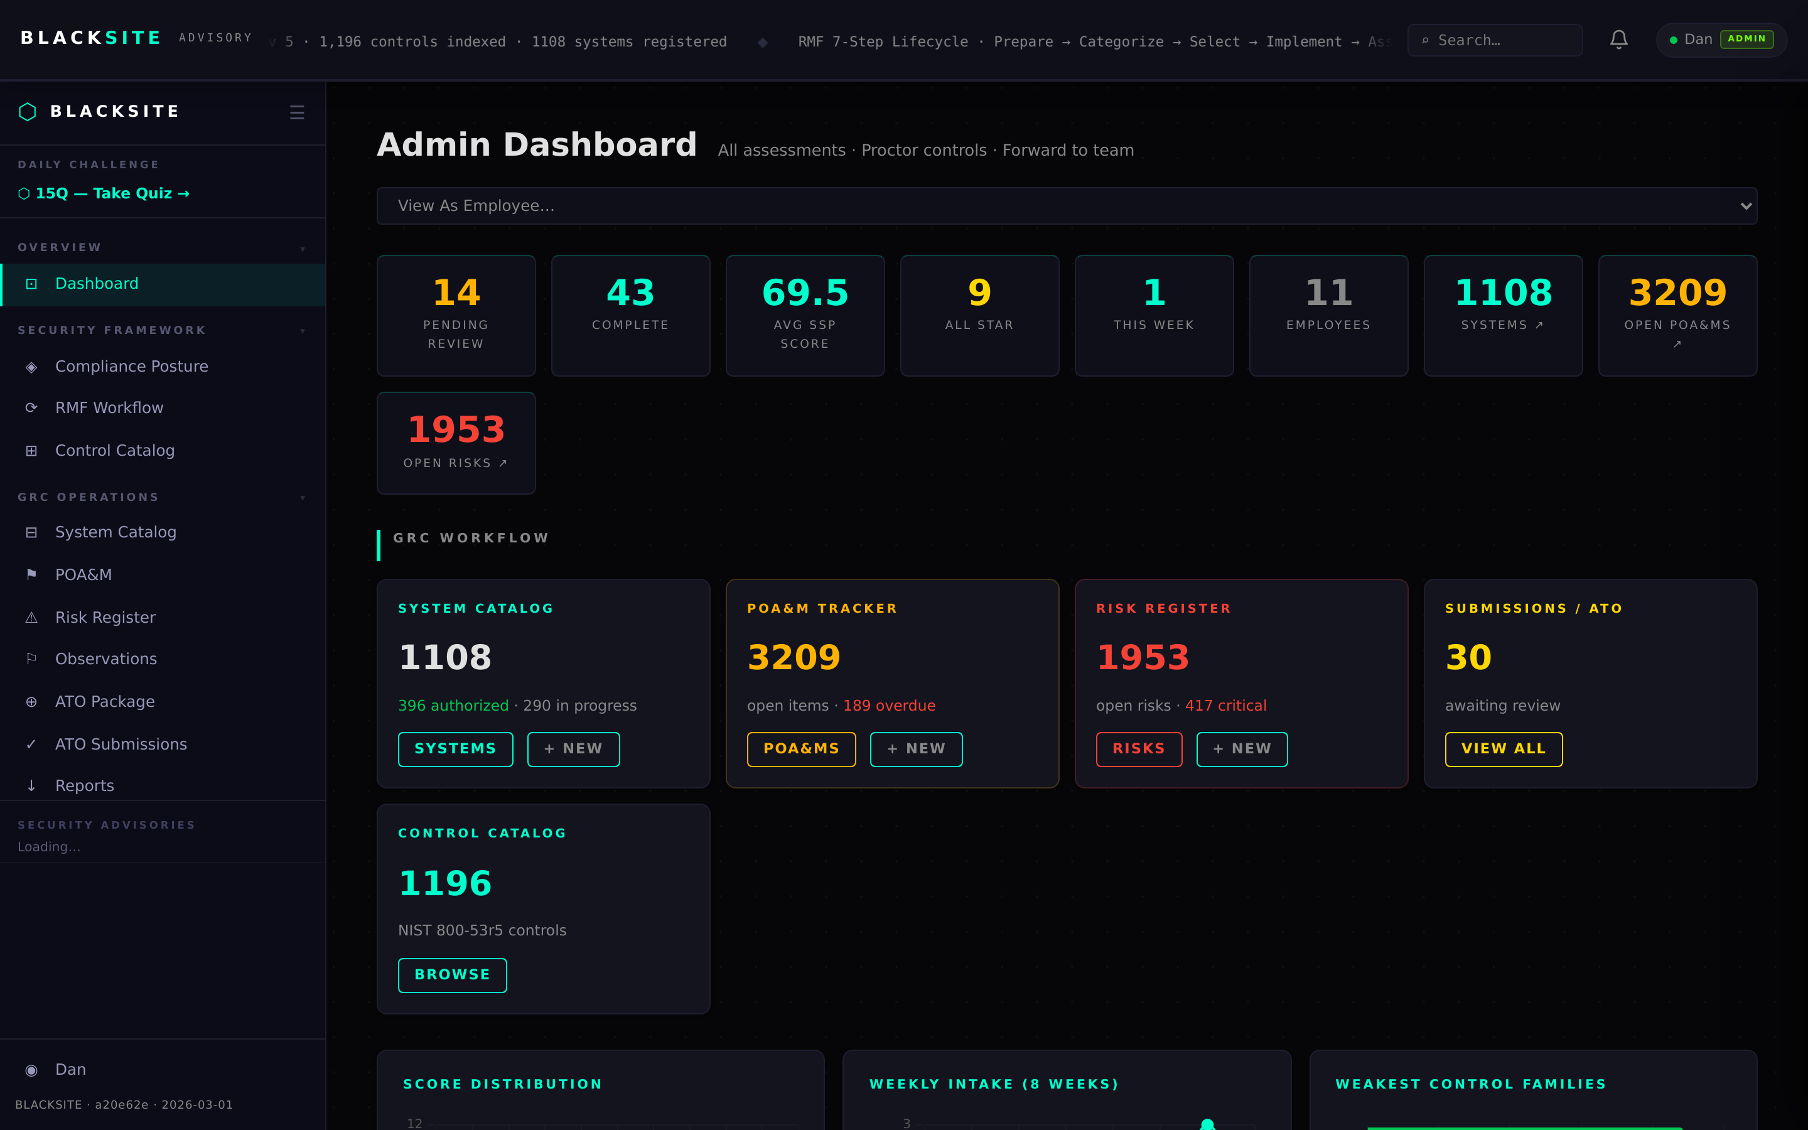
Figure 2: Monitor processing

Step 3: SCA workspace review
Once processing is complete, the assigned SCA sees the assessment in their workspace at /sca/workspace. Click the assessment row to open the review view showing per-control grades, issues, and anomaly flags.
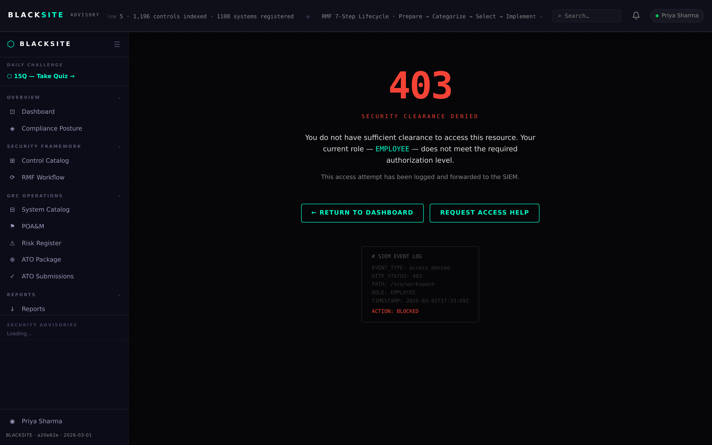
Figure 3: SCA workspace review

Step 4: View results
The assessment results page shows: overall quality score, control-by-control grades, anomaly flags (score anomalies, boilerplate detection, coverage gaps), P1 priority incomplete controls, and quick wins (controls one element away from PARTIAL).
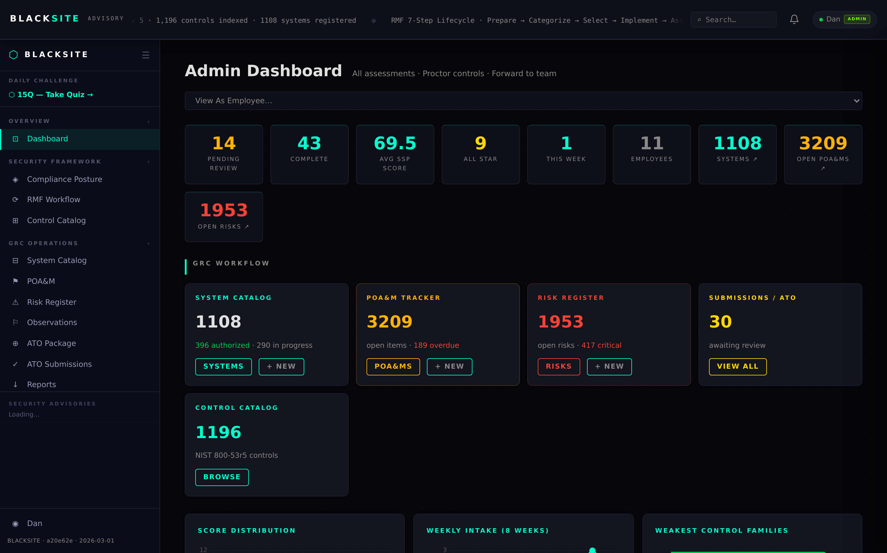
Figure 4: View results

Common Issues and Resolutions
Symptom | Resolution
Upload rejected — file too large | Compress the PDF or split into sections. Maximum file size is 20 MB.
Processing stuck in Pending | The background worker may have crashed. Contact the admin to restart the service.
SCA workspace empty | The SCA may not be assigned to the system. Check assignments at /systems/{id}/assignments.

