━━━━━━━━━━━━━━━━━━━━━━━━━━━━━━━━━━━━━━━━━━━━━━━━━━━━━━━━━━━━━━━━━━━━━━
BLACKSITE GRC Platform · THKR-BSV-001

ATO Document Package
Roles: ISSO, ISSM, SCA, AO, Admin
Version: 1.0 | Date: 2026-03-01 | Classification: INTERNAL USE ONLY
━━━━━━━━━━━━━━━━━━━━━━━━━━━━━━━━━━━━━━━━━━━━━━━━━━━━━━━━━━━━━━━━━━━━━━

Overview
The Authorization to Operate (ATO) document package contains up to 10 required artifacts (SSP, FIPS 199, RAR, SAP, SAR, POA&M, ISA, PIA, BCDR, Authorization Decision). Each document has a defined workflow: Draft → Submitted → Under Review → Approved → Finalized. The AO makes the final authorization decision from the package.

Prerequisites
- System record created with FIPS categorization complete.
- ISSO, SCA, and AO all assigned.

Procedure

Step 1: View the ATO dashboard
Navigate to /ato. The ATO dashboard lists all systems with their authorization status, ATO expiry date, and number of documents in each status. Pending decisions are highlighted with action badges.
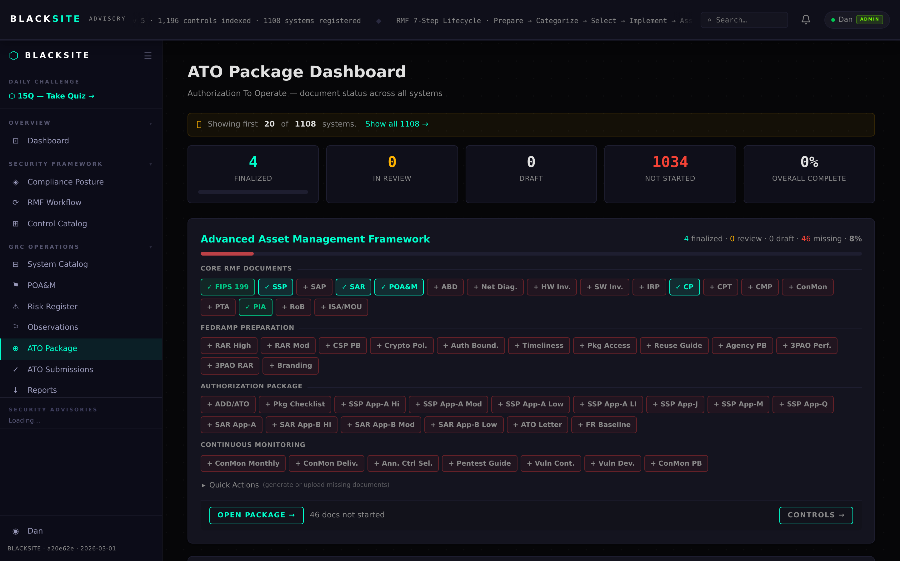
Figure 1: View the ATO dashboard

Step 2: Open a system's ATO matrix
Click a system row or navigate to /ato/{system_id}. The matrix table lists all 10 required documents with their current status, last updated date, and available actions (Generate, Upload, Submit, Approve, Finalize).
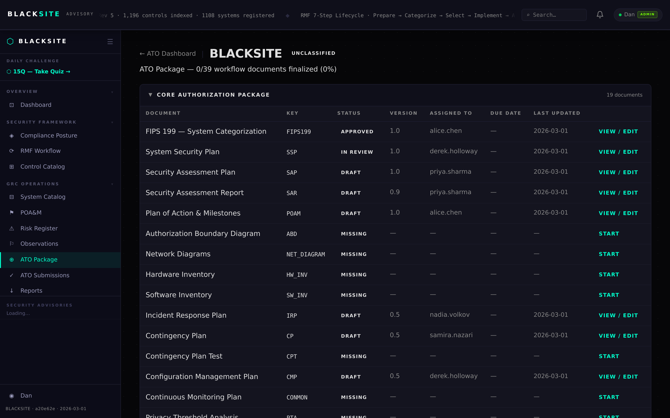
Figure 2: Open a system's ATO matrix

Step 3: View document detail
Click a document row (e.g., System Security Plan) to open its detail page. The page shows document metadata, current status badge, the full status history, and action buttons appropriate for your role.
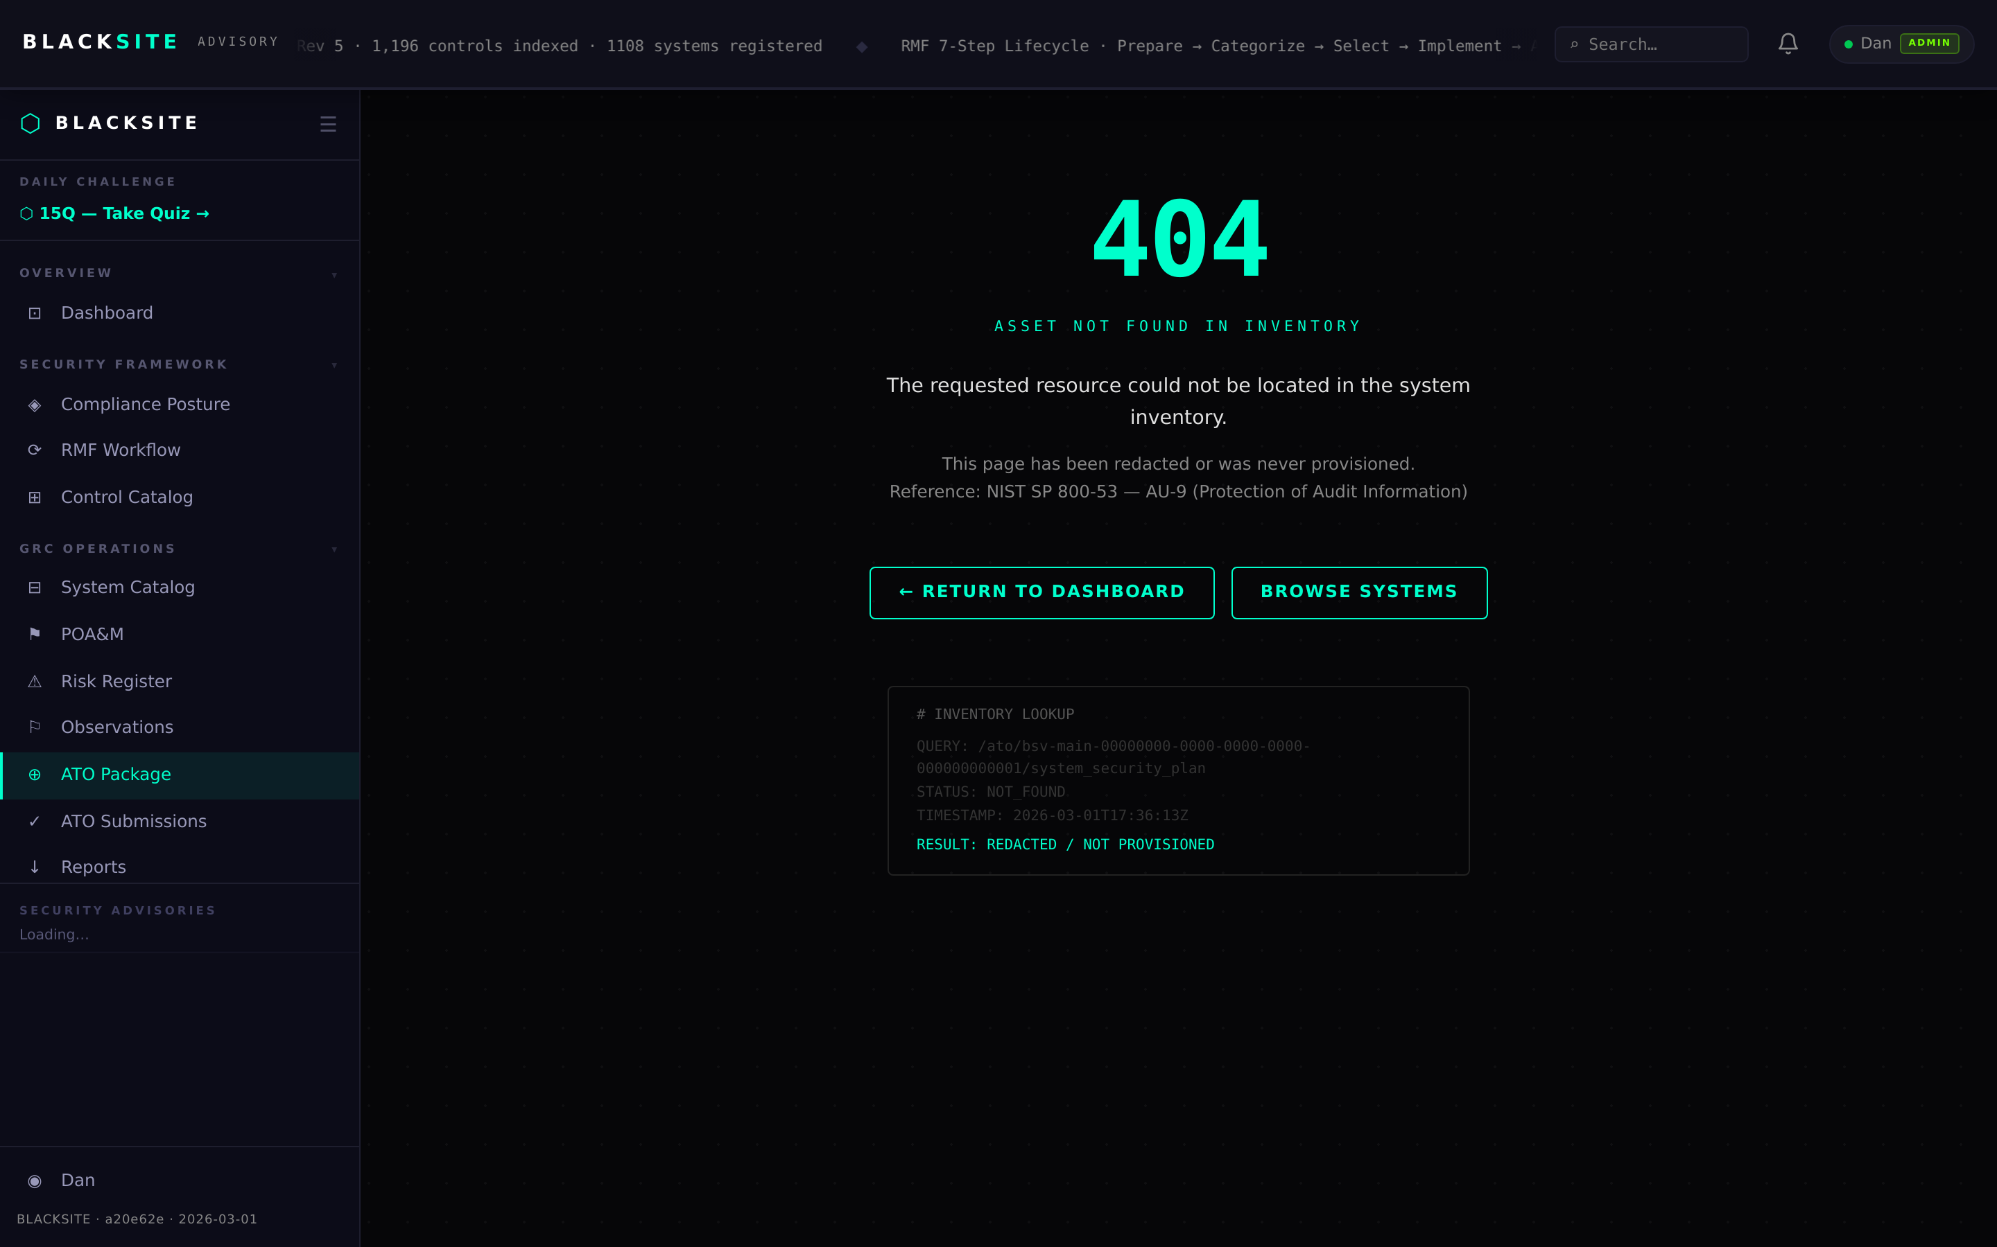
Figure 3: View document detail

Step 4: Submit a draft document
When the document is ready for review, click Submit. You must confirm the submission in a dialog. Status changes to Submitted. The SCA and ISSM receive a notification.
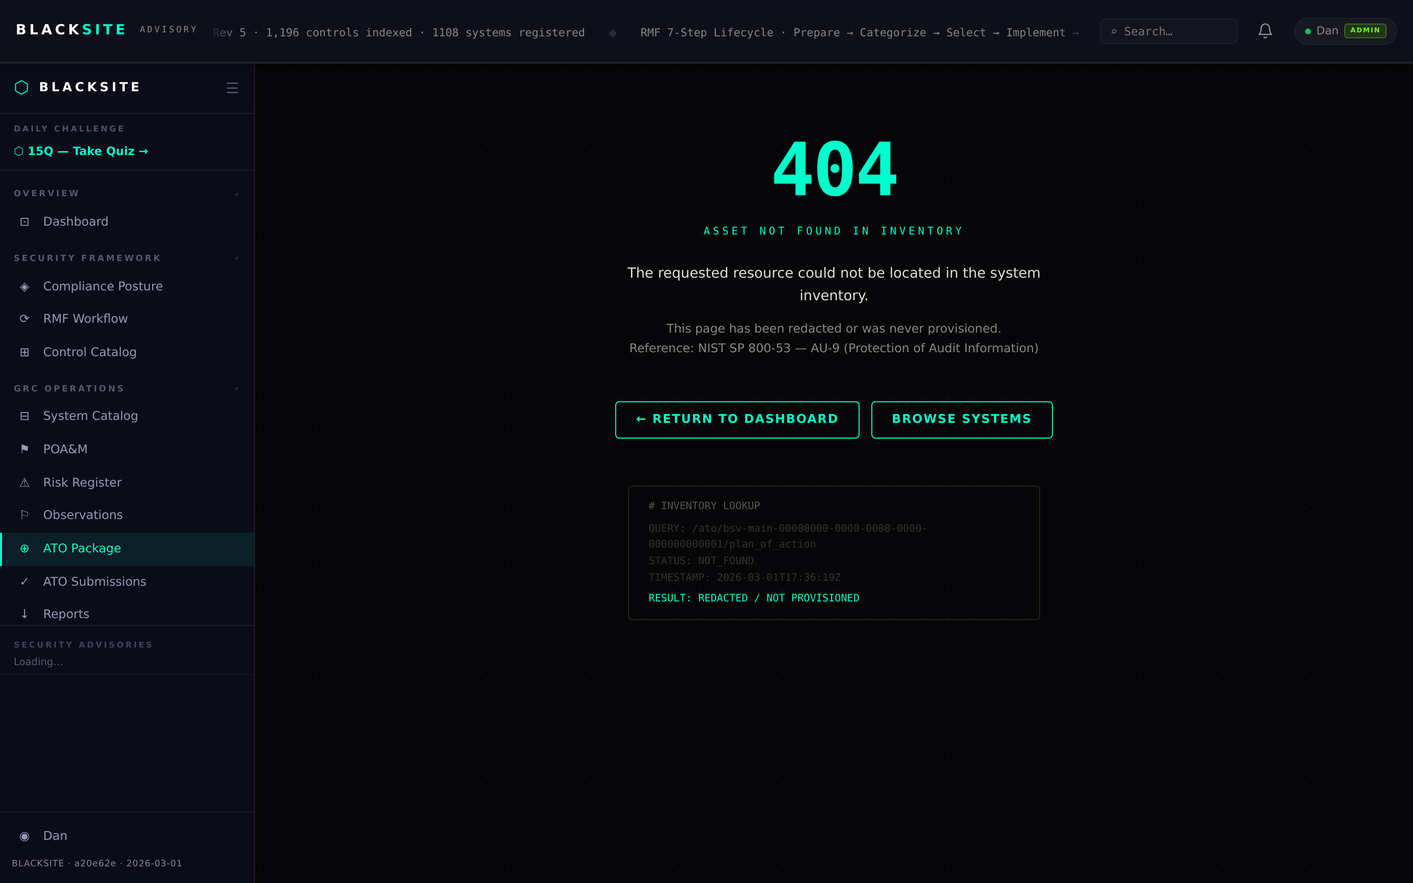
Figure 4: Submit a draft document

Step 5: Generate a document
For auto-generated documents (e.g., FIPS 199 categorization report), click the Generate button. BLACKSITE builds the document in the background using system data. When ready, the document appears as a downloadable PDF.
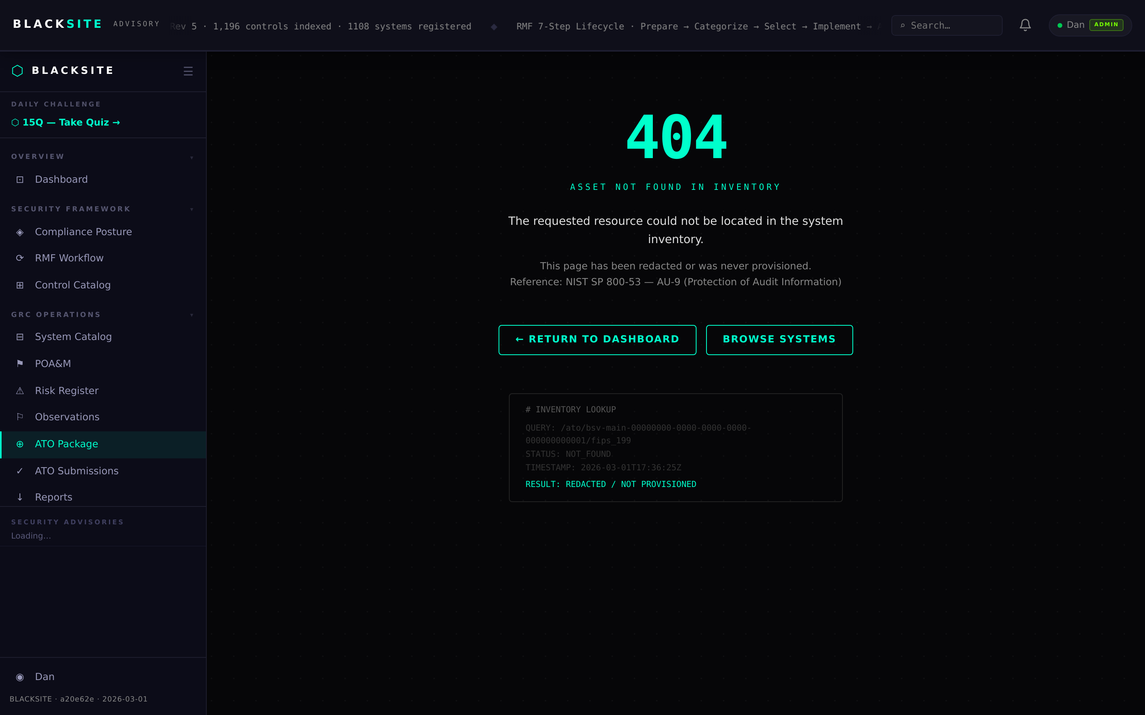
Figure 5: Generate a document

Step 6: Upload a document
For manually prepared documents (e.g., Risk Assessment Report), click Upload and select the file (PDF or DOCX, max 20 MB). The file is stored and the status advances to Submitted automatically.
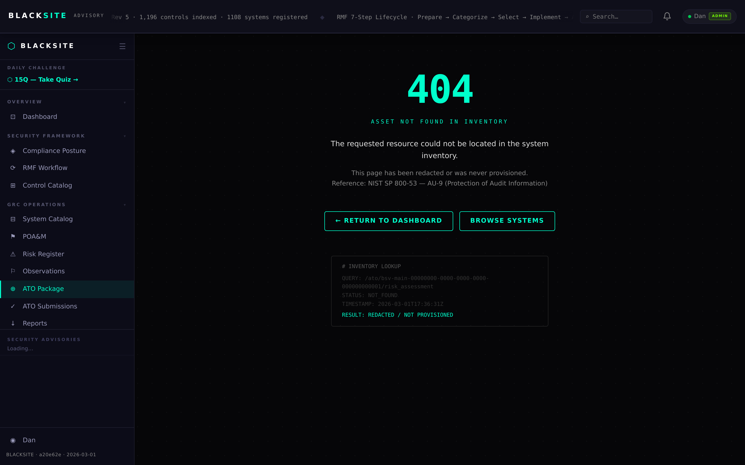
Figure 6: Upload a document

Step 7: Approve a document (SCA/ISSM)
SCA and ISSM can approve documents that are Submitted or Under Review. Click Approve. The approval is recorded in the status trail with your username and timestamp.
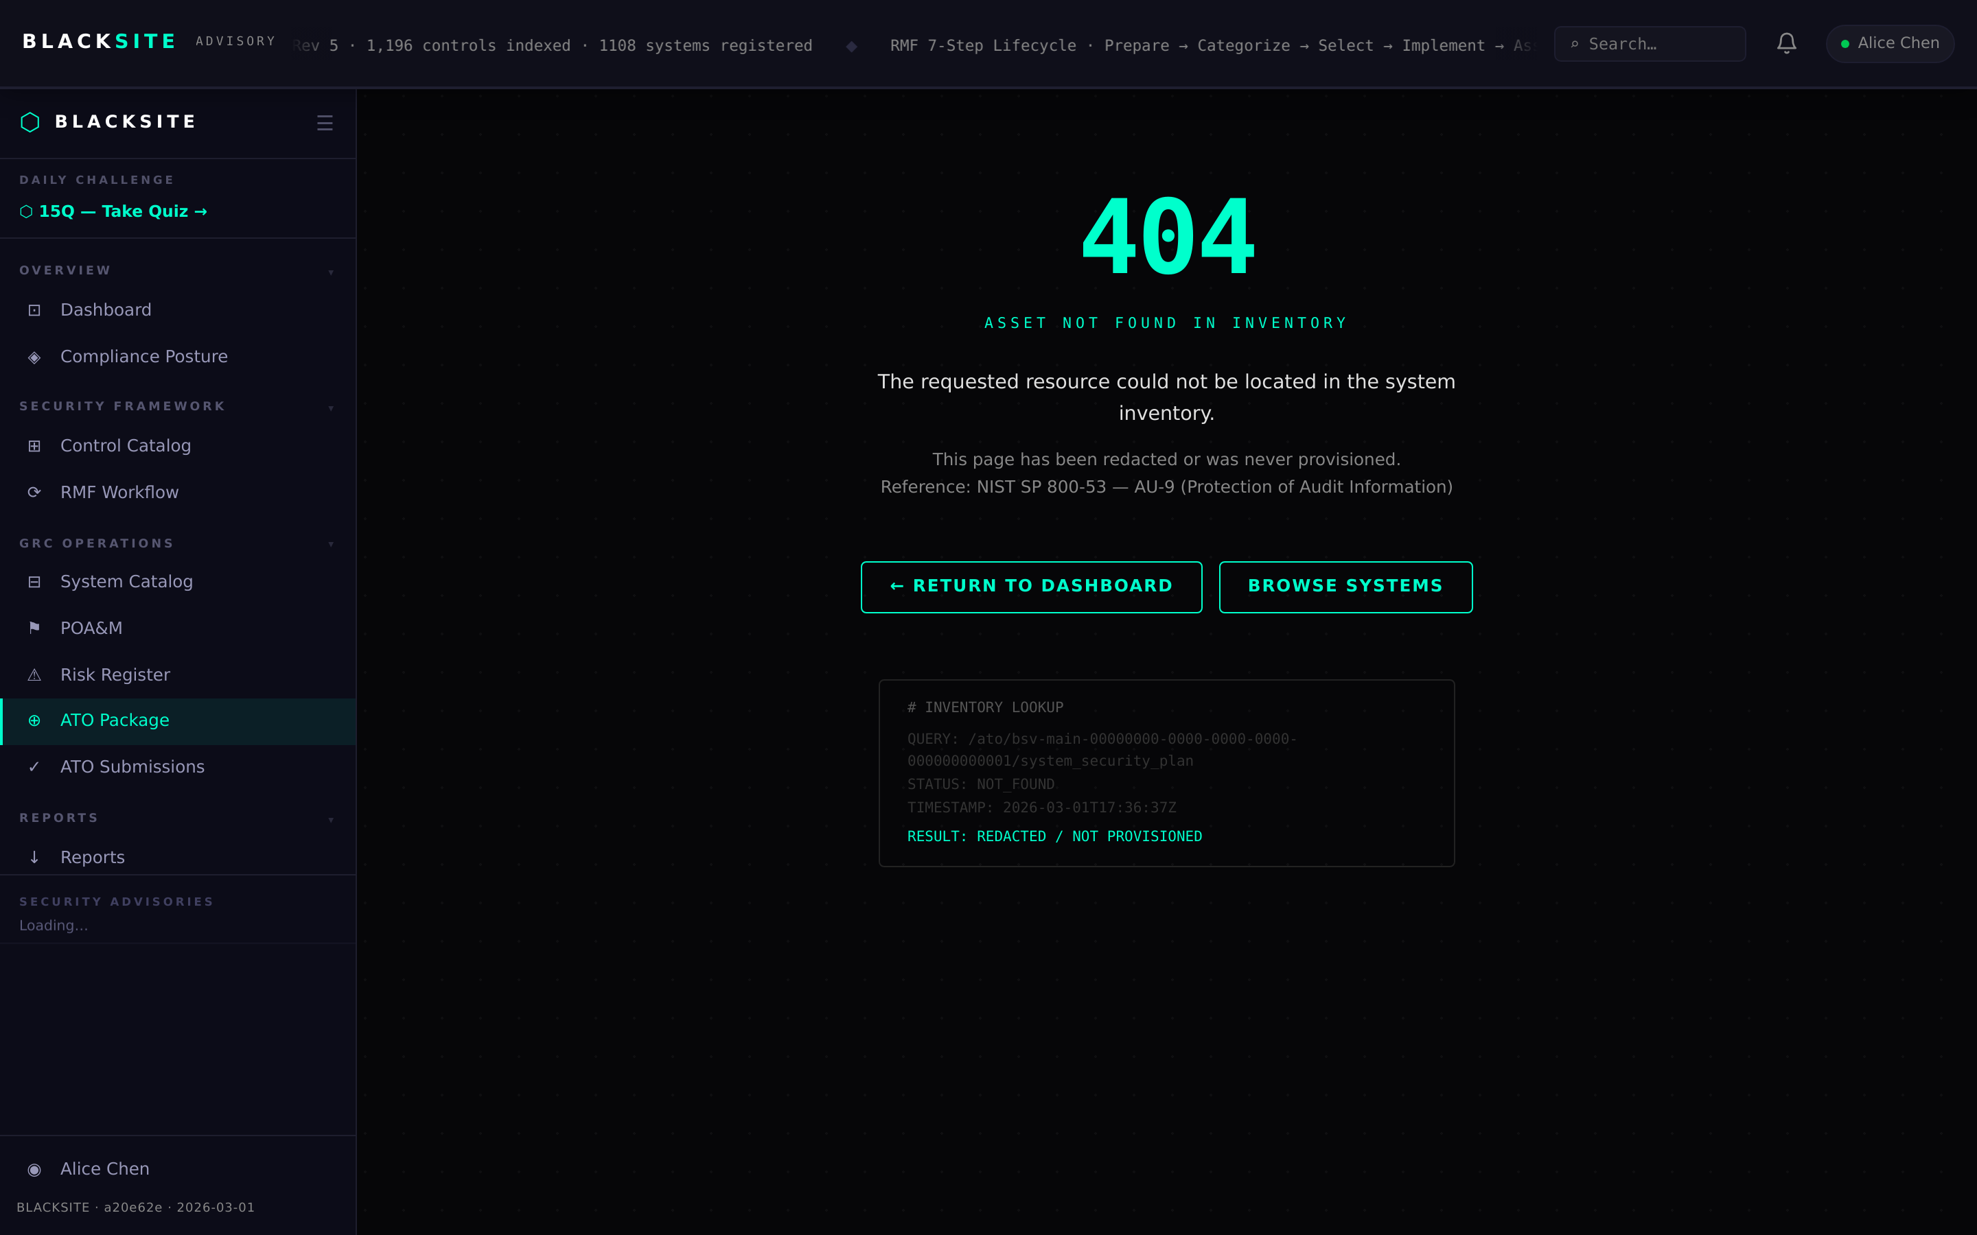
Figure 7: Approve a document (SCA/ISSM)

Step 8: Authorized status
Once the AO grants authorization, the system record shows 'Authorized' status with the authorization date and expiry. The ATO package is locked for the duration of the authorization period.
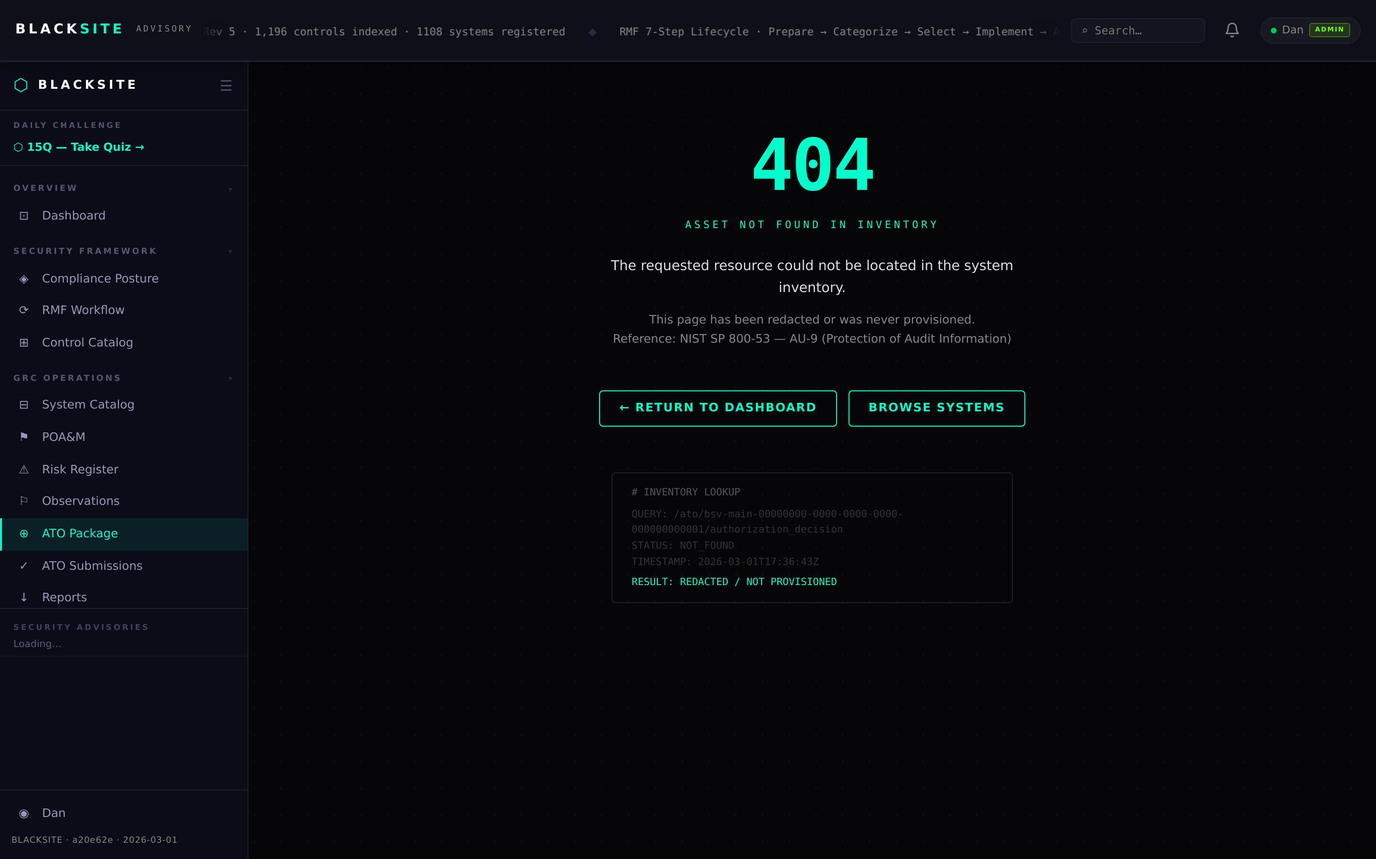
Figure 8: Authorized status

Common Issues and Resolutions
Symptom | Resolution
Generate button absent | Not all documents can be auto-generated. Check which documents have a Generate option in the matrix.
Submit button greyed out | Document may already be in a non-editable status. Check the current status badge.
ATO matrix shows wrong documents | The full 10-document set is shown regardless of system type. NA documents can be marked Not Applicable.

