━━━━━━━━━━━━━━━━━━━━━━━━━━━━━━━━━━━━━━━━━━━━━━━━━━━━━━━━━━━━━━━━━━━━━━
BLACKSITE GRC Platform · THKR-BSV-001

Audit Log Review
Roles: Admin
Version: 1.0 | Date: 2026-03-01 | Classification: INTERNAL USE ONLY
━━━━━━━━━━━━━━━━━━━━━━━━━━━━━━━━━━━━━━━━━━━━━━━━━━━━━━━━━━━━━━━━━━━━━━

Overview
BLACKSITE maintains a comprehensive audit log of all significant actions: logins, role changes, POA&M updates, ATO decisions, file uploads, and admin actions. The audit log is append-only and cannot be modified by any user.

Prerequisites
- Admin account.

Procedure

Step 1: View the audit log
Navigate to /admin/audit. The log shows the most recent 500 entries by default. Each entry shows timestamp, username, action type, and detail string. Entries are color-coded by category (auth=blue, write=green, admin=orange, error=red).
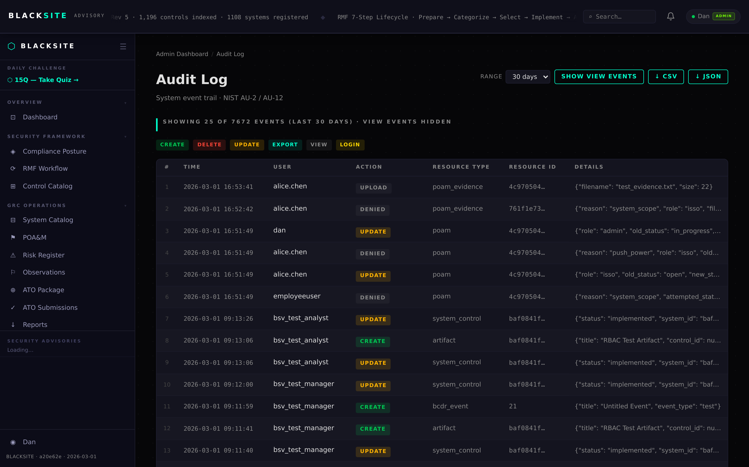
Figure 1: View the audit log

Step 2: Filter by user or action
Use the filter bar at the top to narrow by username, action type, or date range. Click Apply Filters. The table updates to show only matching entries.
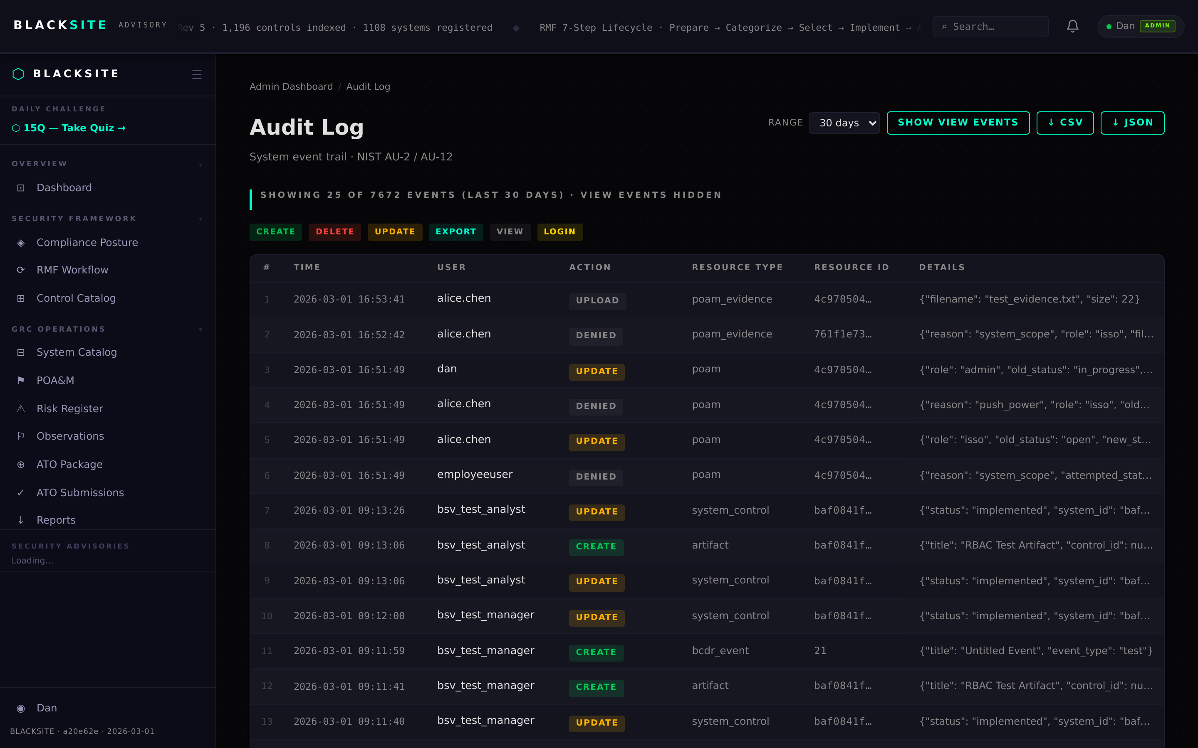
Figure 2: Filter by user or action

Step 3: Export audit log
Click Export CSV at the top of the audit log page. The full filtered audit log downloads as a CSV file with all columns. Use this for compliance reporting or incident investigation.
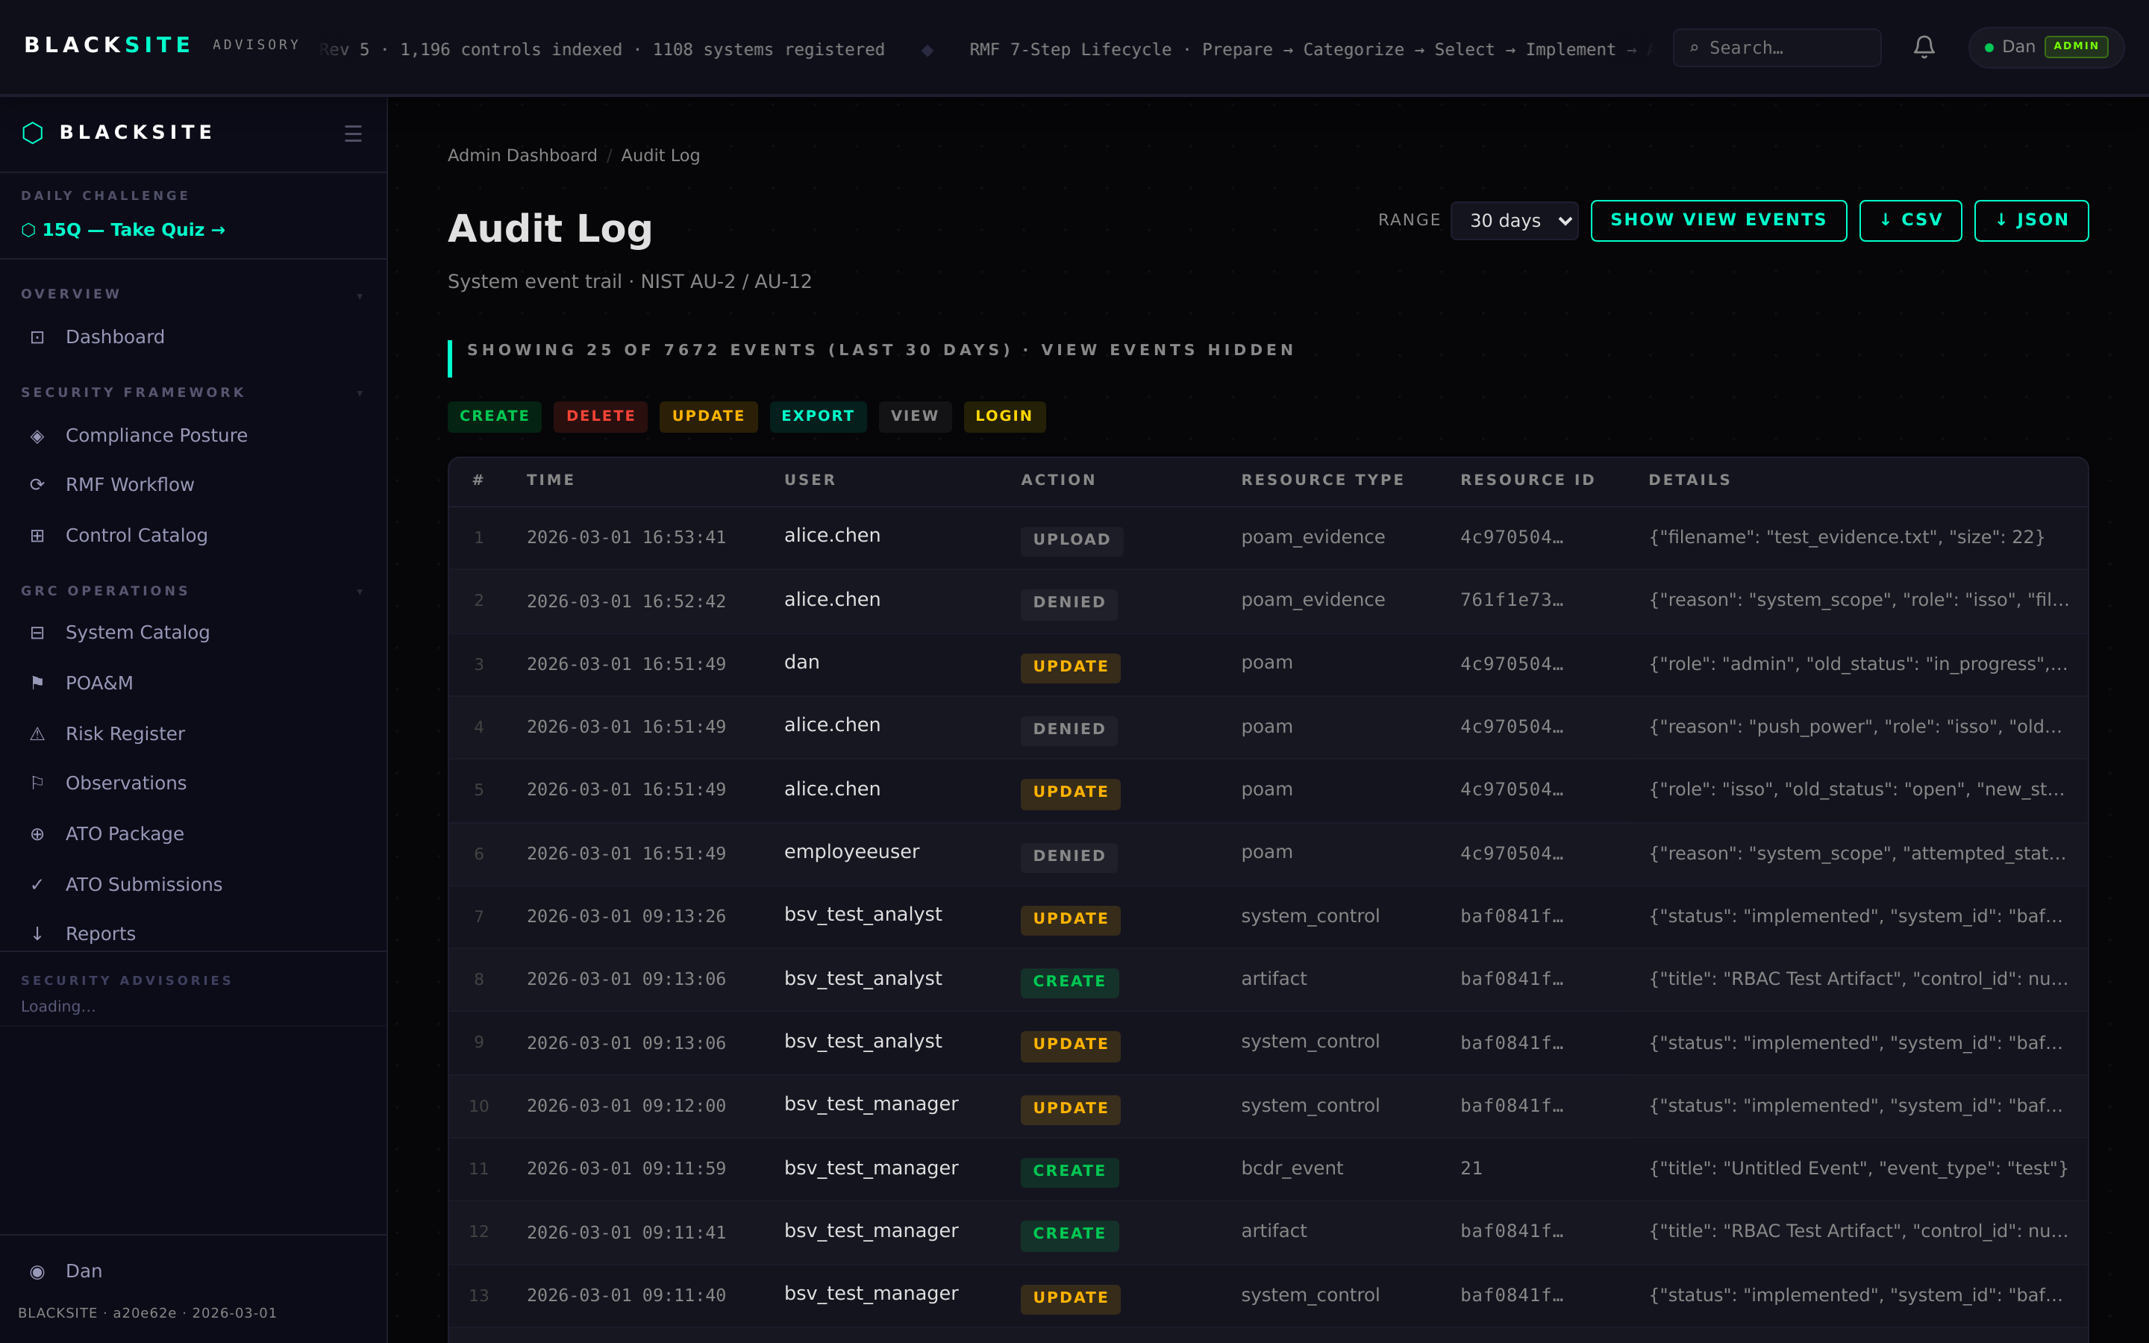
Figure 3: Export audit log

Common Issues and Resolutions
Symptom | Resolution
Audit log empty | No actions have been logged yet, or the filter is too narrow. Clear filters and reload.
Export file empty | Verify the date range includes events. Audit log entries older than the configured retention period may be purged.

