━━━━━━━━━━━━━━━━━━━━━━━━━━━━━━━━━━━━━━━━━━━━━━━━━━━━━━━━━━━━━━━━━━━━━━
BLACKSITE GRC Platform · THKR-BSV-001

BCDR Event and Team Management
Roles: BCDR Coordinator, ISSO, Admin
Version: 1.0 | Date: 2026-03-01 | Classification: INTERNAL USE ONLY
━━━━━━━━━━━━━━━━━━━━━━━━━━━━━━━━━━━━━━━━━━━━━━━━━━━━━━━━━━━━━━━━━━━━━━

Overview
Business Continuity and Disaster Recovery (BCDR) events track activations, exercises, and recovery tests. BCDR Coordinators create events, document the timeline, and record sign-offs from stakeholders. System teams are managed separately as the organizational roster for each system.

Prerequisites
- BCDR Coordinator role assigned.
- System record with teams tab populated.

Procedure

Step 1: View BCDR dashboard
Navigate to /bcdr/dashboard. Active and past BCDR events are listed with type (Activation/Exercise/Test), start date, status, and involved systems. Click + New Event to create one.
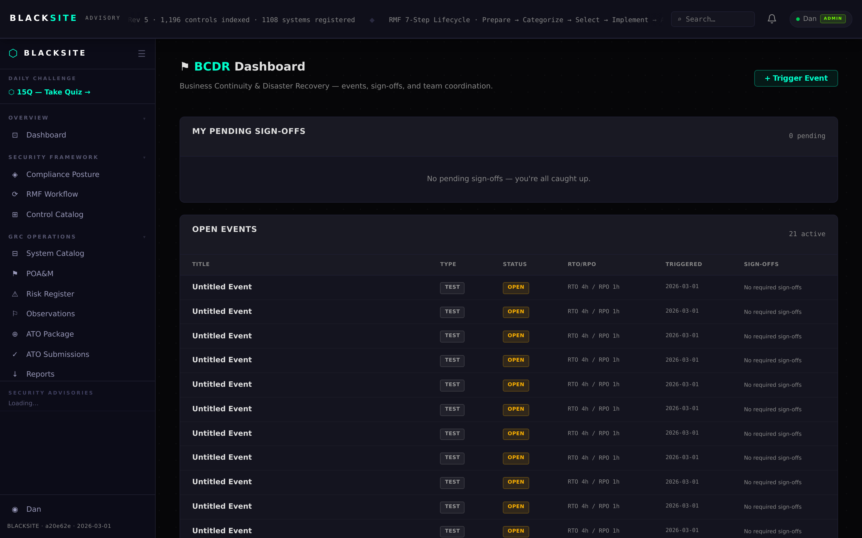
Figure 1: View BCDR dashboard

Step 2: Create a BCDR event
Click + New Event. Fill in: Event Type, Affected Systems (multi-select), Description, Start Time, and Estimated Duration. Click Create. The event opens in Active status. All assigned BCDR personnel receive a notification.
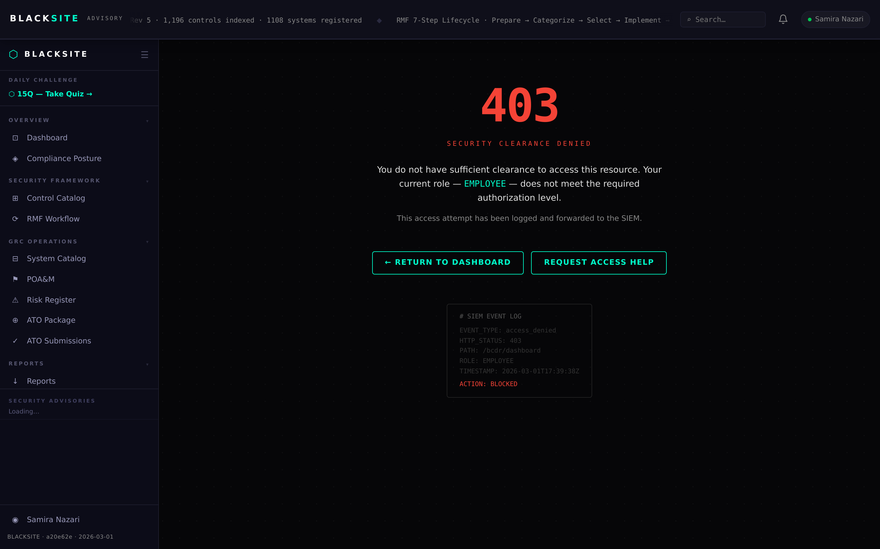
Figure 2: Create a BCDR event

Step 3: Update event detail
Click an active event to open its detail. Update the timeline notes as the event progresses. Document recovery actions taken, systems restored, and any issues encountered.
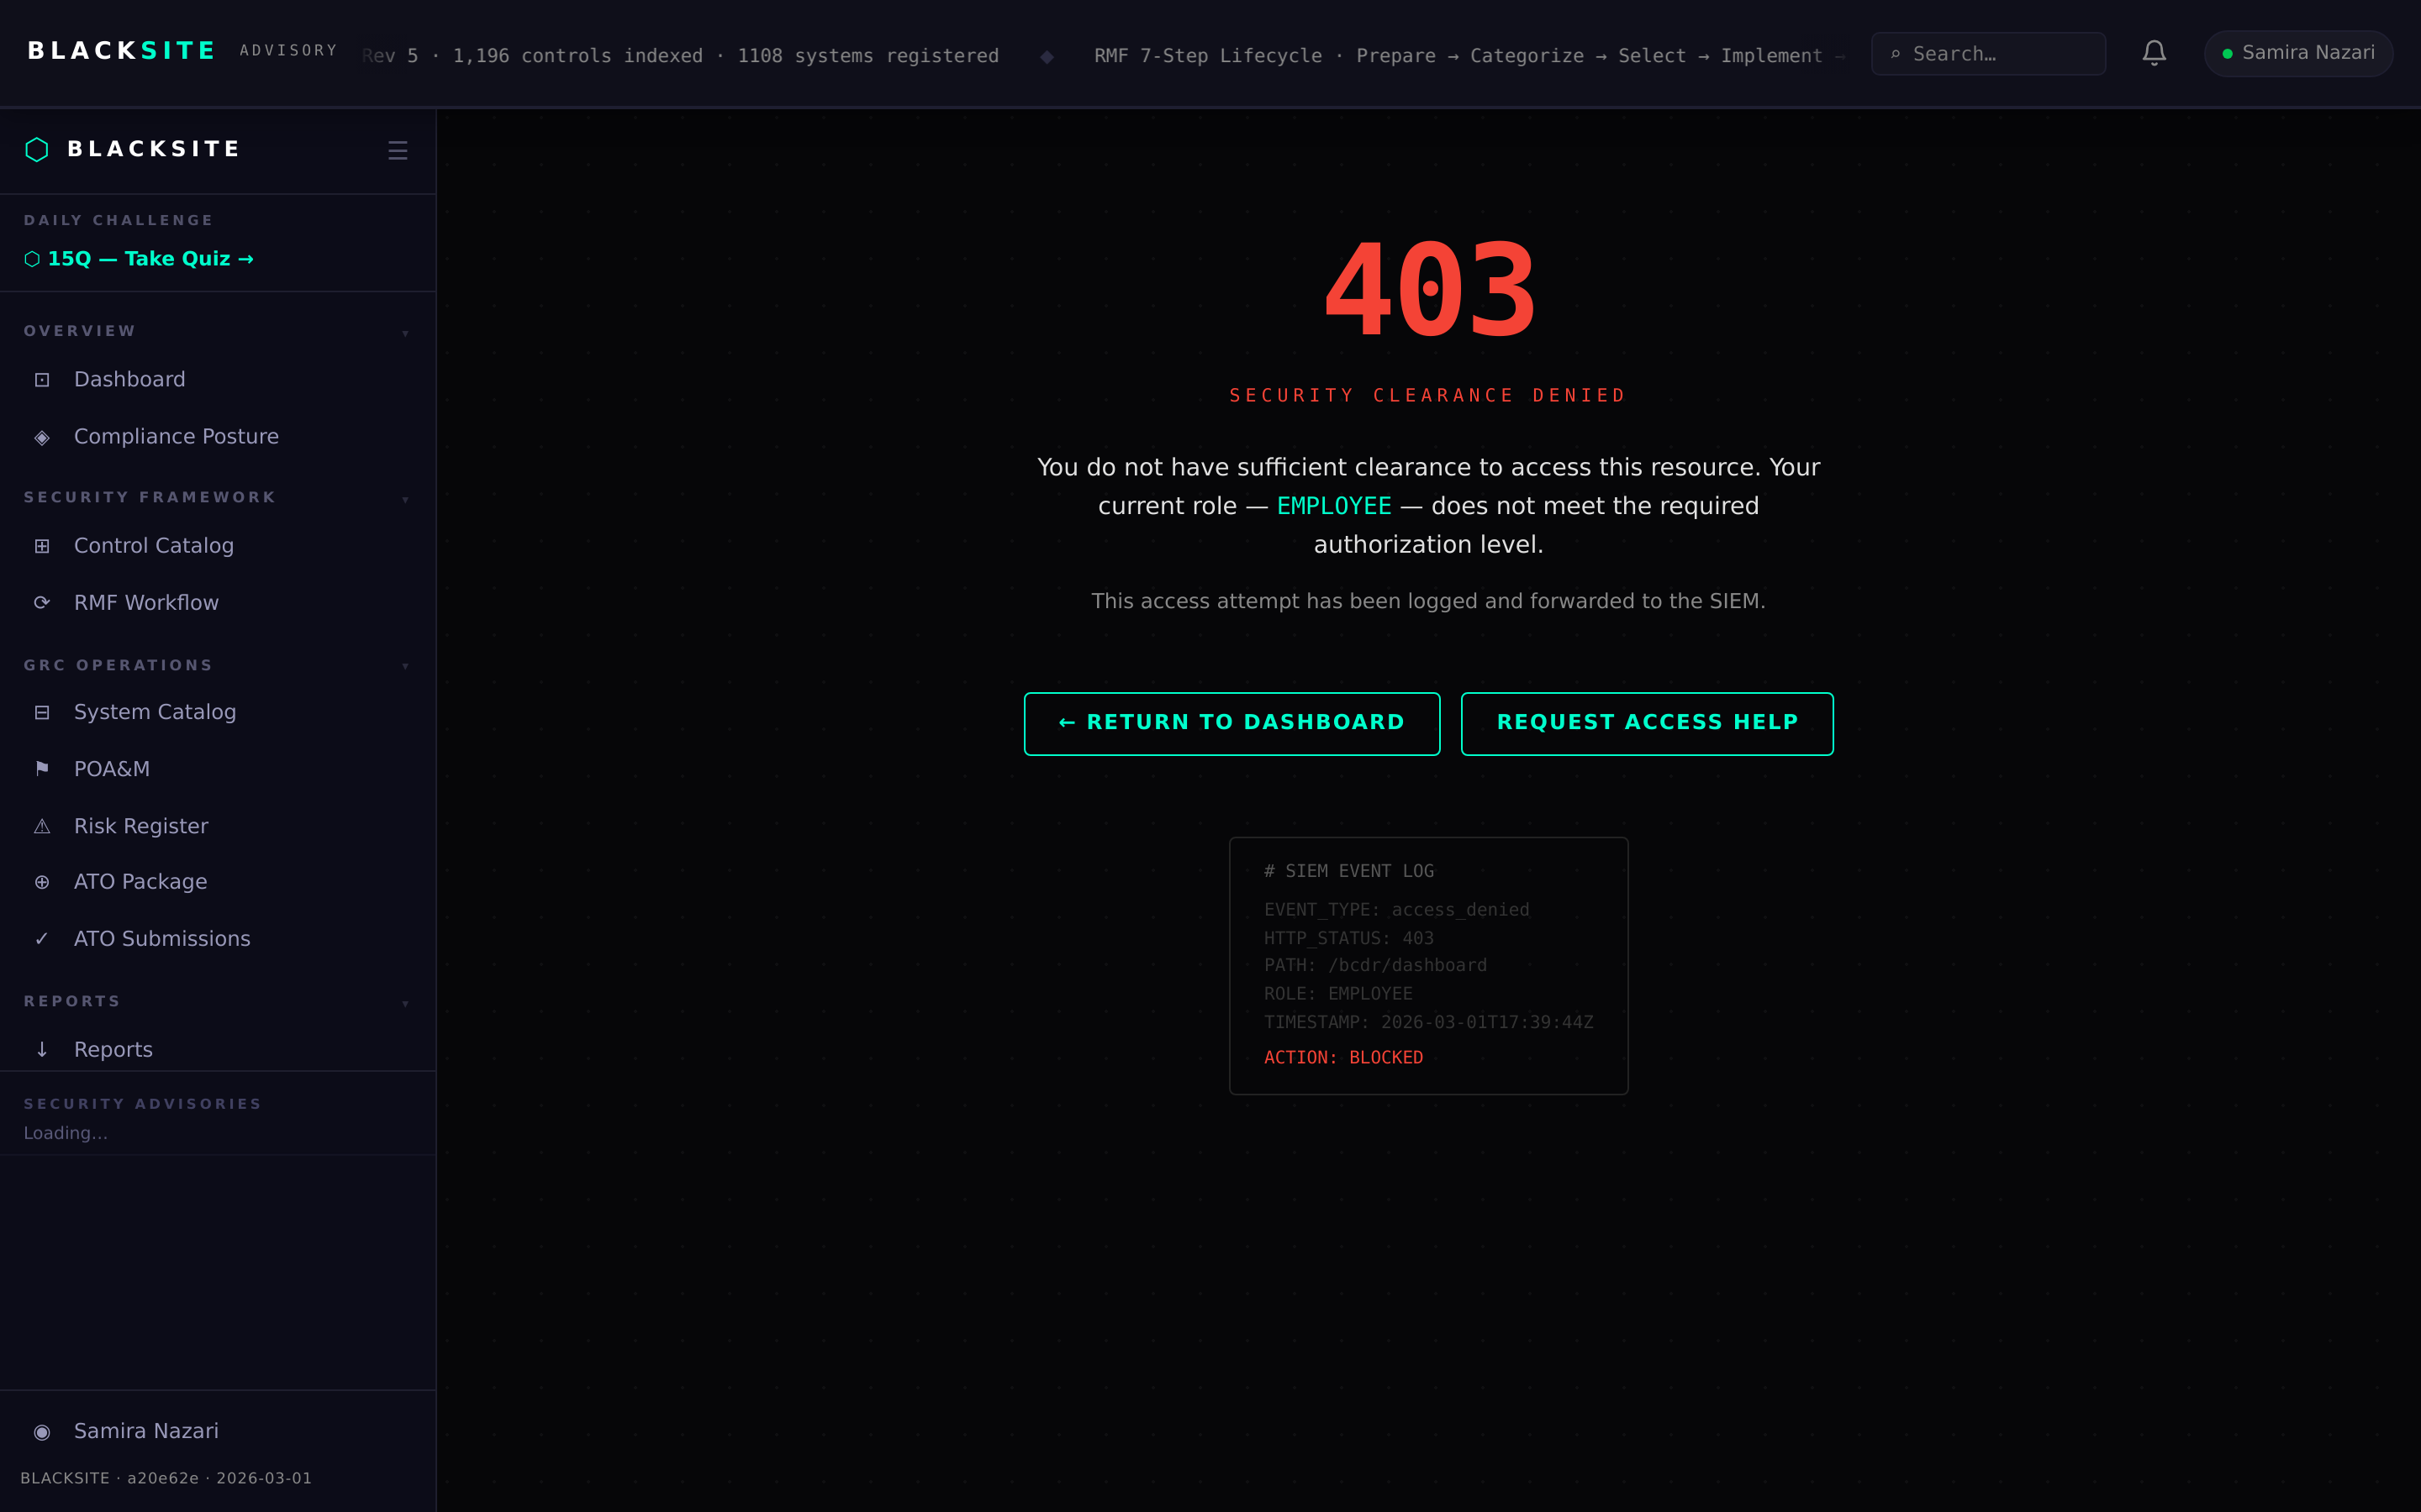
Figure 3: Update event detail

Step 4: Record stakeholder sign-off
When the event is resolved, click Record Sign-off. Enter the stakeholder name and role. Add final resolution notes. Click Complete Event. The event status changes to Closed and a completion timestamp is recorded.
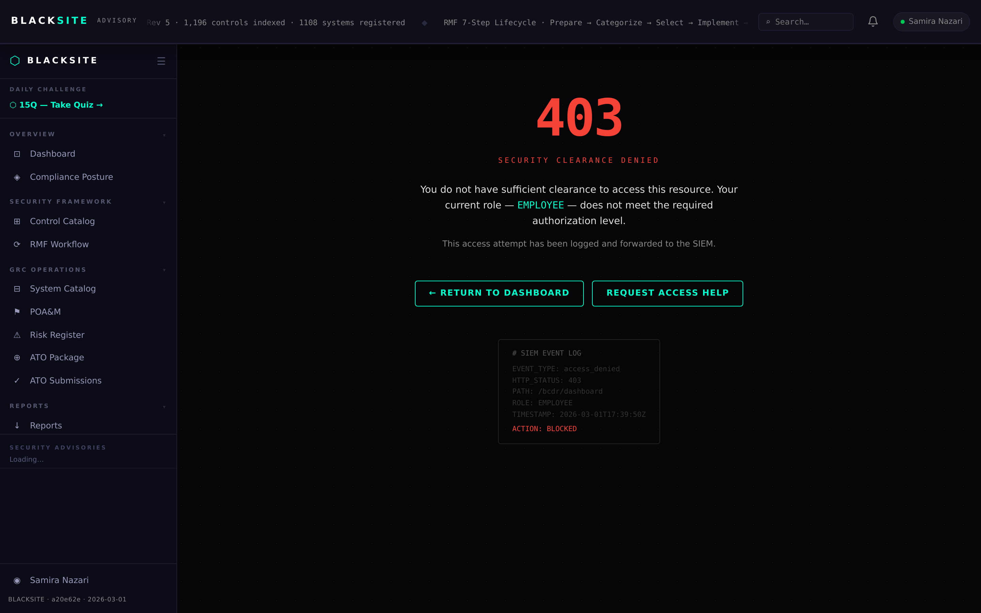
Figure 4: Record stakeholder sign-off

Step 5: Manage system teams
Navigate to /systems/{id}/teams to view and edit the system team roster. Team members are listed with their roles and contact information. Use this page to keep the emergency contact list current.
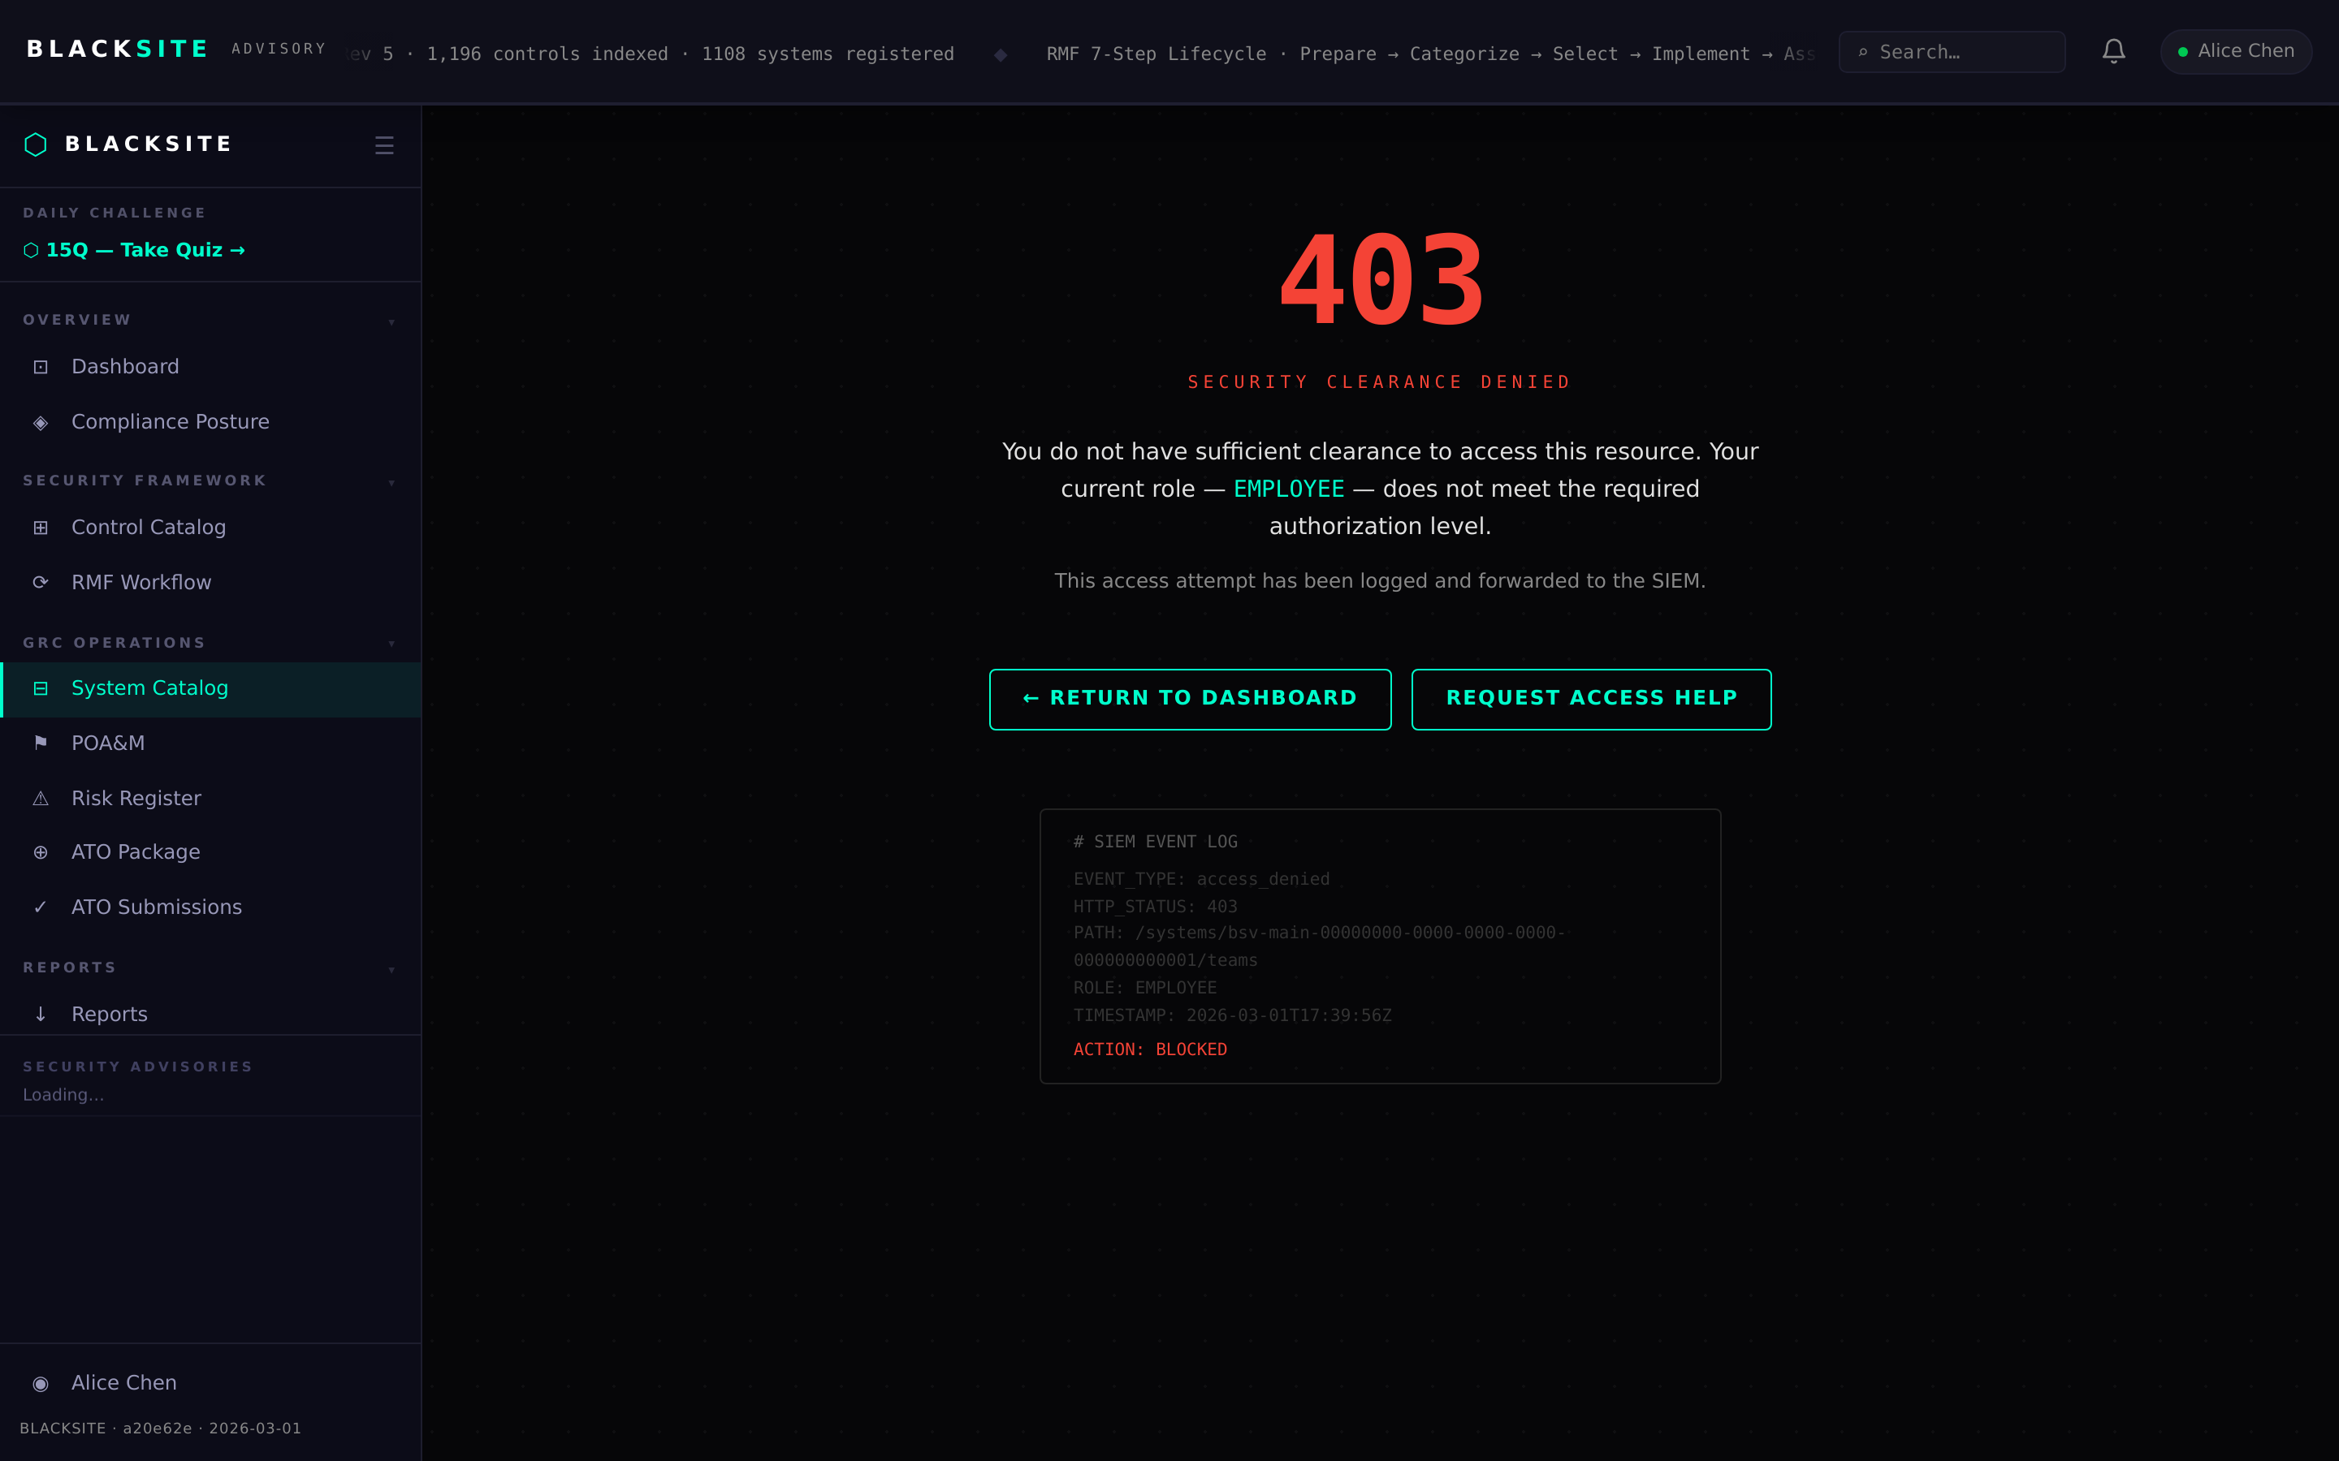
Figure 5: Manage system teams

Common Issues and Resolutions
Symptom | Resolution
Create event fails — no systems listed | You must be assigned to at least one system as BCDR Coordinator.
Sign-off button absent | Only the event creator and admin can record sign-offs. Verify the event owner.

