━━━━━━━━━━━━━━━━━━━━━━━━━━━━━━━━━━━━━━━━━━━━━━━━━━━━━━━━━━━━━━━━━━━━━━
BLACKSITE GRC Platform · THKR-BSV-001

Compliance Record Management
Roles: ISSO, ISSM, Admin
Version: 1.0 | Date: 2026-03-01 | Classification: INTERNAL USE ONLY
━━━━━━━━━━━━━━━━━━━━━━━━━━━━━━━━━━━━━━━━━━━━━━━━━━━━━━━━━━━━━━━━━━━━━━

Overview
BLACKSITE tracks five compliance record types per system: Vendors/BAAs, Interconnection Records (ISAs), Data Flow Records, Privacy Assessments (PTA/PIA), and Restore Test Records. These records provide the evidence base for continuous monitoring and ATO maintenance.

Prerequisites
- System record with ISSO assigned.

Procedure

Step 1: Vendor and BAA registry
Navigate to /systems/{id}/vendors. The vendor list shows all third-party vendors with service type, ePHI flag, BAA status, BAA expiry date, and contact. Click + Add Vendor to add a new entry. BAAs expiring within 90 days are highlighted in yellow.
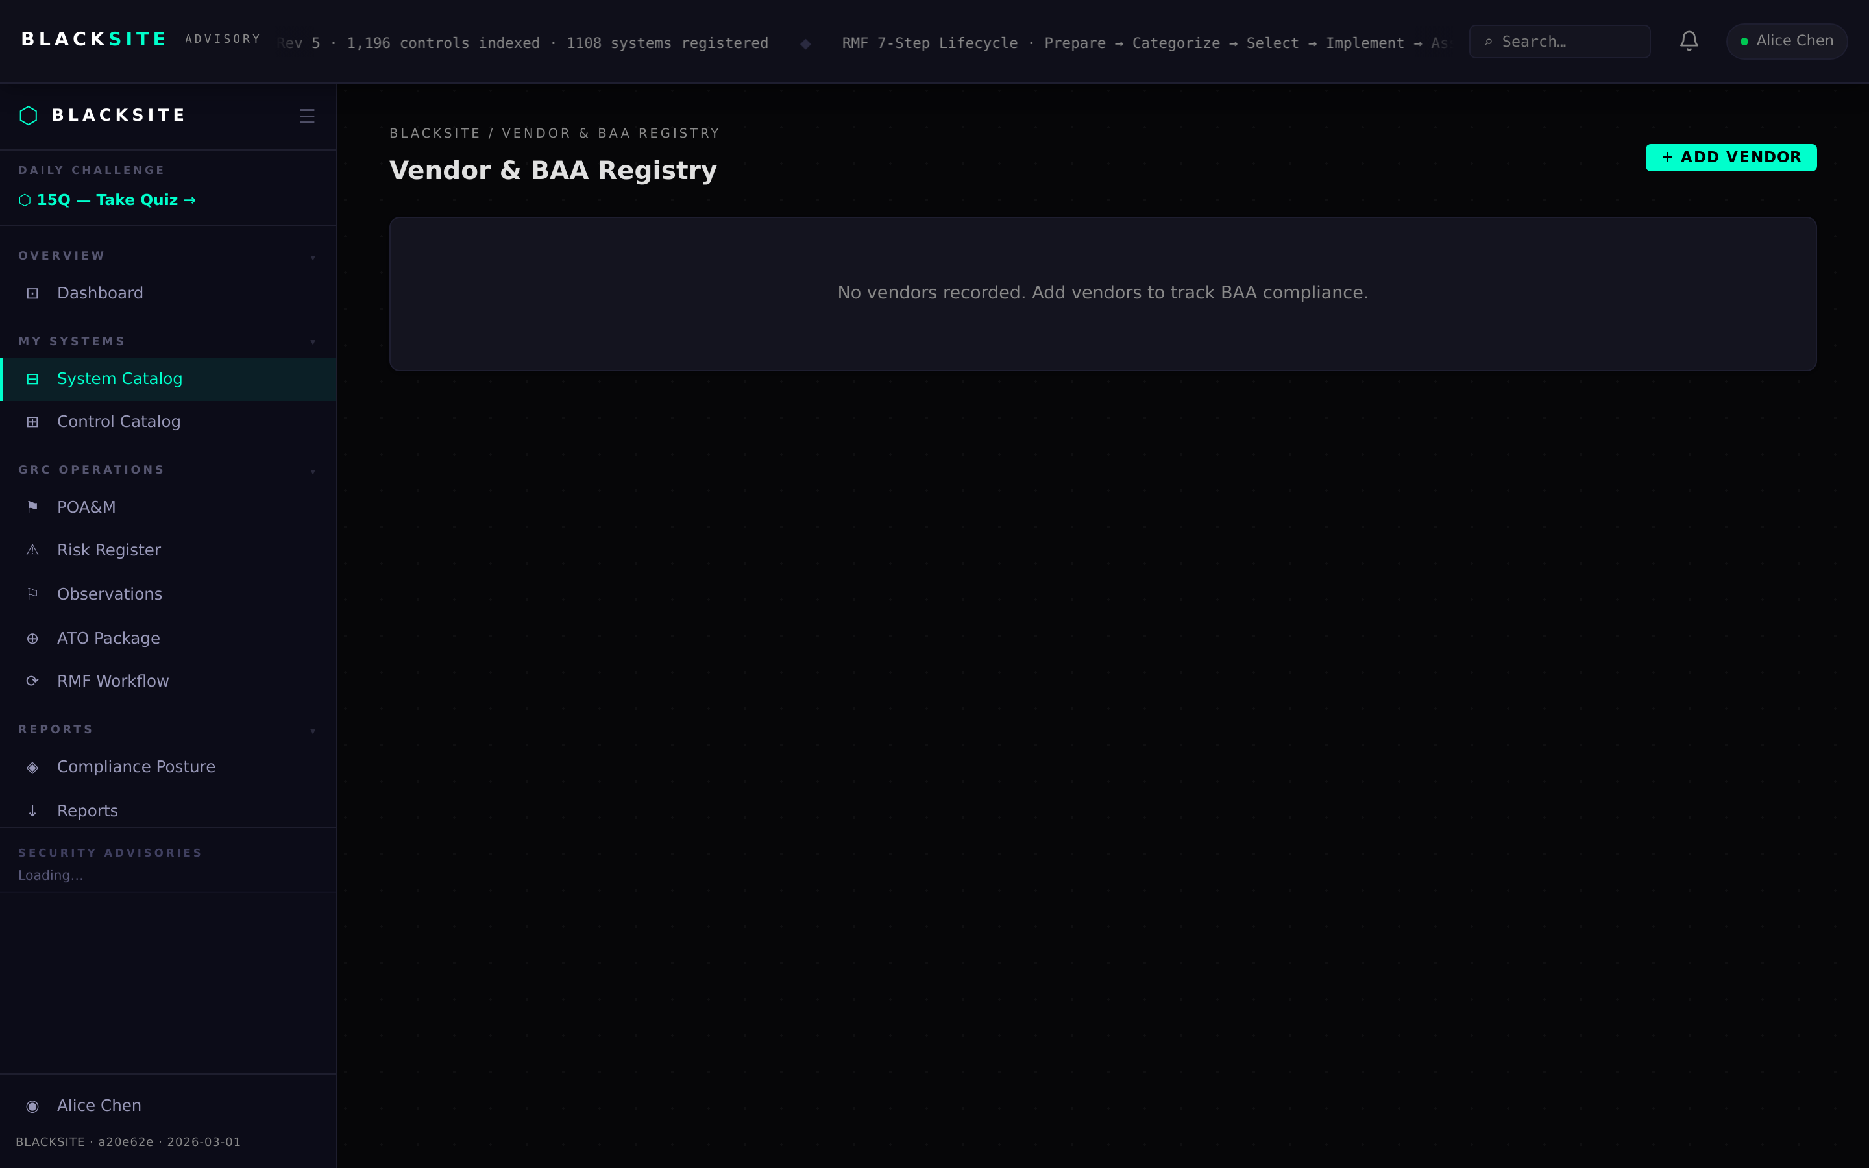
Figure 1: Vendor and BAA registry

Step 2: Interconnection records (ISAs)
Navigate to /systems/{id}/interconnections. Each ISA record shows the partner system, data types exchanged, ISA existence/expiry, monitoring status, and encryption indicators. Add or update records as new connections are established.
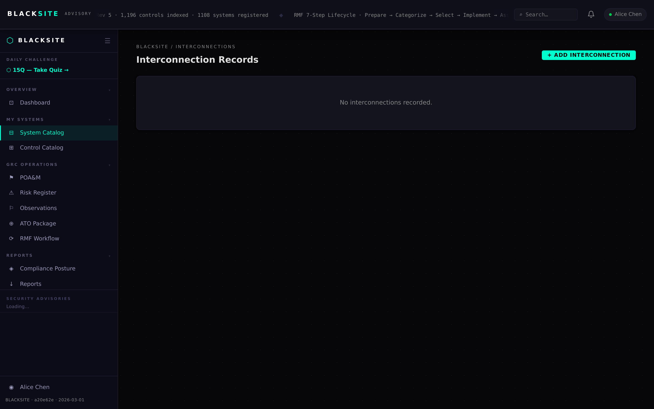
Figure 2: Interconnection records (ISAs)

Step 3: Data flow records
Navigate to /systems/{id}/dataflows. Data flows document API integrations and data pipelines: authentication method, transit/rest encryption, logging status, and termination procedures. Required for HIPAA technical safeguard documentation.
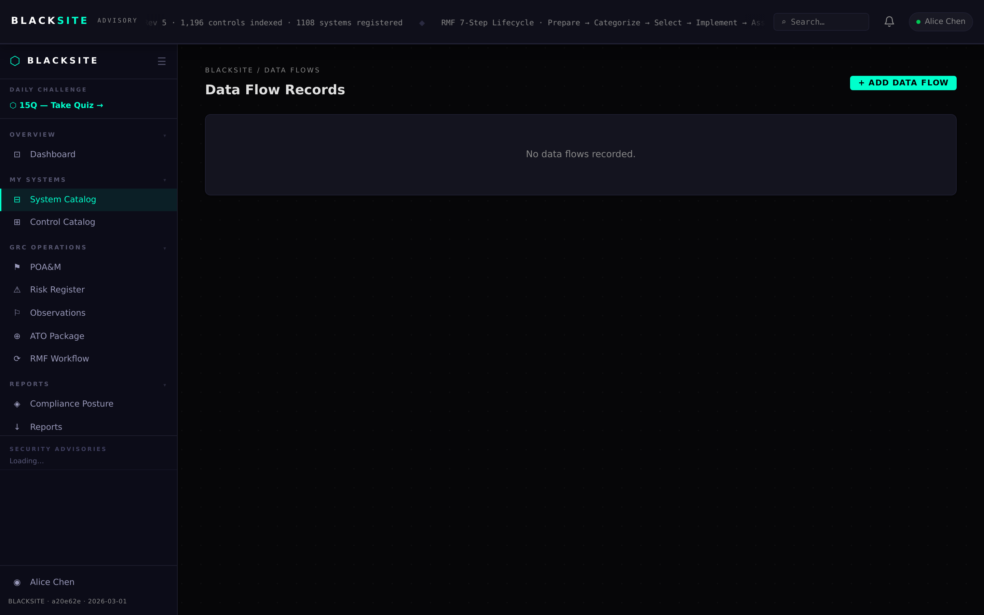
Figure 3: Data flow records

Step 4: Privacy assessments (PTA/PIA)
Navigate to /systems/{id}/privacy-assessments. PTAs (Privacy Threshold Analysis) and PIAs (Privacy Impact Assessment) are listed by assess type. Each record tracks data elements collected, purpose, disclosures, retention policy, and review status (draft/current/needs_review).
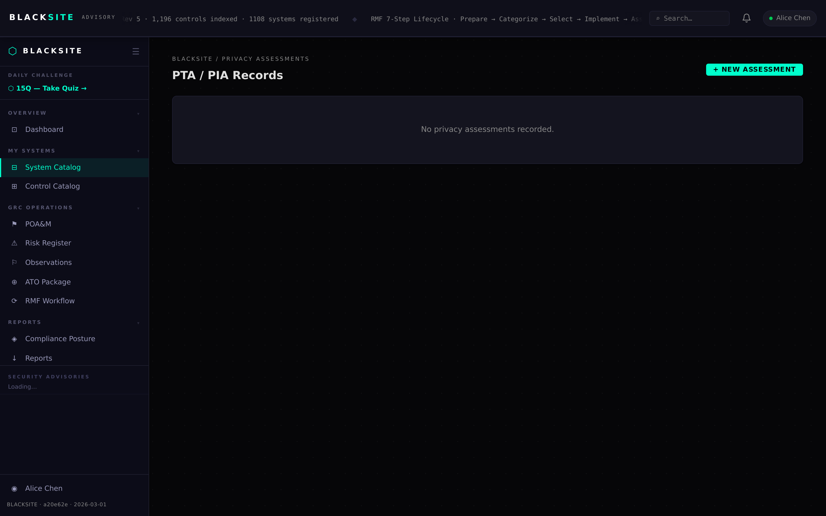
Figure 4: Privacy assessments (PTA/PIA)

Step 5: Restore test records
Navigate to /systems/{id}/restore-tests. Backup restore tests are documented with test date, scope, result (pass/fail/partial), time-to-restore in minutes, validator name, and optional evidence file. HIPAA requires annual testing.
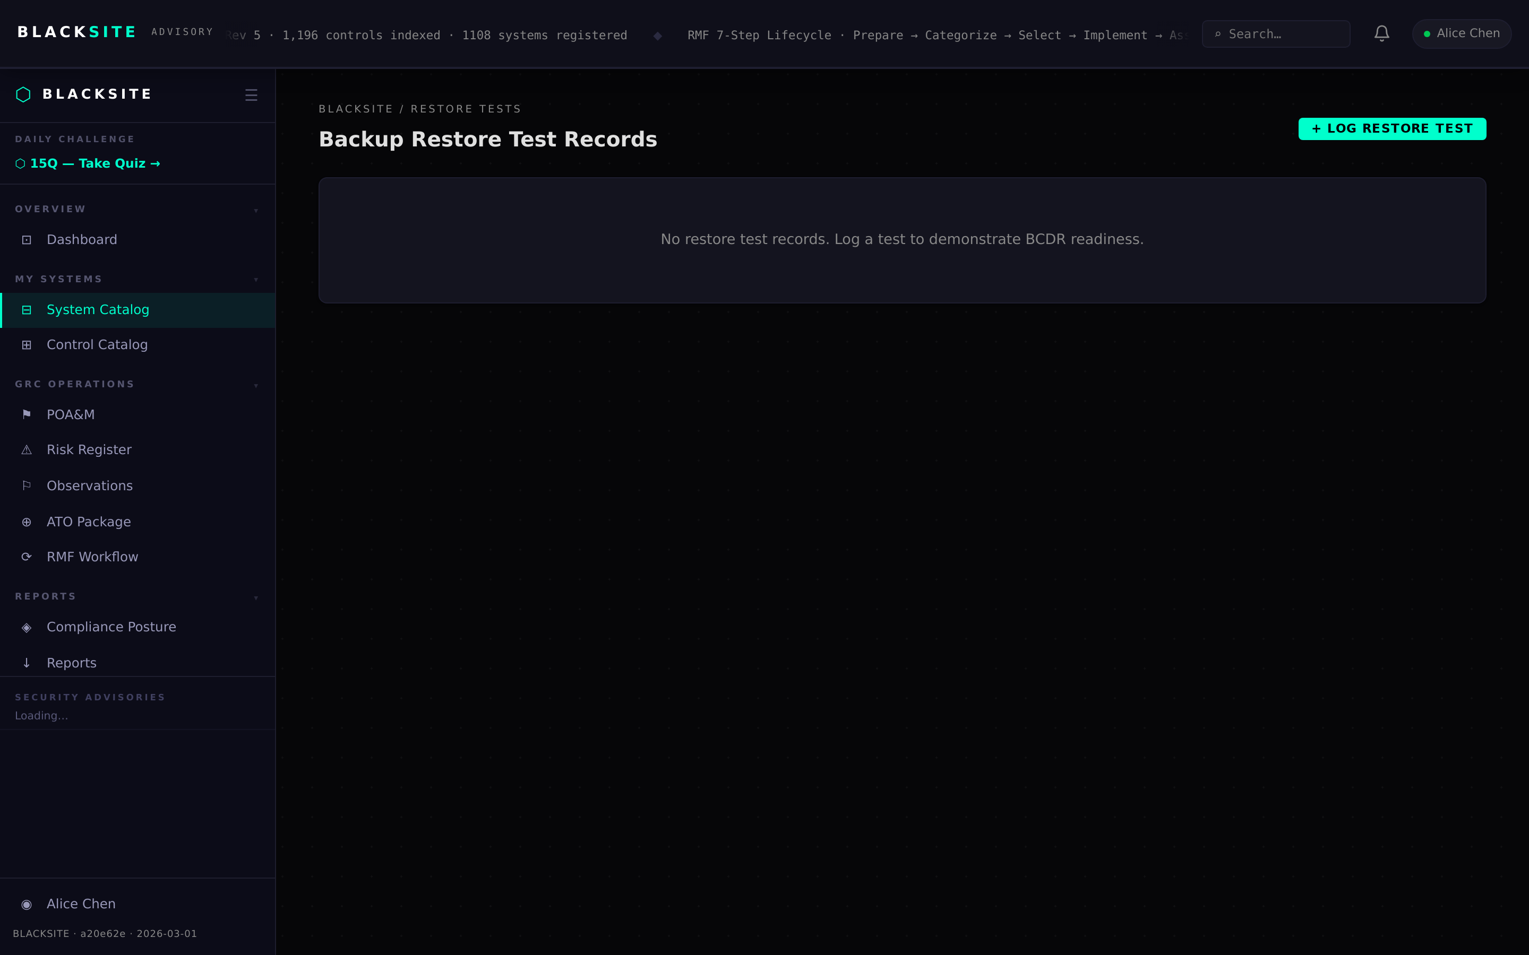
Figure 5: Restore test records

Common Issues and Resolutions
Symptom | Resolution
Vendor BAA expiry not alerting | Alerts appear only for BAAs expiring within 90 days. Check the BAA expiry date field is set correctly.
PIA status stuck on draft | Status must be manually changed to 'current' after completing the assessment. Edit the record and update status.
Restore test result not saving | All required fields (test_date, scope, result) must be filled. Check for validation errors.

