━━━━━━━━━━━━━━━━━━━━━━━━━━━━━━━━━━━━━━━━━━━━━━━━━━━━━━━━━━━━━━━━━━━━━━
BLACKSITE GRC Platform · THKR-BSV-001

NIST Control Catalog and Workspace
Roles: ISSO, SCA, ISSM, Admin
Version: 1.0 | Date: 2026-03-01 | Classification: INTERNAL USE ONLY
━━━━━━━━━━━━━━━━━━━━━━━━━━━━━━━━━━━━━━━━━━━━━━━━━━━━━━━━━━━━━━━━━━━━━━

Overview
BLACKSITE maintains a local copy of the NIST SP 800-53 Rev 5 OSCAL catalog. Controls are browsable, searchable, and can be linked to system records with implementation narratives, status, and responsible roles. The control workspace provides a structured editor for each control.

Prerequisites
- NIST catalog downloaded (automatic on first run, or via /admin/updater).
- System record created and assigned.

Procedure

Step 1: Browse the catalog
Navigate to /controls. The full NIST 800-53 Rev 5 catalog is displayed in a searchable table. Filter by control family (AC, AU, CM, etc.) using the family dropdown. Search by control ID or keyword in the search box.
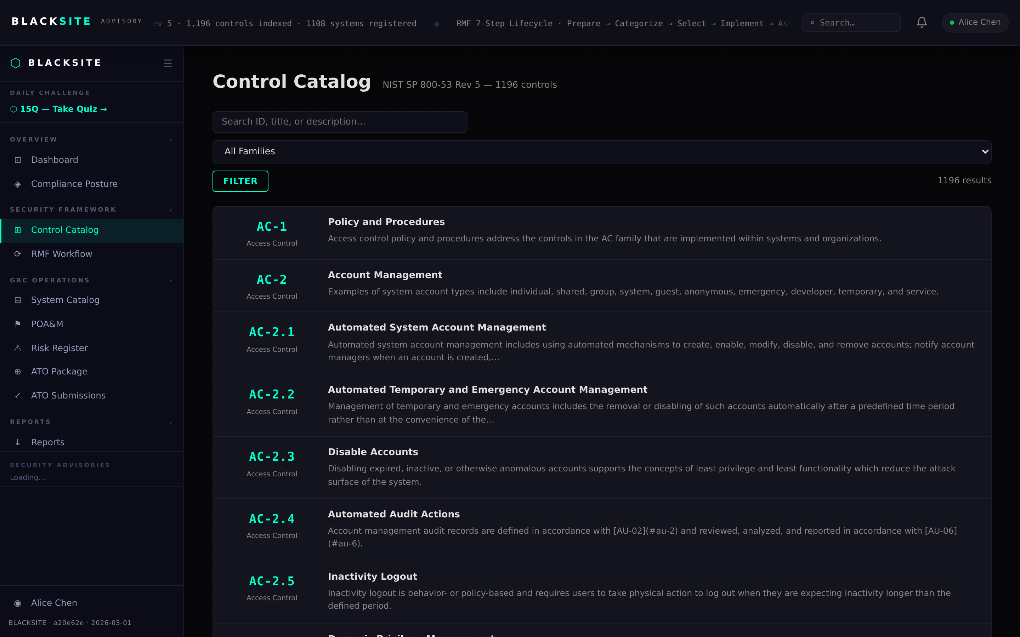
Figure 1: Browse the catalog

Step 2: View control detail — AC-1
Click any control row to open its detail page. The page shows the full control statement with sub-requirements, supplemental guidance, parameters, and related controls. Use this page to understand what the control requires before writing your implementation narrative.

Figure 2: View control detail — AC-1

Step 3: View control detail — AC-2
Complex controls like AC-2 (Account Management) have multiple sub-requirements (a. through j.). Each sub-requirement is listed with its prose. Enhancements (AC-2(1) through AC-2(13)) appear as nested rows.
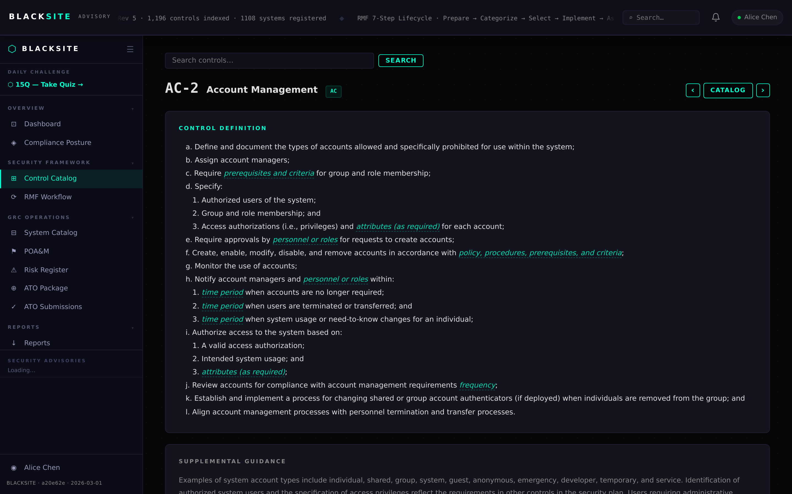
Figure 3: View control detail — AC-2

Step 4: System controls list
Navigate to the Controls tab on a system detail page. This shows the subset of controls scoped to the system with implementation status indicators: Complete (green), Partial (yellow), Insufficient (orange), Not Found (red), NA (gray).
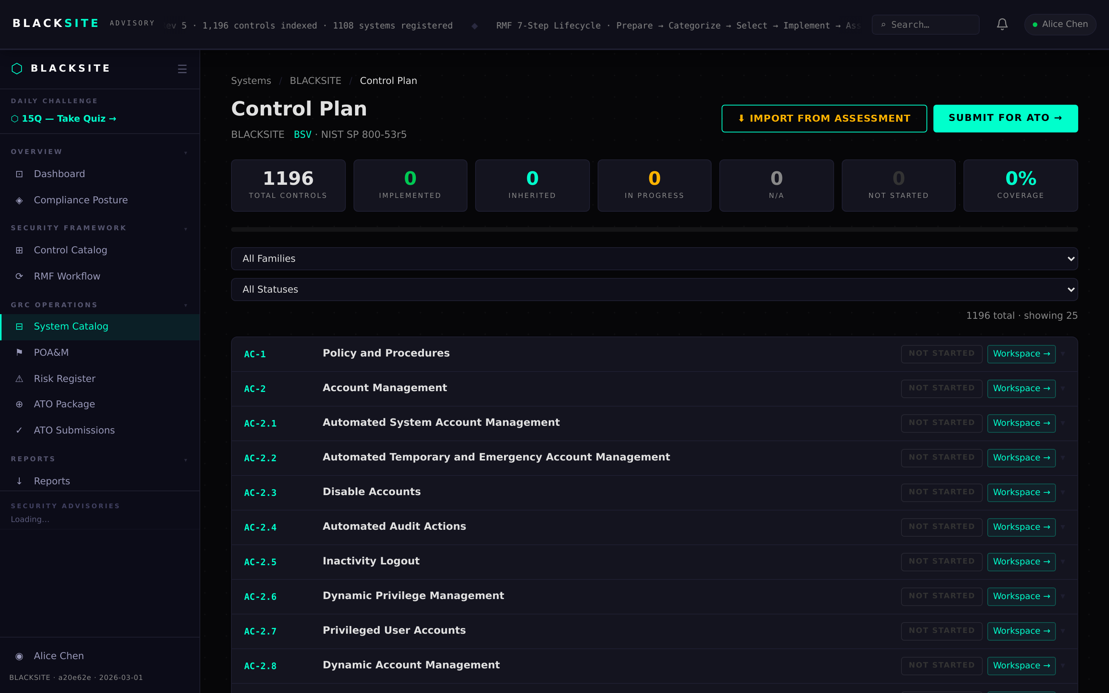
Figure 4: System controls list

Step 5: Open the control workspace
Click a control row in the system controls list to open the workspace editor. The workspace shows the control statement on the left and your implementation fields on the right: Implementation Status, Responsible Role, and Narrative. Fill in all three fields for a complete control.
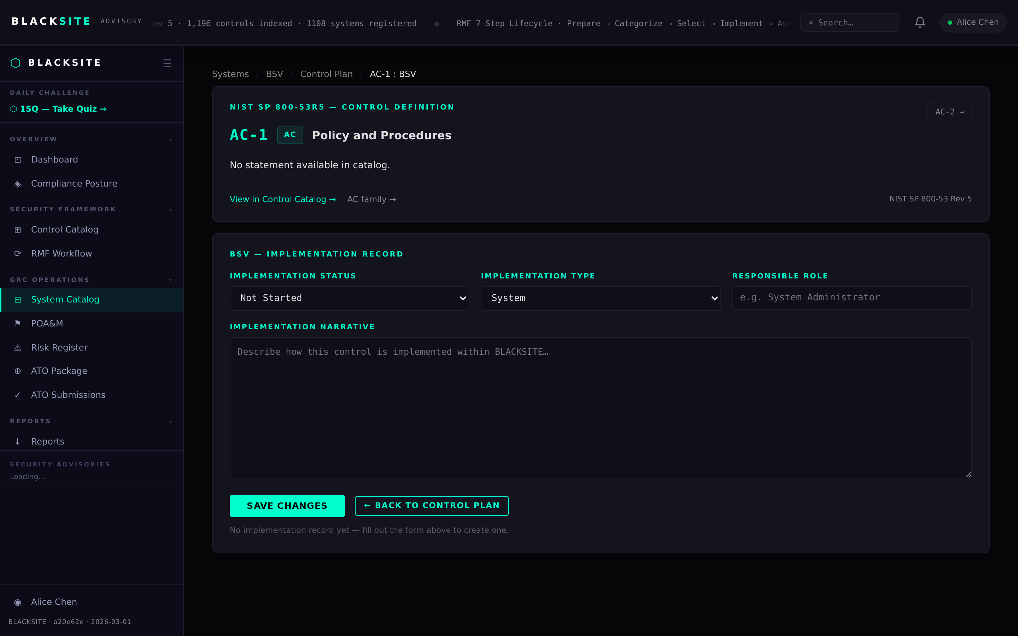
Figure 5: Open the control workspace

Step 6: Import controls from catalog
On the Controls tab, click Import Controls to scope NIST catalog controls to this system. Select the baseline (Low/Moderate/High) or choose individual controls. Click Import to add them.
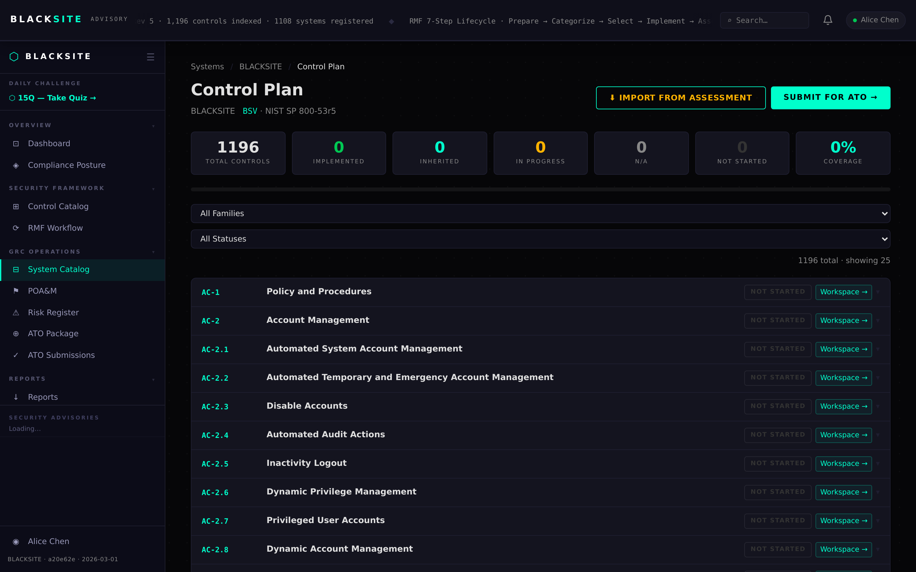
Figure 6: Import controls from catalog

Common Issues and Resolutions
Symptom | Resolution
Catalog empty at /controls | The NIST catalog has not been downloaded. Navigate to /admin and trigger a catalog update.
Workspace save fails | Check that Implementation Status and Responsible Role are filled. Both are required for PARTIAL or above.
Import adds no controls | The selected controls may already be imported. Check the current controls list for existing entries.

