━━━━━━━━━━━━━━━━━━━━━━━━━━━━━━━━━━━━━━━━━━━━━━━━━━━━━━━━━━━━━━━━━━━━━━
BLACKSITE GRC Platform · THKR-BSV-001

Daily Operations Hub
Roles: ISSO, ISSM, SCA, System Owner, PMO, Pen Tester, Auditor, Incident Responder, BCDR Coordinator, Data Owner
Version: 1.0 | Date: 2026-03-01 | Classification: INTERNAL USE ONLY
━━━━━━━━━━━━━━━━━━━━━━━━━━━━━━━━━━━━━━━━━━━━━━━━━━━━━━━━━━━━━━━━━━━━━━

Overview
The Daily Operations Hub provides a structured daily workflow for each assigned role. Each role sees a customized set of 2–8 daily tasks. Completing tasks and saving the logbook creates an audit trail of daily activities. Sub-forms capture structured data for specific tasks (change review, backup check, access spot-check).

Prerequisites
- Assigned to the system.
- System record active.

Procedure

Step 1: Open the Daily Hub (ISSO view)
Navigate to /systems/{id}/daily. The ISSO sees all 8 task cards with checkboxes. The system name and today's date are pre-populated. Metric snapshot (open POA&Ms, risks, observations, incidents) appears in the header strip.
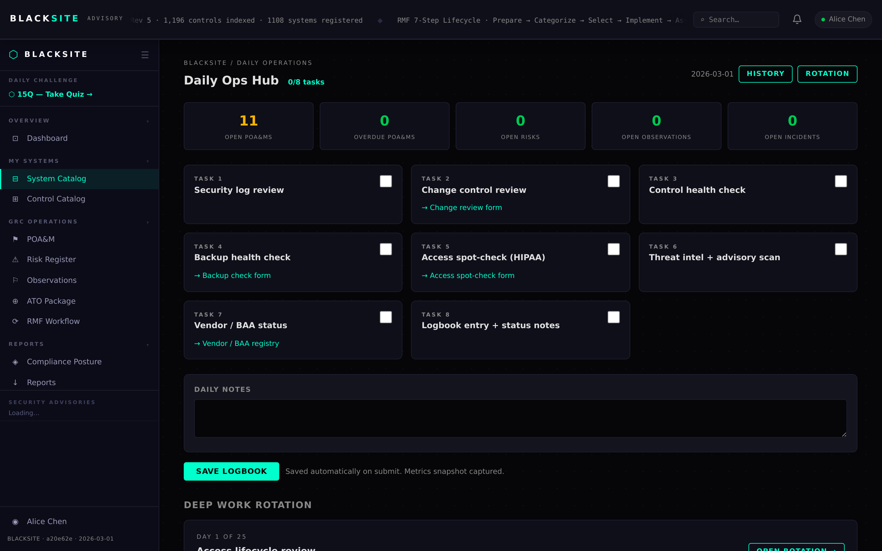
Figure 1: Open the Daily Hub (ISSO view)

Step 2: Complete and save the daily logbook
Check each task as you complete it. Add optional notes in the Notes field. Click Save Daily Log. The logbook row is written to the database with the task flags and metric snapshot. The Daily Ops tab badge updates to show N/8.
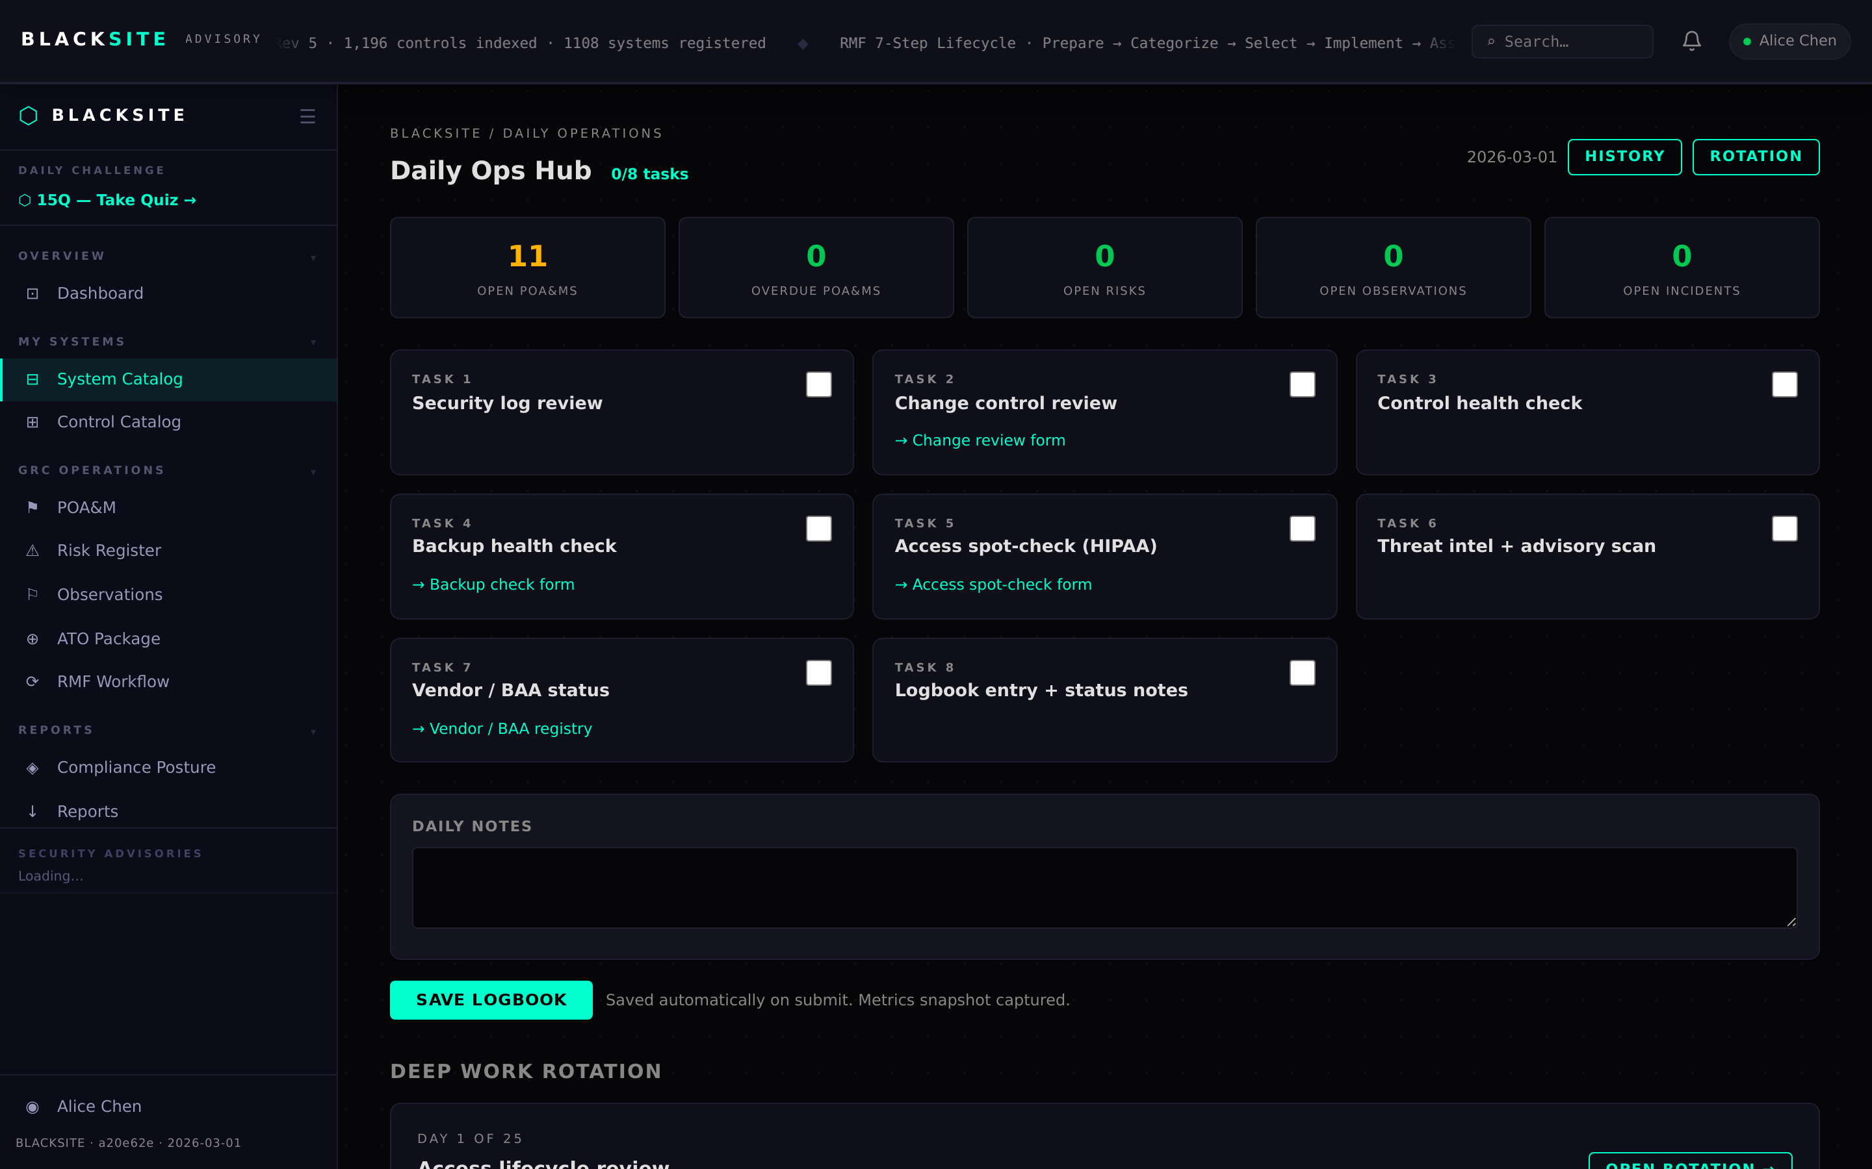
Figure 2: Complete and save the daily logbook

Step 3: View logbook history
Navigate to /systems/{id}/daily/history. A 30-day calendar grid shows each day's completion status (green = all tasks complete, yellow = partial, gray = no log). Click any day to view that day's logbook.
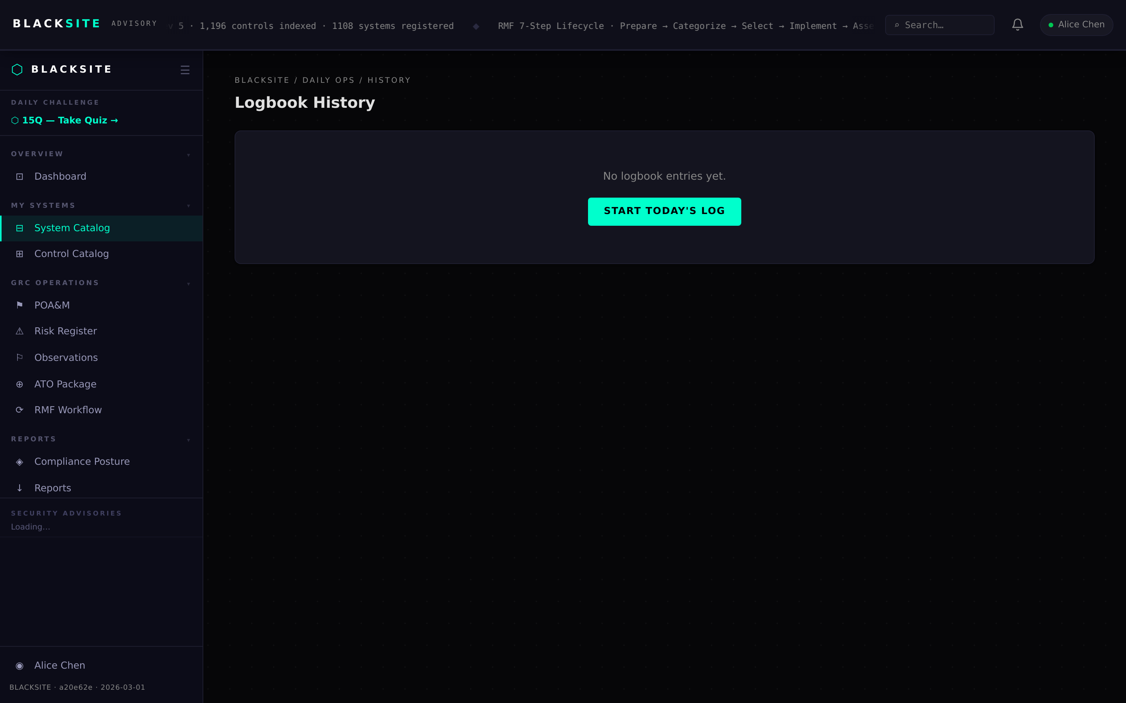
Figure 3: View logbook history

Step 4: Change review sub-form (Task 2)
Navigate to /systems/{id}/daily/change-review. Fill in: ticket references, high-risk change count, all-approved flag, backout plan exists flag, and any untracked changes found. Click Submit. A ChangeReviewRecord is created.
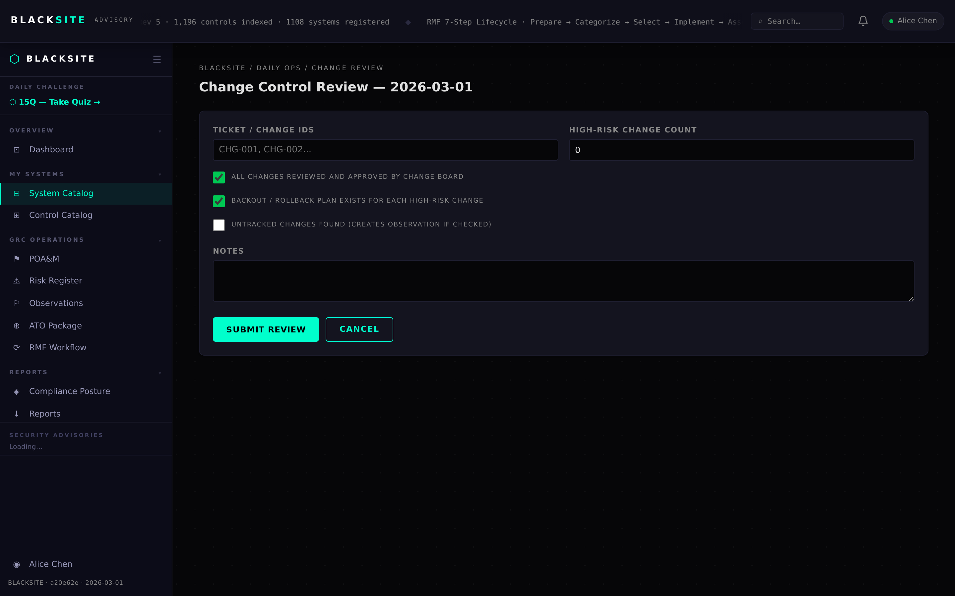
Figure 4: Change review sub-form (Task 2)

Step 5: Backup check sub-form (Task 4)
Navigate to /systems/{id}/daily/backup-check. Fill in: result (pass/fail/partial), affected ePHI systems, job health status, and whether an issue was raised. Click Submit. A BackupCheckRecord is created.
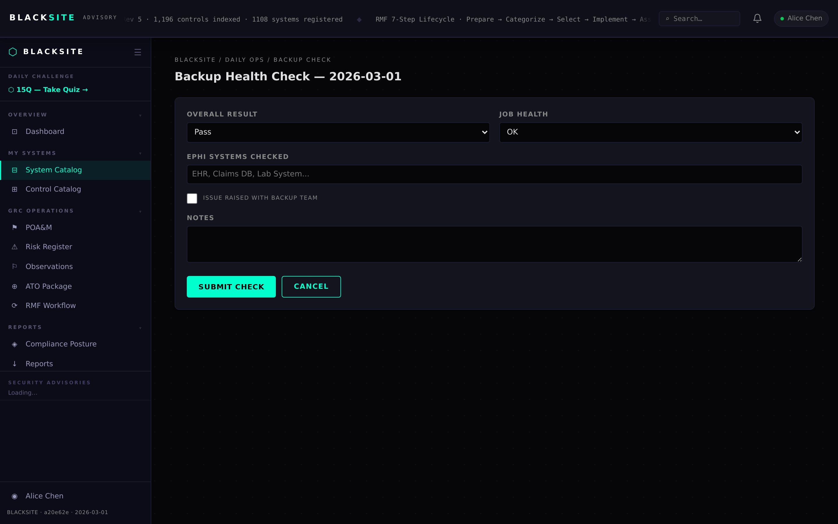
Figure 5: Backup check sub-form (Task 4)

Step 6: Access spot-check sub-form (Task 5 — HIPAA)
Navigate to /systems/{id}/daily/access-spotcheck. Fill in: records sampled count, anomaly found flag, terminated user found flag, and anomaly description if applicable. Click Submit. An AccessSpotCheck record is created.
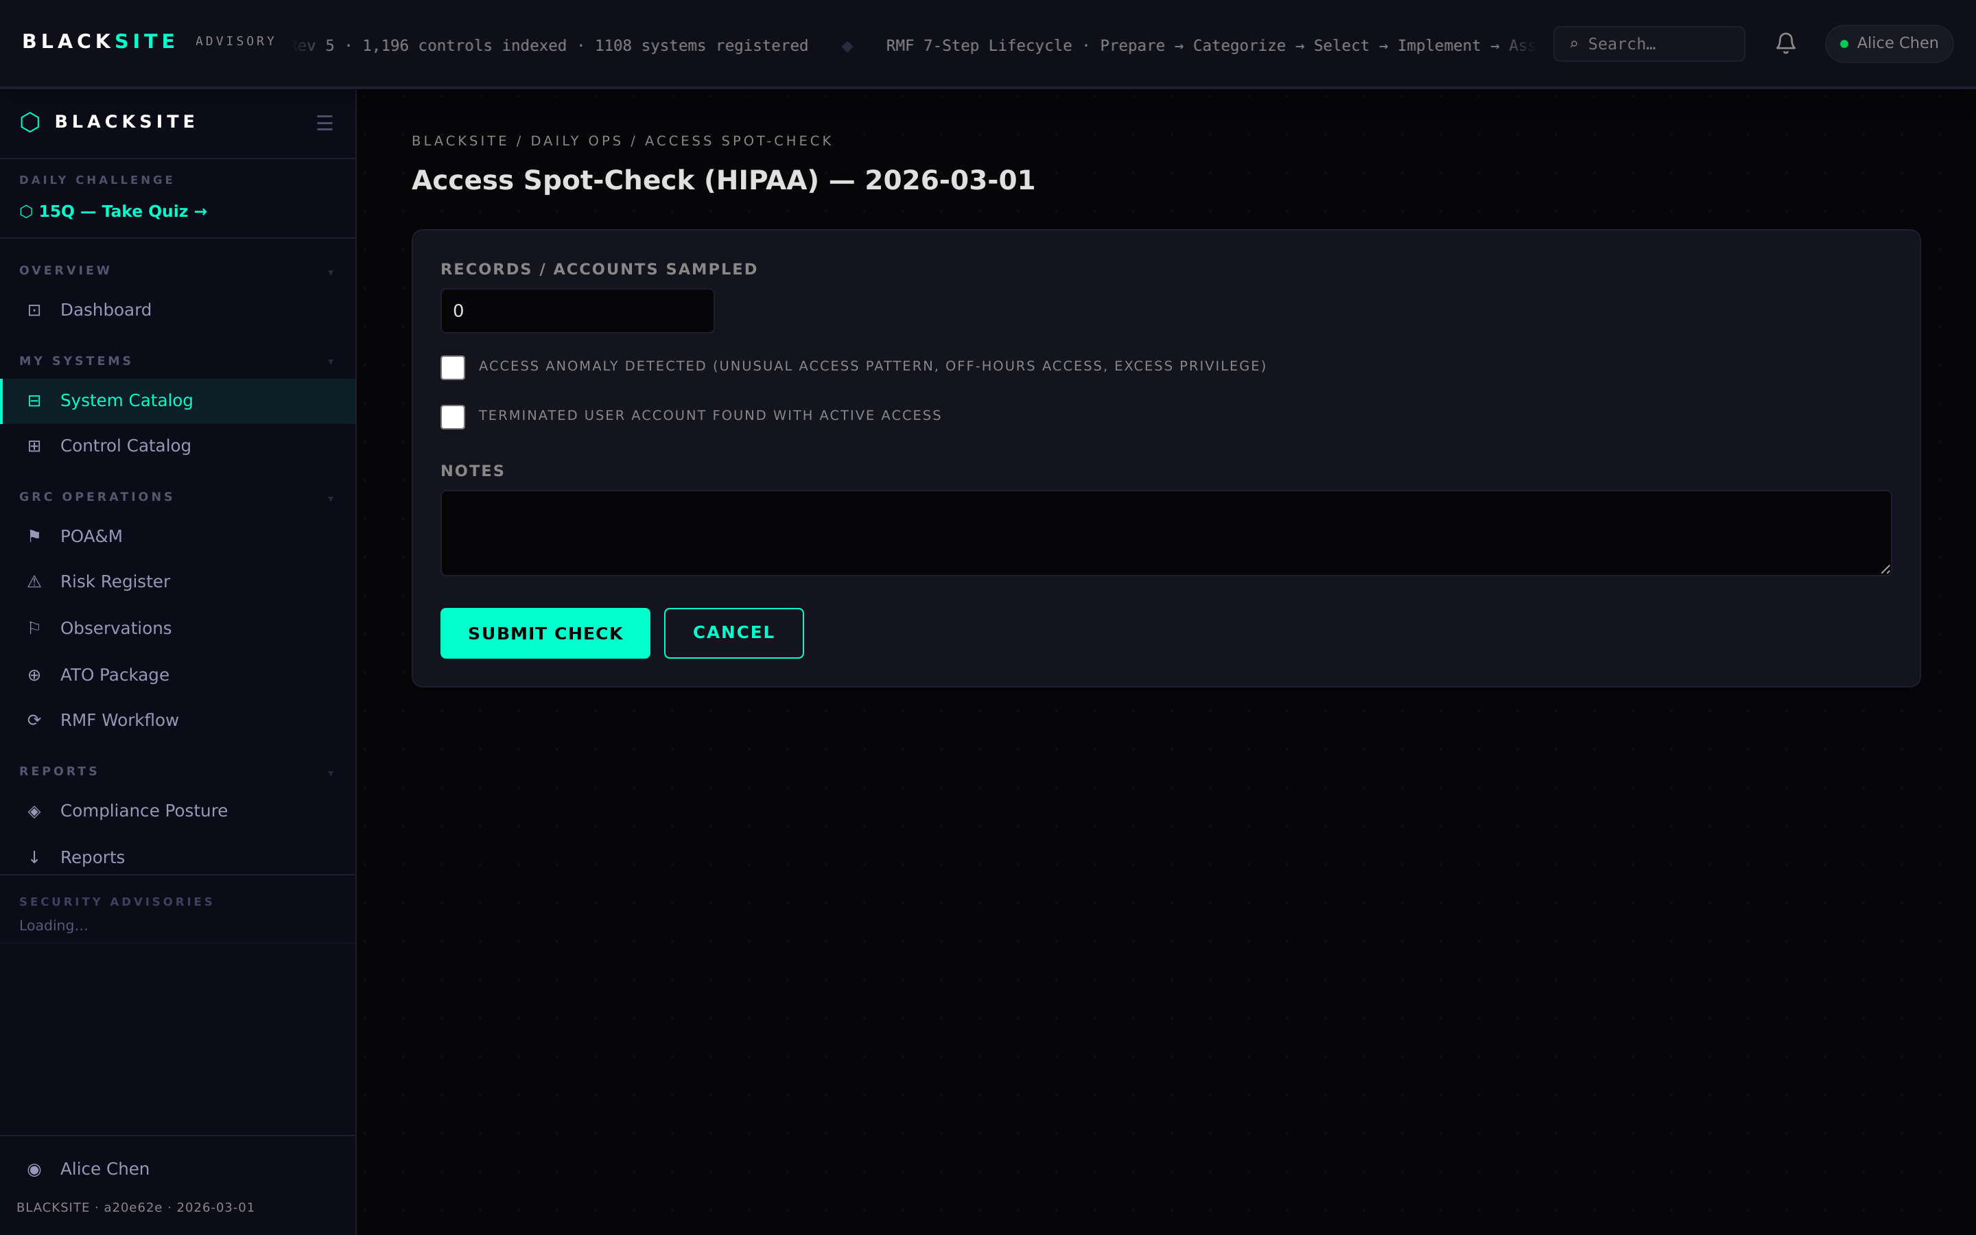
Figure 6: Access spot-check sub-form (Task 5 — HIPAA)

Step 7: Daily Hub (ISSM view)
ISSMs see tasks 1, 2, 6, and 8. The layout is identical to the ISSO view but scoped to ISSM responsibilities. Task labels are customized per role.
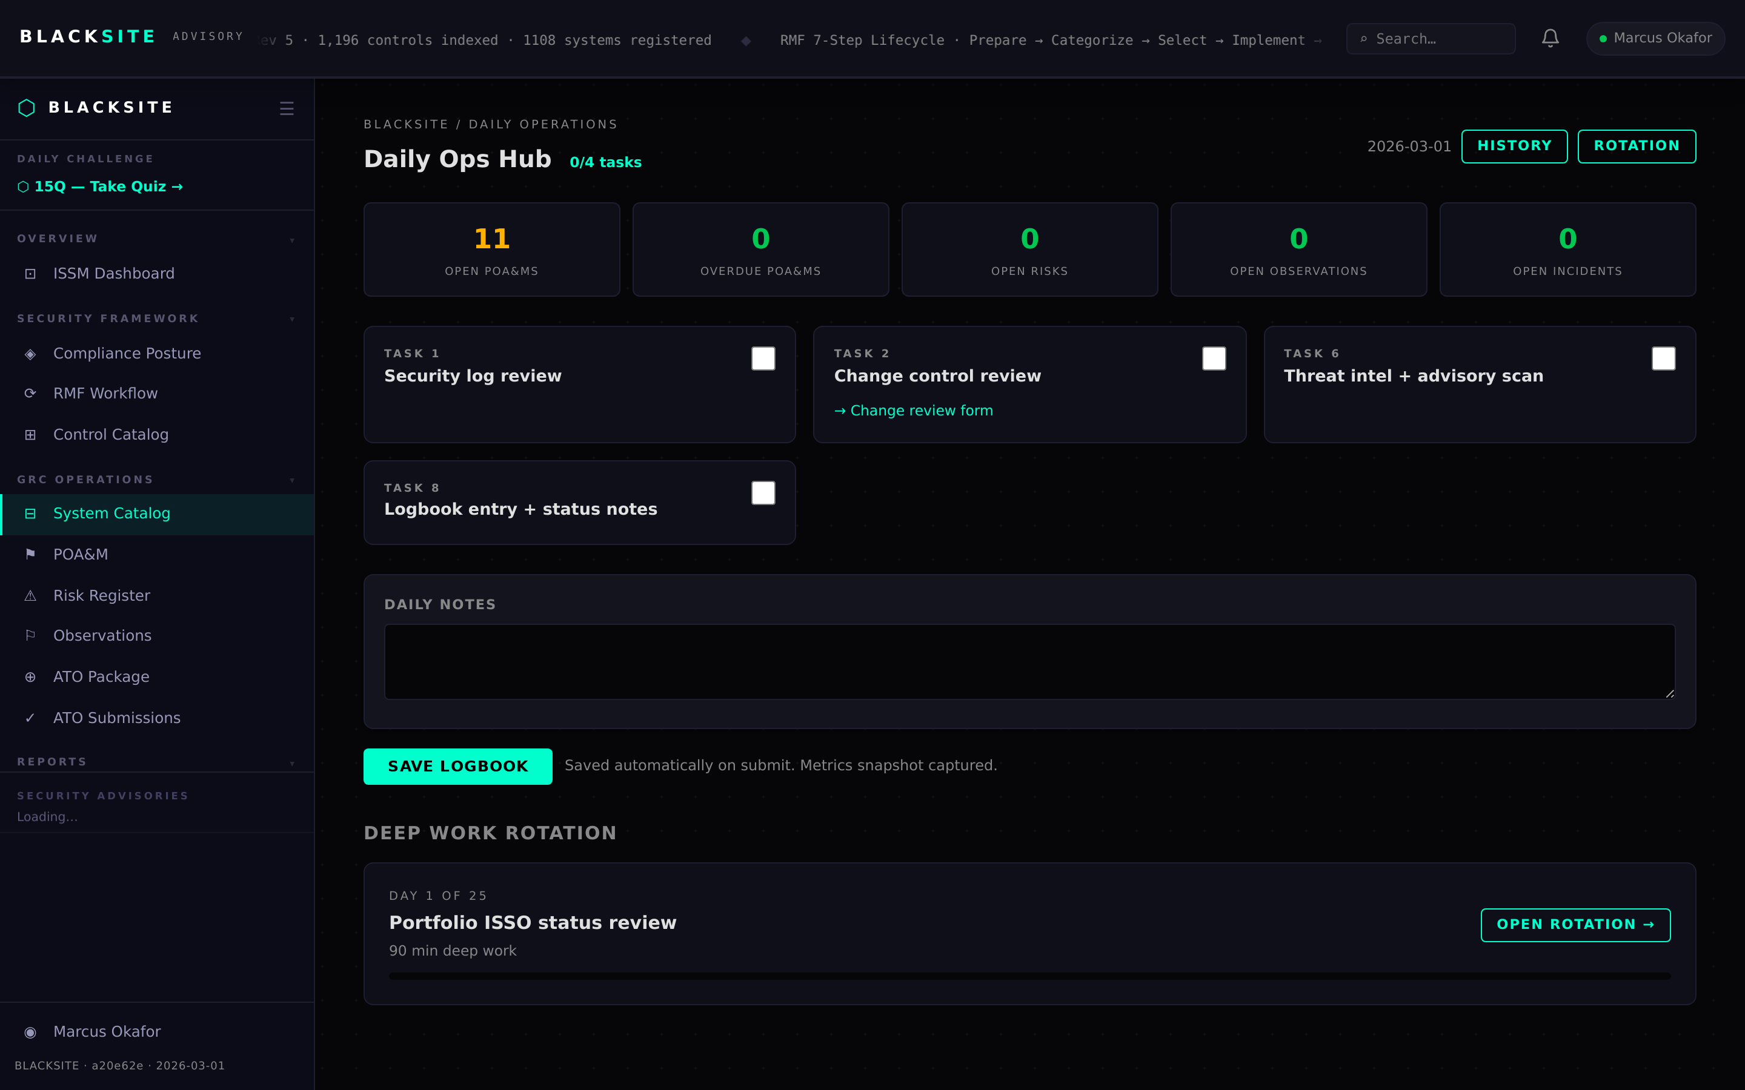
Figure 7: Daily Hub (ISSM view)

Step 8: Daily Hub (SCA view)
SCAs see tasks 3, 6, and 8. The SCA-specific task labels appear in place of ISSO task labels. All other functionality is identical.
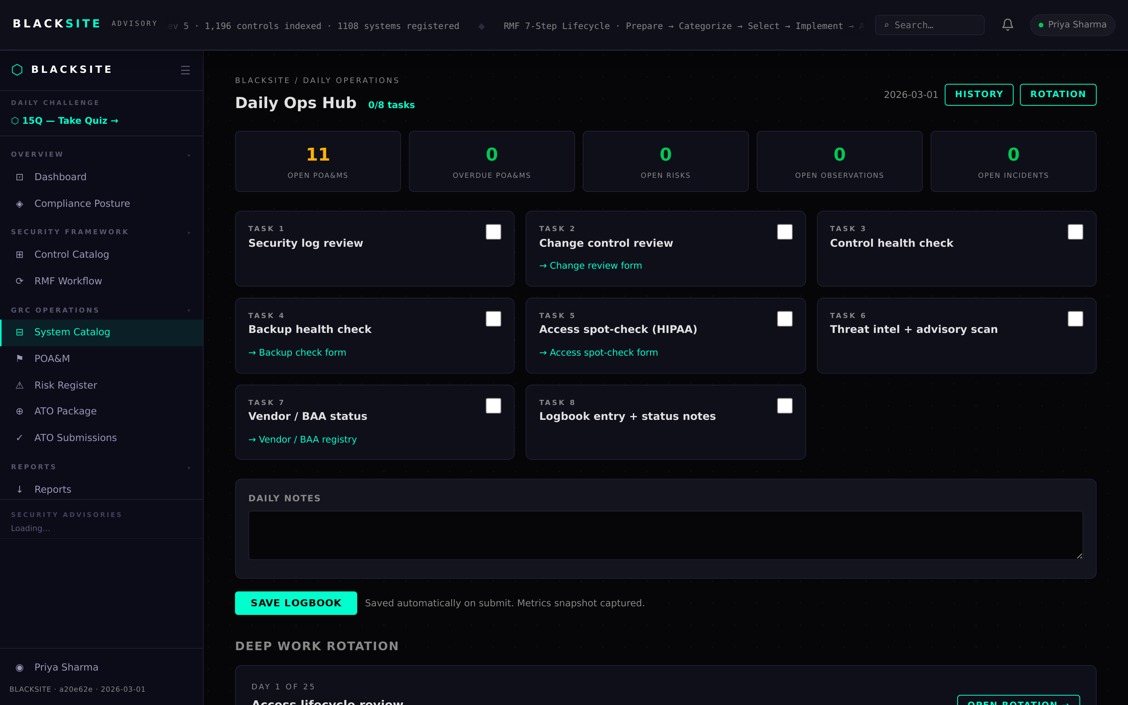
Figure 8: Daily Hub (SCA view)

Common Issues and Resolutions
Symptom | Resolution
Daily Hub shows 403 | You must be assigned to the system. Contact the ISSO to add your role assignment.
Task checkboxes missing | Your role may not have any tasks configured. Contact the admin to verify ROLE_TASK_CONFIGS.
Save fails | Ensure the system_id in the URL is valid. A 422 error indicates a form validation issue.

