━━━━━━━━━━━━━━━━━━━━━━━━━━━━━━━━━━━━━━━━━━━━━━━━━━━━━━━━━━━━━━━━━━━━━━
BLACKSITE GRC Platform · THKR-BSV-001

Role Dashboards and Navigation
Roles: All roles
Version: 1.0 | Date: 2026-03-01 | Classification: INTERNAL USE ONLY
━━━━━━━━━━━━━━━━━━━━━━━━━━━━━━━━━━━━━━━━━━━━━━━━━━━━━━━━━━━━━━━━━━━━━━

Overview
BLACKSITE serves a role-appropriate dashboard to each user upon login. Platform roles (admin, principal, executive, manager, analyst) and system roles (ISSO, ISSM, SCA, AO, CISO, etc.) each receive a tailored landing page with relevant metrics, pending actions, and quick links. This SOP covers the main dashboard variants and the global navigation sidebar.

Prerequisites
- Authenticated session established (see SOP: Session Authentication).
- Account exists in BLACKSITE with a role assigned.

Procedure

Step 1: Admin dashboard
Admin users see a global summary: all systems, active users, recent audit events, and pending submissions. Key metric cards appear across the top. The left sidebar shows admin-only links (Users, Audit, Ingest, System Settings).
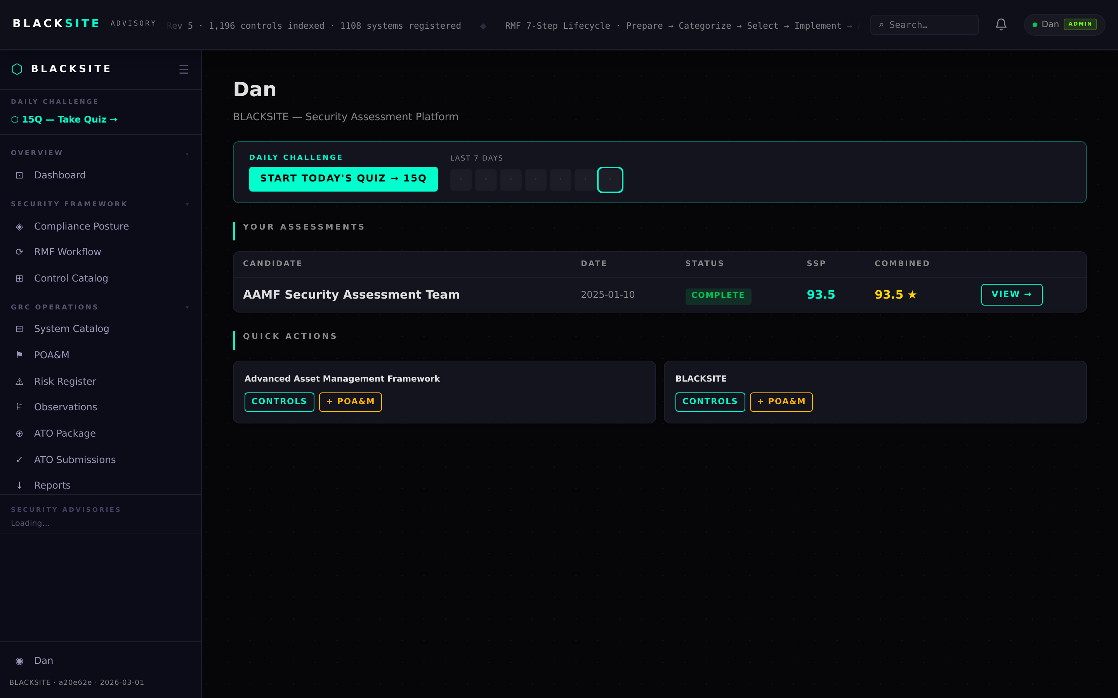
Figure 1: Admin dashboard

Step 2: ISSO dashboard
ISSO users see their assigned systems with control coverage bars, open POA&M counts, overdue items, and a daily tasks widget. The daily quiz prompt appears if today's quiz is not yet completed.
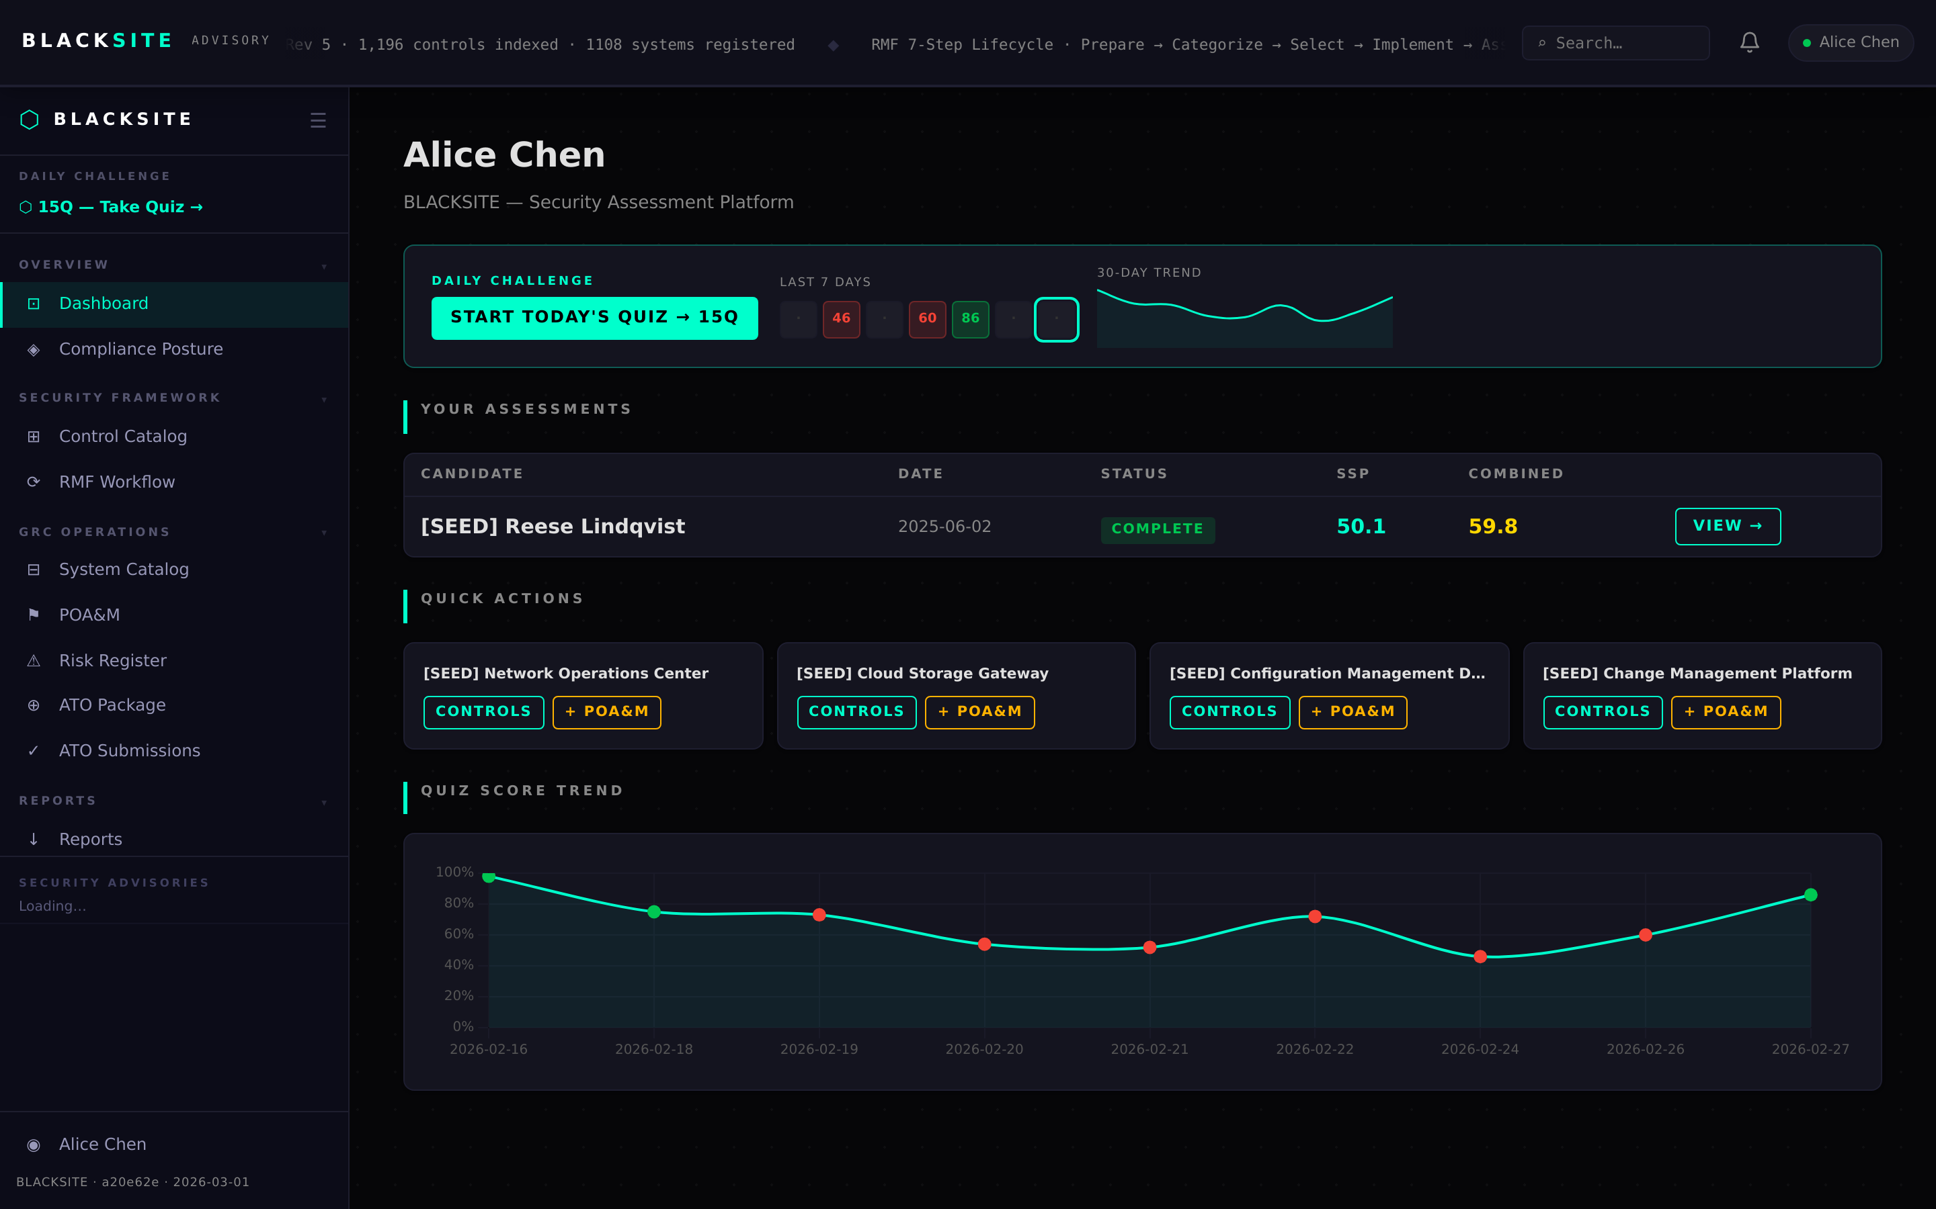
Figure 2: ISSO dashboard

Step 3: ISSM dashboard
ISSMs see a portfolio view of all systems under their oversight. Each system row shows its ISSO, open POA&M count, overdue count, ATO expiry, and rotation day. Click a system row to open its detail.
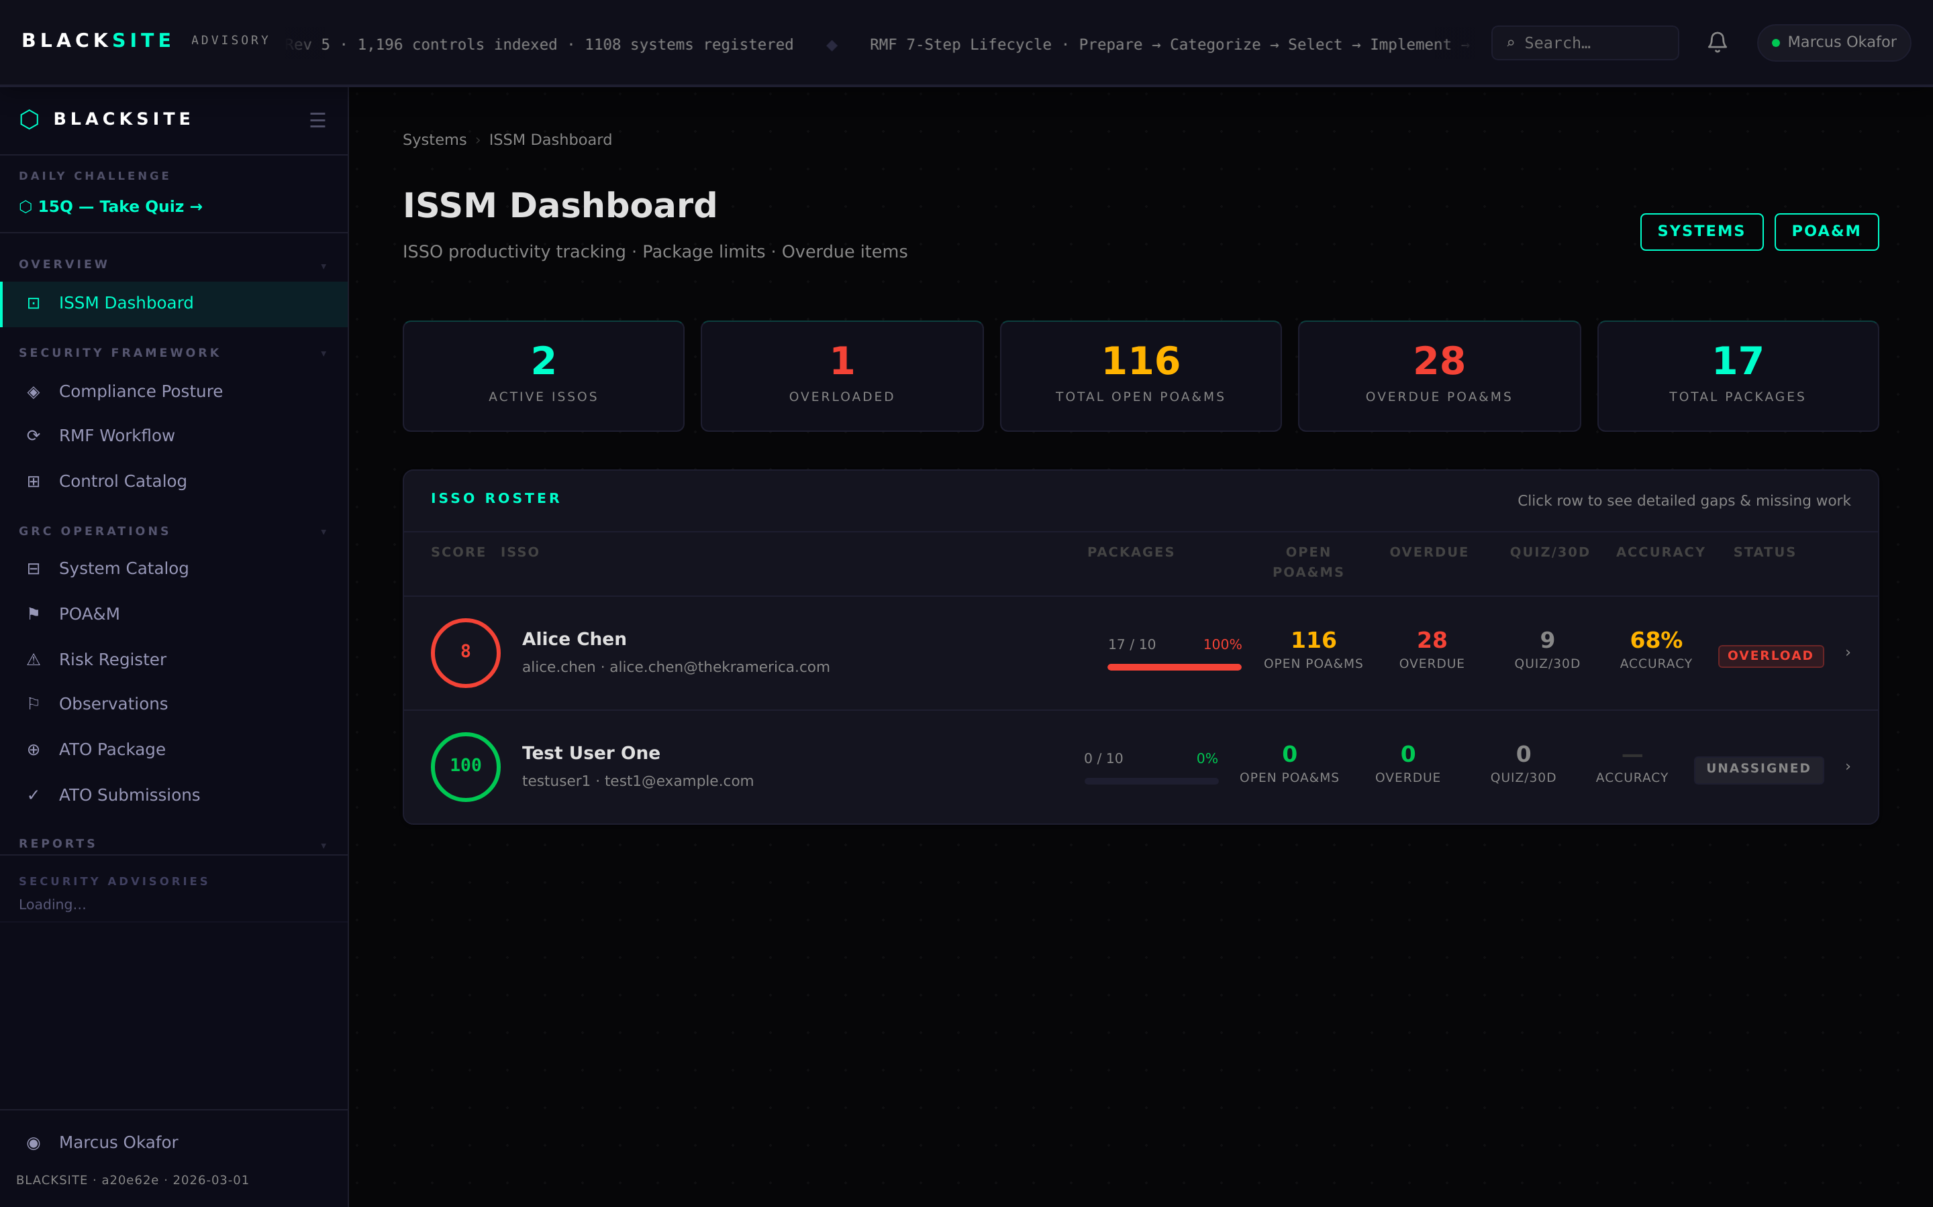
Figure 3: ISSM dashboard

Step 4: SCA / CISO dashboard
SCA users see their workspace queue — assessments pending review and completed assessment reports. CISO users see an executive posture summary with aggregate risk metrics across the portfolio.
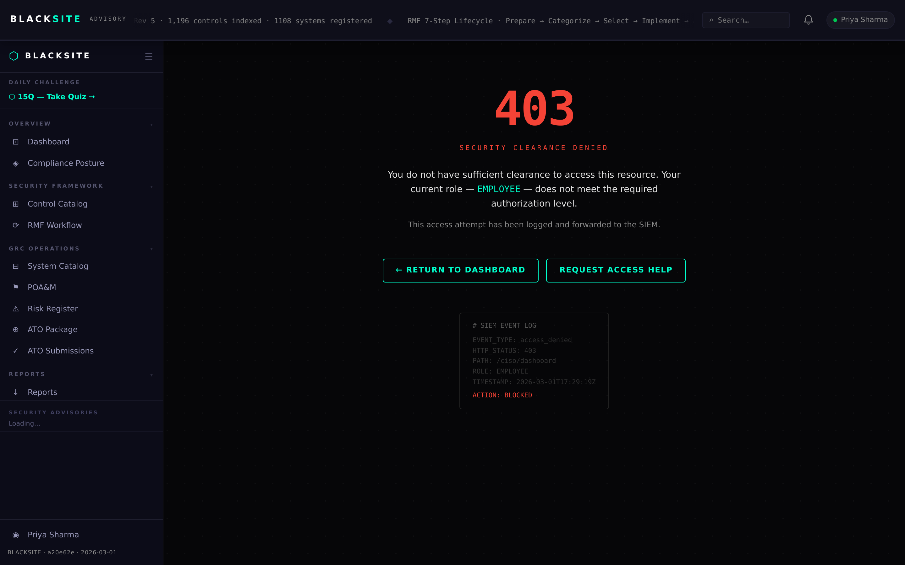
Figure 4: SCA / CISO dashboard

Step 5: AO decisions queue
Authorizing Officials see their pending authorization decisions, risk acceptances awaiting signature, and recent ATO decisions. Each row links to the system's ATO document matrix.
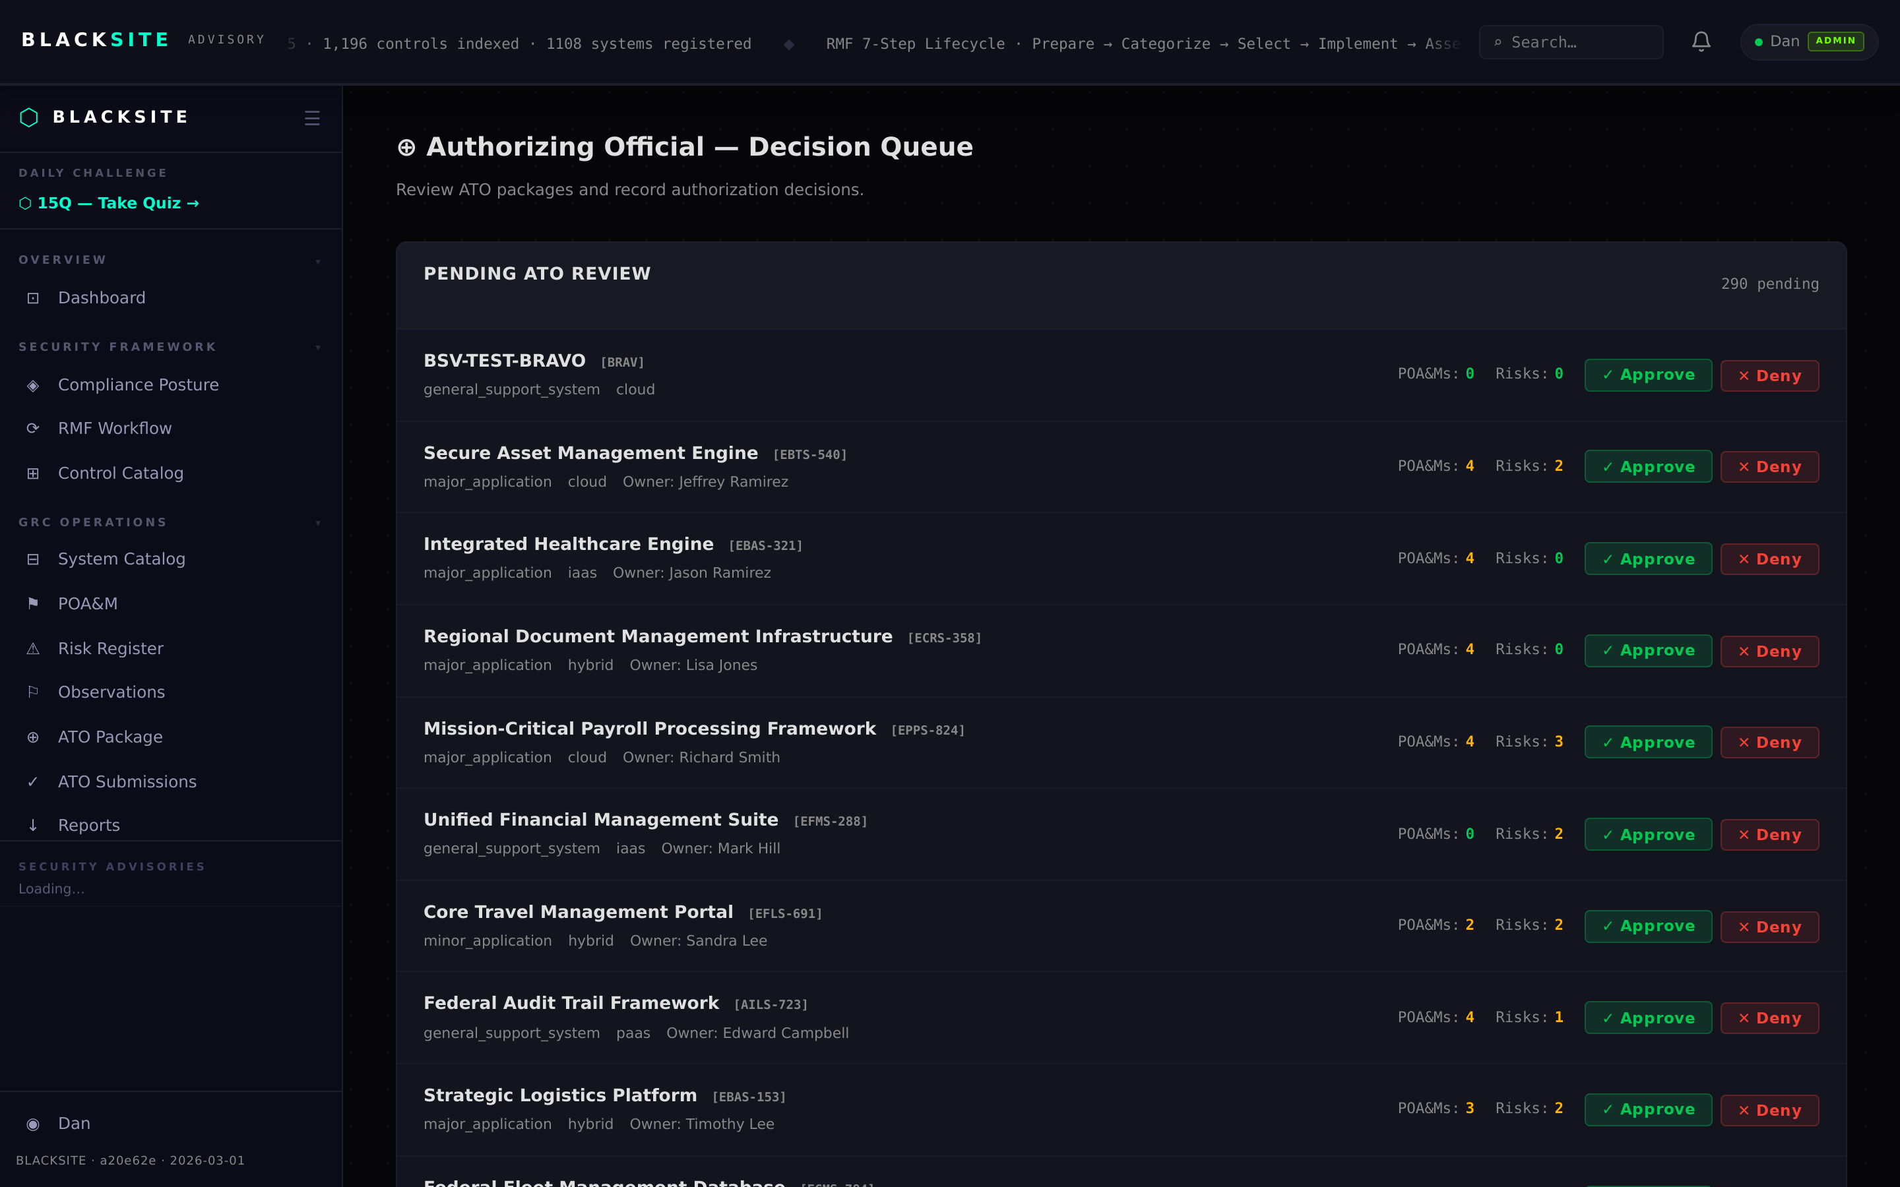
Figure 5: AO decisions queue

Step 6: SCA workspace
Security Control Assessors access their personal workspace with queued assessments. Pending packages appear with upload date, system name, and status badge.
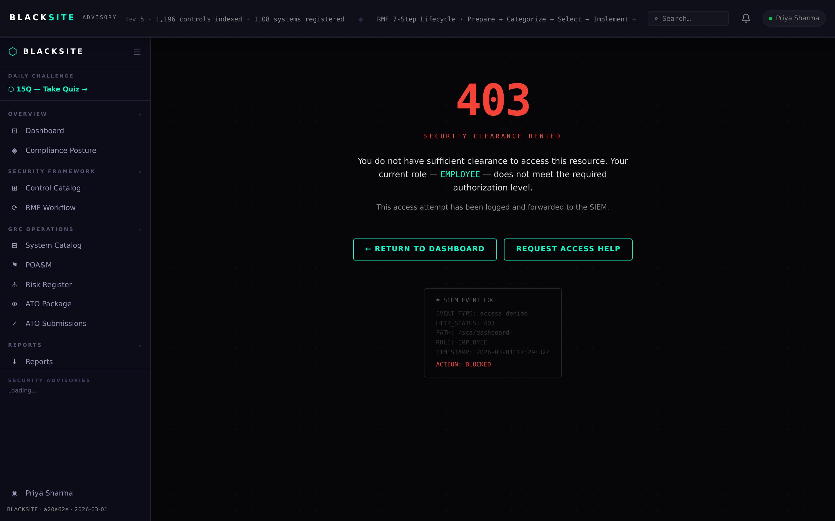
Figure 6: SCA workspace

Step 7: ISSM daily portfolio
ISSMs can view all assigned systems' daily logbook status at /issm/daily. Systems with incomplete daily tasks are highlighted. Rotation day progress for each ISSO is shown in a compact grid.
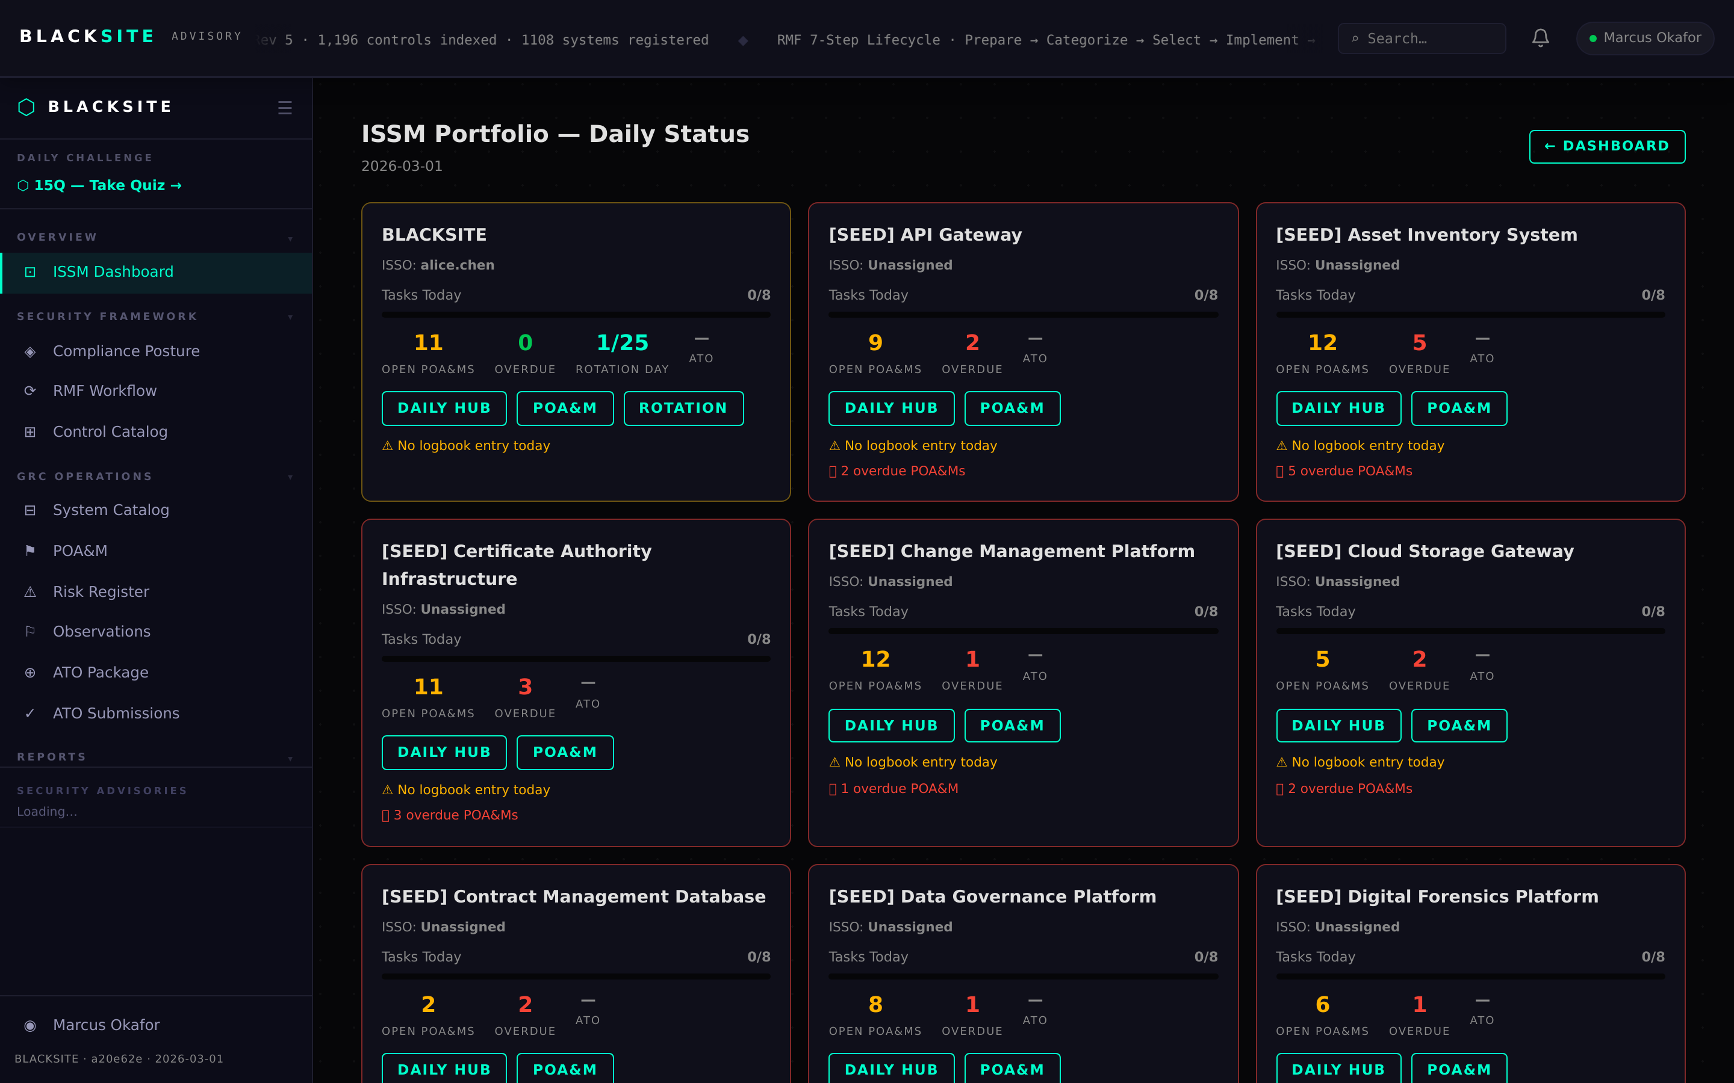
Figure 7: ISSM daily portfolio

Step 8: System Owner dashboard
System Owners see their systems with authorization status, upcoming ATO expiry dates, open risks, and a quick link to submit for authorization review.
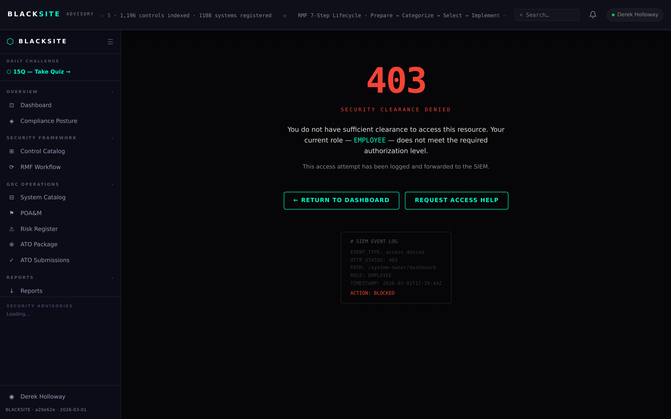
Figure 8: System Owner dashboard

Step 9: Security Posture dashboard
Navigate to /posture for the aggregate posture view: control coverage by family, risk heat map, POA&M aging chart, and assessment score trends. Available to admin, CISO, and AO roles.
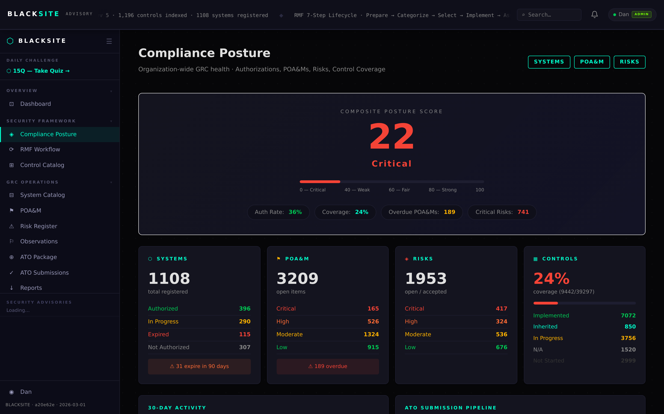
Figure 9: Security Posture dashboard

Step 10: Notifications inbox
The bell icon in the top navigation shows unread notification count. Click it or navigate to /notifications to see all notifications: ATO document status changes, POA&M milestone alerts, and system assignment notices.
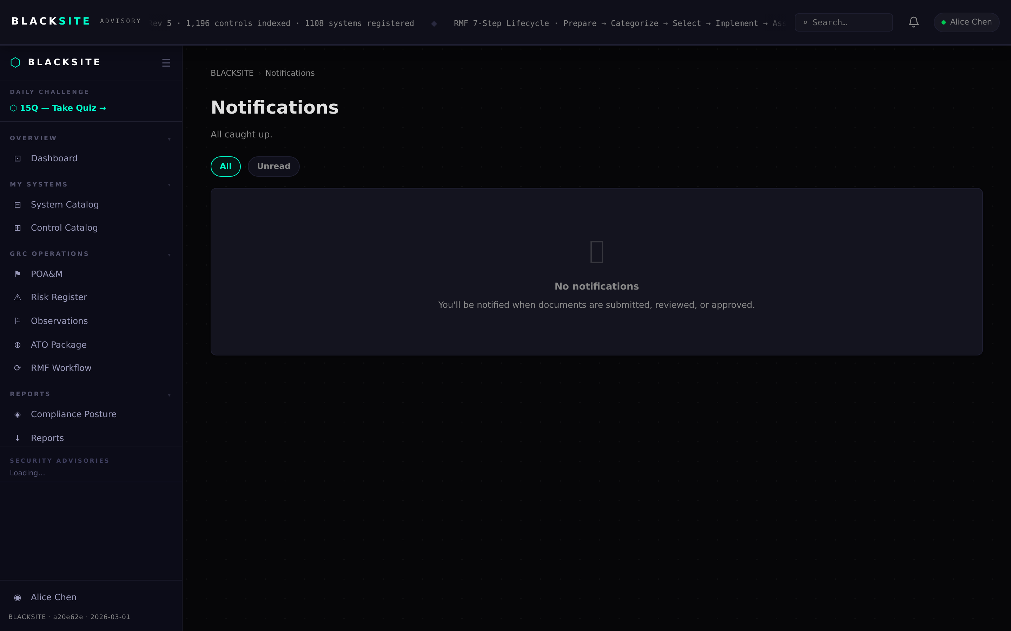
Figure 10: Notifications inbox

Common Issues and Resolutions
Symptom | Resolution
Redirected to wrong dashboard | Your role assignment may be incorrect. Contact an admin to check your role at /admin/users.
Missing sidebar links | Some links are role-gated. If a link you expect is absent, verify your platform role and system assignments.
Notification count stuck | Clear browser cache and reload. If persistent, contact the administrator.

