━━━━━━━━━━━━━━━━━━━━━━━━━━━━━━━━━━━━━━━━━━━━━━━━━━━━━━━━━━━━━━━━━━━━━━
BLACKSITE GRC Platform · THKR-BSV-001

Deep Work Rotation
Roles: ISSO, ISSM, SCA, System Owner, PMO, Pen Tester, Auditor, Incident Responder, BCDR Coordinator, Data Owner
Version: 1.0 | Date: 2026-03-01 | Classification: INTERNAL USE ONLY
━━━━━━━━━━━━━━━━━━━━━━━━━━━━━━━━━━━━━━━━━━━━━━━━━━━━━━━━━━━━━━━━━━━━━━

Overview
The Deep Work Rotation is a structured 25-day cycle of 90-minute focused work sessions. Each day has a specific compliance topic with instructions and required evidence. Days 18, 24, and 25 auto-generate PDF reports on completion. Quarterly overrides replace specific rotation slots with time-bound activities.

Prerequisites
- Assigned to the system.
- Daily Hub active (rotation initializes on first visit).

Procedure

Step 1: View current rotation day
Navigate to /systems/{id}/rotation. The current day's content appears with: day number (1–25), topic title, estimated duration, detailed instructions, and the evidence label describing what to submit. Click Start Session if using the 90-minute timer.
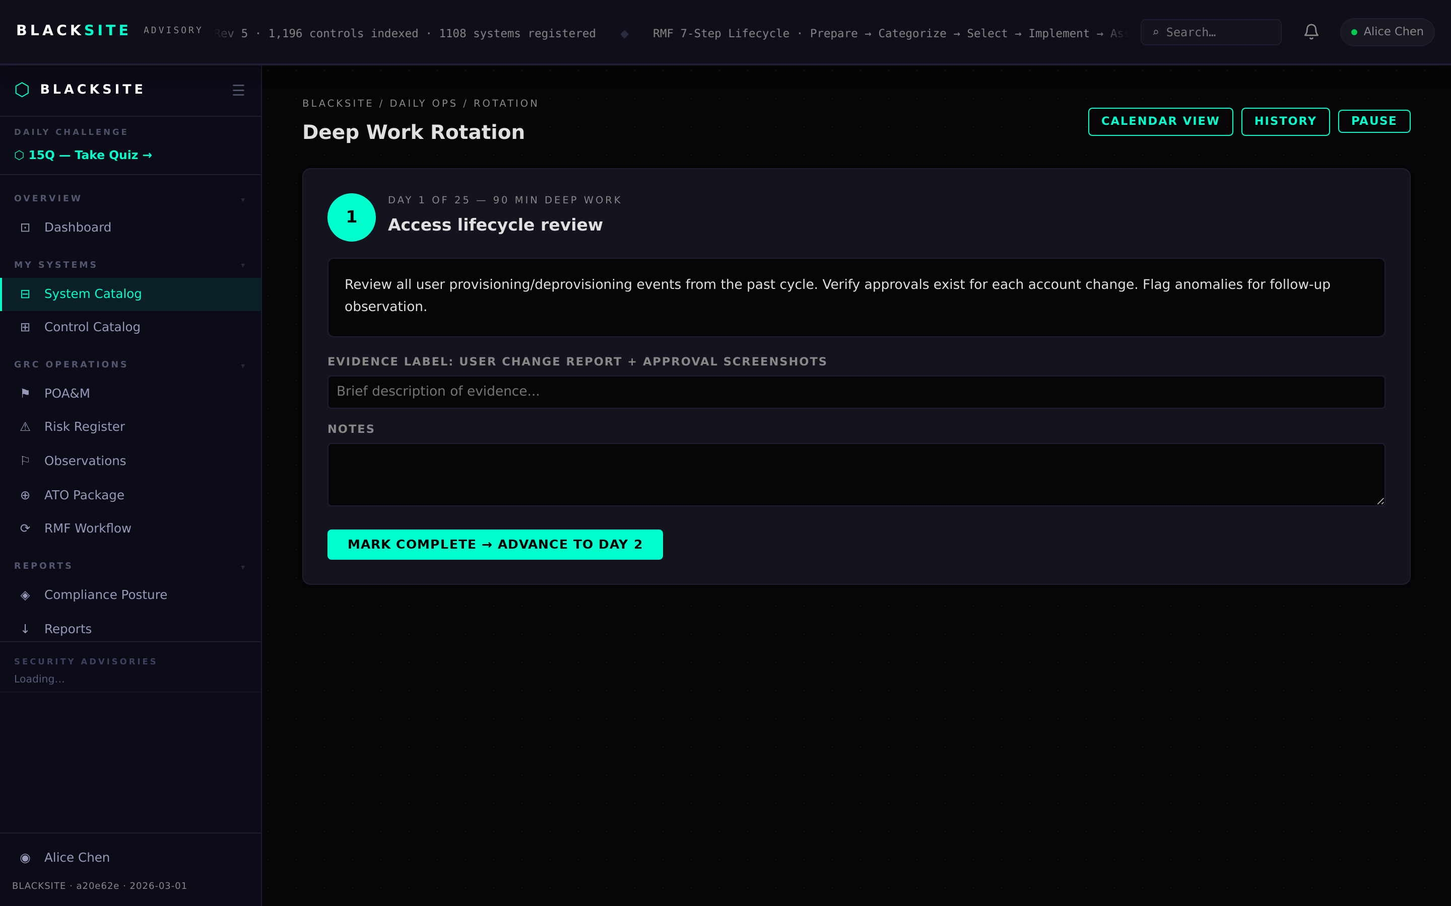
Figure 1: View current rotation day

Step 2: View rotation history
Navigate to /systems/{id}/rotation/history. Past completion records are listed with day number, completion date, notes, and evidence filename. Click a row to view details.
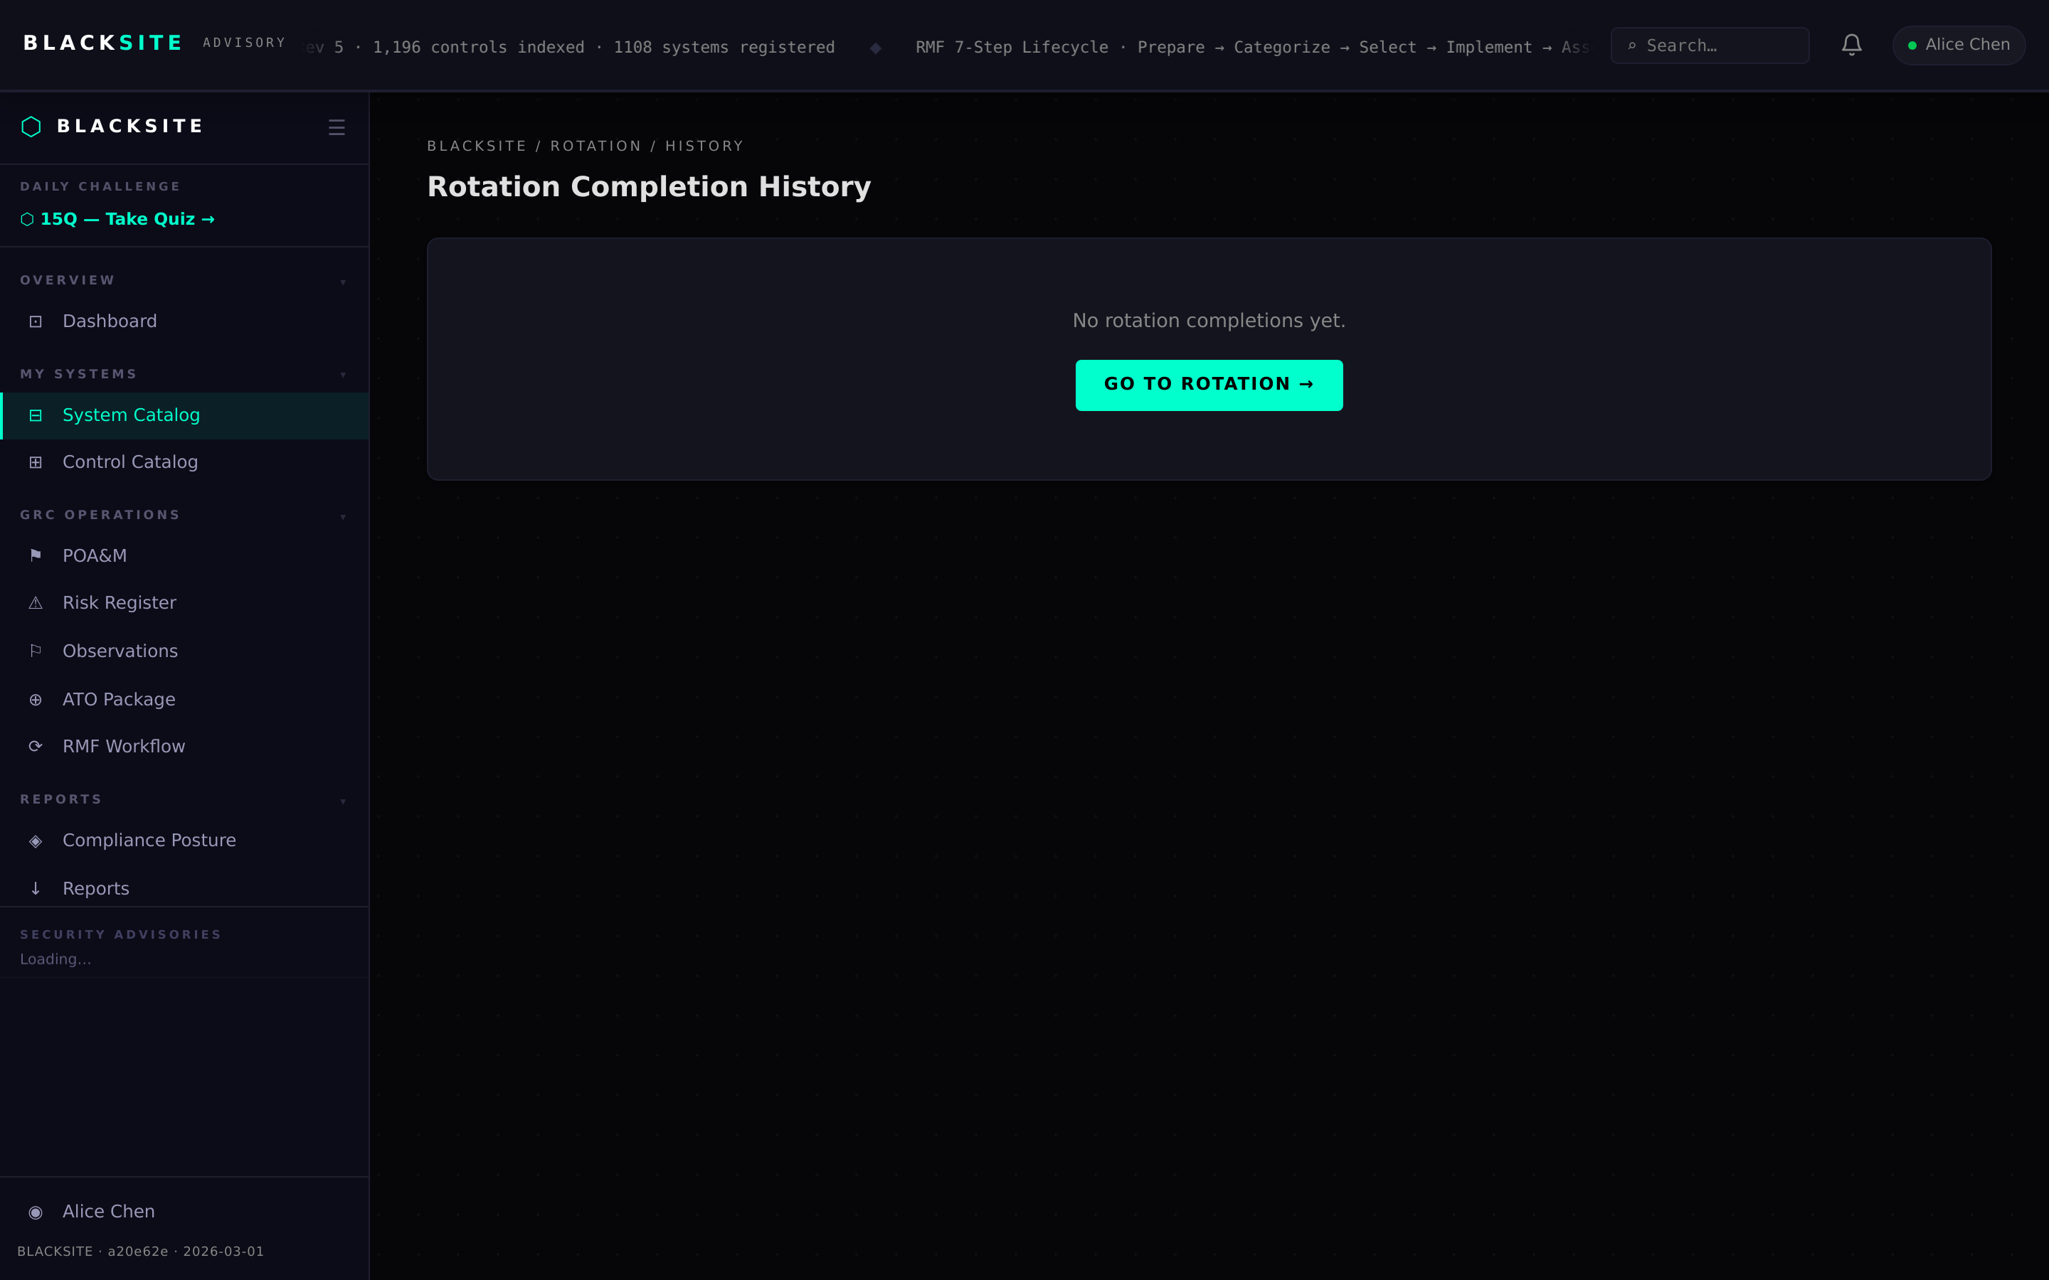
Figure 2: View rotation history

Step 3: View rotation calendar
Navigate to /systems/{id}/rotation/calendar. The 25-day grid shows each day with its topic, completion status (green = done, empty = pending), and federal holiday indicators (gray background). The current day is highlighted.
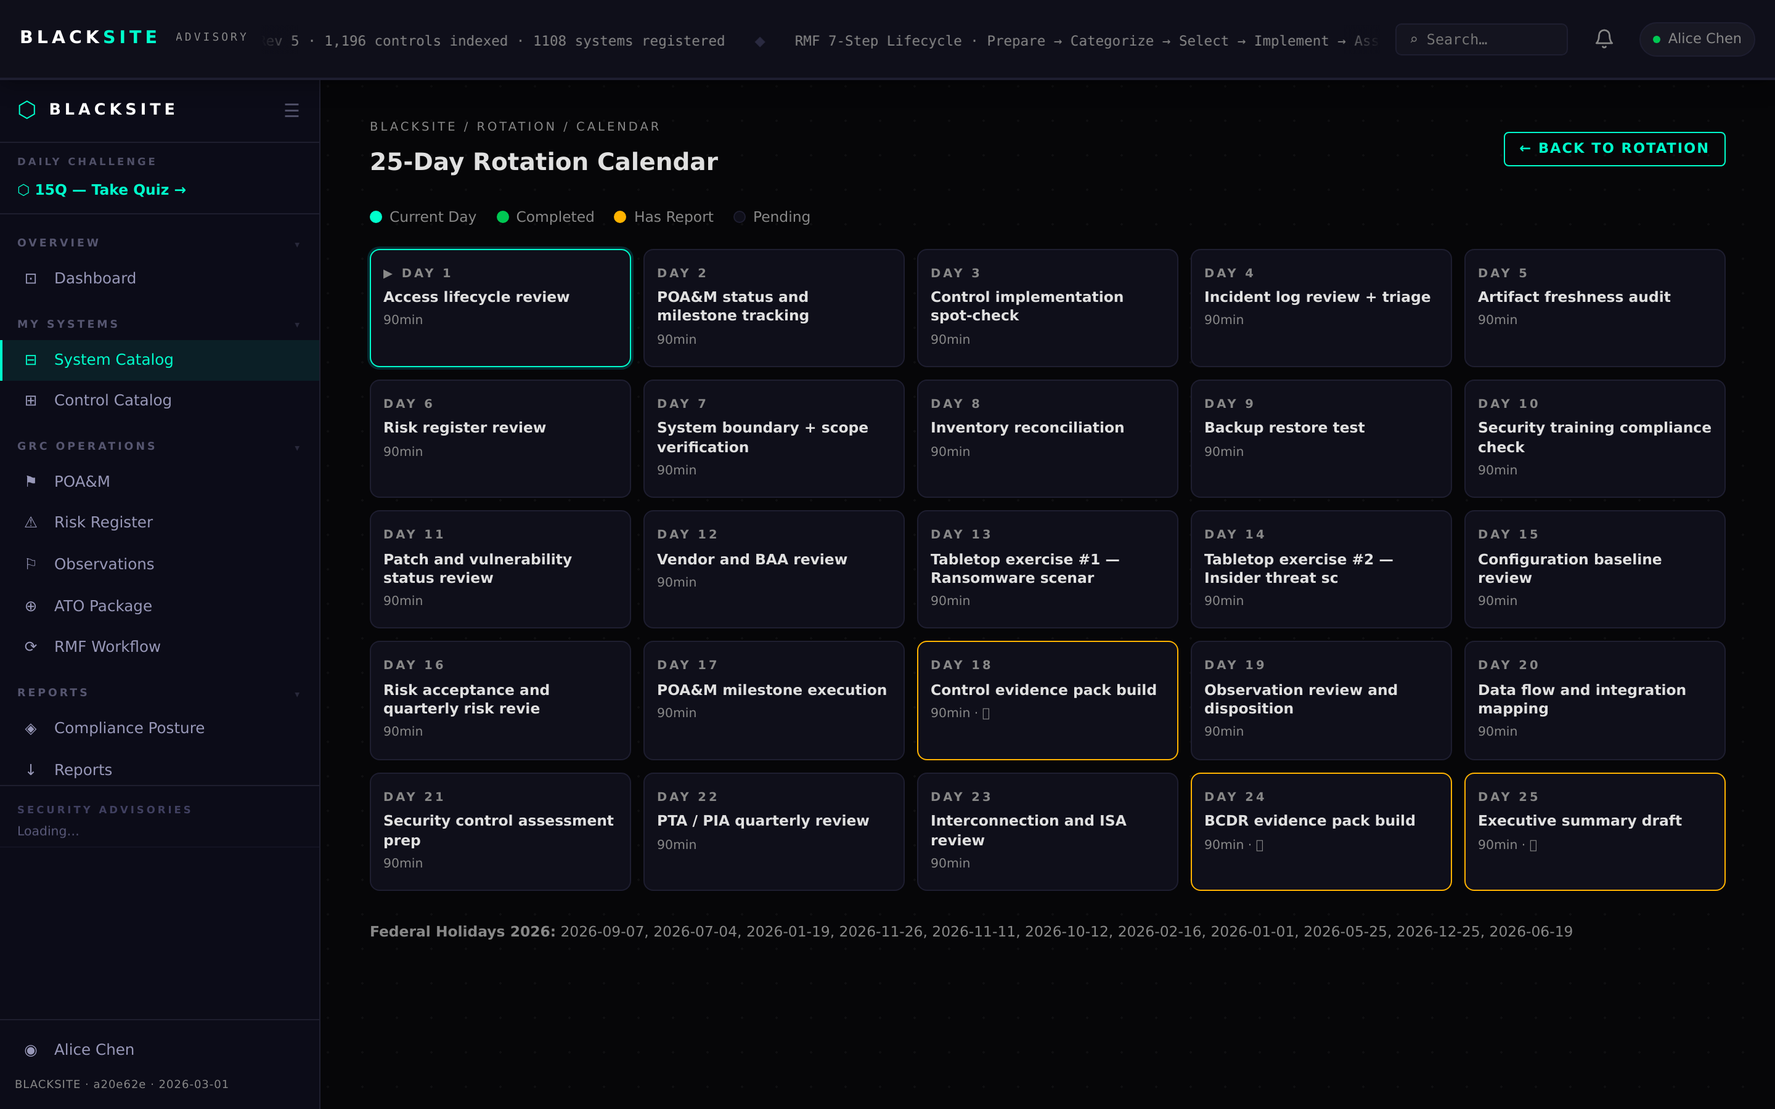
Figure 3: View rotation calendar

Step 4: Complete a rotation day
On the current day page, fill in the evidence notes and optionally upload an evidence file. Click Complete Day. The rotation day advances by 1 (wrapping from 25 to 1). A DeepWorkCompletion record is created. On days 18, 24, and 25, a PDF report generation is triggered automatically.
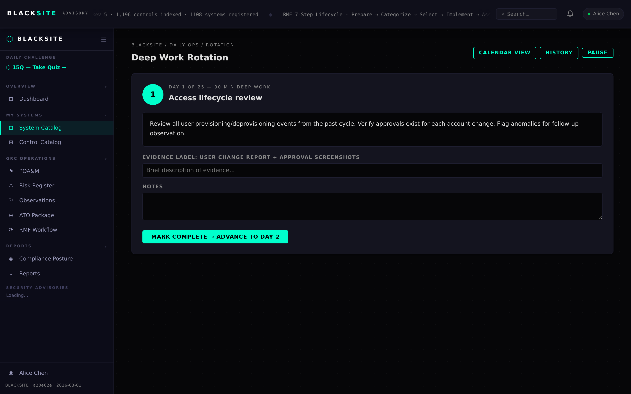
Figure 4: Complete a rotation day

Step 5: ISSM portfolio rotation view
ISSMs navigate to /issm/daily to see all assigned ISSOs' rotation progress. Each ISSO's current rotation day and last completion date are shown. ISSOs who have not completed a rotation day this week are highlighted.
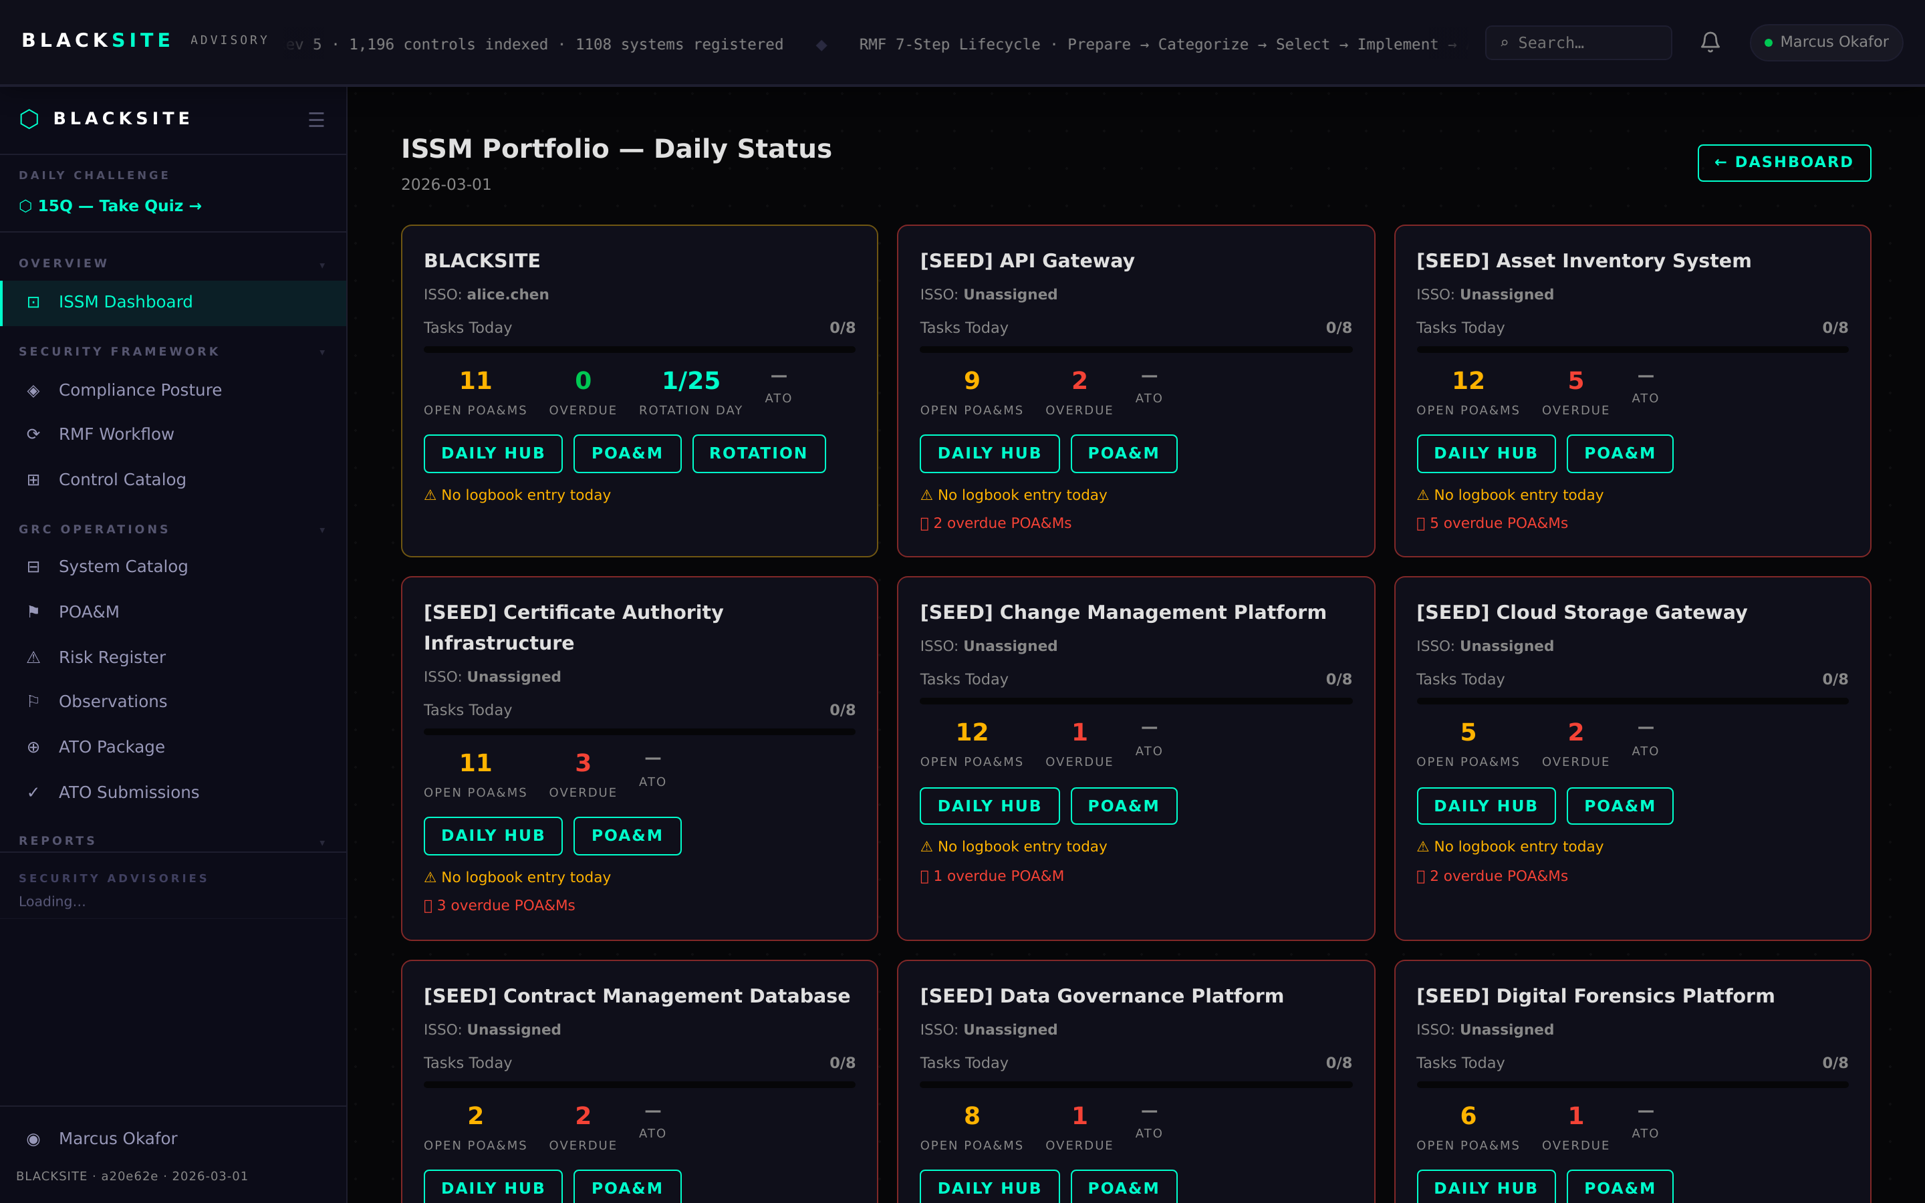
Figure 5: ISSM portfolio rotation view

Common Issues and Resolutions
Symptom | Resolution
Rotation stuck on day 25 | The completion record may be missing. Check /rotation/history for the Day 25 entry. If absent, manually complete.
Auto-generated report not appearing | Check /systems/{id}/reports. The BackgroundTask may still be running. Wait 2 minutes and refresh.
Quarterly override not showing | Quarterly overrides only appear when the current date falls in the override window. Check QUARTERLY_OVERRIDES config.

