━━━━━━━━━━━━━━━━━━━━━━━━━━━━━━━━━━━━━━━━━━━━━━━━━━━━━━━━━━━━━━━━━━━━━━
BLACKSITE GRC Platform · THKR-BSV-001

Daily Employee Security Quiz
Roles: All roles
Version: 1.0 | Date: 2026-03-01 | Classification: INTERNAL USE ONLY
━━━━━━━━━━━━━━━━━━━━━━━━━━━━━━━━━━━━━━━━━━━━━━━━━━━━━━━━━━━━━━━━━━━━━━

Overview
BLACKSITE presents a daily security awareness question on the dashboard. Answering correctly extends your streak. Quiz scores feed into the combined assessment score (30% weight). Streaks and scores are visible on the dashboard and contribute to the Allstar designation.

Prerequisites
- Authenticated session.
- Quiz for today not yet completed.

Procedure

Step 1: Quiz prompt on dashboard
The quiz card appears on your dashboard if today's quiz is not yet answered. The card shows the question category and a 'Take Quiz' button. Dismissed questions cannot be answered later today.
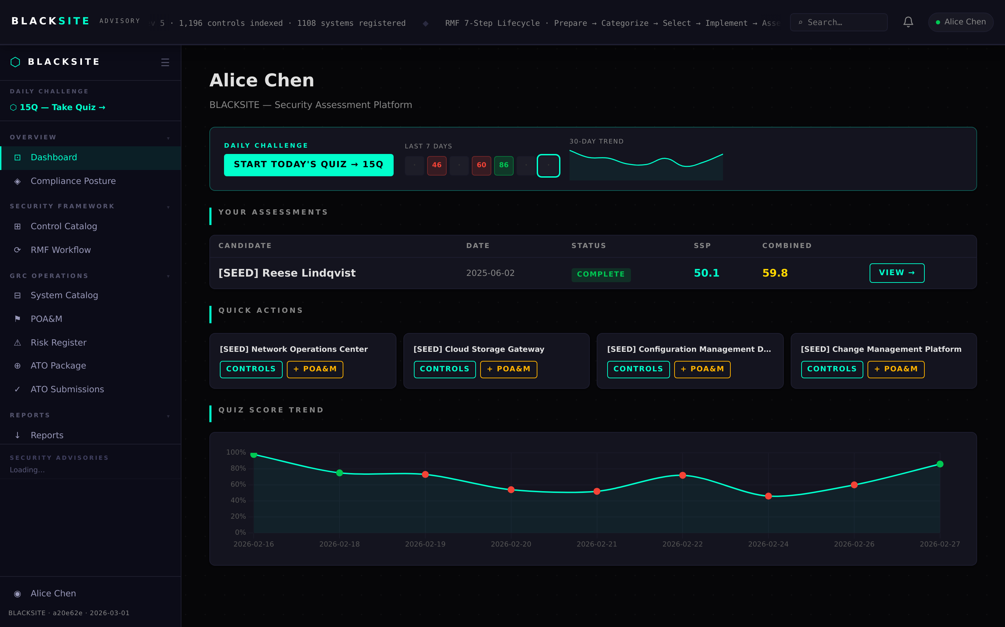
Figure 1: Quiz prompt on dashboard

Step 2: Answer the quiz question
Click Take Quiz or navigate to /dashboard/quiz. The question appears with 4 answer options. Select your answer and click Submit.
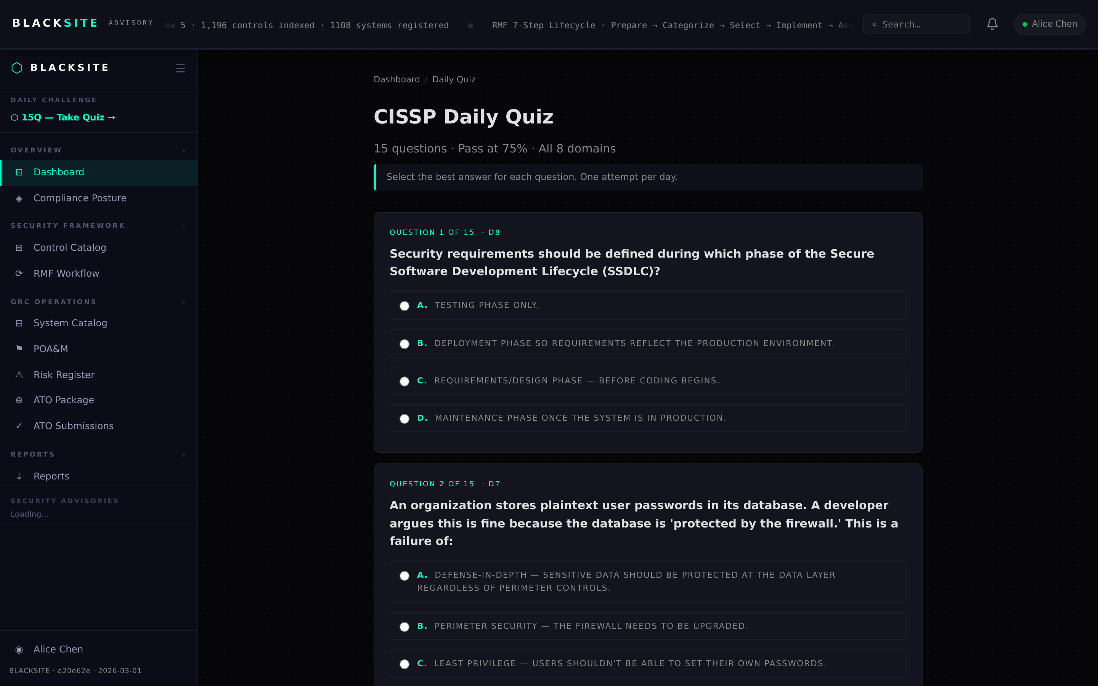
Figure 2: Answer the quiz question

Step 3: Submit and see result
After submitting, the correct answer is highlighted. If correct, a success message shows your current streak. If incorrect, the correct answer explanation appears. Your quiz score is updated in the database.
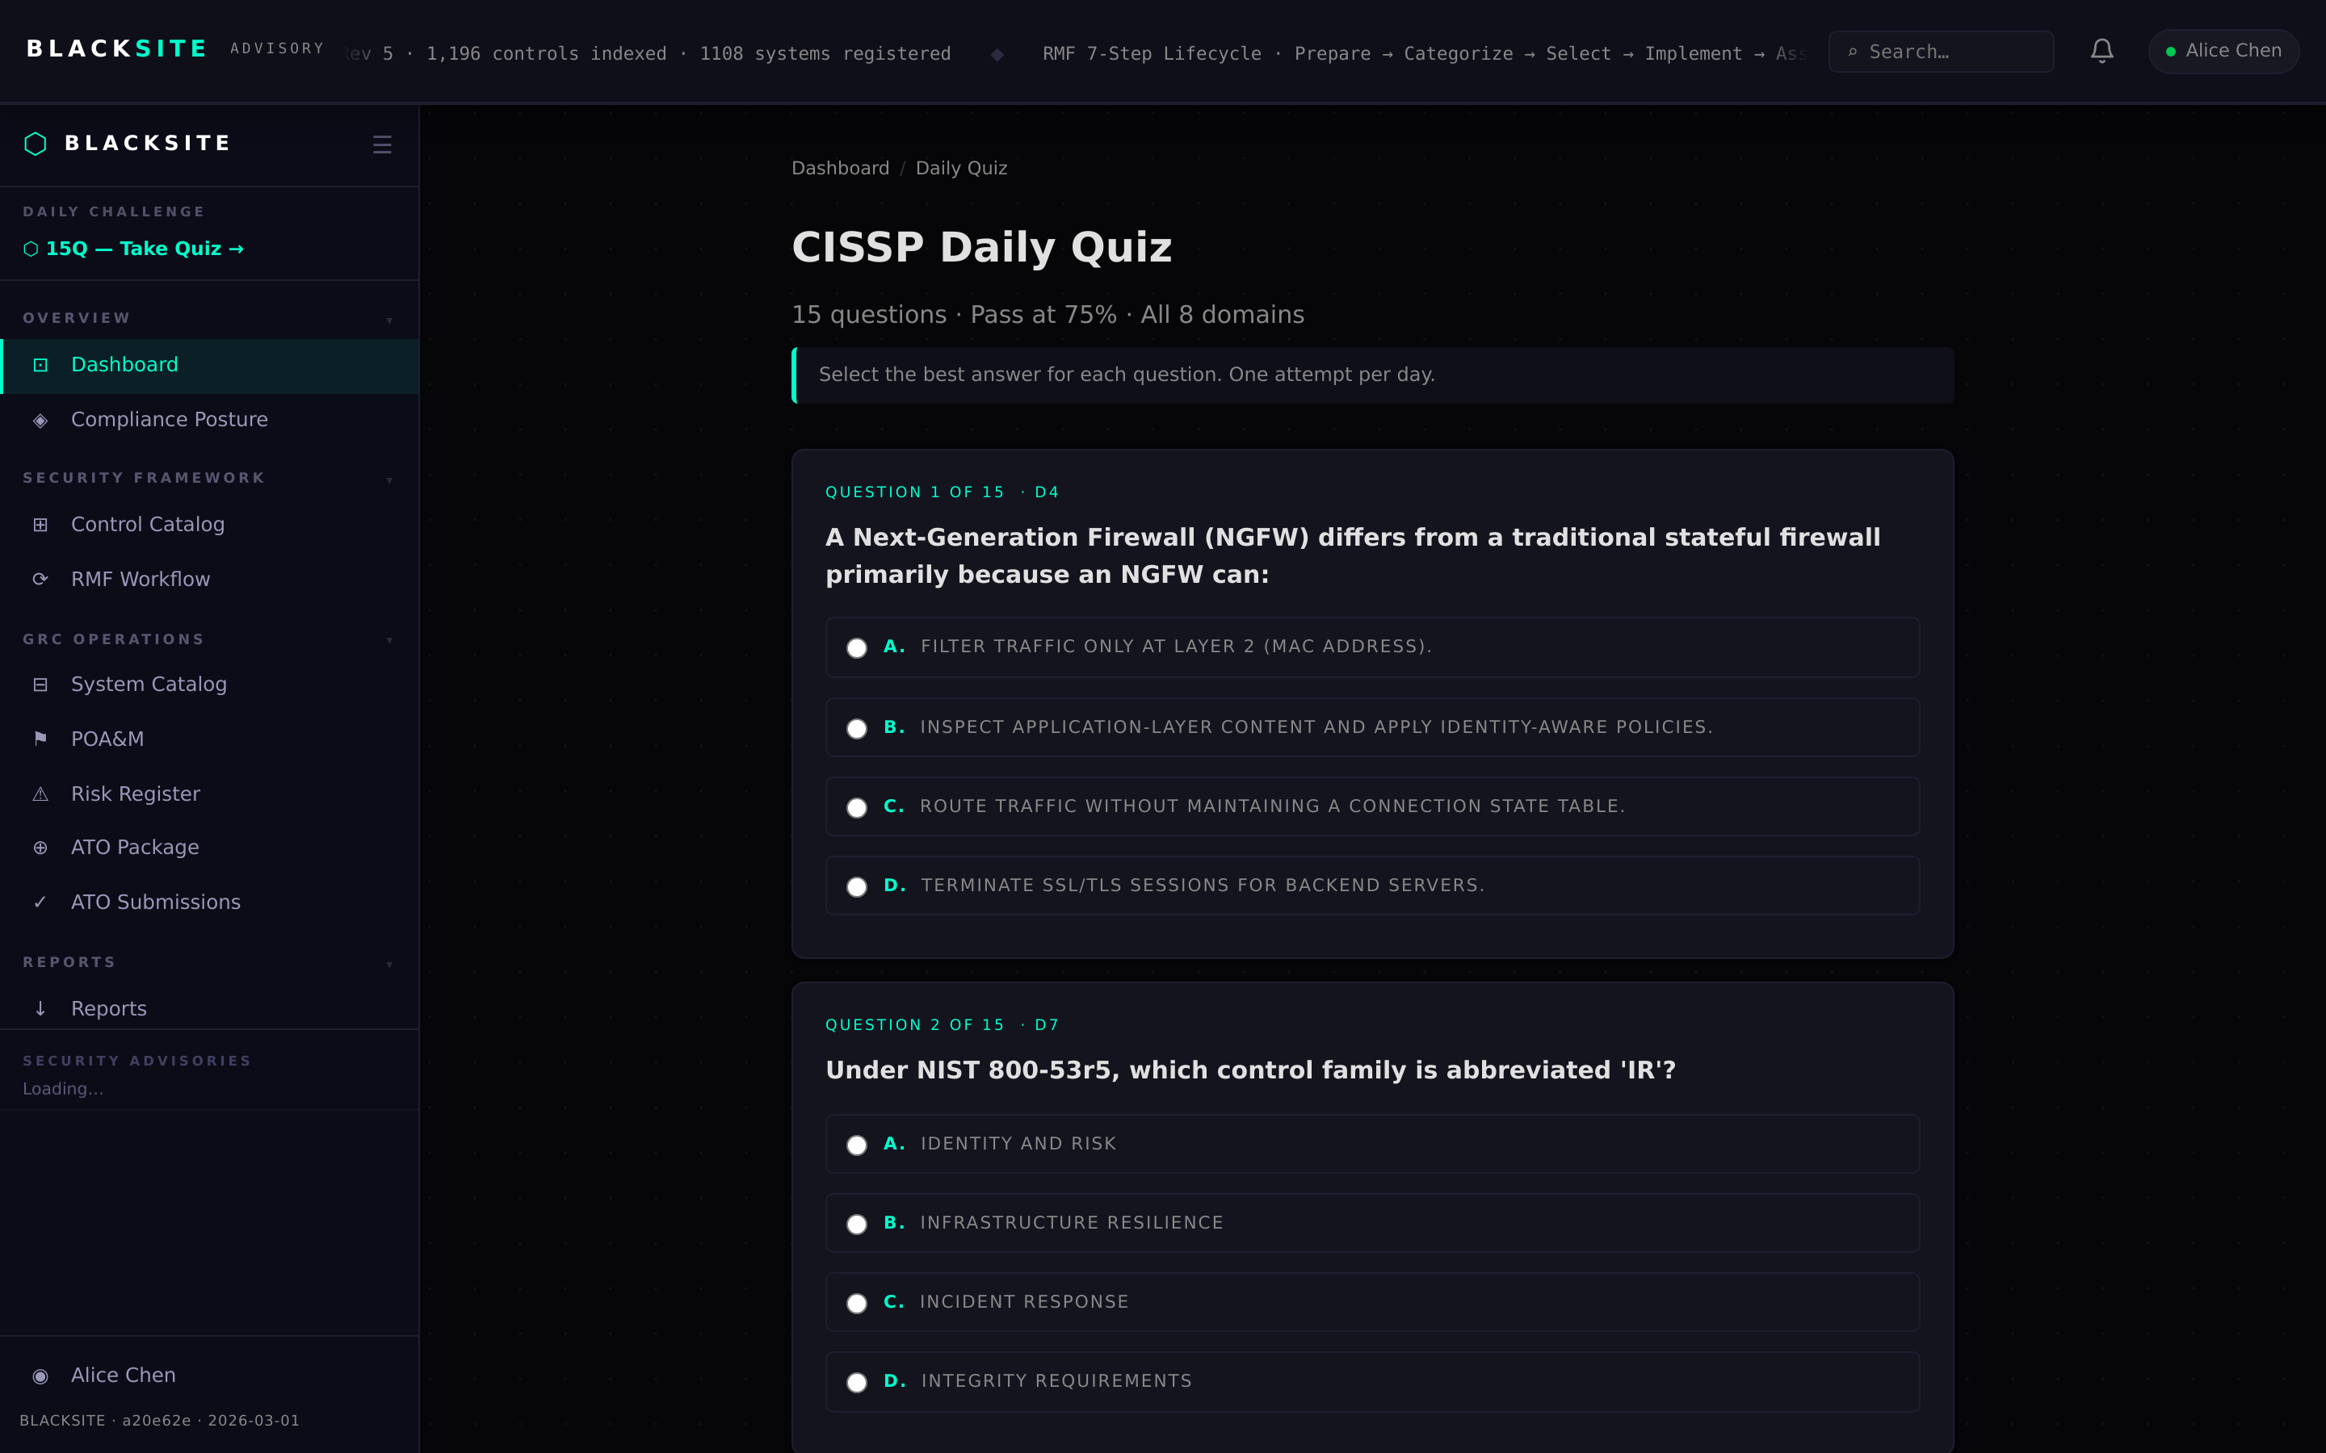
Figure 3: Submit and see result

Step 4: Streak and score on dashboard
Return to the dashboard. The quiz widget now shows your current streak count and today's result (correct/incorrect). The streak resets to 0 if you miss a day or answer incorrectly.
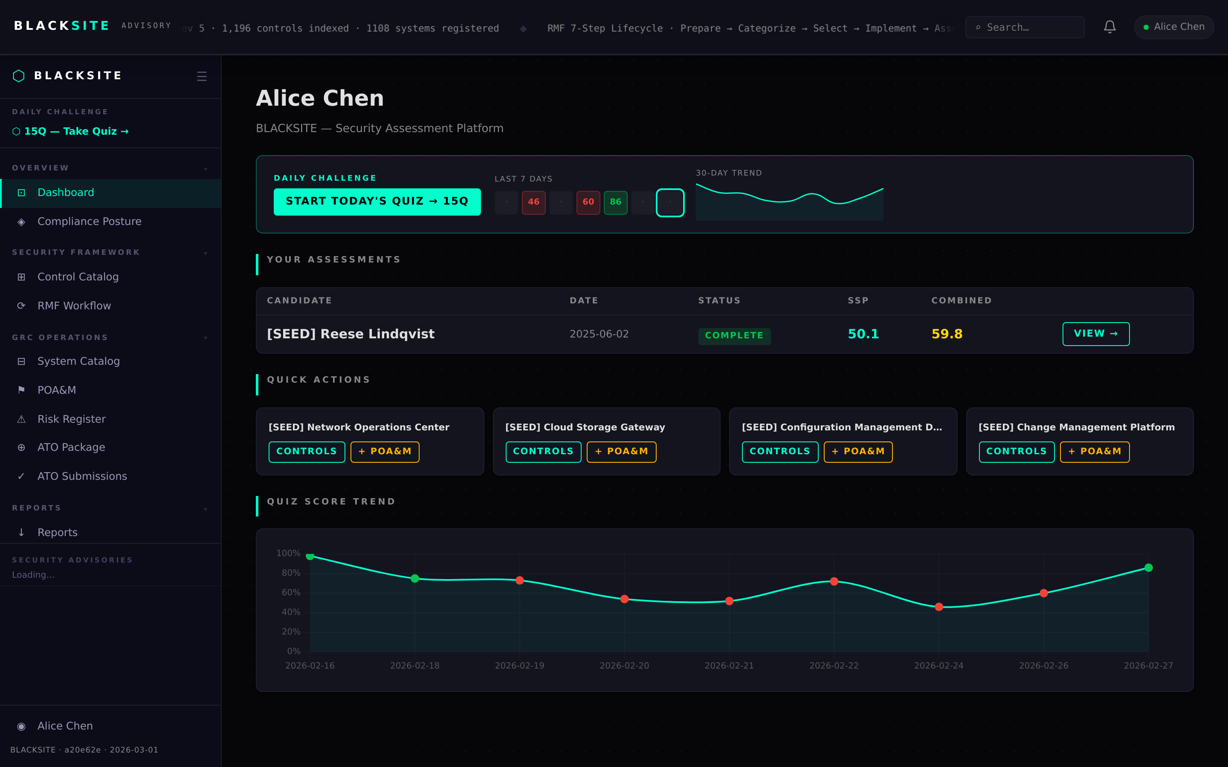
Figure 4: Streak and score on dashboard

Common Issues and Resolutions
Symptom | Resolution
Quiz card not showing | You may have already answered today's quiz. It resets at midnight UTC.
Quiz page shows 'No question today' | The quiz database may not have a question for today. Contact admin to load quiz questions.

