━━━━━━━━━━━━━━━━━━━━━━━━━━━━━━━━━━━━━━━━━━━━━━━━━━━━━━━━━━━━━━━━━━━━━━
BLACKSITE GRC Platform · THKR-BSV-001

Global Search
Roles: All roles
Version: 1.0 | Date: 2026-03-01 | Classification: INTERNAL USE ONLY
━━━━━━━━━━━━━━━━━━━━━━━━━━━━━━━━━━━━━━━━━━━━━━━━━━━━━━━━━━━━━━━━━━━━━━

Overview
The global search at /search finds systems, controls, POA&M items, risks, observations, and users across all data you have access to. Results are grouped by type and ranked by relevance.

Prerequisites
- Authenticated session.

Procedure

Step 1: Open the search page
Navigate to /search or press the search icon in the top navigation. The search page loads with an empty results state and a search input field.
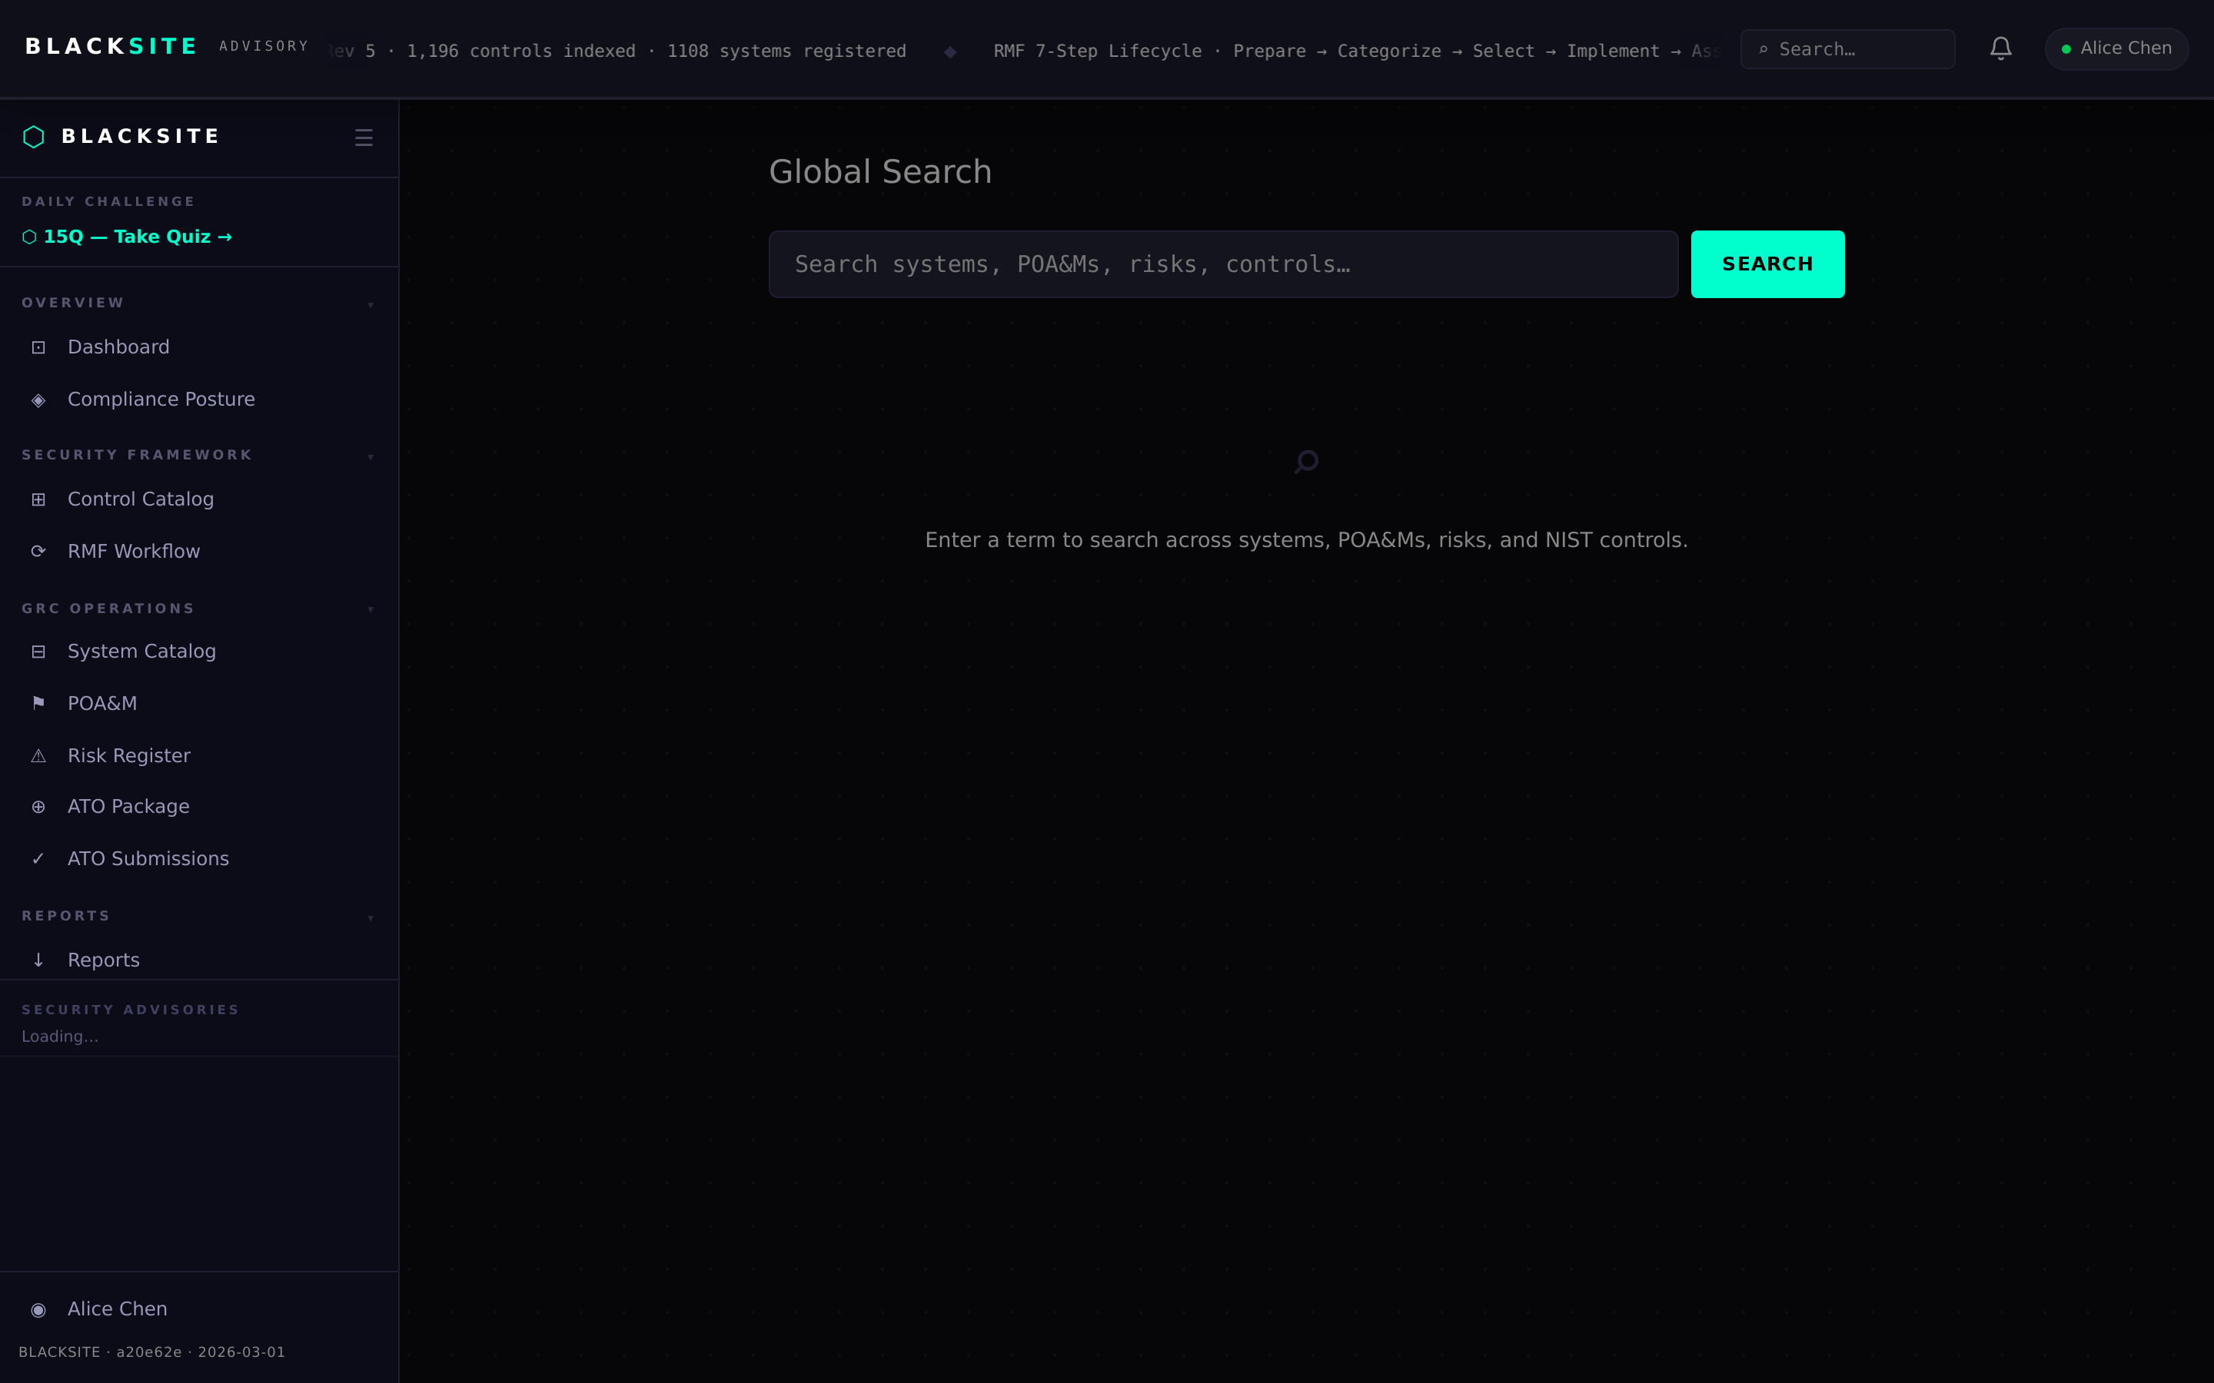
Figure 1: Open the search page

Step 2: Search for a term
Type a search term and press Enter or click Search. Results appear grouped by type (Systems, Controls, POA&Ms, Risks). Each result shows the item name, type badge, and a link to the item's detail page.
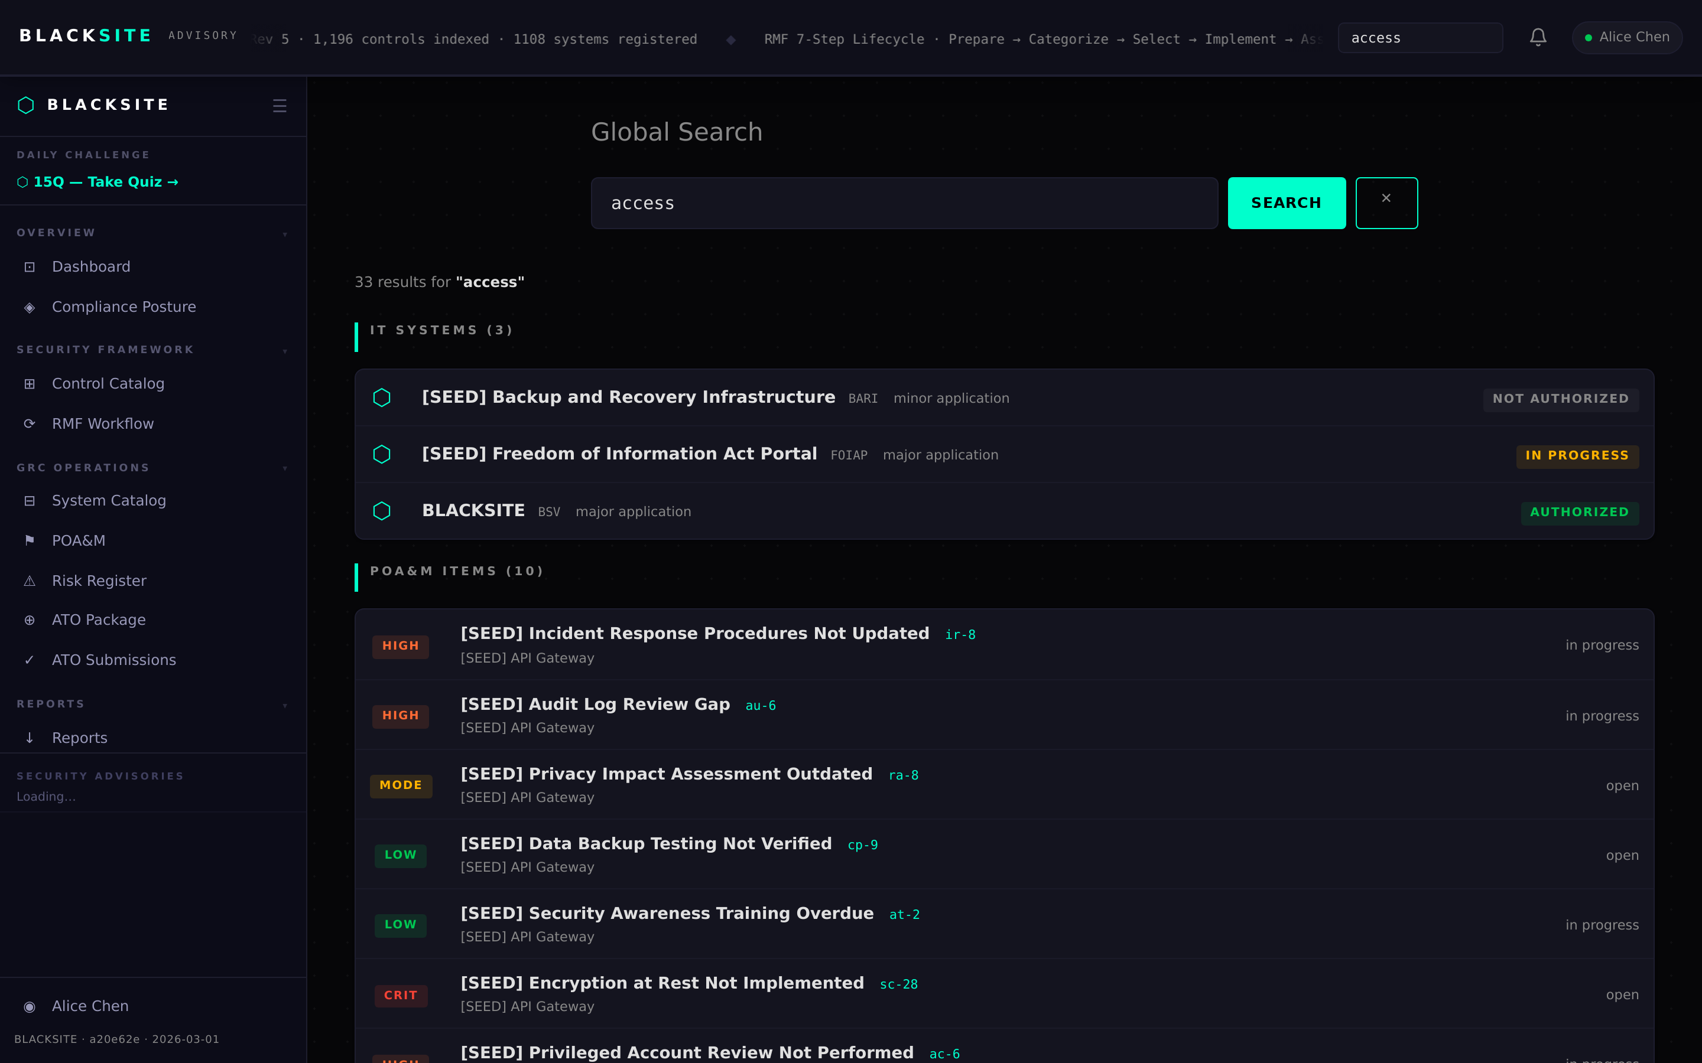
Figure 2: Search for a term

Step 3: Search by control ID
Type a NIST control ID (e.g., 'ac-2') to find the control directly. The result links to both the catalog detail page and any system-control workspace where that control is implemented.
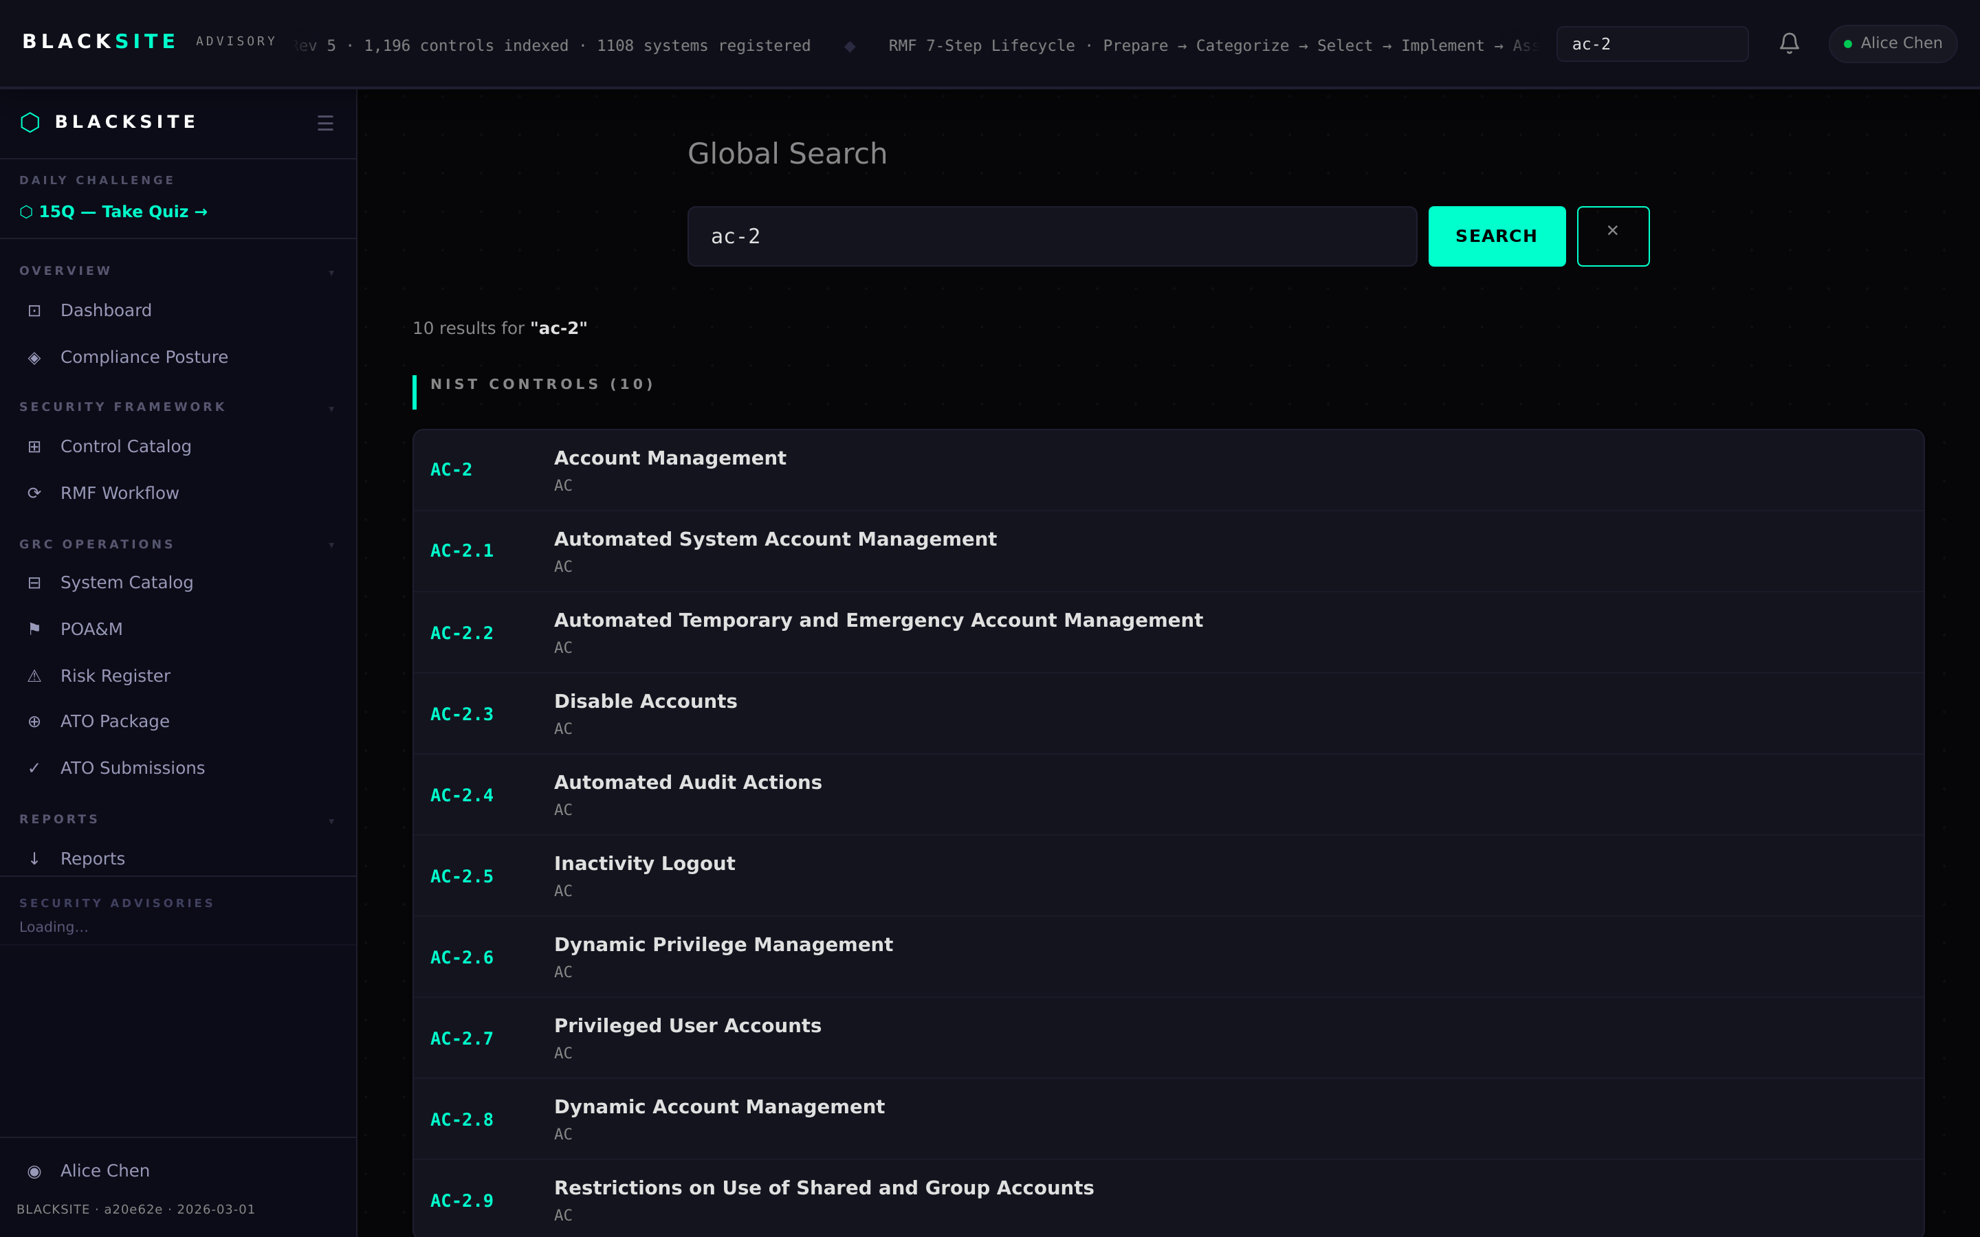
Figure 3: Search by control ID

Common Issues and Resolutions
Symptom | Resolution
No results for known item | Search is scoped to your role's accessible data. If you lack system access, those systems' data will not appear.
Search page returns 404 | The /search route may not be enabled. Contact the admin.

