━━━━━━━━━━━━━━━━━━━━━━━━━━━━━━━━━━━━━━━━━━━━━━━━━━━━━━━━━━━━━━━━━━━━━━
BLACKSITE GRC Platform · THKR-BSV-001

Observations and Finding Promotion
Roles: SCA, Pen Tester, ISSO, Admin
Version: 1.0 | Date: 2026-03-01 | Classification: INTERNAL USE ONLY
━━━━━━━━━━━━━━━━━━━━━━━━━━━━━━━━━━━━━━━━━━━━━━━━━━━━━━━━━━━━━━━━━━━━━━

Overview
Observations are informal findings noted during assessments or pen tests. They can be promoted to formal POA&M items when they rise to the level of a trackable deficiency. This SOP covers creating, reviewing, and promoting observations.

Prerequisites
- System assigned to user.
- Assessment or pen test findings available to document.

Procedure

Step 1: View observations list
Navigate to /observations. Observations are listed with type, severity, system, submitter, and date. Filter by status (Open/Closed) or system using the filter controls.
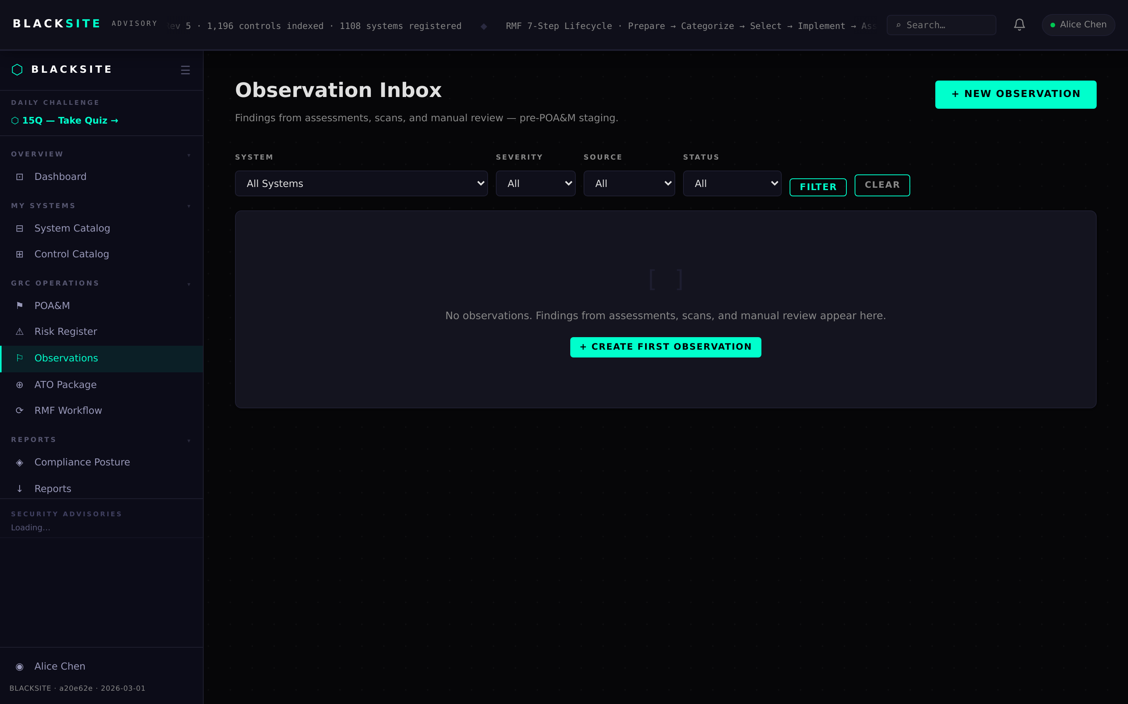
Figure 1: View observations list

Step 2: Create a new observation
Click + New Observation. Fill in: System, Type (Technical/Administrative/Physical), Severity, Title, Description, and Recommended Action. Click Save. The observation is now visible to the ISSO and SCA for the system.
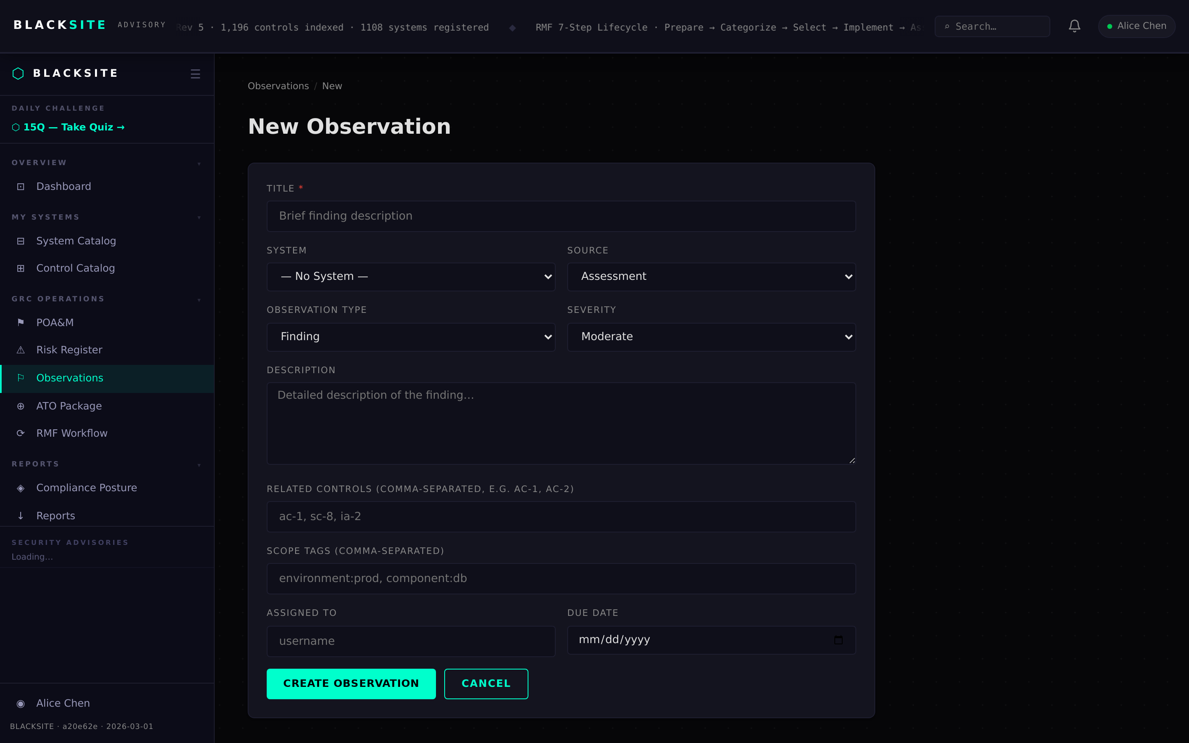
Figure 2: Create a new observation

Step 3: Review observation detail
Click an observation row to open its detail page. The SCA or ISSO can add review notes and change the status. If the finding warrants formal tracking, proceed to promote it to a POA&M item.
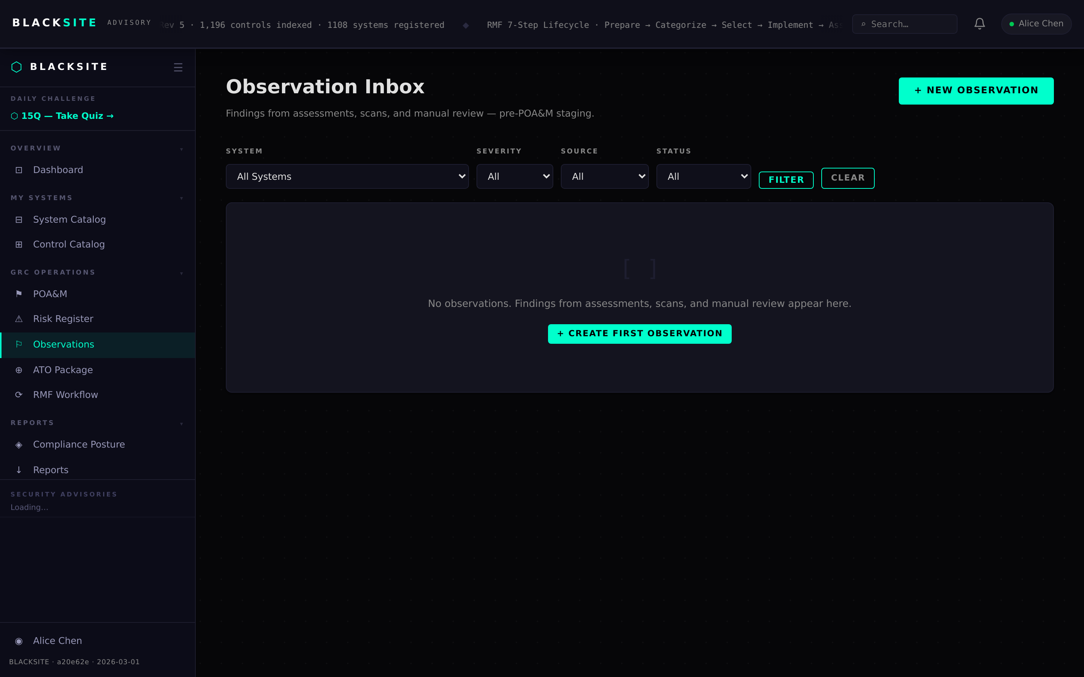
Figure 3: Review observation detail

Step 4: Promote to POA&M
On the observation detail page, click Promote to POA&M. A pre-filled POA&M creation form opens with the observation title, description, and system pre-populated. Complete the remaining POA&M fields (severity, control ID, dates) and save. The observation status updates to Promoted and links to the new POA&M.
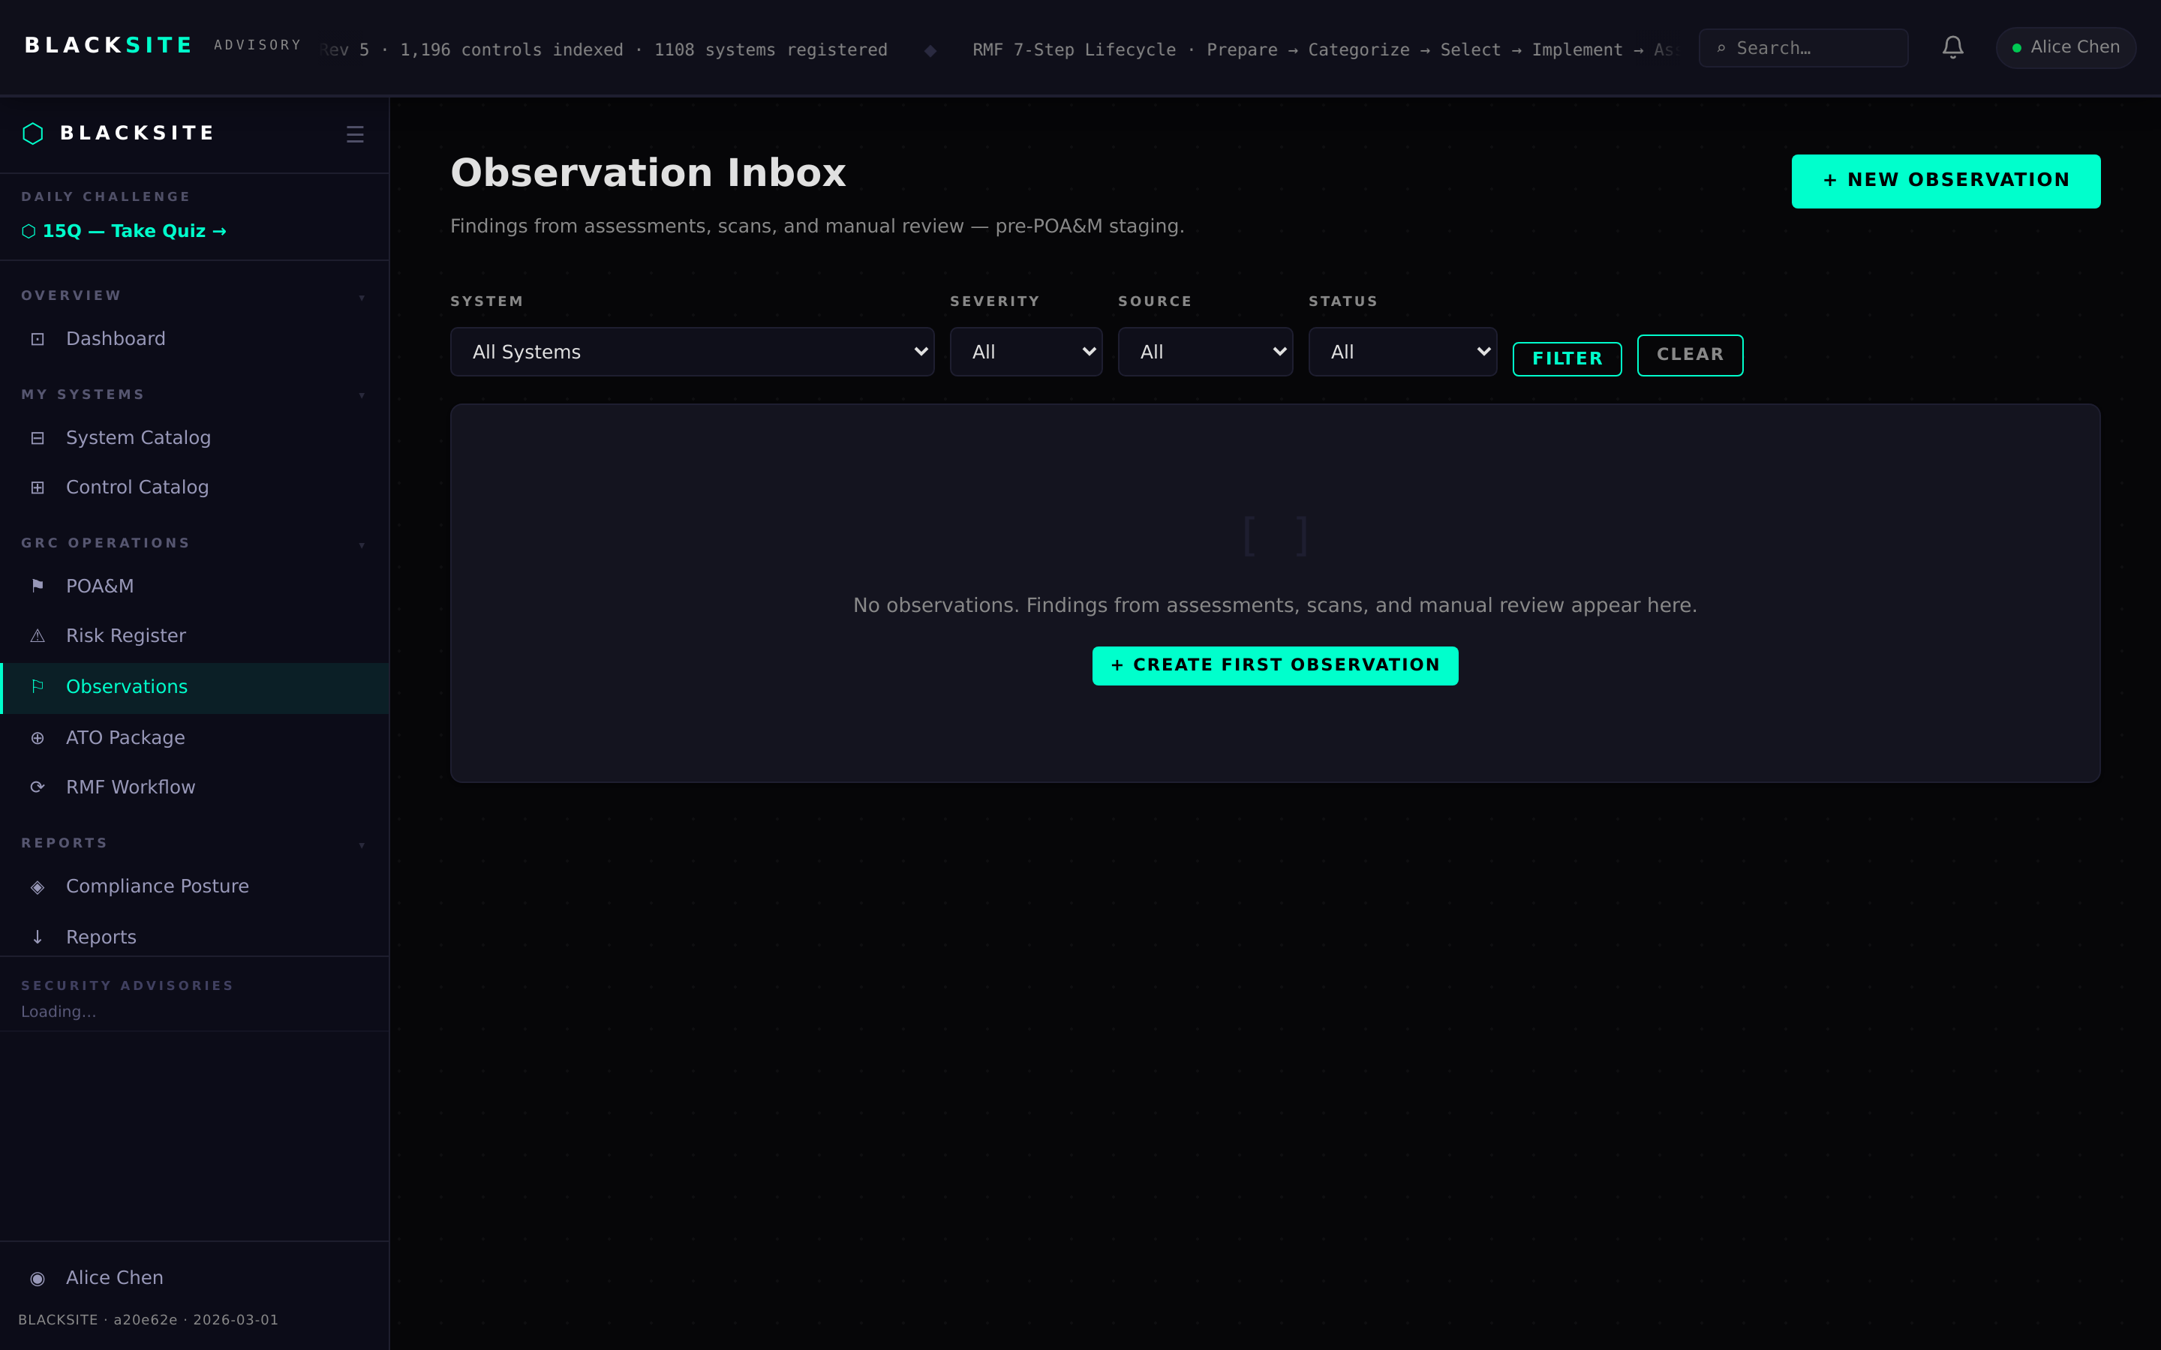
Figure 4: Promote to POA&M

Common Issues and Resolutions
Symptom | Resolution
Promote button absent | Only SCA and admin roles can promote observations. ISSO can view but not promote.
Observation not visible to ISSO | Observations are scoped to the assigned system. Verify the ISSO is assigned.

