━━━━━━━━━━━━━━━━━━━━━━━━━━━━━━━━━━━━━━━━━━━━━━━━━━━━━━━━━━━━━━━━━━━━━━
BLACKSITE GRC Platform · THKR-BSV-001

POA&M Evidence Upload
Roles: ISSO, SCA, Admin
Version: 1.0 | Date: 2026-03-01 | Classification: INTERNAL USE ONLY
━━━━━━━━━━━━━━━━━━━━━━━━━━━━━━━━━━━━━━━━━━━━━━━━━━━━━━━━━━━━━━━━━━━━━━

Overview
Closure evidence (screenshots, test reports, configuration exports) is attached directly to POA&M items. Accepted file types are PDF, PNG, JPG, DOCX, XLSX, TXT, and CSV. Files up to 10 MB per upload. EXE and ZIP files are blocked.

Prerequisites
- POA&M item exists and is In Progress or later.
- Evidence file prepared (PDF, PNG, JPG, DOCX, XLSX, TXT, or CSV).

Procedure

Step 1: Open the evidence section
Open the POA&M detail page. Scroll to the Closure Evidence section near the bottom of the page. The section shows previously uploaded files and an upload form.
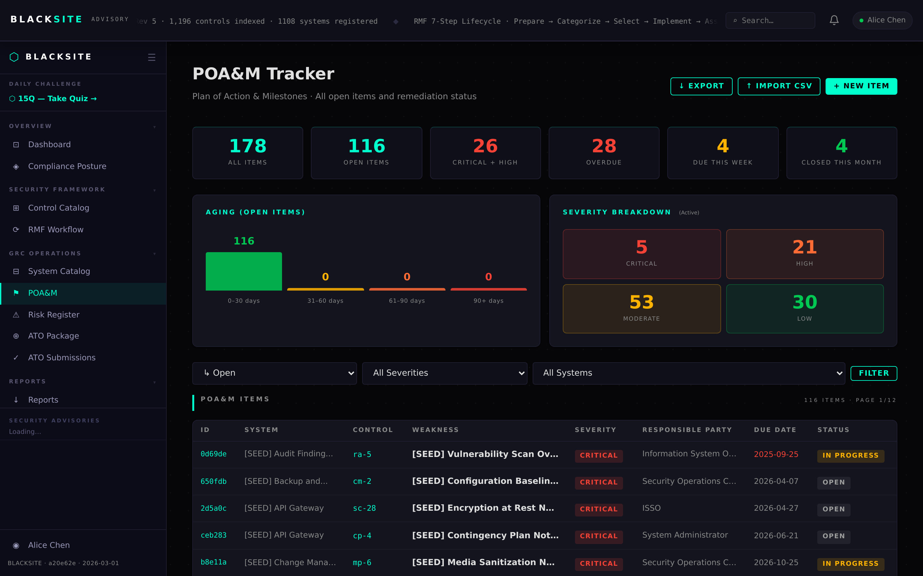
Figure 1: Open the evidence section

Step 2: Upload evidence file
Click Choose File in the evidence upload form. Select your evidence file (accepted: PDF, PNG, JPG, DOCX, XLSX, TXT, CSV — max 10 MB). Add a brief description of what the file demonstrates. Click Upload Evidence. The file appears in the evidence list with a download link and upload timestamp.
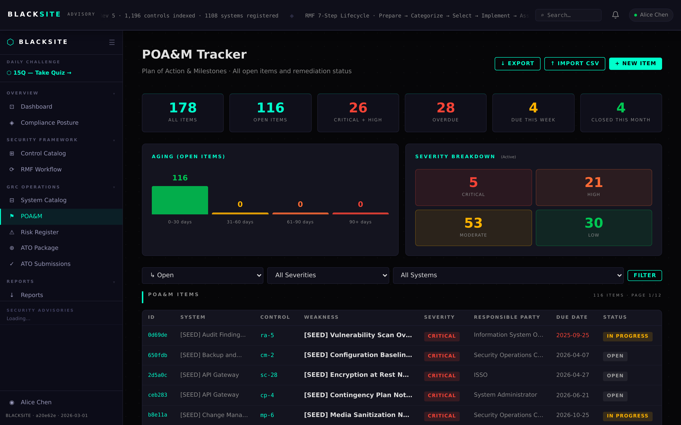
Figure 2: Upload evidence file

Common Issues and Resolutions
Symptom | Resolution
Upload blocked — EXE or ZIP | Executable and archive files are blocked for security. Convert content to PDF or screenshot.
File size error | Maximum file size is 10 MB. Compress the PDF or split into multiple files.
Evidence section absent | The POA&M may still be in Draft status. Submit for review first to enable evidence uploads.

