━━━━━━━━━━━━━━━━━━━━━━━━━━━━━━━━━━━━━━━━━━━━━━━━━━━━━━━━━━━━━━━━━━━━━━
BLACKSITE GRC Platform · THKR-BSV-001

POA&M Lifecycle Management
Roles: ISSO, ISSM, SCA, AO, Admin
Version: 1.0 | Date: 2026-03-01 | Classification: INTERNAL USE ONLY
━━━━━━━━━━━━━━━━━━━━━━━━━━━━━━━━━━━━━━━━━━━━━━━━━━━━━━━━━━━━━━━━━━━━━━

Overview
Plan of Action and Milestones (POA&M) items track identified deficiencies and their remediation plans. BLACKSITE enforces a state machine for POA&M status transitions with role-based push-power rules. Each status change is logged in an immutable approval trail.

Prerequisites
- System record with an assigned ISSO.
- Identified finding or vulnerability to track.

Procedure

Step 1: View the POA&M list
Navigate to /poam. All POA&M items across your assigned systems are listed with status badges, severity, control ID, system name, and scheduled completion date. Use the status filter tabs to narrow the view.
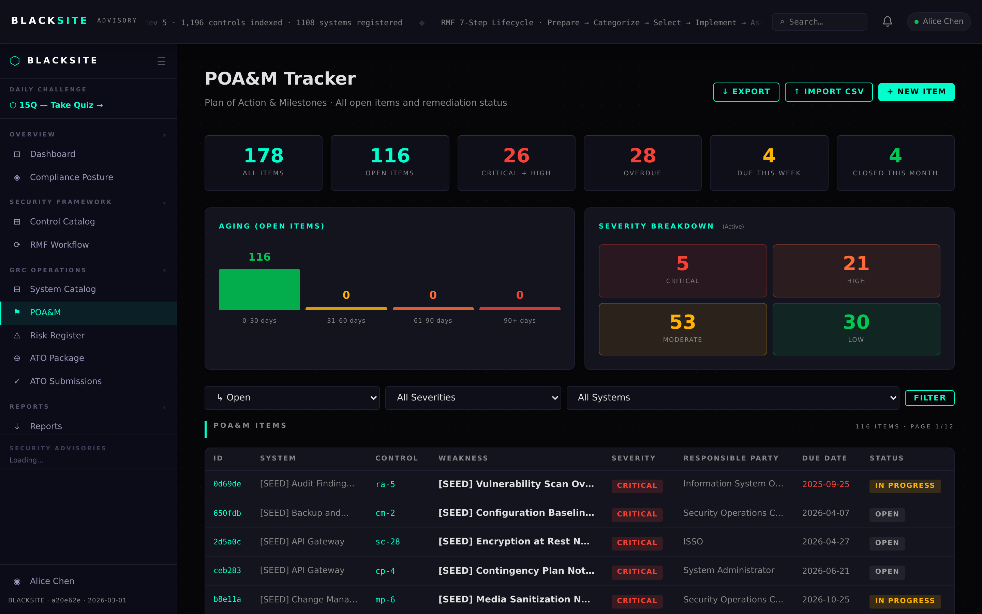
Figure 1: View the POA&M list

Step 2: Create a new POA&M item
Click + New POA&M. Fill in: System, Control ID (from NIST catalog datalist), Title, Weakness Description, Severity (Critical/High/Moderate/Low), Scheduled Completion Date, Responsible Role, and Remediation Plan. Click Save. A POA&M ID (e.g., ABVR022826-1001AC01) is auto-generated.
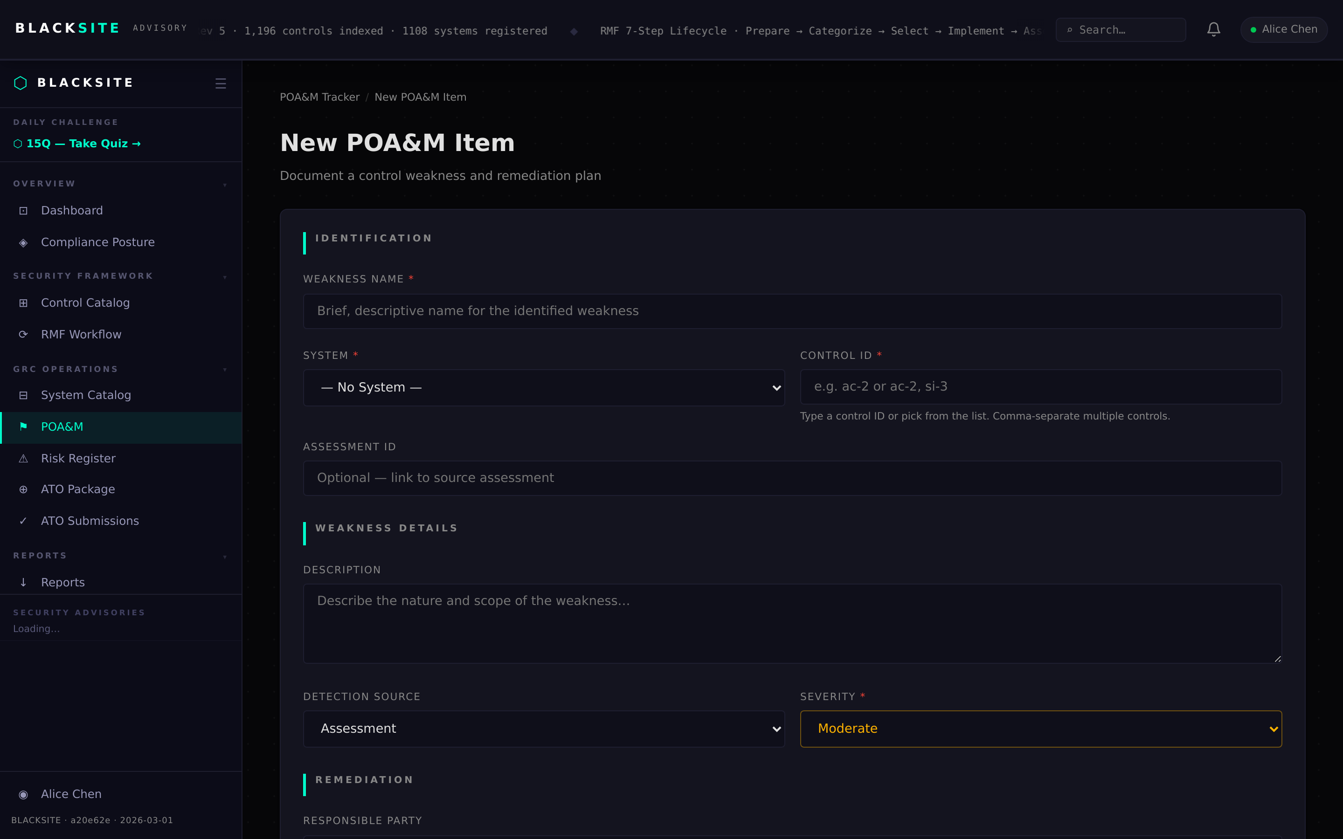
Figure 2: Create a new POA&M item

Step 3: Open POA&M detail (draft status)
Click a POA&M row to open its detail page. In Draft status, the ISSO can edit all fields. The Approval Trail section at the bottom shows an empty log. When ready, click Submit for Review to advance to In Progress.
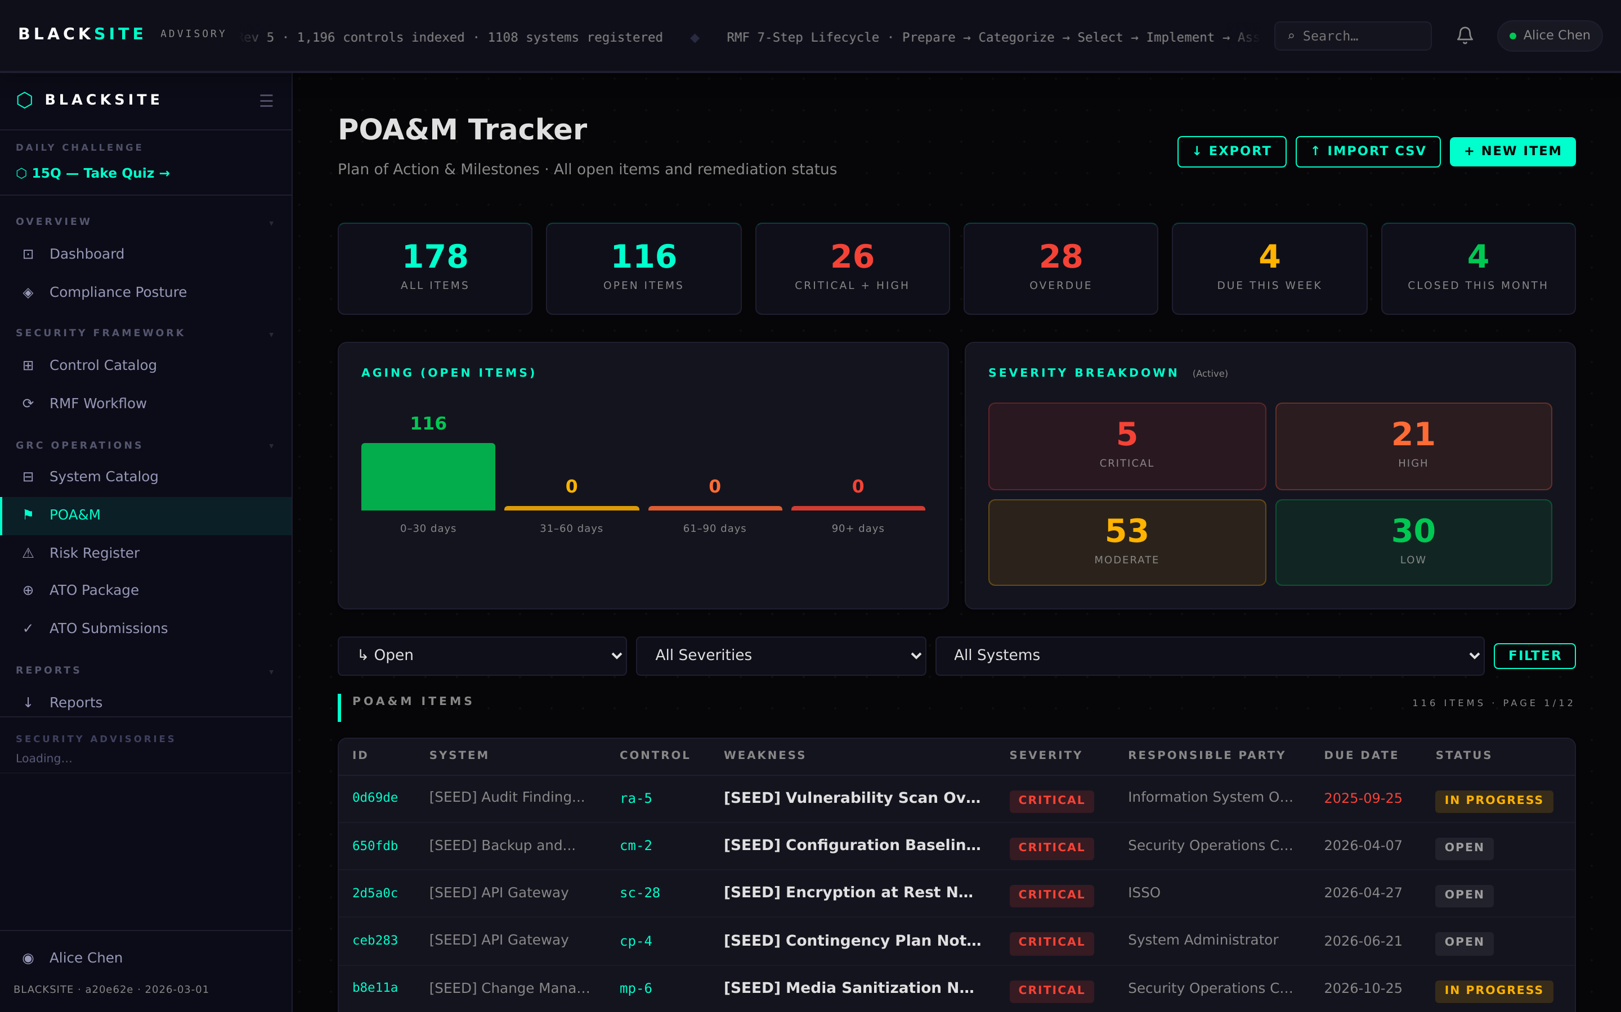
Figure 3: Open POA&M detail (draft status)

Step 4: Import POA&M items
Navigate to /poam/import to bulk-import POA&M items from CSV or XLSX. Download the template first, fill in the required columns, then upload. A preview step shows parsed rows before committing.
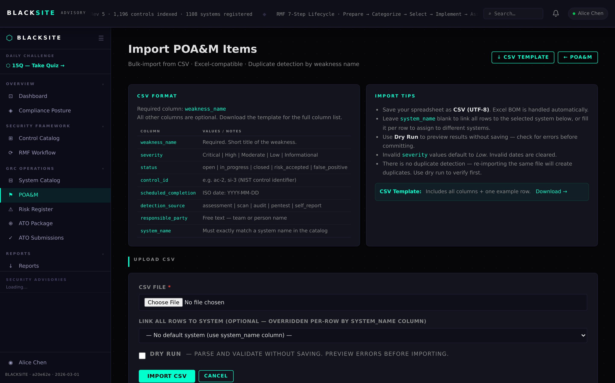
Figure 4: Import POA&M items

Step 5: Export POA&M list
Navigate to /poam/export to download all open POA&M items as CSV or XLSX. The export includes all fields, approval trail entries, and evidence filenames. Use this for FISMA reporting or external review.
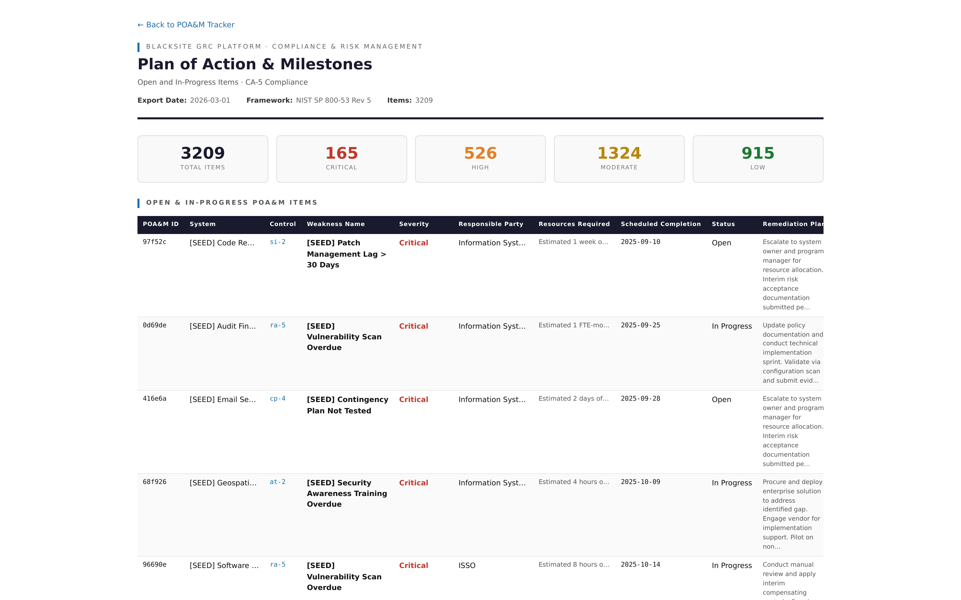
Figure 5: Export POA&M list

Step 6: In Progress status
When submitted, the POA&M moves to In Progress. The ISSO updates milestone progress notes and can upload closure evidence. The SCA can review and request changes or advance to Ready for Review.
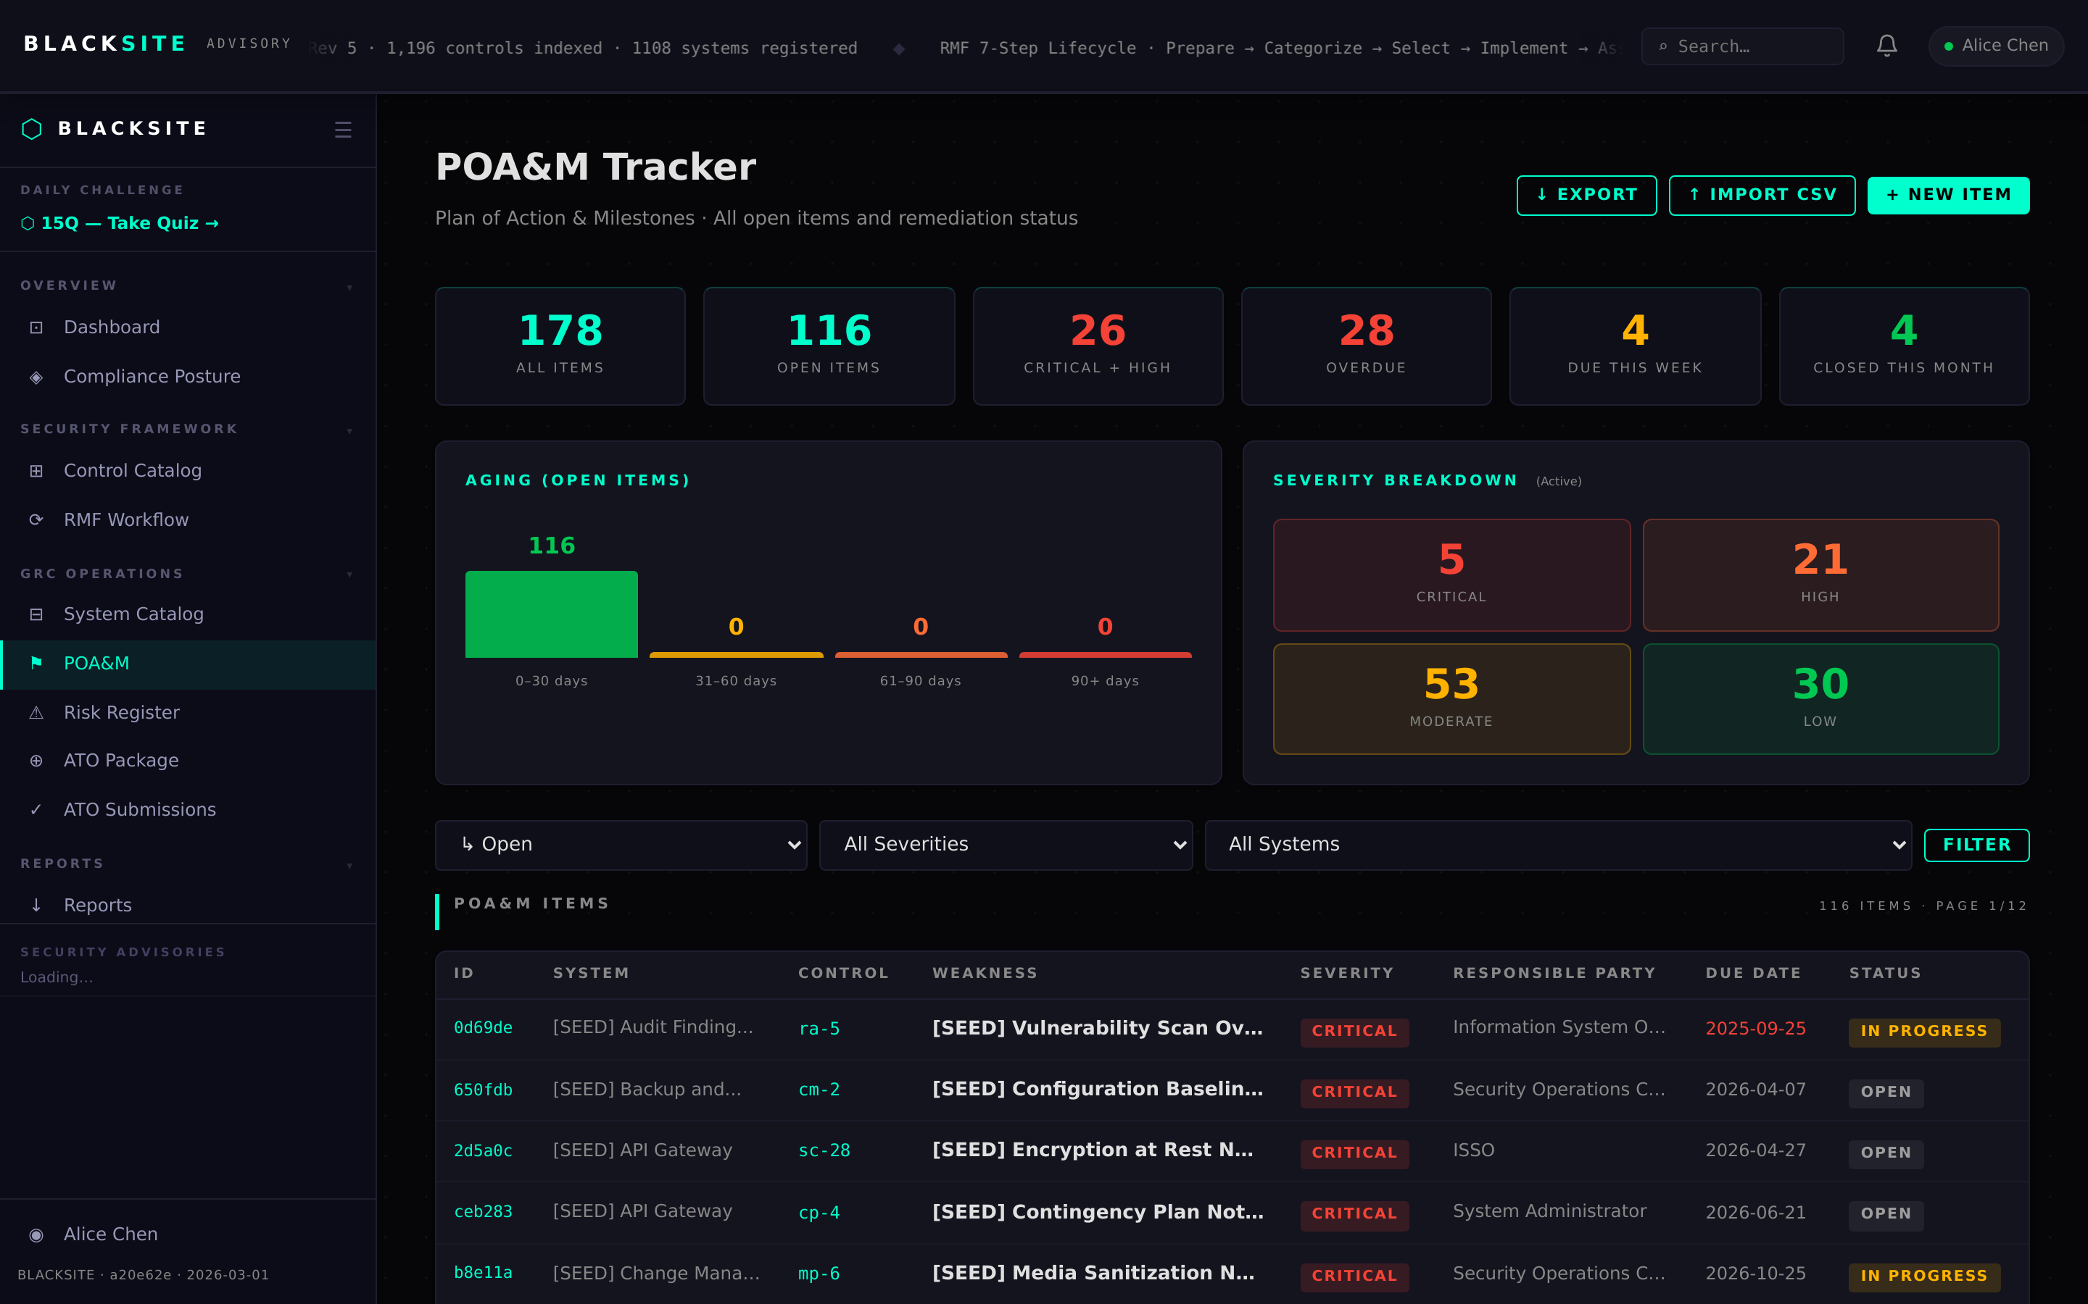
Figure 6: In Progress status

Step 7: Blocked status
If remediation is blocked by an external dependency, the ISSO sets status to Blocked and fills in the blocker description and responsible party. Blocked items are flagged in dashboard counts.
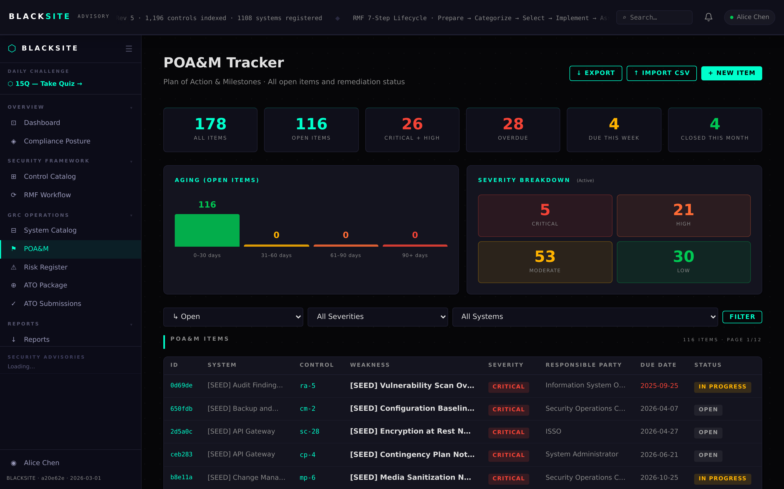
Figure 7: Blocked status

Step 8: Ready for Review status
SCA sets the item to Ready for Review after confirming remediation evidence. The ISSO and SCA both appear in the approval trail. The AO can now review the item.
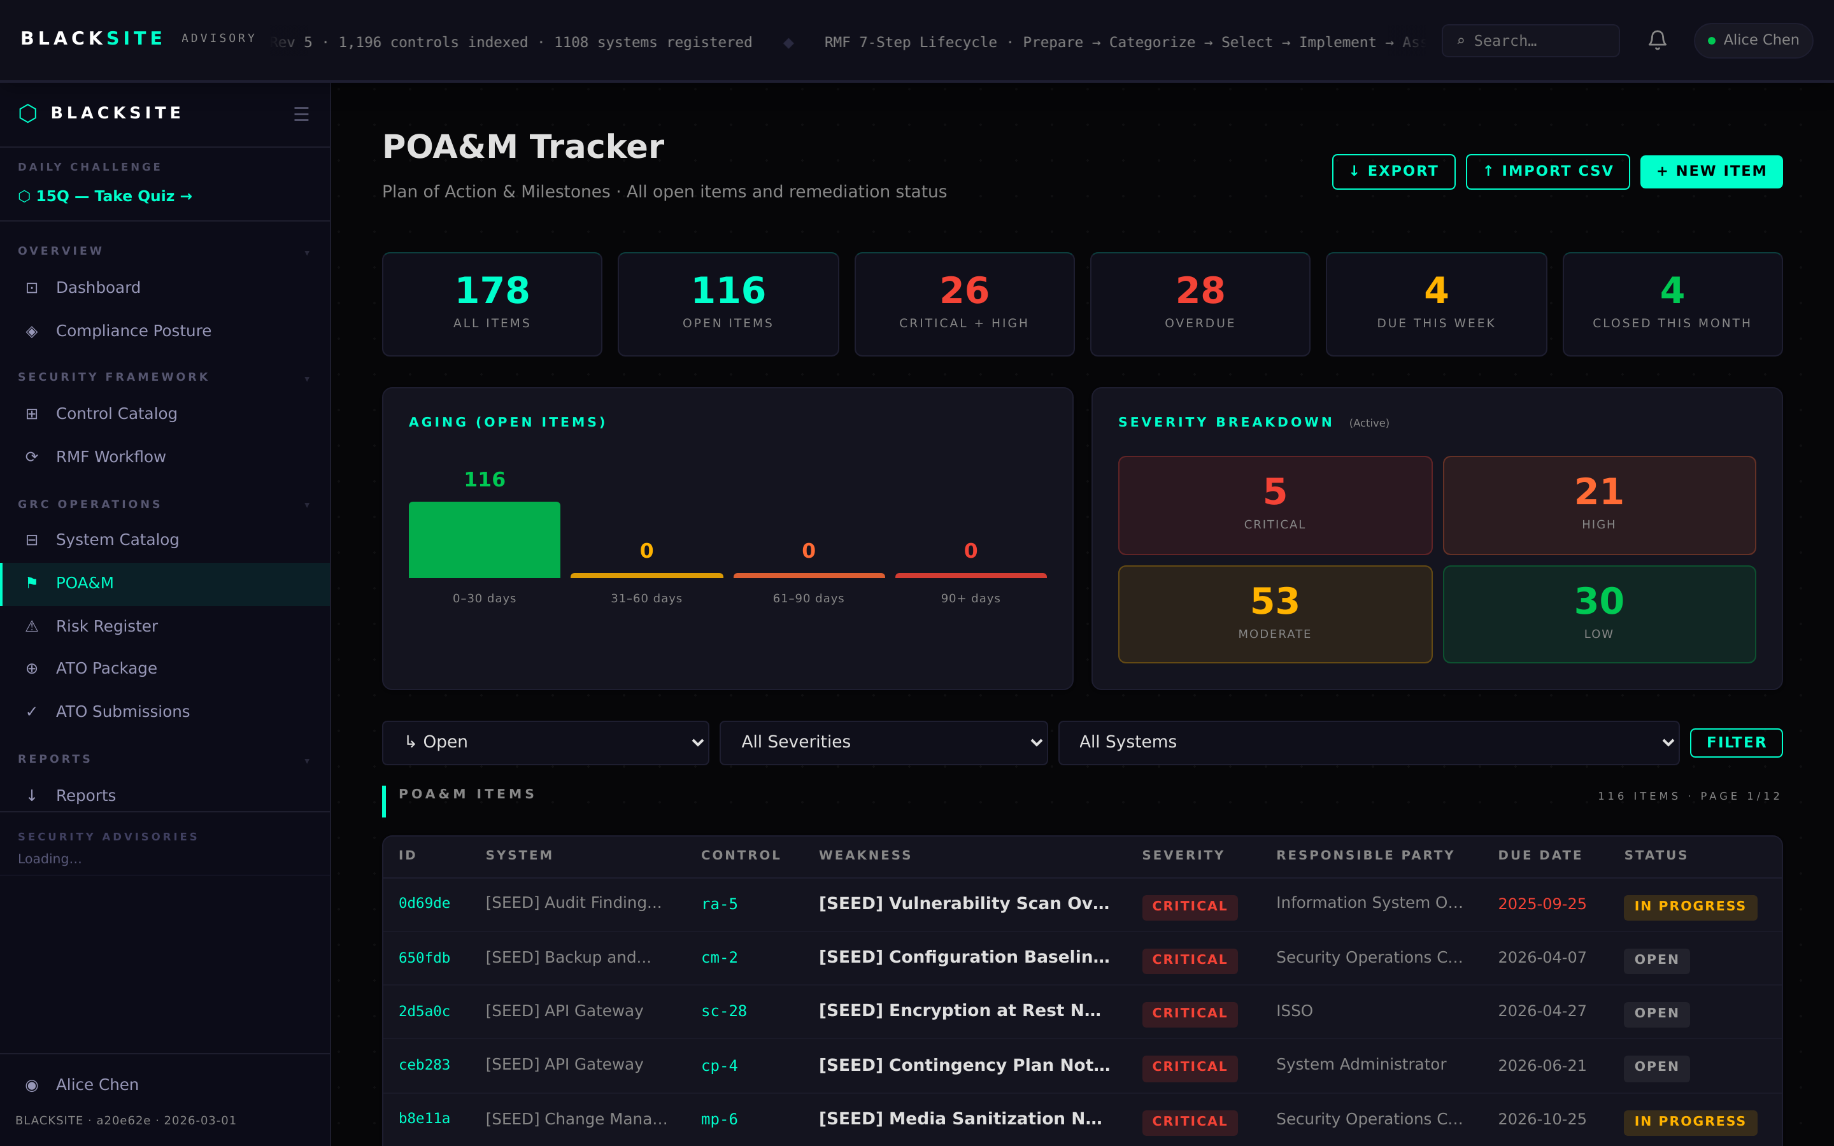
Figure 8: Ready for Review status

Step 9: Closed / Verified status
AO or admin marks the item Closed after verifying the closure evidence. A Completion Date must be entered. The approval trail records the closing official and timestamp. Closed items appear in the audit log.
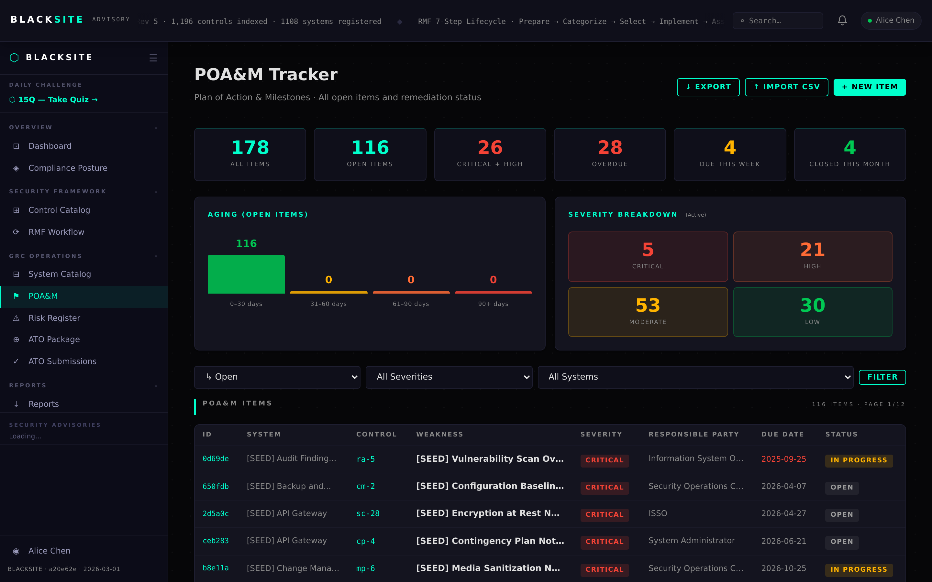
Figure 9: Closed / Verified status

Step 10: Deferred / Waiver status
If remediation cannot be completed by the scheduled date, the ISSO requests a waiver. Fill in the waiver justification and new target date. AO approval is required to grant the waiver.
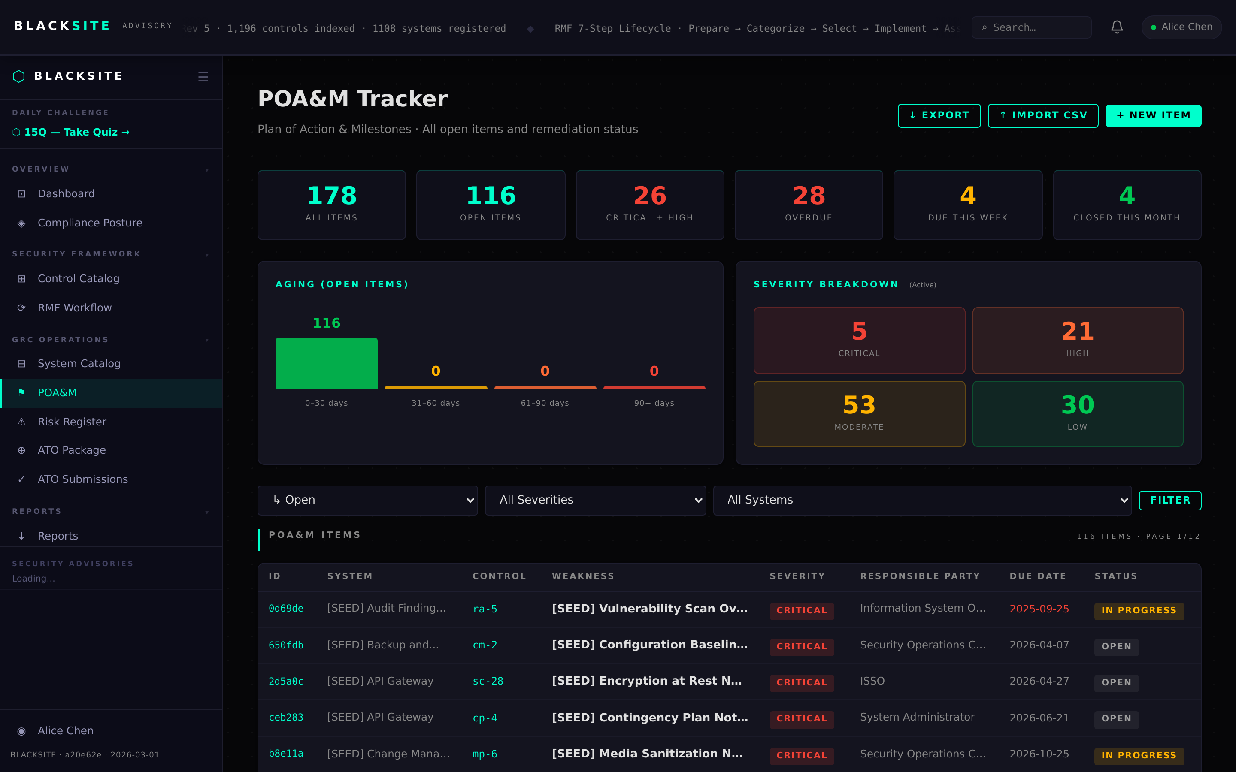
Figure 10: Deferred / Waiver status

Step 11: Accepted Risk status
For risks the organization chooses to accept rather than remediate, the ISSO sets status to Pending AO Acceptance with residual risk justification. The AO then approves or rejects the risk acceptance.
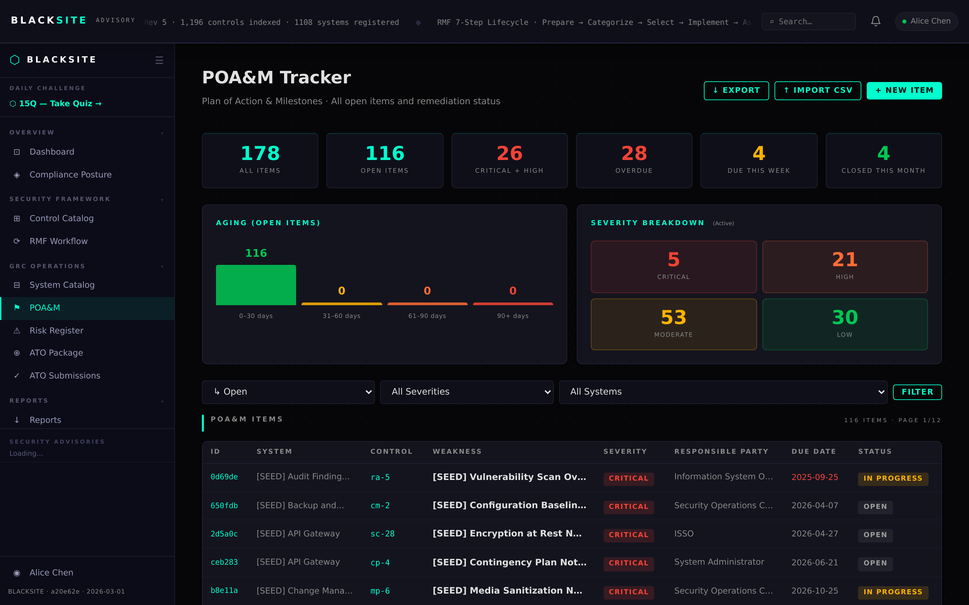
Figure 11: Accepted Risk status

Step 12: False Positive status
If the finding is determined to be a false positive, the SCA documents the rationale and sets status to False Positive. No further action is required. The item remains in the audit trail.
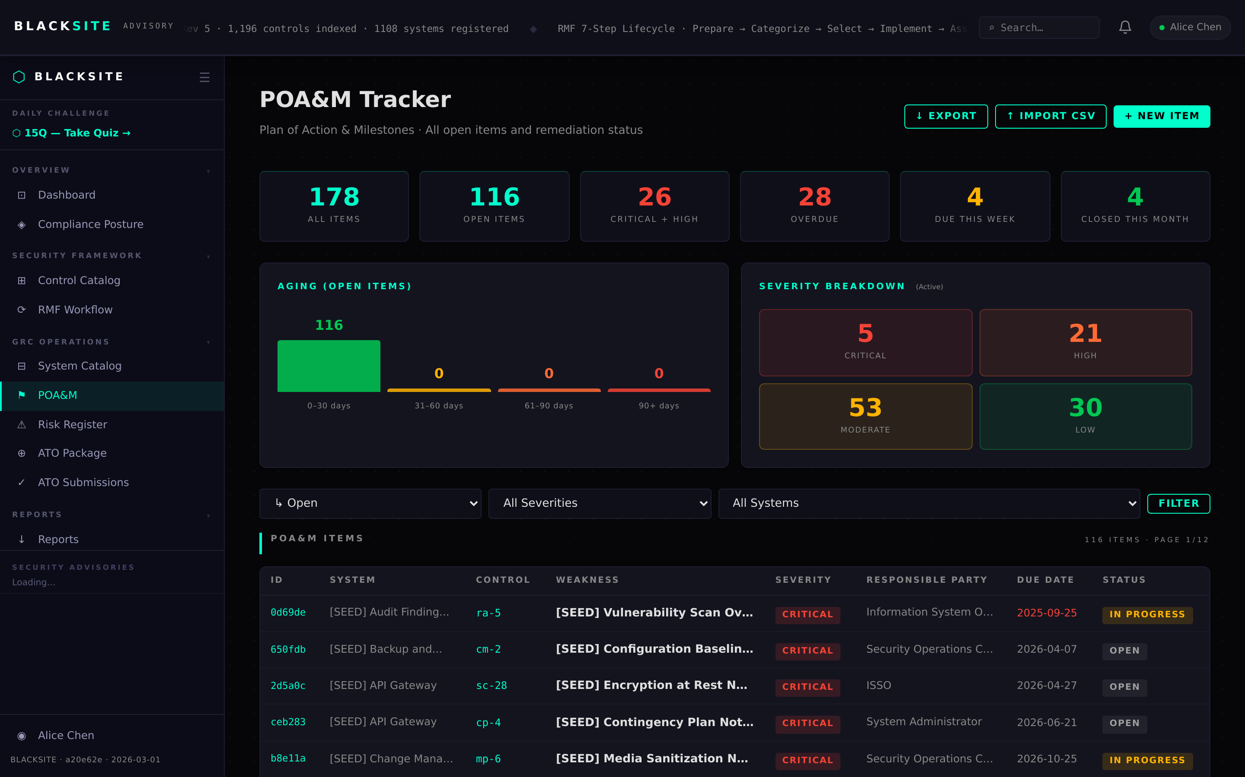
Figure 12: False Positive status

Common Issues and Resolutions
Symptom | Resolution
Status button greyed out | Your role does not have push-power for the target status. Check the POAM_PUSH_POWER role matrix.
POA&M ID not generated | IDs are generated on save. If missing after save, check the database connection.
Completion date field absent | Completion date only appears for terminal statuses (Closed, Verified). Status must be terminal.

