━━━━━━━━━━━━━━━━━━━━━━━━━━━━━━━━━━━━━━━━━━━━━━━━━━━━━━━━━━━━━━━━━━━━━━
BLACKSITE GRC Platform · THKR-BSV-001

Profile and Display Preferences
Roles: All roles
Version: 1.0 | Date: 2026-03-01 | Classification: INTERNAL USE ONLY
━━━━━━━━━━━━━━━━━━━━━━━━━━━━━━━━━━━━━━━━━━━━━━━━━━━━━━━━━━━━━━━━━━━━━━

Overview
Users can customize their BLACKSITE experience: display name, font size, data density, rows per page, theme, and RSS feed subscriptions. Preferences are stored server-side and persist across devices.

Prerequisites
- Authenticated session.

Procedure

Step 1: Open profile page
Click your username in the top navigation and select Profile, or navigate to /profile. The profile page shows your account details and a preferences panel for display settings.
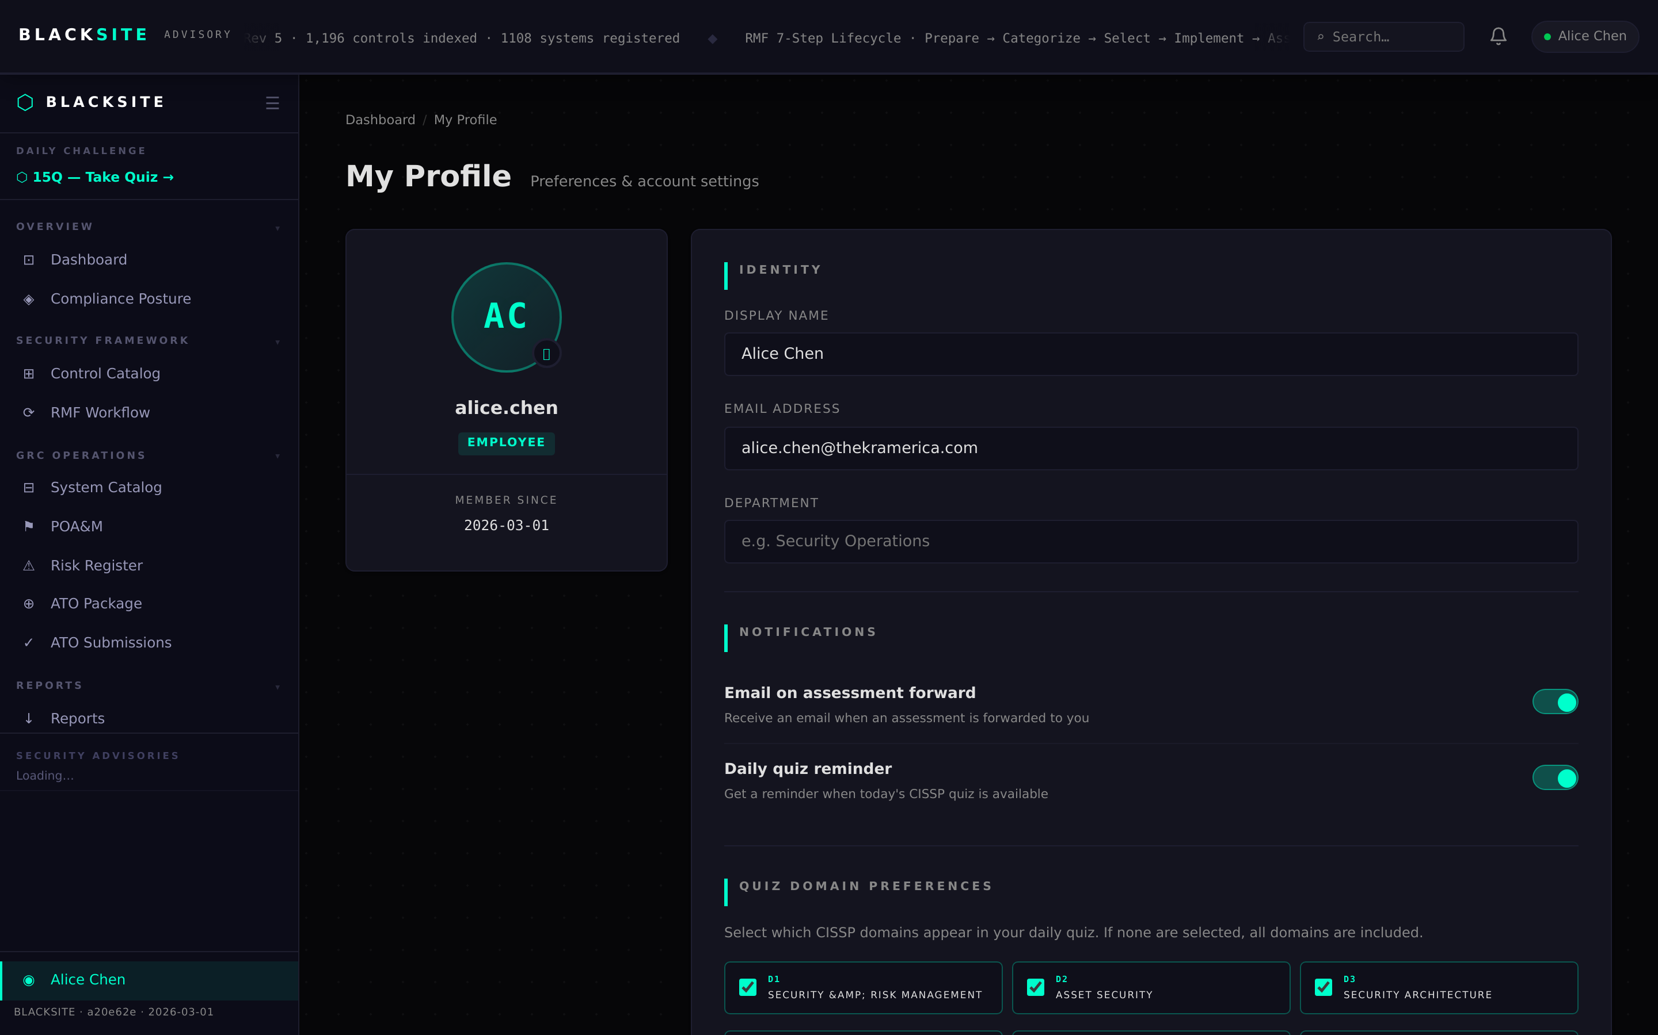
Figure 1: Open profile page

Step 2: RSS feed subscriptions
Navigate to /profile/feeds or click the Feeds link on the profile page. A curated list of 15 cybersecurity RSS feeds is available. Toggle subscriptions on/off. Subscribed feeds appear in the News section of your dashboard.
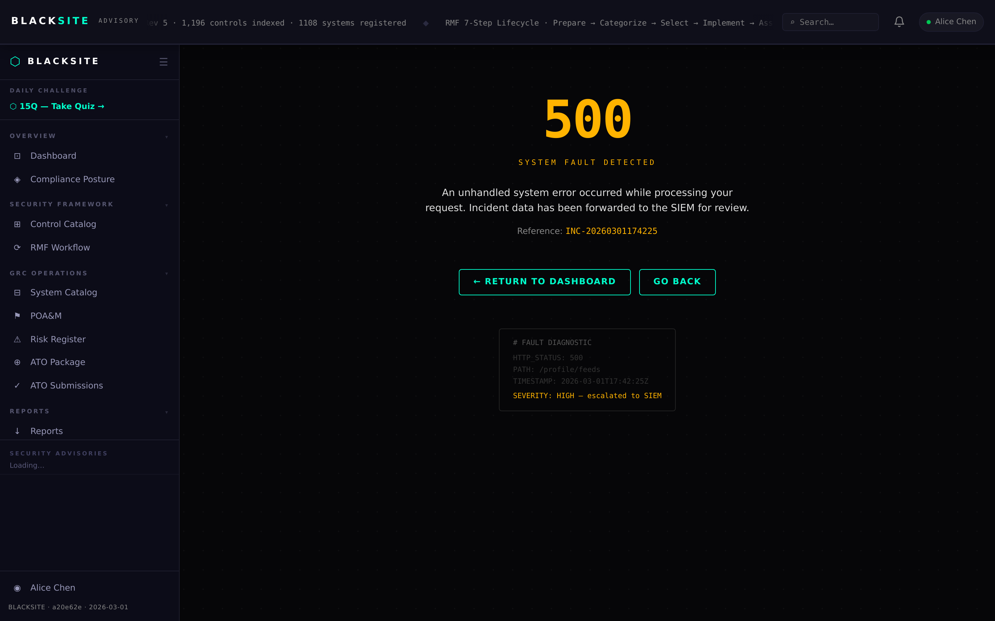
Figure 2: RSS feed subscriptions

Step 3: Theme switcher
Click your username dropdown and select a theme from the theme swatches section. 14 themes are available: default, dark, terminal, synthwave, crimson, ocean, amber, noir, and more. Theme is stored in a cookie and applied on page load.
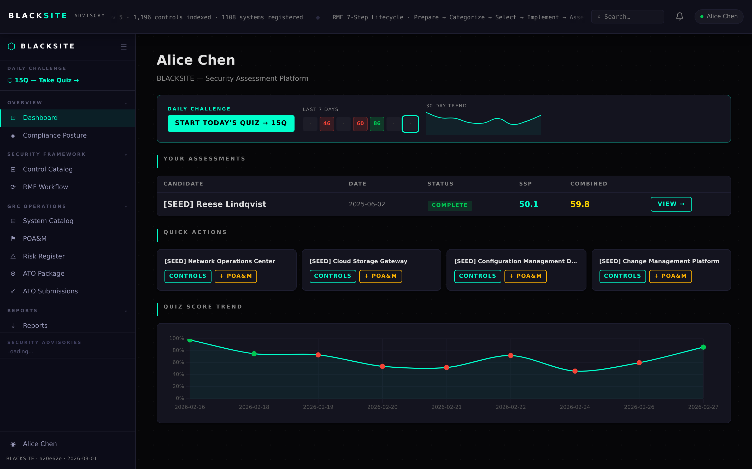
Figure 3: Theme switcher

Common Issues and Resolutions
Symptom | Resolution
Theme not persisting | Ensure cookies are enabled for the BLACKSITE domain. The theme is stored in the bsv_theme cookie.
Feed not appearing on dashboard | After subscribing, reload the dashboard. Feed items may take 15 minutes to populate from the remote RSS source.

