━━━━━━━━━━━━━━━━━━━━━━━━━━━━━━━━━━━━━━━━━━━━━━━━━━━━━━━━━━━━━━━━━━━━━━
BLACKSITE GRC Platform · THKR-BSV-001

Reports and Data Exports
Roles: ISSO, ISSM, SCA, Admin
Version: 1.0 | Date: 2026-03-01 | Classification: INTERNAL USE ONLY
━━━━━━━━━━━━━━━━━━━━━━━━━━━━━━━━━━━━━━━━━━━━━━━━━━━━━━━━━━━━━━━━━━━━━━

Overview
BLACKSITE provides multiple report and export options: system-level PDF reports, generated compliance reports (executive summary, evidence pack, BCDR pack), POA&M exports (CSV/XLSX), risk exports, and audit log exports.

Prerequisites
- Reports are generated on demand or auto-triggered on rotation days 18/24/25.

Procedure

Step 1: Reports center
Navigate to /reports for an overview of all generated reports across all systems. Filter by system, report type, or date range. Each report shows file size, generation date, and status (generating/ready/error).
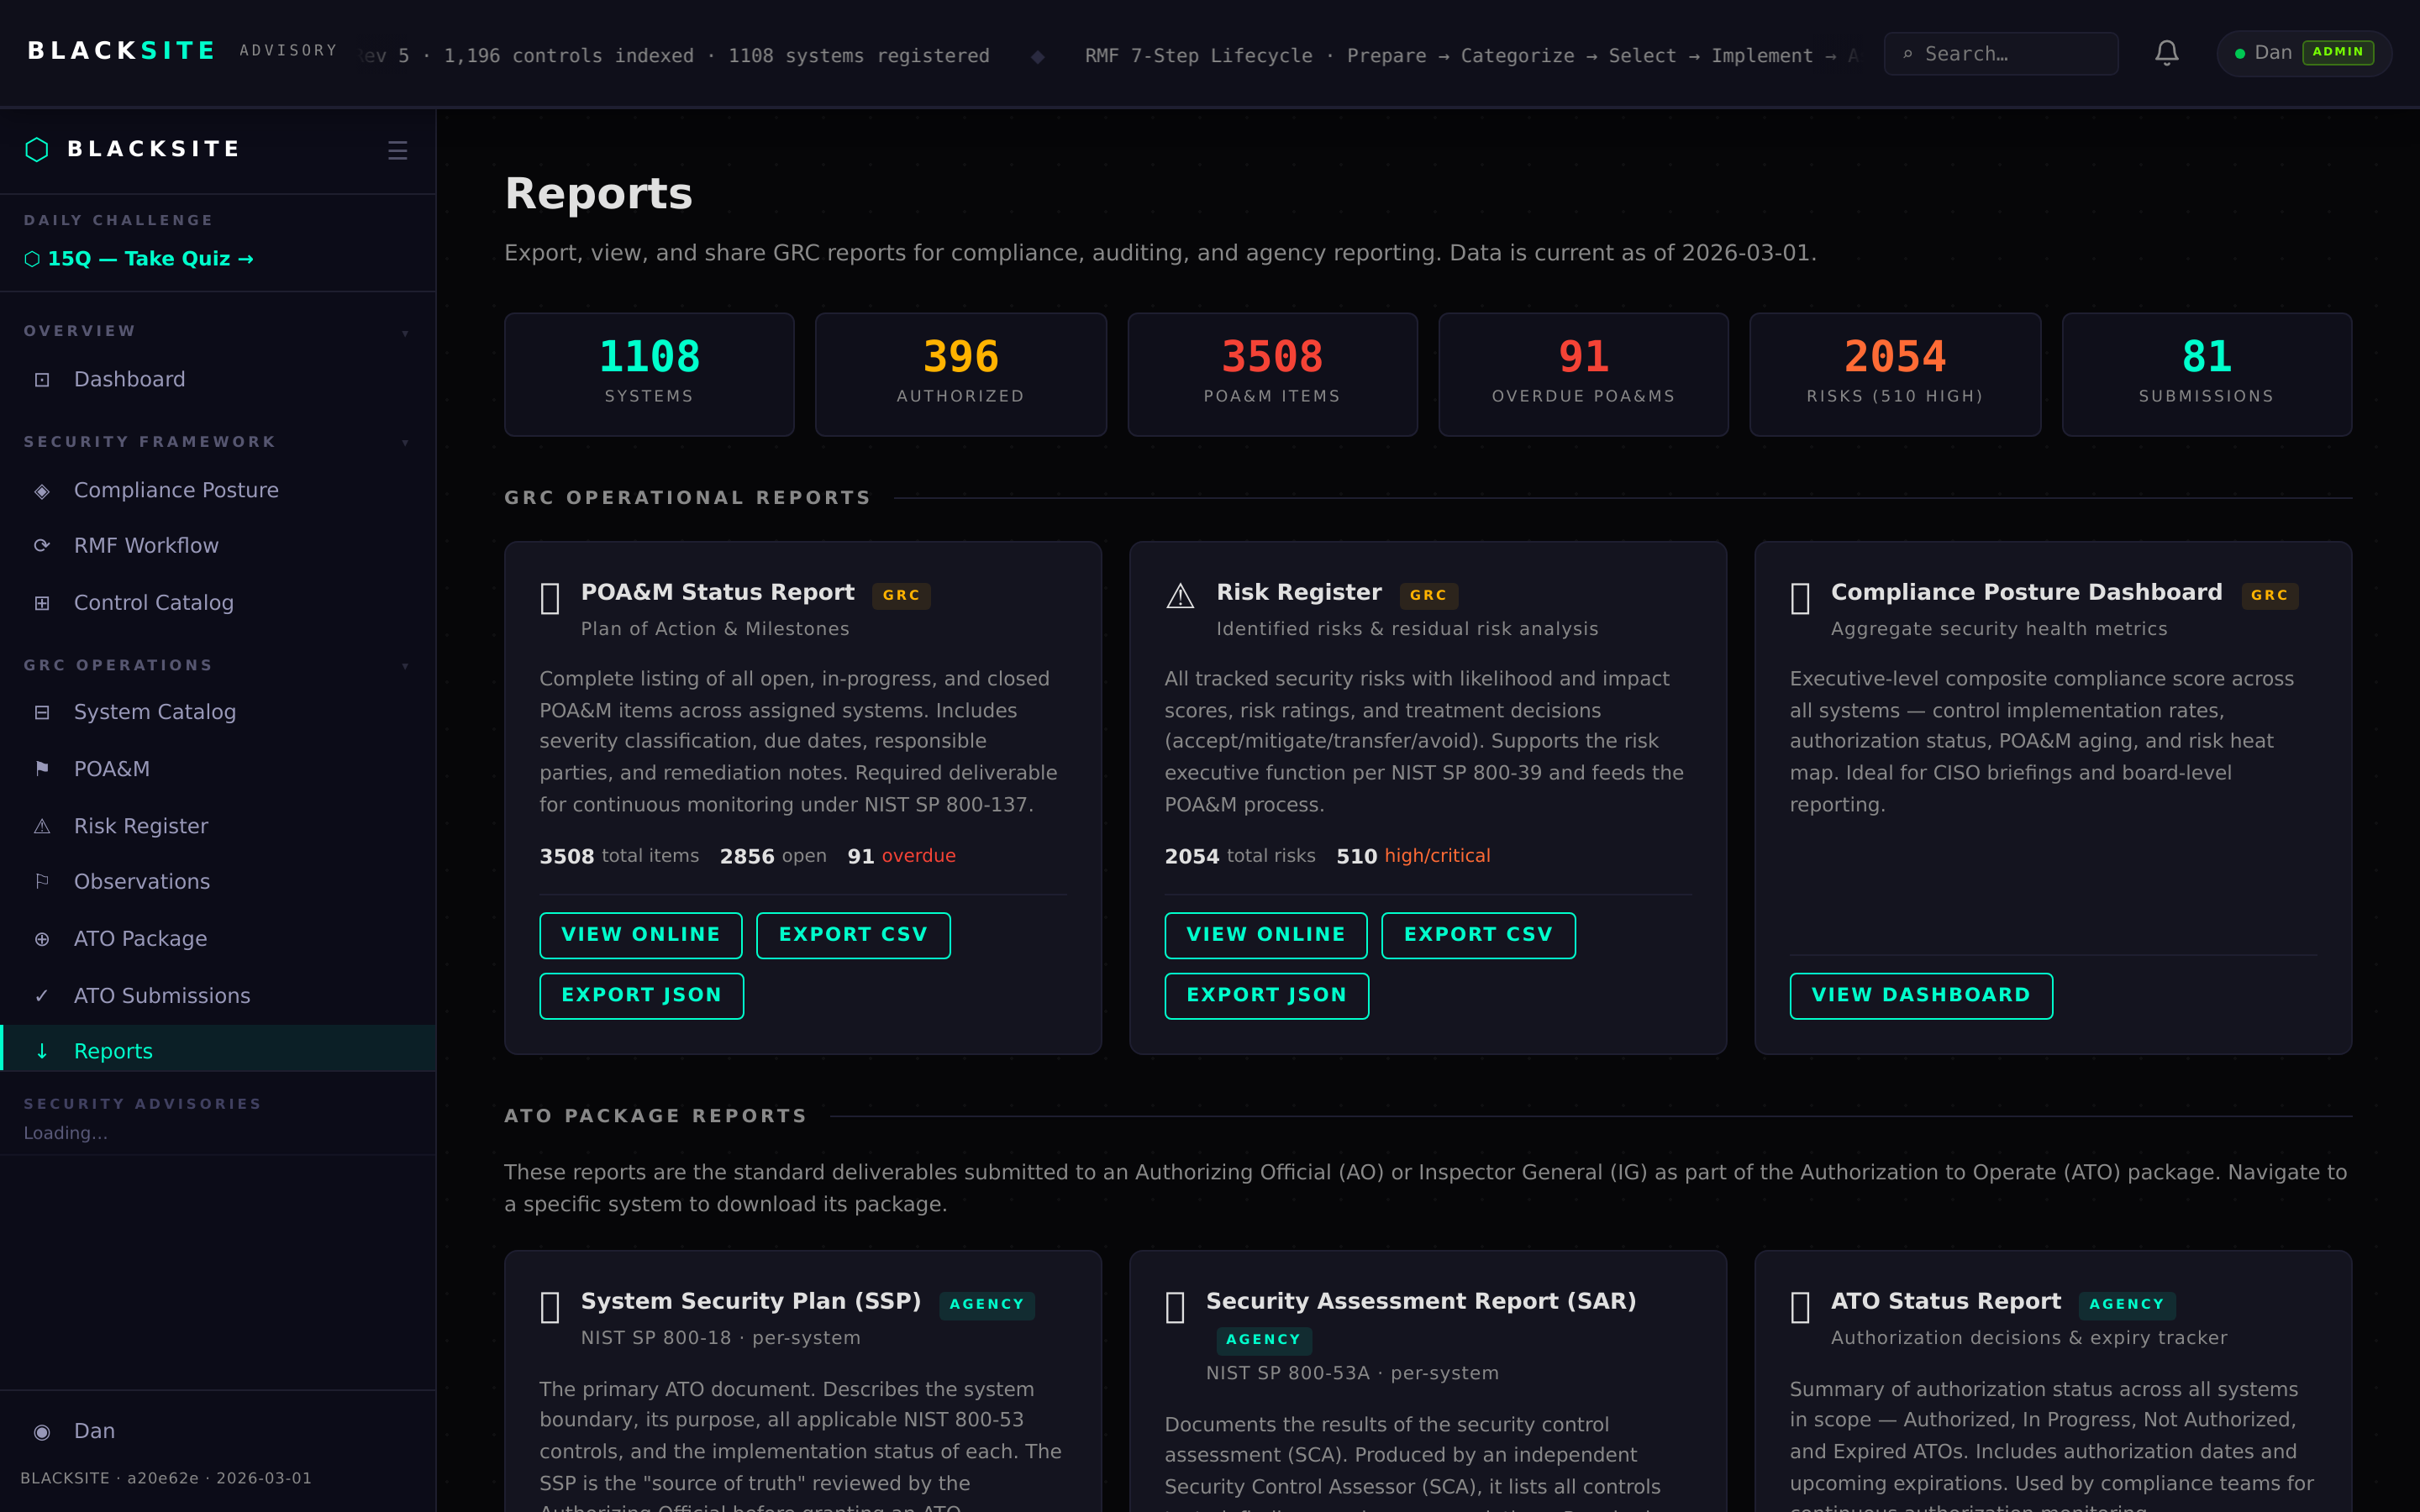
Figure 1: Reports center

Step 2: System print report
Navigate to /systems/{id}/report. This page renders a printer-optimized HTML report of the system's current state. Use Ctrl+P to save as PDF for offline distribution or archival.
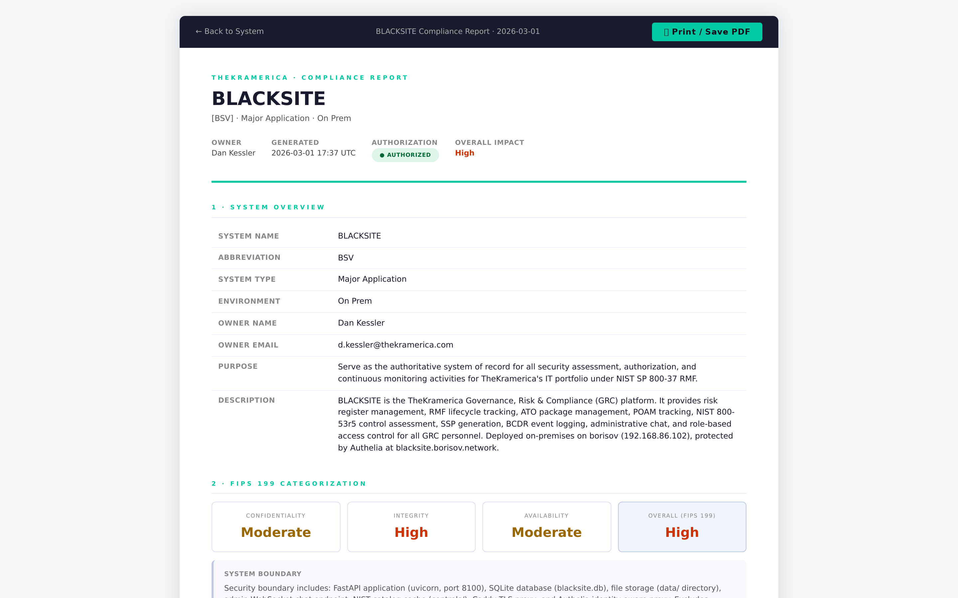
Figure 2: System print report

Step 3: System generated reports list
Navigate to /systems/{id}/reports to see all PDF reports generated for this system. Each row has a Download button that serves the file with the proper Content-Disposition header for browser save.
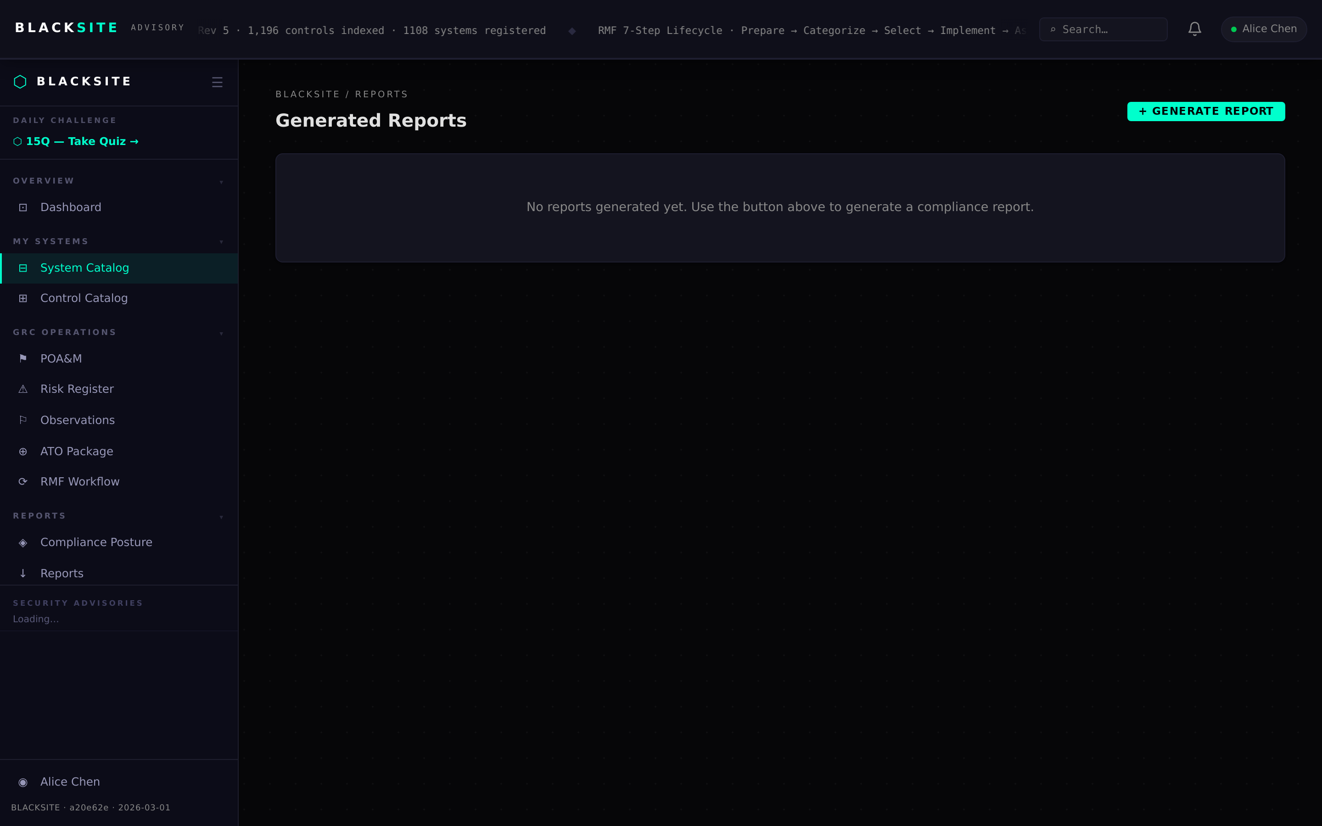
Figure 3: System generated reports list

Step 4: Export POA&M list
Navigate to /poam/export. Select format (CSV or XLSX) and optional date range filter. Click Export. The file downloads immediately.
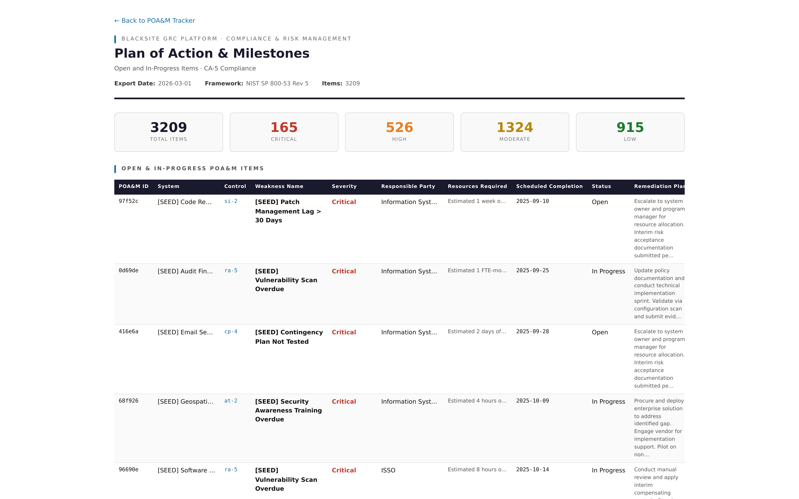
Figure 4: Export POA&M list

Step 5: Export risk register
Navigate to /risks/export. Same format and filter options as POA&M export. The export includes computed risk scores and treatment plans.
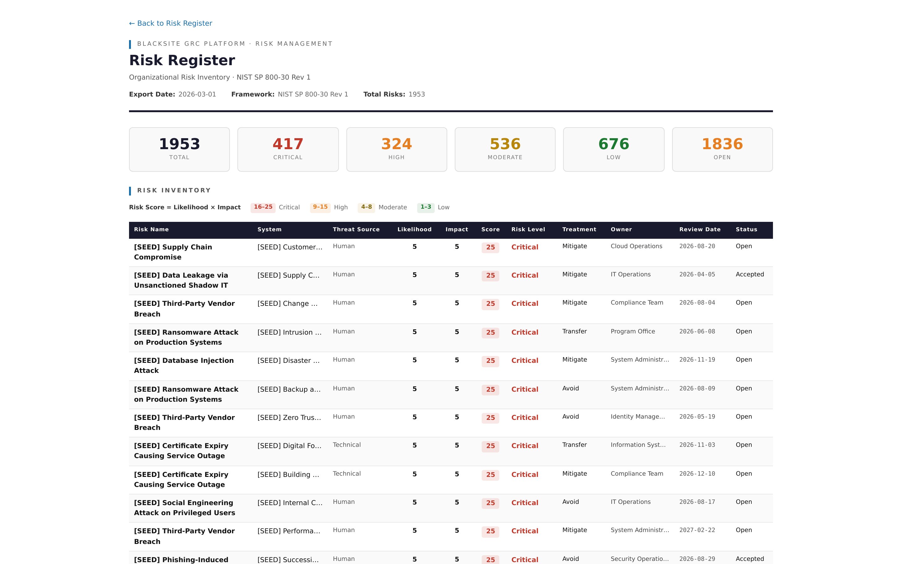
Figure 5: Export risk register

Step 6: Audit log export
Admin only: navigate to /admin/audit. Click Export Audit Log to download the full audit trail as CSV. The audit log records every significant action with timestamp, user, action type, and detail string.
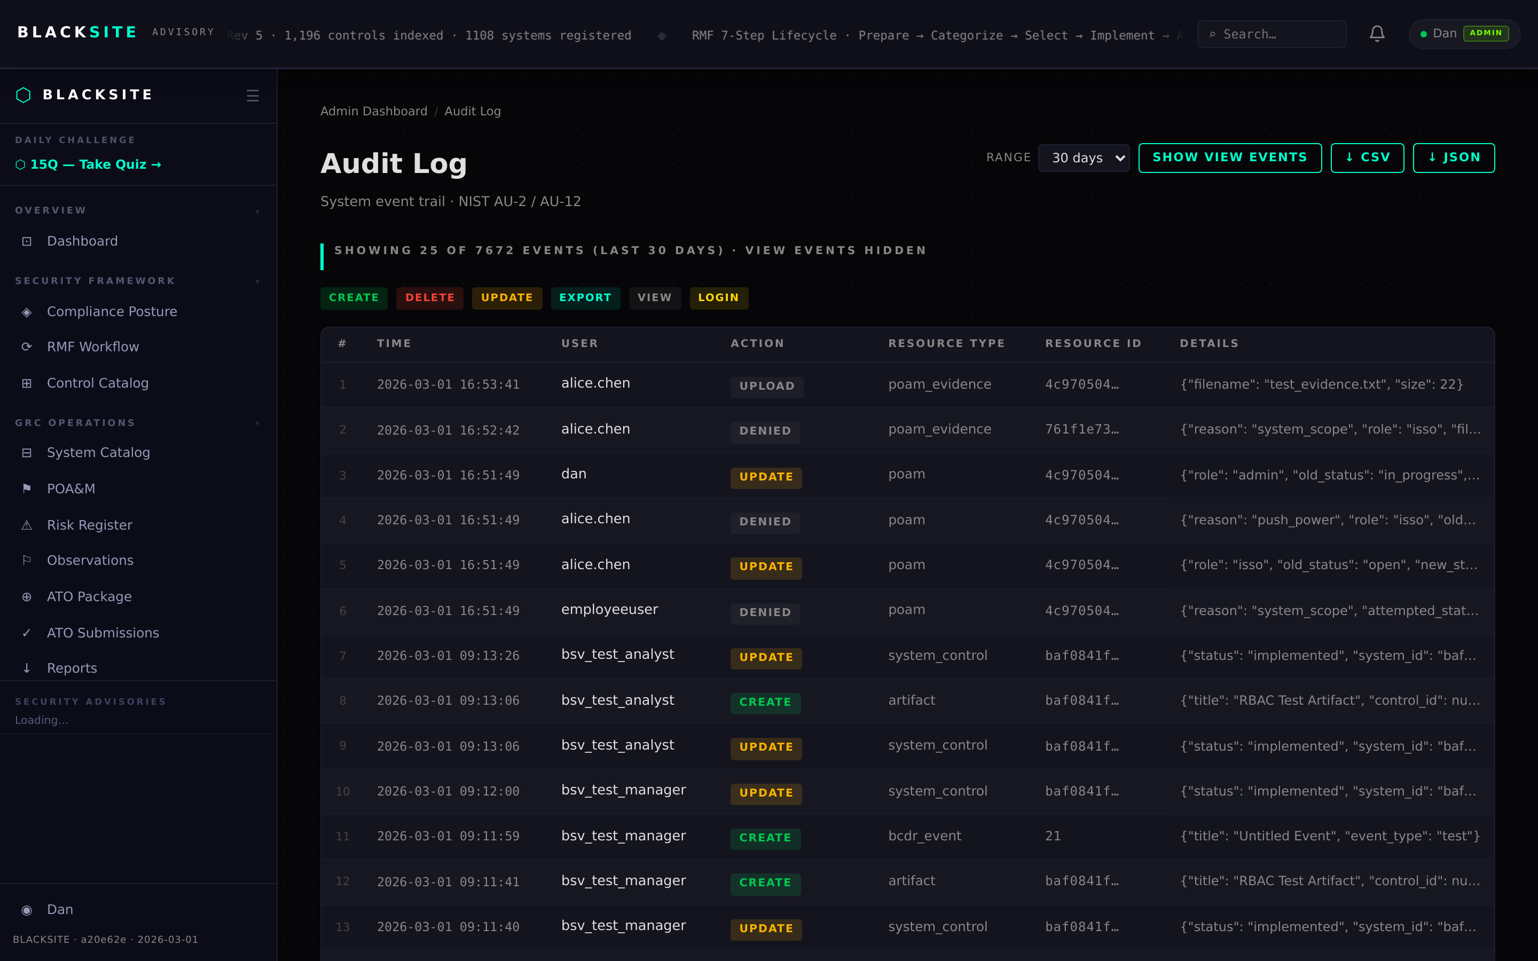
Figure 6: Audit log export

Common Issues and Resolutions
Symptom | Resolution
Report status stuck on 'generating' | The background task may have failed. Check the server logs. Trigger a new generation.
Download returns 404 | The report file may have been deleted from disk. Regenerate the report.
POA&M export empty | Verify your user has assigned systems with POA&M items. The export is scoped to your assignments.

