━━━━━━━━━━━━━━━━━━━━━━━━━━━━━━━━━━━━━━━━━━━━━━━━━━━━━━━━━━━━━━━━━━━━━━
BLACKSITE GRC Platform · THKR-BSV-001

Risk Register Management
Roles: ISSO, ISSM, Admin
Version: 1.0 | Date: 2026-03-01 | Classification: INTERNAL USE ONLY
━━━━━━━━━━━━━━━━━━━━━━━━━━━━━━━━━━━━━━━━━━━━━━━━━━━━━━━━━━━━━━━━━━━━━━

Overview
The risk register tracks identified risks separate from POA&M items. Risks include a likelihood × impact score matrix, treatment plan, and status. The heat map on the risk list provides a visual overview of the risk posture.

Prerequisites
- System record with ISSO assigned.

Procedure

Step 1: View the risk list
Navigate to /risks. All risks across your assigned systems are listed with risk level badges (Critical/High/Moderate/Low), system name, likelihood, impact, and treatment status. The risk heat map appears above the table.
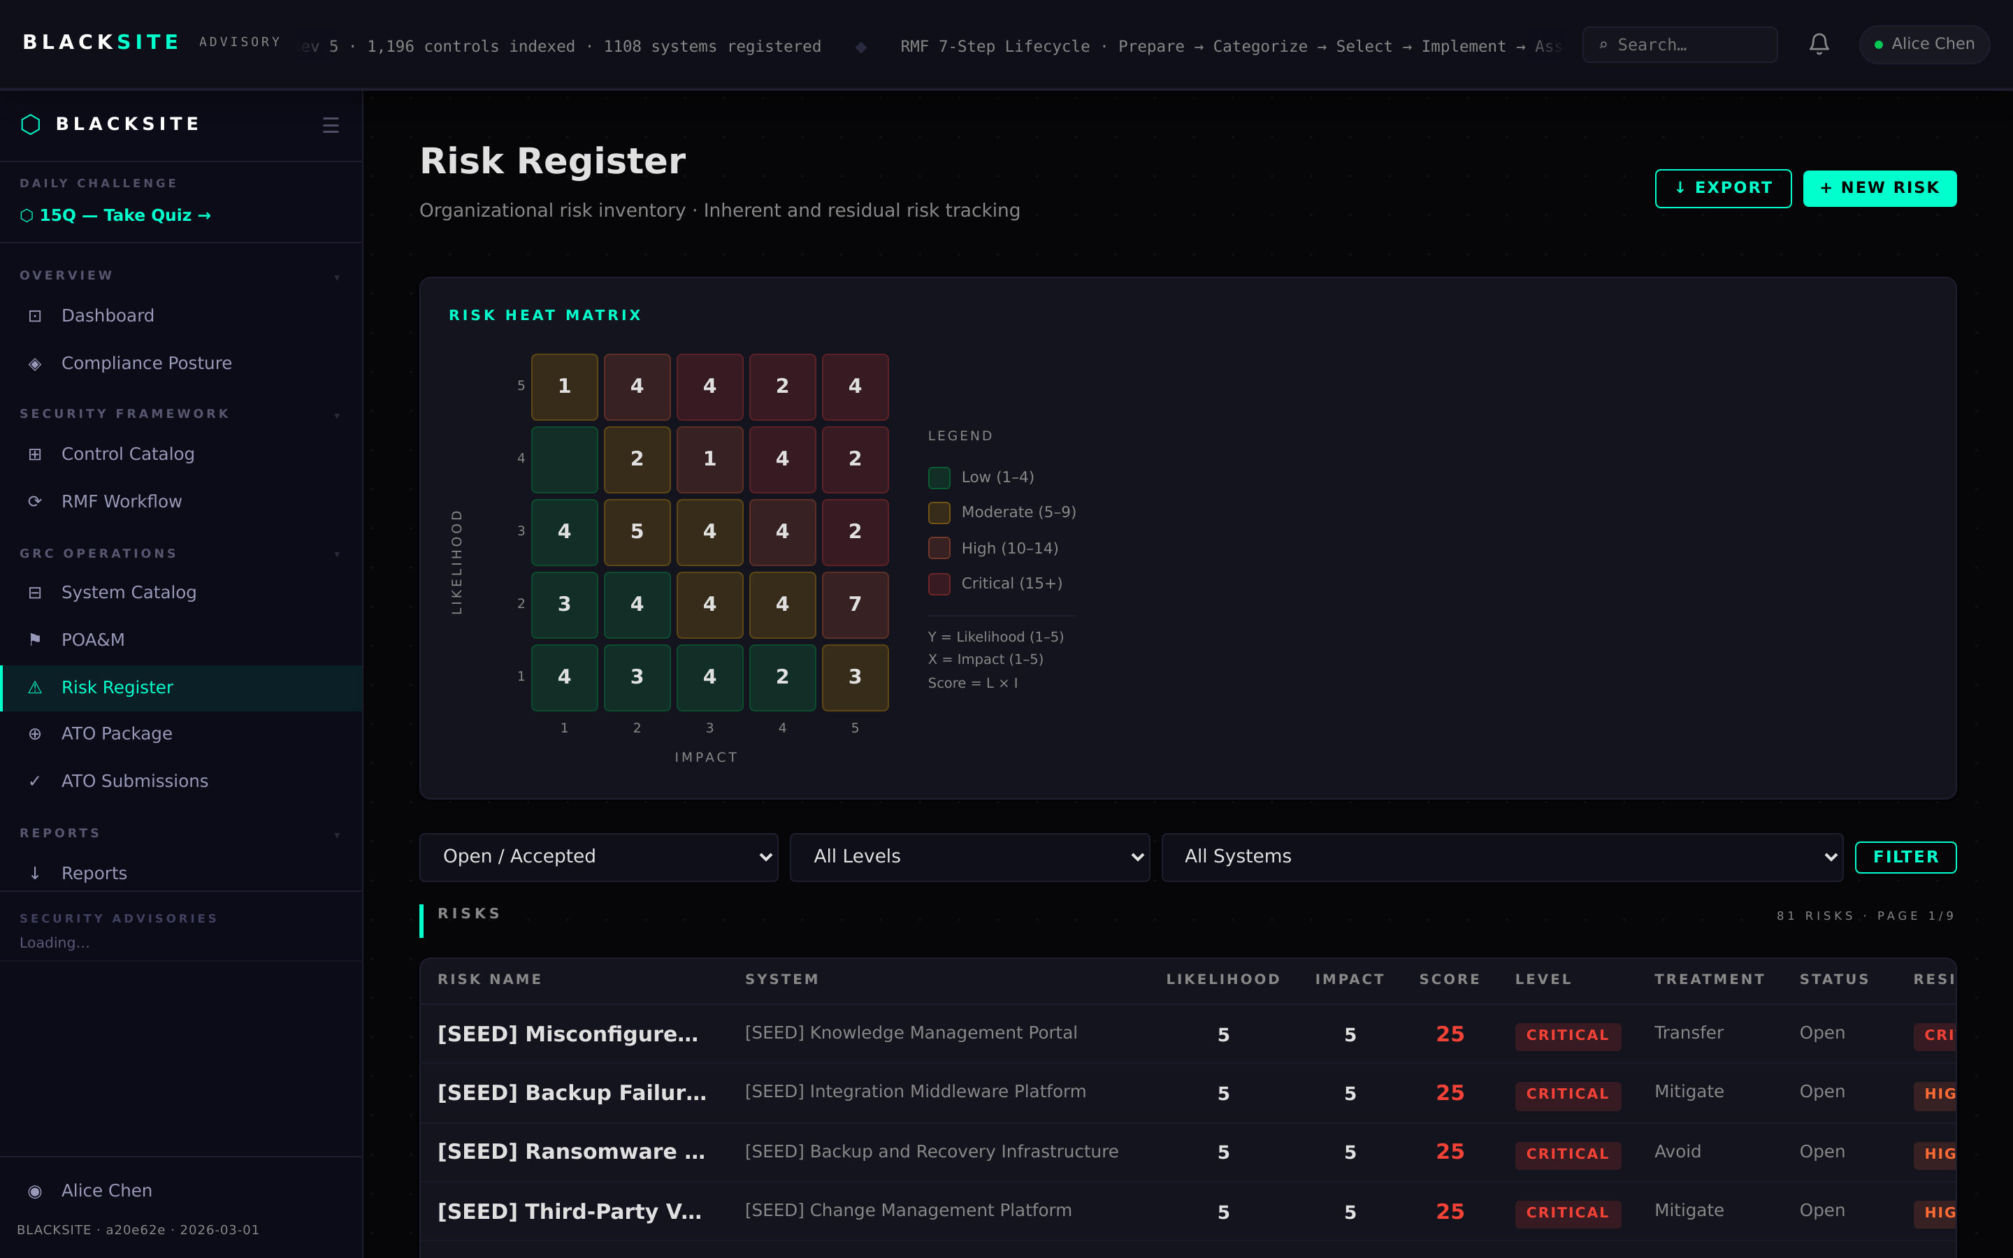
Figure 1: View the risk list

Step 2: Create a new risk
Click + New Risk. Fill in: System, Title, Description, Likelihood (1–5), Impact (1–5), Treatment Plan, and Status (Open/Mitigated/Accepted/Closed). The Risk Score and Level are computed automatically (Likelihood × Impact).
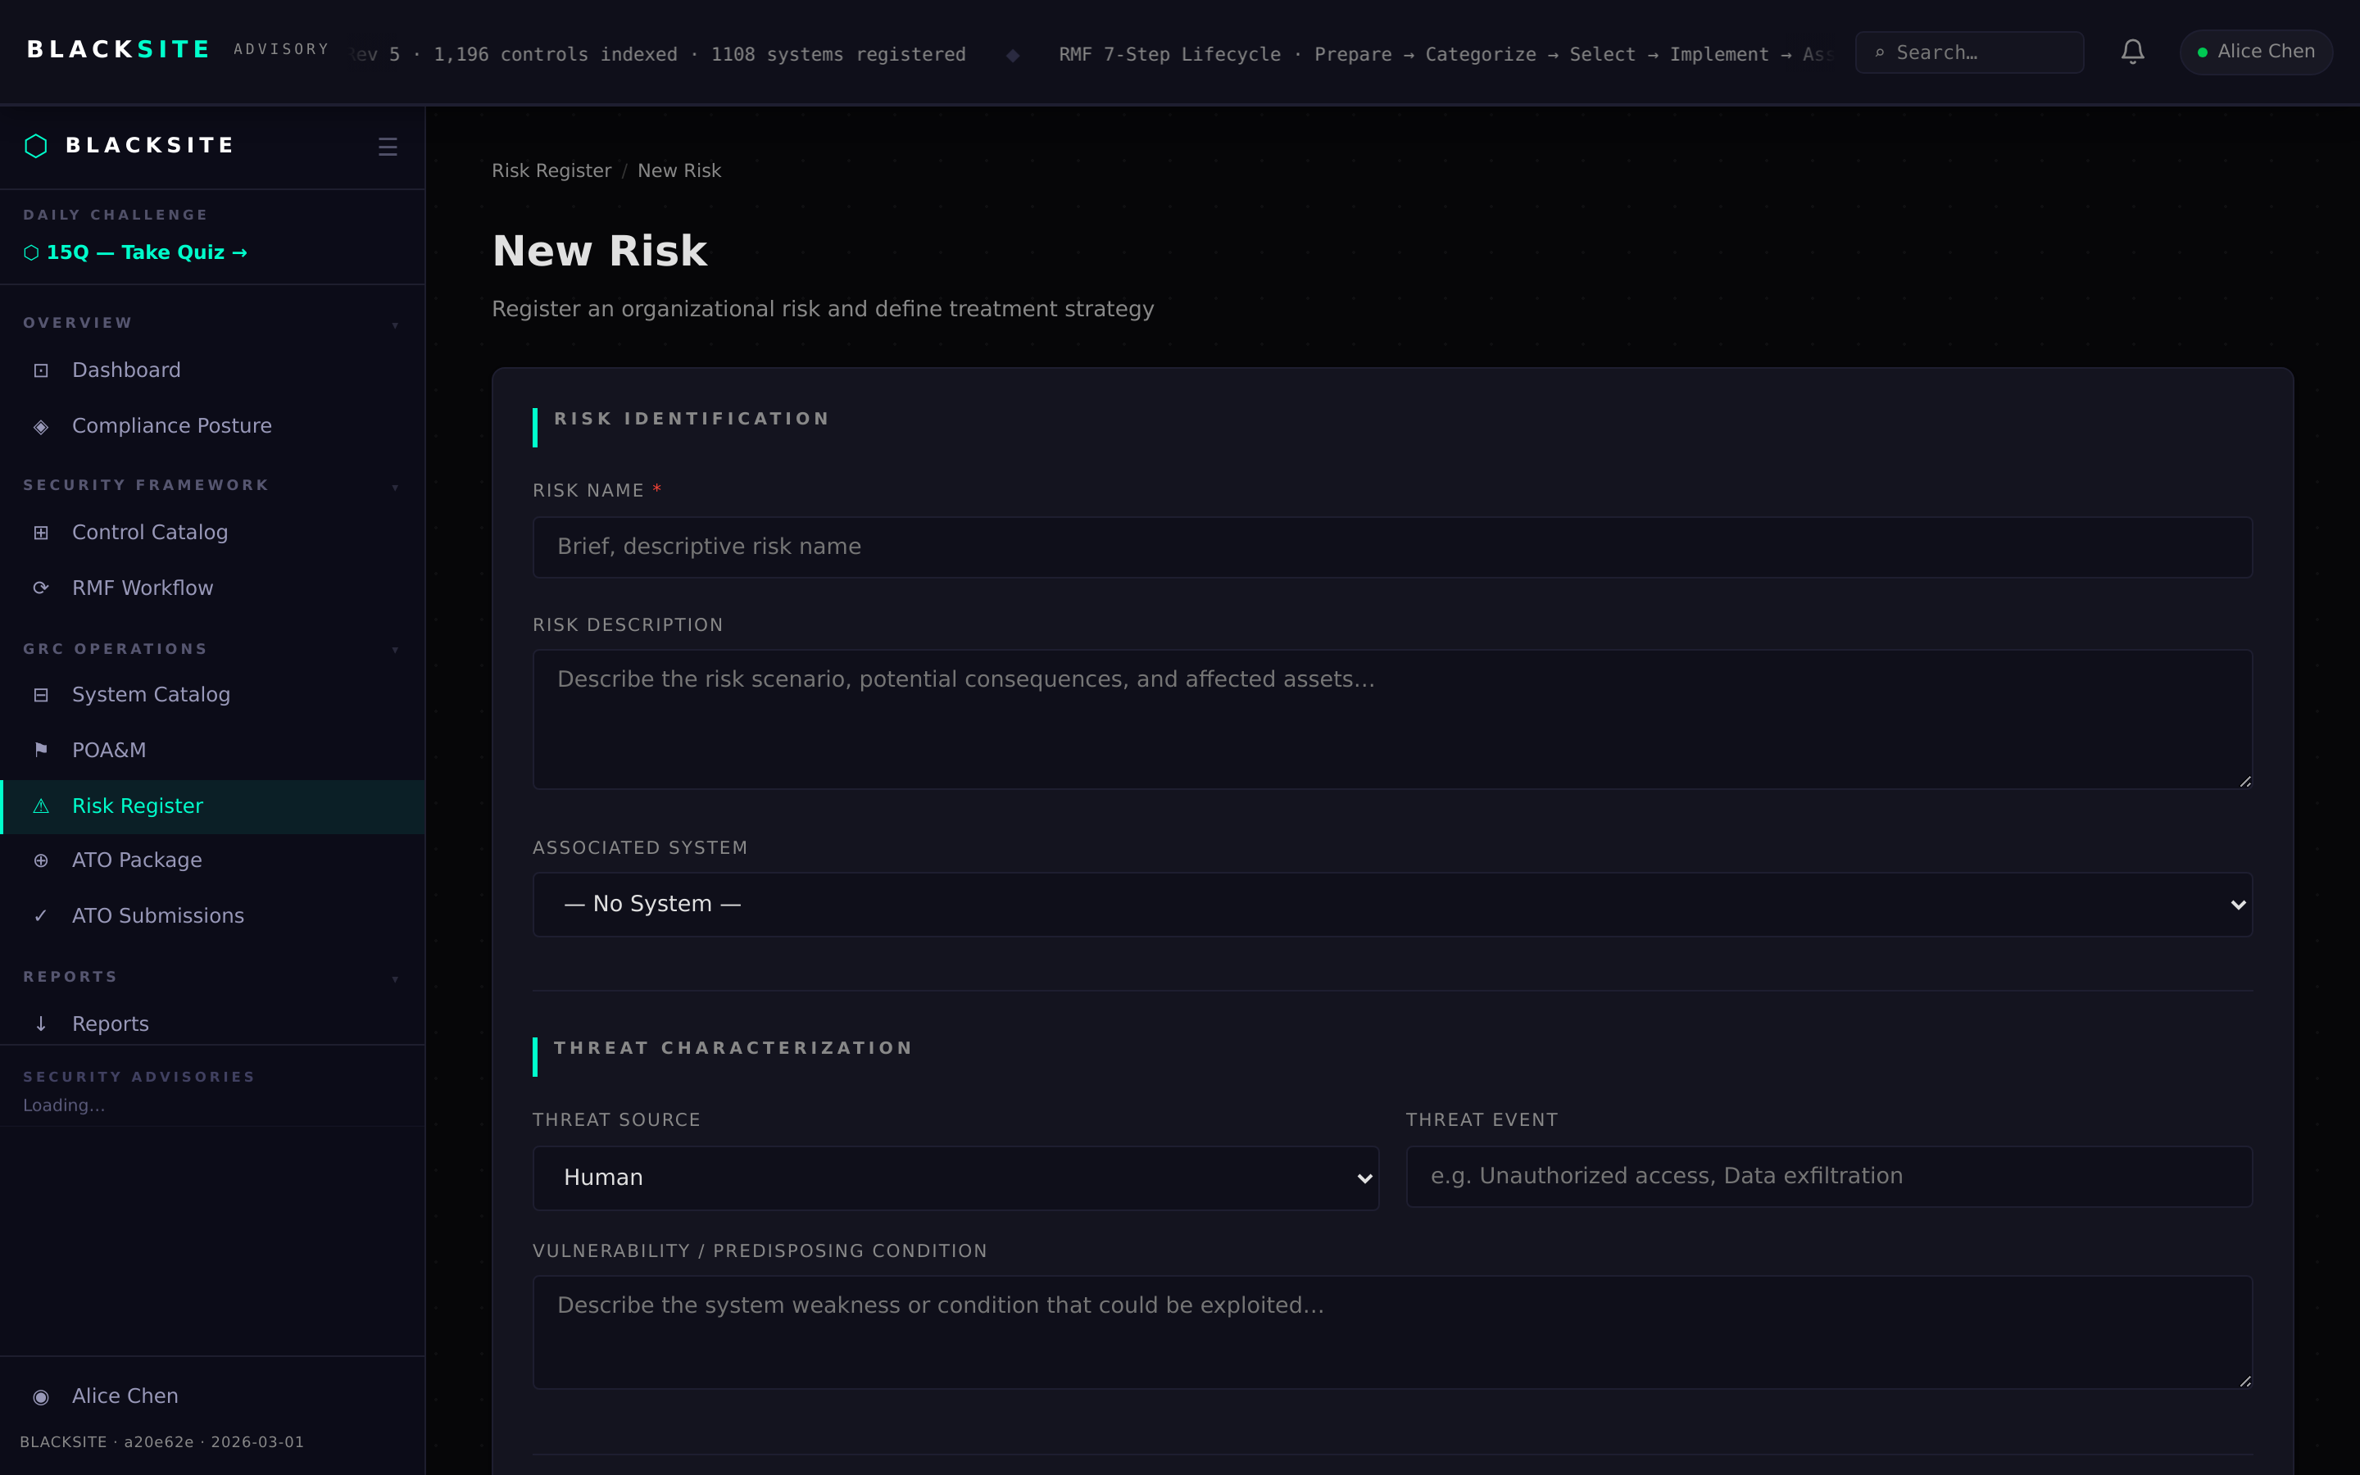
Figure 2: Create a new risk

Step 3: View risk detail
Click a risk row to open its detail page. The detail shows all fields, the computed risk level, treatment plan, and creation/modification history. Edit any field and click Save to update.
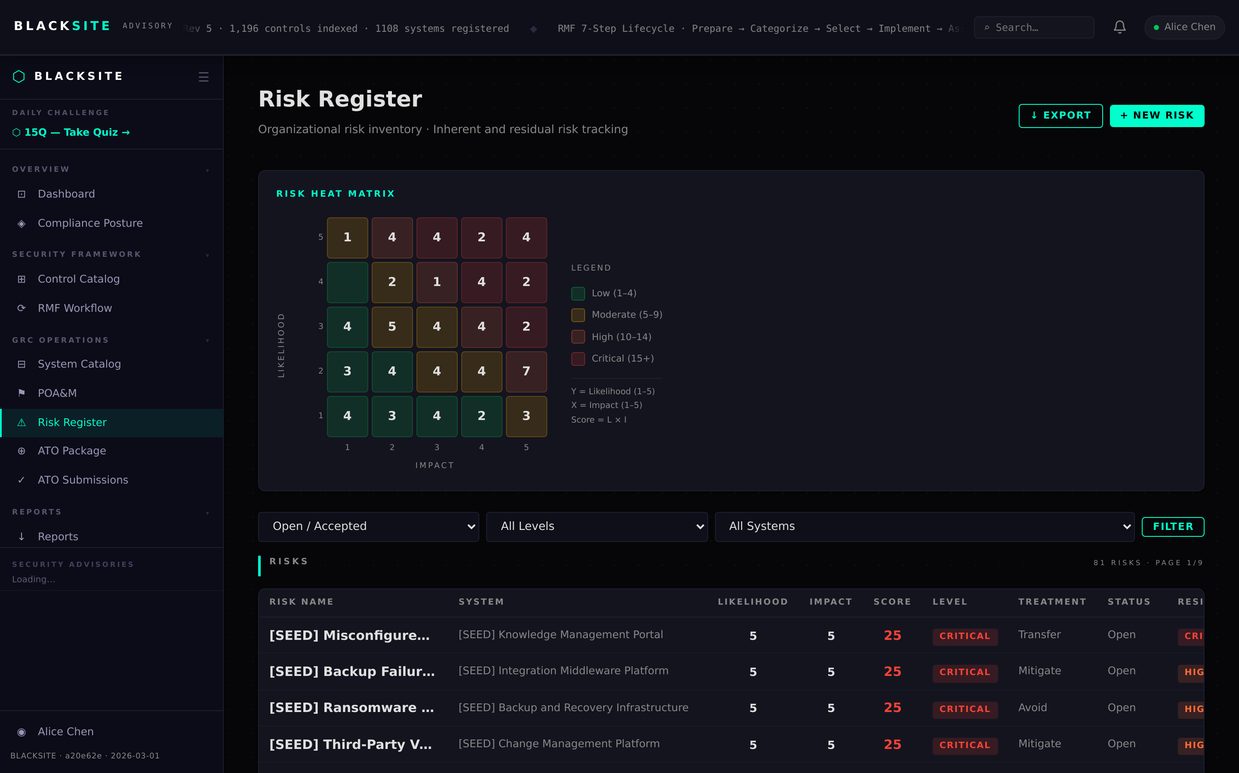
Figure 3: View risk detail

Step 4: Export risk register
Navigate to /risks/export to download the full risk register as CSV or XLSX. The export includes computed risk scores, treatment plans, and status. Use for risk management reporting.
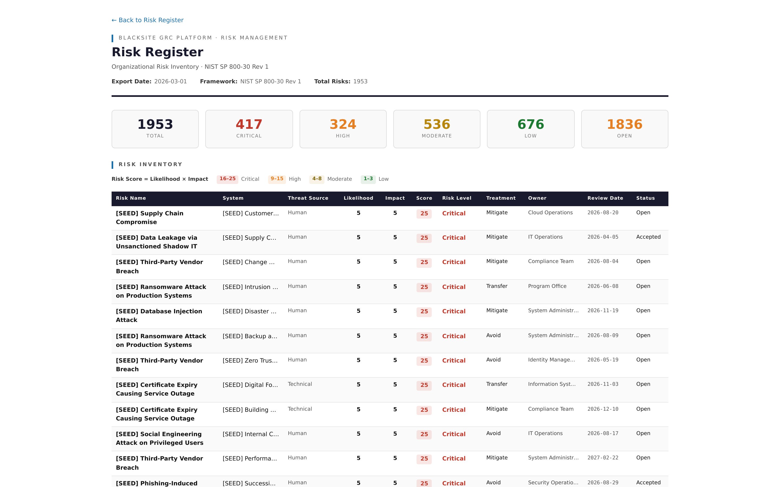
Figure 4: Export risk register

Common Issues and Resolutions
Symptom | Resolution
Risk score shows 0 | Both Likelihood and Impact must be set (1–5). Verify both fields are filled.
Risk level shows Low for high scores | Risk level is computed as L×I. A score of 15 is Critical. Check if fields saved correctly.

