━━━━━━━━━━━━━━━━━━━━━━━━━━━━━━━━━━━━━━━━━━━━━━━━━━━━━━━━━━━━━━━━━━━━━━
BLACKSITE GRC Platform · THKR-BSV-001

Session Authentication and Access
Roles: All roles
Version: 1.0 | Date: 2026-03-01 | Classification: INTERNAL USE ONLY
━━━━━━━━━━━━━━━━━━━━━━━━━━━━━━━━━━━━━━━━━━━━━━━━━━━━━━━━━━━━━━━━━━━━━━

Overview
BLACKSITE uses a reverse proxy (Authelia) to authenticate users before any page is served. The Remote-User header carries the authenticated username. This SOP covers how sessions are established, the idle timeout policy, and how to verify system health.

Prerequisites
- Your username must exist in the BLACKSITE user database.
- You must be authenticated through the Authelia SSO portal at your organization's URL.
- Your browser must accept first-party cookies from the BLACKSITE domain.

Procedure

Step 1: Access the BLACKSITE URL
Navigate to your organization's BLACKSITE URL. Authelia will intercept the request and verify your session. If you are not logged in, you will be redirected to the Authelia login page. Complete SSO authentication there first.
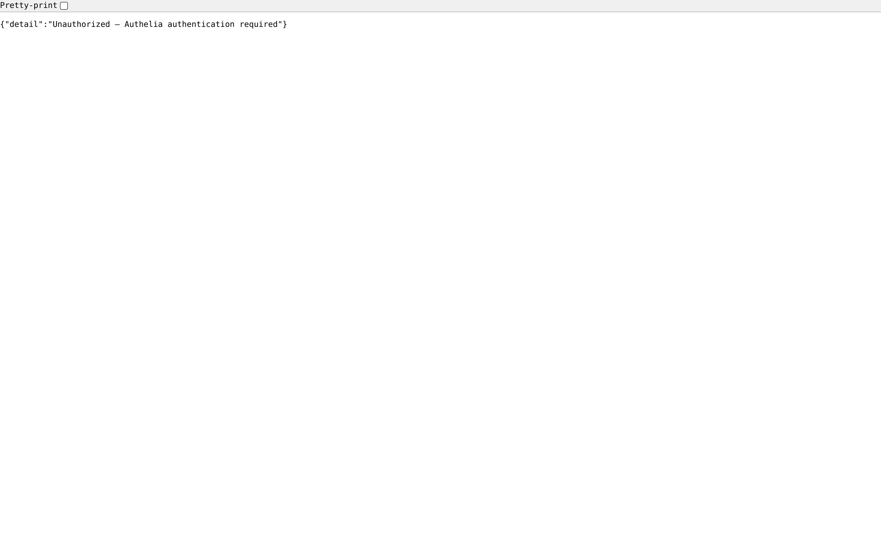
Figure 1: Access the BLACKSITE URL

Step 2: Confirm dashboard loads
After successful authentication, Authelia injects the Remote-User header and forwards the request. BLACKSITE reads this header and identifies your account. You will be redirected to your role-appropriate dashboard automatically.
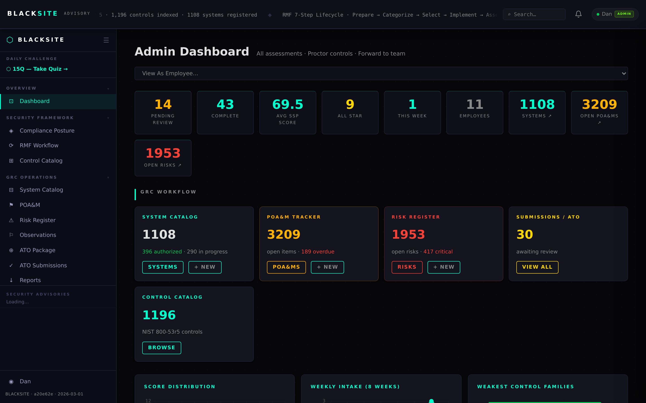
Figure 2: Confirm dashboard loads

Step 3: Verify system health (optional)
Navigate to /health to confirm the application and database are operational. This endpoint returns a JSON payload with status 'ok' and the current timestamp. Use this endpoint to confirm connectivity if the dashboard does not load.

Figure 3: Verify system health (optional)

Step 4: Session idle timeout behavior
BLACKSITE enforces a 15-minute idle session timeout. If you remain inactive, a toast notification will appear warning you. Clicking anywhere on the page resets the timer. The heartbeat API is called automatically every 5 minutes while the page is open.
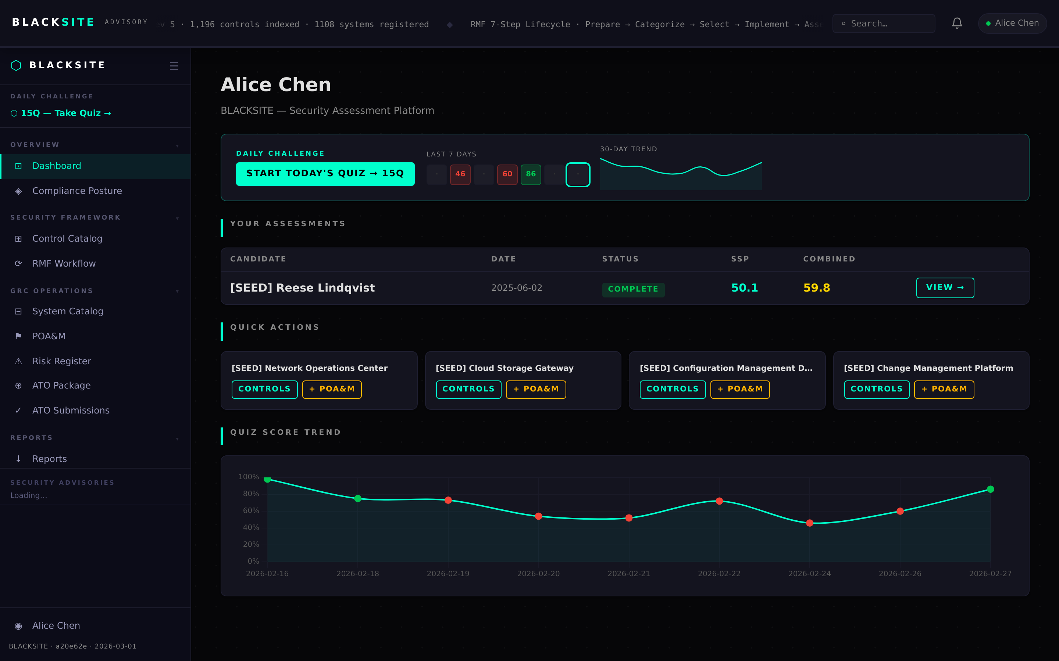
Figure 4: Session idle timeout behavior

Step 5: Sign out
Navigate to /logout or click your username in the top-right navigation and select Sign Out. BLACKSITE clears its session state. You will be redirected to the Authelia logout page. Note: Authelia may keep your SSO session active.
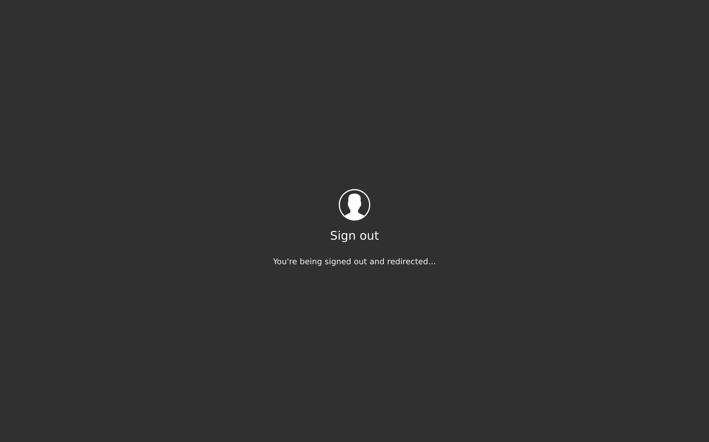
Figure 5: Sign out

Step 6: Check API version
Navigate to /api/version to confirm the running build stamp, version string, and deployment timestamp. Use this when troubleshooting version-specific issues or verifying a new deployment went live.
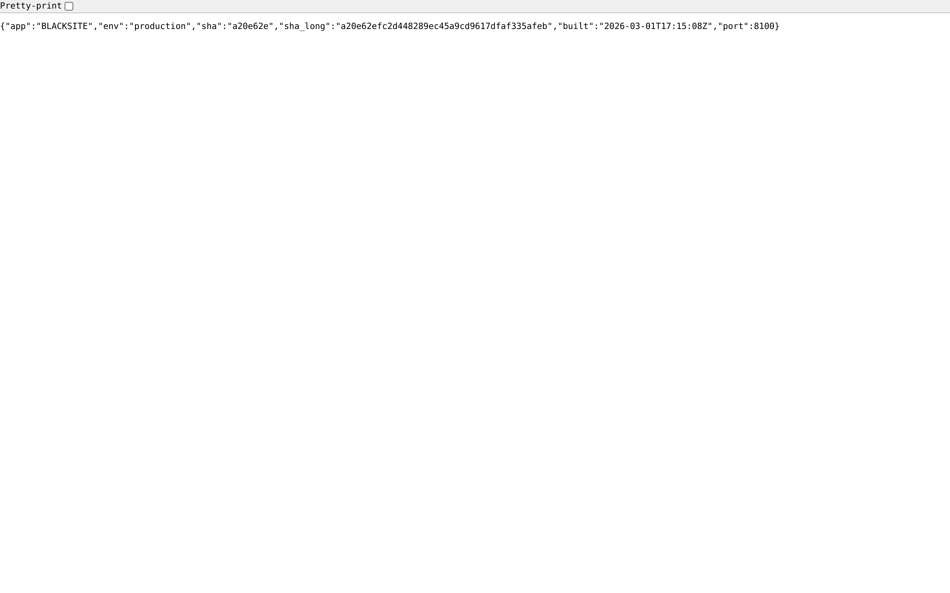
Figure 6: Check API version

Common Issues and Resolutions
Symptom | Resolution
401 Unauthorized page | Your Authelia session expired. Return to the Authelia portal and re-authenticate.
Dashboard blank / spinner stuck | The database may be unavailable. Check /health. Contact the system administrator.
Session logs out immediately | Your account may be frozen. Contact an admin to verify account status at /admin/users.

