━━━━━━━━━━━━━━━━━━━━━━━━━━━━━━━━━━━━━━━━━━━━━━━━━━━━━━━━━━━━━━━━━━━━━━
BLACKSITE GRC Platform · THKR-BSV-001

SIEM Security Events
Roles: Admin, ISSO
Version: 1.0 | Date: 2026-03-01 | Classification: INTERNAL USE ONLY
━━━━━━━━━━━━━━━━━━━━━━━━━━━━━━━━━━━━━━━━━━━━━━━━━━━━━━━━━━━━━━━━━━━━━━

Overview
BLACKSITE receives and displays SIEM events via the /api/siem/ingest API endpoint. Events are categorized by severity (Critical/High/Medium/Low/Info) and type. ISSOs and admins can review events, filter by severity, and drill into event details.

Prerequisites
- SIEM integration configured and sending events to /api/siem/ingest.

Procedure

Step 1: View SIEM event list
Navigate to /admin/siem. Events are listed in reverse chronological order with severity badge, event type, source IP, timestamp, and brief description. The total event count appears at the top.
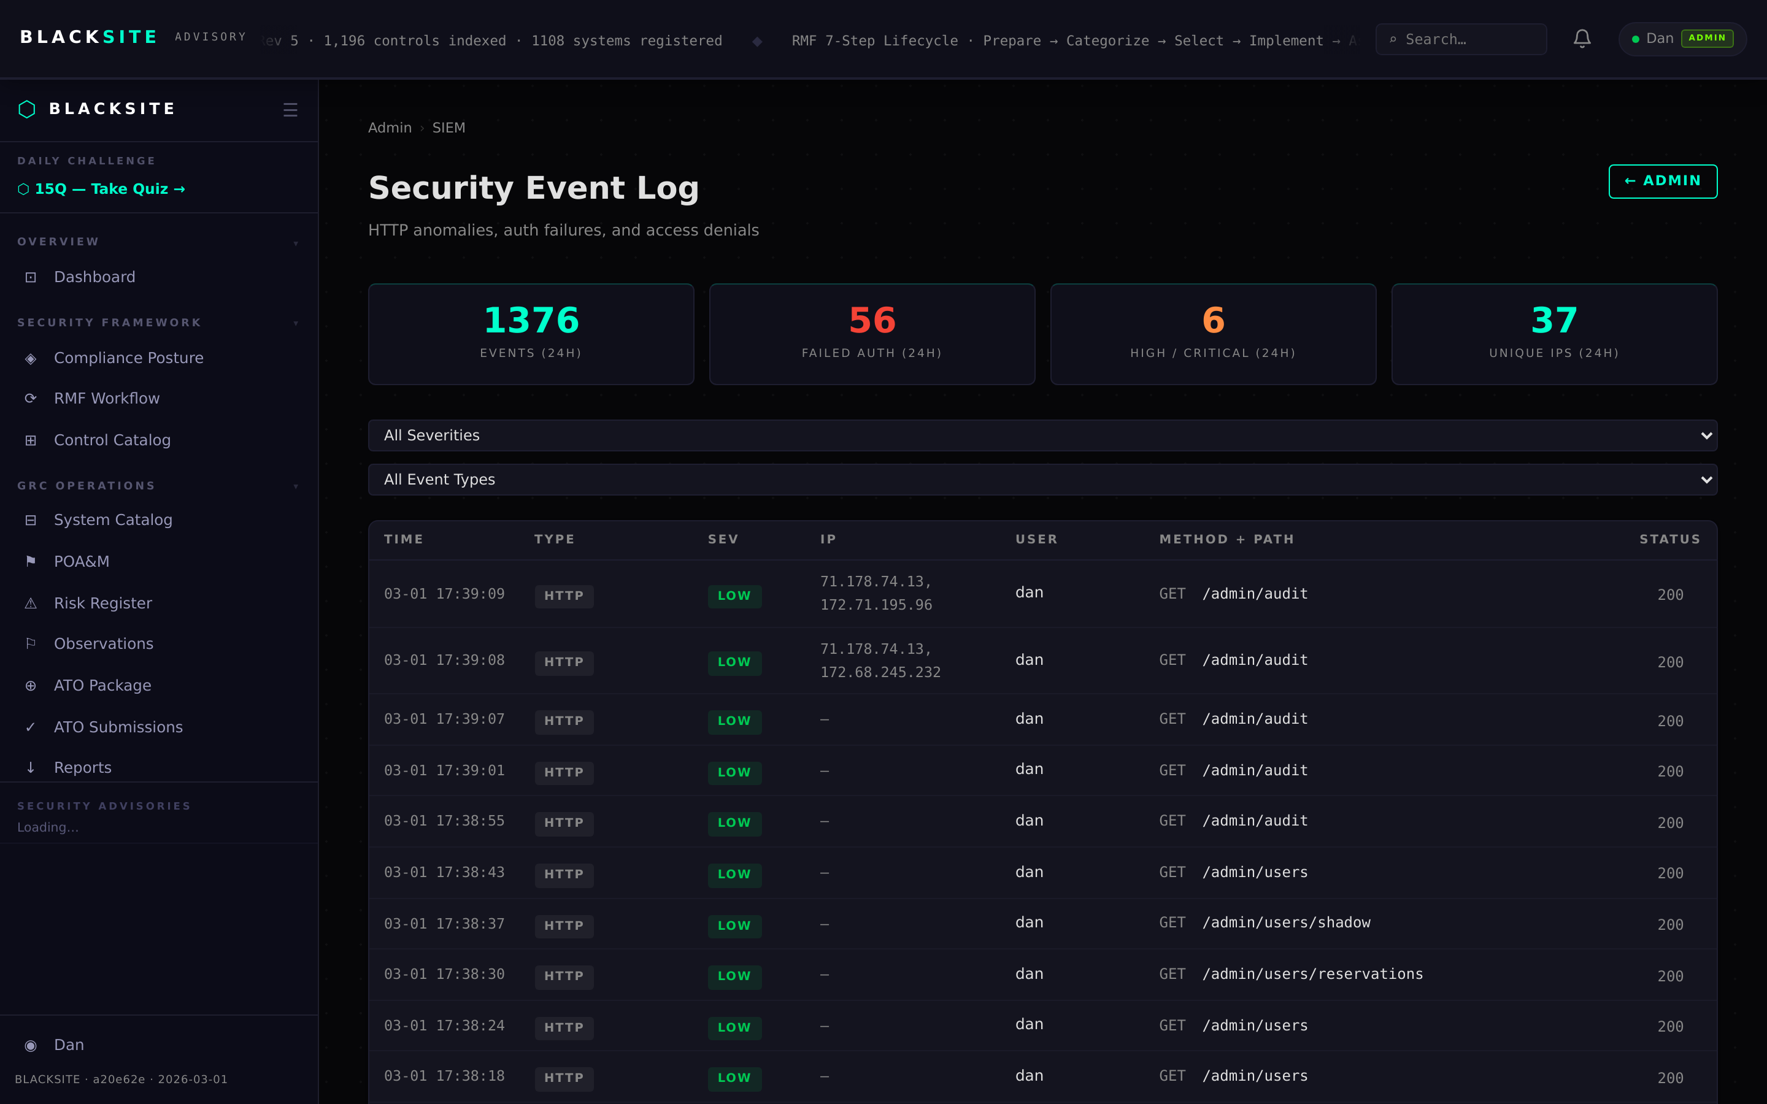
Figure 1: View SIEM event list

Step 2: Filter by severity
Click a severity filter button (Critical, High, Medium, Low, Info) to narrow the view. Multiple filters can be active simultaneously. The count badge updates to reflect filtered results.
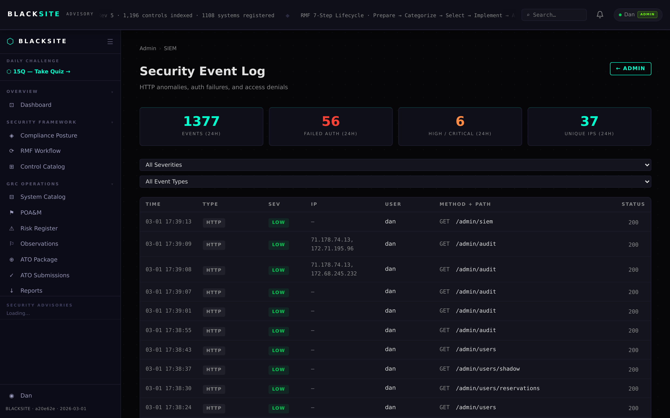
Figure 2: Filter by severity

Step 3: Drill into event details
Click an event row to expand its detail panel. The detail shows the full event payload, source system, affected host, and raw event data. Use the Create POA&M link to promote a significant event to a tracked finding.
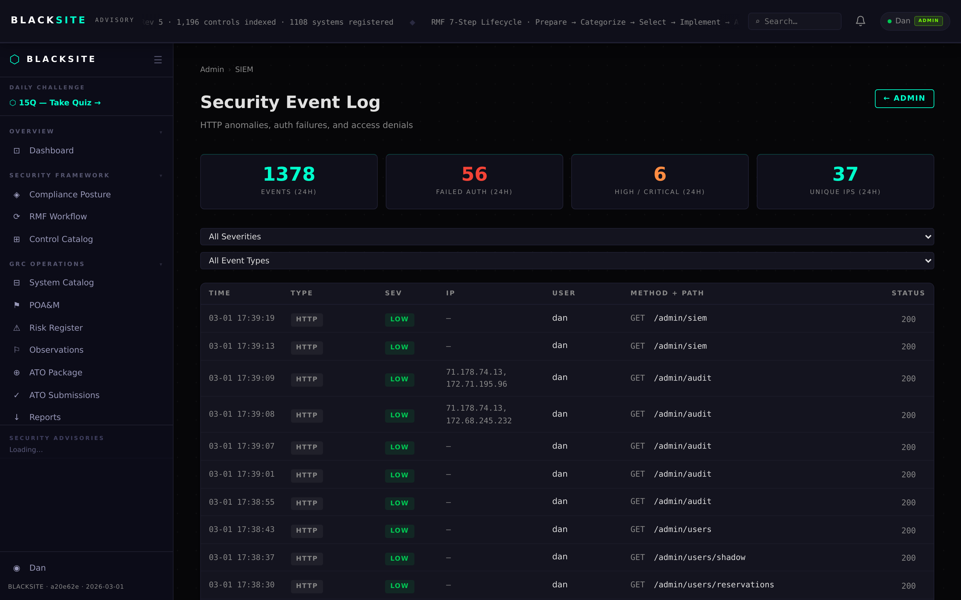
Figure 3: Drill into event details

Common Issues and Resolutions
Symptom | Resolution
No events showing | SIEM integration may not be configured, or no events have been ingested. Check integration settings.
Create POA&M link absent | This action requires ISSO or admin role. Verify your role assignment.

