━━━━━━━━━━━━━━━━━━━━━━━━━━━━━━━━━━━━━━━━━━━━━━━━━━━━━━━━━━━━━━━━━━━━━━
BLACKSITE GRC Platform · THKR-BSV-001

SSP Generation and Analyzer
Roles: ISSO, ISSM, Admin
Version: 1.0 | Date: 2026-03-01 | Classification: INTERNAL USE ONLY
━━━━━━━━━━━━━━━━━━━━━━━━━━━━━━━━━━━━━━━━━━━━━━━━━━━━━━━━━━━━━━━━━━━━━━

Overview
BLACKSITE can generate a System Security Plan (SSP) document in two modes: Controls-only (structured control table) or Full (includes approved artifacts as appendices). The SSP Analyzer allows admins to upload an external SSP for automated quality scoring.

Prerequisites
- System record with controls populated.
- Artifacts approved if Full mode appendices are needed.

Procedure

Step 1: Select SSP output mode
Navigate to the SSP export section (available from the system detail page or reports center). The mode selector page shows two options: Controls mode (control table only) and Full mode (control table + artifact appendices).
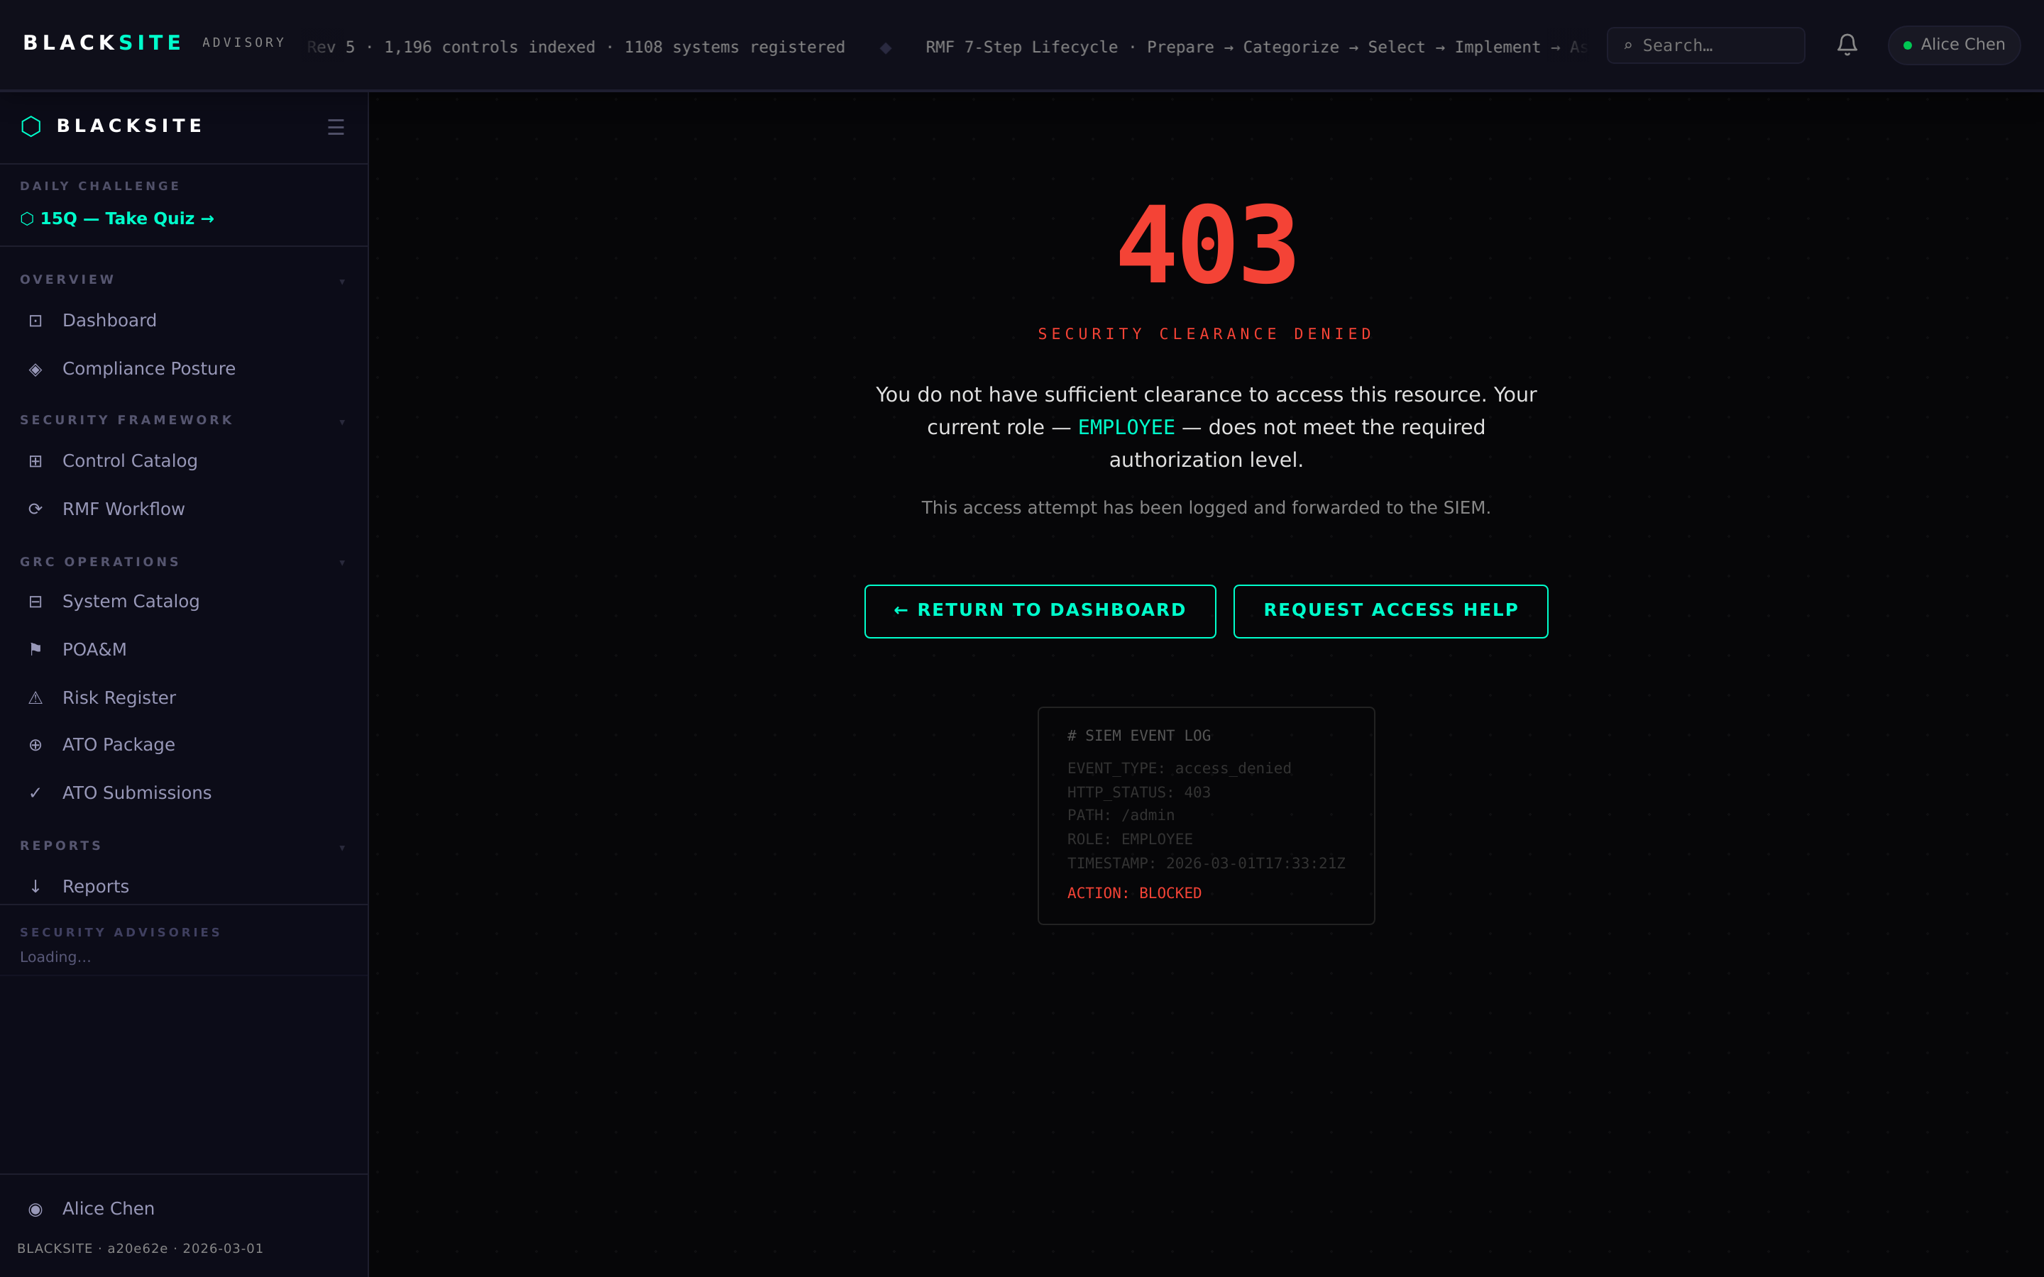
Figure 1: Select SSP output mode

Step 2: SSP Analyzer — upload external SSP
Admin only: navigate to /admin/ssp. Click Upload SSP to submit an existing SSP document for automated scoring. The analyzer parses narratives, scores quality, and identifies gaps using the same engine as the assessment uploader.
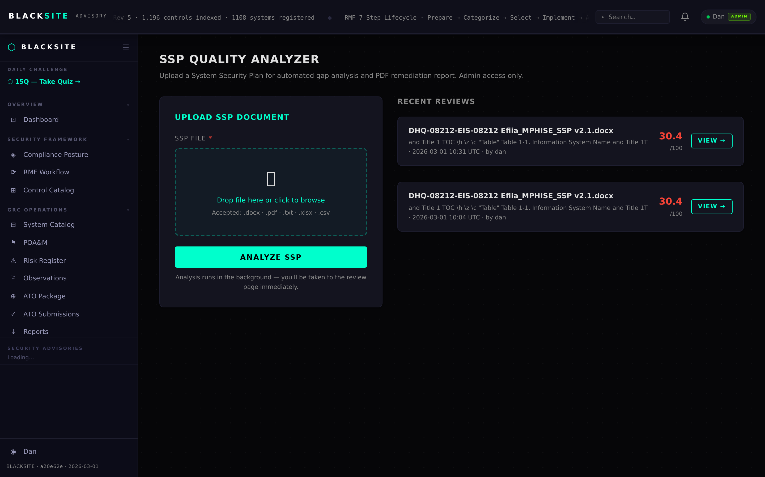
Figure 2: SSP Analyzer — upload external SSP

Step 3: Review SSP analysis results
The analysis results page shows per-control grades (Critical/High/Medium/Adequate), narrative quality indicators, missing element warnings, and a family-level coverage heat map. Export the findings as a PDF report.
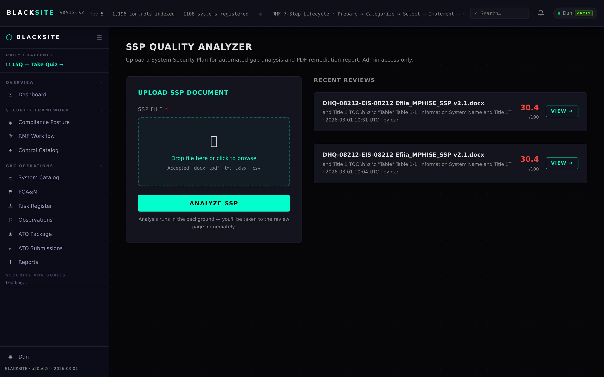
Figure 3: Review SSP analysis results

Step 4: Reports center
Navigate to /reports to see all generated reports for all systems. Each row shows the report type, system, generation date, file size, and a Download button. Reports are retained until manually deleted.
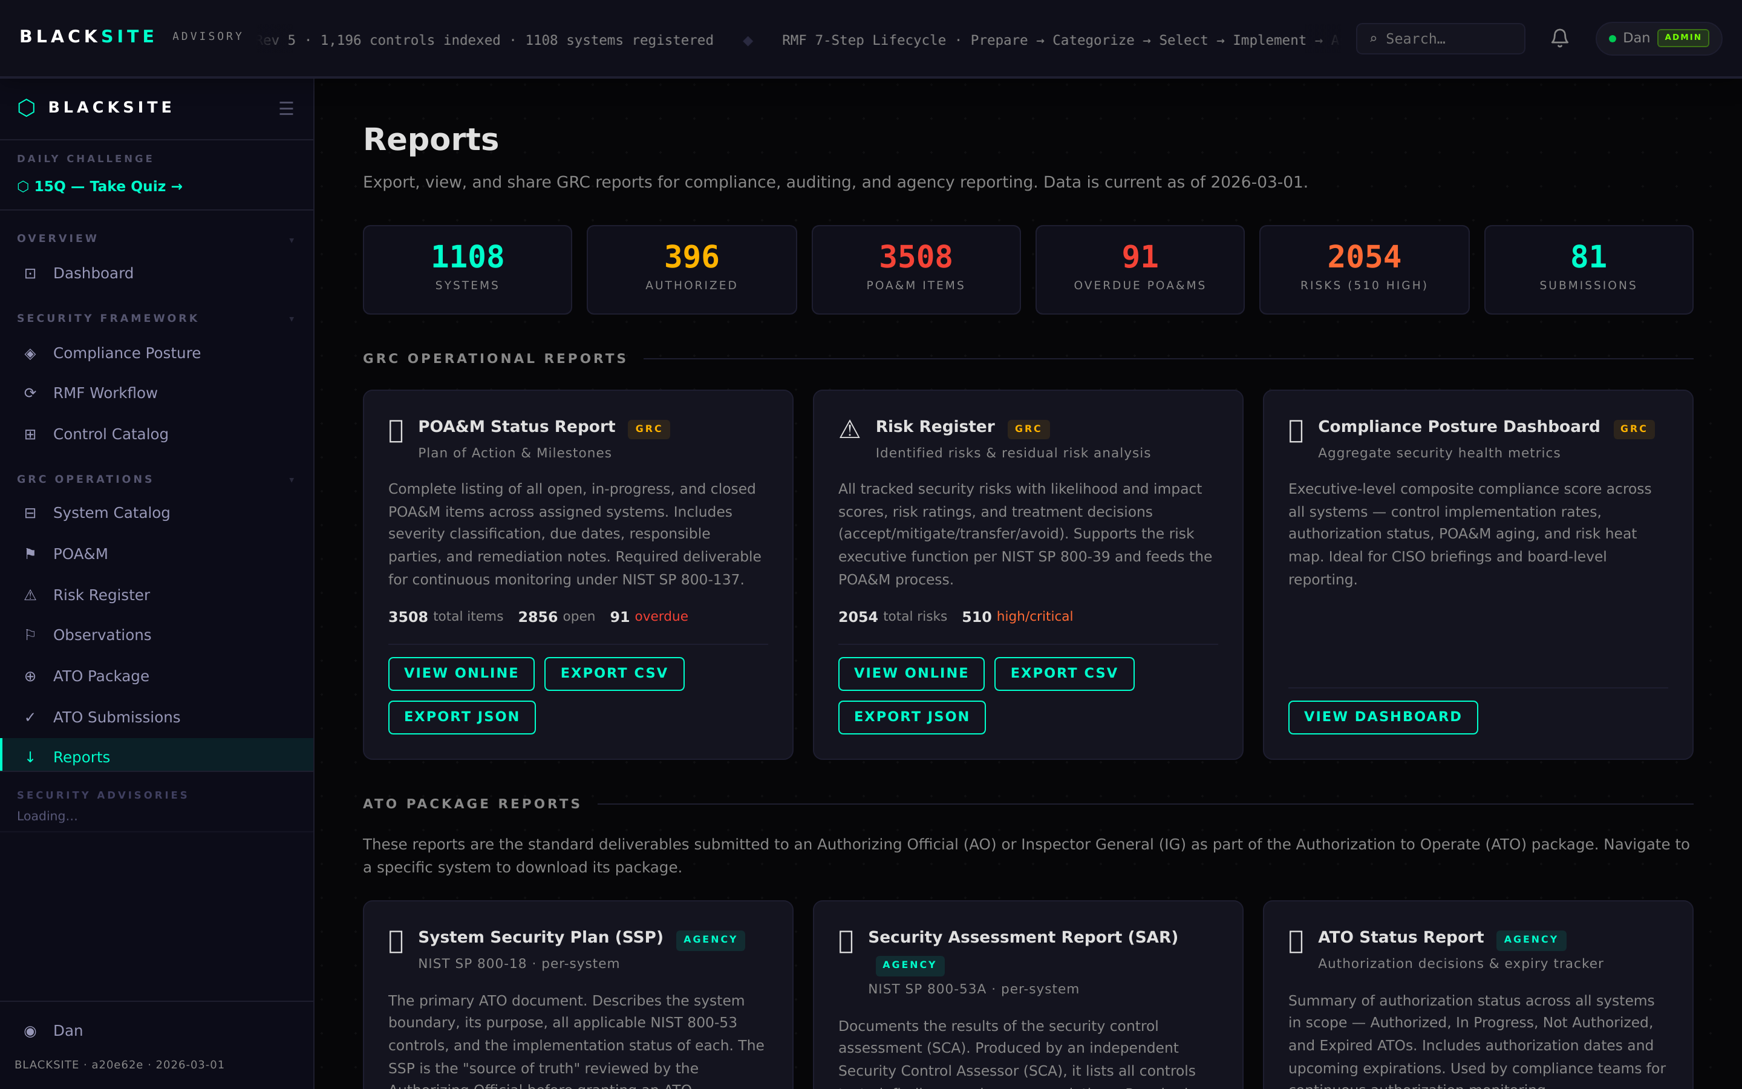
Figure 4: Reports center

Common Issues and Resolutions
Symptom | Resolution
SSP generation fails with 500 | Check that the system has at least one control with a narrative. Empty systems cannot generate SSPs.
Full mode appendices missing | Ensure artifacts are uploaded and their status is set to 'approved' on the Artifacts tab.
Analyzer stuck in Processing | Large SSPs (>10 MB) can take up to 5 minutes. If stuck beyond 10 minutes, contact admin.

