━━━━━━━━━━━━━━━━━━━━━━━━━━━━━━━━━━━━━━━━━━━━━━━━━━━━━━━━━━━━━━━━━━━━━━
BLACKSITE GRC Platform · THKR-BSV-001

Authorization Submission and AO Decision
Roles: ISSO, System Owner, AO, Admin
Version: 1.0 | Date: 2026-03-01 | Classification: INTERNAL USE ONLY
━━━━━━━━━━━━━━━━━━━━━━━━━━━━━━━━━━━━━━━━━━━━━━━━━━━━━━━━━━━━━━━━━━━━━━

Overview
When an ATO package is complete, the ISSO submits it for AO review. The AO reviews the package, makes a risk determination, and records an authorization decision with duration (1/3/5 years or ongoing). The decision updates the system's authorization status immediately.

Prerequisites
- ATO document package complete with all required documents approved.
- AO assigned to the system.

Procedure

Step 1: Submit for authorization
Navigate to /systems/{id}/submit or click Submit for Authorization on the system detail page. Confirm the submission in the dialog. Status changes to Pending Authorization. The AO receives a notification.
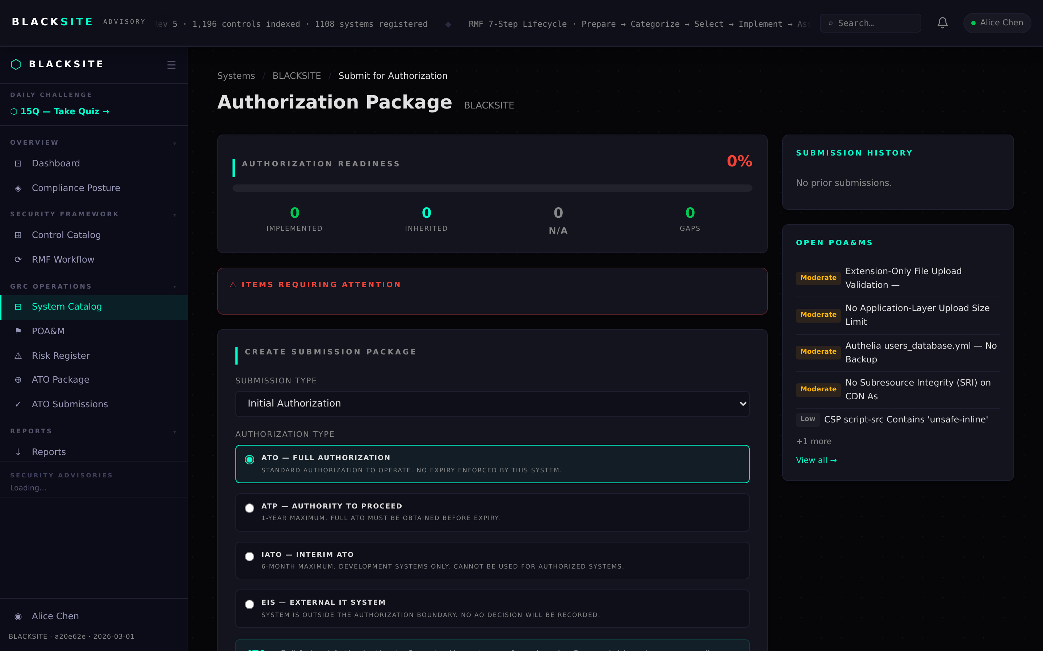
Figure 1: Submit for authorization

Step 2: View submissions list
Navigate to /submissions to see all submitted packages with status, system name, submission date, and AO assignment. ISSOs see only their own systems; AOs see all pending submissions assigned to them.
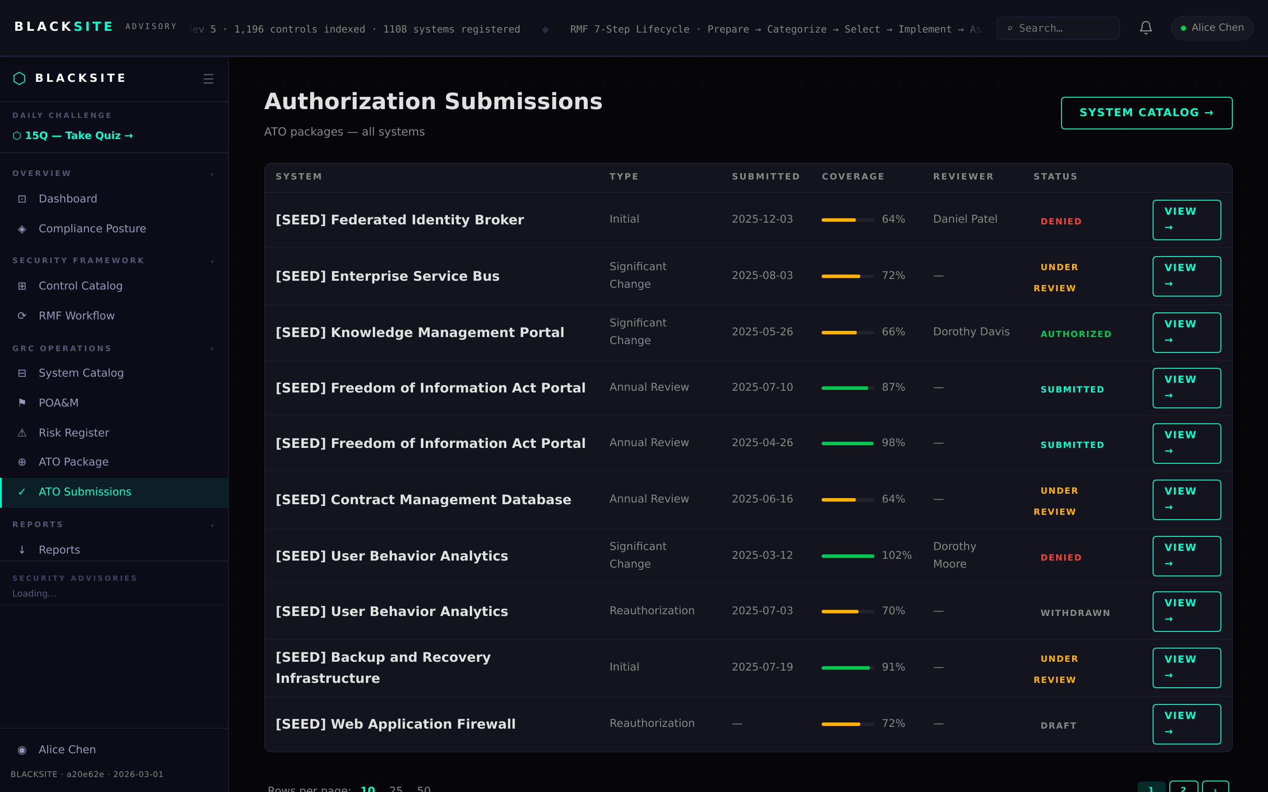
Figure 2: View submissions list

Step 3: Submission detail review
Click a submission row to open its detail. The detail page shows the package contents, all document statuses, open POA&M count, and risk summary. The AO uses this view to make their determination.
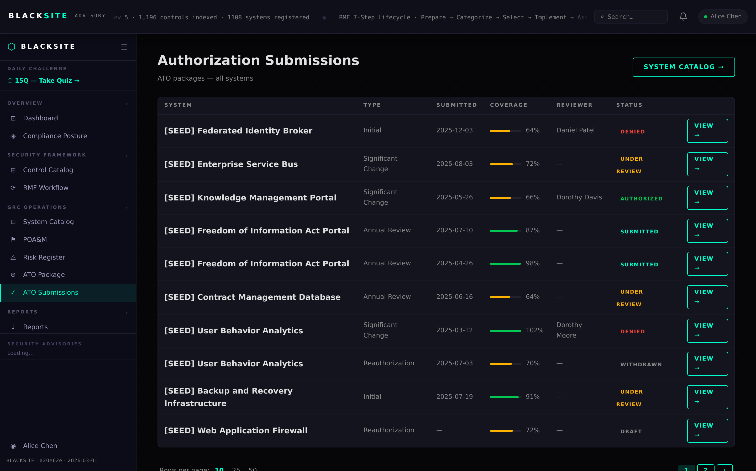
Figure 3: Submission detail review

Step 4: AO decisions queue
AOs navigate to /ao/decisions to see all packages awaiting their decision. Each row shows the system name, ISSO, submission date, and outstanding risk items. Click a row to open the decision form.
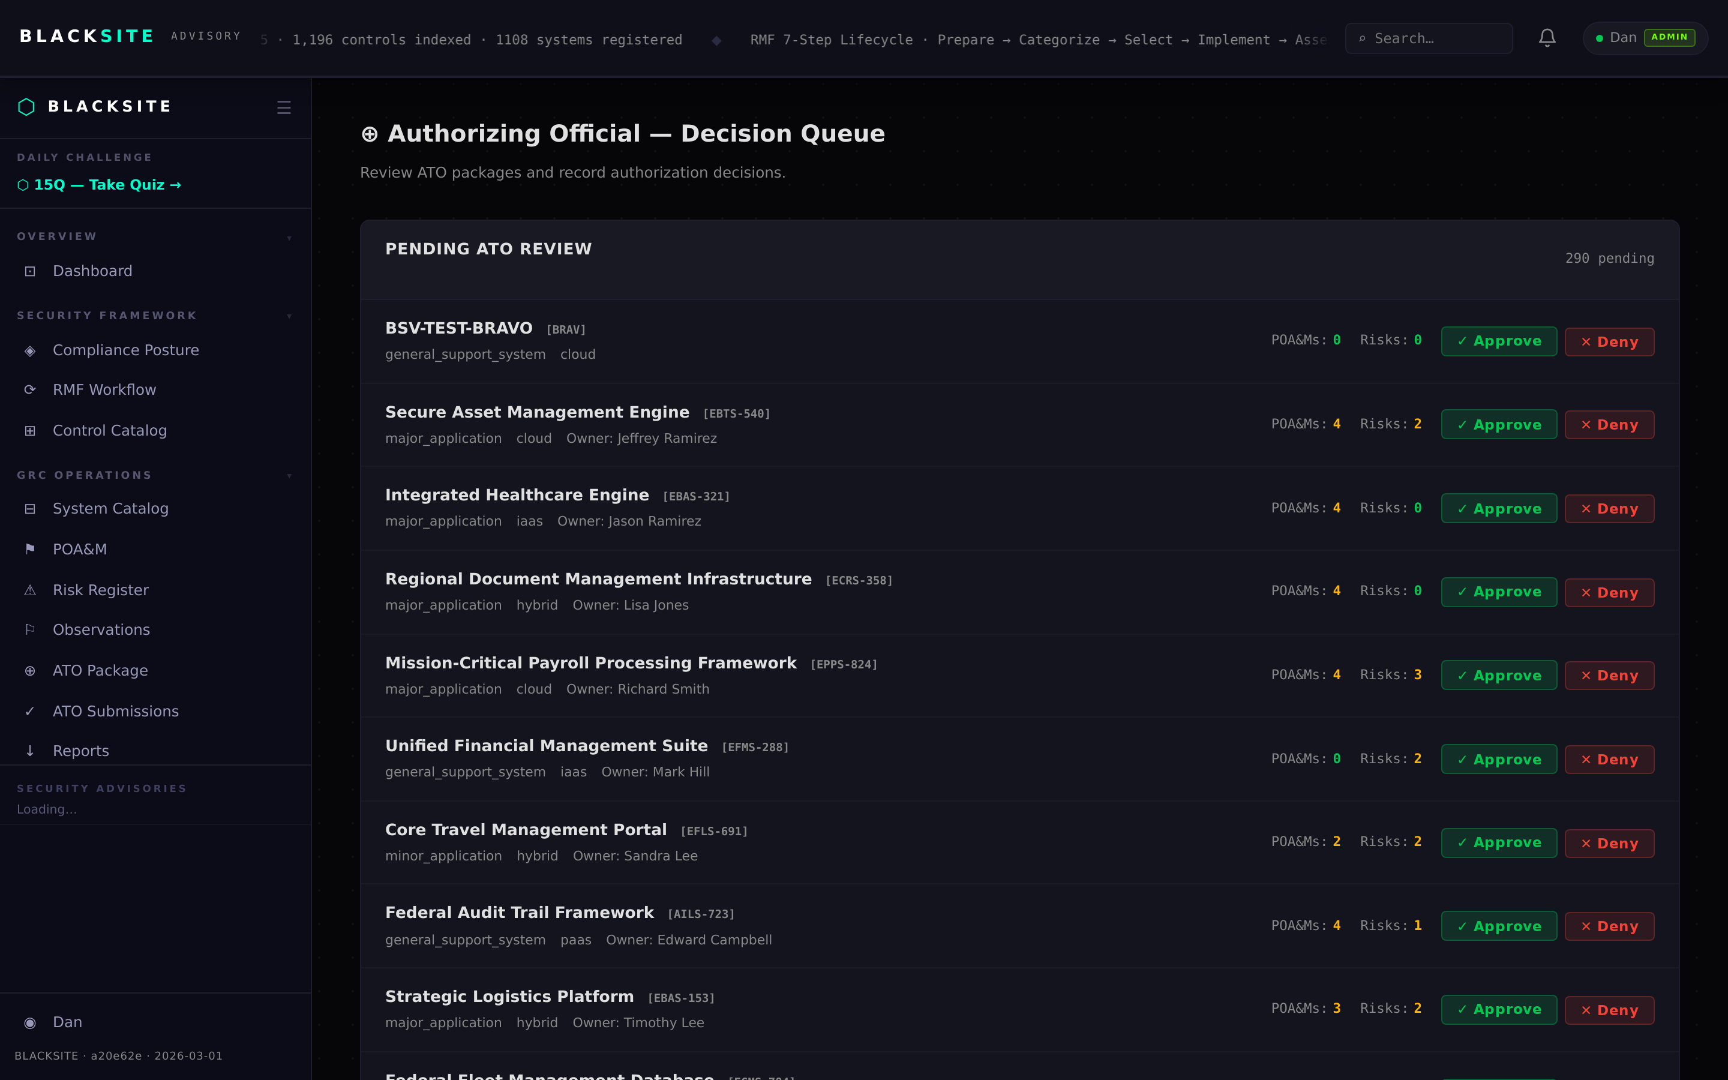
Figure 4: AO decisions queue

Step 5: Record AO decision
On the AO decision form, select: Authorize (select duration: 1yr/3yr/5yr/ ongoing/custom), Deny, or Authorize with Conditions. Add decision notes. Click Record Decision. The system's auth_status and expiry date are updated immediately. The ISSO receives a notification.
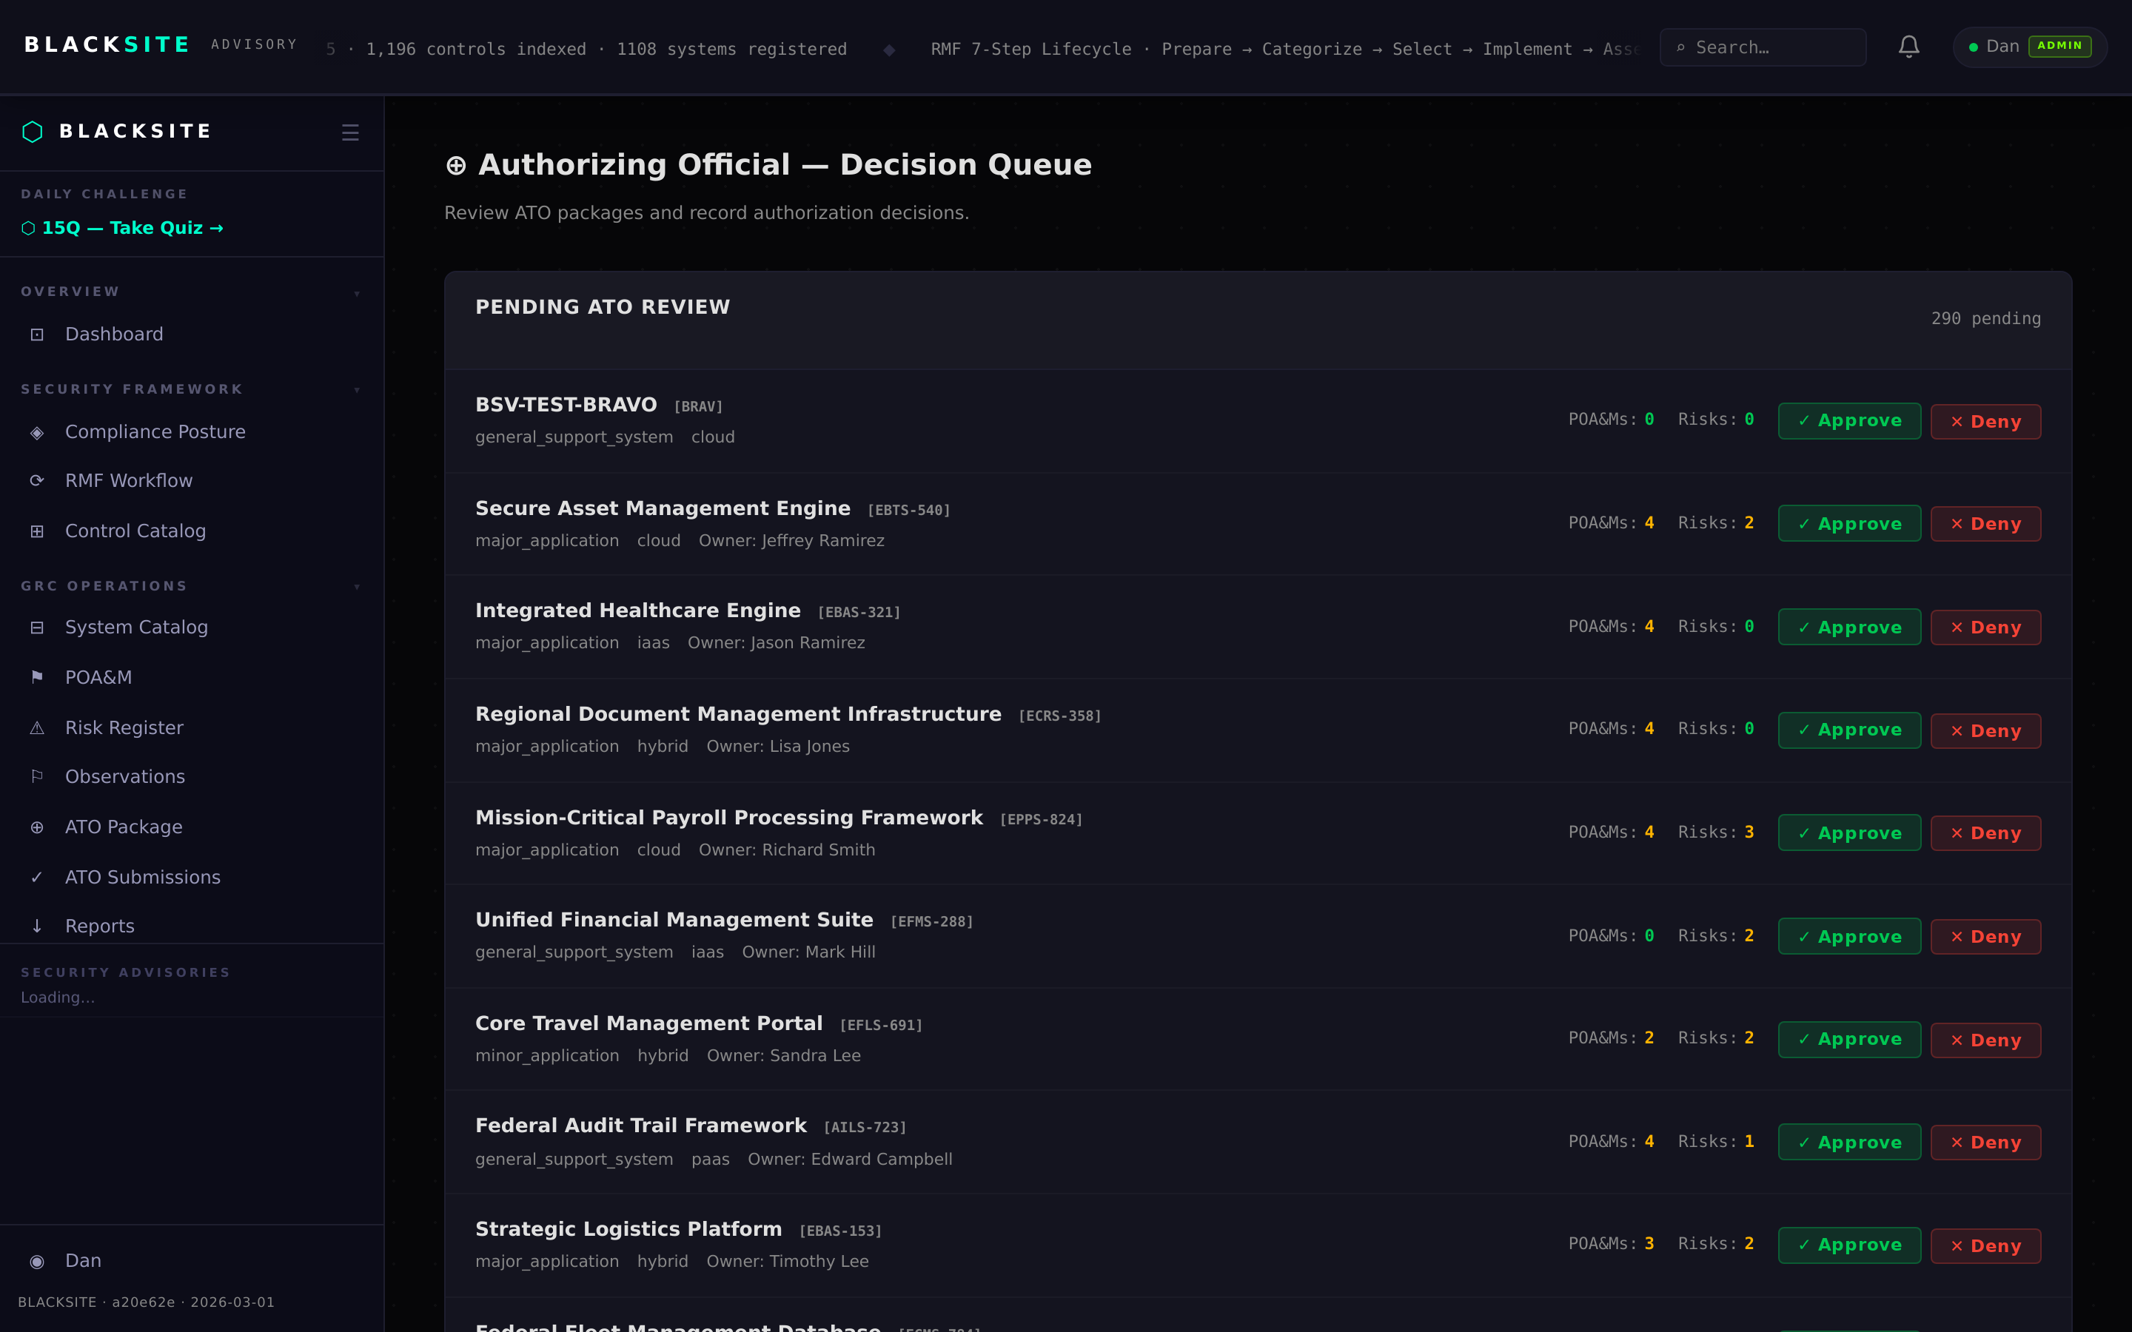
Figure 5: Record AO decision

Step 6: Authorized status confirmed
Return to the system detail page. The overview tab shows 'Authorized' status badge, authorization date, and expiry date. The ATO package is now locked for the authorization period.
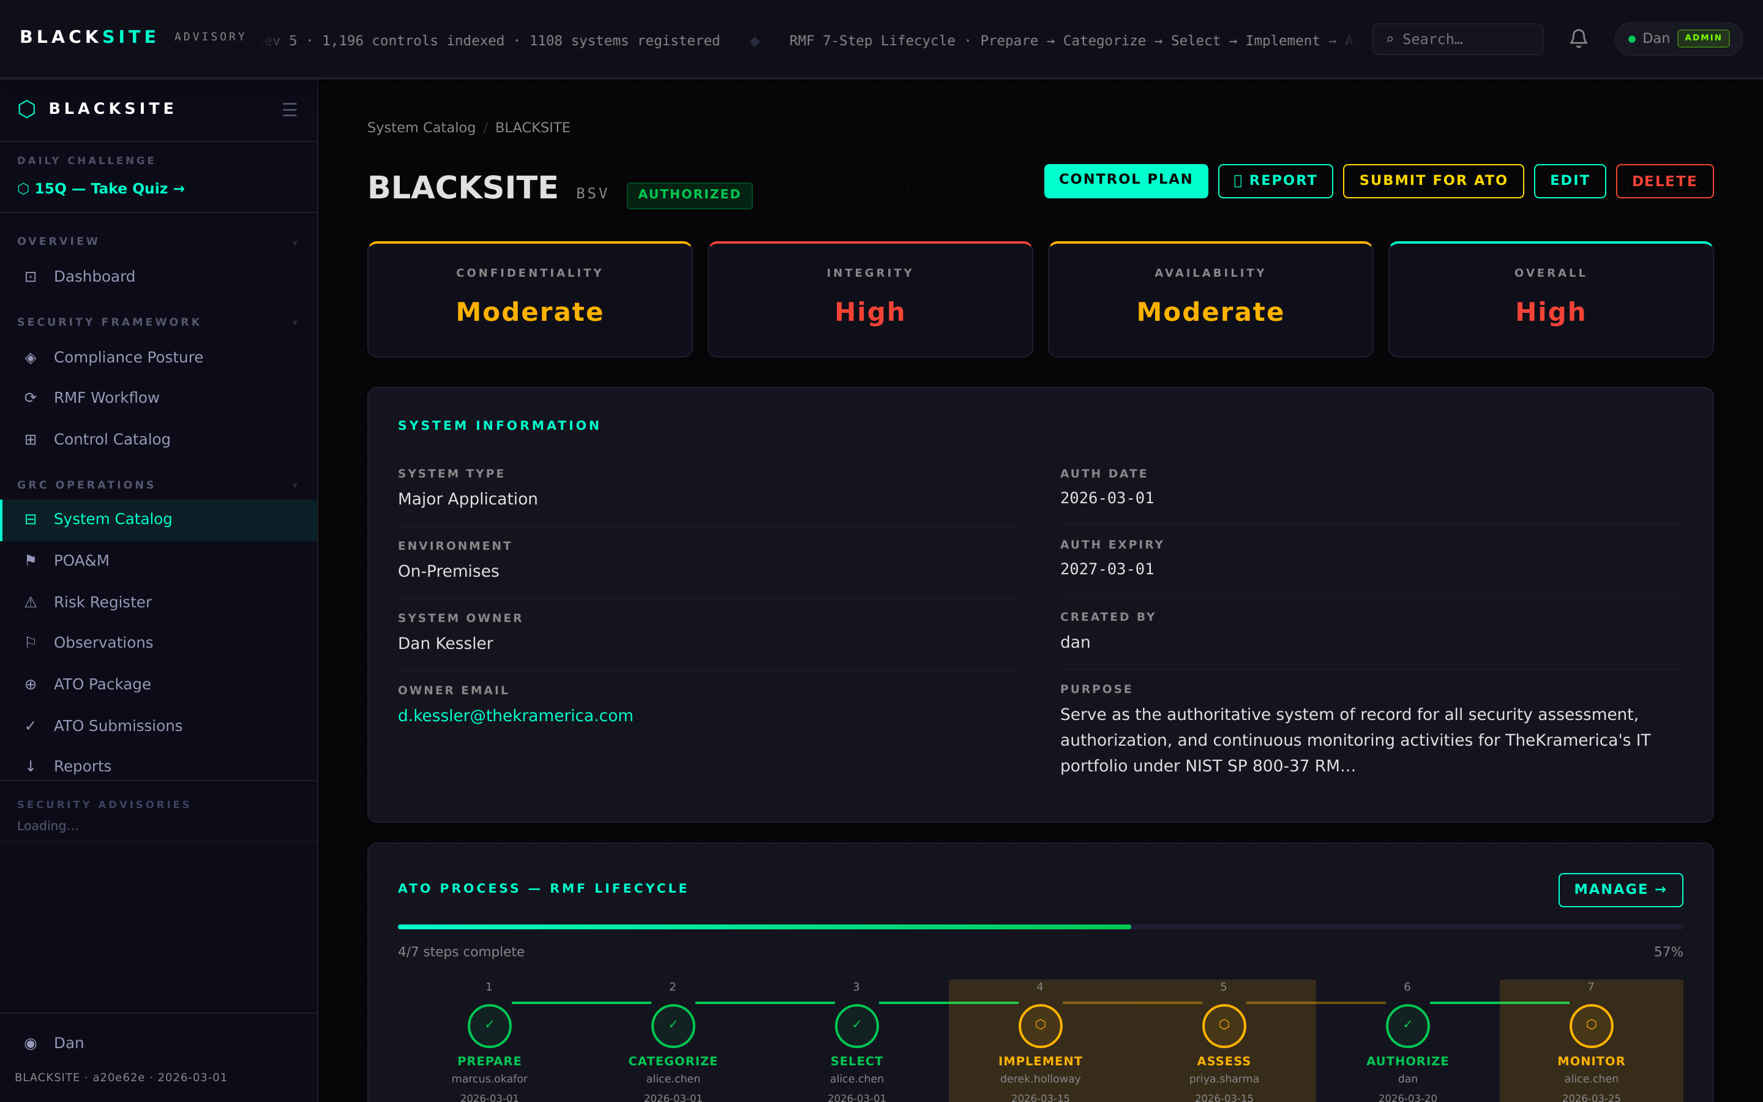
Figure 6: Authorized status confirmed

Common Issues and Resolutions
Symptom | Resolution
Submit button unavailable | Required ATO documents may not all be in Approved status. Check the ATO matrix.
AO decision form missing duration picker | The AO must select an authorization type (Authorize) before the duration pills appear.
Status still Pending after decision | Refresh the page. If still pending after 30 seconds, check the audit log for errors.

