━━━━━━━━━━━━━━━━━━━━━━━━━━━━━━━━━━━━━━━━━━━━━━━━━━━━━━━━━━━━━━━━━━━━━━
BLACKSITE GRC Platform · THKR-BSV-001

System Detail Tab Navigation
Roles: All roles assigned to the system
Version: 1.0 | Date: 2026-03-01 | Classification: INTERNAL USE ONLY
━━━━━━━━━━━━━━━━━━━━━━━━━━━━━━━━━━━━━━━━━━━━━━━━━━━━━━━━━━━━━━━━━━━━━━

Overview
The system detail page organizes all compliance data into tabs. Each tab provides a focused view of a specific compliance domain. This SOP covers what each tab contains and when to use it.

Prerequisites
- Assigned to the system or admin role.
- System record exists and is active.

Procedure

Step 1: Overview tab
The default tab shows system metadata: name, abbreviation, boundary, FIPS impact levels, ATO status, expiry date, ePHI/EIS flags, and assigned personnel. The RMF step progress bar shows where the system stands in the 7-step process.
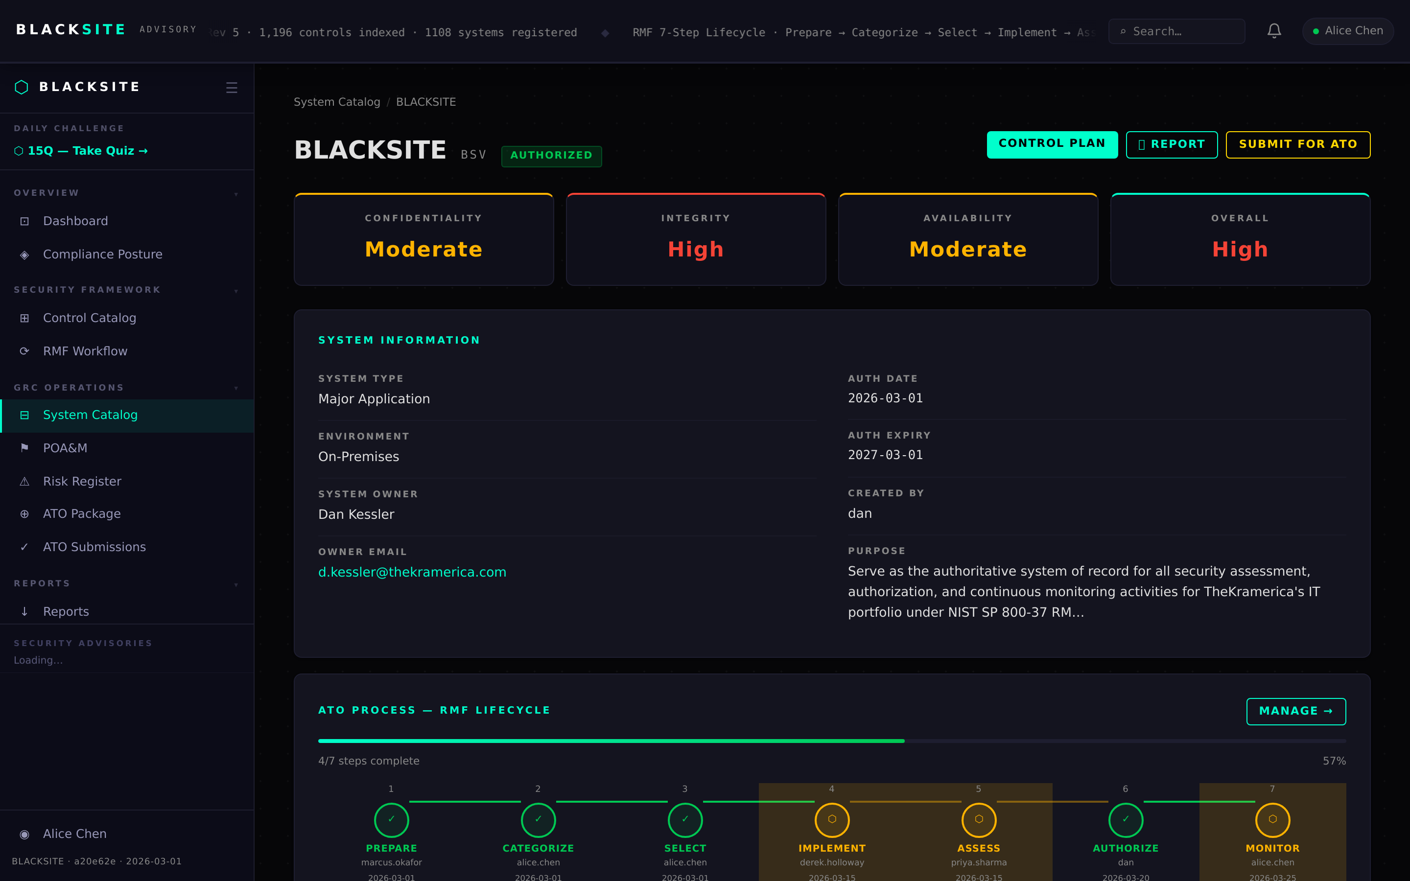
Figure 1: Overview tab

Step 2: Controls tab
Lists all NIST 800-53 Rev 5 controls scoped to this system, with implementation status, responsible role, and narrative excerpt. Filter by family or status. Click a control row to open the workspace editor.
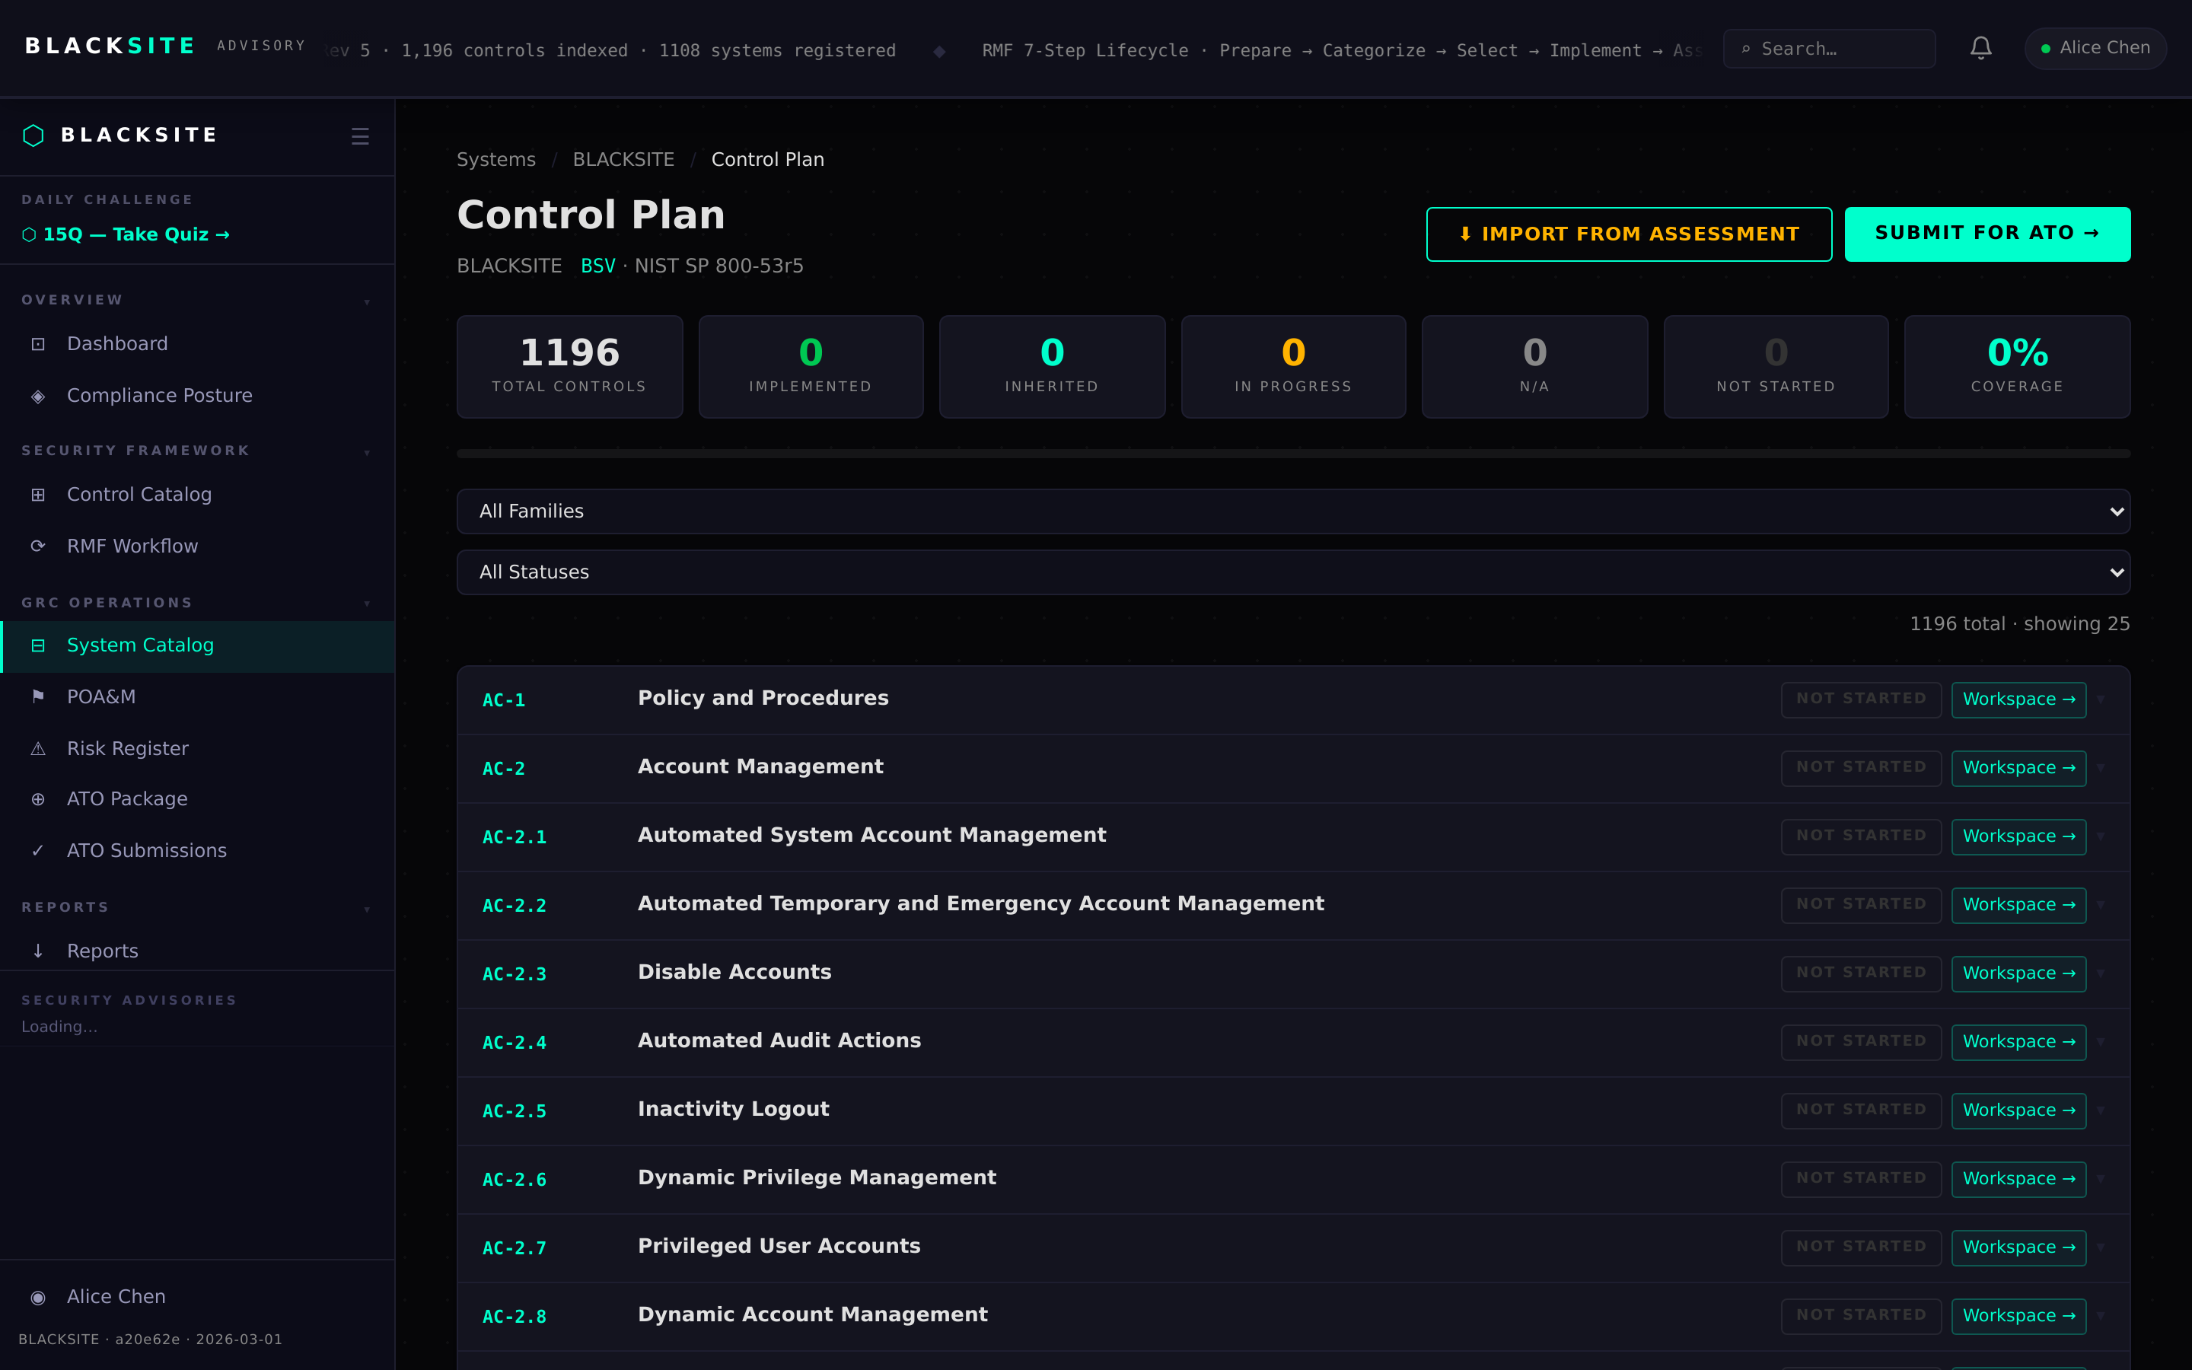
Figure 2: Controls tab

Step 3: Inventory tab
Hardware and software inventory for the system boundary. Each item has type, description, vendor, version, and criticality. Use the + Add Item button to add new inventory entries.
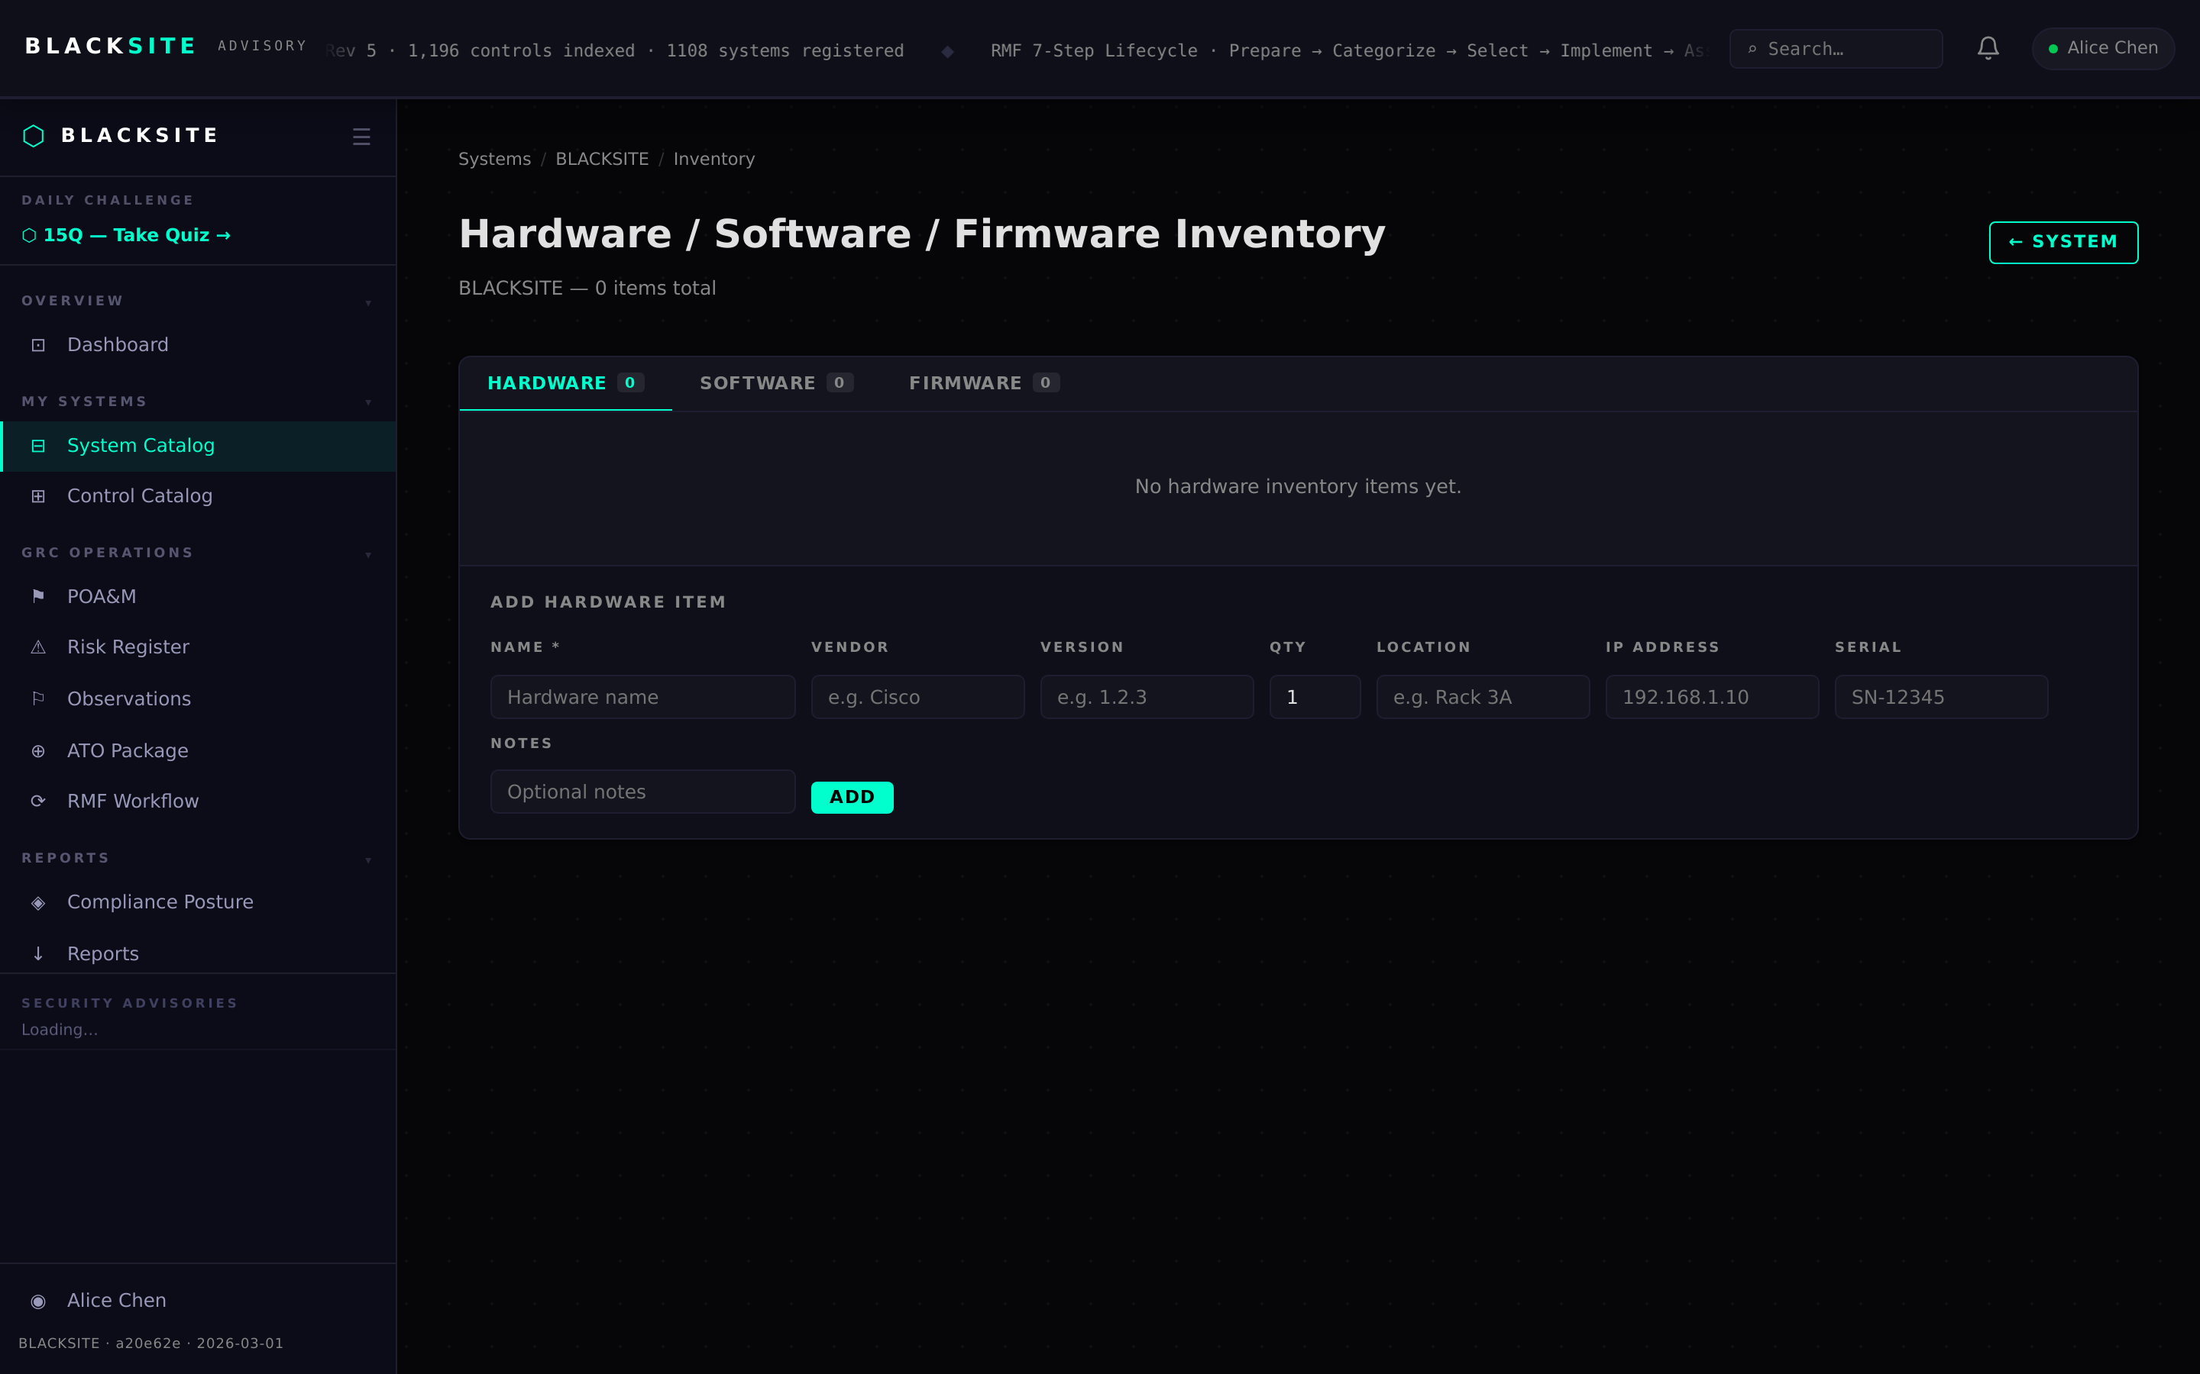
Figure 3: Inventory tab

Step 4: Connections tab
External and internal connections (ISAs, MOU/As, API integrations). Each record shows the partner name, data flow direction, and agreement type. Alerts appear when ISA expiry dates are within 90 days.
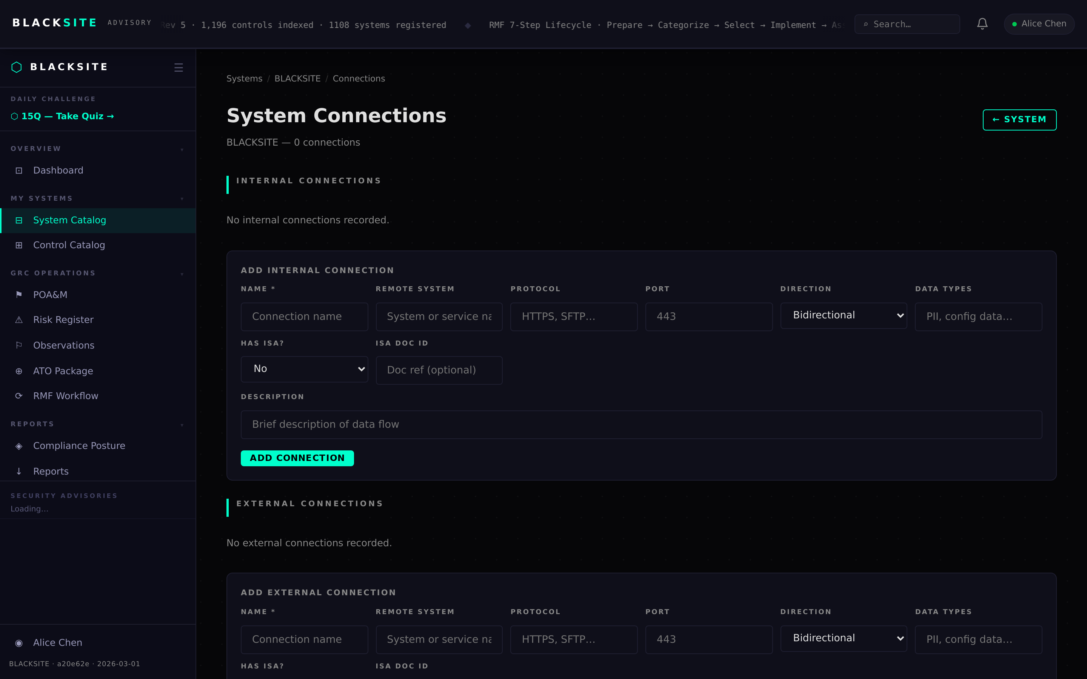
Figure 4: Connections tab

Step 5: Artifacts tab
Uploaded compliance artifacts (diagrams, policies, evidence files). Each artifact has a type label, upload date, and approval status. Artifacts marked 'approved' are available for ATO document appendix embedding.
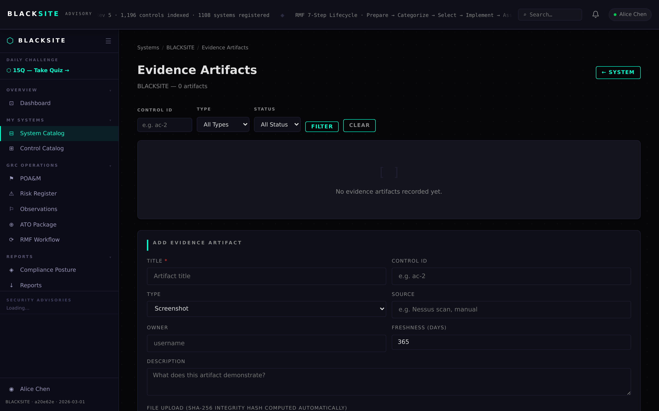
Figure 5: Artifacts tab

Step 6: Teams tab
System team roster showing all assigned personnel with their system roles, duty assignments, and last activity date. BCDR events for the system are listed in the lower panel.
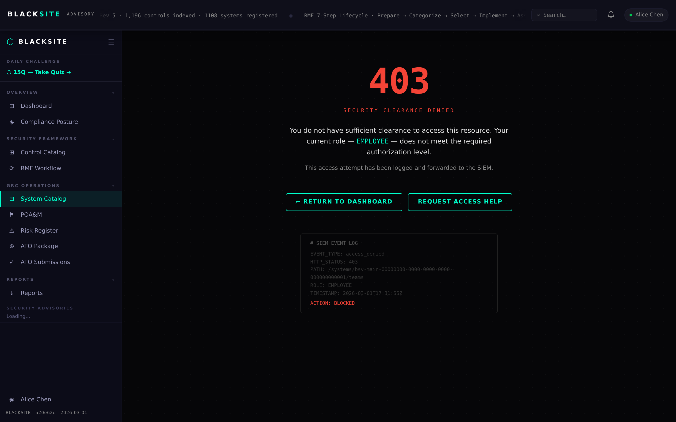
Figure 6: Teams tab

Step 7: EIS Assessment tab
Enterprise Information System assessment checklist. Mark each criterion as met/not met with supporting notes. The overall EIS determination (Yes/No/Unknown) feeds into the system categorization report.
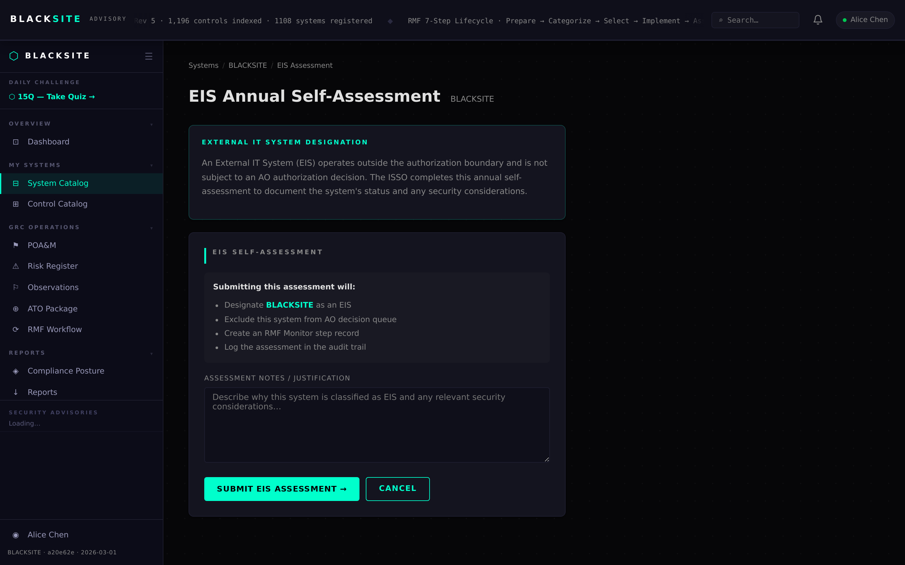
Figure 7: EIS Assessment tab

Step 8: Parameters tab
System-specific parameter overrides for NIST control assignments. Each parameter maps to a control family. Setting values here auto-populates corresponding control workspace fields.
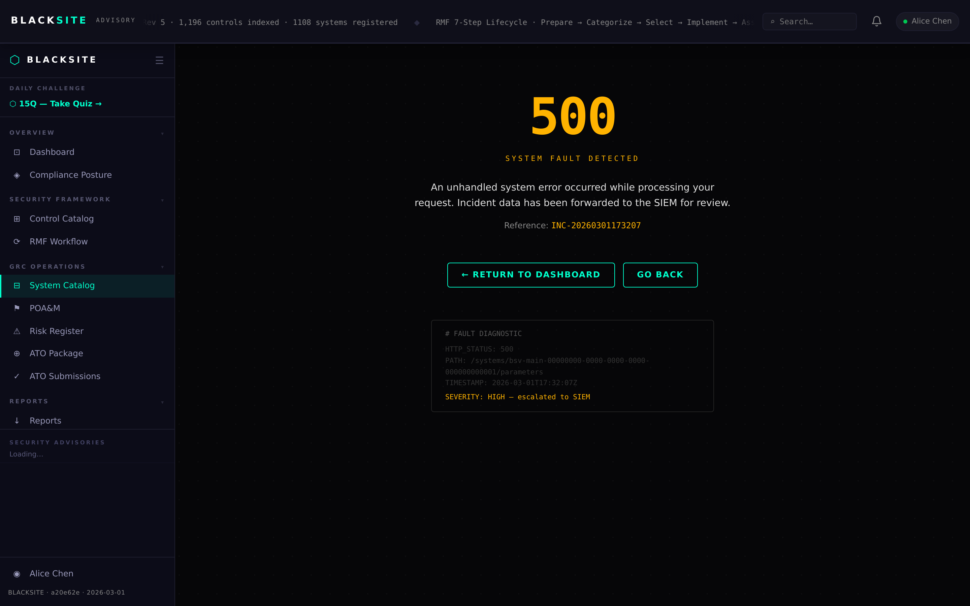
Figure 8: Parameters tab

Step 9: Daily Ops tab
Shows today's task completion status (N/M badge) and the current deep work rotation day. Click Open Daily Hub to access the full daily workflow interface. This tab is visible to all assigned roles.
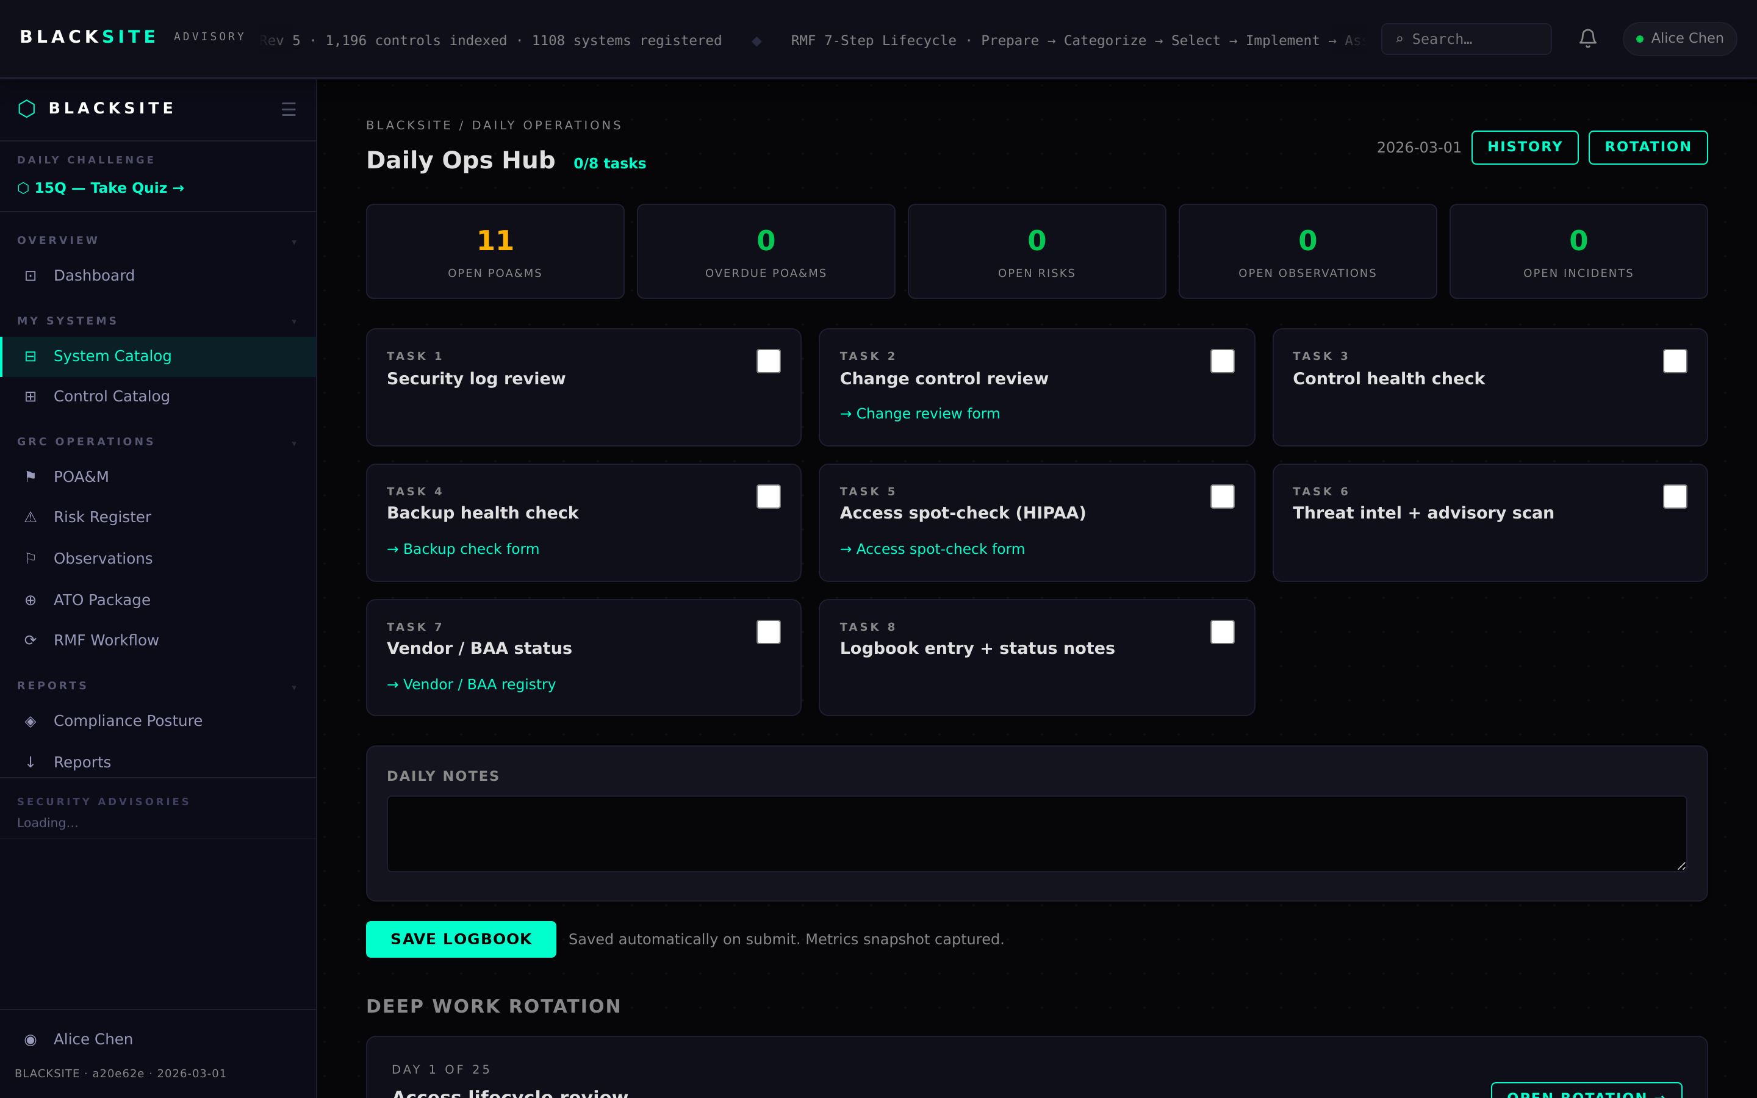
Figure 9: Daily Ops tab

Common Issues and Resolutions
Symptom | Resolution
Tab shows 403 | You are not assigned to this system. Ask your ISSO or admin to add you.
Controls tab empty | No controls have been added yet. Import from the NIST catalog on the Controls tab.
Artifacts not showing in ATO appendix | Artifact must be in 'approved' status. Change status via the artifact detail edit form.

