━━━━━━━━━━━━━━━━━━━━━━━━━━━━━━━━━━━━━━━━━━━━━━━━━━━━━━━━━━━━━━━━━━━━━━
BLACKSITE GRC Platform · THKR-BSV-001

System Record Lifecycle
Roles: Admin, ISSM, System Owner
Version: 1.0 | Date: 2026-03-01 | Classification: INTERNAL USE ONLY
━━━━━━━━━━━━━━━━━━━━━━━━━━━━━━━━━━━━━━━━━━━━━━━━━━━━━━━━━━━━━━━━━━━━━━

Overview
A system record in BLACKSITE represents one information system in the RMF program. It holds the FIPS 199 categorization, boundary description, ATO status, team assignments, and all associated compliance artifacts. This SOP covers creating, editing, assigning, archiving, and printing a system record.

Prerequisites
- Admin or ISSM platform role.
- System name, abbreviation, and FIPS categorization ready.

Procedure

Step 1: Browse systems list
Navigate to /systems. All active systems are listed with status badges (Authorized, In Progress, Not Authorized), ATO expiry dates, and assigned ISSO names. Use the search bar to filter by name or abbreviation.
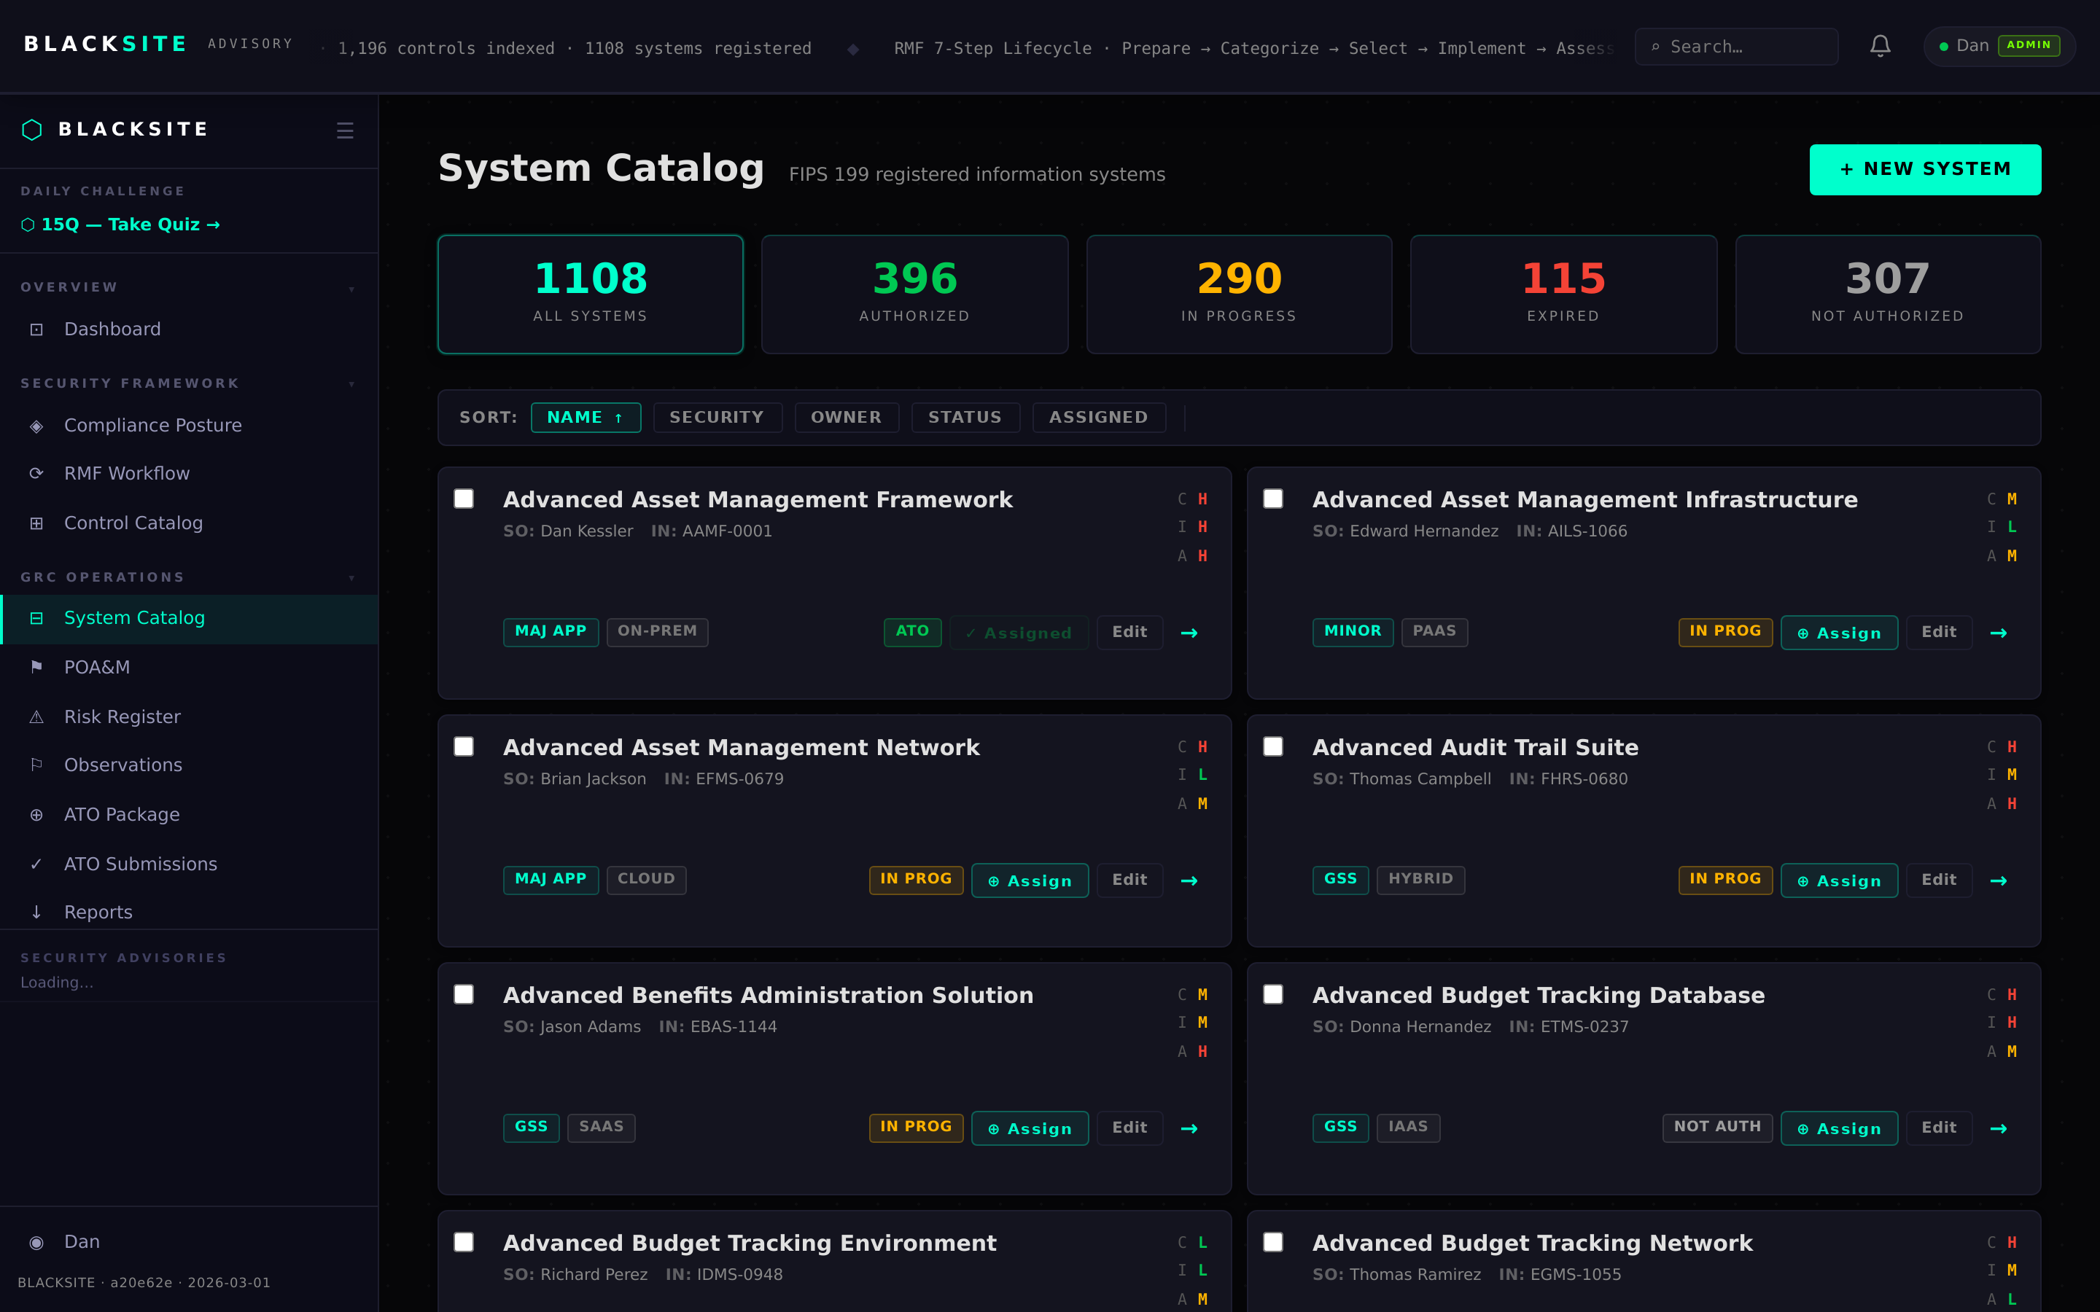
Figure 1: Browse systems list

Step 2: Create a new system
Click + New System. Fill in: System Name (required), Abbreviation (2-8 chars), Boundary Description, FIPS 199 Confidentiality/Integrity/Availability impact levels (Low/Moderate/High), ePHI flag, EIS flag, and initial ATO notes. Click Save System.
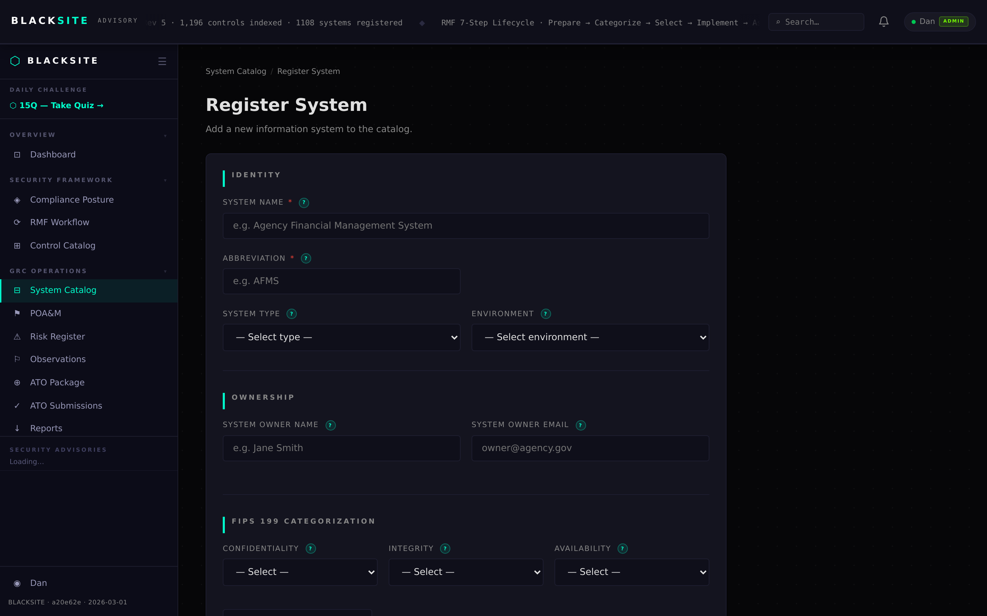
Figure 2: Create a new system

Step 3: Review system detail
After saving, you land on the system detail page showing all fields and the tab navigation bar. Verify the Overall Impact was computed correctly (FIPS 199 max rule). Confirm the system ID and abbreviation are correct before proceeding.
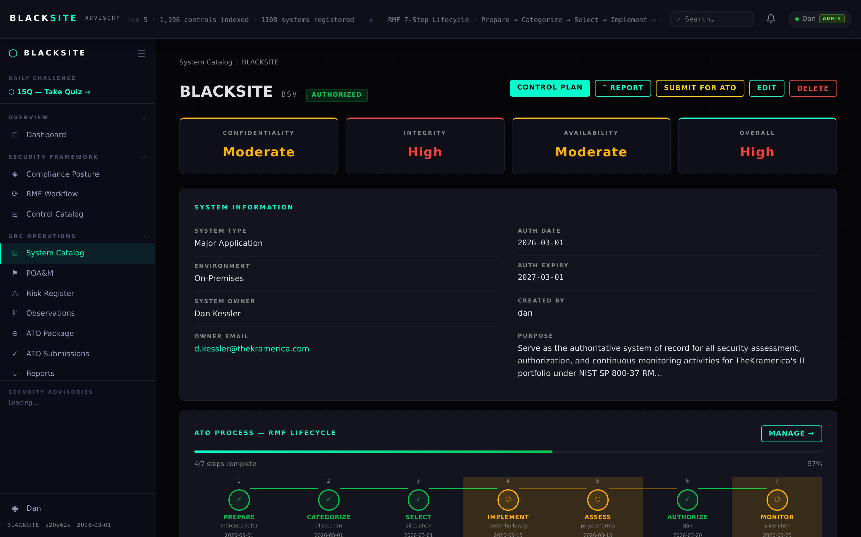
Figure 3: Review system detail

Step 4: Edit system record
Click Edit on the system detail page or navigate to /systems/{id}/edit. Update any field and click Save. Changes are logged in the audit trail. Do not change the abbreviation after ATO documents have been generated — the filename convention embeds it.
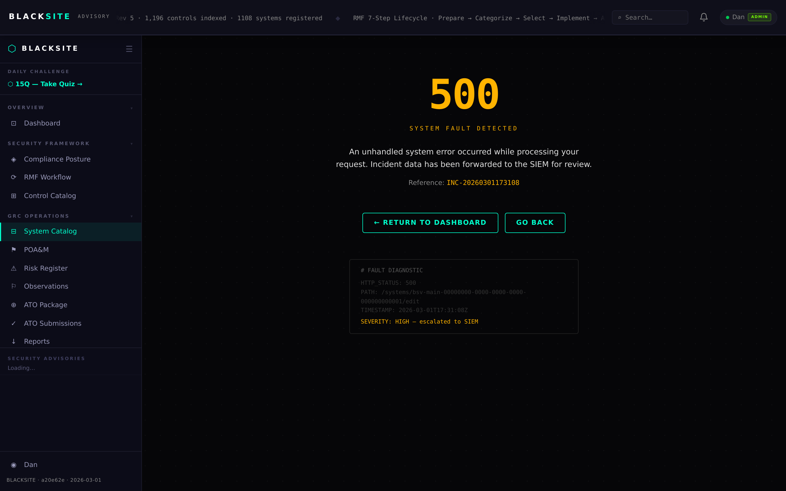
Figure 4: Edit system record

Step 5: Manage assignments
Navigate to the Assignments tab or /systems/{id}/assignments. Assign an ISSO, ISSM, SCA, System Owner, PMO lead, and other duty roles. Each assignment sends a notification to the assigned user. Remove assignments by clicking the × next to a user's name.
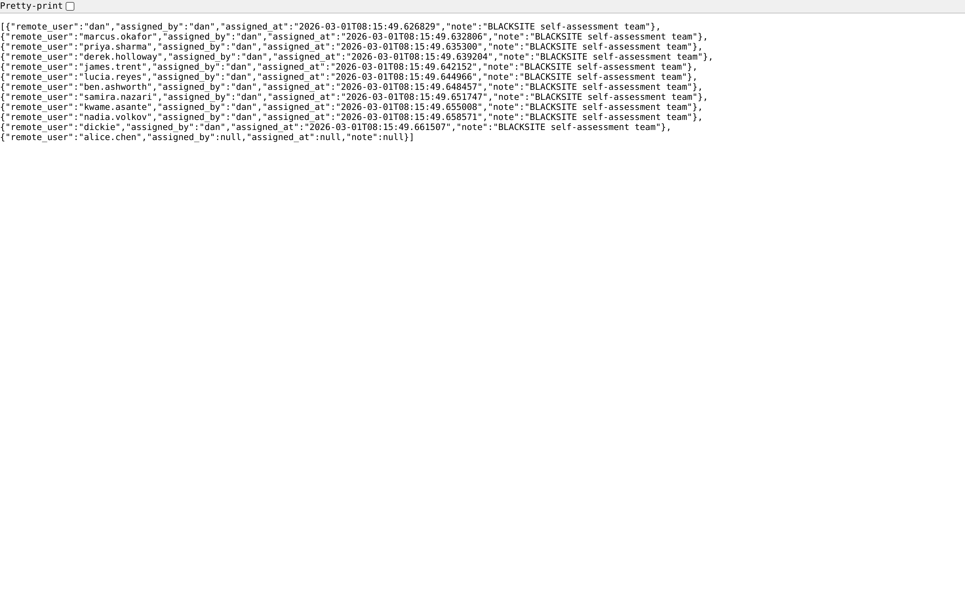
Figure 5: Manage assignments

Step 6: Archive a system
Admin only: navigate to /admin/systems/archived to view archived systems. To archive an active system, use the Archive action on the system edit page. Archived systems are hidden from all standard views but retain all data. Unarchiving restores the system to active status.
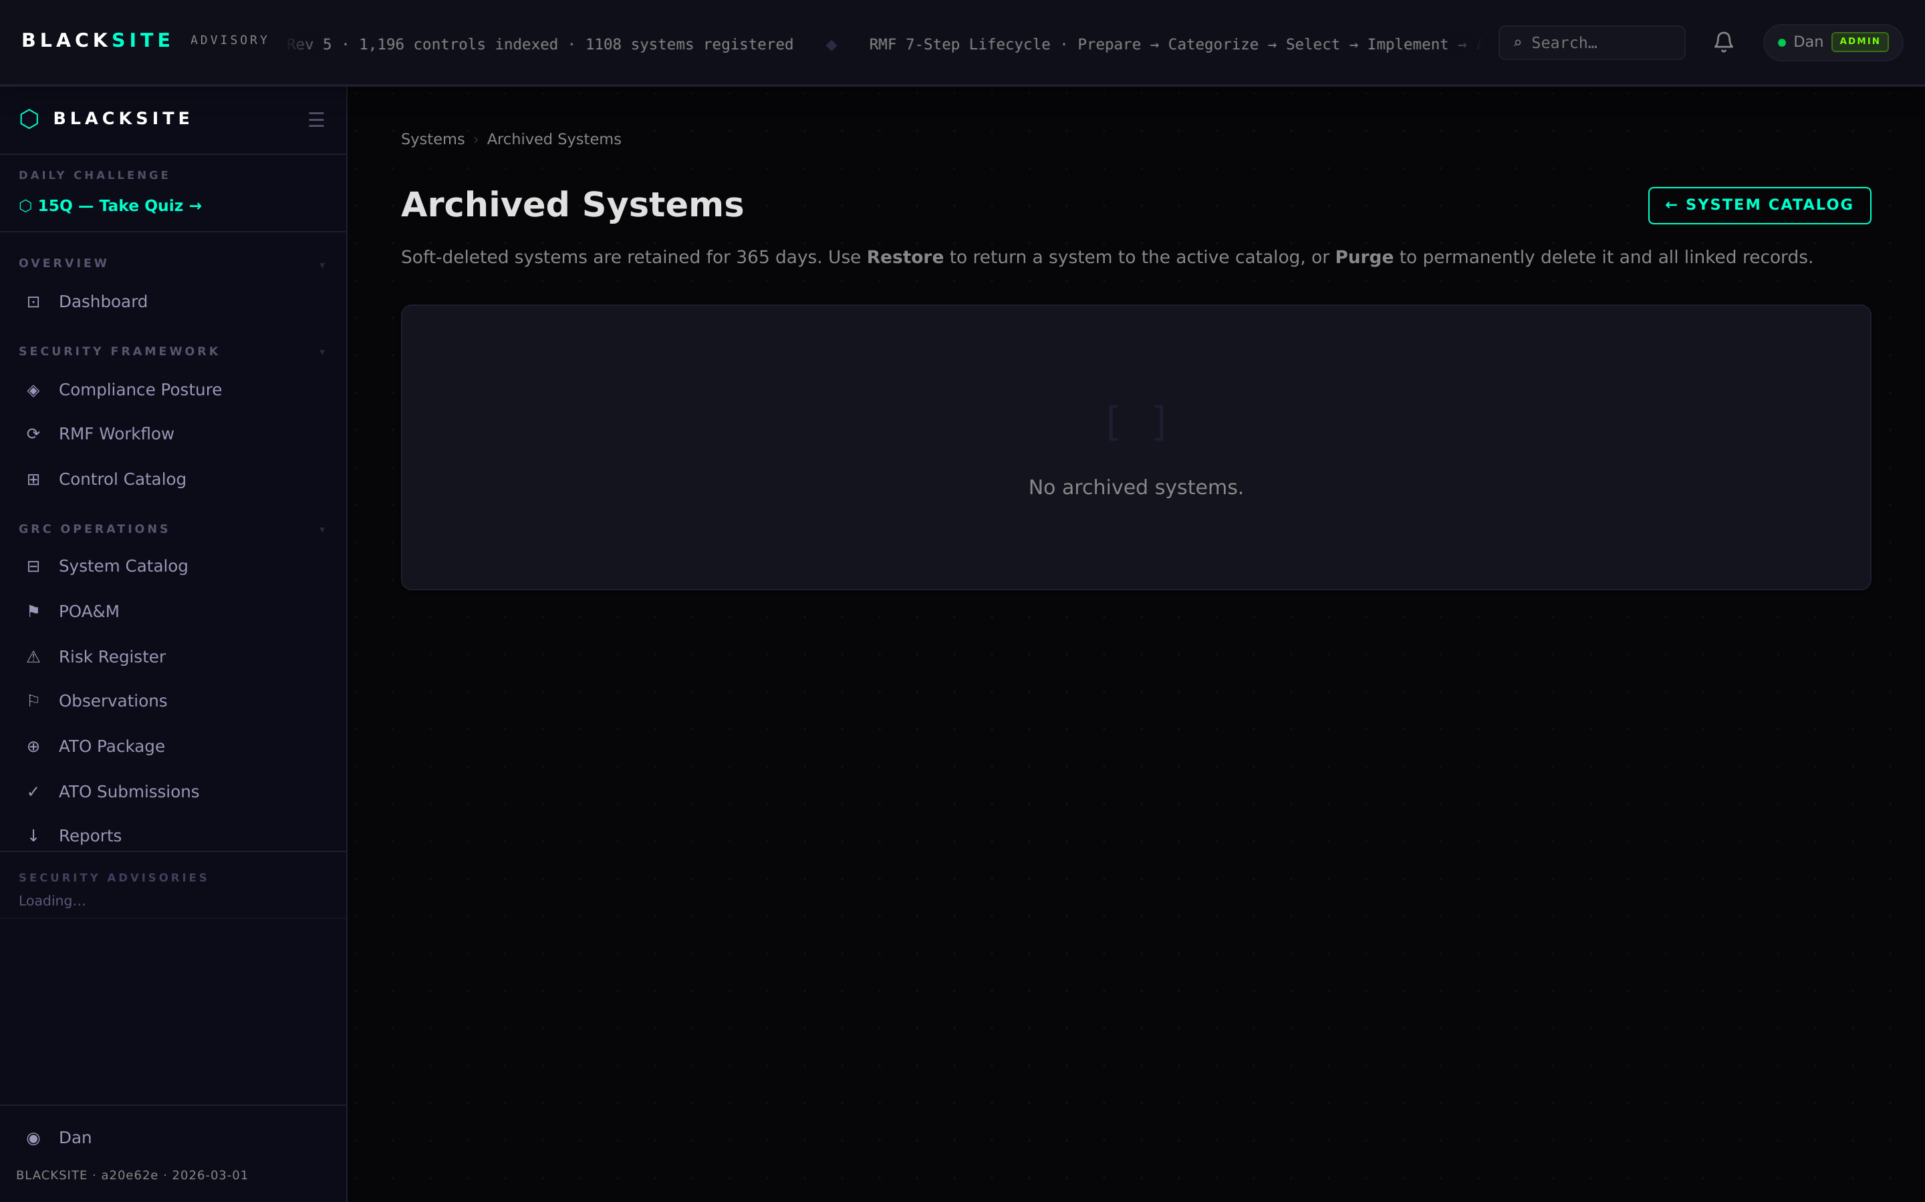
Figure 6: Archive a system

Step 7: Print system report
Navigate to /systems/{id}/report or click the Print Report button on the system detail page. A printer-friendly HTML report opens showing categorization, team assignments, control summary, and open POA&M list. Use your browser's Print function (Ctrl+P) to save as PDF.
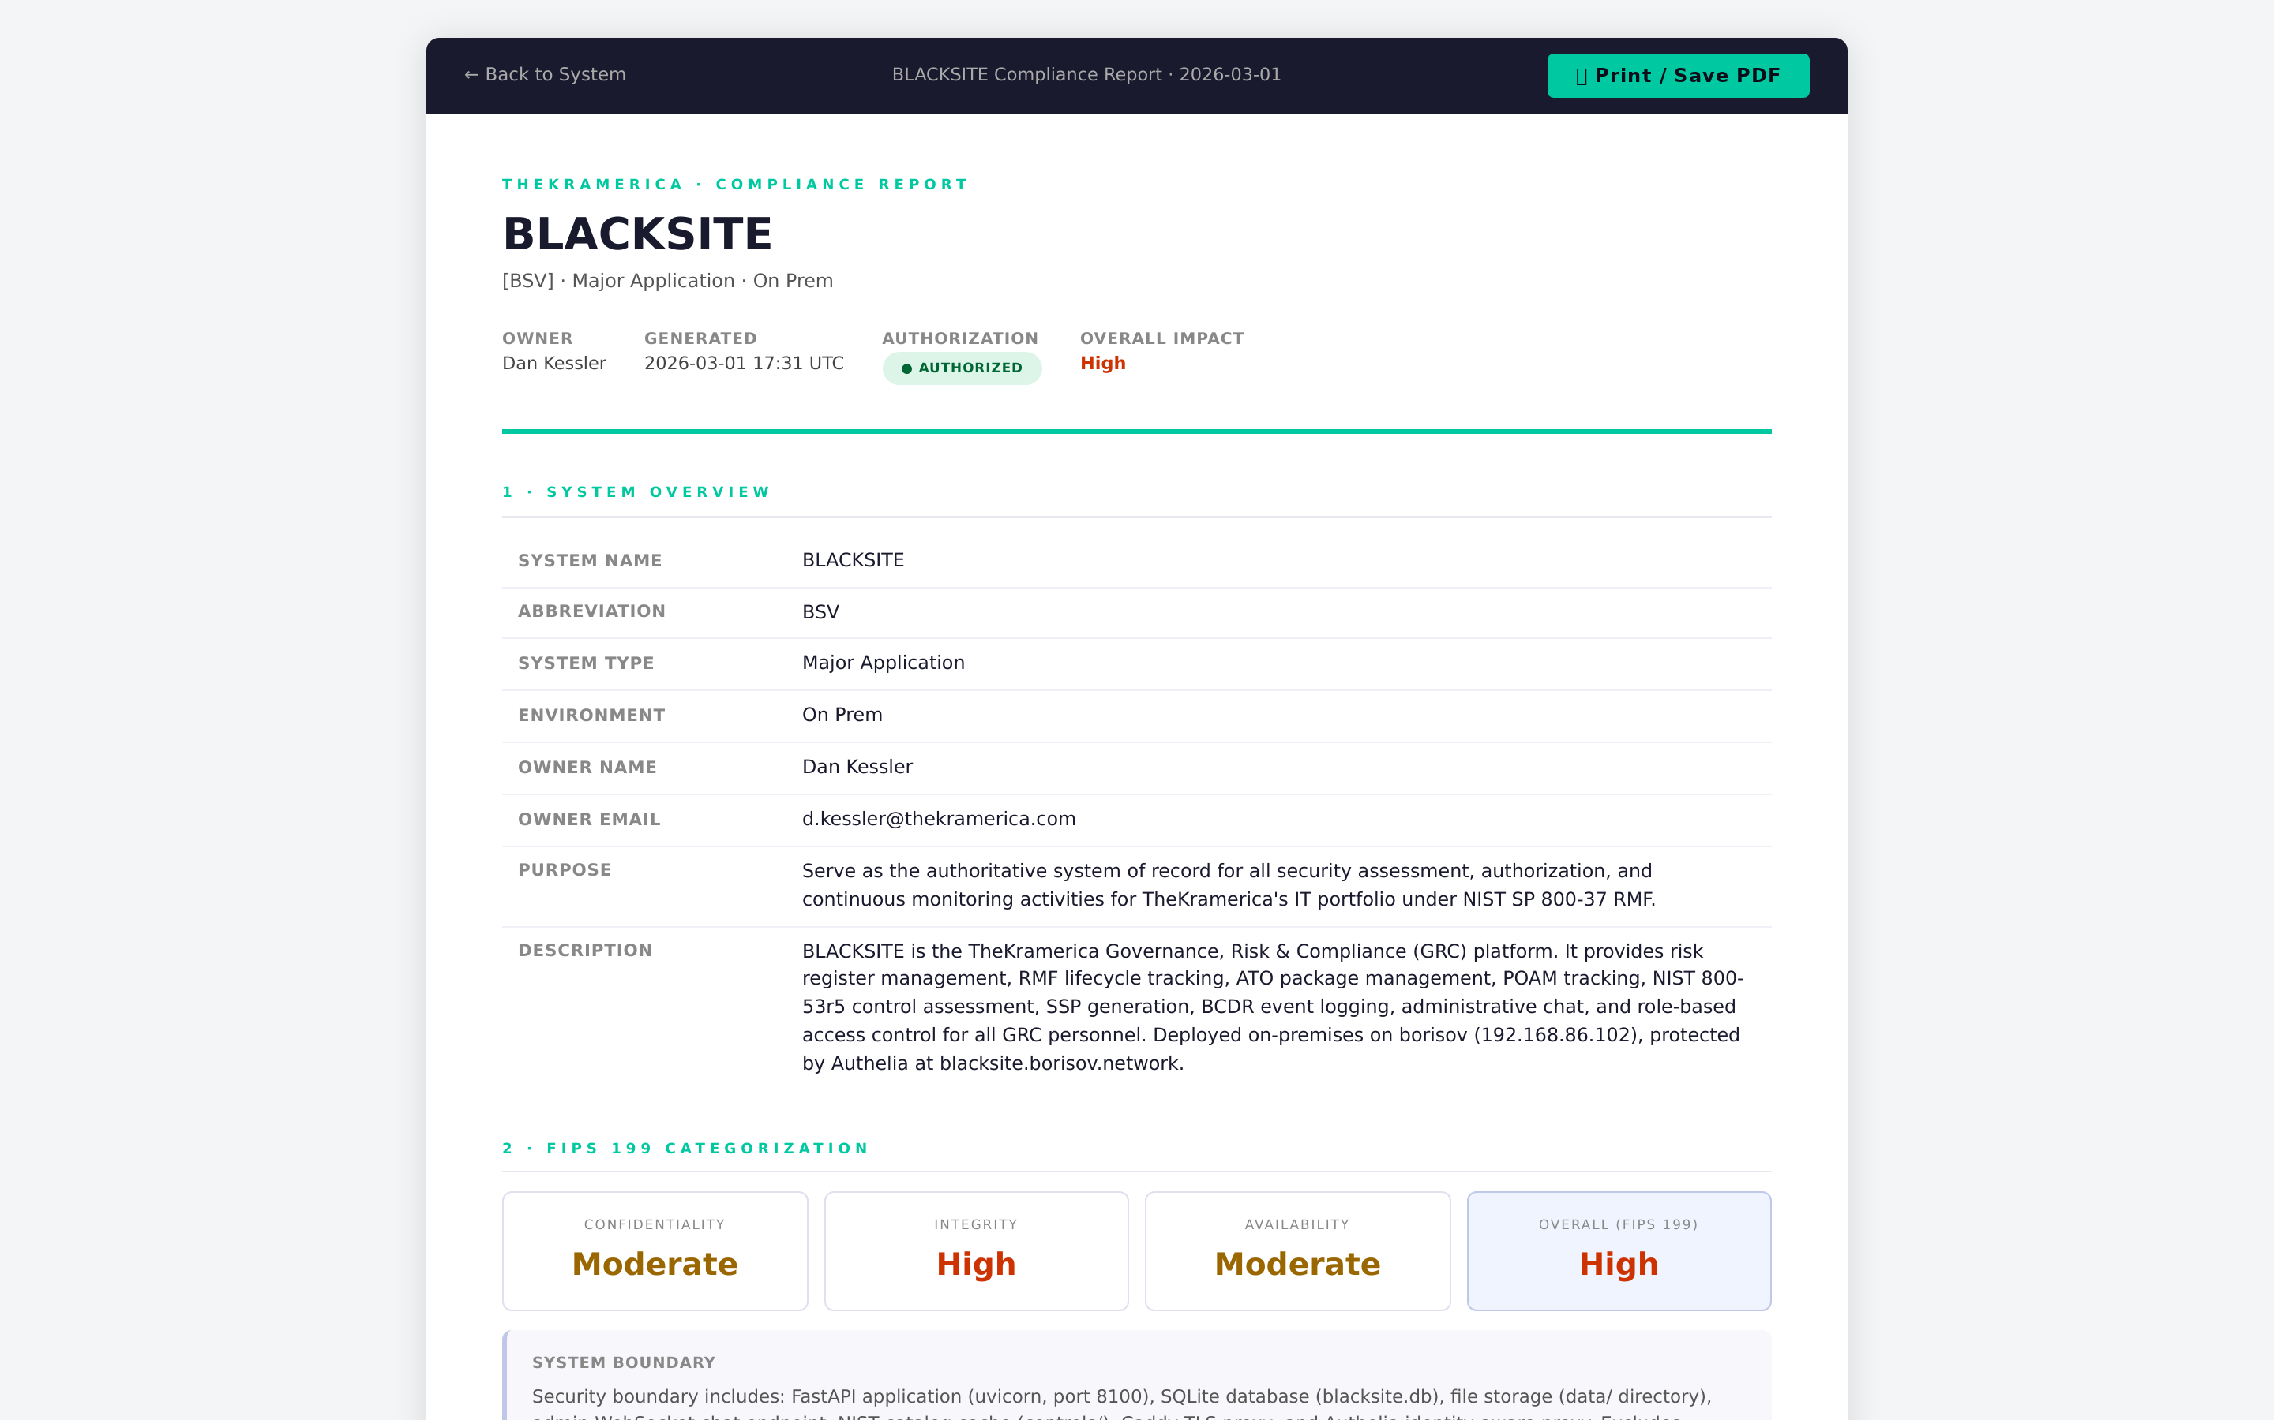
Figure 7: Print system report

Common Issues and Resolutions
Symptom | Resolution
Abbreviation already in use | Each abbreviation must be unique. Choose a different one or check if the system already exists.
FIPS impact fields blank after save | Ensure all three CIA fields are set before saving. The form requires all three.
Assignment not visible to assigned user | The user may lack a system role assignment. Verify their role at /admin/users.

