━━━━━━━━━━━━━━━━━━━━━━━━━━━━━━━━━━━━━━━━━━━━━━━━━━━━━━━━━━━━━━━━━━━━━━
BLACKSITE GRC Platform · THKR-BSV-001

User Account Management
Roles: Admin
Version: 1.0 | Date: 2026-03-01 | Classification: INTERNAL USE ONLY
━━━━━━━━━━━━━━━━━━━━━━━━━━━━━━━━━━━━━━━━━━━━━━━━━━━━━━━━━━━━━━━━━━━━━━

Overview
Admins manage all user accounts: creating, provisioning, freezing, removing, and role assignment. BLACKSITE uses a reservation system to hold usernames for provisioned accounts. Shadow users are accounts that have never logged in.

Prerequisites
- Admin account.

Procedure

Step 1: View users list
Navigate to /admin/users. All accounts are listed with platform role badges, last login date, status (active/frozen/shadow), and action buttons. The search bar filters by username or display name.
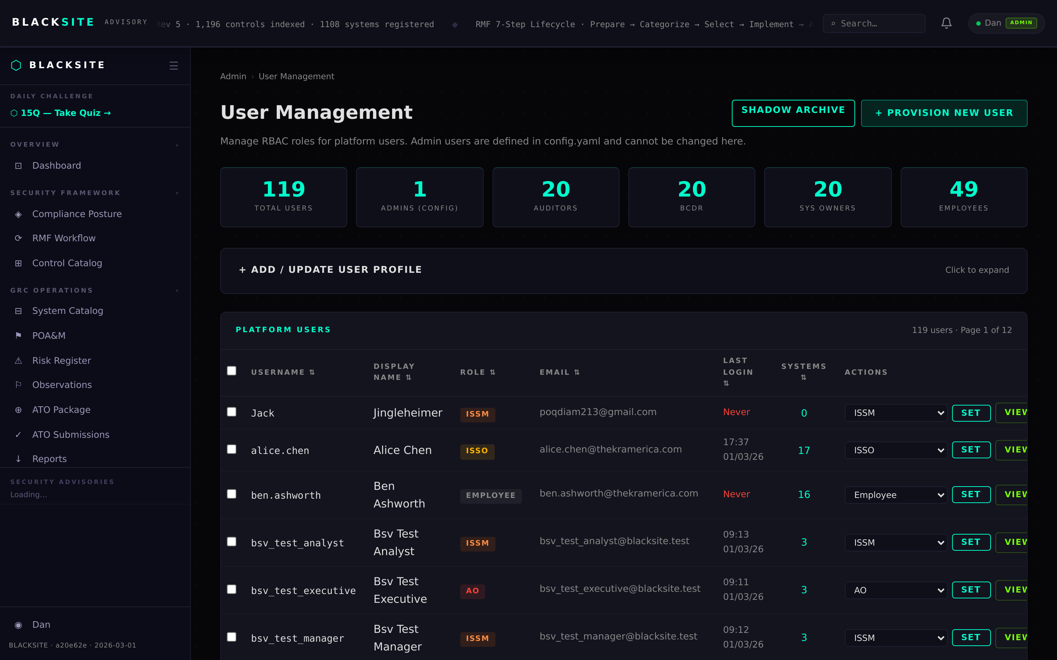
Figure 1: View users list

Step 2: Add a user account
Click + Add User. Enter the username (must match the Authelia/proxy username exactly), Display Name, and Platform Role. Click Add User. The account is created and the user can log in immediately.
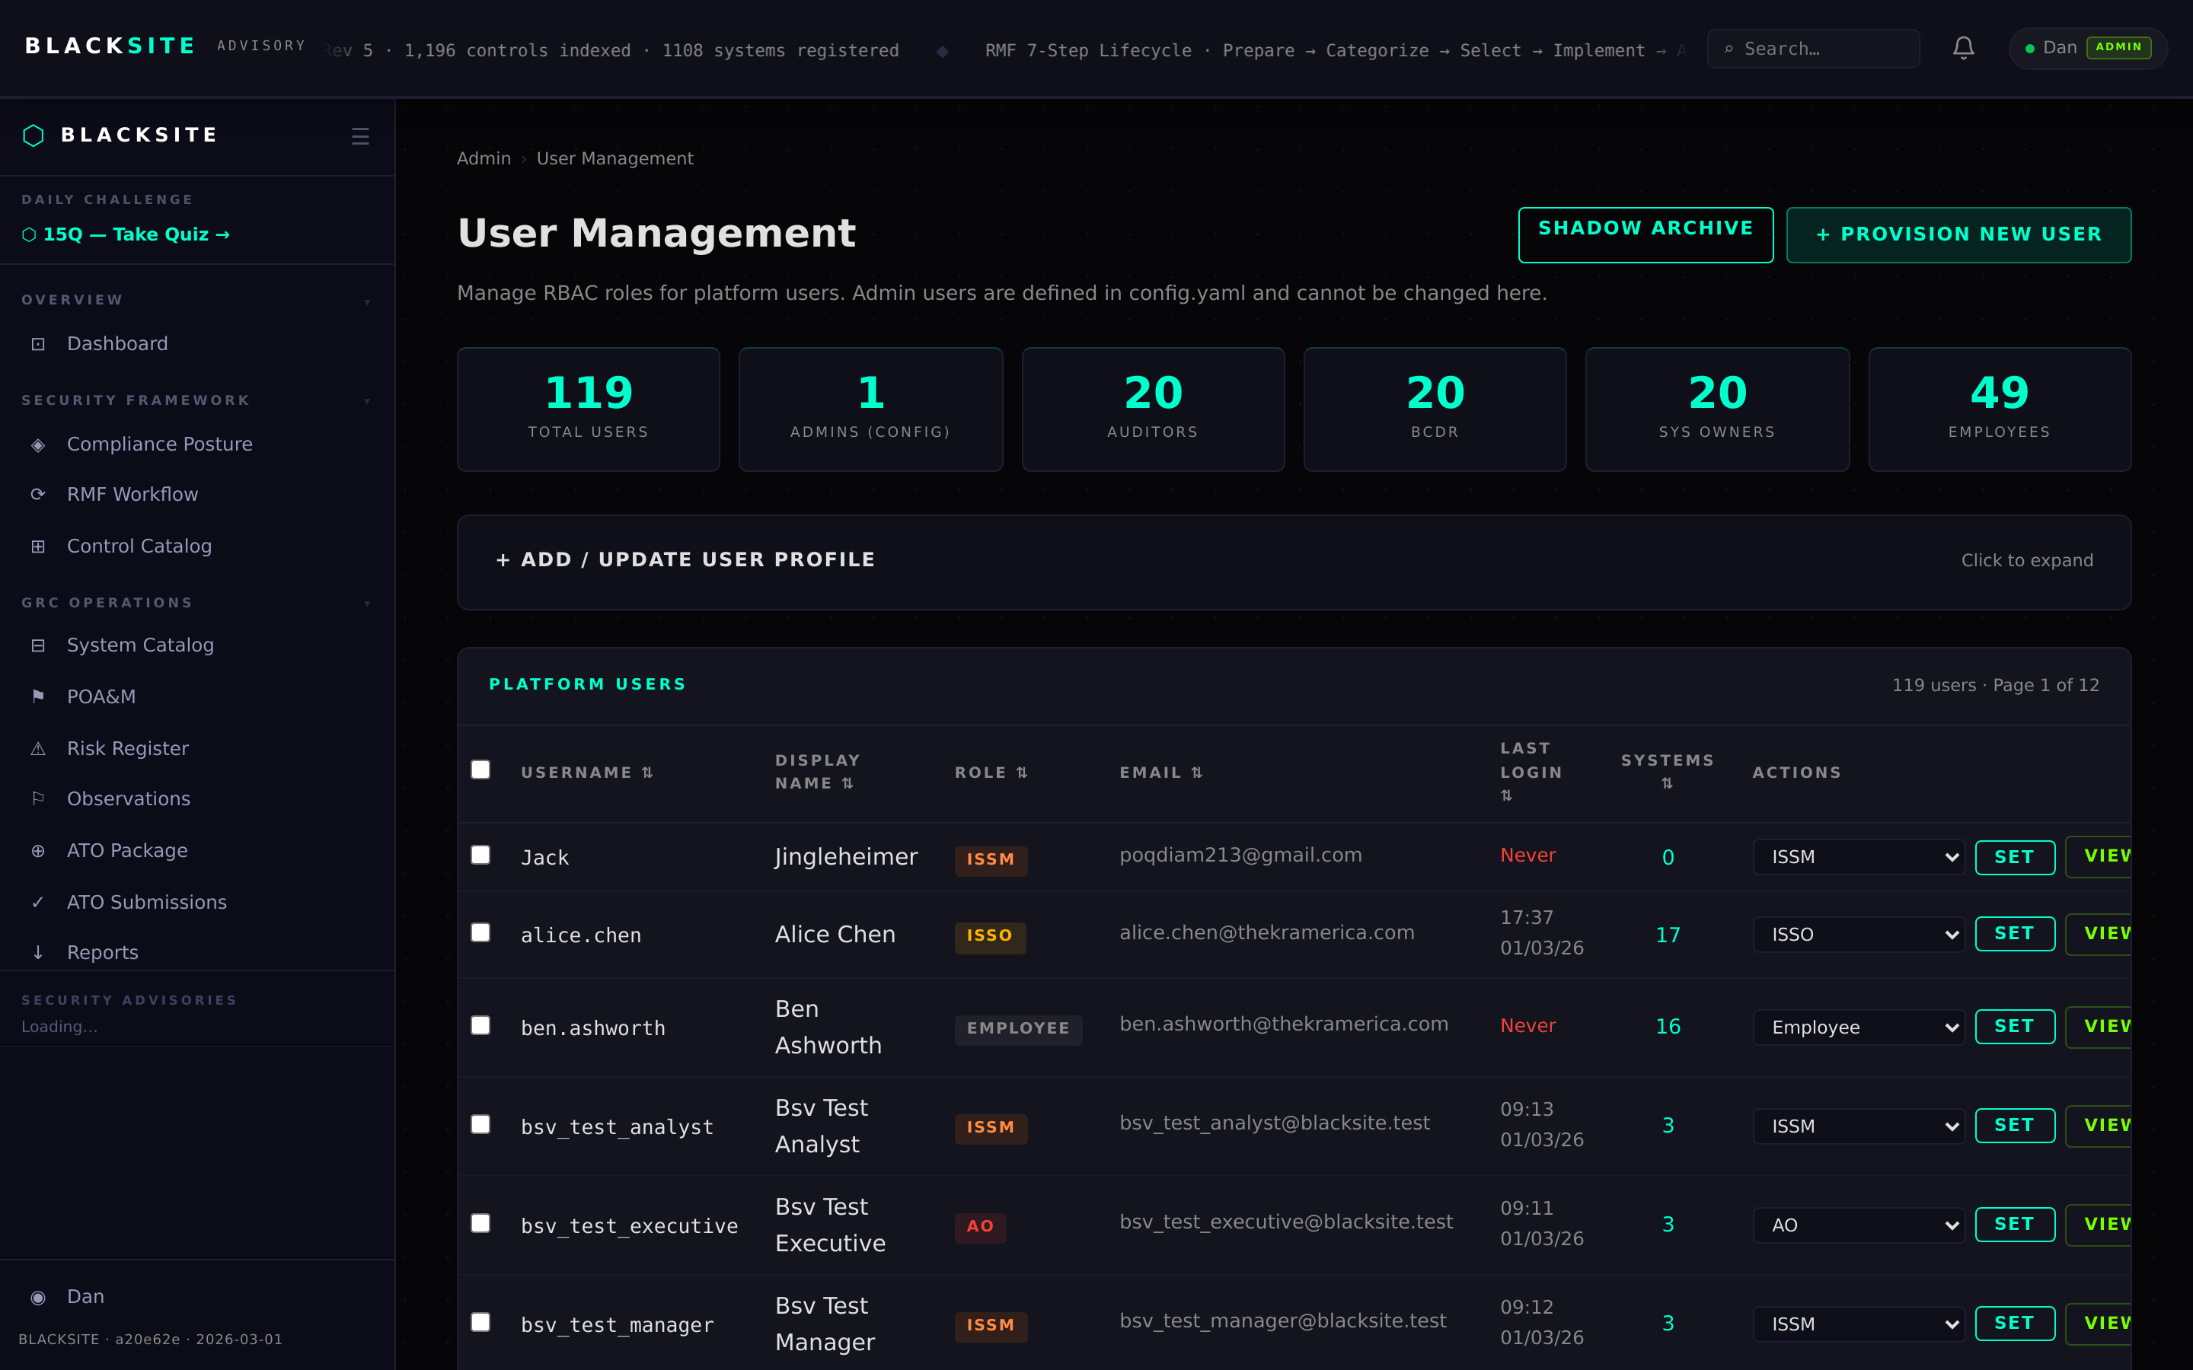
Figure 2: Add a user account

Step 3: Provision a user (guided setup)
Navigate to /admin/users/provision. Provisioning creates a user with a pre-configured role and optional system assignment in one step. Fill in username, display name, role, and optionally a system to assign. Click Provision. A notification email is sent if mail is configured.
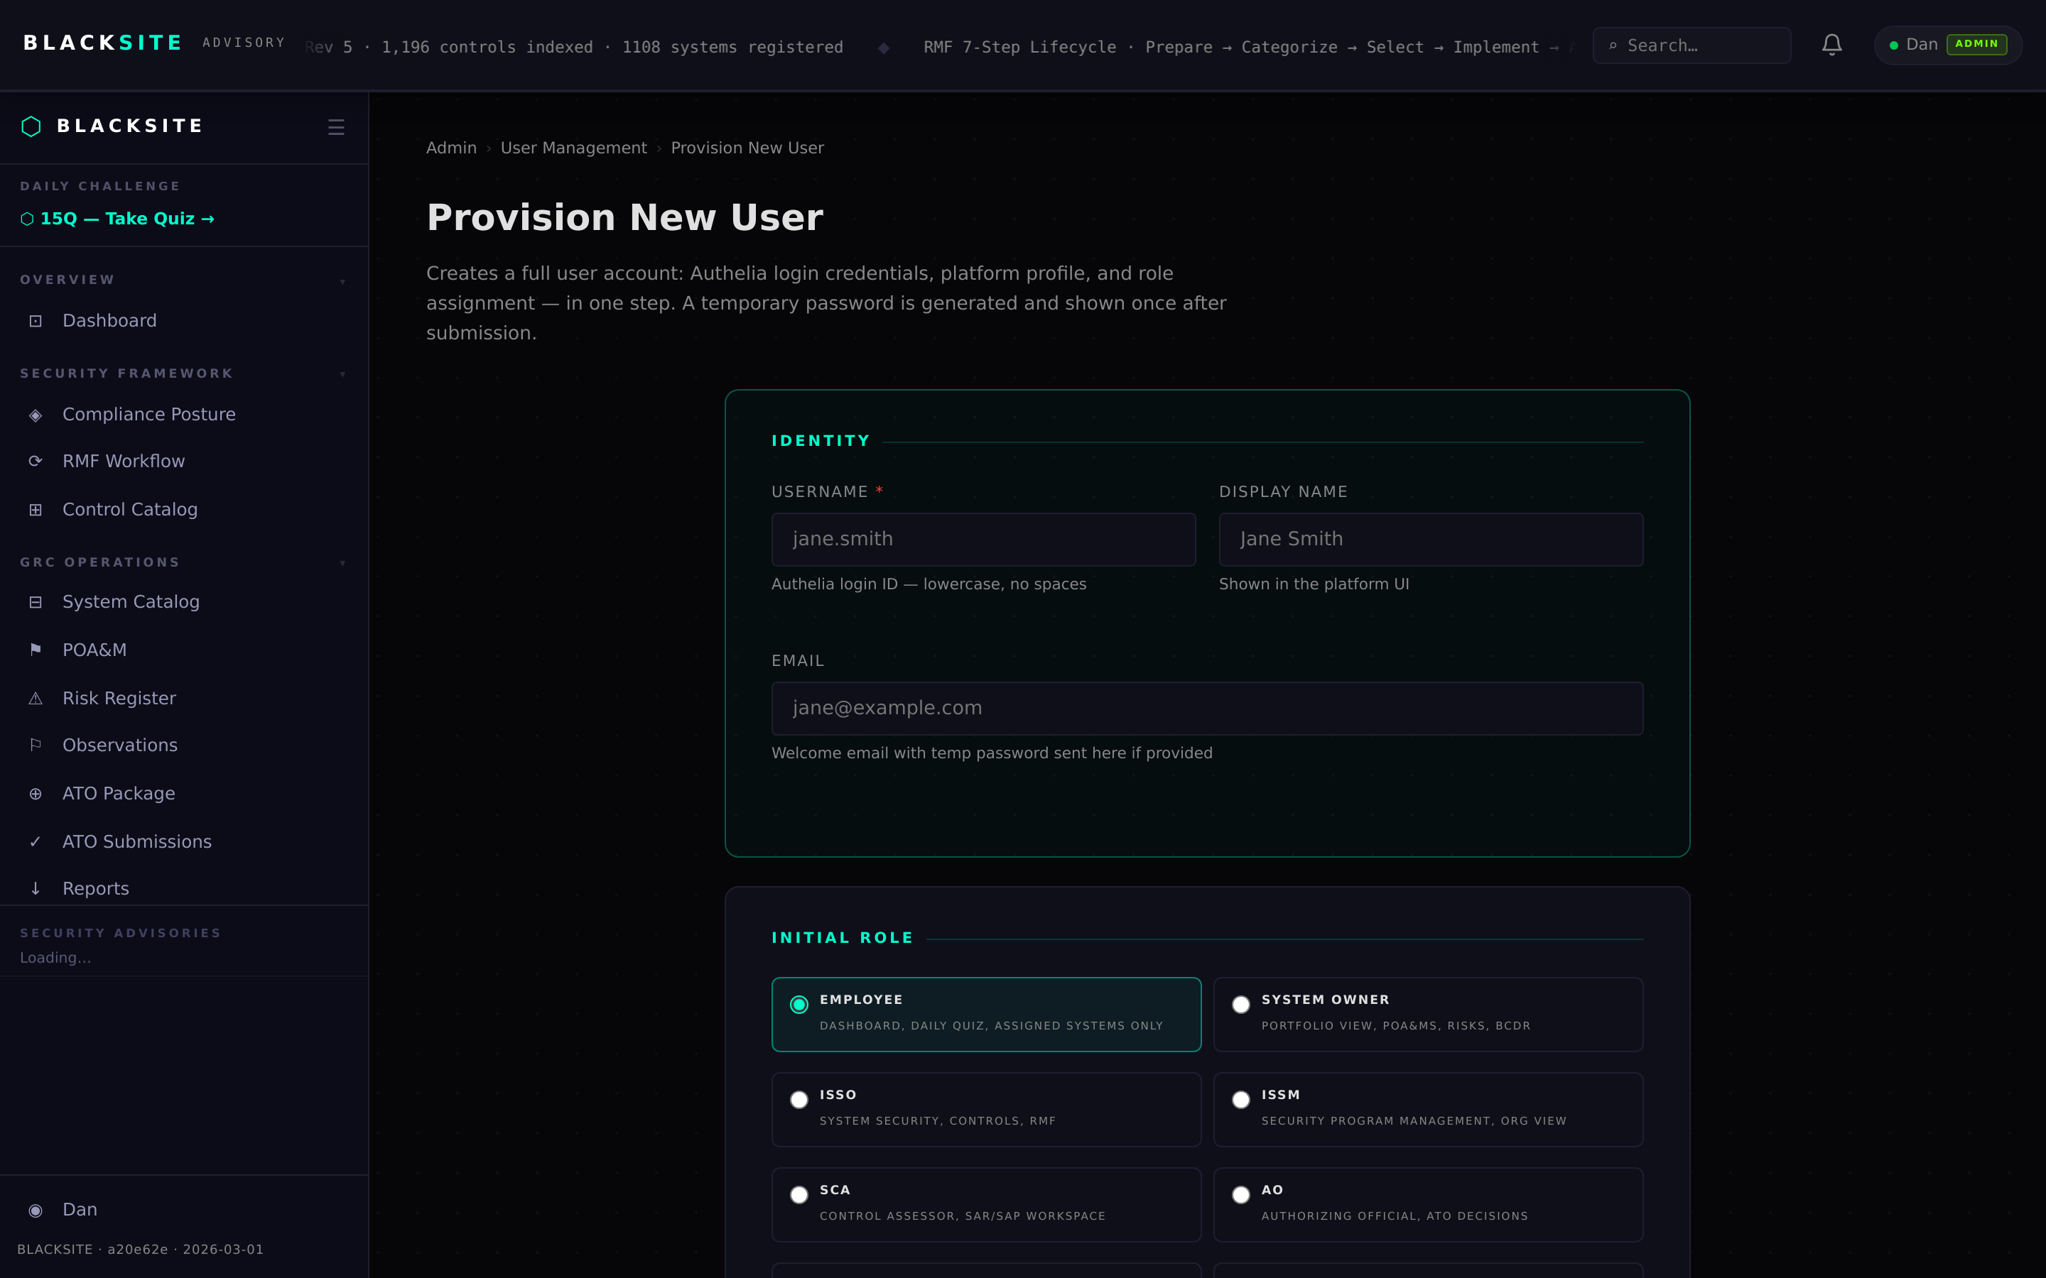
Figure 3: Provision a user (guided setup)

Step 4: Freeze a user account
Click Freeze next to a user. Confirm in the dialog. Frozen accounts cannot log in and their sessions are invalidated immediately. The account remains in the database. Freeze is reversible via the Unfreeze action.
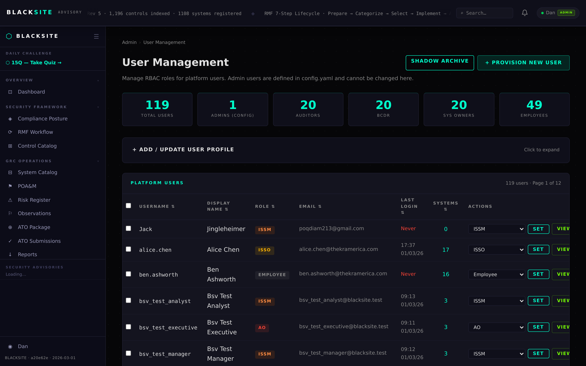
Figure 4: Freeze a user account

Step 5: Remove a user account
Click Remove next to a user. Confirm in the dialog. The username is held in RemovedUserReservation for 1 year (prevents username reuse). All assignments for the user are removed. This action is logged in the audit trail.
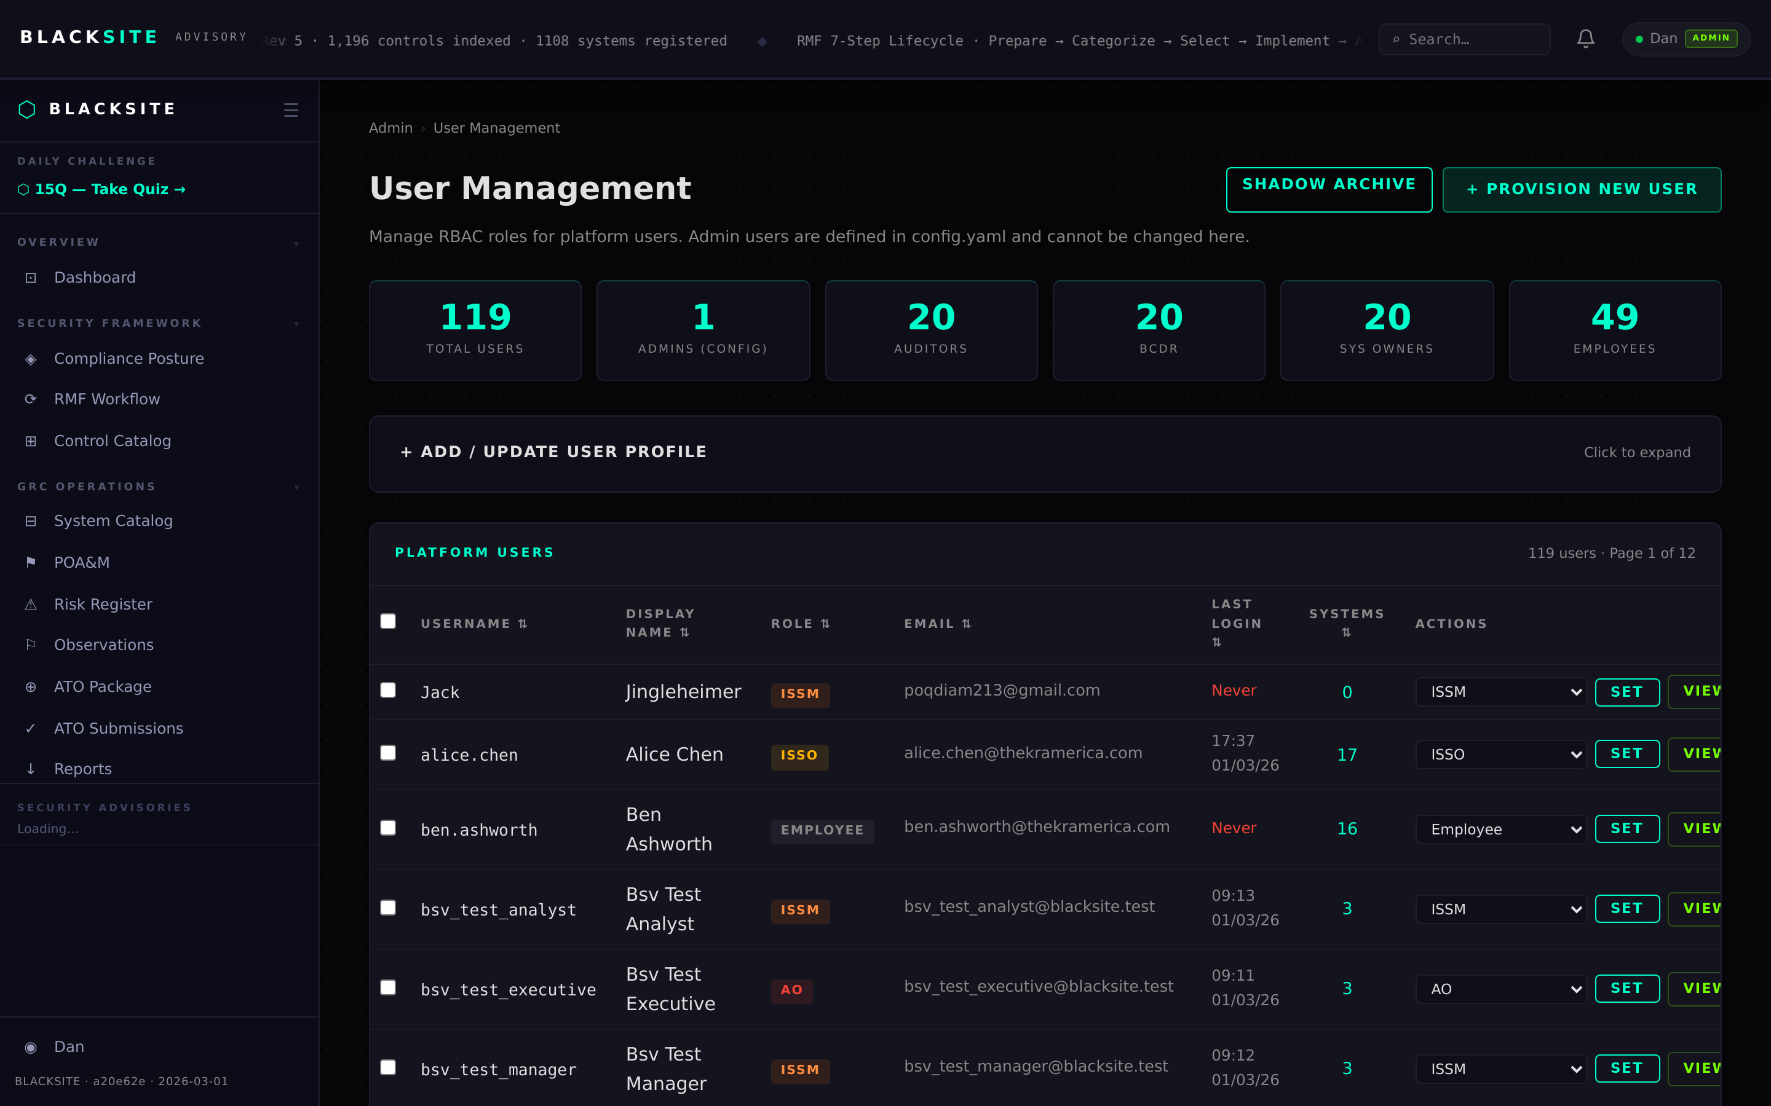
Figure 5: Remove a user account

Step 6: View name reservations
Navigate to /admin/users/reservations to see all held usernames from removed accounts. Each reservation shows the original account's removal date and 1-year expiry. Admins can override and release a reservation early if needed.
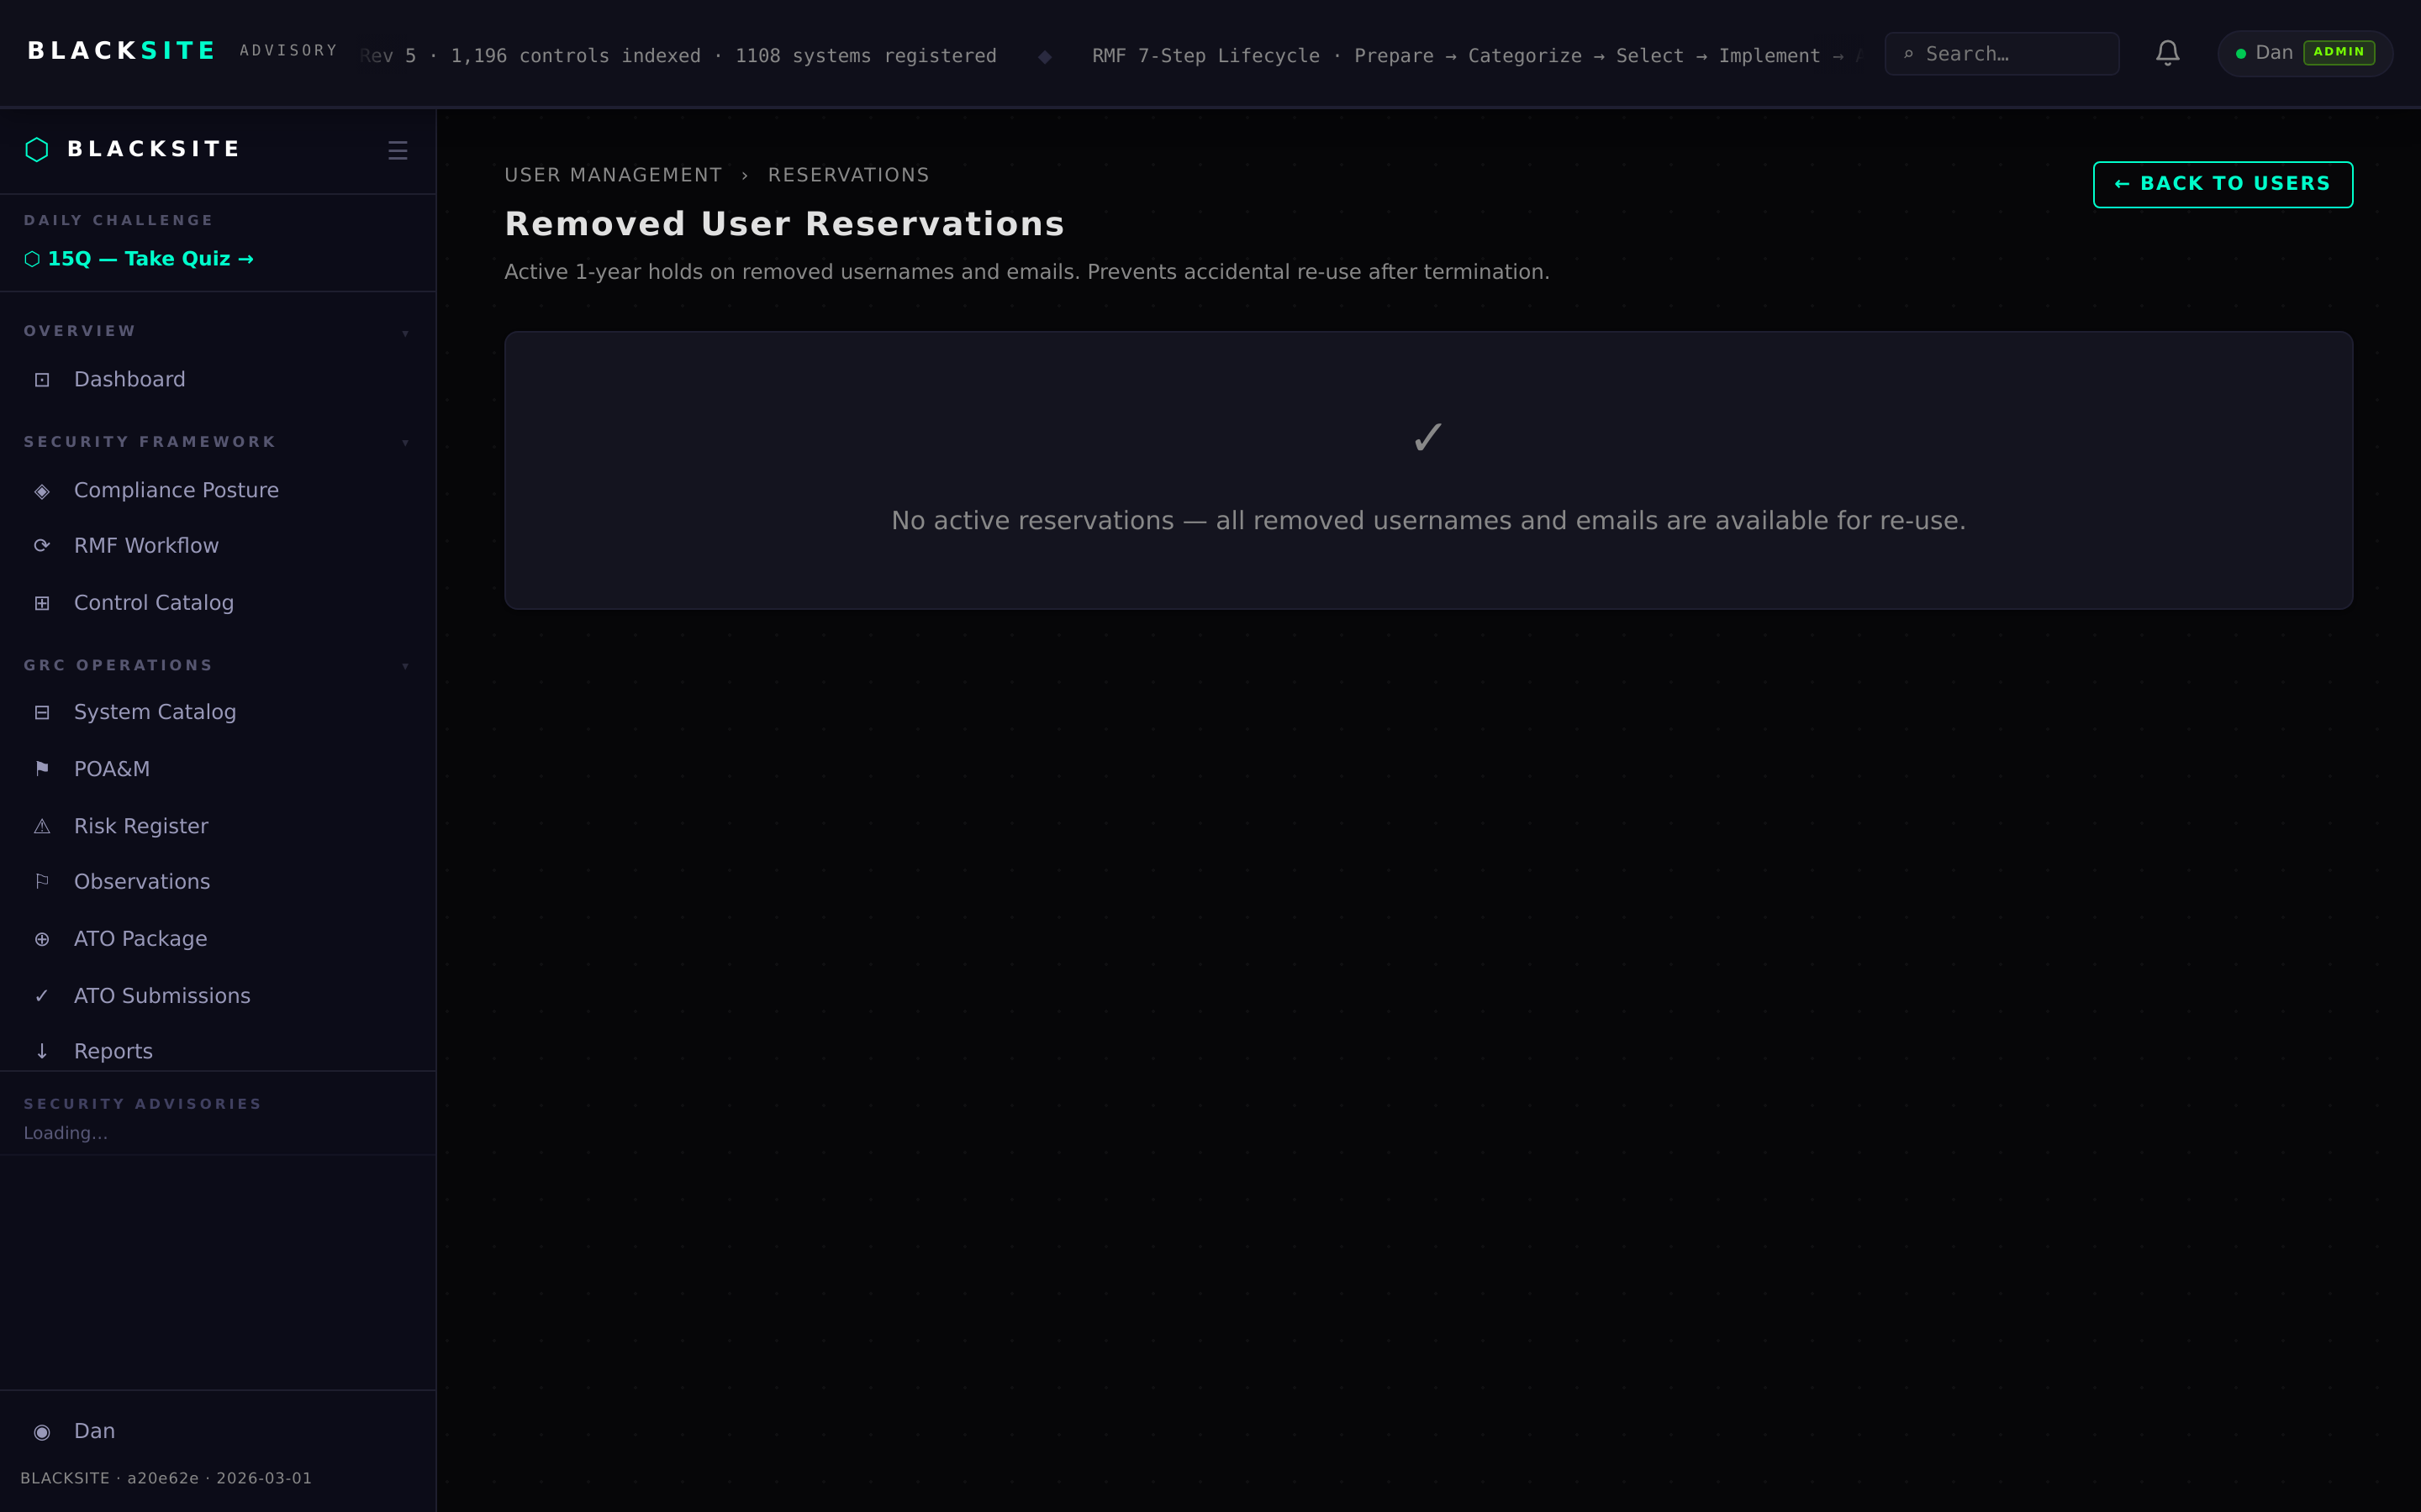
Figure 6: View name reservations

Step 7: Shadow users
Navigate to /admin/users/shadow to see accounts that have been provisioned but have never logged in. These accounts may represent onboarding delays or incorrect usernames. Follow up with the user or remove if stale.
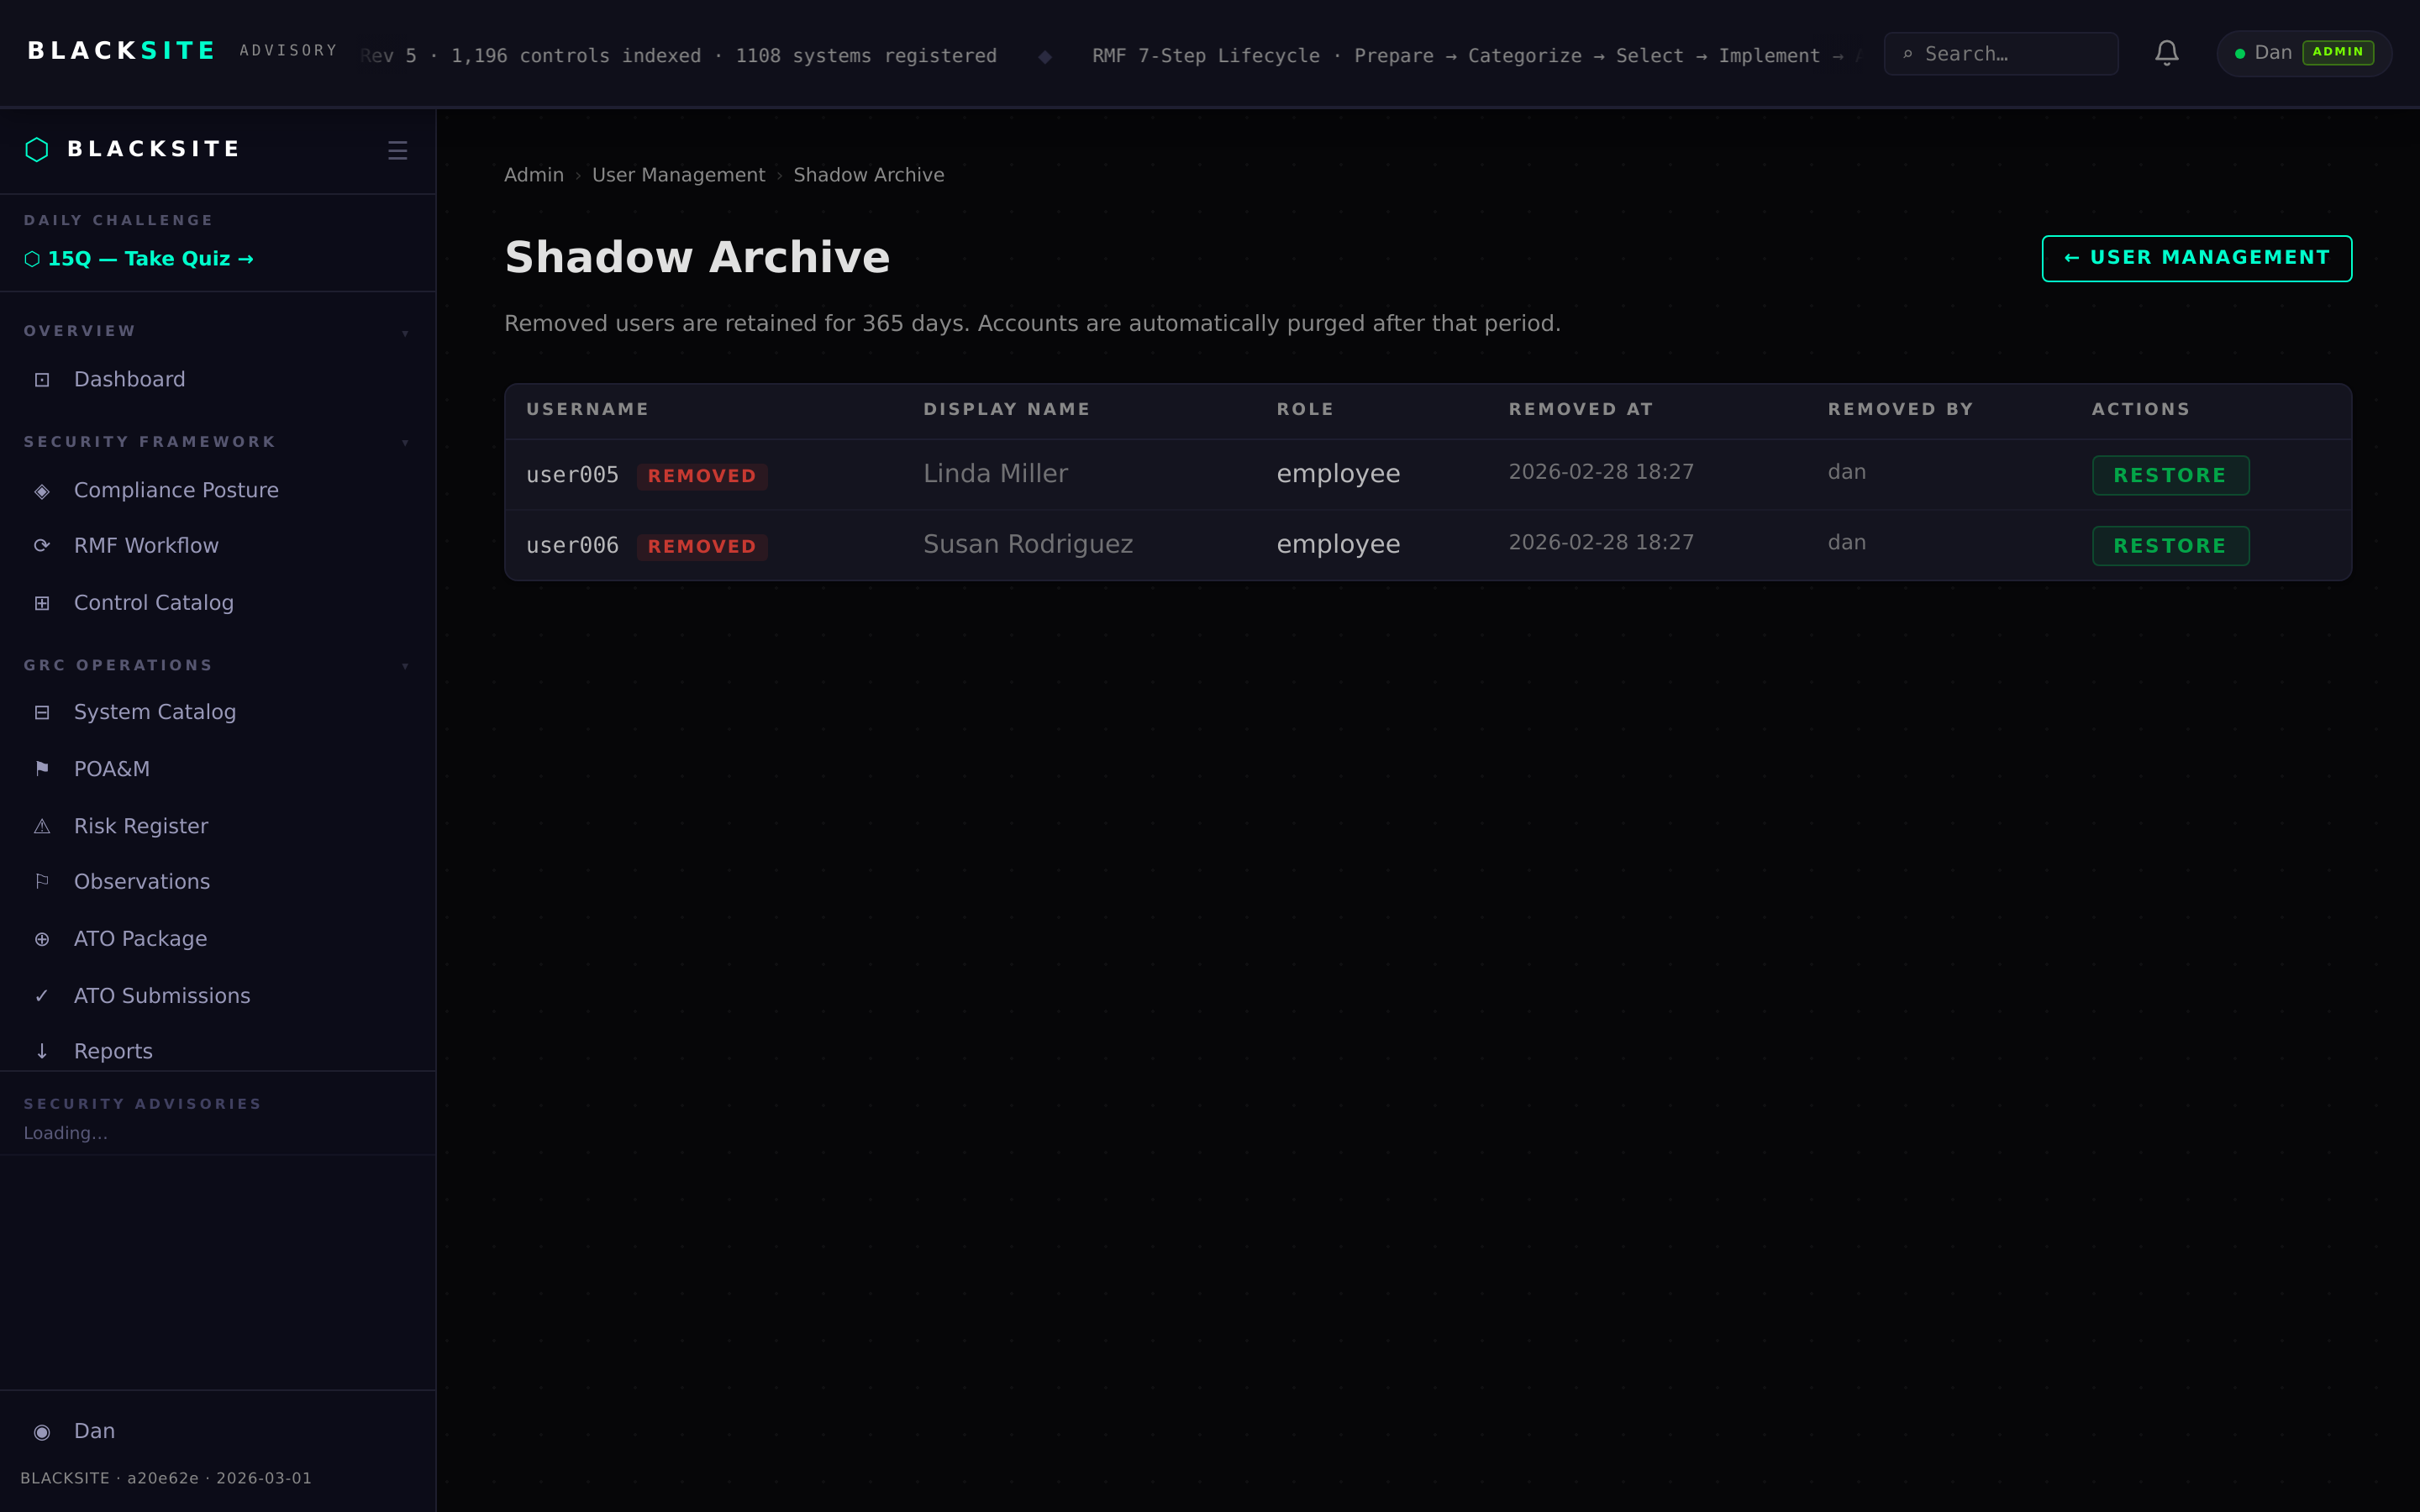
Figure 7: Shadow users

Step 8: Bulk role assignment
On the users list, use the role selector dropdown next to each user to change their platform role individually. Changes take effect on the user's next page load. Role changes are logged in the audit trail.
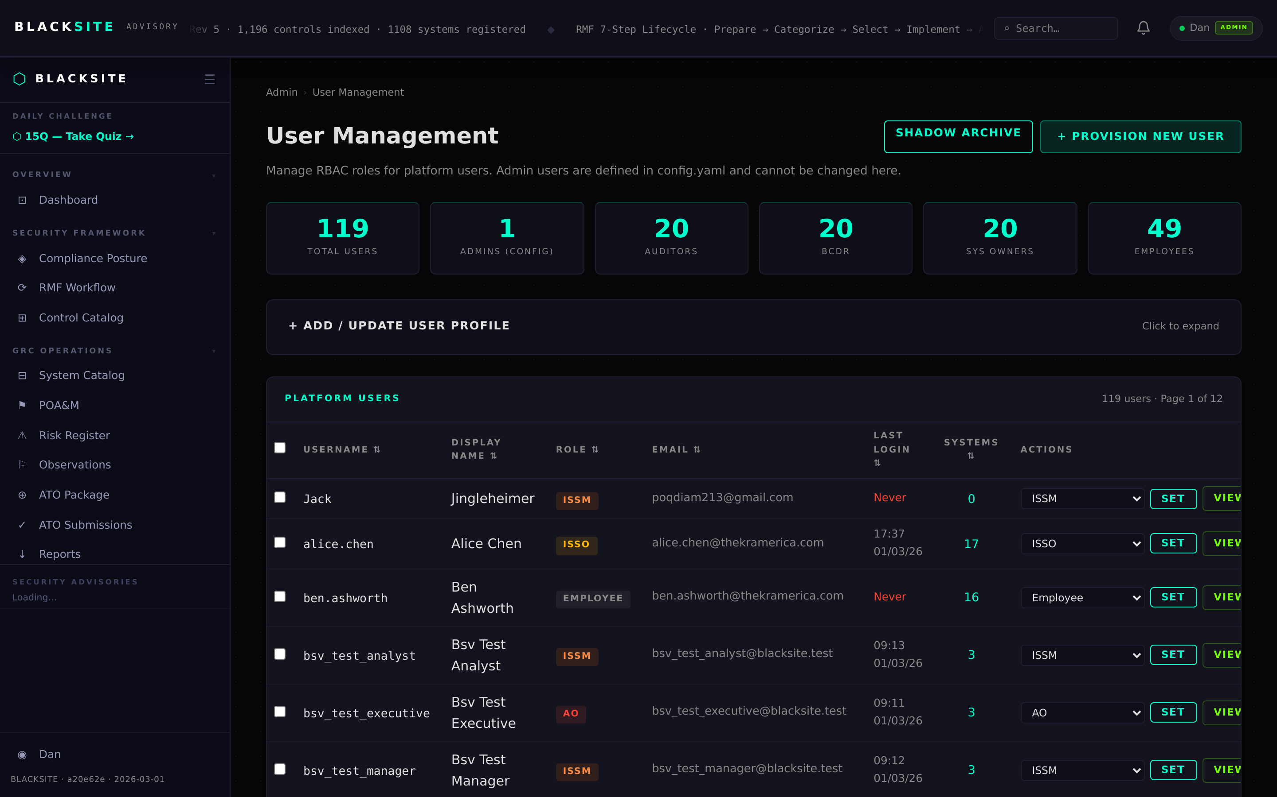
Figure 8: Bulk role assignment

Step 9: Configure max packages per user
ISSMs can set a per-user maximum concurrent assessment package limit on the ISSM dashboard. This controls how many simultaneous packages an ISSO can have in the assessment queue.
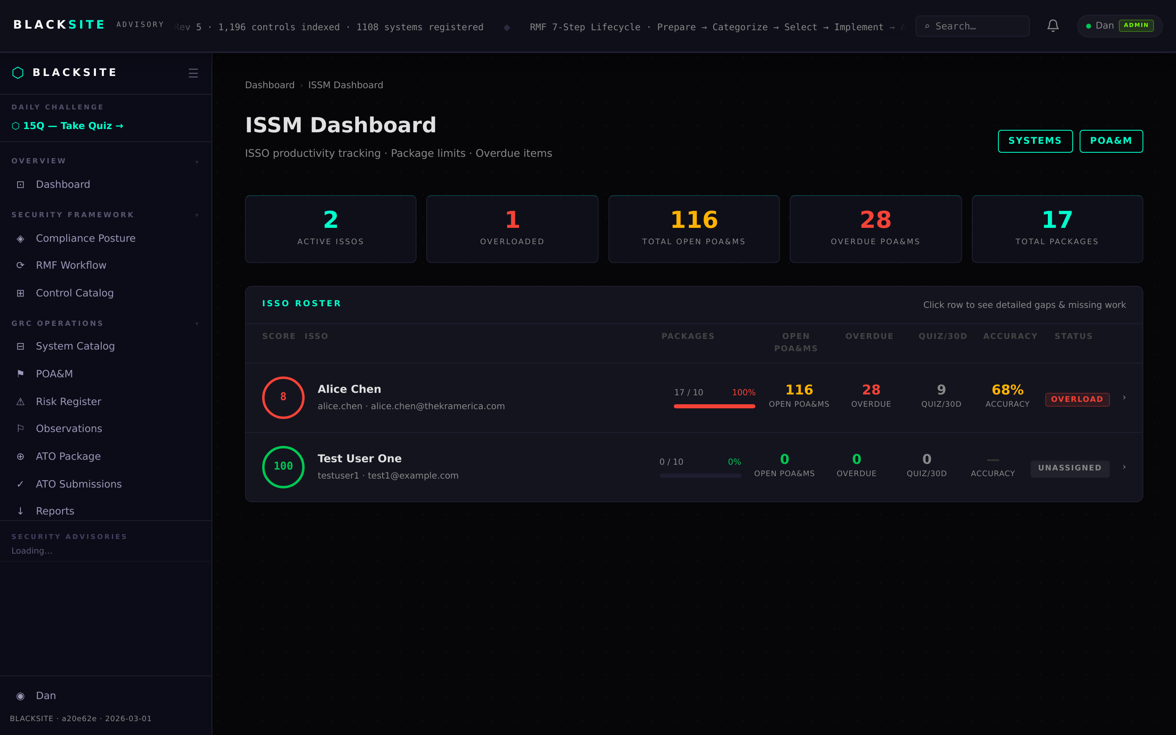
Figure 9: Configure max packages per user

Common Issues and Resolutions
Symptom | Resolution
Add User fails — username exists | The username is already taken or reserved. Check the reservations list.
Freeze has no effect on active session | Sessions expire after the 15-minute idle timeout. The freeze blocks future logins immediately.
Provision email not sent | Mail may not be configured. Check /admin/system-settings for SMTP configuration.

