━━━━━━━━━━━━━━━━━━━━━━━━━━━━━━━━━━━━━━━━━━━━━━━━━━━━━━━━━━━━━━━━━━━━━━
BLACKSITE GRC Platform · THKR-BSV-001

View-As and Role Shell
Roles: Admin, ISSM, SCA
Version: 1.0 | Date: 2026-03-01 | Classification: INTERNAL USE ONLY
━━━━━━━━━━━━━━━━━━━━━━━━━━━━━━━━━━━━━━━━━━━━━━━━━━━━━━━━━━━━━━━━━━━━━━

Overview
Admins can view the application as any user (View-As) to troubleshoot issues without sharing credentials. Users with multiple role lenses can switch their active role view via the Role Shell dropdown, scoping the UI to that role's perspective without changing their actual account permissions.

Prerequisites
- Admin account for View-As feature.
- Multiple system-role assignments for Role Shell switching.

Procedure

Step 1: Open user management
Navigate to /admin/users. The users table lists all accounts with role badges and status indicators. Find the target user whose perspective you want to inspect.
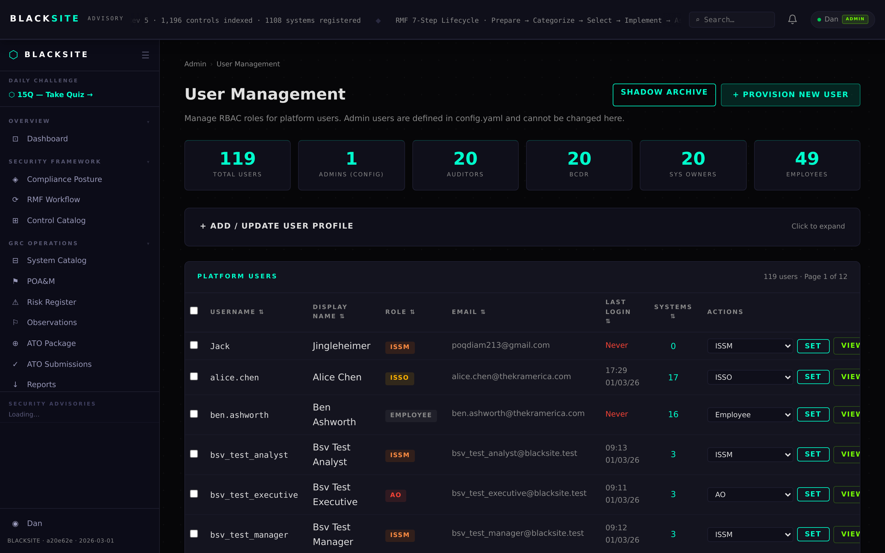
Figure 1: Open user management

Step 2: Activate View-As
Click the View button next to the target user's row. You will be redirected to the dashboard, now viewing as that user. A persistent orange banner reads 'Viewing as [username] — click to exit'. Your own session cookie is preserved via an HMAC-signed bsv_user_view cookie.
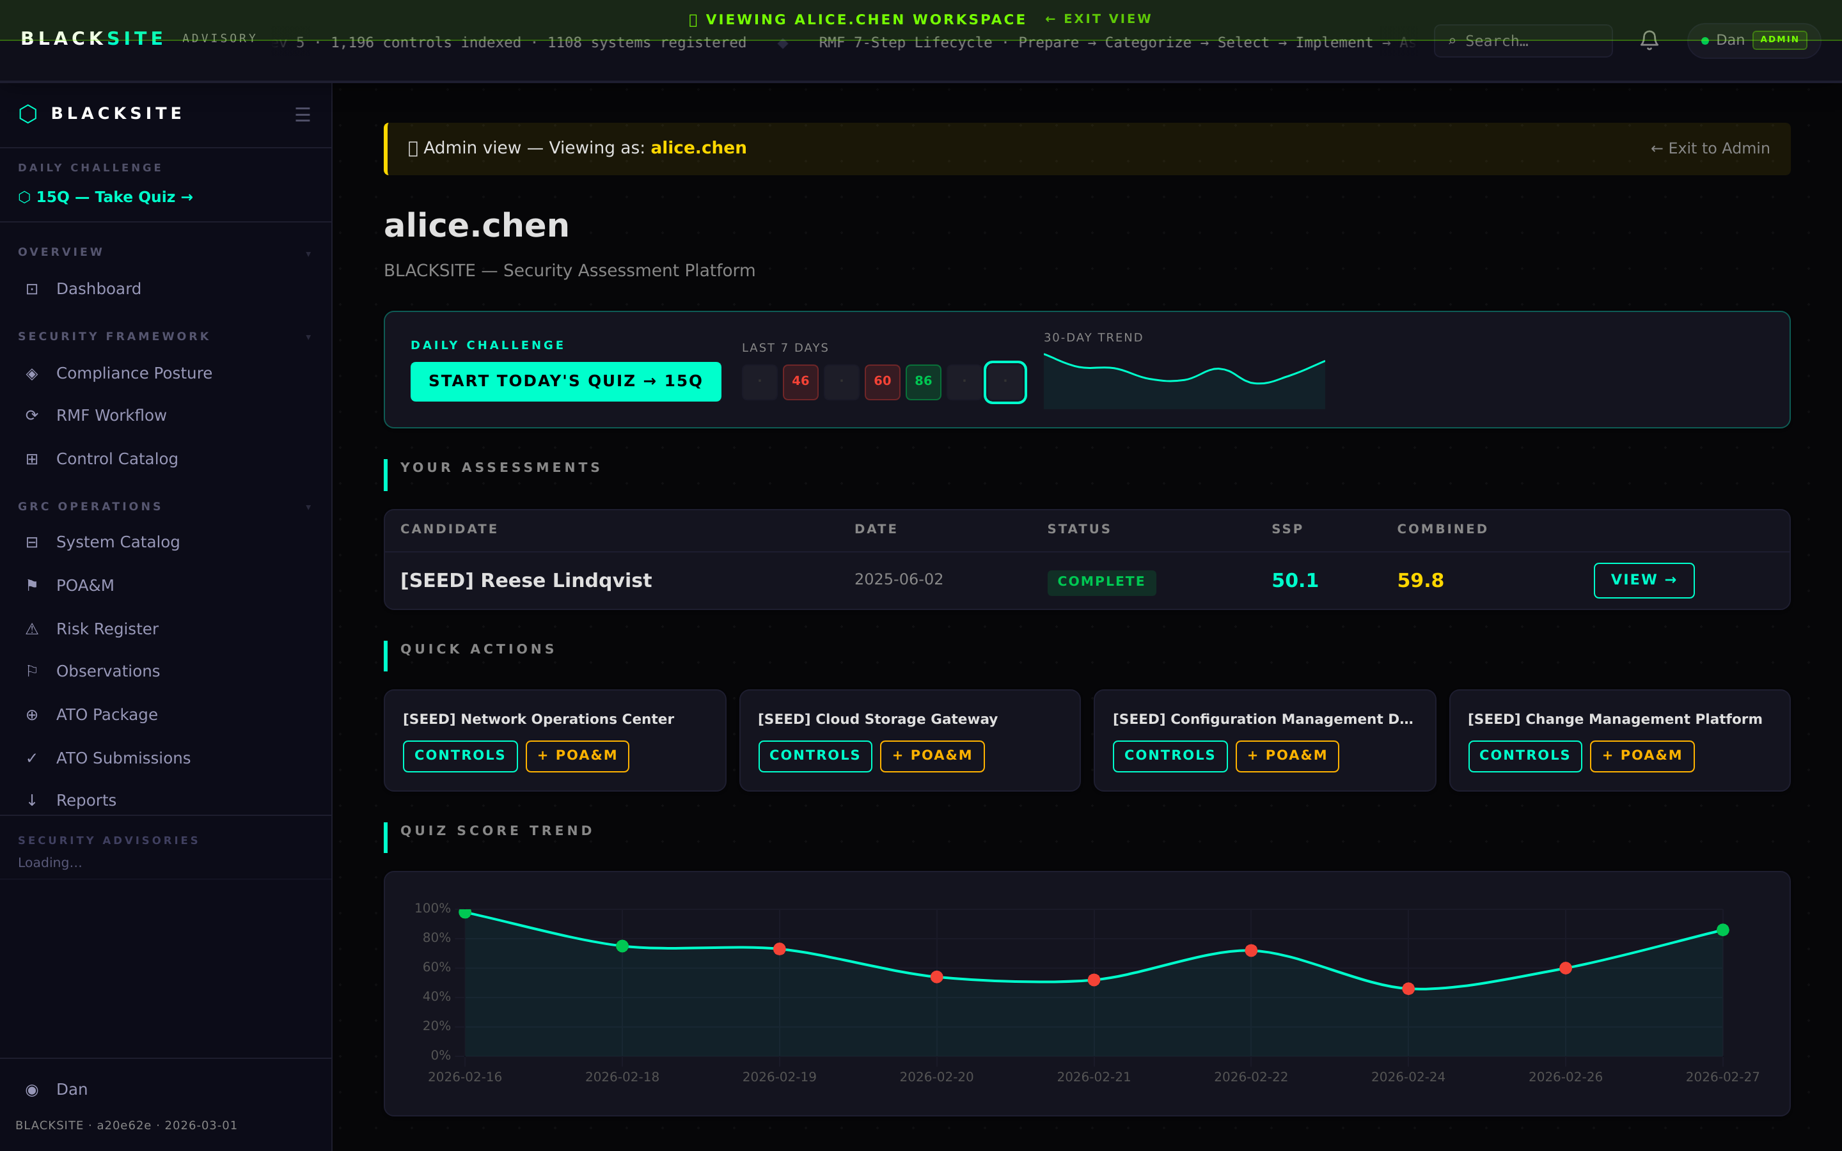
Figure 2: Activate View-As

Step 3: Navigate in View-As mode
Browse any page as the viewed user. The sidebar, dashboard widgets, and system access reflect exactly what that user sees. You cannot perform write actions while in View-As mode — all forms are read-only.
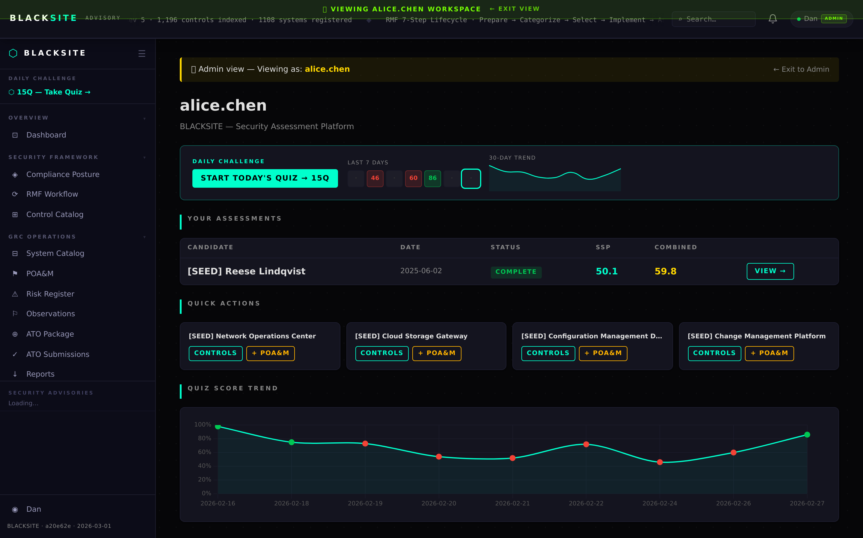
Figure 3: Navigate in View-As mode

Step 4: Exit View-As
Click the banner or navigate to /exit-view-as. The bsv_user_view cookie is cleared and your original admin session is restored.
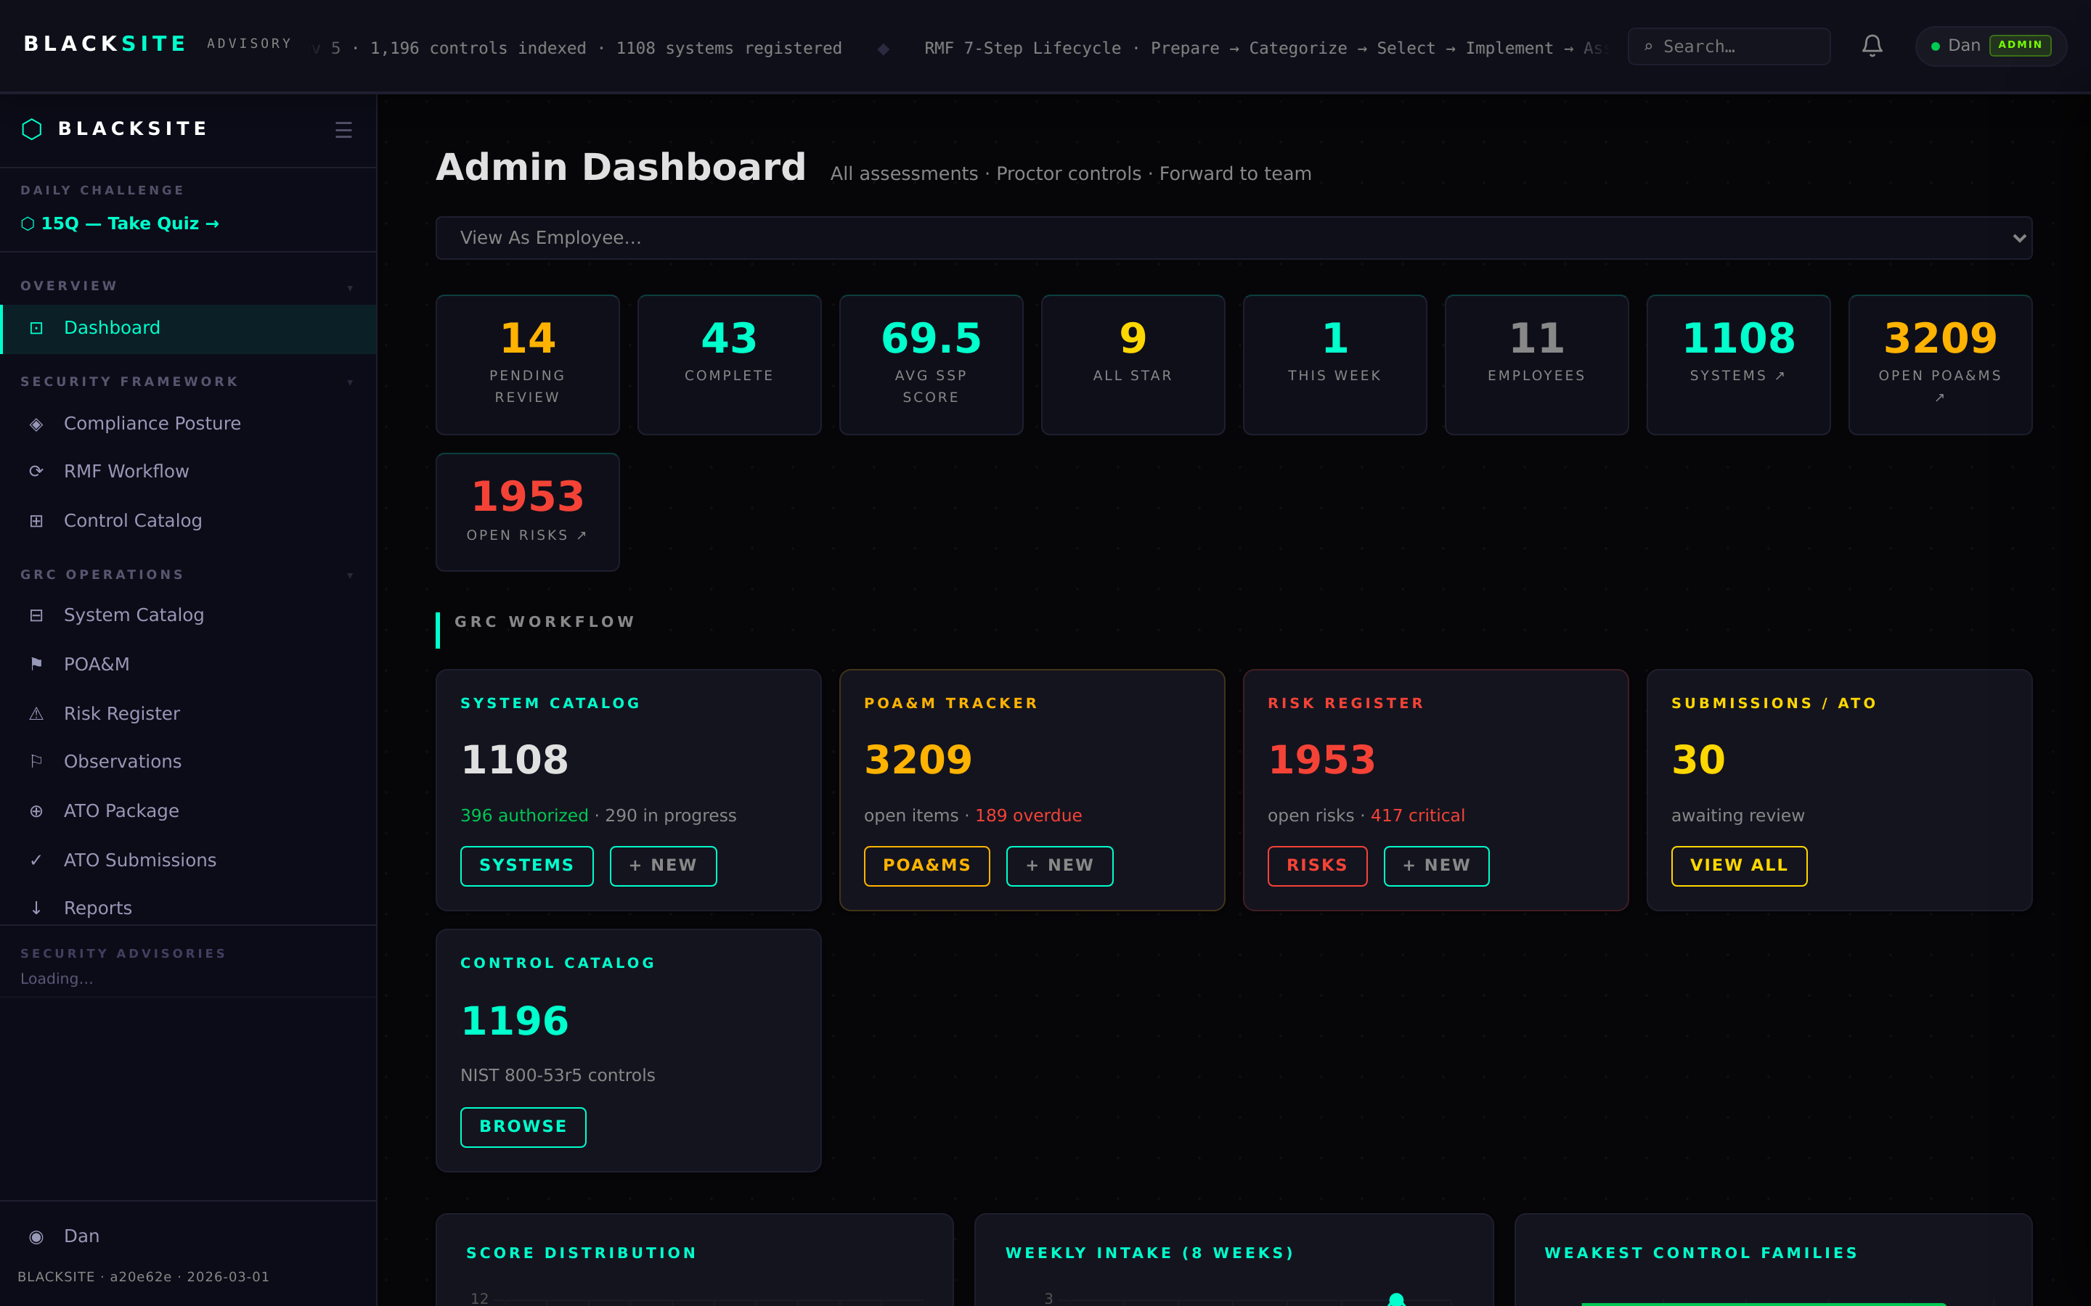
Figure 4: Exit View-As

Step 5: Switch view (role lens)
Users with multiple roles click the role badge in the top navigation to open the role switcher dropdown. Select a different role lens. The page reloads scoped to that role's view without changing your underlying permissions.
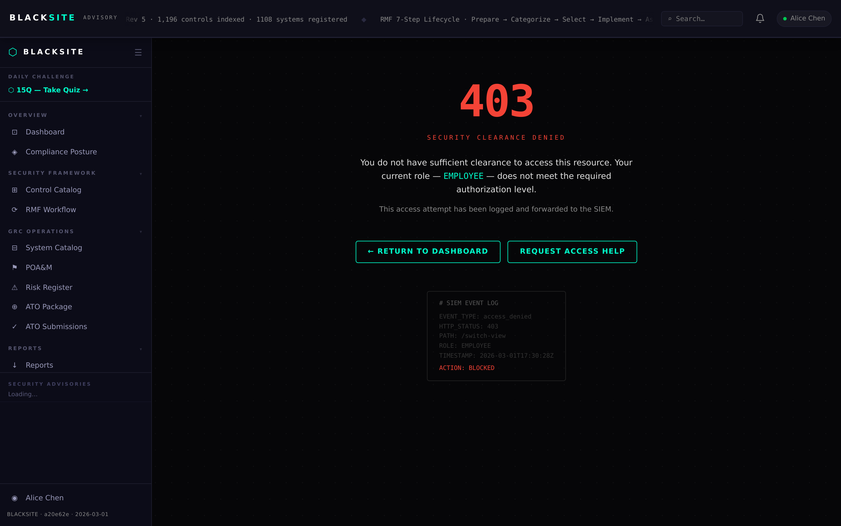
Figure 5: Switch view (role lens)

Step 6: Switch-role-view (admin shell)
Admins can enter a role shell via the admin dropdown → Switch Role. Select a role name to view the application as if you held that role. A purple 'WORKING AS [ROLE]' banner appears in the navigation.
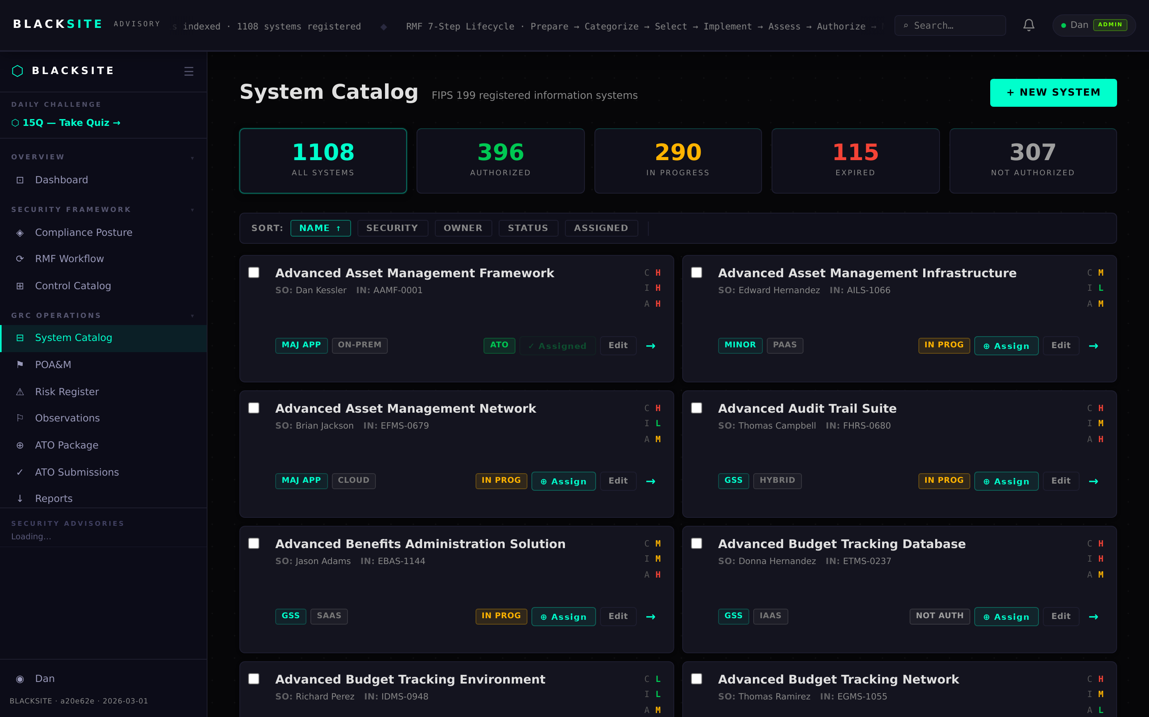
Figure 6: Switch-role-view (admin shell)

Step 7: Exit role shell
Click the 'Exit Shell' link in the navigation banner or navigate to /exit-shell. Your admin view is restored.
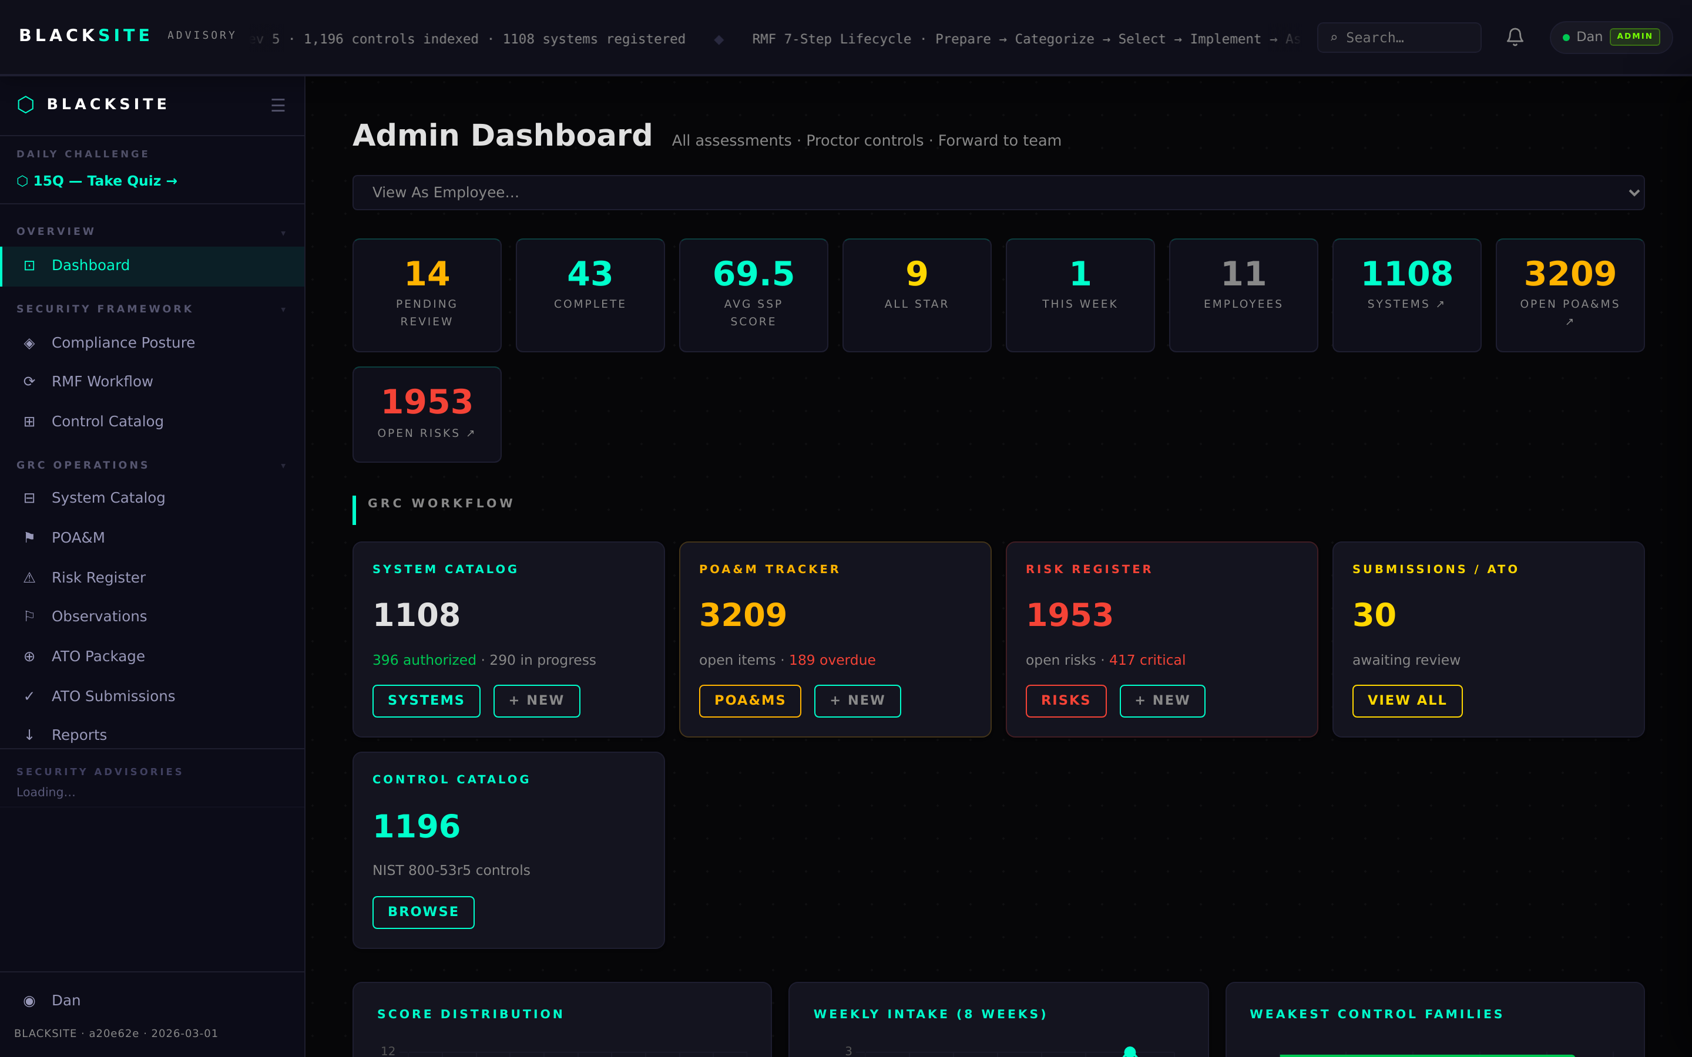
Figure 7: Exit role shell

Common Issues and Resolutions
Symptom | Resolution
View button absent for a user | The user may be frozen or a reserved account. Frozen accounts cannot be viewed-as.
Role shell missing a role option | That role has no active assignments in the system. Role options are dynamically populated.
Banner persists after exit | Hard refresh (Ctrl+Shift+R) to clear cached headers. The cookie should have been removed.

