APPROVED
Vice-rector for Academic Affairs
VSU named after P.M. Masherov
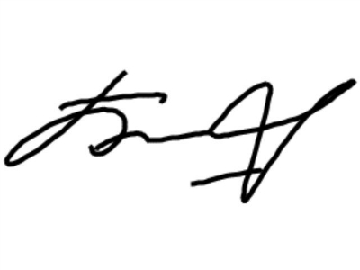Bobrik M. Y
«13» February 2023

SCHEDULE
Winter examination session of the 2022-2023 academic year for Master’s course students studying in English, daytime form of education of the specialty 1-08 80 02 “Theory and Methods of Education and Upbringing (by fields and levels of education). Educational management”
Enrolment October 2022

Examination period: 27.02.2023-11.03.2023

Discipline, teacher | Examination |  | Credit
Discipline, teacher | Date, time | Classroom | Date, time | Classroom
Methodology and methods of scientific research,  Amasovich N. V. |  |  | 02.03.2023  9.35
Sociological aspects of education,  Teterina V.V. |  |  | 27.02.2023  11.35
Educational management in an international and intercultural context  Teterina V.V. |  |  | 06.03.2023  11.35
Dean of the Faculty of Foreign Citizens Training 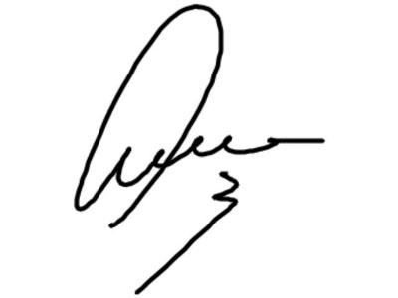 Yanch V.V.

