APPROVED
Vice-rector for Academic Affairs
VSU named after P.M. Masherov
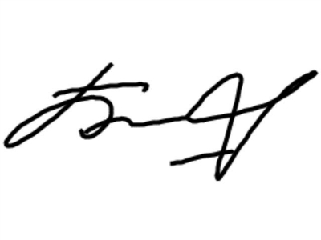 Bobrik M. Y
«13» February 2023
SCHEDULE
Winter examination session of the 2022-2023 academic year for master’s course students studying in English, daytime form of education of the specialty 1-24 80 01 «Jurisprudence»
Enrolment October 2022

Examination period: 27.02.2023-11.03.2023

Discipline, teacher | Examination |  | Credit
Discipline, teacher | Date, time | Classroom | Date,  time | Classroom
Implementation of international treaties in the national legal system  Saphonov A.I. |  |  | 28.02.2023  ^{11.30}
Lawmaking of representative, executive and judicial authorities  Stacenko V.G. |  |  | 03.03.2023  11.30
Conflict regulation in international business  Mihailova O.P. |  |  | 07.03.2023  11.30
Module "Scientific research work"  Research seminar  Ivashkevich E.F. |  |  | 11.03.2023  11.30

Dean of the Faculty of Foreign Citizens Training 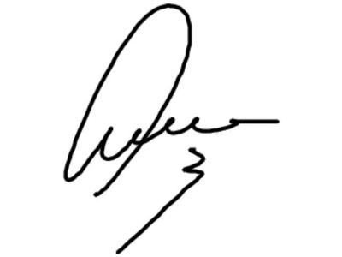 Yanch V.V

