APPROVED
Vice-rector for Academic Affairs
VSU named after P.M. Masherov
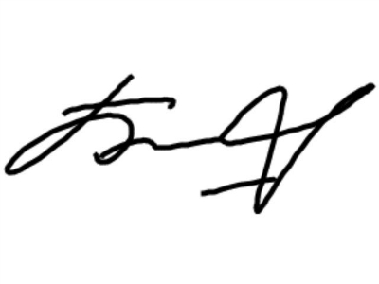Bobrik M. Y
«13» February 2023

SCHEDULE
Winter examination session of the 2022-2023 academic year for master’s course students studying in English, daytime form of education of the specialty 1-19 80 01 “Design Studies”
Enrolment October 2022
Examination period: 27.02.2023-11.03.2023

Discipline, teacher | Examination |  | Credit
Discipline, teacher | Date, time | Classroom | Date, time | Classroom
Module "Research work":  Organization and methodology of scientific research in design,  Sergeev A.G.  Scientific research (practical work),  Sergeev A.G. |  |  | 02.03.2023  14.40
Information technologies in the design activity of the designer, Sergeev A.G. |  |  | 09.03.2023  13.00

Dean of the Faculty of Foreign Citizens Training  Yanch V.V

