APPROVED
Vice-rector for Academic Affairs
VSU named after P.M. Masherov
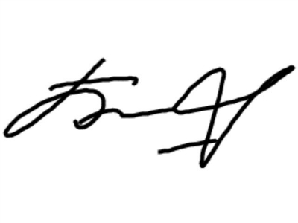Bobrik M. Y
«13» February 2023

SCHEDULE
Winter examination session of the 2022-2023 academic year for master’s course students studying in English, daytime form of education of the specialty 1-21 80 14 “Art Studies”
Enrolment October 2022

Examination period: 27.02.2023-11.03.2023

Discipline, teacher | Examination |  | Credit
Discipline, teacher | Date, time | Classroom | Date, time | Classroom
Module "Scientific research work":  Organization and methodology of scientific research, Tsybulskiy M.L.  Scientific research (practical work), Tsybulskiy M.L. |  |  | 01.03.2023  11.35

Dean of the Faculty of Foreign Citizens Training 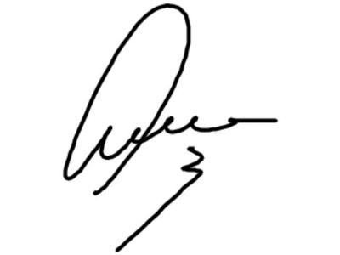 Yanch V.V

