APPROVED
Vice-rector for Academic Affairs
VSU named after P.M. Masherov
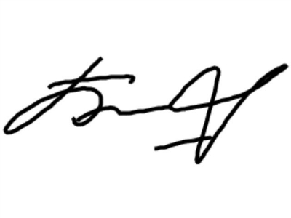 Bobrik M. Y
«13» February 2023

SCHEDULE
Winter examination session of the 2022-2023 academic year for master’s course students studying in English, daytime form of education of the specialty 1-23 80 03 “Psychology”
Enrolment October 2022

Examination period: 27.02.2023-11.03.2023

Discipline, teacher | Examination |  | Credit
Discipline, teacher | Date, time | Classroom | Date, time | Classroom
Modern methods of psychodiagnostics in social psychology, Soveiko E.I. |  |  | 28.02.2023  9.35
Methodology of modern psychological science,  Karaterzi V.A. |  |  | 03.03.2023  11.30
Social psychology of personality,  Karaterzi V.A. |  |  | 07.03.2023  11.30
Scientific research seminar,  Karaterzi V.A. |  |  | 11.03.2023  11.30

Dean of the Faculty of Foreign Citizens Training 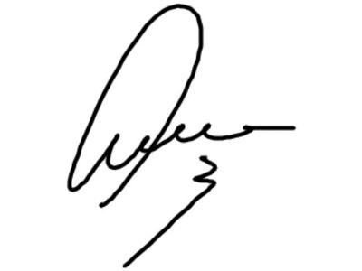 Yanch V.V

