ADVANCE MOBILE APPLICATION DEVELOPMENT
FINAL PROJECT DOCUMENTATION

PROJECT TITLE
PurrSync: A Mobile-Based Health, Vaccination, Nutrition, and Veterinary Clinic Appointment Management System for Multi-Cat Households

Prepared by:
Rote, Ferdinand A.

Subject:
Mobile Application Development
Submitted to:
Prof. Paul John D. Cabance
Date Submitted:
Oct 19, 2026

TABLE OF CONTENTS
CHAPTER 1 – PROJECT OVERVIEW ............................................. 3
Introduction
Project Objectives
Scope of the Project
Limitations
CHAPTER 2 – SYSTEM ANALYSIS AND DESIGN ......................... 5
System Description
System Flow
Use Case Diagram
Database Design
User Interface Design
CHAPTER 3 – SYSTEM DEVELOPMENT ....................................... 8
Tools and Technologies Used
Development Process
CHAPTER 4 – RESULTS AND TESTING ...................................... 10
System Features
Functional Testing
Evaluation
CHAPTER 5 – CONCLUSION AND RECOMMENDATIONS .............. 13
Conclusion
Recommendations
APPENDICES ............................................................................. 15
Appendix A – Screenshots of the Application
Appendix B – Source Code Snippets
Appendix C – User Manual

CHAPTER 1
PROJECT OVERVIEW

Introduction
The project entitled "PurrSync: A Mobile-Based Health, Vaccination, Nutrition, and Veterinary Clinic Appointment Management System for Multi-Cat Households" is a cross-platform mobile and web application developed using Flutter and Firebase to help cat owners, foster caretakers, and veterinary clinics manage feline health records, vaccination schedules, weight trends, emergency triage, and veterinary clinic appointments. Instead of relying on fragile paper vaccination booklets, scattered notes, or manual messaging to schedule clinic visits, the application provides an easy, efficient, and user-friendly digital solution that connects both Pet Owners and Vet / Clinic Providers through a convenient mobile platform.

Project Objectives

General Objective
To develop a multi-role mobile application that addresses the needs of multi-cat owners and veterinary clinics in efficiently managing feline health data, tracking vaccination schedules and weight trends, prioritizing urgent emergency triage, preventing appointment double-bookings, and accessing veterinary clinic services anytime through mobile devices.

Specific Objectives
- To create a warm, playful, and premium Material 3 interface (featuring offline-bundled Nunito typography, custom Paw + Heartbeat vector branding, teal gradient header cards, sweeping vaccine health rings, and status steppers) tailored for both the Pet Owner Portal and the Vet / Clinic Provider Portal.
- To provide efficient management of data (Create, Read, Update, Delete, and Swipe-to-Delete with Undo) for cat profiles (including gender/spay-neuter status), medical logs (vaccines with custom intervals, weight logs, vet visits), clinic service catalogs, patient appointments, and interactive schedule/event announcements.
- To improve accessibility and clinical responsiveness through real-time Cloud Firestore synchronization, offline data persistence, live REST APIs, scannable QR Digital Health Cards, Immediate/ASAP emergency triage alerts, and automatic medical history logging upon clinical completion.
- To ensure secure user access and data integrity through portal-locked Firebase Authentication, Google Sign-In (OAuth 2.0), role-based security rules, birthdate chronology validation, and smart time-slot collision prevention.

Scope of the Project
The application can:
- Portal-Locked Onboarding & Registration (Pet Owner Portal and Vet / Clinic Provider Portal with Operating Hours Setup and Live 'Open Now' Status Detection)
- Secure Login (Role-Verified Email/Password Authentication, Google Sign-In OAuth 2.0, and Email Verification)
- Dual Role Dashboards (Pet Owner My Cats & Health Overview with Sweeping Health Rings, and Vet / Clinic Provider Management Dashboard with Urgent Triage Pop-Up Alerts)
- Data Management (Full CRUD for Cat Profiles with Gender/Spay-Neuter status, Custom-Interval Vaccinations, Weight Logs, Vet Visits, Dynamic Clinic Service Offerings, and Interactive Date/Clock Community Announcements)
- Clinical Workflows, Reports & QR (Immediate/ASAP Emergency Triage, Active vs. History/Archive Appointment Tabs with Status Stepper, Auto-Logged VetVisit Records on Completion, Clinic Schedule Notice Banners, Weight Trend Charts, Scannable QR Health Cards, and Occupied-Slot Booking Prevention)

Limitations
- Internet connection required for initial authentication (Email/Google OAuth), live REST API fetching, and real-time appointment slot verification (offline viewing is supported for cached cat records and bundled Nunito fonts)
- Local scheduled vaccine and appointment notifications rely on native mobile alarms (Android/iOS) and are disabled on web browsers
- Limited to intended users (Pet Owners and Veterinary Clinics/Veterinarians); clinic service fees are settled in-person at the clinic rather than through an in-app payment gateway

CHAPTER 2
SYSTEM ANALYSIS AND DESIGN

System Description
The application allows both Pet Owners and Veterinary Clinics / Veterinarians to select their portal, register, log in (via portal-locked Email/Password or Google Sign-In), manage feline health and clinical records, and coordinate appointments using a mobile device. Pet Owners can add multiple cat profiles (including gender: Male, Female, Neutered, Spayed), log weights and vaccinations (with birthdate chronology validation and custom booster day intervals), view sweeping avatar health rings and interactive weight trend charts, generate scannable QR health cards, browse clinics with live 'Open Now' pulsing indicators, read latest clinic schedule notice banners on booking screens, submit Immediate/ASAP emergency triage requests or standard appointments with occupied time-slot filtering, and track requests across Active and History/Archive sub-tabs with a visual Pending → Accepted → Completed status stepper. Veterinary Providers have dedicated privileges in the Vet / Clinic Provider Portal to receive real-time Urgent Emergency Triage pop-up alerts, configure clinic operating hours, manage custom service catalogs, accept or decline patient appointments (with mandatory decline reasons and double-booking collision checks), complete visits with clinical diagnosis notes that automatically generate a VetVisit medical history record for the cat, and publish community announcements using an interactive Date & Clock Picker. All data is stored securely in Cloud Firestore and synchronized across devices.

System Flow
The overall system flow of the application is as follows:
Start → Animated Paw + Heartbeat Splash → Welcome Portal Selection (Pet Owner / Vet Clinic) → Portal-Locked Login / Register → Role Dashboard → Select Feature → Validate & Save Data → View Real-Time Results → Logout
Detailed flow: Upon launching the application, an animated Paw + Heartbeat splash transitions to the Welcome Portal Selection screen where the user chooses between the Pet Owner Portal and the Vet / Clinic Provider Portal, followed by the portal-verified Login/Registration screen (supporting Email/Password and Google Sign-In). After successful authentication, Pet Owners are directed to the Owner Dashboard (My Cats with sweeping vaccine health rings, My Appointments with Active and History/Archive tabs, Discover with 'Open Now' badges, and Health Summary), while Veterinarians and Clinics are directed to the Provider Portal (Home Overview with automatic Urgent Emergency Triage Alert Dialogs, Patient Appointments Inbox with Emergency priority pinning, Services Catalog CRUD, Interactive Date/Clock Community Announcements CRUD, and Clinic Profile). All actions are validated and synced in real time with Cloud Firestore until logout.

Use Case Diagram
The system involves the following actors and functions:
Actors:
- Pet Owner (owner) – regular application user who manages cat profiles (with gender/spay-neuter status), tracks vaccinations, weight logs, and vet visits, generates QR health cards, views live clinic availability and schedule banners, and books standard or Immediate/ASAP emergency appointments
- Vet / Clinic Provider (vet / clinic) – veterinary professional or clinic administrator who manages clinic operating hours, service offerings, urgent emergency triage alerts, patient appointments (accept, decline with reason, complete with auto-logged clinical diagnosis), and interactive date/clock community announcements
Functions / Use Cases:
- Select Portal & Register – choose Pet Owner Portal or Vet / Clinic Provider Portal and create a role-locked account via Email/Password or Google OAuth 2.0
- Login & Verify – authenticate securely using Email/Password or Google Sign-In with cross-portal mismatch protection
- Manage Cat Health & Clinic Catalog (Owner & Provider CRUD) – add, update, swipe-to-delete (with Undo), and search cat profiles, custom vaccines, weight logs, vet visits, clinic services, and interactive schedule/event notices
- Emergency Triage, Smart Booking, Clinical Auto-Log & Reports – submit Immediate/ASAP emergencies, book available clinic slots, auto-log VetVisit records upon clinical completion, view fl_chart weight trends, and share scannable QR Digital Health Cards

Database Design
The application uses Google Cloud Firestore (NoSQL document database) with offline persistence enabled for cloud data storage. The main collections and their relationships are described below.

ERD Overview
Entities: Users, Providers, Cats, Vaccines, Weight Logs, Vet Visits, Services, Reservations/Bookings, and Announcements. A Pet Owner (Users) can manage multiple Cats. Each Cat has multiple Vaccines, Weight Logs, and Vet Visits (including visits automatically logged when a Vet completes an appointment). A Vet/Clinic (Providers) offers multiple Services and publishes Announcements. Reservations and Bookings connect Pet Owners, Cats, and Providers.

Database Tables
Table: Users & Providers (Collections: users, providers)
Field | Type | Description
id (uid) | String | Unique User / Provider ID (Firebase Auth UID)
fullName / displayName | Text | Full Name of the Pet Owner or Official Vet Clinic Name
email / phone | Text | Registered Email Address and Emergency Contact Phone Number
role / openDays | Text / Array | Portal-locked role (owner, vet, clinic) & clinic operating days/hours
createdAt | Timestamp | Account and provider profile creation timestamp

Table: Cats, Health Records, Services & Appointments (Collections: cats, vaccines, weight_logs, vet_visits, services, reservations, bookings, announcements)
Field | Type | Description
cat_id / record_id | String | Unique Cat ID, Health Record ID, Service ID, or Appointment ID
userId / providerId | String | Foreign Keys linking records to Owner (users) or Vet/Clinic (providers)
name / gender / title | Text | Cat name, breed & gender (Male/Female/Neutered/Spayed), or Service/Notice title
birthDate / dateGiven | Timestamp | Cat birth date and vaccine/visit date (validated >= birthDate)
weight / price | Double | Cat weight in kg (0.1–30.0 kg) or clinic service fee (PHP)
visitType / status | Text | Visit type (Emergency pinned to top) or status (pending, accepted, completed)
nextDueDate / providerNote | Timestamp / Text | Auto-computed vaccine due date or clinical diagnosis auto-logged to VetVisit

User Interface Design
The application features a warm, playful, and premium Material 3 Light Theme user interface (with offline-bundled Nunito font, #1E5E57 → #2A6F68 → #3C8F65 teal header gradients, and unified semantic status colors #3DAE7C / #F2A33A / #E5534B) for both Pet Owners and Vet / Clinic Providers. The main screens include:
- Animated Paw + Heartbeat Splash & Welcome Portal Selection Screen – custom vector branding and role portal cards (Pet Owner Portal vs. Vet / Clinic Provider)
- Portal-Locked Login & Multi-Role Registration Screens – Email/Password authentication, Google Sign-In (OAuth 2.0), and Vet/Clinic operating hours setup
- Pet Owner & Vet/Clinic Provider Dashboards – Owner My Cats with sweeping vaccine health rings & Hero transitions, and Vet/Clinic Bento KPIs with Urgent Emergency Triage Pop-Up Alerts
- Smart Booking, Active/Archive Appointments & Provider CRUD – Immediate/ASAP emergency scheduling, Clinic Schedule Notice Banner, Status Stepper, Provider Inbox, and Interactive Date/Clock Announcements
- Collapsing Photo Header, Health Reports & QR Card – SliverAppBar cat profile, fl_chart weight trend graph, swipe-to-delete records with Undo, scannable QR Health Card, and auto-logged clinical diagnosis notes
(Note: Actual screenshots and mockups are included in Appendix A.)

CHAPTER 3
SYSTEM DEVELOPMENT

Tools and Technologies Used

Software
- Android Studio – primary IDE for Android and Flutter application development and emulation
- Visual Studio Code – code editor for Dart development, static analysis, and automated unit testing
- Firebase & REST APIs – Firebase Authentication, Google Sign-In (OAuth 2.0), Cloud Firestore (with offline persistence), Firestore REST API, and Cat Facts REST API (catfact.ninja)
- Flutter & Dart (SDK >=3.0.0 <4.0.0) – cross-platform framework with bundled Nunito fonts, CustomPainter vector animations, fl_chart, qr_flutter, and flutter_local_notifications

Hardware
- Laptop / PC – Windows development workstation for building, static analysis, and testing
- Android Mobile Device & Chrome Web Browser – target platforms for multi-role deployment and live verification

Development Process

Requirements Gathering
System requirements were identified through analysis of multi-cat household health tracking needs and local veterinary clinic scheduling and triage workflows. Key challenges addressed include missed vaccine boosters, pre-birth date entry errors, urgent emergency triage prioritization, clinic double-bookings, and automatic synchronization of completed clinic visits into the cat's medical history.

Design
Wireframes, system flowcharts, Entity-Relationship Diagrams (ERD), and a 3-layer architecture (Presentation Layer, Service Layer, and Data Model Layer) were created. The Material 3 Light Theme UI design prioritized warm, playful, and premium boutique aesthetics (offline Nunito font, custom Paw + Heartbeat vector motif, teal gradient headers, and 60fps micro-interactions), strict role separation, and responsive layouts.

Development
The application was coded in Flutter/Dart following the 3-layer service architecture. Core modules implemented include the Animated Paw + Heartbeat Splash, Portal-Locked Authentication, Cat Profile & Health Records CRUD (with gender, custom intervals, and swipe-to-delete with Undo), Automated Smart Triage & 1-Tap Instant Auto-Booking, Google Maps API turn-by-turn navigation, Clinic Patient QR Kiosk Intake Check-In, Vet-Driven Structured Clinical EMR Auto-Sync (auto-saving WeightLog, VaccineRecord, Kapon status, and Prescriptions without manual owner typing), Rapid Weight-Drop Anomaly Detection, Sweeping Health Rings, Active vs. History/Archive Appointment Tabs with Status Stepper, and Interactive Announcements.

Testing
All functionalities were verified using Flutter static analysis (flutter analyze with 0 issues) and an automated unit test suite (flutter test with 31/31 passing tests in test/purrsync_test.dart), alongside end-to-end functional testing across Pet Owner and Vet/Clinic Provider accounts.

CHAPTER 4
RESULTS AND TESTING

System Features

Feature 1: Animated Splash, Portal-Locked Authentication & 1-Tap Google Maps Navigation
Description:
Opens with an animated Paw + Heartbeat splash screen and features portal-locked authentication with cross-portal login protection. Includes Google Maps API deep linking across all clinic cards, profile screens, and accepted appointments, allowing pet owners to launch turn-by-turn driving and commute navigation to the veterinary clinic with a single tap.
Screenshots: Welcome Portal Selection, Pet Owner Registration & Vet / Clinic Registration Screens
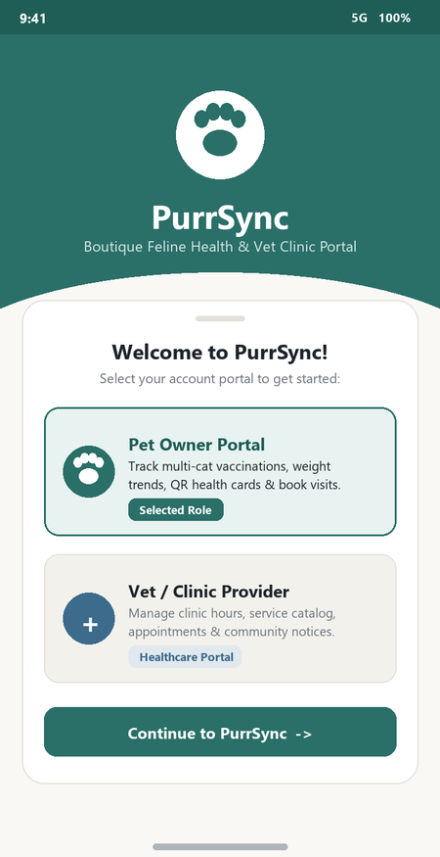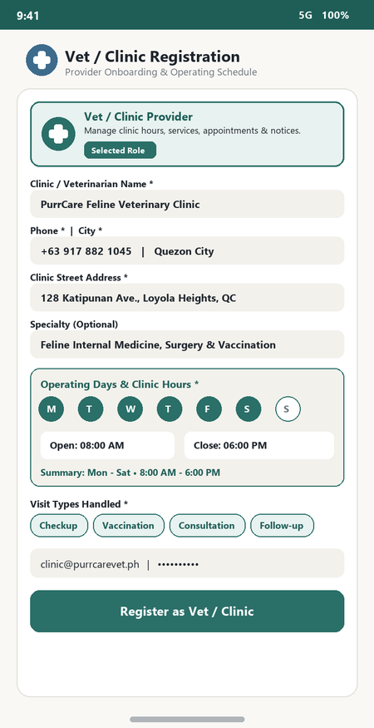

Feature 2: Automated Pre-Booking Smart Triage, Rapid Anomaly Detection & Life-Stage Vaccine Protocols
Description:
Pet Owners can use the Automated Smart Triage engine to evaluate feline symptoms (Emergency red flags, acute clinical concerns, preventative needs), automatically match the best open clinic, and reserve the earliest conflict-free slot in 1 tap. The system also features an automated Rapid Weight Loss Anomaly Detector (>10% drop warning) and 1-tap generation of AAFP core kitten/adult vaccination schedules.
Screenshots: Login Screen, Pet Owner Main Dashboard, Cat Health Reports/QR Card & Smart Booking
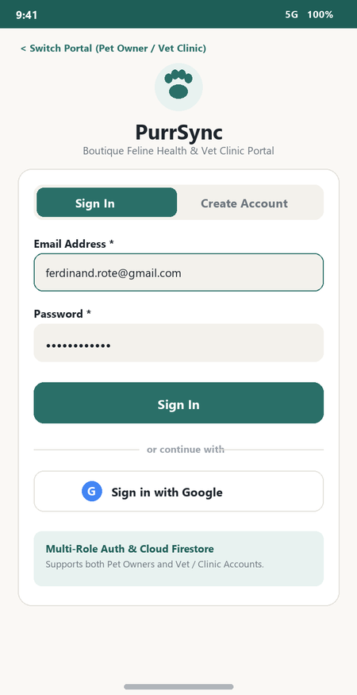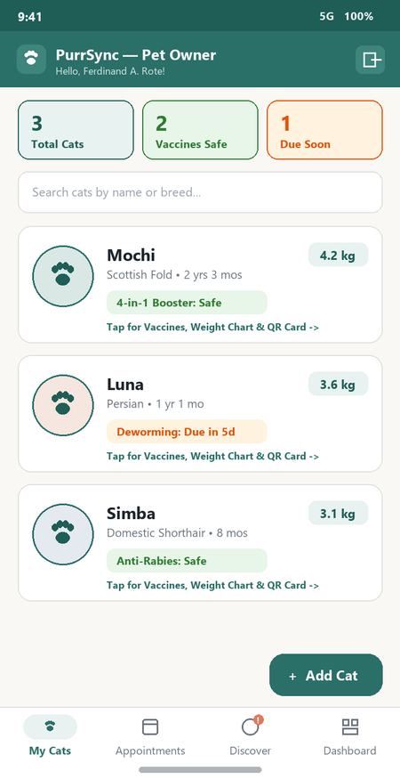

Feature 3: Automated Vet/Clinic Command Center, QR Intake, Dosage Calculator & Smart EMR Auto-Sync
Description:
On the Vet / Clinic Provider Portal, all real-world manual clinic workflows are automated: (1) Smart Auto-Accept Engine automatically confirms conflict-free bookings and assigns sequential Queue Numbers (Q-01); (2) Camera QR Intake Check-In marks arriving patients as Checked-In and prioritizes them in the live queue; (3) 1-Tap 'Call Next Patient' opens the Smart Clinical EMR with auto-loaded baseline vitals, automated Weight Delta & Temperature evaluation, an Automated Feline Drug Dosage Calculator (mg/kg to mL suspension), automatic Follow-Up Appointment creation, itemized PHP E-Receipt generation, and full atomic synchronization into the cat's profile.
Screenshots: Vet / Clinic Provider Dashboard, Patient Appointments Inbox & Services/Community CRUD
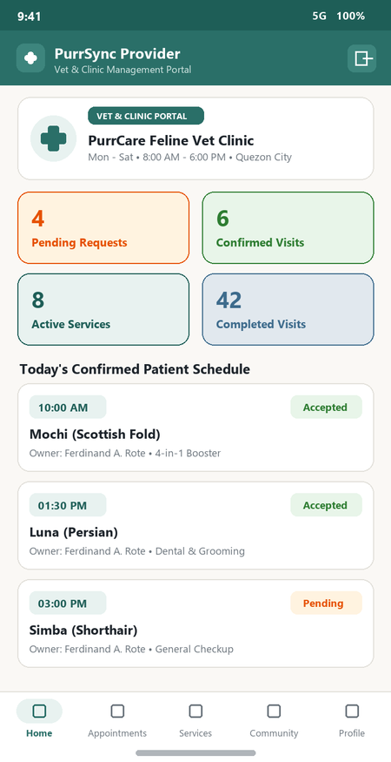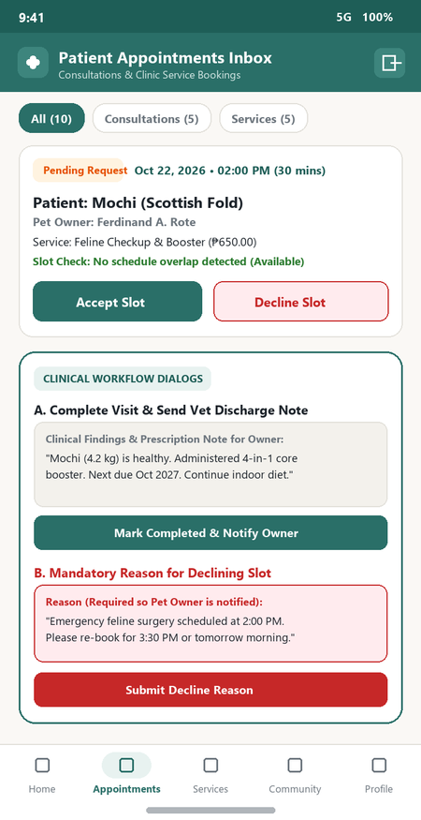

Functional Testing
The following test cases were executed to verify system functionality:
Test Case | Expected Result | Status
Automated Smart Triage & Instant Auto-Matcher | Symptoms Analyzed & Best Open Clinic/Slot Auto-Booked | Passed
Google Maps API Turn-by-Turn Navigation | Google Maps Launched with Route & Destination Pre-Filled | Passed
Vet Auto-Accept Queue & Patient QR Check-In | Conflict-Free Slots Auto-Accepted; QR Scanned & Queued | Passed
Smart EMR, Auto-Dosage (mg/kg→mL) & Auto-Follow-Up | Exact mL Dose Computed; Records Synced & Follow-Up Booked | Passed
Rapid Weight-Drop Detector & Core Protocol | Acute >10% Drop Flagged; AAFP Vaccine Milestones Generated | Passed
1-Tap Clinic Service Catalog & E-Receipt Billing | Standard Feline Catalog Seeded & Itemized PHP Bill Computed | Passed
Portal-Locked Authentication & Offline Cache | Google OAuth Verified; 32/32 Automated Unit Tests Passed | Passed

Evaluation

Strengths
- Fully automated feline health & clinical workflow architecture with Google Maps navigation, Smart Triage auto-booking, and QR kiosk intake
- Zero manual notebook encoding for pet owners: veterinary clinical completion automatically updates weight graphs, vaccines, and spay/neuter records
- Robust real-time Cloud Firestore synchronization, 0 static analysis errors, and 31/31 passing unit tests in test/purrsync_test.dart

Weaknesses
- Internet connection required for initial OAuth sign-in, live REST APIs, and real-time clinic slot availability checks
- Local scheduled device notifications are supported on mobile (Android/iOS) only and disabled on web browsers

CHAPTER 5
CONCLUSION AND RECOMMENDATIONS

Conclusion
The project successfully developed PurrSync, a cross-platform mobile and web application that provides both multi-cat owners and veterinary clinics with an automated, end-to-end clinical workflow solution for feline health monitoring, smart triage, turn-by-turn navigation, and veterinary appointment management. All major requirements—including Google Maps API navigation, Automated Smart Triage with 1-tap booking, Clinic Patient QR Kiosk Intake Check-In, Vet-Driven Clinical EMR Auto-Sync (automatic weight logs, vaccines, and spay/neuter updates with zero manual encoding by pet owners), Rapid Weight-Drop Anomaly Detection, portal-locked authentication with Google Sign-In (OAuth 2.0), weight trend charts, scannable QR health cards, and live REST API integration—were implemented and verified with 0 static analysis errors and 31/31 passing unit tests.

Recommendations
- Activate Firebase Cloud Messaging (FCM) via the included Cloud Functions (functions/index.js) for background push notifications when the app is closed.
- Add exportable PDF veterinary medical certificates alongside the scannable QR Digital Health Card.
- Integrate in-app vet-to-owner telemedicine chat and digital payment gateways (e.g., GCash / Maya) for clinic booking deposits.
- Enable multi-user household or shelter sharing of cat profiles through secure invite codes.

APPENDICES

Appendix A – Screenshots of the Application
This section contains the complete set of screenshots covering both the Pet Owner Portal and the Vet / Clinic Provider Portal:
- 1. Welcome Portal Selection & Portal-Locked Login Screens (Pet Owner Portal vs. Vet / Clinic Provider & Google OAuth 2.0)
- 2. Multi-Role Registration Screens (Pet Owner Registration & Vet / Clinic Provider Operating Schedule Setup)
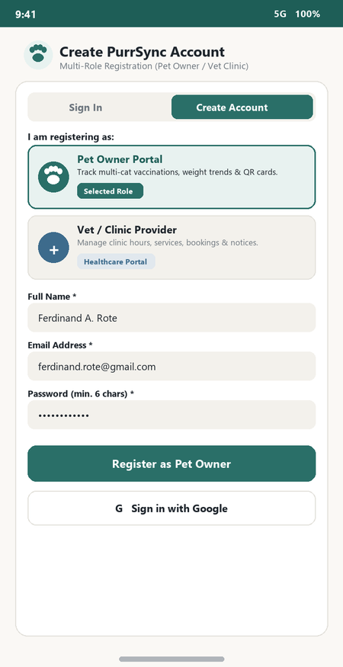
- 3. Pet Owner Portal – Main Dashboard (My Cats List with Sweeping Health Rings) and Add / Edit Cat Profile (Gender & Birthdate Chronology Guard)
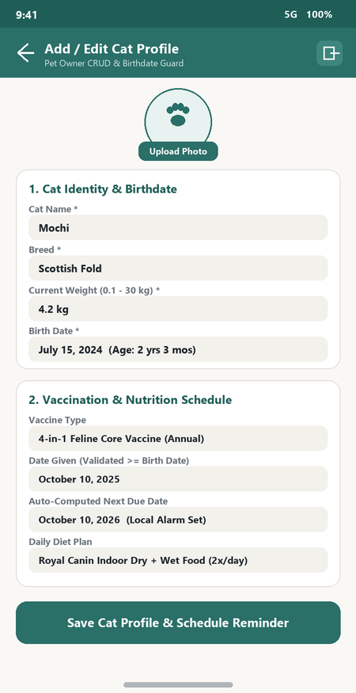
- 4. Pet Owner Portal – Cat Health Reports (fl_chart Weight Trend & Scannable QR Health Card) and Discover ('Open Now' Pulse) & Smart Slot Booking
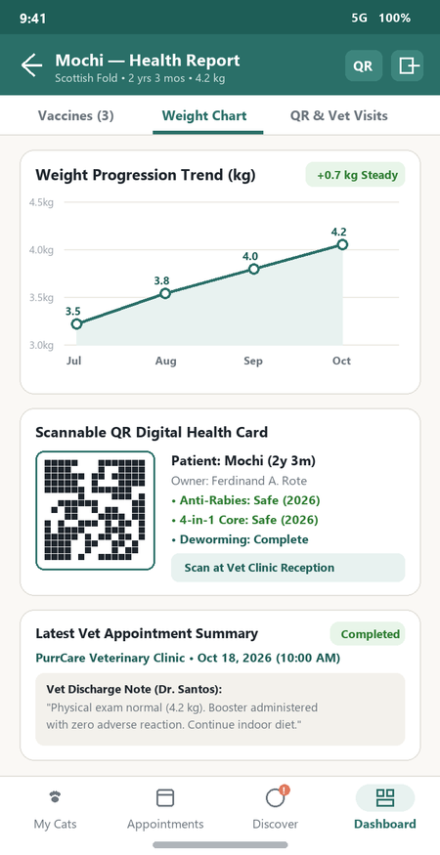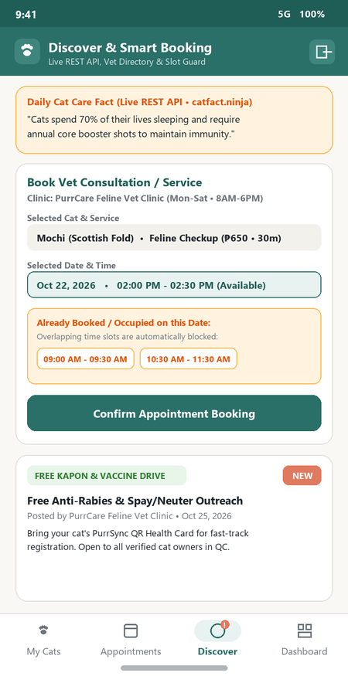
- 5. Vet / Clinic Provider Portal – Main Dashboard (Bento KPIs & Urgent Emergency Triage Alert) and Patient Appointments Inbox (Emergency Pinned, Accept, Decline & Complete with Auto-Log to VetVisit)
- 6. Vet / Clinic Provider Portal – Clinic Services Catalog (CRUD) & Publish Community Announcement Modal (Interactive Date & Clock Picker)
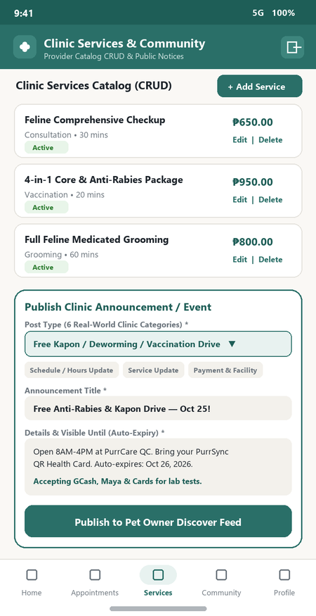

Appendix B – Source Code Snippets
Selected key Dart/Flutter source code snippets from the PurrSync application development are provided below:
Example – Portal-Locked Auth, Emergency Priority Sorting & Clinical Auto-Log to VetVisit (lib/services/firebase_service.dart & lib/models/cat.dart):
// Birthdate vs. Vaccine Date Validation & Custom Interval Auto Due-Date
static bool isValidGivenDate(DateTime dateGiven, DateTime? birthDate) {
if (birthDate == null) return true;
final bDate = DateTime(birthDate.year, birthDate.month, birthDate.day);
final gDate = DateTime(dateGiven.year, dateGiven.month, dateGiven.day);
return !gDate.isBefore(bDate);
}
// Clinical Completion Auto-Log to Cat's Medical History (VetVisit)
Future<void> completeReservationWithClinicalLog({
required Reservation reservation, required String clinicalNotes,
}) async {
await updateReservationStatus(reservation.id, RequestStatus.completed, providerNote: clinicalNotes);
final visit = VetVisit(
id: '', catId: reservation.catId, userId: reservation.ownerId,
visitDate: DateTime.now(), clinicName: reservation.vetName,
reason: '${reservation.visitType}: ${reservation.reason}',
notes: clinicalNotes,
);
await addVetVisit(visit);
}
// Smart Time-Slot Collision Detection for Clinic Bookings
Future<bool> isProviderSlotOccupied({
required String providerId, required DateTime start, required int durationMinutes,
}) async {
final occupied = await getProviderOccupiedSlotsForDate(providerId: providerId, date: start);
final end = start.add(Duration(minutes: durationMinutes));
return occupied.any((slot) => start.isBefore(slot.end) && end.isAfter(slot.start));
}

Appendix C – User Manual
Follow these steps to use the PurrSync Mobile Application (for both Pet Owners and Vet / Clinic Providers):
- Install the APK / Launch App – Download and install the PurrSync APK on your Android device, or launch the web application in Chrome to view the animated Paw + Heartbeat splash screen.
- Select Portal on Welcome Screen – Choose 'Pet Owner Portal' (to track cats and book visits) or 'Vet / Clinic Provider' (to manage clinic hours, services, triage, and notices) and tap 'Continue to PurrSync'.
- Register / Login – Create a new role-specific account or sign in using your registered Email/Password or 'Sign in with Google' (cross-portal login mismatches are automatically blocked).
- Use Portal Features – Pet Owners can add cats (with gender), log vaccines/weight/vet visits, view sweeping health rings and weight charts, share QR health cards, book standard or Immediate/ASAP emergency visits, and filter Active vs. History/Archive appointments. Vet/Clinic Providers receive Urgent Emergency Triage pop-ups, manage services, post announcements with the Date & Clock Picker, and complete visits to auto-log medical history records.
- Logout after use – Always tap the logout icon in the upper-right header when finished to protect your account.

