AUtoMLy Medicaid Policy Copilot
INAI 6986 AI Capstone · Milestone 3: Automation and Decision-Support Integration · Evidence as of November 10, 2026 (Central)
J.O.

1. System Overview
AUtoMLy supports Alabama Medicaid policy and billing questions. A staff member submits a question to the saved “ALPHIN - Policy Workflow” model in Open WebUI. The workflow validates the input, searches the Administrative Code and Provider Manual knowledge bases (64 and 74 files), checks evidence, drafts an answer with the untouched Nemotron base model, and estimates answer support with a second call to the base model. A confidence threshold determines whether the answer is released or sent to a person. The staff member sees the answer, sources, confidence, trace and path diagram; decisions can be recorded with review buttons. Nothing is submitted, paid or decided automatically.
Automation tool and approved substitution. Open WebUI (stock v0.12.5, not a fork) is the declared tool instead of n8n or Make. The instructor approved this substitution and adaptation of the rubric for the conversational RAG workflow (approval reported by the project owner). The workflow is an explicit Pipe and Action inside Open WebUI.

2. Architecture
Per event: user question → input validation → retrieval → evidence gate → base-model draft → confidence and coded verification → threshold branch → release or human review → SQLite log. Notification is not implemented: buttons record a decision but do not notify staff. Documents are parsed with Docling, split into 2,000-character chunks with 500 overlap, embedded by Nomic and stored in Open WebUI’s ChromaDB; retrieval returns up to eight passages.
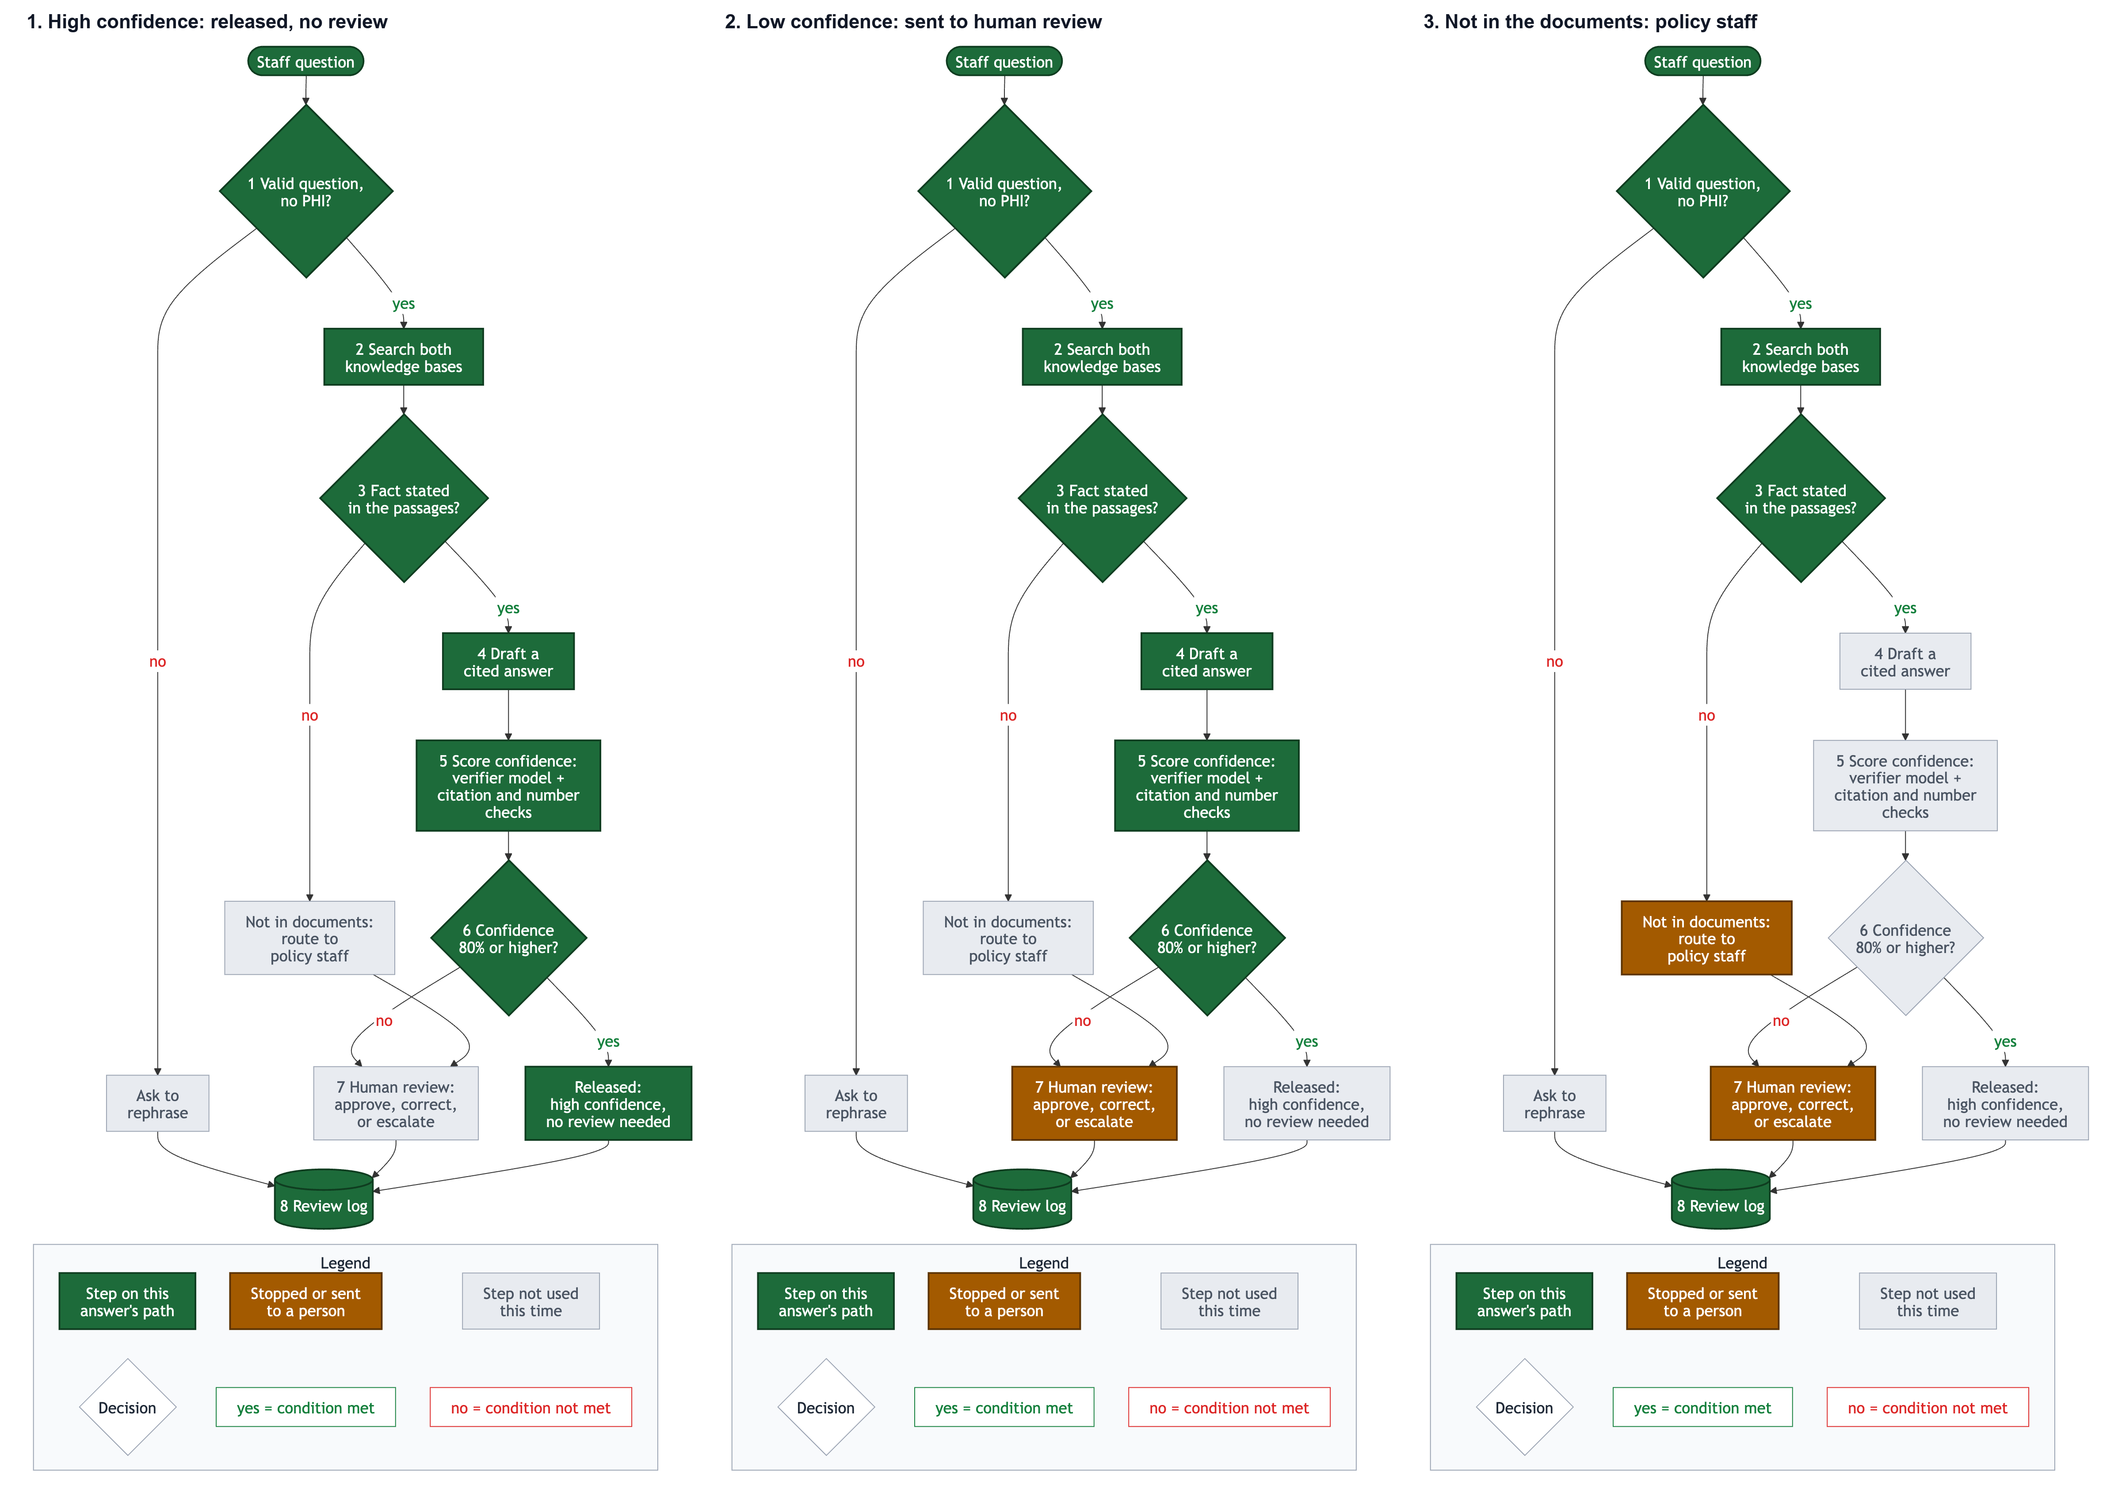
Figure 1. Current workflow paths: high-confidence release, low-confidence human review, and insufficient evidence routed to policy staff. Legend and decision paths are included in the diagram.
Step | Implementation
1 Intake | Code enforces 8–1,500 characters and screens Social Security / recipient-ID patterns.
2 Retrieve | Search both knowledge bases; retrieval errors stop the run.
3 Evidence gate | Untouched Nemotron base: is the asked-for fact stated in a passage? INSUFFICIENT routes to policy staff.
4 Draft | Untouched Nemotron base generates a cited answer.
5 Score | Base verifier estimates P(YES) from token log probabilities; citation/number failures cap confidence at 40%; verifier failure is 0%.
6 Threshold | Default 0.80: HIGH_CONFIDENCE is released (AUTO_RELEASED); LOW_CONFIDENCE is sent for review (pending).
7 Review | Approve, Needs correction (note required), Escalate (note optional).
8 Log | SQLite run and review records; /log displays recent outcomes.

The high-confidence route releases without review; low-confidence answers remain pending until a person acts. Review decisions do not trigger external transactions or notifications.
The workflow uses a pinned Nemotron 3.5 Lightning BF16 model served by vLLM for gating, drafting and verification; the Milestone 2 low-rank adapter is saved and reproducible but is not the current draft model. The implementation, model config and pin are in the repository.

3. Interface Contract
Item | Contract
Input | Required question text, 8–1,500 characters. SSN / recipient-ID patterns are rejected before retrieval. No upload or additional fields.
Output | Cited answer or explicit no-answer/rephrase/service message; source list, trace, confidence score, route (HIGH_CONFIDENCE, LOW_CONFIDENCE, NO_ANSWER, REPHRASE, ERROR), and review status. No calibrated factual probability is claimed.
Branch rule | Threshold valve CONFIDENCE_THRESHOLD defaults to 0.80. Failed citation/number check caps score at 0.40; unavailable verifier gives 0 and sends answer to review. Confidence is a model estimate, not a guarantee.
Timing and freshness | Per event. The confidence-routing demo chats completed in approximately 2–7 seconds; this is a small demonstration, not a latency service-level guarantee. Corpus is a snapshot of 138 source PDFs; updates are not automatic.
Scope | Alabama Medicaid Administrative Code and Provider Manual only. No web access, payment, eligibility decision, or agency transaction.

4. Failure Handling And Duplicate Runs
Case | Designed / Tested Behavior | Remaining Limit
Bad input | Code rejects <8 or >1,500 characters and SSN/recipient-ID patterns before retrieval; route REPHRASE. Unit tests cover the guards; captured October 29 confidence-demo screenshots show accepted/review paths, not these failures. | Other identifiers, adversarial and non-English inputs need testing.
Retrieval / gate / draft / verifier service failure | Retrieval or drafting errors stop rather than answer; verifier outage produces confidence 0 and routes the answer to review. Automated tests exercise these branches. | No current-version browser capture of a deliberate service outage is included; obtain one for the walkthrough if safely available. Error messages and recovery need additional usability review.
Low confidence or failed coded check | Below threshold (or citation/number check failure) is routed LOW_CONFIDENCE to a human; high-risk check failures cap confidence at 40%. | Confidence is not calibrated; the 80% default is not established as a safe operating threshold.
Repeated model run / duplicate review action | Run records are keyed by chat and message; regeneration updates the same record. Repeating the same decision is idempotent. No external write-side action exists to duplicate. | SQLite is editable and is not an immutable audit log.

These controls are implemented and covered by automated tests. A fresh browser demonstration of both a bad-input rejection and a deliberate service failure is still needed to present them as current-design live demonstrations; the older November 10 footage predates confidence routing and is not evidence for this version.

5. Human-In-The-Loop Design
Escalation trigger: evidence gate INSUFFICIENT → policy-staff route; confidence below 0.80 → LOW_CONFIDENCE review; citation/number failure caps confidence at 0.40 and therefore triggers review. At or above threshold the answer is released without review (AUTO_RELEASED). The selected threshold is adjustable in the Pipe Valves. The retrospective suggests 90% may be safer than the current 80% default, but the sample is reused and model-judged; no threshold has been safety-certified.
Reviewer view/actions: answer, sources, trace, confidence and path diagram; colored Approve, Needs correction and Escalate actions, with reviewer and time stored in the log. No-review default: low-confidence items remain pending; nothing expires or escalates automatically. High-confidence outputs are released by the configured rule, with review still possible. Buttons do not notify anyone. The prototype makes no binding decision, so no unattended downstream action occurs.

6. Evidence And Results
Confidence-routing demonstration (October 29, Mac Open WebUI v0.12.5): four high-confidence saved chats (89–97%) were released, four low-confidence chats (9–59%) were sent for review, and one hearing-aid replacement question was routed as not in the documents. These captures were made before the separate decision to switch the draft model from the adapter to the untouched base; they demonstrate the confidence-routing logic, not an end-to-end test of the current base-draft configuration. Screenshots and deployment receipt: docs/evidence/2026-10-29-confidence-routing.md and its linked image files. No comparative accuracy benchmark has been run for the current base-draft workflow.
Retrospective threshold check: 84 already-judged outputs from the earlier adapter-draft workflow; reused questions, one judge, not held out, not a test of the current base-draft system. At threshold 0.80, 49 were released and 5 had wrong core answers; at 0.90, 36 were released and none had a wrong core answer (6 had unsupported extra detail); at 0.95, 17 were released and all had correct core answers. AUROC 0.753. This is exploratory evidence only; 90% is a candidate for fresh validation, not a proven safe threshold.
Historical 49-question comparison (adapter-draft version, not current design): one blinded Claude Sonnet 5.5 judge; no human scoring; the 49 items were reused from Milestone 2 and are no longer held out. The earlier Pipe obtained 33/40 answerable correct, 26/40 strict; the no-workflow adapter + KBs obtained 30/40 and 28/40. Strict accuracy did not improve (McNemar p=0.79). Historical results must not be attributed to the current base-draft confidence workflow. Per-output data and scoring code remain in evaluation/milestone3_kb_comparison/.
Walkthrough MP4 (public-repo placeholder): https://github.com/porespellar/INAI6986_project_deliverables/blob/main/videos/INAI6986_Milestone3_Walkthrough.md. The recording is pending; its intended future path is `videos/INAI6986_Milestone3_Walkthrough.mp4` and will be added or replaced after final review.

7. Reproducibility
The complete deployment/source-of-record repository is private: https://github.com/porespellar/INAI_6986_AUtoMLy_solution. The public course deliverables repository is https://github.com/porespellar/INAI6986_project_deliverables. Its `milestone3/` package contains this J.O.-only report, rubric map, workflow documentation and exported Pipe/Action source, diagrams, confidence-routing evidence screenshots, and de-identified evaluation summaries. Together with the existing public Milestone 1 and 2 reports, this provides most materials needed to assess the Milestone 3 work. The public repository is an evaluation/evidence package, not a standalone deployment: the full installer/configuration, large model artifacts, live runtime state and protected source-level audit trail remain in the private repository. No passwords, tokens, private runtime databases, protected benchmark questions/keys, or reviewer-identifying records are published. The base model is identified by pinned public model revision; its weights are downloaded separately. The instructor can be given read access to the private repository if full deployment inspection is needed.

8. Known Gaps And Production Distance
Gap | Why It Matters / Next Step
Threshold evidence is retrospective; current base-draft accuracy is unmeasured | Validate on a fresh, independently reviewed question set before relying on automatic release; consider 90% threshold pending validation.
No current-version browser capture of bad-input and service-failure routes | Record both in the updated walkthrough, if safely available; old-version footage cannot establish new-version behavior.
Confidence is not calibrated; a high score can still be wrong | Calibrate on fresh, representative data and retain a human-review policy for consequential use.
No notifications, expiry or reviewer queue; pending work can wait indefinitely | Add accountable reviewer assignment, aging, reminders and escalation.
Log is editable SQLite; review status display may not refresh promptly | Test current UI after review; make log append-only/exportable and ensure displayed status agrees with stored state.
Snapshot-only corpus; single user; no live systems or protected data | Version/update sources, then complete privacy, security, access-control and operational review before any agency use.

Appendix A: Confidence-Routing Evidence (October 29; Adapter-Draft Configuration)
These saved-chat screenshots document confidence routing before the draft model was changed to the untouched base. They demonstrate the routing interface, but do not prove an end-to-end run with the current base-draft setting. See docs/evidence/2026-10-29-confidence-routing.md.
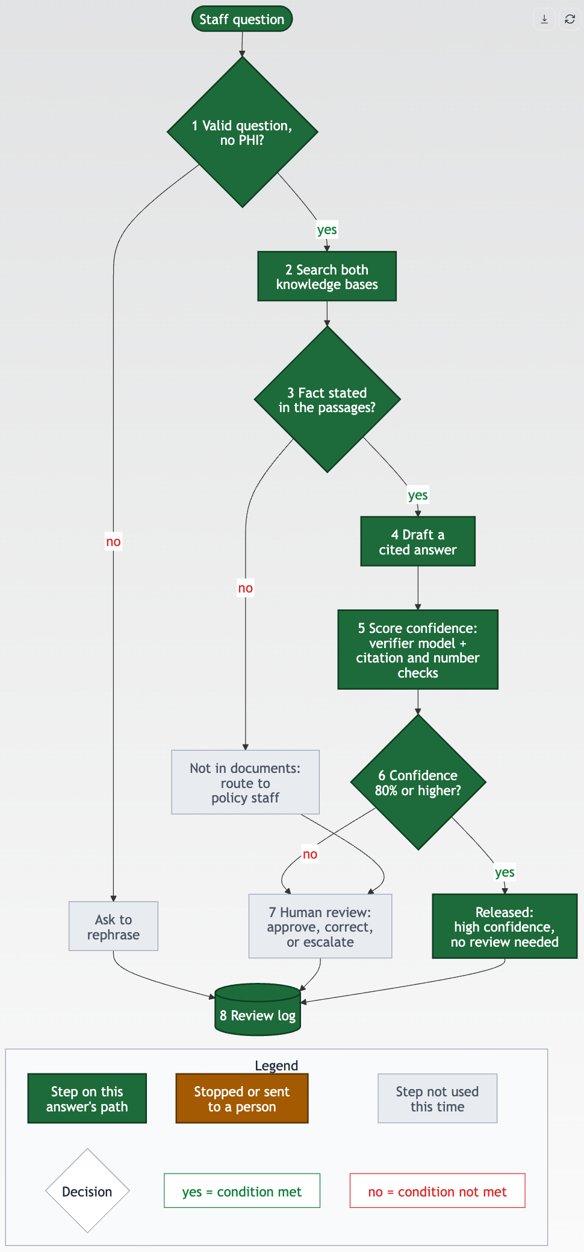
Figure A1. High-confidence answer released with the confidence-route diagram.
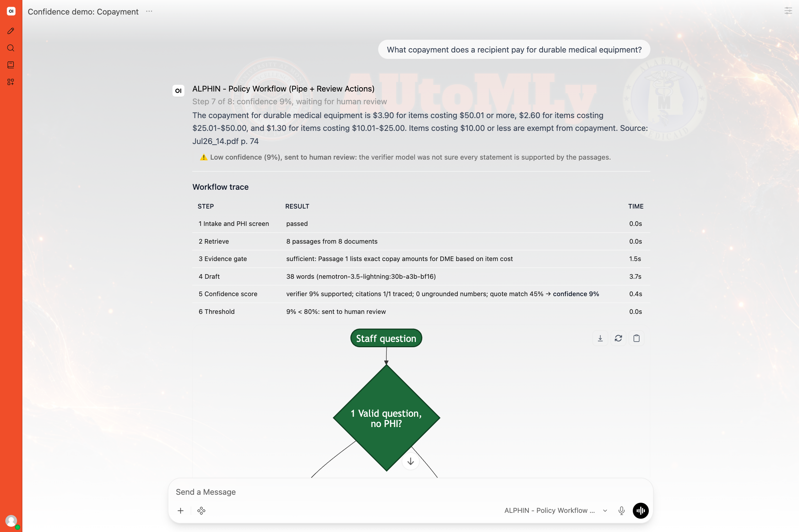
Figure A2. Low-confidence answer shown for human review.
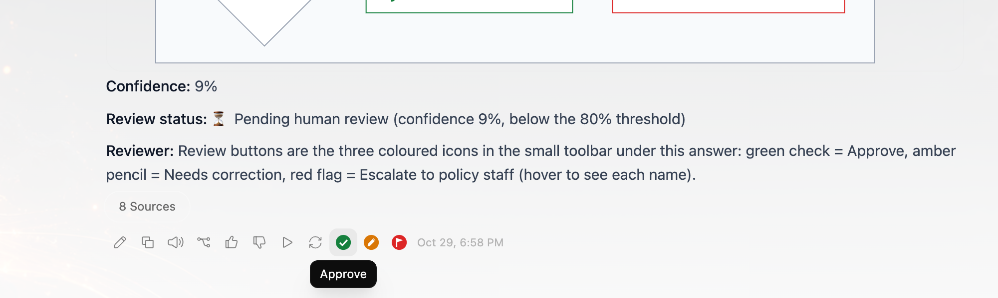
Figure A3. Review controls in the updated Open WebUI interface.

Appendix B: Evidence Index
Evidence | Repository Location
Workflow and current design | docs/workflow/README.md; config/openwebui/functions/; docs/MILESTONE3_RUBRIC_MAP.md
Confidence-routing live captures and deployment record | docs/evidence/2026-10-29-confidence-routing.md and linked PNGs
Threshold retrospective (84 previously judged outputs) | evaluation/confidence_routing/README.md and retro_summary.json
Historical 49-question measurements; not current design | evaluation/milestone3_kb_comparison/README.md; summary_workflow.json; per-output JSONL
Install, source corpus, models | README.md; docs/DEPLOYMENT.md; source_documents/2026-10-20/; adapters/nemotron/
Automated tests | tests/ (run with the documented Python environment)

AI Use Disclosure
Student contribution. The student defined the capstone problem, project goals, scope and decision-support use case; selected the Alabama Medicaid policy domain and local deployment direction; set the model, retrieval and evaluation priorities; approved Open WebUI as the instructor-approved alternative to n8n/Make; chose the untouched Nemotron base over the experimental adapter for current drafting; directed the tests and demonstrations; reviewed the saved evidence and results; and made project and production-boundary decisions. The student remains responsible for the project, report and its accuracy. AI assistance. Hermes Agent (Claude Sonnet 5.5 and OpenAI GPT-6 models) helped configure/test Open WebUI, implement the Pipe and Action, run model tests, analyze outputs, write scoring code, and draft this report. Claude Sonnet 5.5 judged historical outputs; AI supplied no human ratings. The experimental adapter is retained but is not the current draft model.

