AUtoMLy
MEDICAID POLICY COPILOT
ALPHIN Model Component
INAI 6986 — Artificial Intelligence Capstone
Milestone 1 — Data and Model Selection
Field | Submission Information
Student | J.O.
Course / Instructor | INAI 6986 / the course instructor
Declared Family | Deep Learning (DL): local Muse Glimmer 30B LLM adaptation with QLoRA
Instructor Authorization | Explicit permission was granted to fine-tune an LLM for this capstone; the permission does not relax the same-split evidence requirements.
Primary Metric | Human-adjudicated factual accuracy on answerable cases
Evidence Cutoff | September 22, 2026, 7:49 AM Central
Public Deliverables Repository | https://github.com/porespellar/INAI6986_project_deliverables

Current Evidence Boundary
Data preparation and two 211-step all-Muse adapter runs are complete. A same-split 191-question diagnostic run is also complete, but it did not produce a promotable winner. The committed factual-accuracy score, student-authored control, manual-workflow baseline, retrieval/no-retrieval comparison, and measured model ablations remain open. No score or approval is inferred from training loss or token overlap.

Submission package: editable DOCX, matching PDF, executed reproducibility notebook, and evidence snapshots

1. Data Characteristics
The modeling target is a concise, source-cited response to a public Alabama Medicaid policy or provider-billing question. It is not a beneficiary-level prediction or an eligibility, payment, clinical, legal, fraud, or enforcement decision. The preparation path preserves document, page, URL, snapshot date, and SHA-256 file fingerprint so every candidate can be traced to its source.
Characteristic | Verified Value and Why It Matters
Immutable source snapshot | 138 public PDFs / 2,433 pages dated 2026-09-14; 64 Administrative Code files and 74 core Provider Manual files.
Candidate-bearing documents | 136. Two one-page reserved Administrative Code PDFs contain no candidate-bearing text.
Final ordinary SFT shape | 1,999 records after quarantining one intentionally unanswerable blank-page record from the 2,000-record candidate file.
Source-family distribution | 750 Administrative Code records and 1,249 Provider Manual records.
Answer-length distribution | Whitespace-delimited words: minimum 1; p25 8; median 18; p75 30; p90 43; p95 52; maximum 147.
Target / safety distribution | 1,999 answerable ordinary-SFT records; one separate unanswerable safety case. One case is insufficient to estimate a 90% abstention rate.
Privacy and rights boundary | Public-information sources only; no PII, PHI, claims, medical records, provider-account records, or confidential agency data.

Split Strategy
The split is grouped by source-document ID, not by row. A SHA-256 bucket assigns an entire document to train, validation, or test. This prevents adjacent pages and repeated headings from the same manual appearing on both sides of the evaluation boundary.
Split | Records | Documents | Purpose
Train | 1,684 | 113 | Fit the QLoRA adapter.
Validation | 124 | 10 | Monitor training without touching the final test set.
Test | 191 | 13 | Same frozen prompts for base and candidate diagnostics.

Changes Since the Week 4 Gate
- Rejected the mixed-model candidate and its September 16 run because 326 records came from the retired Qwen generator; that run is procedural evidence only.
- Rebuilt the canonical all-Muse file, quarantined the blank-answer safety case, and froze the 1,684/124/191 document-level split.
- Completed a clean corrective run on September 17 and a second all-Muse run on September 18; froze both adapters and preserved their fingerprints.
- Completed 512-token same-split diagnostics on September 21–22; the formal comparison blocked promotion rather than selecting a favorable number.
Approval Terminology
“Deterministically accepted” means schema, identity, provenance, and quarantine checks passed. It does not mean every answer has completed human factual review. The 1,999-record file still has an open human-review gate.

2. Candidates Considered
The declared family is Deep Learning. the course instructor explicitly authorized LLM fine-tuning for the capstone, and the proposal feedback recognized the QLoRA-centered redesign as a defensible trade. The following fitted candidates stay inside that family and use the same Muse base architecture; retrieval remains a separate experimental condition, not a different model family.
Candidate | Why Plausible | Trade-Off / Current Disposition
A — Muse QLoRA, canonical clean run (Sep. 17) | Uses 1,684 deterministically accepted Muse-only training records, answer-only Muse ATEM masking, and a reversible adapter suited to local private execution. | Canonical clean-data candidate. Completed 211 steps. Diagnostic gains are promising, but the one-record abstention check failed and factual accuracy is unscored.
B — Muse QLoRA, second all-Muse run (Sep. 18) | A sensitivity candidate using the same base and QLoRA recipe with a slightly different 1,685-row operational render; it tests engineering robustness, not strict same-data replication. | Completed 211 steps and passed the one safety probe. It is kept separate from the canonical 1,684-row lineage and is not treated as an independent architecture.

Actual tuning configuration. Both runs used the pinned `unsloth/Muse-Glimmer-30B-unsloth-bnb-4bit` revision with 4-bit loading and BF16 compute; LoRA rank 16, alpha 16, dropout 0; attention and MLP modules trainable; vision/perception layers frozen; maximum sequence length 4,096; micro-batch 1; gradient accumulation 8; learning rate 2×10⁻⁴; 20 warmup steps; one epoch / 211 steps; seed 3407; gradient checkpointing; and assistant-response-only ATEM masking.
Why this is defensible for about 2,000 records. A small adapter reduces memory use and limits the number of trainable parameters compared with full-model fine-tuning. It preserves rollback, fits the local two-GPU environment, and avoids claiming that a small corpus can safely support unrestricted full-model retraining. The central risk is overfitting to generated answer conventions, which is why the independent student-authored control remains mandatory.

3. Baseline
The operational baseline is the current practice of manual document search and drafting. It must be timed and factually scored on a predeclared subset of the locked questions; that measurement is not yet complete. The technical baseline is untouched Muse Glimmer 30B with the same 191 prompts, deterministic decoding, and 512-token limit used for both adapters.
Baseline | Same-Split Evidence | Primary-Metric Status
Manual search and drafting | Protocol defined; same source library and review rules. | Not yet timed or human-scored.
Untouched Muse Glimmer 30B | 191/191 diagnostic outputs completed; answer-token F1 0.2076; numeric exact match 6.96%; citation-URL presence 0%; 9/191 outputs length-truncated. | Human-adjudicated factual accuracy not yet scored.

4. Evidence
All three systems received the same 191 generated test prompts (`89e747…d334`), prompt IDs (`44bf14…e703`), and deterministic generation settings. All 573 ordinary outputs plus the three safety outputs are preserved in the repository; the notebook verifies their hashes and recomputes the table from those per-prompt rows. The table reports engineering diagnostics only. Answer-token F1 is lexical overlap; citation presence checks formatting; neither is factual accuracy. The generated key also shares a model family with training-candidate generation. The completed 30-record Student-Authored Independent Control Set in Appendix D provides the required separate human-authored check before the headline claim can be supported.
System | n | Factual Accuracy | Answer F1 | Numeric Exact | Citation URL | Truncated | Abstention
Untouched Muse | 191 | Not scored | 0.2076 | 7.0% | 0.0% | 9/191 | 1/1
Sep. 17 clean adapter | 191 | Not scored | 0.3973 | 17.4% | 24.1% | 4/191 | 0/1
Sep. 18 adapter | 191 | Not scored | 0.4083 | 17.4% | 23.0% | 4/191 | 1/1

Formal comparison result. Relative to untouched Muse, the clean adapter improved answer-token F1 by 0.1897 and citation-URL presence by 24.08 percentage points. The fail-closed comparison still returned `pass=false`: both systems produced truncated outputs, and the clean adapter regressed on the one-record abstention check. The second adapter completed diagnostics but was not promoted after the pipeline stopped at this gate. No winner or deployment claim is made.
Answer-key provenance. The 191 expected answers were generated by the same local Muse family used to create the training candidates. Document separation blocks passage overlap but not generator-style leakage. Following the instructor's feedback, the 30-record independent control in Appendix D was authored directly by the student against the source PDFs, with expected answer, exact quote, locator, source hash, and browser evidence. It is excluded from generation and training; post-freeze human factual scoring remains separate from the generated set.
Evaluation design selected — Option 2. We retain the generated evaluation set and add the 30-question student-authored control set as an independent check. The two sets will be scored separately for the untouched base model and each adapter under the same locked evaluation conditions. Agreement between the sets would support the robustness of the result; a material difference would be reported as evidence that the generated answer key rewards generator conventions. The student-authored control remains excluded from training and from the generation pipeline.

5. Selection and Justification
The September 17 clean Muse QLoRA adapter is retained as the provisional model-selection candidate because it is the only adapter tied to the canonical 1,999-record ordinary-SFT artifact and exact 1,684/124/191 split. It fits the local/private deployment requirement, preserves rollback, leaves current policy facts in versioned retrieval, freezes unused vision layers, and is evaluated under fail-closed gates that prefer no promotion to an unsupported quality claim. It is not selected as a demonstrated winner: factual accuracy, unsupported-claim rate, locator accuracy, robust abstention, latency, and retrieval attribution remain unmeasured or incomplete.
Decision at the Evidence Cutoff
Proceed with evidence completion; do not promote an adapter. The lexical and citation diagnostics justify continued evaluation, not a quality claim. A well-measured null or negative result is an acceptable project outcome.

6. Interpretability and Leakage Check
For an LLM, the practical interpretability equivalent is whether outputs change for business-relevant reasons when source context, dates, rule numbers, exceptions, negations, locator instructions, or misleading headers are removed. Those model ablations are specified but not yet measured. The completed structural checks are shown below. Appendix D also separates factual validation from generator-convention diagnostics by preserving a student-authored control that was never used to generate or train the candidates.
Check | Measured Result | Disposition
Document overlap | 0 documents cross splits. | Pass.
Exact duplicate questions | 2 groups; 0 cross-split groups. | No exact question leakage observed.
Exact duplicate answers | 68 groups; 16 cross-split groups covering 57 records. | Review or stratify before factual scoring.
Near-duplicate questions | 1 cross-split candidate at Jaccard ≥0.85 (train ↔ validation). | Human disposition required.
Generator-convention leakage | Generated test answers share the Muse generation family with training candidates. | Student-authored control required.
Ablations | Not yet run. | Required before claiming business-sensible model influence.

7. What Would Change My Mind
I would reject or revise the adapter if human-scored factual accuracy fails to improve by at least 10 percentage points over untouched Muse; locator accuracy is below 95%; unsupported claims are 2% or higher; correct abstention is below 90%; safety routing is below 95%; general/format regression exceeds 3 points; latency prevents interactive use; the student-authored control in Appendix D disagrees materially with the generated set; or leakage and rights defects remain unresolved. A favorable lexical score cannot override these gates.
Fallback trigger. If a merged or adapter-loaded ALPHIN artifact has not loaded and produced a complete validated answer by October 9, 2026, at 5:00 PM CDT, the adaptation critical path stops. The project proceeds with untouched Muse plus versioned retrieval on the same locked benchmark, and the adaptation attempt is reported as a documented negative result. If base-plus-retrieval and ALPHIN-plus-retrieval are similar, the conclusion will be that retrieval supplied most of the benefit and adaptation added little once grounding was available.

8. Repository
Public deliverables repository: https://github.com/porespellar/INAI6986_project_deliverables. Direct executed-notebook link: https://github.com/porespellar/INAI6986_project_deliverables/blob/main/notebook/milestone1_reproducibility.ipynb. The source PDFs are downloaded locally from official URLs with scripts/download_public_sources.py and verified against SHA-256; they are not committed because the official manuals can contain published contact details. The notebook rebuilds the public, endpoint-redacted 1,999-record SFT artifact from the 2,000 candidates, reproduces the 1,684/124/191 split, checks all downloaded PDF fingerprints, recomputes diagnostics from the saved per-prompt predictions, executes the tests, and emits the evidence ledger. This is a sanitized viewer copy with independent public Git history; the private working repository and its history are not mirrored.

AI Use Disclosure
AI assistance. Hermes Agent using GPT-5.6 Sol 900k and GPT-5.6 Luna assisted with comparing the assignment rubric and instructor feedback, organizing evidence, drafting and formatting this revision, updating the reproducibility notebook, and running document/code quality checks. Local Muse endpoints—not ChatGPT or a cloud teacher—generated the candidate question-and-answer records from approved public source text. Hermes Agent did not independently choose the capstone, authorize the data scope, create the required student-authored control, adjudicate factual accuracy as a human reviewer, approve training data, or invent model results.
Human authorship, engineering, and oversight. J.O. conceived AUtoMLy and ALPHIN and made the substantive decisions about the problem, architecture, model family, source corpus, QLoRA strategy, split design, success metrics, local-only boundary, retrieval separation, review controls, fallback, and proceed/stop/retry/quarantine actions. He configured the hardware, containers, services, schedules, storage, and training environment; directed AI tools and local agents; diagnosed and resolved data, tokenizer, checkpoint, service, GPU-memory, adapter, and evaluation failures; reviewed source support and evidence; and remains responsible for all corrections, conclusions, approvals, and presentation.
Responsibility boundary. AI-produced wording, code suggestions, and analyses were treated as drafts. Material claims in this report are tied to local files, hashes, executed notebook outputs, or measured services. J.O. authorized project actions and accepts final responsibility. The instructor's permission to fine-tune an LLM authorized this Deep Learning path; it did not transfer authorship or relax the evidence standard.
Verification Performed
The notebook was executed from a clean kernel; the raw source manifest and all 138 PDFs matched; deterministic preparation reproduced the saved artifact byte-for-byte; split and leakage counts matched; all 573 ordinary and three safety outputs matched their fingerprints; diagnostic metrics were recomputed from those rows; 194 tests / 197 subtests passed in-notebook; and the final DOCX/PDF were rendered and visually reviewed.

Appendix A — Progress Through September 22, 2026
This chronology includes verified data, training, evaluation, repository, backup, and model-development activity through the stated evidence cutoff.
Date | Activity | Verified Result / Current Meaning
Sep. 14 | Source and candidate preparation | 138 PDFs / 2,433 pages frozen; 2,000 local Muse-family candidates generated with provenance.
Sep. 16 | First 211-step run | Completed on a mixed-generator file; later rejected because 326 rows came from retired Qwen. Procedural evidence only.
Sep. 17 | Canonical cleanup and corrective training | Blank case quarantined; 1,999 ordinary records; 1,684/124/191 split; clean Muse-only adapter completed 211 steps; train loss 0.6201, validation loss 0.5722; loss is not factual accuracy.
Sep. 18 | Second all-Muse run | Completed 211 steps; train loss 0.6169, validation loss 0.5736. Operational 1,685-row lineage kept separate from canonical clean evidence.
Sep. 21 | Repository, backups, adapter freeze | Private source-of-record repository consolidated; two adapters frozen; seven model-backup release assets published with manifest/checksums; same-split evaluation started.
Sep. 22 | 512-token diagnostic evaluation | Untouched Muse and both adapters completed 191 outputs. Formal clean-adapter comparison blocked on truncation and abstention gates; no winner, merge, promotion, or factual-accuracy claim.

Current Model-Development State
Workstream | State
Data preparation | Deterministic pass after quarantine; human factual approval and quality-flag disposition remain open.
Training | Two all-Muse QLoRA adapters completed; canonical clean adapter is the provisional candidate.
Evaluation | Same-split engineering diagnostics complete; human factual scoring and retrieval attribution incomplete.
Merge / serving | Current BF16 merge and promoted runtime not complete.
Repository / recovery | Private GitHub source of record active; backup release and SHA-256 restore manifest present.
Tests | Notebook-executed default target: 194 tests passed / 197 subtests. `pytest.ini` excludes archived duplicate modules that otherwise collide during collection.

Appendix B — Evidence Status and Remaining Gates
The independent control-set requirement is now satisfied by Appendix D. The table distinguishes completed evidence from the remaining post-freeze scoring and performance gates required before final model selection.
Open Gate | Required Completion Evidence
Independent answer-key control | Complete: 30 student-authored records SA-001–SA-030 are reproduced in Appendix D with expected answer, exact quote, URL, page, source hash, snapshot date, browser evidence, and exclusion from generation/training.
Primary metric | Remaining: human factual adjudication for untouched Muse and both adapters on identical generated and student-authored sets; report correct/n and percentage separately for each set.
Operational baseline | Time and score manual search/drafting on a predeclared subset under the same source and review rules.
Retrieval attribution | Base and ALPHIN, each with and without identical versioned retrieval context; same prompts, decoding, scorer, and failure analysis.
Interpretability equivalent | Measured context/date/rule/exception/negation/locator/header ablations with paired outputs and representative failures.
Quality-review disposition | Review the one near-duplicate candidate, 16 cross-split duplicate-answer groups, and flagged quality classes using a documented individual or sampled-category protocol.
Safety denominator | Expand beyond one unanswerable case before interpreting a percentage target; preserve prohibited-use and insufficient-context cases separately.
Artifact promotion | Validate adapter load or merge, complete answer, runtime controls, and rollback; promotion remains blocked if any gate fails.
Public repository access | Public viewer copy is available at https://github.com/porespellar/INAI6986_project_deliverables; anyone may view or clone it.

Why this matters. The instructor explicitly warned against treating a completed pipeline as model success. The current evidence already shows why: lexical and citation diagnostics improved, yet the canonical clean adapter failed the one-record abstention check. The independent control set closes the answer-key provenance gap, but scoring it alongside the generated set is still required before declaring a factual-accuracy result.

Appendix C — Reproducibility and Evidence Ledger
Evidence | Repository-Relative Path / Fingerprint
Source manifest | data/source/2026-09-14/source_manifest.jsonl — dd2e9146…6c84
Source PDFs | Not committed; download and verify with scripts/download_public_sources.py (138 official PDFs / 2,433 pages).
All-Muse candidates | data/curated/2026-09-14/sft_train_candidates.jsonl — 44d07cf9…8099 (local endpoint identifiers redacted)
Canonical ordinary-SFT file | artifacts/milestone1/2026-09-17/approved_candidates.jsonl — 98ff96d7…602a (public endpoint-redacted SFT artifact)
Clean training summary | artifacts/training/2026-09-17-muse-only-rerun.json — adapter b27cca00…ac0
Current progress snapshot | artifacts/milestone1/2026-09-22/progress_snapshot.json
Current evaluation snapshot | artifacts/milestone1/2026-09-22/evaluation_snapshot.json — test set 89e747ac…d334
Per-prompt evaluation rows | artifacts/evaluation/2026-09-18/{base,adapter-muse-only,adapter-2026-09-18}/ — 573 ordinary + 3 safety rows
Student-authored control set | data/curated/student-authored-control-set-2026-09-22.jsonl — a6e47f06…a2596; rendered in Appendix D
Executed notebook | notebook/milestone1_reproducibility.ipynb
Preparation / tests | scripts/milestone1_data_prep.py; tests/test_milestone1_data_prep.py; tests/test_evaluate_milestone1_api.py
Evidence source commit | Fresh, sanitized public-repository history; no private-repository commits carried over.

Selected Sources
[1] Assignment 3: Milestone 1 — Data & Model Selection, course rubric and template, due September 27, 2026.
[2] the course instructor, Proposal Resubmission Feedback: answer-key provenance, retrieval-only fallback, model-family declaration, and anticipated null result.
[3] the course instructor, PM Plan & Progress Log 1 Feedback: student-authored control, dated fallback, procedural-only status of the earlier run, quality review, and repository remote.
[4] Alabama Medicaid Administrative Code: https://medicaid.alabama.gov/content/9.0_Resources/9.2_Administrative_Code.aspx
[5] Alabama Medicaid Provider Manuals: https://medicaid.alabama.gov/content/Gated/7.6.1G_Provider_Manuals.aspx
[6] Muse Glimmer 30B model card: https://huggingface.co/meta-models/Muse-Glimmer-30B
[7] Hu et al., LoRA: Low-Rank Adaptation of Large Language Models: https://arxiv.org/abs/2106.09685

Appendix D — Student-Authored Independent Control Set
This appendix contains the completed 30-question independent control set required by the instructor feedback. J.O. wrote the final question wording directly against the frozen Alabama Medicaid source PDFs. These records were kept outside model generation, training, candidate selection, and answer-key generation. Each item preserves its expected answer, exact supporting quote, source locator, source URL, source SHA-256, snapshot date, browser search anchor, and PDF search/highlight evidence. The set is reserved for post-freeze human factual scoring alongside the generated evaluation set.
Control-set field | Verified value
Completed record count | 30
Record range | SA-001 through SA-030
Authorship boundary | Student-authored final wording; no model-generated questions are included.
Training / answer-key boundary | Excluded from training data and from the local generation pipeline that produced the 191-record engineering key.
Source boundary | Frozen public Alabama Medicaid Administrative Code and Provider Manual PDFs, snapshot 2026-09-14.
Dataset fingerprint | SHA-256 a6e47f0654b47687a4d9170f1e835f24ac04c74410ea32150fce0b3b663a2596
Scoring status | Authored and source-verified; post-freeze human factual scoring remains a separate evaluation step.

SA-001 — Student-Authored Control Record
Independent source-grounded factual lookup item
Field | Completed record
Record ID | SA-001
Question | What page number in the table of contents lists Rule 560-X-1-.07, Provider Rights and Responsibilities?
Expected answer | Page 3.
Question type | Answerable — source lookup
Exact supporting quote | 560-X-1-.07 Provider Rights and Responsibilities 3
Source PDF | 9.2_Adm_Code_Chap_1_General_3-18-21.pdf
PDF page | 1
Source URL | https://medicaid.alabama.gov/documents/9.0_Resources/9.2_Administrative_Code/9.2_Adm_Code_Chap_1_General_3-18-21.pdf
Browser search anchor | 560-X-1-.07
Source SHA-256 | 1febe8438b5e38699d6ab1f94fda02eccc33cba2e8599b62f9e986b82e4aafc4
Snapshot date | 2026-09-14
Authorship | Student-authored final wording supplied by the student.
Training exclusion | Excluded from training data and answer-key generation.
Browser verification | Verified in the PDF viewer; source-search evidence is included below.
Post-freeze factual scoring | To be scored after the control set is locked, alongside the generated evaluation set.
Browser source evidence
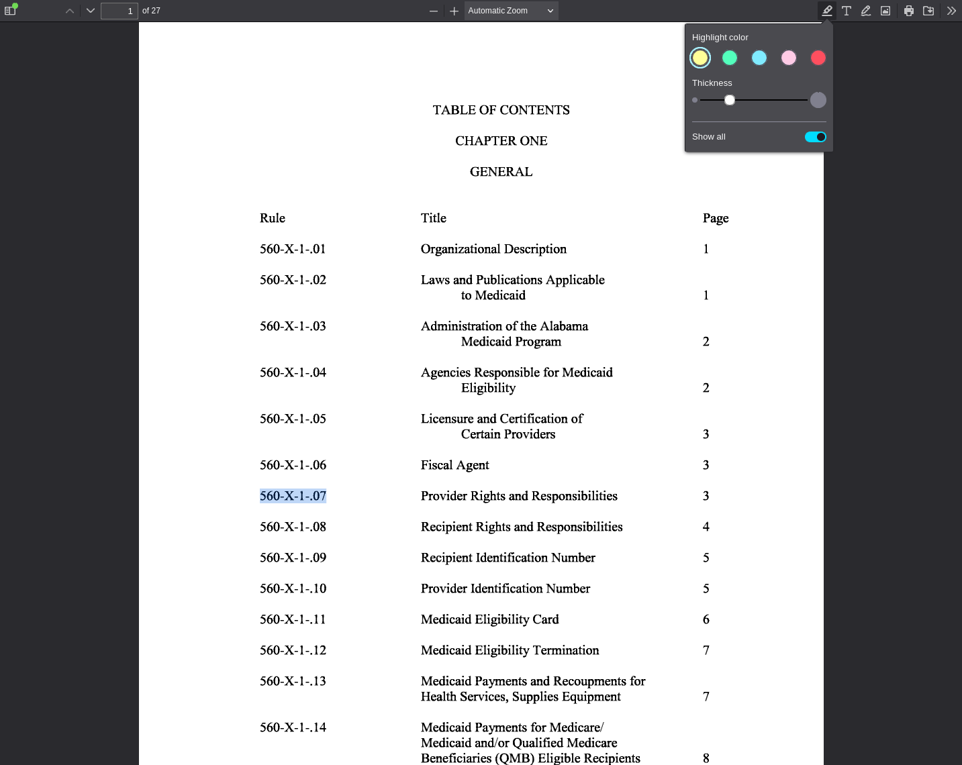
PDF viewer page 1 | Search anchor: 560-X-1-.07

SA-002 — Student-Authored Control Record
Independent source-grounded factual lookup item
Field | Completed record
Record ID | SA-002
Question | What page number in the table of contents lists Rule 560-X-28-.02, Summary of State Law Regarding Advanced Directives?
Expected answer | Page 2.
Question type | Answerable — source lookup
Exact supporting quote | 560-X-28-.02 Summary of State Law Regarding Advanced Directives 2
Source PDF | 9.2_Adm_Code_Chap_28_Alabama_Medicaid_Forms_7-26-18.pdf
PDF page | 1
Source URL | https://medicaid.alabama.gov/documents/9.0_Resources/9.2_Administrative_Code/9.2_Adm_Code_Chap_28_Alabama_Medicaid_Forms_7-26-18.pdf
Browser search anchor | 560-X-28-.02
Source SHA-256 | ef30588f3d8916fc44d2a10ccdedd756cd5108abcd31dbea8dad008881d70985
Snapshot date | 2026-09-14
Authorship | Student-authored final wording supplied by the student.
Training exclusion | Excluded from training data and answer-key generation.
Browser verification | Verified in the PDF viewer; source-search evidence is included below.
Post-freeze factual scoring | To be scored after the control set is locked, alongside the generated evaluation set.
Browser source evidence
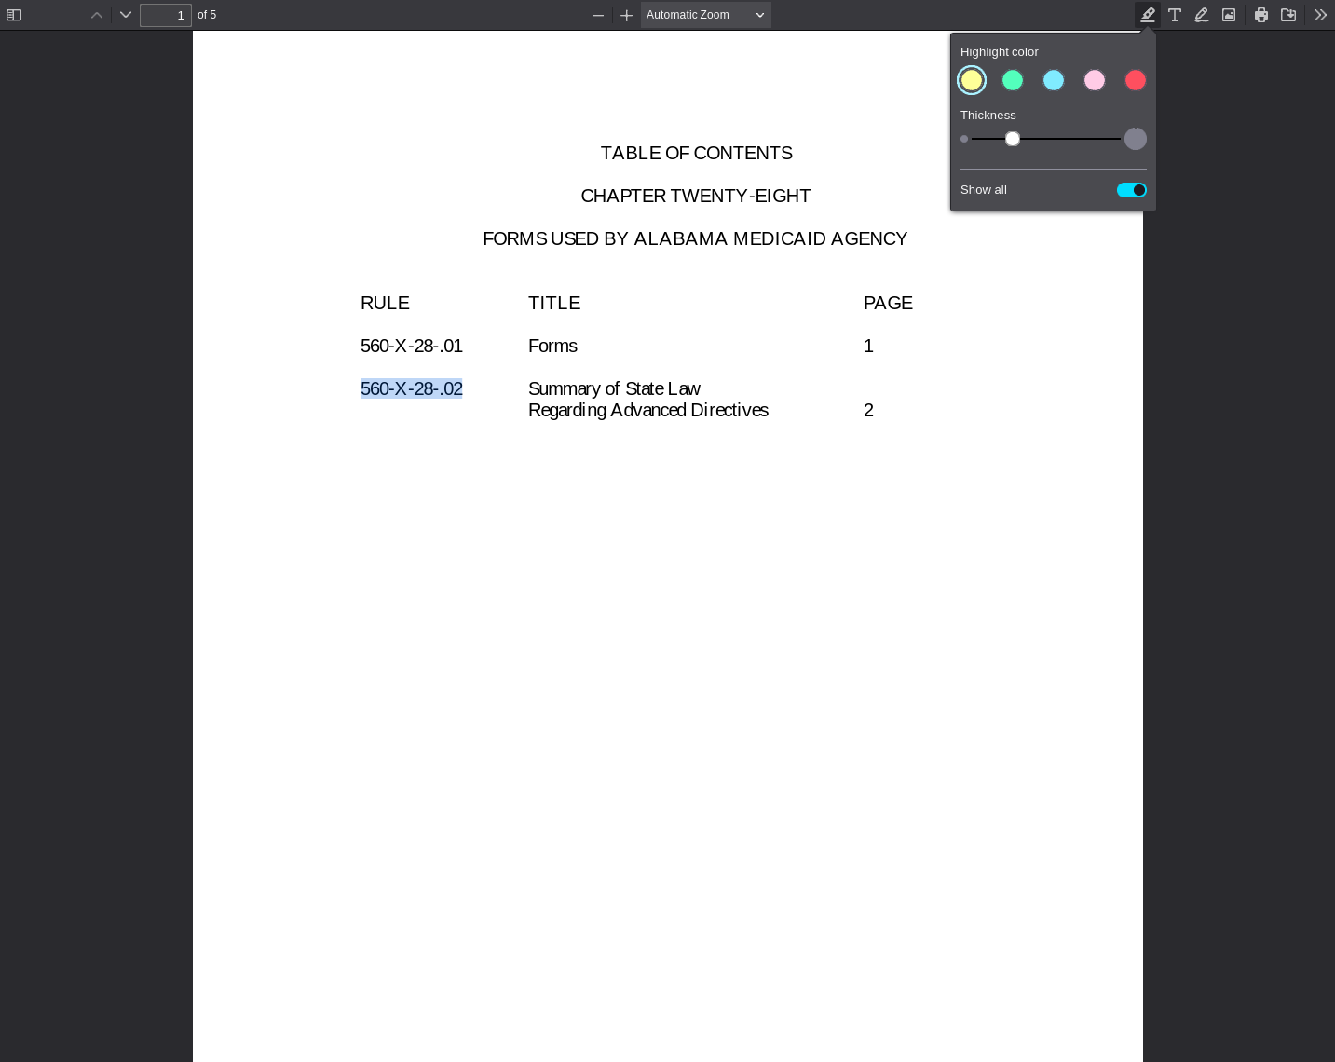
PDF viewer page 1 | Search anchor: 560-X-28-.02

SA-003 — Student-Authored Control Record
Independent source-grounded factual lookup item
Field | Completed record
Record ID | SA-003
Question | What page number in the table of contents lists Rule 560-X-49-.07, Copayment?
Expected answer | Page 2.
Question type | Answerable — source lookup
Exact supporting quote | 560-X-49-.07 Copayment (Cost-sharing) 2
Source PDF | 9.2_Adm_Code_Chap_49_Certified_NP_Program_9-23-19.pdf
PDF page | 1
Source URL | https://medicaid.alabama.gov/documents/9.0_Resources/9.2_Administrative_Code/9.2_Adm_Code_Chap_49_Certified_NP_Program_9-23-19.pdf
Browser search anchor | 560-X-49-.07
Source SHA-256 | 2f7e7e18cf5f882e3c90f8179309947f6d01805df0c8484762d94d1120a7a064
Snapshot date | 2026-09-14
Authorship | Student-authored final wording supplied by the student.
Training exclusion | Excluded from training data and answer-key generation.
Browser verification | Verified in the PDF viewer; source-search evidence is included below.
Post-freeze factual scoring | To be scored after the control set is locked, alongside the generated evaluation set.
Browser source evidence
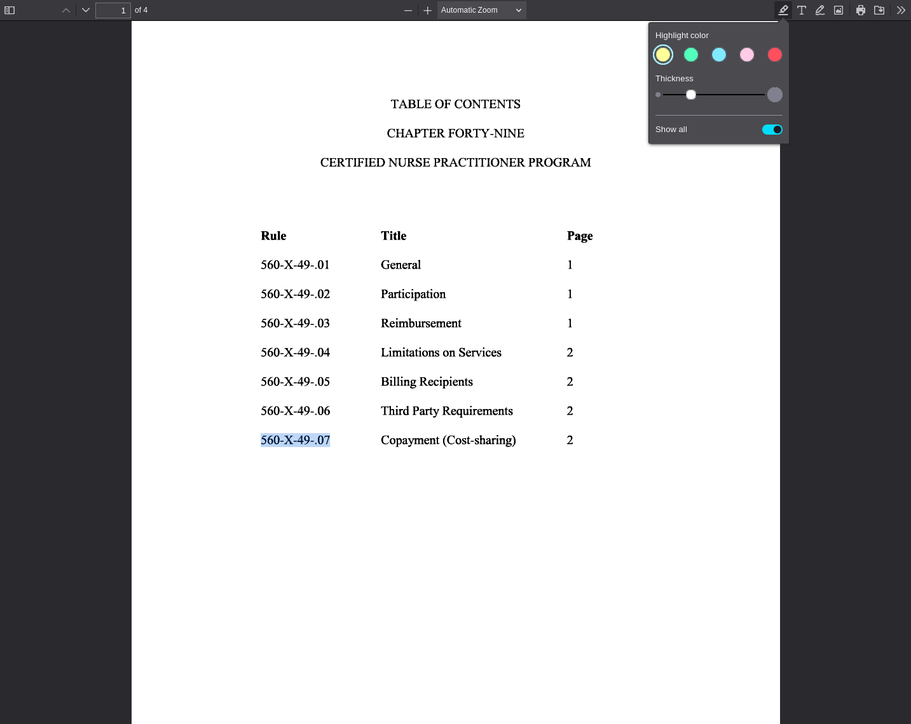
PDF viewer page 1 | Search anchor: 560-X-49-.07

SA-004 — Student-Authored Control Record
Independent source-grounded factual lookup item
Field | Completed record
Record ID | SA-004
Question | What page number in the table of contents lists Rule 560-X-50-.03, Recipient Eligibility?
Expected answer | Page 3.
Question type | Answerable — source lookup
Exact supporting quote | 560-X-50-.03 Recipient Eligibility 3
Source PDF | 9.2_Adm_Code_Chap_50_Preventive_Health_Ed_Program.pdf
PDF page | 1
Source URL | https://medicaid.alabama.gov/documents/9.0_Resources/9.2_Administrative_Code/9.2_Adm_Code_Chap_50_Preventive_Health_Ed_Program.pdf
Browser search anchor | 560-X-50-.03
Source SHA-256 | e8545bbf634daee6536fe96fe20ba914512ec4e05d14e7345f39e8ab6b355899
Snapshot date | 2026-09-14
Authorship | Student-authored final wording supplied by the student.
Training exclusion | Excluded from training data and answer-key generation.
Browser verification | Verified in the PDF viewer; source-search evidence is included below.
Post-freeze factual scoring | To be scored after the control set is locked, alongside the generated evaluation set.
Browser source evidence
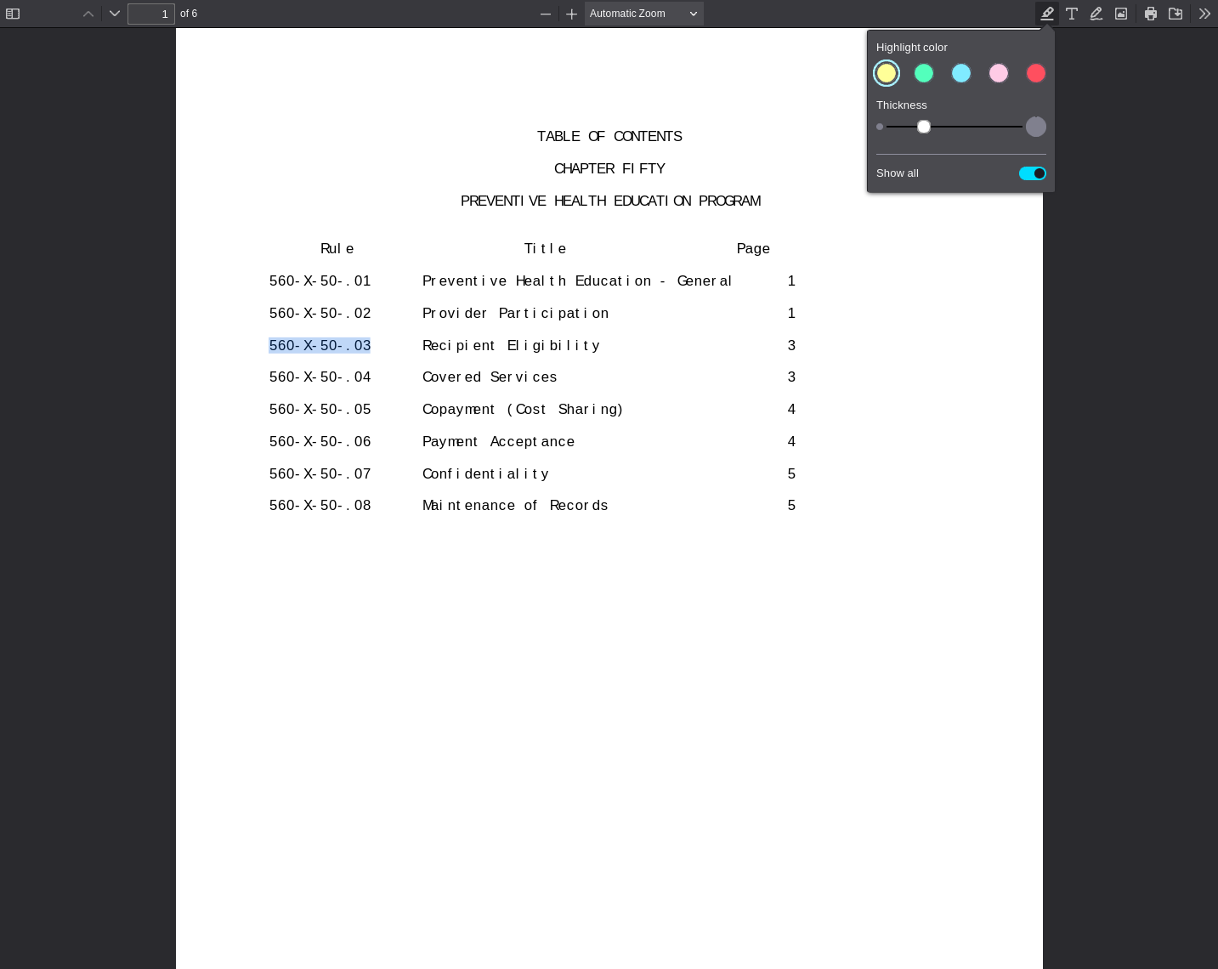
PDF viewer page 1 | Search anchor: 560-X-50-.03

SA-005 — Student-Authored Control Record
Independent source-grounded factual lookup item
Field | Completed record
Record ID | SA-005
Question | What Medicaid provider type is assigned to Licensed Social Workers?
Expected answer | Provider type 11, Crossovers Only.
Question type | Answerable — source lookup
Exact supporting quote | Licensed Social Workers are assigned a provider type of 11 (Crossovers Only).
Source PDF | Apr26_23.pdf
PDF page | 1
Source URL | https://medicaid.alabama.gov/content/Gated/7.6.1G_Provider_Manuals/7.6.1.2G_Apr_2026/Apr26_23.pdf
Browser search anchor | Licensed Social Workers are assigned
Source SHA-256 | 6c6a8cda335c0758f3cec8f72c2ba1911c6912674348eb40bba5bdf4926baa78
Snapshot date | 2026-09-14
Authorship | Student-authored final wording supplied by the student.
Training exclusion | Excluded from training data and answer-key generation.
Browser verification | Verified in the PDF viewer; source-search evidence is included below.
Post-freeze factual scoring | To be scored after the control set is locked, alongside the generated evaluation set.
Browser source evidence
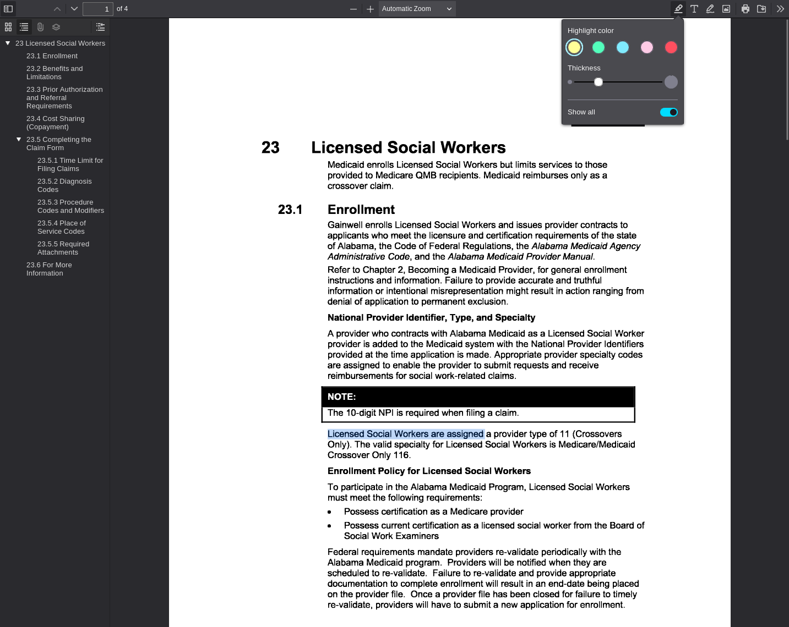
PDF viewer page 1 | Search anchor: Licensed Social Workers are assigned

SA-006 — Student-Authored Control Record
Independent source-grounded factual lookup item
Field | Completed record
Record ID | SA-006
Question | What provider type is assigned to therapy providers?
Expected answer | Provider type 17, Therapy.
Question type | Answerable — source lookup
Exact supporting quote | Therapy providers are assigned a provider type of 17 (Therapy).
Source PDF | Apr26_37.pdf
PDF page | 2
Source URL | https://medicaid.alabama.gov/content/Gated/7.6.1G_Provider_Manuals/7.6.1.2G_Apr_2026/Apr26_37.pdf
Browser search anchor | provider type of 17
Source SHA-256 | 7dda7fb89e4a91948f14446db97cc59dd65dae17d2f1f322acca2d6eaabb9145
Snapshot date | 2026-09-14
Authorship | Student-authored final wording supplied by the student.
Training exclusion | Excluded from training data and answer-key generation.
Browser verification | Verified in the PDF viewer; source-search evidence is included below.
Post-freeze factual scoring | To be scored after the control set is locked, alongside the generated evaluation set.
Browser source evidence
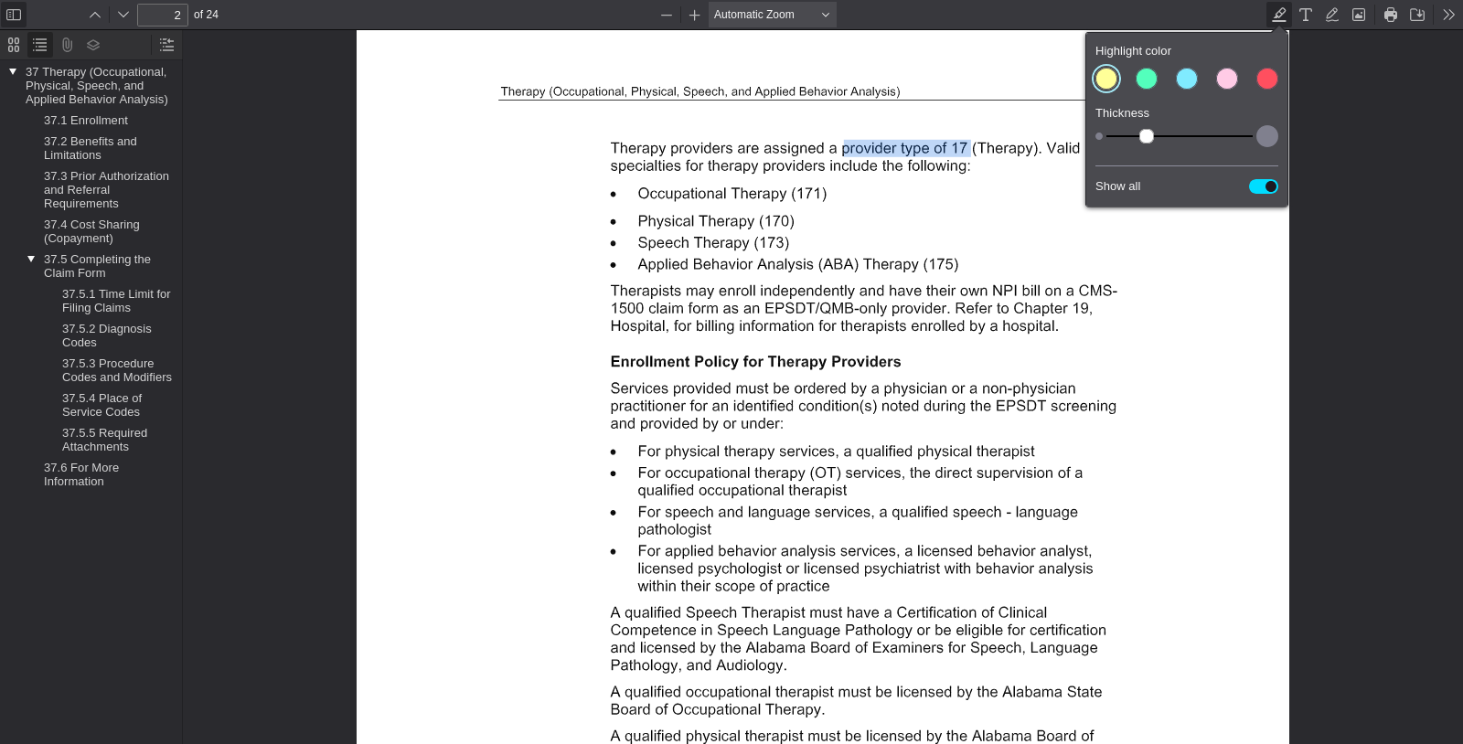
PDF viewer page 2 | Search anchor: provider type of 17

SA-007 — Student-Authored Control Record
Independent source-grounded factual lookup item
Field | Completed record
Record ID | SA-007
Question | What provider type is assigned to Remote Patient Monitoring providers?
Expected answer | Provider type 08, Remote Patient Monitoring.
Question type | Answerable — source lookup
Exact supporting quote | Remote Patient Monitoring providers are assigned a provider type of 08 (Remote Patient Monitoring) and provider specialty 085 or 086.
Source PDF | Jul26_111.pdf
PDF page | 1
Source URL | https://medicaid.alabama.gov/content/Gated/7.6.1G_Provider_Manuals/7.6.1.3G_July_2026/Jul26_111.pdf
Browser search anchor | Remote Patient Monitoring providers are assigned
Source SHA-256 | 950bc66ef512fc94ba54df0951c2593a3dbf85fa97473b22a6558705d9af23fd
Snapshot date | 2026-09-14
Authorship | Student-authored final wording supplied by the student.
Training exclusion | Excluded from training data and answer-key generation.
Browser verification | Verified in the PDF viewer; source-search evidence is included below.
Post-freeze factual scoring | To be scored after the control set is locked, alongside the generated evaluation set.
Browser source evidence
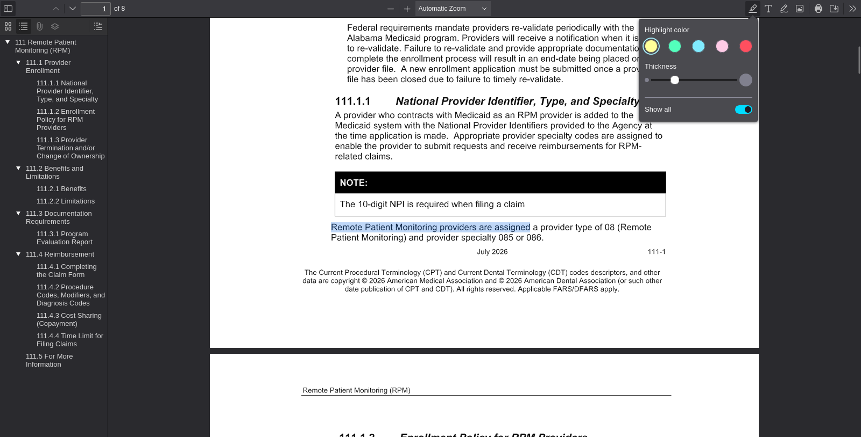
PDF viewer page 1 | Search anchor: Remote Patient Monitoring providers are assigned

SA-008 — Student-Authored Control Record
Independent source-grounded factual lookup item
Field | Completed record
Record ID | SA-008
Question | What provider type is assigned to physicians?
Expected answer | Provider type 31, Physician.
Question type | Answerable — source lookup
Exact supporting quote | Physicians are assigned a provider type of 31 (Physician).
Source PDF | Jul26_28.pdf
PDF page | 2
Source URL | https://medicaid.alabama.gov/content/Gated/7.6.1G_Provider_Manuals/7.6.1.3G_July_2026/Jul26_28.pdf
Browser search anchor | Physicians are assigned
Source SHA-256 | 5816647d97b5acb0fc6d84fb6ded0f609aa3e7418072d8d93c35b3a442879d04
Snapshot date | 2026-09-14
Authorship | Student-authored final wording supplied by the student.
Training exclusion | Excluded from training data and answer-key generation.
Browser verification | Verified in the PDF viewer; source-search evidence is included below.
Post-freeze factual scoring | To be scored after the control set is locked, alongside the generated evaluation set.
Browser source evidence
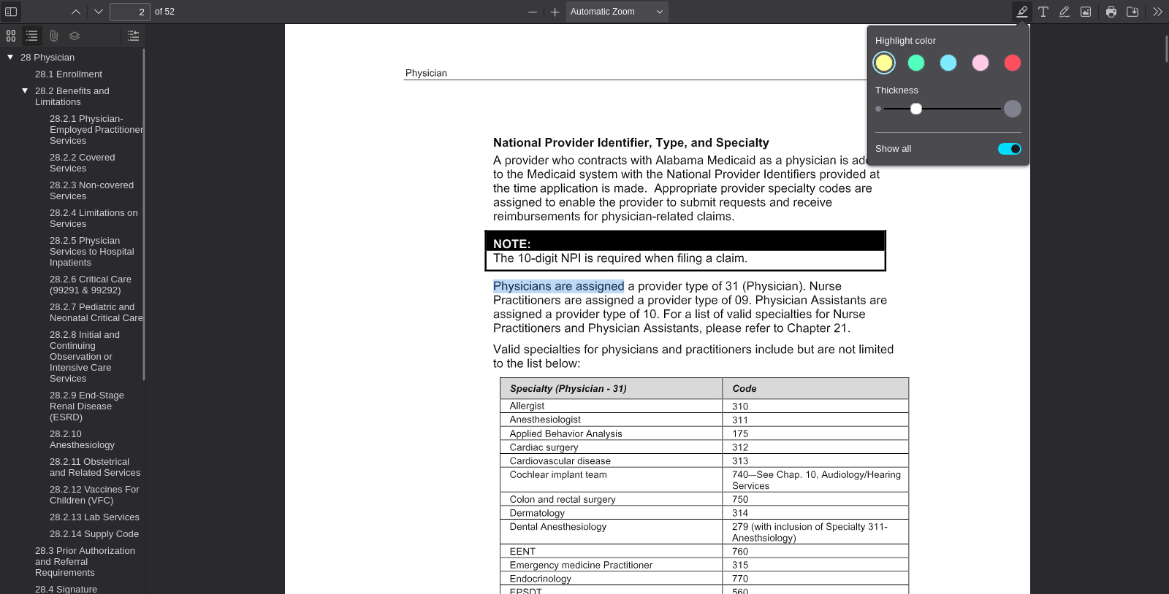
PDF viewer page 2 | Search anchor: Physicians are assigned

SA-009 — Student-Authored Control Record
Independent source-grounded factual lookup item
Field | Completed record
Record ID | SA-009
Question | What provider type is assigned to preventive health education providers?
Expected answer | Provider type 55.
Question type | Answerable — source lookup
Exact supporting quote | Preventive health education providers are assigned a provider type of 55 (Private Prenatal Education).
Source PDF | Jul26_30.pdf
PDF page | 1
Source URL | https://medicaid.alabama.gov/content/Gated/7.6.1G_Provider_Manuals/7.6.1.3G_July_2026/Jul26_30.pdf
Browser search anchor | Preventive health education providers are assigned
Source SHA-256 | eb21fa6f0eabfb878cdc053a14730b96bf8b3763ed00c2336c9f4795f56f295e
Snapshot date | 2026-09-14
Authorship | Student-authored final wording supplied by the student.
Training exclusion | Excluded from training data and answer-key generation.
Browser verification | Verified in the PDF viewer; source-search evidence is included below.
Post-freeze factual scoring | To be scored after the control set is locked, alongside the generated evaluation set.
Browser source evidence
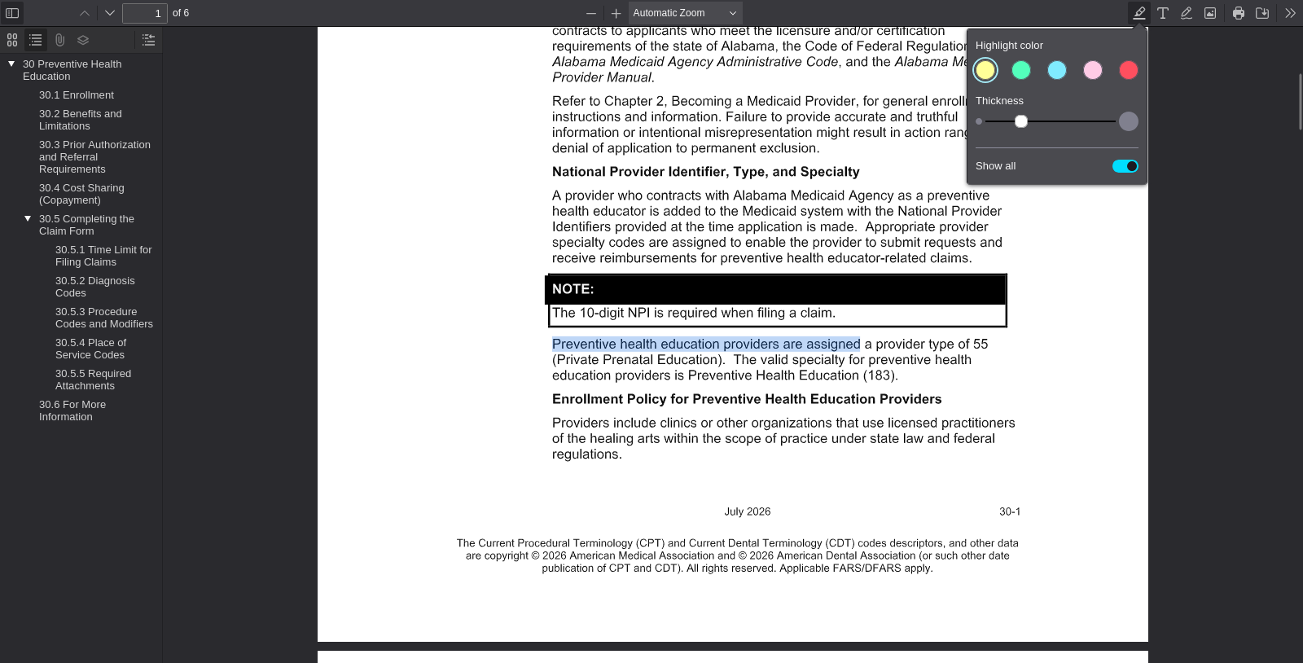
PDF viewer page 1 | Search anchor: Preventive health education providers are assigned

SA-010 — Student-Authored Control Record
Independent source-grounded factual lookup item
Field | Completed record
Record ID | SA-010
Question | What provider type is assigned to psychology providers?
Expected answer | Provider type 54, Psychologist.
Question type | Answerable — source lookup
Exact supporting quote | Psychology providers are assigned a provider type of 54 (Psychologist).
Source PDF | Jul26_34.pdf
PDF page | 2
Source URL | https://medicaid.alabama.gov/content/Gated/7.6.1G_Provider_Manuals/7.6.1.3G_July_2026/Jul26_34.pdf
Browser search anchor | Psychology providers are assigned
Source SHA-256 | 5d1a8052d80742b29fa8ba93ec2db5ff427507a8fed00488d2b99ce9488b56cf
Snapshot date | 2026-09-14
Authorship | Student-authored final wording supplied by the student.
Training exclusion | Excluded from training data and answer-key generation.
Browser verification | Verified in the PDF viewer; source-search evidence is included below.
Post-freeze factual scoring | To be scored after the control set is locked, alongside the generated evaluation set.
Browser source evidence
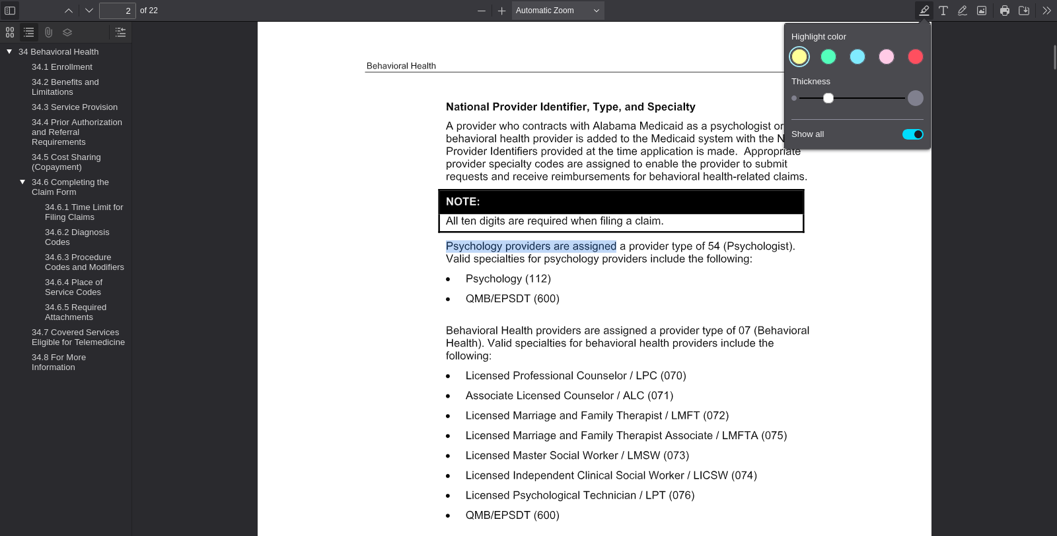
PDF viewer page 2 | Search anchor: Psychology providers are assigned

SA-011 — Student-Authored Control Record
Independent source-grounded factual lookup item
Field | Completed record
Record ID | SA-011
Question | What provider type is assigned to Behavioral Health providers?
Expected answer | Provider type 07, Behavioral Health.
Question type | Answerable — source lookup
Exact supporting quote | Behavioral Health providers are assigned a provider type of 07 (Behavioral Health).
Source PDF | Jul26_34.pdf
PDF page | 2
Source URL | https://medicaid.alabama.gov/content/Gated/7.6.1G_Provider_Manuals/7.6.1.3G_July_2026/Jul26_34.pdf
Browser search anchor | provider type of 07
Source SHA-256 | 5d1a8052d80742b29fa8ba93ec2db5ff427507a8fed00488d2b99ce9488b56cf
Snapshot date | 2026-09-14
Authorship | Student-authored final wording supplied by the student.
Training exclusion | Excluded from training data and answer-key generation.
Browser verification | Verified in the PDF viewer; source-search evidence is included below.
Post-freeze factual scoring | To be scored after the control set is locked, alongside the generated evaluation set.
Browser source evidence
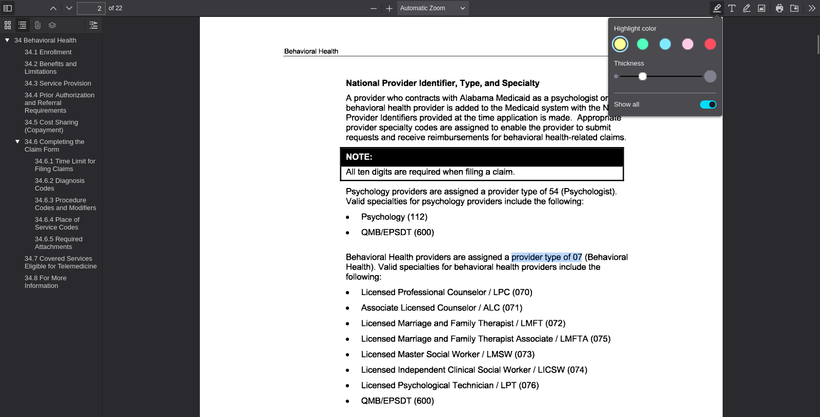
PDF viewer page 2 | Search anchor: provider type of 07

SA-012 — Student-Authored Control Record
Independent source-grounded factual lookup item
Field | Completed record
Record ID | SA-012
Question | What specialty code is listed for Psychology providers?
Expected answer | Psychology specialty code 112.
Question type | Answerable — source lookup
Exact supporting quote | Psychology (112)
Source PDF | Jul26_34.pdf
PDF page | 2
Source URL | https://medicaid.alabama.gov/content/Gated/7.6.1G_Provider_Manuals/7.6.1.3G_July_2026/Jul26_34.pdf
Browser search anchor | Psychology (112)
Source SHA-256 | 5d1a8052d80742b29fa8ba93ec2db5ff427507a8fed00488d2b99ce9488b56cf
Snapshot date | 2026-09-14
Authorship | Student-authored final wording supplied by the student.
Training exclusion | Excluded from training data and answer-key generation.
Browser verification | Verified in the PDF viewer; source-search evidence is included below.
Post-freeze factual scoring | To be scored after the control set is locked, alongside the generated evaluation set.
Browser source evidence
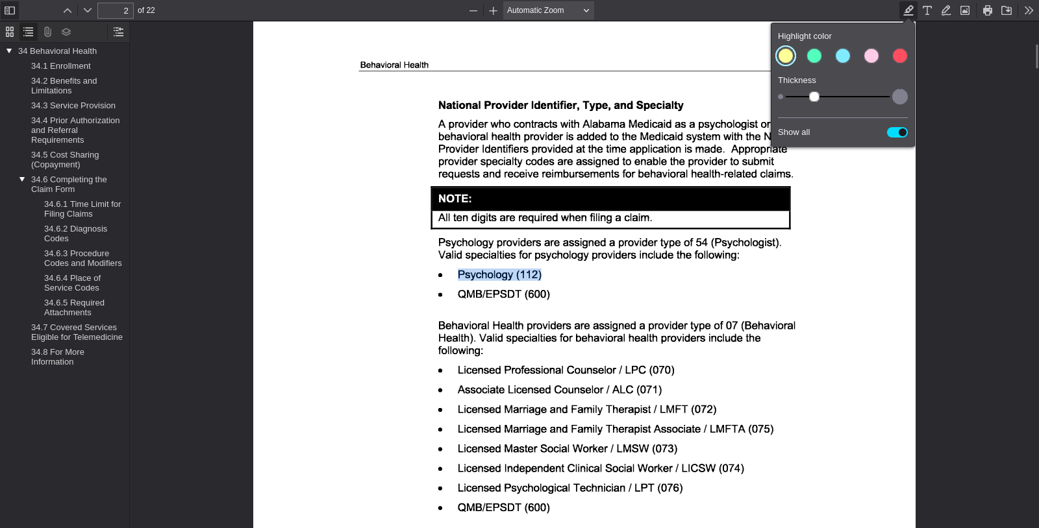
PDF viewer page 2 | Search anchor: Psychology (112)

SA-013 — Student-Authored Control Record
Independent source-grounded factual lookup item
Field | Completed record
Record ID | SA-013
Question | What specialty code is listed for a Licensed Professional Counselor / LPC?
Expected answer | Specialty code 070
Question type | Answerable — source lookup
Exact supporting quote | Licensed Professional Counselor / LPC (070)
Source PDF | Jul26_34.pdf
PDF page | 2
Source URL | https://medicaid.alabama.gov/content/Gated/7.6.1G_Provider_Manuals/7.6.1.3G_July_2026/Jul26_34.pdf
Browser search anchor | Licensed Professional Counselor / LPC (070)
Source SHA-256 | 5d1a8052d80742b29fa8ba93ec2db5ff427507a8fed00488d2b99ce9488b56cf
Snapshot date | 2026-09-14
Authorship | Student-authored final wording supplied by the student.
Training exclusion | Excluded from training data and answer-key generation.
Browser verification | Verified in the PDF viewer; source-search evidence is included below.
Post-freeze factual scoring | To be scored after the control set is locked, alongside the generated evaluation set.
Browser source evidence
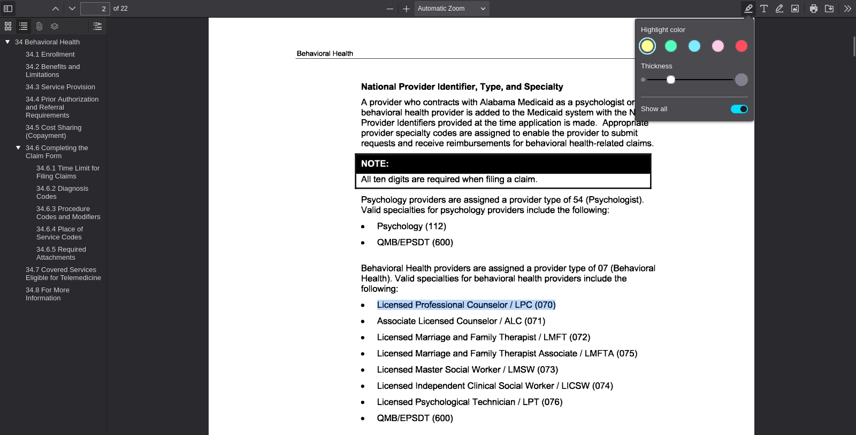
PDF viewer page 2 | Search anchor: Licensed Professional Counselor / LPC (070)

SA-014 — Student-Authored Control Record
Independent source-grounded factual lookup item
Field | Completed record
Record ID | SA-014
Question | What provider type is assigned to Nurse Practitioners?
Expected answer | Provider type 09.
Question type | Answerable — source lookup
Exact supporting quote | Nurse Practitioners are assigned a provider type of 09.
Source PDF | Jul26_28.pdf
PDF page | 2
Source URL | https://medicaid.alabama.gov/content/Gated/7.6.1G_Provider_Manuals/7.6.1.3G_July_2026/Jul26_28.pdf
Browser search anchor | provider type of 09
Source SHA-256 | 5816647d97b5acb0fc6d84fb6ded0f609aa3e7418072d8d93c35b3a442879d04
Snapshot date | 2026-09-14
Authorship | Student-authored final wording supplied by the student.
Training exclusion | Excluded from training data and answer-key generation.
Browser verification | Verified in the PDF viewer; source-search evidence is included below.
Post-freeze factual scoring | To be scored after the control set is locked, alongside the generated evaluation set.
Browser source evidence
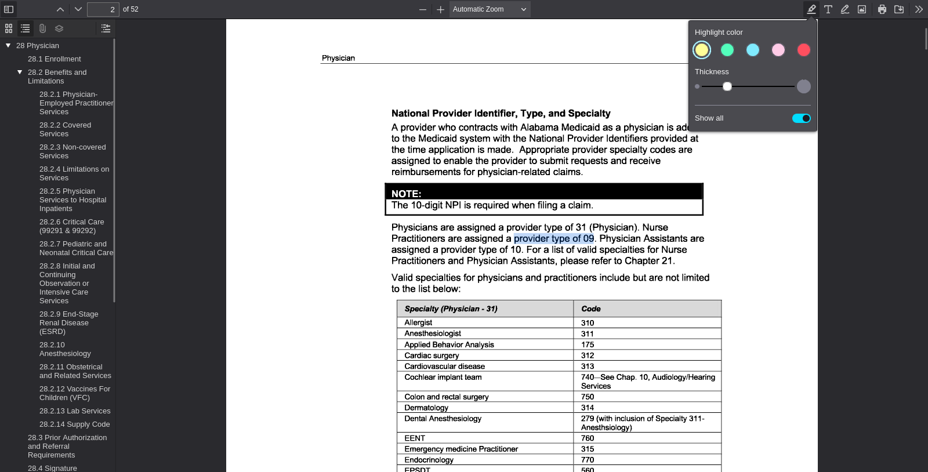
PDF viewer page 2 | Search anchor: provider type of 09

SA-015 — Student-Authored Control Record
Independent source-grounded factual lookup item
Field | Completed record
Record ID | SA-015
Question | What provider type is assigned to Physician Assistants?
Expected answer | Provider type 10.
Question type | Answerable — source lookup
Exact supporting quote | Physician Assistants are assigned a provider type of 10.
Source PDF | Jul26_28.pdf
PDF page | 2
Source URL | https://medicaid.alabama.gov/content/Gated/7.6.1G_Provider_Manuals/7.6.1.3G_July_2026/Jul26_28.pdf
Browser search anchor | provider type of 10
Source SHA-256 | 5816647d97b5acb0fc6d84fb6ded0f609aa3e7418072d8d93c35b3a442879d04
Snapshot date | 2026-09-14
Authorship | Student-authored final wording supplied by the student.
Training exclusion | Excluded from training data and answer-key generation.
Browser verification | Verified in the PDF viewer; source-search evidence is included below.
Post-freeze factual scoring | To be scored after the control set is locked, alongside the generated evaluation set.
Browser source evidence
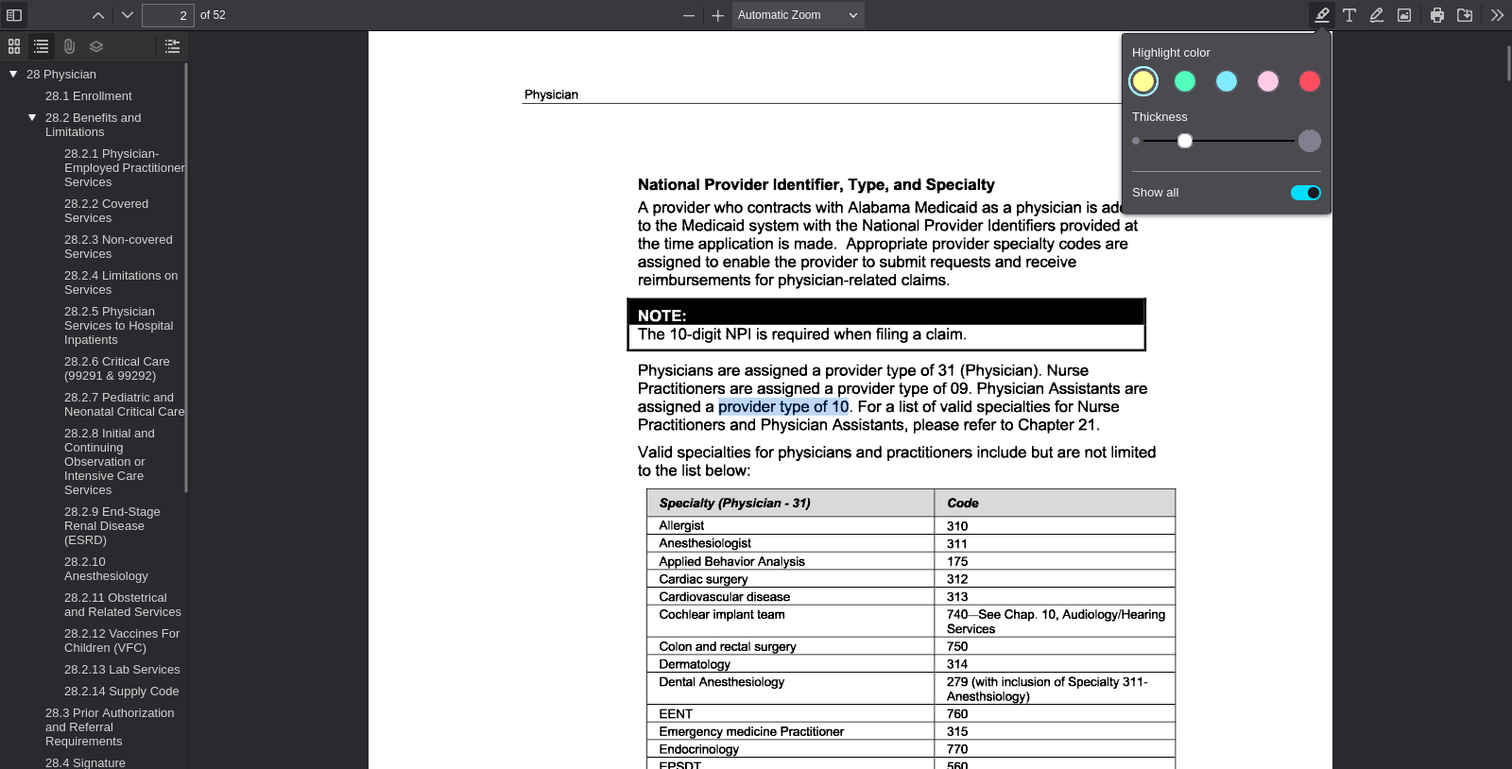
PDF viewer page 2 | Search anchor: provider type of 10

SA-016 — Student-Authored Control Record
Independent source-grounded factual lookup item
Field | Completed record
Record ID | SA-016
Question | What specialty code is listed for Occupational Therapy?
Expected answer | Occupational Therapy code 171.
Question type | Answerable — source lookup
Exact supporting quote | Occupational Therapy (171)
Source PDF | Apr26_37.pdf
PDF page | 2
Source URL | https://medicaid.alabama.gov/content/Gated/7.6.1G_Provider_Manuals/7.6.1.2G_Apr_2026/Apr26_37.pdf
Browser search anchor | Occupational Therapy (171)
Source SHA-256 | 7dda7fb89e4a91948f14446db97cc59dd65dae17d2f1f322acca2d6eaabb9145
Snapshot date | 2026-09-14
Authorship | Student-authored final wording supplied by the student.
Training exclusion | Excluded from training data and answer-key generation.
Browser verification | Verified in the PDF viewer; source-search evidence is included below.
Post-freeze factual scoring | To be scored after the control set is locked, alongside the generated evaluation set.
Browser source evidence
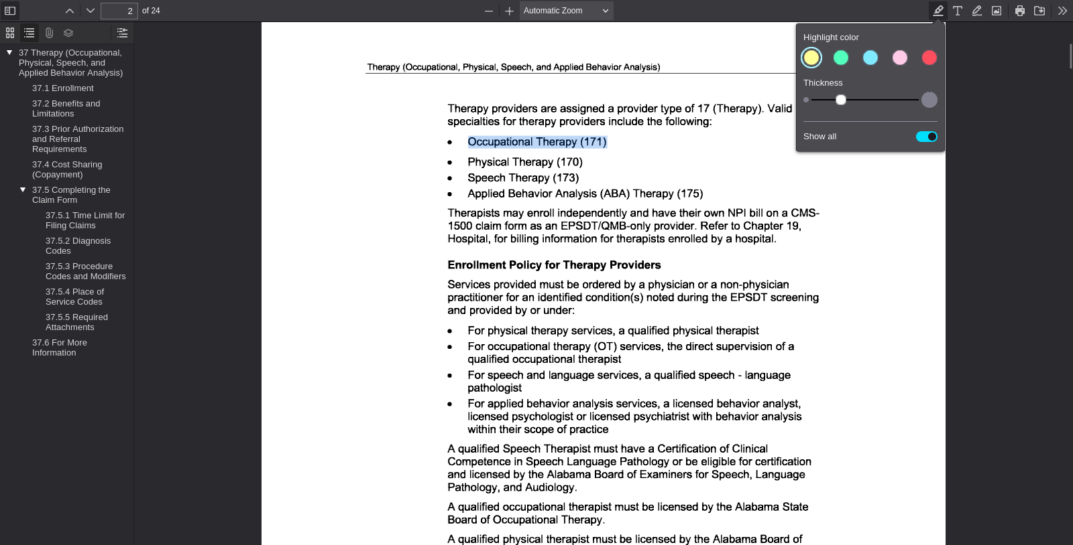
PDF viewer page 2 | Search anchor: Occupational Therapy (171)

SA-017 — Student-Authored Control Record
Independent source-grounded factual lookup item
Field | Completed record
Record ID | SA-017
Question | What specialty code is listed for Physical Therapy?
Expected answer | Physical Therapy code 170.
Question type | Answerable — source lookup
Exact supporting quote | Physical Therapy (170)
Source PDF | Apr26_37.pdf
PDF page | 2
Source URL | https://medicaid.alabama.gov/content/Gated/7.6.1G_Provider_Manuals/7.6.1.2G_Apr_2026/Apr26_37.pdf
Browser search anchor | Physical Therapy (170)
Source SHA-256 | 7dda7fb89e4a91948f14446db97cc59dd65dae17d2f1f322acca2d6eaabb9145
Snapshot date | 2026-09-14
Authorship | Student-authored final wording supplied by the student.
Training exclusion | Excluded from training data and answer-key generation.
Browser verification | Verified in the PDF viewer; source-search evidence is included below.
Post-freeze factual scoring | To be scored after the control set is locked, alongside the generated evaluation set.
Browser source evidence
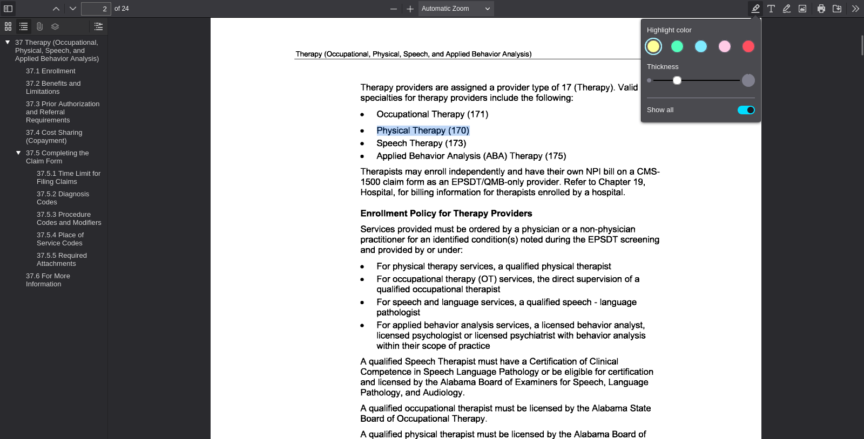
PDF viewer page 2 | Search anchor: Physical Therapy (170)

SA-018 — Student-Authored Control Record
Independent source-grounded factual lookup item
Field | Completed record
Record ID | SA-018
Question | What specialty code is listed for Speech Therapy?
Expected answer | Speech Therapy code 173.
Question type | Answerable — source lookup
Exact supporting quote | Speech Therapy (173)
Source PDF | Apr26_37.pdf
PDF page | 2
Source URL | https://medicaid.alabama.gov/content/Gated/7.6.1G_Provider_Manuals/7.6.1.2G_Apr_2026/Apr26_37.pdf
Browser search anchor | Speech Therapy (173)
Source SHA-256 | 7dda7fb89e4a91948f14446db97cc59dd65dae17d2f1f322acca2d6eaabb9145
Snapshot date | 2026-09-14
Authorship | Student-authored final wording supplied by the student.
Training exclusion | Excluded from training data and answer-key generation.
Browser verification | Verified in the PDF viewer; source-search evidence is included below.
Post-freeze factual scoring | To be scored after the control set is locked, alongside the generated evaluation set.
Browser source evidence
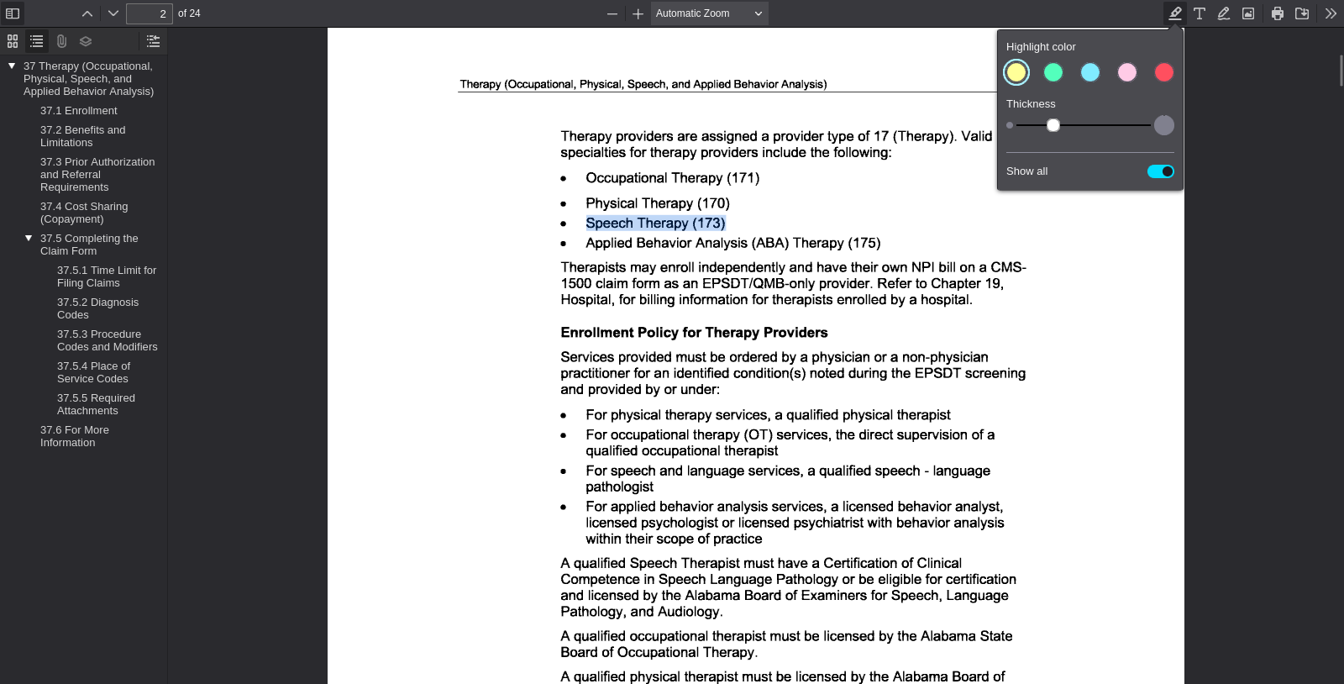
PDF viewer page 2 | Search anchor: Speech Therapy (173)

SA-019 — Student-Authored Control Record
Independent source-grounded factual lookup item
Field | Completed record
Record ID | SA-019
Question | What specialty code is listed for Applied Behavior Analysis Therapy.
Expected answer | Applied Behavior Analysis (ABA) Therapy. Code 175.
Question type | Answerable — source lookup
Exact supporting quote | Applied Behavior Analysis (ABA) Therapy (175)
Source PDF | Apr26_37.pdf
PDF page | 2
Source URL | https://medicaid.alabama.gov/content/Gated/7.6.1G_Provider_Manuals/7.6.1.2G_Apr_2026/Apr26_37.pdf
Browser search anchor | Applied Behavior Analysis (ABA) Therapy (175)
Source SHA-256 | 7dda7fb89e4a91948f14446db97cc59dd65dae17d2f1f322acca2d6eaabb9145
Snapshot date | 2026-09-14
Authorship | Student-authored final wording supplied by the student.
Training exclusion | Excluded from training data and answer-key generation.
Browser verification | Verified in the PDF viewer; source-search evidence is included below.
Post-freeze factual scoring | To be scored after the control set is locked, alongside the generated evaluation set.
Browser source evidence
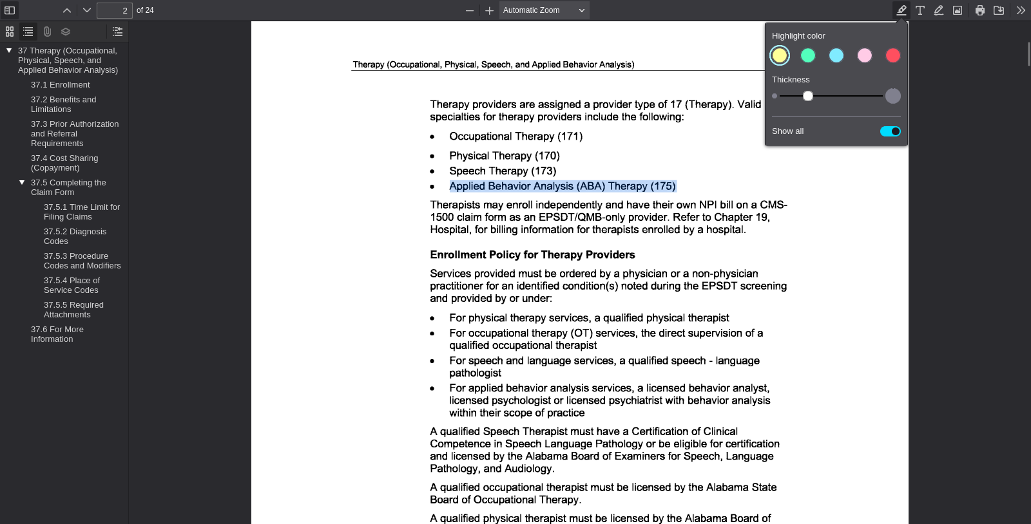
PDF viewer page 2 | Search anchor: Applied Behavior Analysis (ABA) Therapy (175)

SA-020 — Student-Authored Control Record
Independent source-grounded factual lookup item
Field | Completed record
Record ID | SA-020
Question | What provider specialties are assigned to Remote Patient Monitoring providers?
Expected answer | Provider specialties 085 or 086.
Question type | Answerable — source lookup
Exact supporting quote | Remote Patient Monitoring providers are assigned a provider type of 08 (Remote Patient Monitoring) and provider specialty 085 or 086.
Source PDF | Jul26_111.pdf
PDF page | 1
Source URL | https://medicaid.alabama.gov/content/Gated/7.6.1G_Provider_Manuals/7.6.1.3G_July_2026/Jul26_111.pdf
Browser search anchor | provider specialty 085 or 086
Source SHA-256 | 950bc66ef512fc94ba54df0951c2593a3dbf85fa97473b22a6558705d9af23fd
Snapshot date | 2026-09-14
Authorship | Student-authored final wording supplied by the student.
Training exclusion | Excluded from training data and answer-key generation.
Browser verification | Verified in the PDF viewer; source-search evidence is included below.
Post-freeze factual scoring | To be scored after the control set is locked, alongside the generated evaluation set.
Browser source evidence
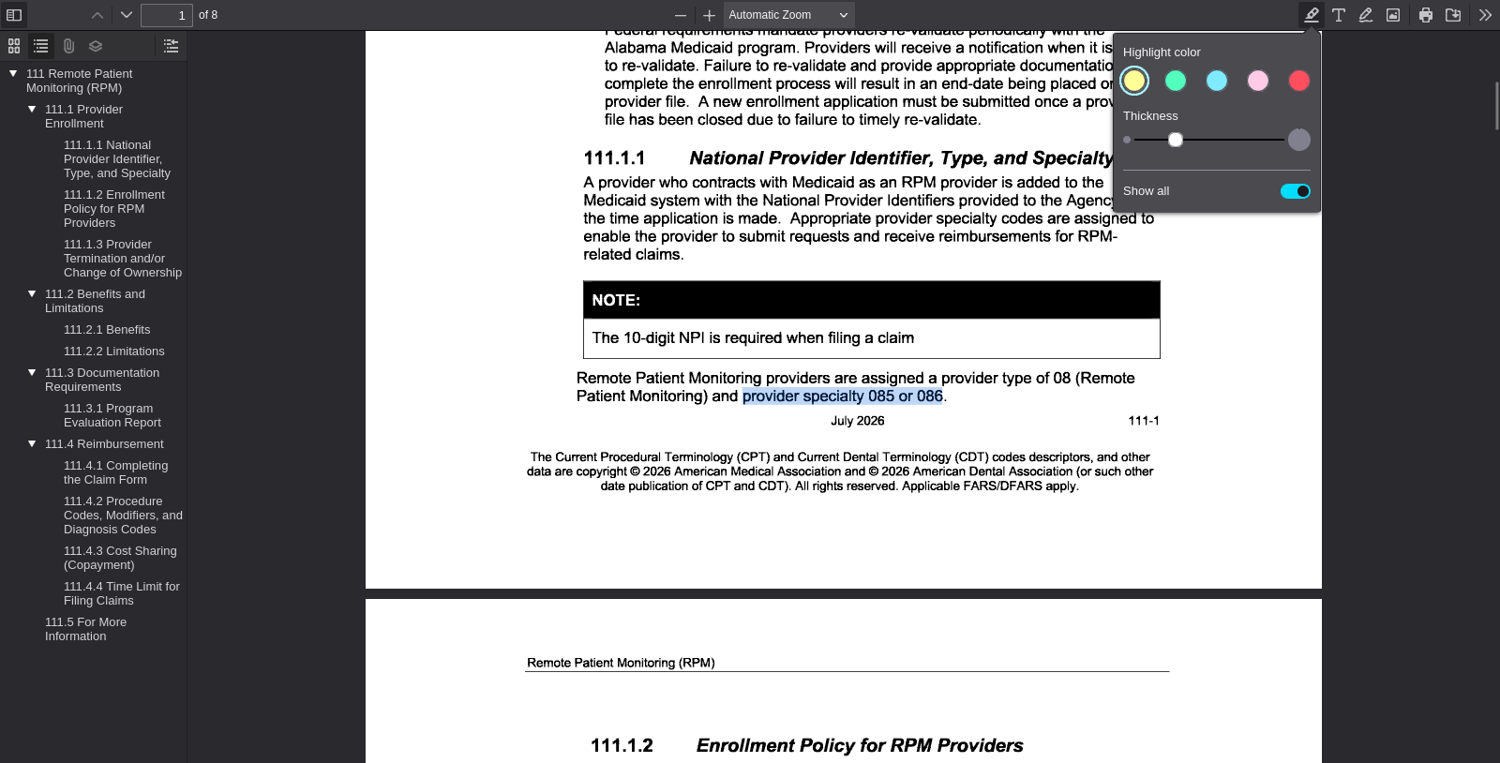
PDF viewer page 1 | Search anchor: provider specialty 085 or 086

SA-021 — Student-Authored Control Record
Independent source-grounded factual lookup item
Field | Completed record
Record ID | SA-021
Question | What specialty code is listed for an Associate Licensed Counselor / ALC?
Expected answer | Specialty code 071.
Question type | Answerable — source lookup
Exact supporting quote | Associate Licensed Counselor / ALC (071)
Source PDF | Jul26_34.pdf
PDF page | 2
Source URL | https://medicaid.alabama.gov/content/Gated/7.6.1G_Provider_Manuals/7.6.1.3G_July_2026/Jul26_34.pdf
Browser search anchor | Associate Licensed Counselor / ALC (071)
Source SHA-256 | 5d1a8052d80742b29fa8ba93ec2db5ff427507a8fed00488d2b99ce9488b56cf
Snapshot date | 2026-09-14
Authorship | Student-authored final wording supplied by the student.
Training exclusion | Excluded from training data and answer-key generation.
Browser verification | Verified in the PDF viewer; source-search evidence is included below.
Post-freeze factual scoring | To be scored after the control set is locked, alongside the generated evaluation set.
Browser source evidence
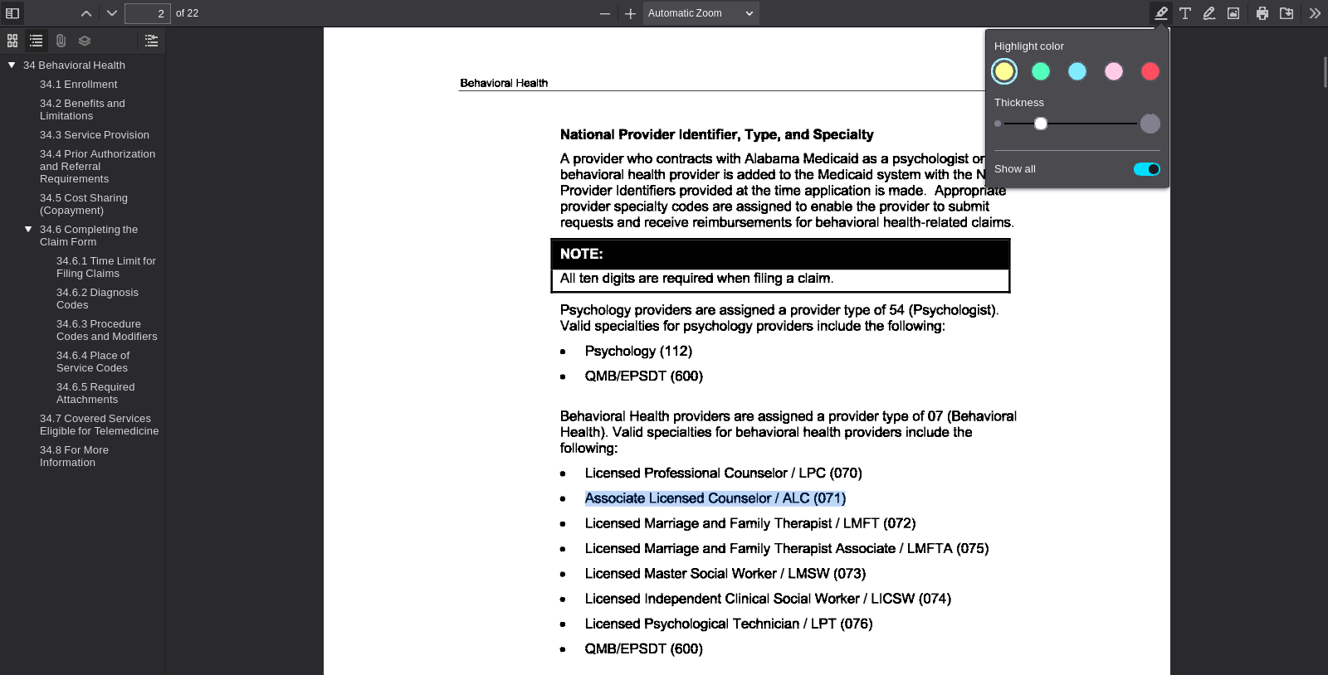
PDF viewer page 2 | Search anchor: Associate Licensed Counselor / ALC (071)

SA-022 — Student-Authored Control Record
Independent source-grounded factual lookup item
Field | Completed record
Record ID | SA-022
Question | What specialty code is listed for a Licensed Marriage and Family Therapist / LMFT?
Expected answer | Specialty code 072.
Question type | Answerable — source lookup
Exact supporting quote | Licensed Marriage and Family Therapist / LMFT (072)
Source PDF | Jul26_34.pdf
PDF page | 2
Source URL | https://medicaid.alabama.gov/content/Gated/7.6.1G_Provider_Manuals/7.6.1.3G_July_2026/Jul26_34.pdf
Browser search anchor | Licensed Marriage and Family Therapist / LMFT (072)
Source SHA-256 | 5d1a8052d80742b29fa8ba93ec2db5ff427507a8fed00488d2b99ce9488b56cf
Snapshot date | 2026-09-14
Authorship | Student-authored final wording supplied by the student.
Training exclusion | Excluded from training data and answer-key generation.
Browser verification | Verified in the PDF viewer; source-search evidence is included below.
Post-freeze factual scoring | To be scored after the control set is locked, alongside the generated evaluation set.
Browser source evidence
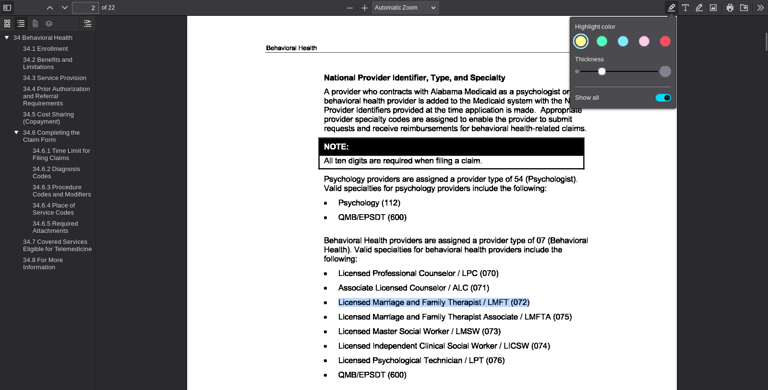
PDF viewer page 2 | Search anchor: Licensed Marriage and Family Therapist / LMFT (072)

SA-023 — Student-Authored Control Record
Independent source-grounded factual lookup item
Field | Completed record
Record ID | SA-023
Question | What specialty code is listed for a Licensed Marriage and Family Therapist Associate / LMFTA?
Expected answer | Specialty code 075.
Question type | Answerable — source lookup
Exact supporting quote | Licensed Marriage and Family Therapist Associate / LMFTA (075)
Source PDF | Jul26_34.pdf
PDF page | 2
Source URL | https://medicaid.alabama.gov/content/Gated/7.6.1G_Provider_Manuals/7.6.1.3G_July_2026/Jul26_34.pdf
Browser search anchor | Licensed Marriage and Family Therapist Associate / LMFTA (075)
Source SHA-256 | 5d1a8052d80742b29fa8ba93ec2db5ff427507a8fed00488d2b99ce9488b56cf
Snapshot date | 2026-09-14
Authorship | Student-authored final wording supplied by the student.
Training exclusion | Excluded from training data and answer-key generation.
Browser verification | Verified in the PDF viewer; source-search evidence is included below.
Post-freeze factual scoring | To be scored after the control set is locked, alongside the generated evaluation set.
Browser source evidence
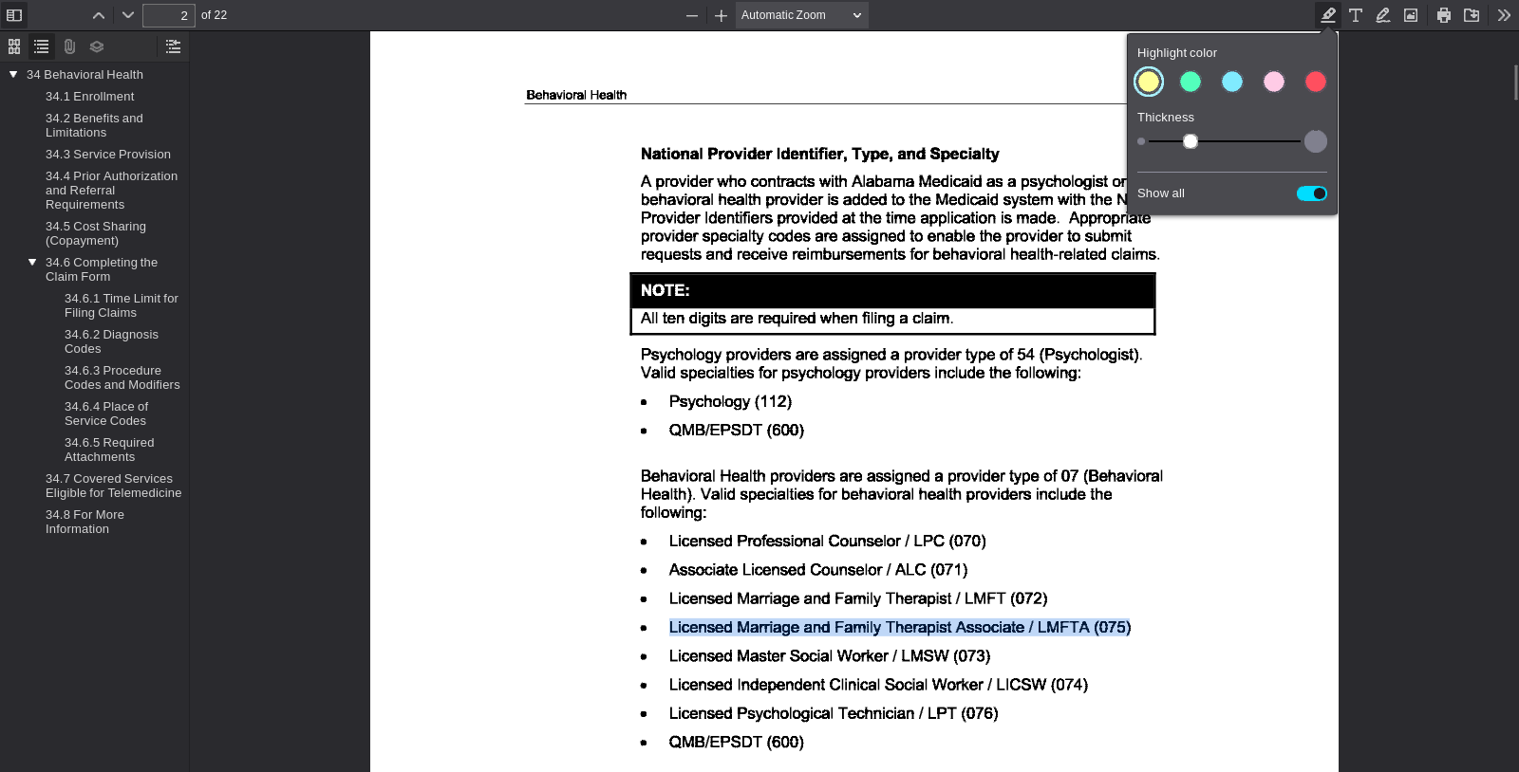
PDF viewer page 2 | Search anchor: Licensed Marriage and Family Therapist Associate / LMFTA (075)

SA-024 — Student-Authored Control Record
Independent source-grounded factual lookup item
Field | Completed record
Record ID | SA-024
Question | What specialty code is listed for a Licensed Master Social Worker / LMSW?
Expected answer | Specialty code 073.
Question type | Answerable — source lookup
Exact supporting quote | Licensed Master Social Worker / LMSW (073)
Source PDF | Jul26_34.pdf
PDF page | 2
Source URL | https://medicaid.alabama.gov/content/Gated/7.6.1G_Provider_Manuals/7.6.1.3G_July_2026/Jul26_34.pdf
Browser search anchor | Licensed Master Social Worker / LMSW (073)
Source SHA-256 | 5d1a8052d80742b29fa8ba93ec2db5ff427507a8fed00488d2b99ce9488b56cf
Snapshot date | 2026-09-14
Authorship | Student-authored final wording supplied by the student.
Training exclusion | Excluded from training data and answer-key generation.
Browser verification | Verified in the PDF viewer; source-search evidence is included below.
Post-freeze factual scoring | To be scored after the control set is locked, alongside the generated evaluation set.
Browser source evidence
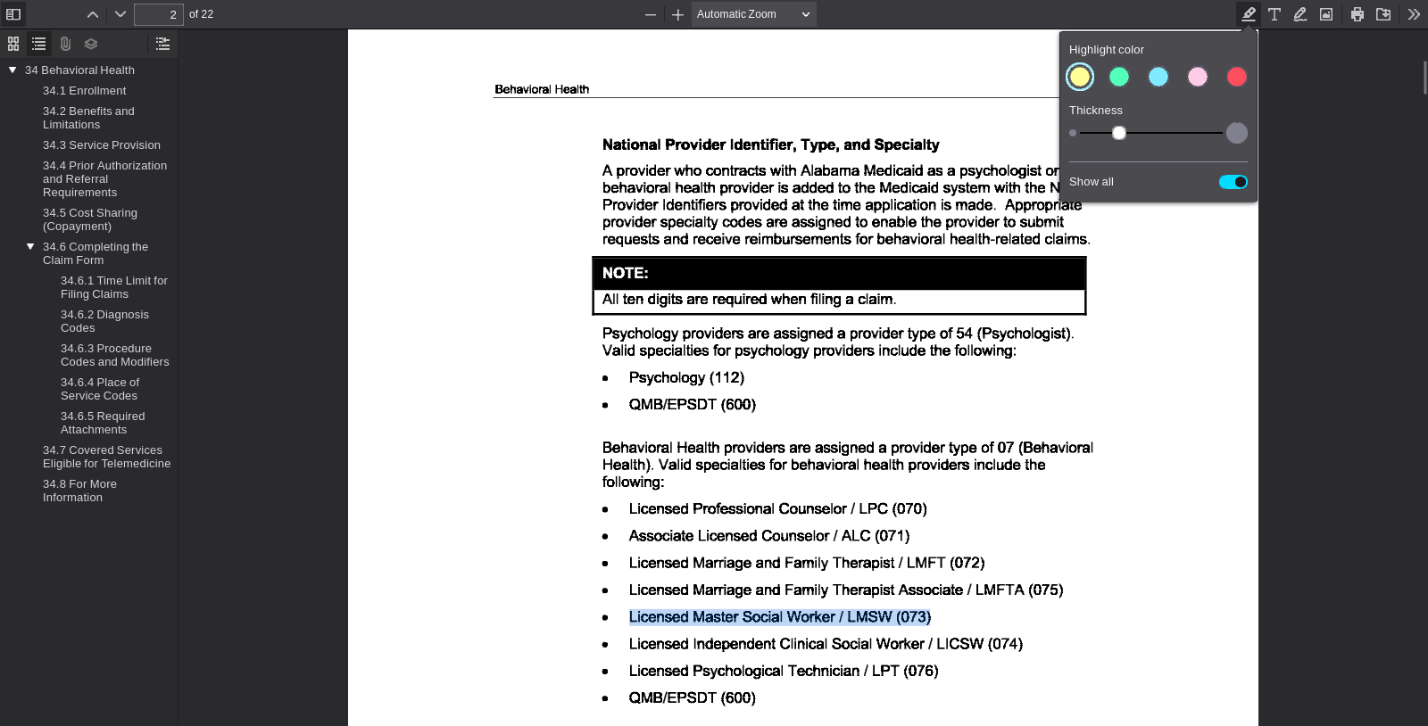
PDF viewer page 2 | Search anchor: Licensed Master Social Worker / LMSW (073)

SA-025 — Student-Authored Control Record
Independent source-grounded factual lookup item
Field | Completed record
Record ID | SA-025
Question | What specialty code is listed for a Licensed Independent Clinical Social Worker / LICSW.
Expected answer | Specialty code 074.
Question type | Answerable — source lookup
Exact supporting quote | Licensed Independent Clinical Social Worker / LICSW (074)
Source PDF | Jul26_34.pdf
PDF page | 2
Source URL | https://medicaid.alabama.gov/content/Gated/7.6.1G_Provider_Manuals/7.6.1.3G_July_2026/Jul26_34.pdf
Browser search anchor | Licensed Independent Clinical Social Worker / LICSW (074)
Source SHA-256 | 5d1a8052d80742b29fa8ba93ec2db5ff427507a8fed00488d2b99ce9488b56cf
Snapshot date | 2026-09-14
Authorship | Student-authored final wording supplied by the student.
Training exclusion | Excluded from training data and answer-key generation.
Browser verification | Verified in the PDF viewer; source-search evidence is included below.
Post-freeze factual scoring | To be scored after the control set is locked, alongside the generated evaluation set.
Browser source evidence
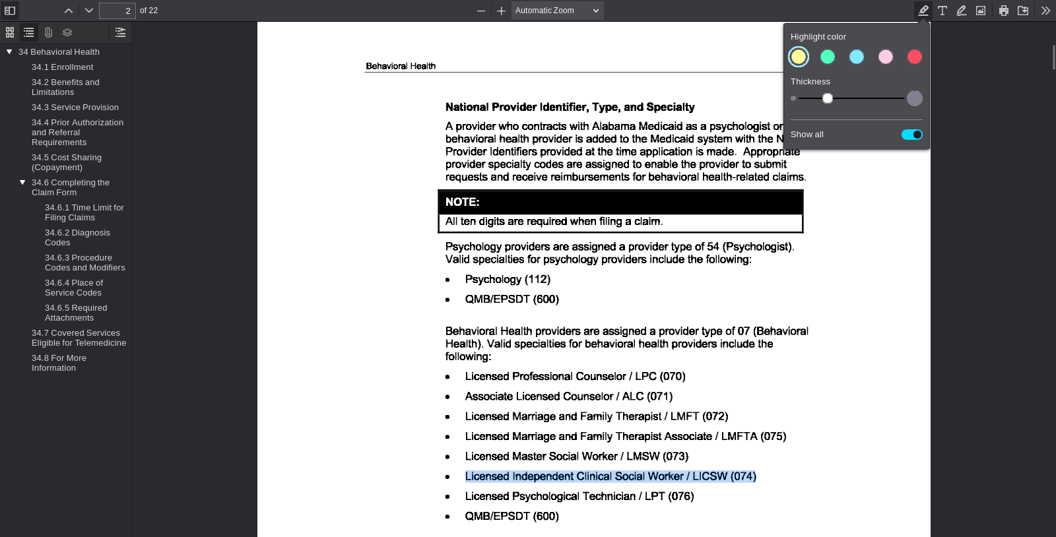
PDF viewer page 2 | Search anchor: Licensed Independent Clinical Social Worker / LICSW (074)

SA-026 — Student-Authored Control Record
Independent source-grounded factual lookup item
Field | Completed record
Record ID | SA-026
Question | What specialty code is listed for a Licensed Psychological Technician / LPT?
Expected answer | Specialty code 076.
Question type | Answerable — source lookup
Exact supporting quote | Licensed Psychological Technician / LPT (076)
Source PDF | Jul26_34.pdf
PDF page | 2
Source URL | https://medicaid.alabama.gov/content/Gated/7.6.1G_Provider_Manuals/7.6.1.3G_July_2026/Jul26_34.pdf
Browser search anchor | Licensed Psychological Technician / LPT (076)
Source SHA-256 | 5d1a8052d80742b29fa8ba93ec2db5ff427507a8fed00488d2b99ce9488b56cf
Snapshot date | 2026-09-14
Authorship | Student-authored final wording supplied by the student.
Training exclusion | Excluded from training data and answer-key generation.
Browser verification | Verified in the PDF viewer; source-search evidence is included below.
Post-freeze factual scoring | To be scored after the control set is locked, alongside the generated evaluation set.
Browser source evidence
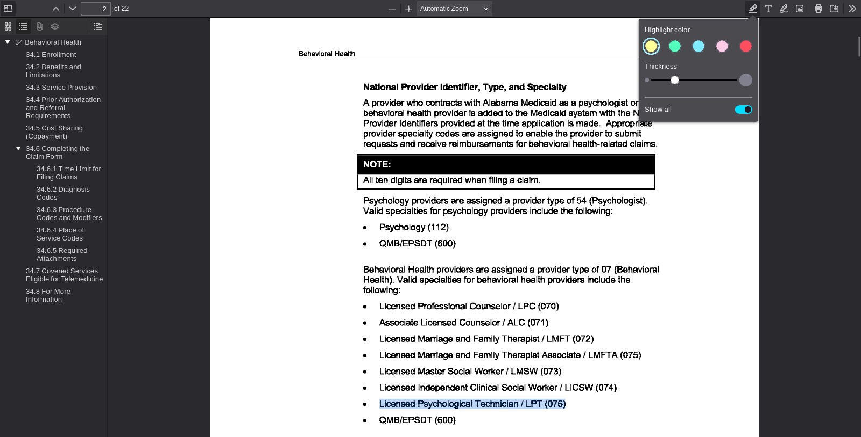
PDF viewer page 2 | Search anchor: Licensed Psychological Technician / LPT (076)

SA-027 — Student-Authored Control Record
Independent source-grounded factual lookup item
Field | Completed record
Record ID | SA-027
Question | What specialty code is listed for Preventive Health Education?
Expected answer | Specialty code 183.
Question type | Answerable — source lookup
Exact supporting quote | The valid specialty for preventive health education providers is Preventive Health Education (183).
Source PDF | Jul26_30.pdf
PDF page | 1
Source URL | https://medicaid.alabama.gov/content/Gated/7.6.1G_Provider_Manuals/7.6.1.3G_July_2026/Jul26_30.pdf
Browser search anchor | Preventive Health Education (183)
Source SHA-256 | eb21fa6f0eabfb878cdc053a14730b96bf8b3763ed00c2336c9f4795f56f295e
Snapshot date | 2026-09-14
Authorship | Student-authored final wording supplied by the student.
Training exclusion | Excluded from training data and answer-key generation.
Browser verification | Verified in the PDF viewer; source-search evidence is included below.
Post-freeze factual scoring | To be scored after the control set is locked, alongside the generated evaluation set.
Browser source evidence
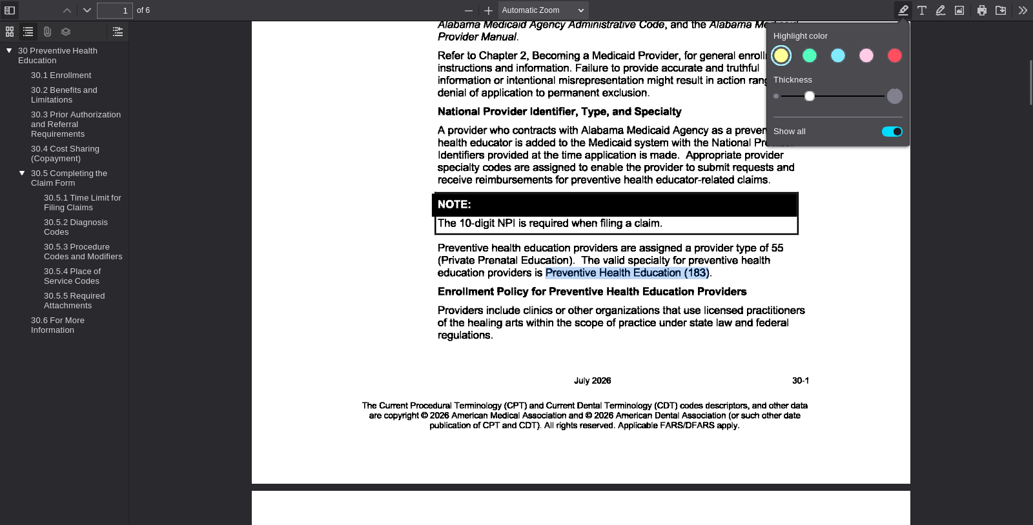
PDF viewer page 1 | Search anchor: Preventive Health Education (183)

SA-028 — Student-Authored Control Record
Independent source-grounded factual lookup item
Field | Completed record
Record ID | SA-028
Question | What specialty code is listed for EPSDT in the physician specialty table?
Expected answer | EPSDT code 560.
Question type | Answerable — source lookup
Exact supporting quote | EPSDT 560
Source PDF | Jul26_28.pdf
PDF page | 2
Source URL | https://medicaid.alabama.gov/content/Gated/7.6.1G_Provider_Manuals/7.6.1.3G_July_2026/Jul26_28.pdf
Browser search anchor | EPSDT
Source SHA-256 | 5816647d97b5acb0fc6d84fb6ded0f609aa3e7418072d8d93c35b3a442879d04
Snapshot date | 2026-09-14
Authorship | Student-authored final wording supplied by the student.
Training exclusion | Excluded from training data and answer-key generation.
Browser verification | Verified in the PDF viewer; source-search evidence is included below.
Post-freeze factual scoring | To be scored after the control set is locked, alongside the generated evaluation set.
Browser source evidence
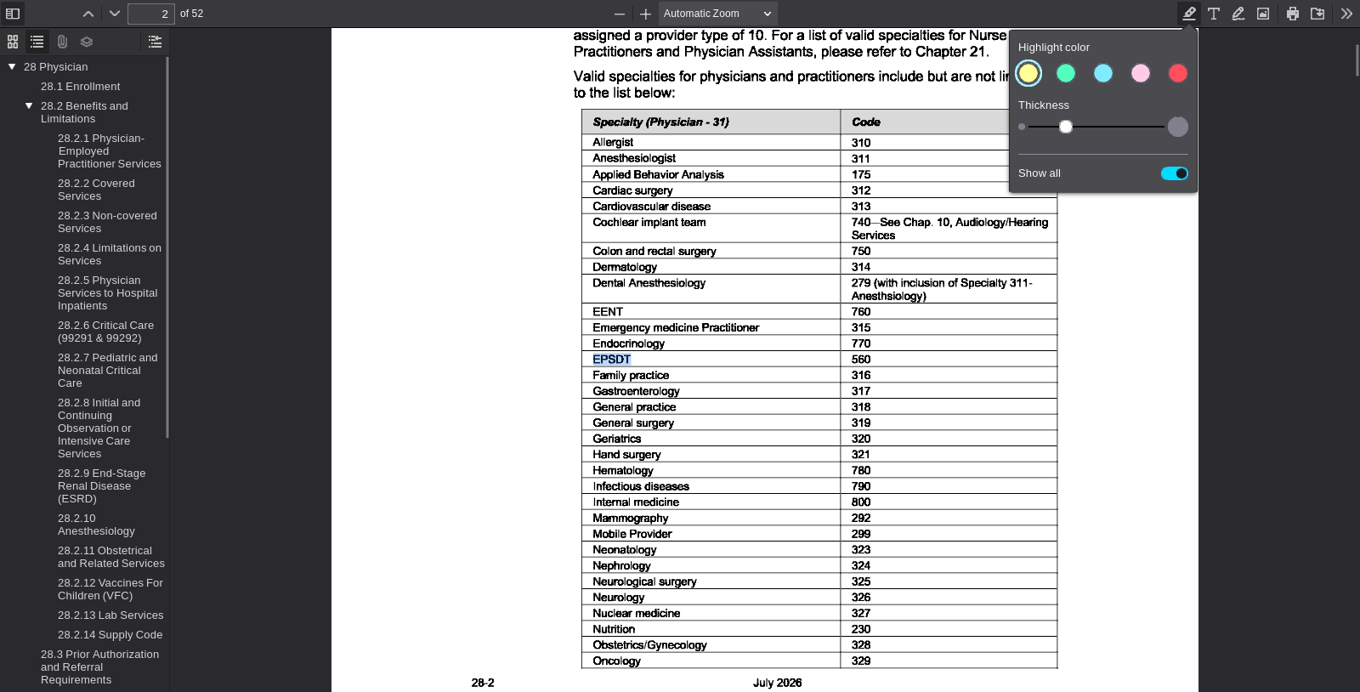
PDF viewer page 2 | Search anchor: EPSDT

SA-029 — Student-Authored Control Record
Independent source-grounded factual lookup item
Field | Completed record
Record ID | SA-029
Question | What specialty code is listed for Family Practice in the physician specialty table?
Expected answer | Family Practice code 316.
Question type | Answerable — source lookup
Exact supporting quote | Family practice 316
Source PDF | Jul26_28.pdf
PDF page | 2
Source URL | https://medicaid.alabama.gov/content/Gated/7.6.1G_Provider_Manuals/7.6.1.3G_July_2026/Jul26_28.pdf
Browser search anchor | Family practice
Source SHA-256 | 5816647d97b5acb0fc6d84fb6ded0f609aa3e7418072d8d93c35b3a442879d04
Snapshot date | 2026-09-14
Authorship | Student-authored final wording supplied by the student.
Training exclusion | Excluded from training data and answer-key generation.
Browser verification | Verified in the PDF viewer; source-search evidence is included below.
Post-freeze factual scoring | To be scored after the control set is locked, alongside the generated evaluation set.
Browser source evidence
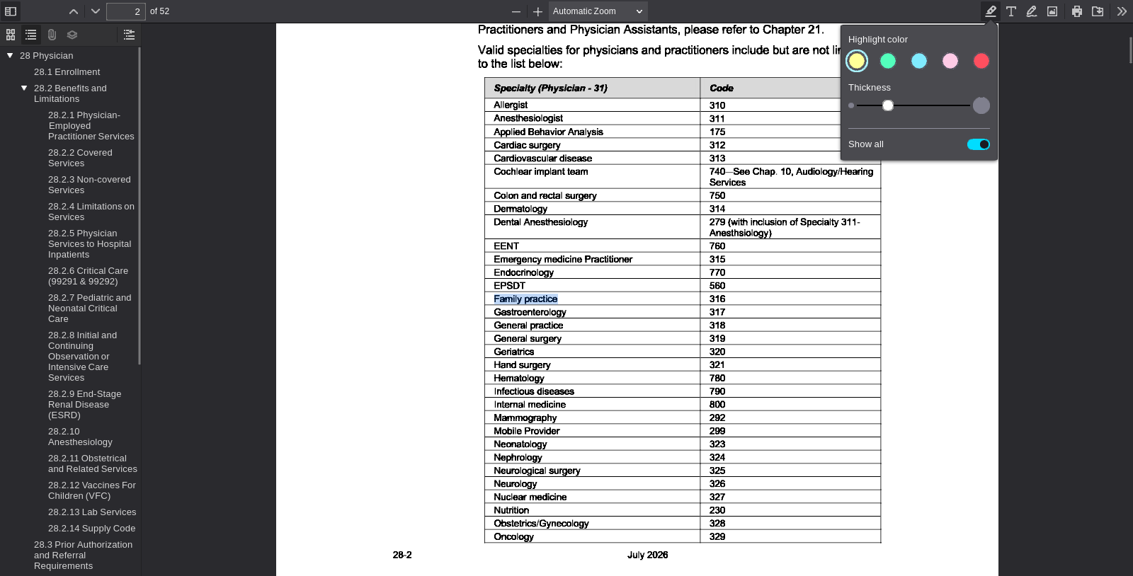
PDF viewer page 2 | Search anchor: Family practice

SA-030 — Student-Authored Control Record
Independent source-grounded factual lookup item
Field | Completed record
Record ID | SA-030
Question | What specialty code is listed for Cardiac Surgery in the physician specialty table?
Expected answer | Cardiac Surgery code 312.
Question type | Answerable — source lookup
Exact supporting quote | Cardiac surgery 312
Source PDF | Jul26_28.pdf
PDF page | 2
Source URL | https://medicaid.alabama.gov/content/Gated/7.6.1G_Provider_Manuals/7.6.1.3G_July_2026/Jul26_28.pdf
Browser search anchor | Cardiac surgery
Source SHA-256 | 5816647d97b5acb0fc6d84fb6ded0f609aa3e7418072d8d93c35b3a442879d04
Snapshot date | 2026-09-14
Authorship | Student-authored final wording supplied by the student.
Training exclusion | Excluded from training data and answer-key generation.
Browser verification | Verified in the PDF viewer; source-search evidence is included below.
Post-freeze factual scoring | To be scored after the control set is locked, alongside the generated evaluation set.
Browser source evidence
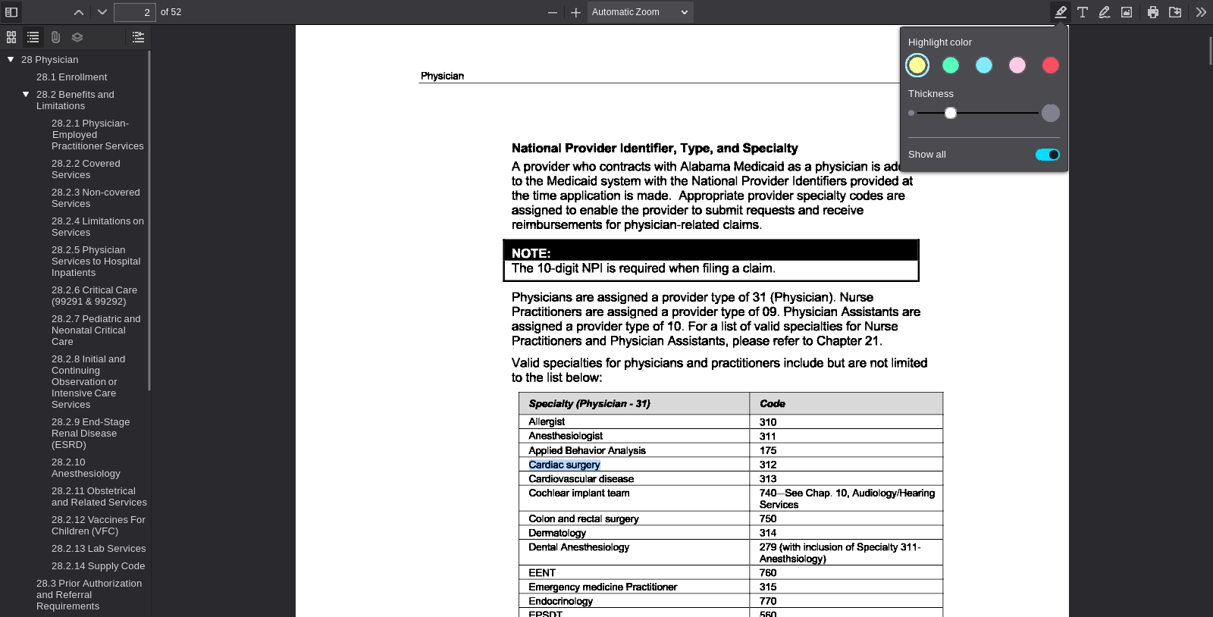
PDF viewer page 2 | Search anchor: Cardiac surgery

