SA-001 — Student-Authored Control Record
Independent source-grounded factual lookup item
Field | Completed record
Record ID | SA-001
Question | What page number in the table of contents lists Rule 560-X-1-.07, Provider Rights and Responsibilities?
Expected answer | Page 3.
Question type | Answerable — source lookup
Exact supporting quote | 560-X-1-.07 Provider Rights and Responsibilities 3
Source PDF | 9.2_Adm_Code_Chap_1_General_3-18-21.pdf
PDF page | 1
Source URL | https://medicaid.alabama.gov/documents/9.0_Resources/9.2_Administrative_Code/9.2_Adm_Code_Chap_1_General_3-18-21.pdf
Browser search anchor | 560-X-1-.07
Source SHA-256 | 1febe8438b5e38699d6ab1f94fda02eccc33cba2e8599b62f9e986b82e4aafc4
Snapshot date | 2026-09-14
Authorship | Student-authored final wording supplied by the student.
Training exclusion | Excluded from training data and answer-key generation.
Browser verification | Verified in the PDF viewer; source-search evidence is included below.
Post-freeze factual scoring | To be scored after the control set is locked, alongside the generated evaluation set.
Browser source evidence
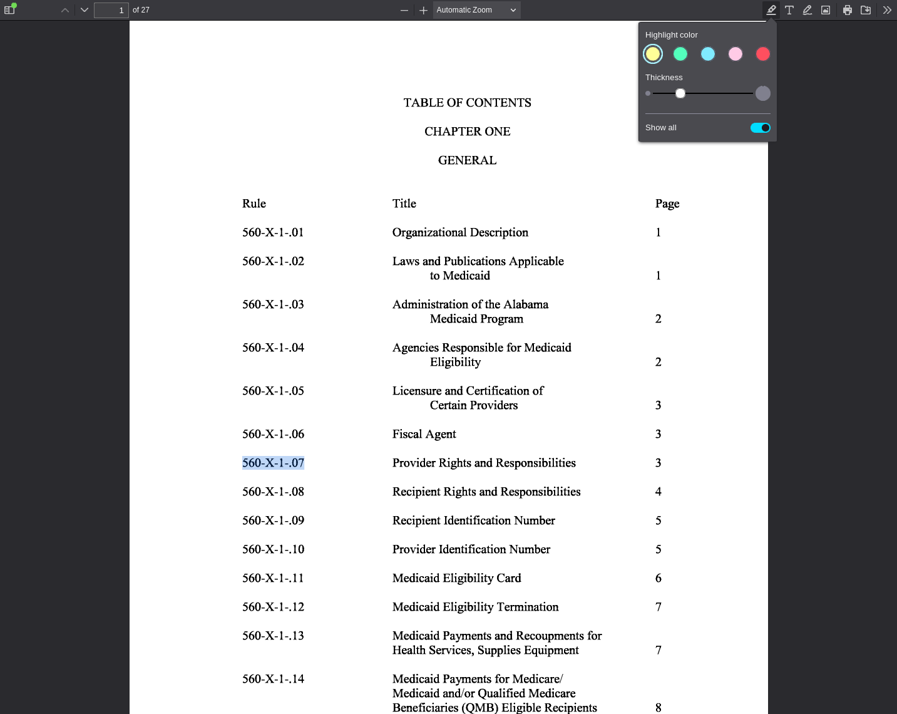
PDF viewer page 1 | Search anchor: 560-X-1-.07

SA-002 — Student-Authored Control Record
Independent source-grounded factual lookup item
Field | Completed record
Record ID | SA-002
Question | What page number in the table of contents lists Rule 560-X-28-.02, Summary of State Law Regarding Advanced Directives?
Expected answer | Page 2.
Question type | Answerable — source lookup
Exact supporting quote | 560-X-28-.02 Summary of State Law Regarding Advanced Directives 2
Source PDF | 9.2_Adm_Code_Chap_28_Alabama_Medicaid_Forms_7-26-18.pdf
PDF page | 1
Source URL | https://medicaid.alabama.gov/documents/9.0_Resources/9.2_Administrative_Code/9.2_Adm_Code_Chap_28_Alabama_Medicaid_Forms_7-26-18.pdf
Browser search anchor | 560-X-28-.02
Source SHA-256 | ef30588f3d8916fc44d2a10ccdedd756cd5108abcd31dbea8dad008881d70985
Snapshot date | 2026-09-14
Authorship | Student-authored final wording supplied by the student.
Training exclusion | Excluded from training data and answer-key generation.
Browser verification | Verified in the PDF viewer; source-search evidence is included below.
Post-freeze factual scoring | To be scored after the control set is locked, alongside the generated evaluation set.
Browser source evidence
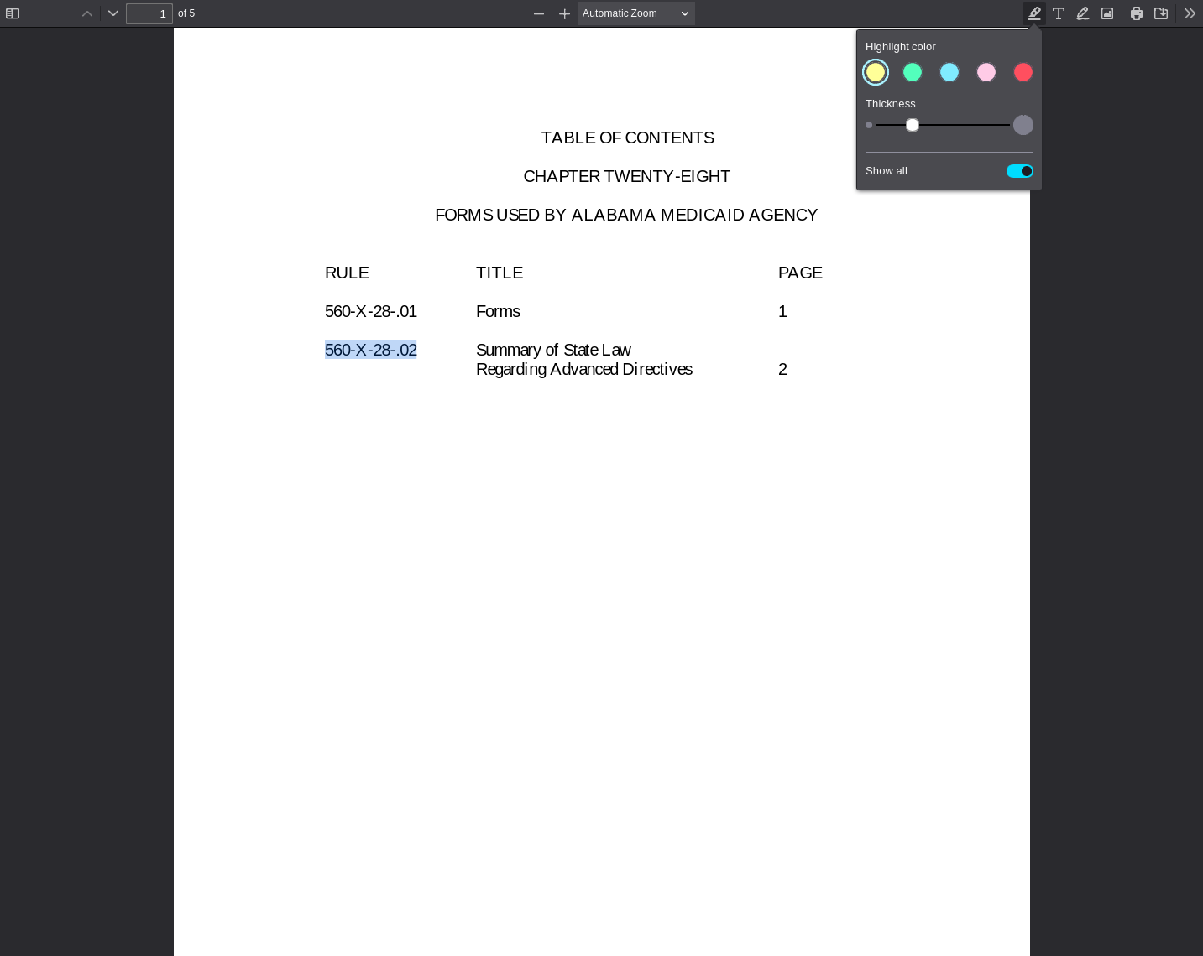
PDF viewer page 1 | Search anchor: 560-X-28-.02

SA-003 — Student-Authored Control Record
Independent source-grounded factual lookup item
Field | Completed record
Record ID | SA-003
Question | What page number in the table of contents lists Rule 560-X-49-.07, Copayment?
Expected answer | Page 2.
Question type | Answerable — source lookup
Exact supporting quote | 560-X-49-.07 Copayment (Cost-sharing) 2
Source PDF | 9.2_Adm_Code_Chap_49_Certified_NP_Program_9-23-19.pdf
PDF page | 1
Source URL | https://medicaid.alabama.gov/documents/9.0_Resources/9.2_Administrative_Code/9.2_Adm_Code_Chap_49_Certified_NP_Program_9-23-19.pdf
Browser search anchor | 560-X-49-.07
Source SHA-256 | 2f7e7e18cf5f882e3c90f8179309947f6d01805df0c8484762d94d1120a7a064
Snapshot date | 2026-09-14
Authorship | Student-authored final wording supplied by the student.
Training exclusion | Excluded from training data and answer-key generation.
Browser verification | Verified in the PDF viewer; source-search evidence is included below.
Post-freeze factual scoring | To be scored after the control set is locked, alongside the generated evaluation set.
Browser source evidence
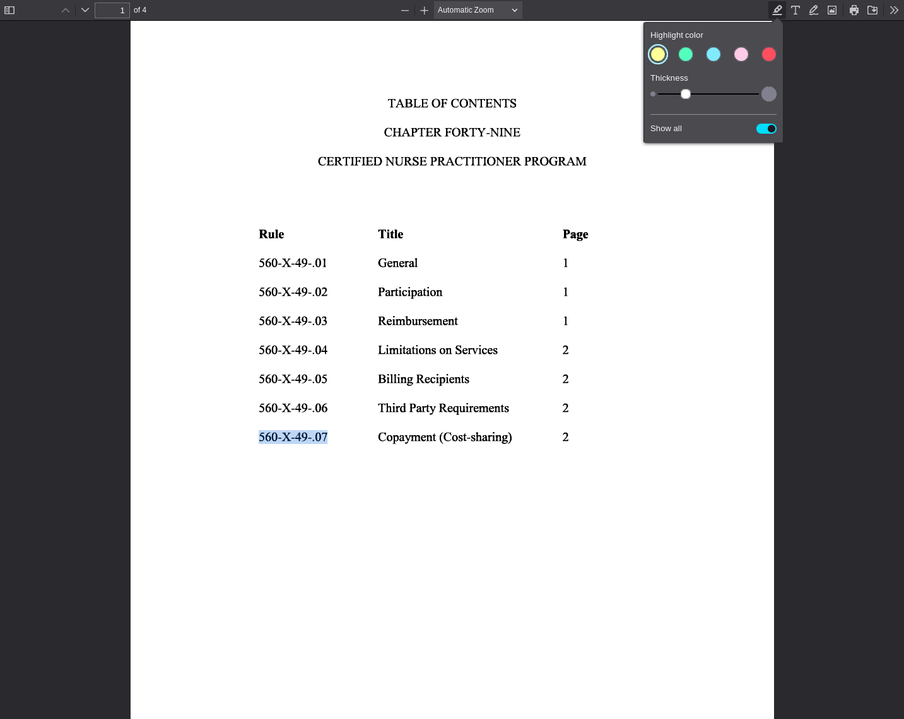
PDF viewer page 1 | Search anchor: 560-X-49-.07

SA-004 — Student-Authored Control Record
Independent source-grounded factual lookup item
Field | Completed record
Record ID | SA-004
Question | What page number in the table of contents lists Rule 560-X-50-.03, Recipient Eligibility?
Expected answer | Page 3.
Question type | Answerable — source lookup
Exact supporting quote | 560-X-50-.03 Recipient Eligibility 3
Source PDF | 9.2_Adm_Code_Chap_50_Preventive_Health_Ed_Program.pdf
PDF page | 1
Source URL | https://medicaid.alabama.gov/documents/9.0_Resources/9.2_Administrative_Code/9.2_Adm_Code_Chap_50_Preventive_Health_Ed_Program.pdf
Browser search anchor | 560-X-50-.03
Source SHA-256 | e8545bbf634daee6536fe96fe20ba914512ec4e05d14e7345f39e8ab6b355899
Snapshot date | 2026-09-14
Authorship | Student-authored final wording supplied by the student.
Training exclusion | Excluded from training data and answer-key generation.
Browser verification | Verified in the PDF viewer; source-search evidence is included below.
Post-freeze factual scoring | To be scored after the control set is locked, alongside the generated evaluation set.
Browser source evidence
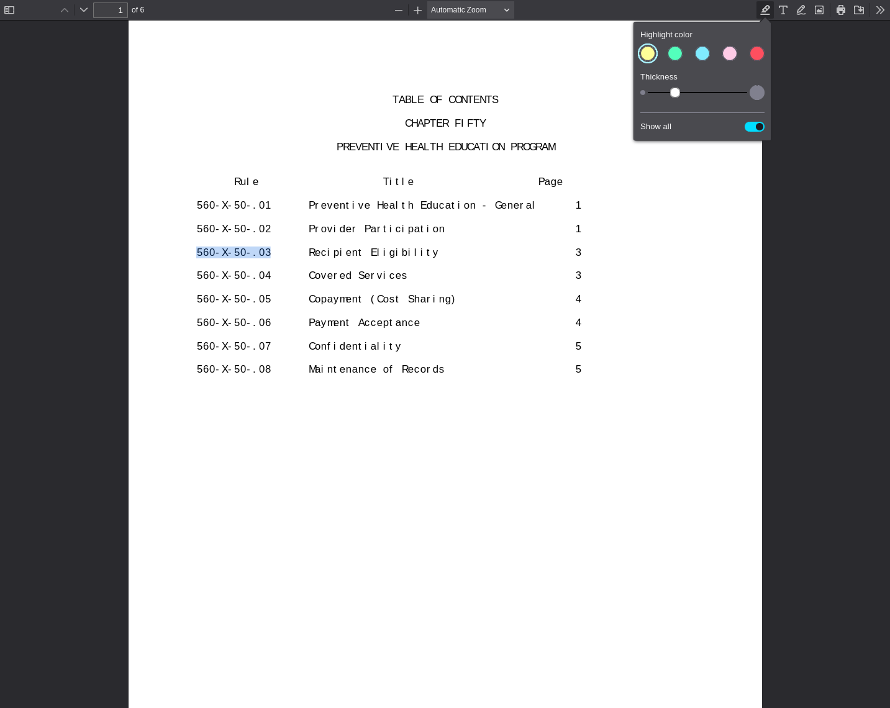
PDF viewer page 1 | Search anchor: 560-X-50-.03

SA-005 — Student-Authored Control Record
Independent source-grounded factual lookup item
Field | Completed record
Record ID | SA-005
Question | What Medicaid provider type is assigned to Licensed Social Workers?
Expected answer | Provider type 11, Crossovers Only.
Question type | Answerable — source lookup
Exact supporting quote | Licensed Social Workers are assigned a provider type of 11 (Crossovers Only).
Source PDF | Apr26_23.pdf
PDF page | 1
Source URL | https://medicaid.alabama.gov/content/Gated/7.6.1G_Provider_Manuals/7.6.1.2G_Apr_2026/Apr26_23.pdf
Browser search anchor | Licensed Social Workers are assigned
Source SHA-256 | 6c6a8cda335c0758f3cec8f72c2ba1911c6912674348eb40bba5bdf4926baa78
Snapshot date | 2026-09-14
Authorship | Student-authored final wording supplied by the student.
Training exclusion | Excluded from training data and answer-key generation.
Browser verification | Verified in the PDF viewer; source-search evidence is included below.
Post-freeze factual scoring | To be scored after the control set is locked, alongside the generated evaluation set.
Browser source evidence
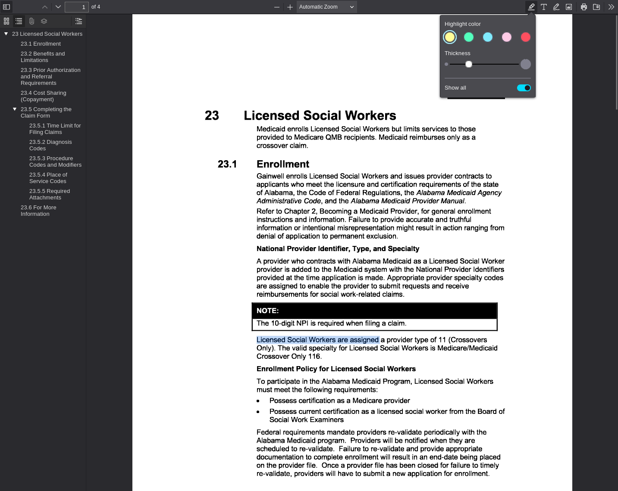
PDF viewer page 1 | Search anchor: Licensed Social Workers are assigned

SA-006 — Student-Authored Control Record
Independent source-grounded factual lookup item
Field | Completed record
Record ID | SA-006
Question | What provider type is assigned to therapy providers?
Expected answer | Provider type 17, Therapy.
Question type | Answerable — source lookup
Exact supporting quote | Therapy providers are assigned a provider type of 17 (Therapy).
Source PDF | Apr26_37.pdf
PDF page | 2
Source URL | https://medicaid.alabama.gov/content/Gated/7.6.1G_Provider_Manuals/7.6.1.2G_Apr_2026/Apr26_37.pdf
Browser search anchor | provider type of 17
Source SHA-256 | 7dda7fb89e4a91948f14446db97cc59dd65dae17d2f1f322acca2d6eaabb9145
Snapshot date | 2026-09-14
Authorship | Student-authored final wording supplied by the student.
Training exclusion | Excluded from training data and answer-key generation.
Browser verification | Verified in the PDF viewer; source-search evidence is included below.
Post-freeze factual scoring | To be scored after the control set is locked, alongside the generated evaluation set.
Browser source evidence
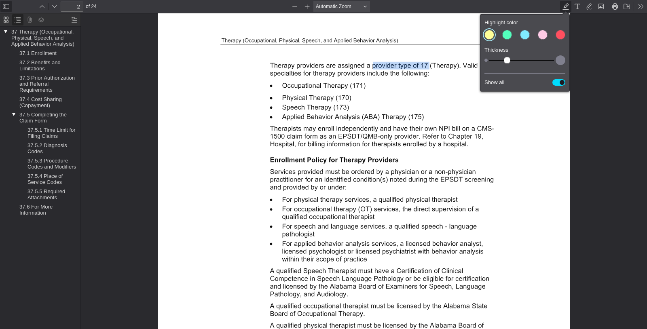
PDF viewer page 2 | Search anchor: provider type of 17

SA-007 — Student-Authored Control Record
Independent source-grounded factual lookup item
Field | Completed record
Record ID | SA-007
Question | What provider type is assigned to Remote Patient Monitoring providers?
Expected answer | Provider type 08, Remote Patient Monitoring.
Question type | Answerable — source lookup
Exact supporting quote | Remote Patient Monitoring providers are assigned a provider type of 08 (Remote Patient Monitoring) and provider specialty 085 or 086.
Source PDF | Jul26_111.pdf
PDF page | 1
Source URL | https://medicaid.alabama.gov/content/Gated/7.6.1G_Provider_Manuals/7.6.1.3G_July_2026/Jul26_111.pdf
Browser search anchor | Remote Patient Monitoring providers are assigned
Source SHA-256 | 950bc66ef512fc94ba54df0951c2593a3dbf85fa97473b22a6558705d9af23fd
Snapshot date | 2026-09-14
Authorship | Student-authored final wording supplied by the student.
Training exclusion | Excluded from training data and answer-key generation.
Browser verification | Verified in the PDF viewer; source-search evidence is included below.
Post-freeze factual scoring | To be scored after the control set is locked, alongside the generated evaluation set.
Browser source evidence
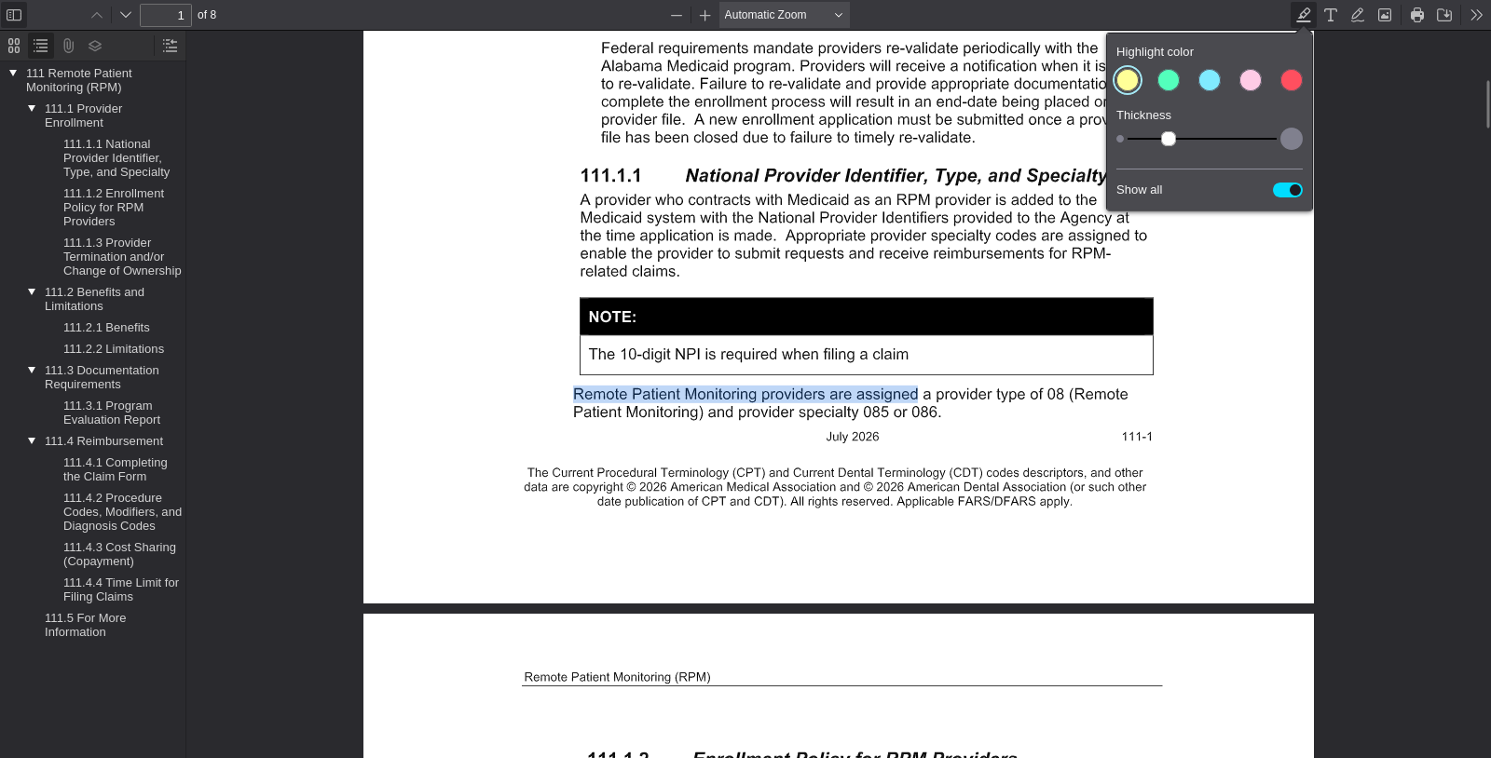
PDF viewer page 1 | Search anchor: Remote Patient Monitoring providers are assigned

SA-008 — Student-Authored Control Record
Independent source-grounded factual lookup item
Field | Completed record
Record ID | SA-008
Question | What provider type is assigned to physicians?
Expected answer | Provider type 31, Physician.
Question type | Answerable — source lookup
Exact supporting quote | Physicians are assigned a provider type of 31 (Physician).
Source PDF | Jul26_28.pdf
PDF page | 2
Source URL | https://medicaid.alabama.gov/content/Gated/7.6.1G_Provider_Manuals/7.6.1.3G_July_2026/Jul26_28.pdf
Browser search anchor | Physicians are assigned
Source SHA-256 | 5816647d97b5acb0fc6d84fb6ded0f609aa3e7418072d8d93c35b3a442879d04
Snapshot date | 2026-09-14
Authorship | Student-authored final wording supplied by the student.
Training exclusion | Excluded from training data and answer-key generation.
Browser verification | Verified in the PDF viewer; source-search evidence is included below.
Post-freeze factual scoring | To be scored after the control set is locked, alongside the generated evaluation set.
Browser source evidence
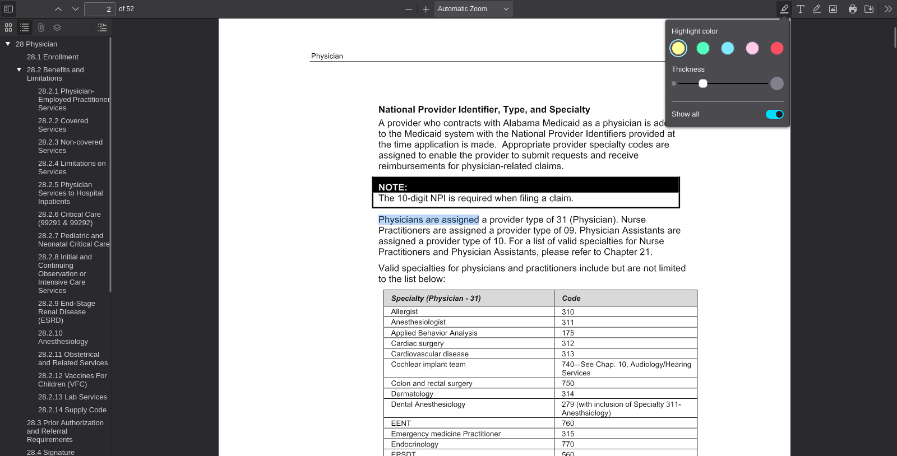
PDF viewer page 2 | Search anchor: Physicians are assigned

SA-009 — Student-Authored Control Record
Independent source-grounded factual lookup item
Field | Completed record
Record ID | SA-009
Question | What provider type is assigned to preventive health education providers?
Expected answer | Provider type 55.
Question type | Answerable — source lookup
Exact supporting quote | Preventive health education providers are assigned a provider type of 55 (Private Prenatal Education).
Source PDF | Jul26_30.pdf
PDF page | 1
Source URL | https://medicaid.alabama.gov/content/Gated/7.6.1G_Provider_Manuals/7.6.1.3G_July_2026/Jul26_30.pdf
Browser search anchor | Preventive health education providers are assigned
Source SHA-256 | eb21fa6f0eabfb878cdc053a14730b96bf8b3763ed00c2336c9f4795f56f295e
Snapshot date | 2026-09-14
Authorship | Student-authored final wording supplied by the student.
Training exclusion | Excluded from training data and answer-key generation.
Browser verification | Verified in the PDF viewer; source-search evidence is included below.
Post-freeze factual scoring | To be scored after the control set is locked, alongside the generated evaluation set.
Browser source evidence
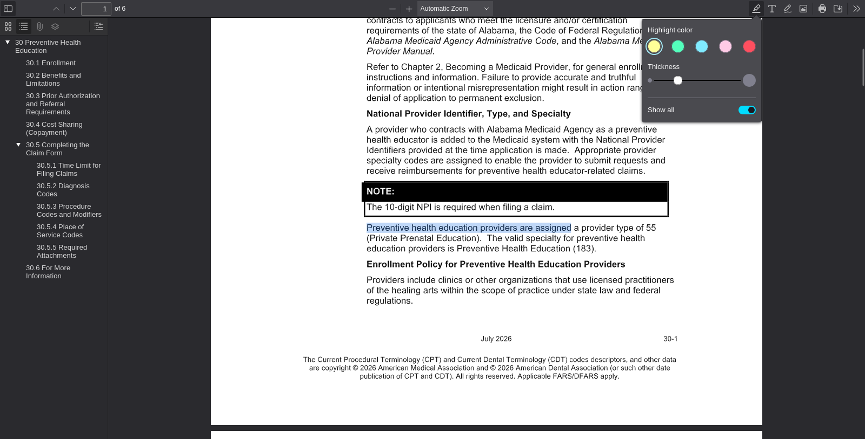
PDF viewer page 1 | Search anchor: Preventive health education providers are assigned

SA-010 — Student-Authored Control Record
Independent source-grounded factual lookup item
Field | Completed record
Record ID | SA-010
Question | What provider type is assigned to psychology providers?
Expected answer | Provider type 54, Psychologist.
Question type | Answerable — source lookup
Exact supporting quote | Psychology providers are assigned a provider type of 54 (Psychologist).
Source PDF | Jul26_34.pdf
PDF page | 2
Source URL | https://medicaid.alabama.gov/content/Gated/7.6.1G_Provider_Manuals/7.6.1.3G_July_2026/Jul26_34.pdf
Browser search anchor | Psychology providers are assigned
Source SHA-256 | 5d1a8052d80742b29fa8ba93ec2db5ff427507a8fed00488d2b99ce9488b56cf
Snapshot date | 2026-09-14
Authorship | Student-authored final wording supplied by the student.
Training exclusion | Excluded from training data and answer-key generation.
Browser verification | Verified in the PDF viewer; source-search evidence is included below.
Post-freeze factual scoring | To be scored after the control set is locked, alongside the generated evaluation set.
Browser source evidence
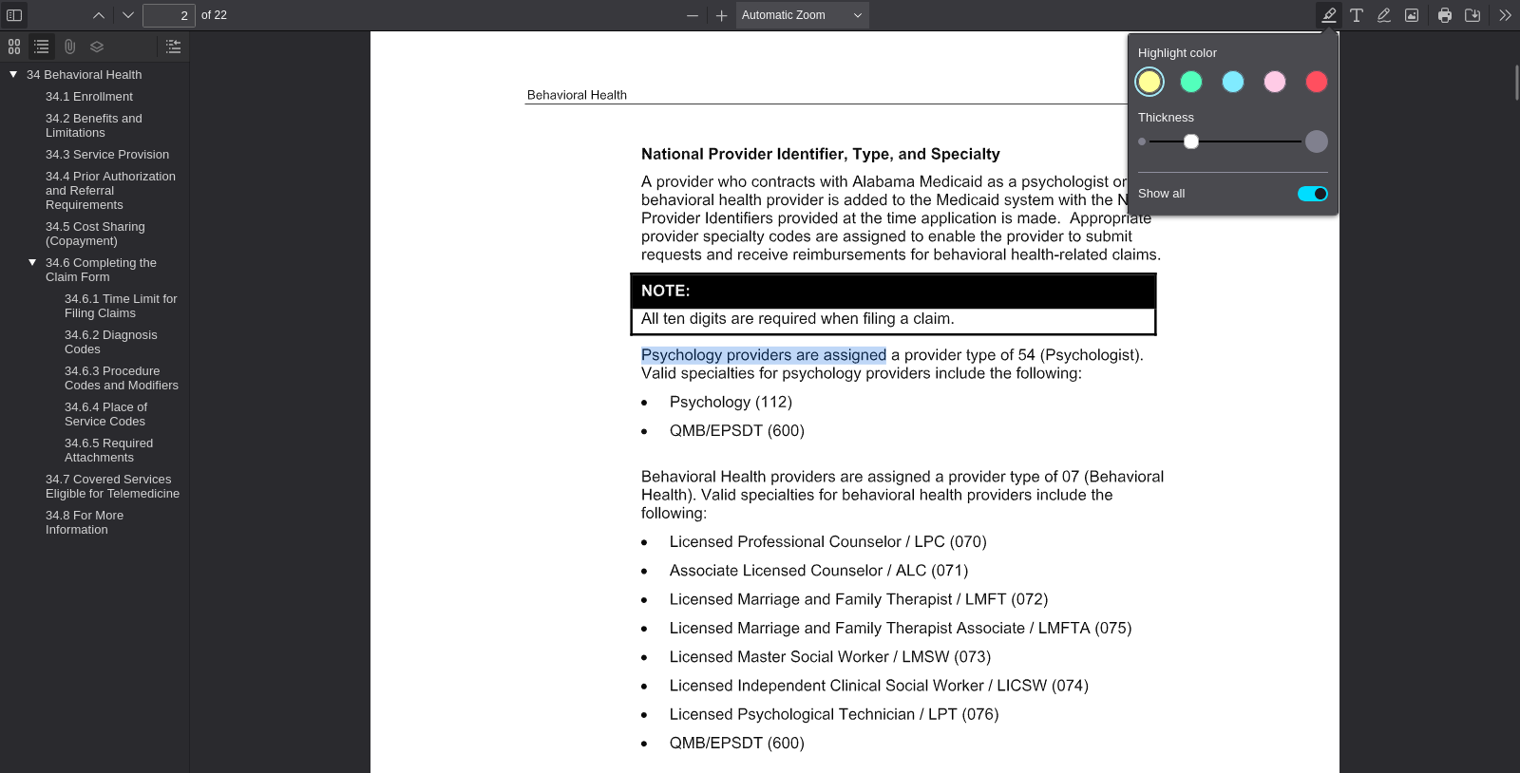
PDF viewer page 2 | Search anchor: Psychology providers are assigned

SA-011 — Student-Authored Control Record
Independent source-grounded factual lookup item
Field | Completed record
Record ID | SA-011
Question | What provider type is assigned to Behavioral Health providers?
Expected answer | Provider type 07, Behavioral Health.
Question type | Answerable — source lookup
Exact supporting quote | Behavioral Health providers are assigned a provider type of 07 (Behavioral Health).
Source PDF | Jul26_34.pdf
PDF page | 2
Source URL | https://medicaid.alabama.gov/content/Gated/7.6.1G_Provider_Manuals/7.6.1.3G_July_2026/Jul26_34.pdf
Browser search anchor | provider type of 07
Source SHA-256 | 5d1a8052d80742b29fa8ba93ec2db5ff427507a8fed00488d2b99ce9488b56cf
Snapshot date | 2026-09-14
Authorship | Student-authored final wording supplied by the student.
Training exclusion | Excluded from training data and answer-key generation.
Browser verification | Verified in the PDF viewer; source-search evidence is included below.
Post-freeze factual scoring | To be scored after the control set is locked, alongside the generated evaluation set.
Browser source evidence
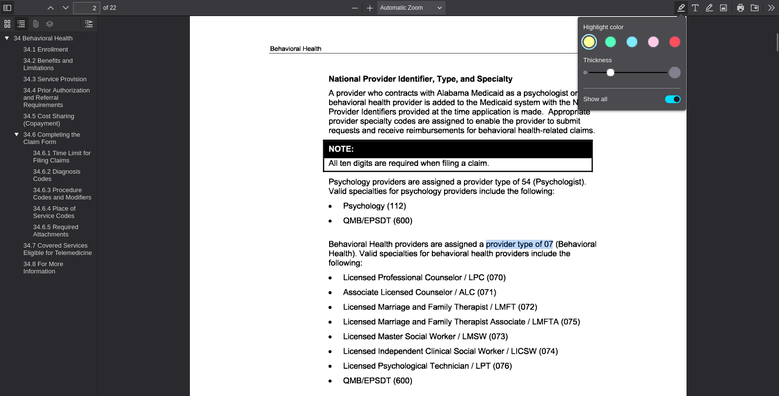
PDF viewer page 2 | Search anchor: provider type of 07

SA-012 — Student-Authored Control Record
Independent source-grounded factual lookup item
Field | Completed record
Record ID | SA-012
Question | What specialty code is listed for Psychology providers?
Expected answer | Psychology specialty code 112.
Question type | Answerable — source lookup
Exact supporting quote | Psychology (112)
Source PDF | Jul26_34.pdf
PDF page | 2
Source URL | https://medicaid.alabama.gov/content/Gated/7.6.1G_Provider_Manuals/7.6.1.3G_July_2026/Jul26_34.pdf
Browser search anchor | Psychology (112)
Source SHA-256 | 5d1a8052d80742b29fa8ba93ec2db5ff427507a8fed00488d2b99ce9488b56cf
Snapshot date | 2026-09-14
Authorship | Student-authored final wording supplied by the student.
Training exclusion | Excluded from training data and answer-key generation.
Browser verification | Verified in the PDF viewer; source-search evidence is included below.
Post-freeze factual scoring | To be scored after the control set is locked, alongside the generated evaluation set.
Browser source evidence
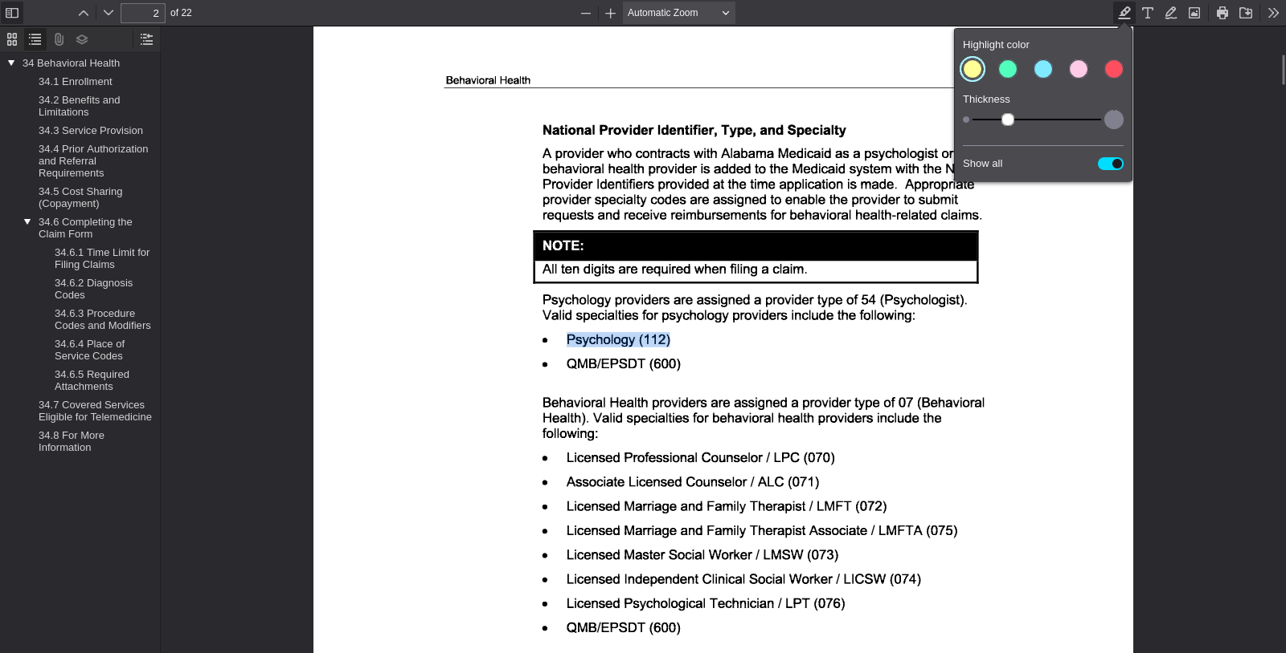
PDF viewer page 2 | Search anchor: Psychology (112)

SA-013 — Student-Authored Control Record
Independent source-grounded factual lookup item
Field | Completed record
Record ID | SA-013
Question | What specialty code is listed for a Licensed Professional Counselor / LPC?
Expected answer | Specialty code 070
Question type | Answerable — source lookup
Exact supporting quote | Licensed Professional Counselor / LPC (070)
Source PDF | Jul26_34.pdf
PDF page | 2
Source URL | https://medicaid.alabama.gov/content/Gated/7.6.1G_Provider_Manuals/7.6.1.3G_July_2026/Jul26_34.pdf
Browser search anchor | Licensed Professional Counselor / LPC (070)
Source SHA-256 | 5d1a8052d80742b29fa8ba93ec2db5ff427507a8fed00488d2b99ce9488b56cf
Snapshot date | 2026-09-14
Authorship | Student-authored final wording supplied by the student.
Training exclusion | Excluded from training data and answer-key generation.
Browser verification | Verified in the PDF viewer; source-search evidence is included below.
Post-freeze factual scoring | To be scored after the control set is locked, alongside the generated evaluation set.
Browser source evidence
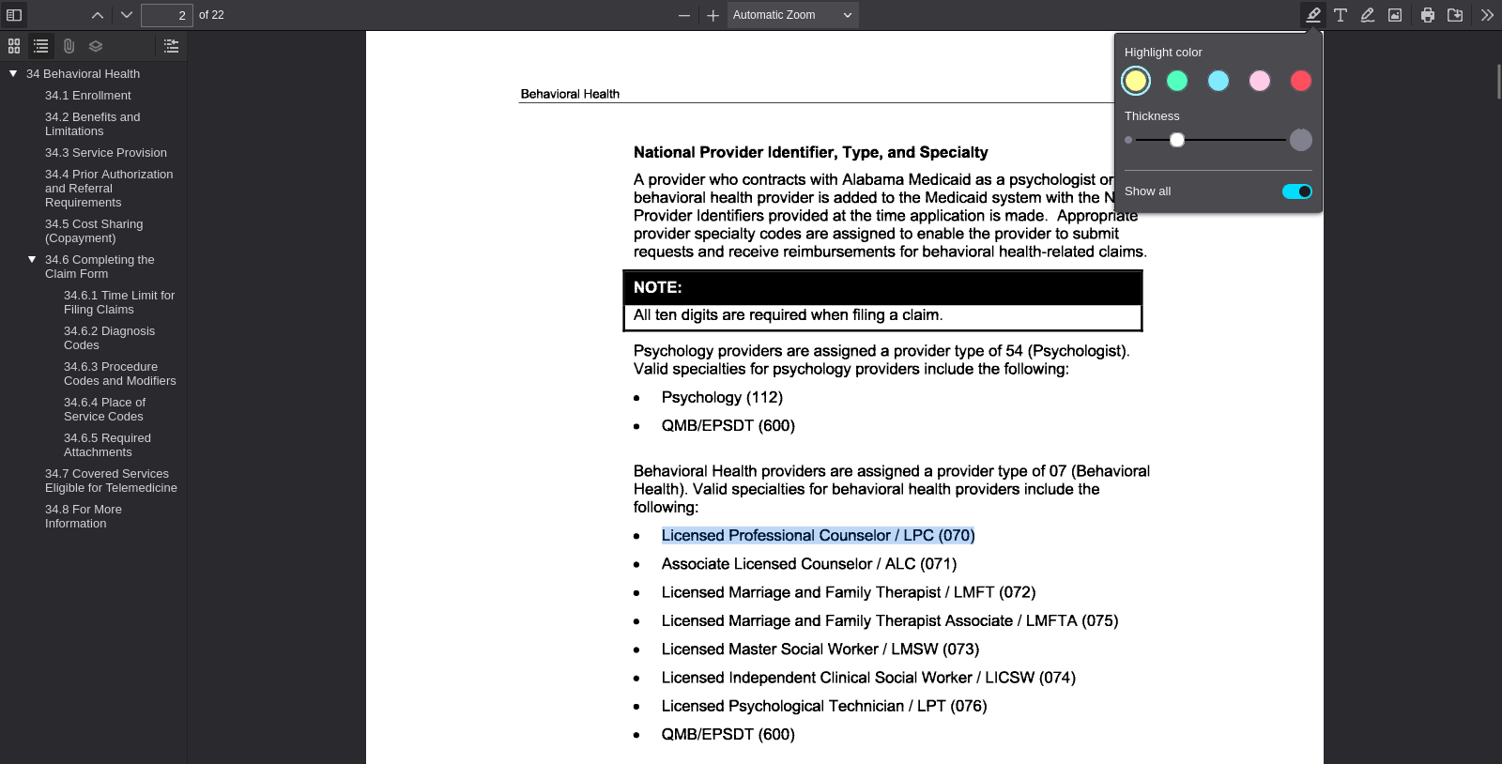
PDF viewer page 2 | Search anchor: Licensed Professional Counselor / LPC (070)

SA-014 — Student-Authored Control Record
Independent source-grounded factual lookup item
Field | Completed record
Record ID | SA-014
Question | What provider type is assigned to Nurse Practitioners?
Expected answer | Provider type 09.
Question type | Answerable — source lookup
Exact supporting quote | Nurse Practitioners are assigned a provider type of 09.
Source PDF | Jul26_28.pdf
PDF page | 2
Source URL | https://medicaid.alabama.gov/content/Gated/7.6.1G_Provider_Manuals/7.6.1.3G_July_2026/Jul26_28.pdf
Browser search anchor | provider type of 09
Source SHA-256 | 5816647d97b5acb0fc6d84fb6ded0f609aa3e7418072d8d93c35b3a442879d04
Snapshot date | 2026-09-14
Authorship | Student-authored final wording supplied by the student.
Training exclusion | Excluded from training data and answer-key generation.
Browser verification | Verified in the PDF viewer; source-search evidence is included below.
Post-freeze factual scoring | To be scored after the control set is locked, alongside the generated evaluation set.
Browser source evidence
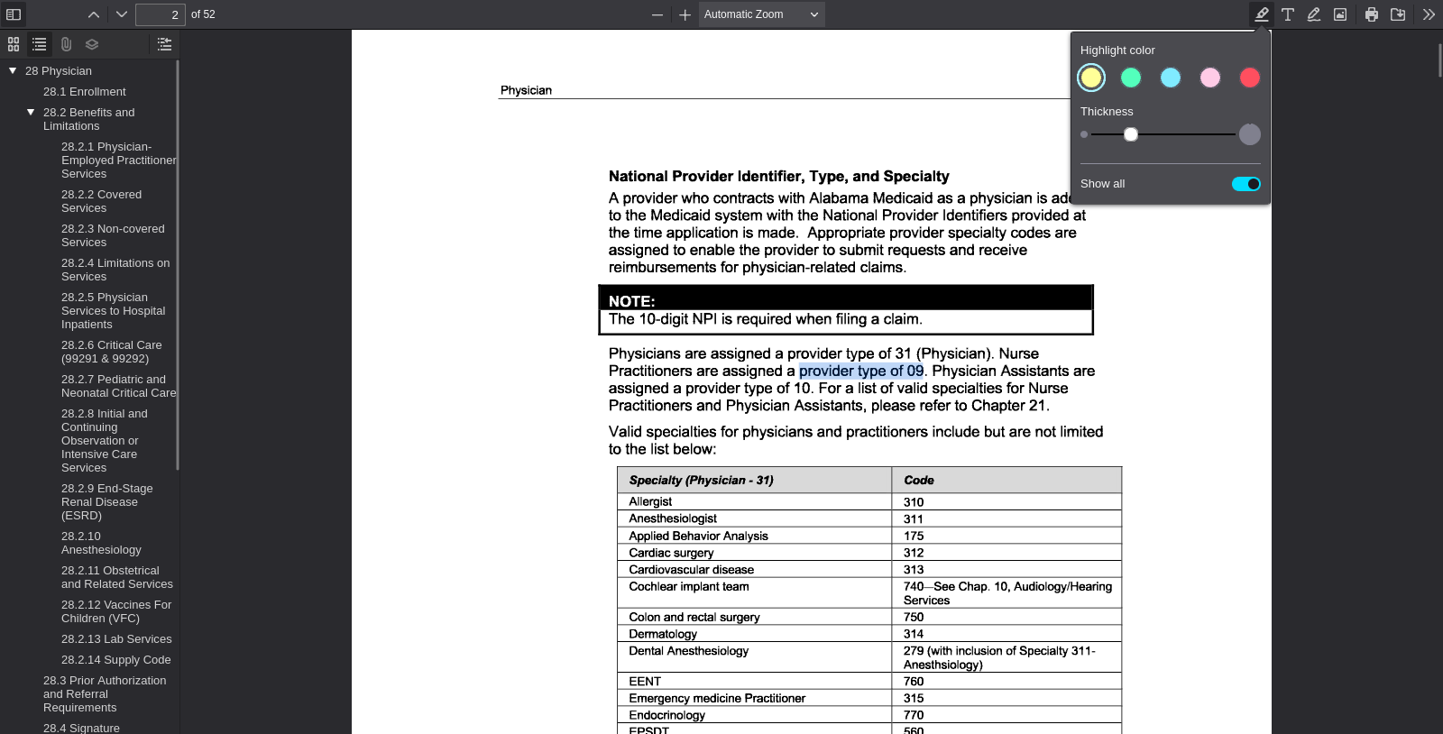
PDF viewer page 2 | Search anchor: provider type of 09

SA-015 — Student-Authored Control Record
Independent source-grounded factual lookup item
Field | Completed record
Record ID | SA-015
Question | What provider type is assigned to Physician Assistants?
Expected answer | Provider type 10.
Question type | Answerable — source lookup
Exact supporting quote | Physician Assistants are assigned a provider type of 10.
Source PDF | Jul26_28.pdf
PDF page | 2
Source URL | https://medicaid.alabama.gov/content/Gated/7.6.1G_Provider_Manuals/7.6.1.3G_July_2026/Jul26_28.pdf
Browser search anchor | provider type of 10
Source SHA-256 | 5816647d97b5acb0fc6d84fb6ded0f609aa3e7418072d8d93c35b3a442879d04
Snapshot date | 2026-09-14
Authorship | Student-authored final wording supplied by the student.
Training exclusion | Excluded from training data and answer-key generation.
Browser verification | Verified in the PDF viewer; source-search evidence is included below.
Post-freeze factual scoring | To be scored after the control set is locked, alongside the generated evaluation set.
Browser source evidence
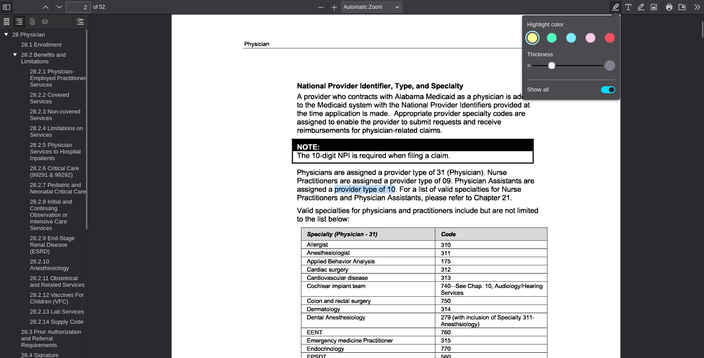
PDF viewer page 2 | Search anchor: provider type of 10

SA-016 — Student-Authored Control Record
Independent source-grounded factual lookup item
Field | Completed record
Record ID | SA-016
Question | What specialty code is listed for Occupational Therapy?
Expected answer | Occupational Therapy code 171.
Question type | Answerable — source lookup
Exact supporting quote | Occupational Therapy (171)
Source PDF | Apr26_37.pdf
PDF page | 2
Source URL | https://medicaid.alabama.gov/content/Gated/7.6.1G_Provider_Manuals/7.6.1.2G_Apr_2026/Apr26_37.pdf
Browser search anchor | Occupational Therapy (171)
Source SHA-256 | 7dda7fb89e4a91948f14446db97cc59dd65dae17d2f1f322acca2d6eaabb9145
Snapshot date | 2026-09-14
Authorship | Student-authored final wording supplied by the student.
Training exclusion | Excluded from training data and answer-key generation.
Browser verification | Verified in the PDF viewer; source-search evidence is included below.
Post-freeze factual scoring | To be scored after the control set is locked, alongside the generated evaluation set.
Browser source evidence
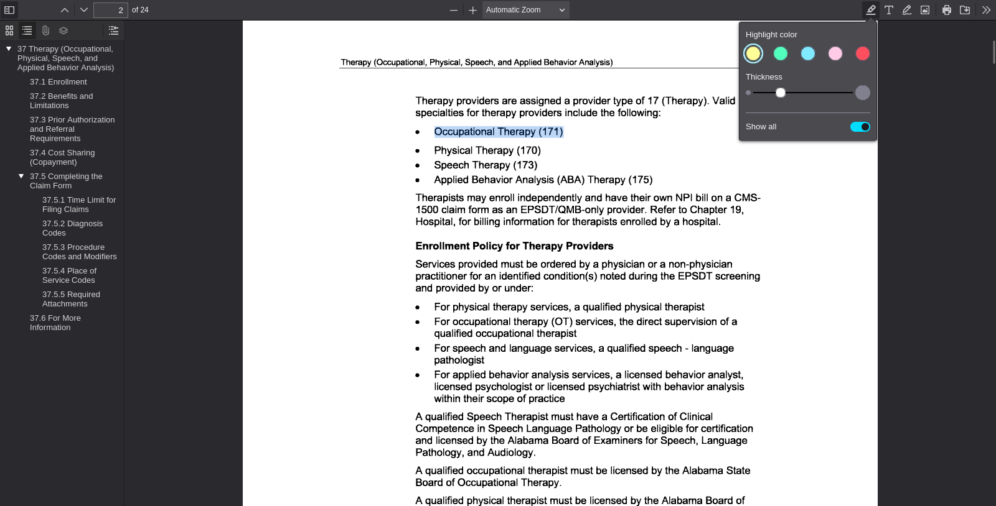
PDF viewer page 2 | Search anchor: Occupational Therapy (171)

SA-017 — Student-Authored Control Record
Independent source-grounded factual lookup item
Field | Completed record
Record ID | SA-017
Question | What specialty code is listed for Physical Therapy?
Expected answer | Physical Therapy code 170.
Question type | Answerable — source lookup
Exact supporting quote | Physical Therapy (170)
Source PDF | Apr26_37.pdf
PDF page | 2
Source URL | https://medicaid.alabama.gov/content/Gated/7.6.1G_Provider_Manuals/7.6.1.2G_Apr_2026/Apr26_37.pdf
Browser search anchor | Physical Therapy (170)
Source SHA-256 | 7dda7fb89e4a91948f14446db97cc59dd65dae17d2f1f322acca2d6eaabb9145
Snapshot date | 2026-09-14
Authorship | Student-authored final wording supplied by the student.
Training exclusion | Excluded from training data and answer-key generation.
Browser verification | Verified in the PDF viewer; source-search evidence is included below.
Post-freeze factual scoring | To be scored after the control set is locked, alongside the generated evaluation set.
Browser source evidence
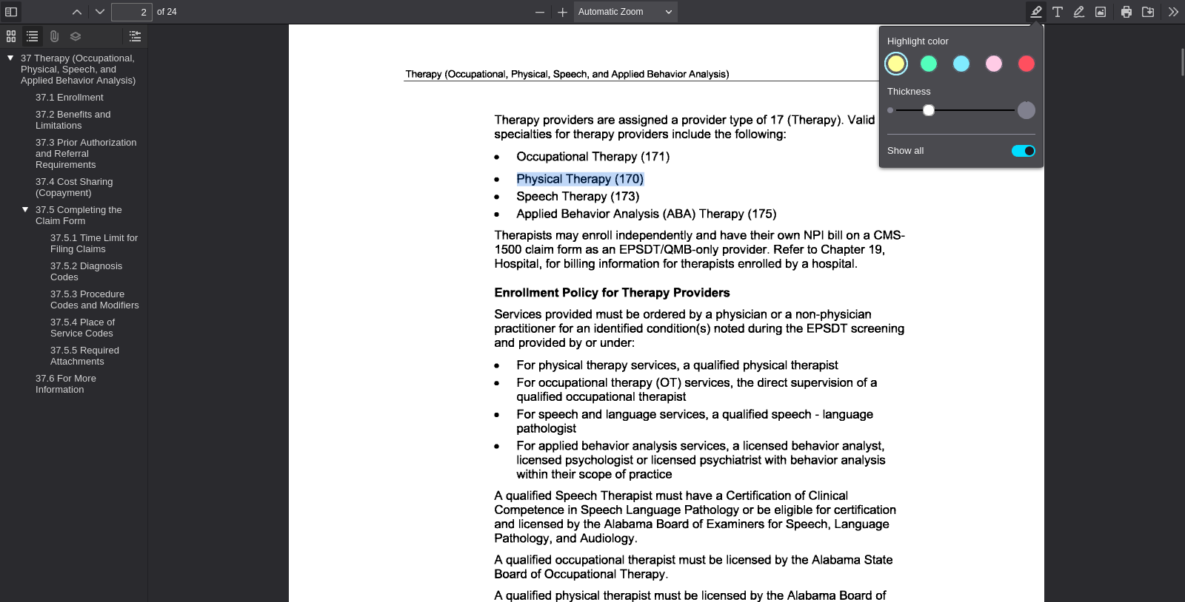
PDF viewer page 2 | Search anchor: Physical Therapy (170)

SA-018 — Student-Authored Control Record
Independent source-grounded factual lookup item
Field | Completed record
Record ID | SA-018
Question | What specialty code is listed for Speech Therapy?
Expected answer | Speech Therapy code 173.
Question type | Answerable — source lookup
Exact supporting quote | Speech Therapy (173)
Source PDF | Apr26_37.pdf
PDF page | 2
Source URL | https://medicaid.alabama.gov/content/Gated/7.6.1G_Provider_Manuals/7.6.1.2G_Apr_2026/Apr26_37.pdf
Browser search anchor | Speech Therapy (173)
Source SHA-256 | 7dda7fb89e4a91948f14446db97cc59dd65dae17d2f1f322acca2d6eaabb9145
Snapshot date | 2026-09-14
Authorship | Student-authored final wording supplied by the student.
Training exclusion | Excluded from training data and answer-key generation.
Browser verification | Verified in the PDF viewer; source-search evidence is included below.
Post-freeze factual scoring | To be scored after the control set is locked, alongside the generated evaluation set.
Browser source evidence
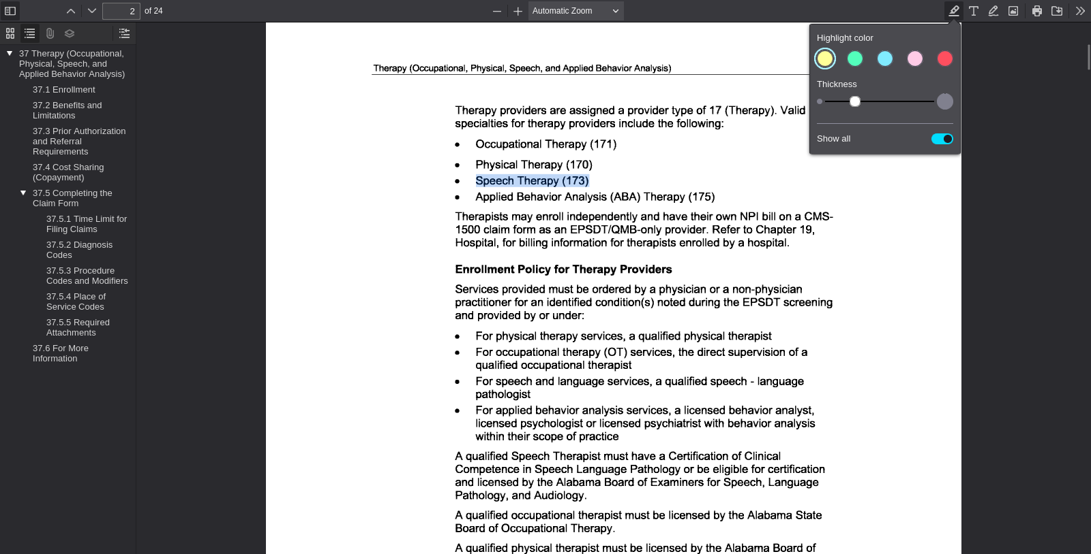
PDF viewer page 2 | Search anchor: Speech Therapy (173)

SA-019 — Student-Authored Control Record
Independent source-grounded factual lookup item
Field | Completed record
Record ID | SA-019
Question | What specialty code is listed for Applied Behavior Analysis Therapy.
Expected answer | Applied Behavior Analysis (ABA) Therapy. Code 175.
Question type | Answerable — source lookup
Exact supporting quote | Applied Behavior Analysis (ABA) Therapy (175)
Source PDF | Apr26_37.pdf
PDF page | 2
Source URL | https://medicaid.alabama.gov/content/Gated/7.6.1G_Provider_Manuals/7.6.1.2G_Apr_2026/Apr26_37.pdf
Browser search anchor | Applied Behavior Analysis (ABA) Therapy (175)
Source SHA-256 | 7dda7fb89e4a91948f14446db97cc59dd65dae17d2f1f322acca2d6eaabb9145
Snapshot date | 2026-09-14
Authorship | Student-authored final wording supplied by the student.
Training exclusion | Excluded from training data and answer-key generation.
Browser verification | Verified in the PDF viewer; source-search evidence is included below.
Post-freeze factual scoring | To be scored after the control set is locked, alongside the generated evaluation set.
Browser source evidence
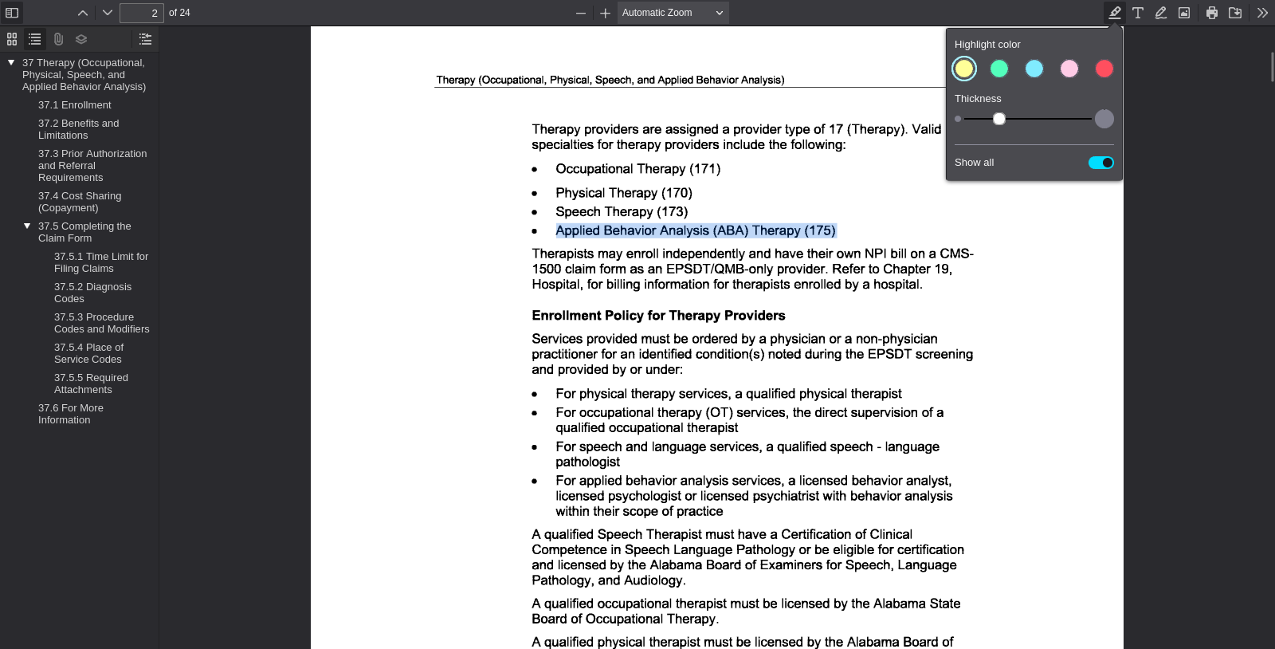
PDF viewer page 2 | Search anchor: Applied Behavior Analysis (ABA) Therapy (175)

SA-020 — Student-Authored Control Record
Independent source-grounded factual lookup item
Field | Completed record
Record ID | SA-020
Question | What provider specialties are assigned to Remote Patient Monitoring providers?
Expected answer | Provider specialties 085 or 086.
Question type | Answerable — source lookup
Exact supporting quote | Remote Patient Monitoring providers are assigned a provider type of 08 (Remote Patient Monitoring) and provider specialty 085 or 086.
Source PDF | Jul26_111.pdf
PDF page | 1
Source URL | https://medicaid.alabama.gov/content/Gated/7.6.1G_Provider_Manuals/7.6.1.3G_July_2026/Jul26_111.pdf
Browser search anchor | provider specialty 085 or 086
Source SHA-256 | 950bc66ef512fc94ba54df0951c2593a3dbf85fa97473b22a6558705d9af23fd
Snapshot date | 2026-09-14
Authorship | Student-authored final wording supplied by the student.
Training exclusion | Excluded from training data and answer-key generation.
Browser verification | Verified in the PDF viewer; source-search evidence is included below.
Post-freeze factual scoring | To be scored after the control set is locked, alongside the generated evaluation set.
Browser source evidence
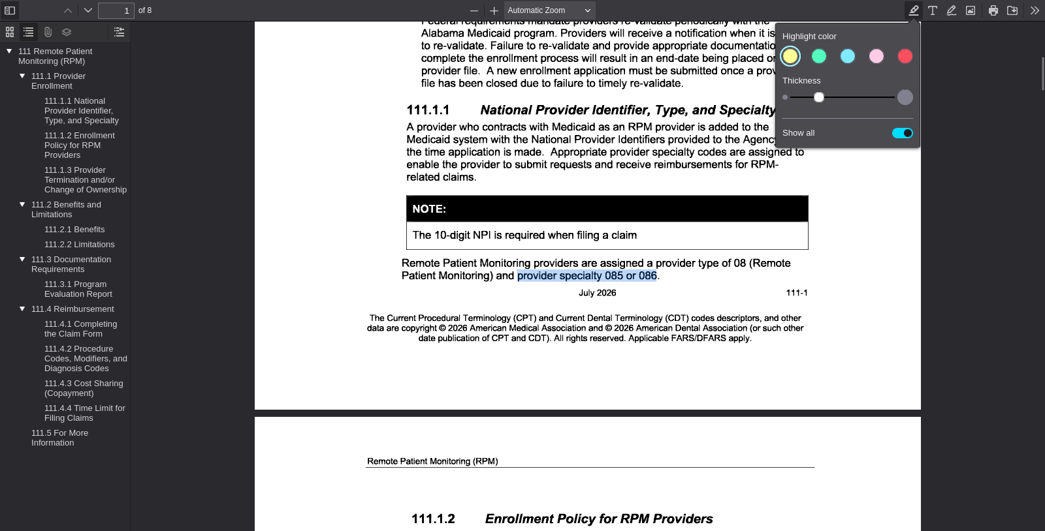
PDF viewer page 1 | Search anchor: provider specialty 085 or 086

SA-021 — Student-Authored Control Record
Independent source-grounded factual lookup item
Field | Completed record
Record ID | SA-021
Question | What specialty code is listed for an Associate Licensed Counselor / ALC?
Expected answer | Specialty code 071.
Question type | Answerable — source lookup
Exact supporting quote | Associate Licensed Counselor / ALC (071)
Source PDF | Jul26_34.pdf
PDF page | 2
Source URL | https://medicaid.alabama.gov/content/Gated/7.6.1G_Provider_Manuals/7.6.1.3G_July_2026/Jul26_34.pdf
Browser search anchor | Associate Licensed Counselor / ALC (071)
Source SHA-256 | 5d1a8052d80742b29fa8ba93ec2db5ff427507a8fed00488d2b99ce9488b56cf
Snapshot date | 2026-09-14
Authorship | Student-authored final wording supplied by the student.
Training exclusion | Excluded from training data and answer-key generation.
Browser verification | Verified in the PDF viewer; source-search evidence is included below.
Post-freeze factual scoring | To be scored after the control set is locked, alongside the generated evaluation set.
Browser source evidence
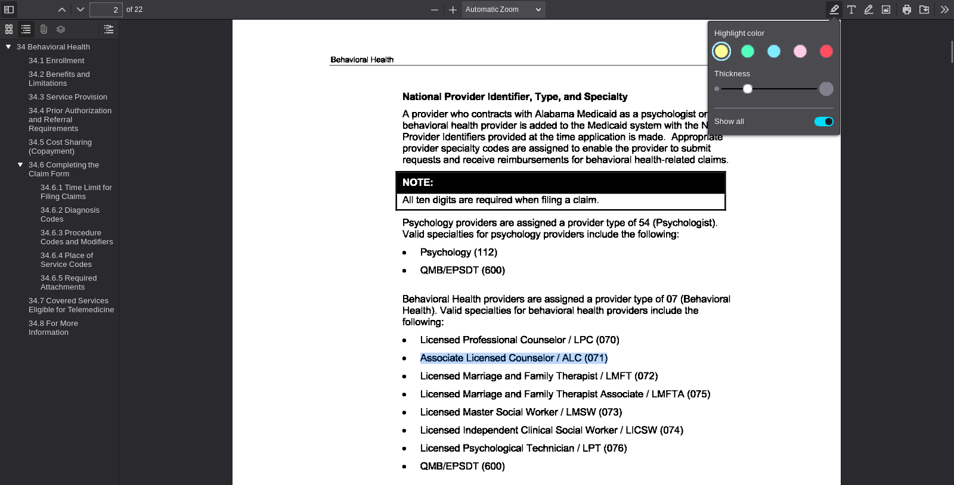
PDF viewer page 2 | Search anchor: Associate Licensed Counselor / ALC (071)

SA-022 — Student-Authored Control Record
Independent source-grounded factual lookup item
Field | Completed record
Record ID | SA-022
Question | What specialty code is listed for a Licensed Marriage and Family Therapist / LMFT?
Expected answer | Specialty code 072.
Question type | Answerable — source lookup
Exact supporting quote | Licensed Marriage and Family Therapist / LMFT (072)
Source PDF | Jul26_34.pdf
PDF page | 2
Source URL | https://medicaid.alabama.gov/content/Gated/7.6.1G_Provider_Manuals/7.6.1.3G_July_2026/Jul26_34.pdf
Browser search anchor | Licensed Marriage and Family Therapist / LMFT (072)
Source SHA-256 | 5d1a8052d80742b29fa8ba93ec2db5ff427507a8fed00488d2b99ce9488b56cf
Snapshot date | 2026-09-14
Authorship | Student-authored final wording supplied by the student.
Training exclusion | Excluded from training data and answer-key generation.
Browser verification | Verified in the PDF viewer; source-search evidence is included below.
Post-freeze factual scoring | To be scored after the control set is locked, alongside the generated evaluation set.
Browser source evidence
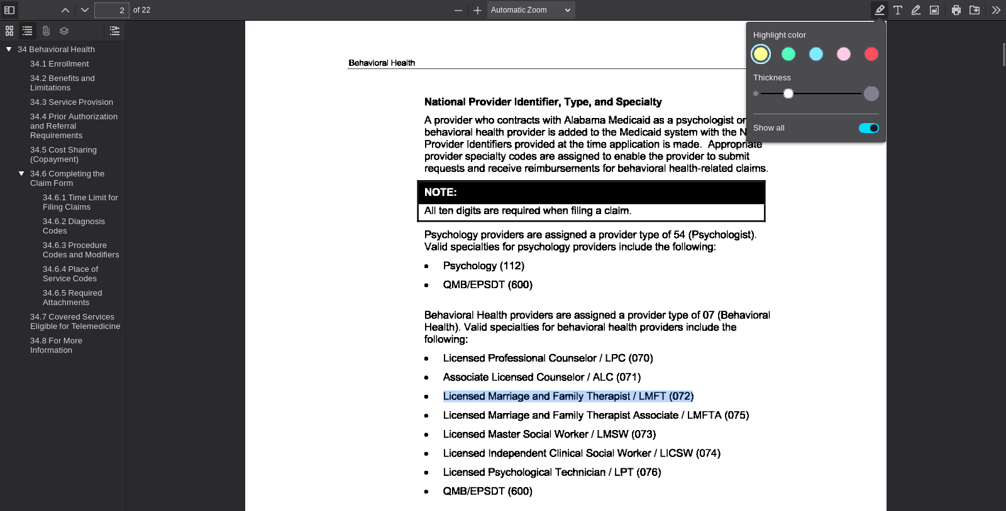
PDF viewer page 2 | Search anchor: Licensed Marriage and Family Therapist / LMFT (072)

SA-023 — Student-Authored Control Record
Independent source-grounded factual lookup item
Field | Completed record
Record ID | SA-023
Question | What specialty code is listed for a Licensed Marriage and Family Therapist Associate / LMFTA?
Expected answer | Specialty code 075.
Question type | Answerable — source lookup
Exact supporting quote | Licensed Marriage and Family Therapist Associate / LMFTA (075)
Source PDF | Jul26_34.pdf
PDF page | 2
Source URL | https://medicaid.alabama.gov/content/Gated/7.6.1G_Provider_Manuals/7.6.1.3G_July_2026/Jul26_34.pdf
Browser search anchor | Licensed Marriage and Family Therapist Associate / LMFTA (075)
Source SHA-256 | 5d1a8052d80742b29fa8ba93ec2db5ff427507a8fed00488d2b99ce9488b56cf
Snapshot date | 2026-09-14
Authorship | Student-authored final wording supplied by the student.
Training exclusion | Excluded from training data and answer-key generation.
Browser verification | Verified in the PDF viewer; source-search evidence is included below.
Post-freeze factual scoring | To be scored after the control set is locked, alongside the generated evaluation set.
Browser source evidence
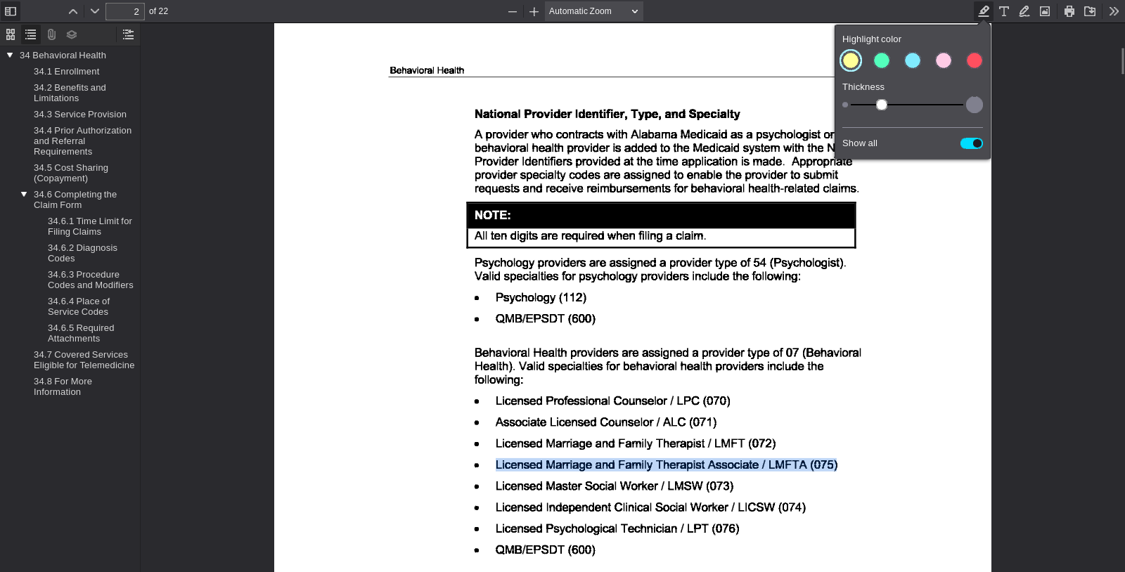
PDF viewer page 2 | Search anchor: Licensed Marriage and Family Therapist Associate / LMFTA (075)

SA-024 — Student-Authored Control Record
Independent source-grounded factual lookup item
Field | Completed record
Record ID | SA-024
Question | What specialty code is listed for a Licensed Master Social Worker / LMSW?
Expected answer | Specialty code 073.
Question type | Answerable — source lookup
Exact supporting quote | Licensed Master Social Worker / LMSW (073)
Source PDF | Jul26_34.pdf
PDF page | 2
Source URL | https://medicaid.alabama.gov/content/Gated/7.6.1G_Provider_Manuals/7.6.1.3G_July_2026/Jul26_34.pdf
Browser search anchor | Licensed Master Social Worker / LMSW (073)
Source SHA-256 | 5d1a8052d80742b29fa8ba93ec2db5ff427507a8fed00488d2b99ce9488b56cf
Snapshot date | 2026-09-14
Authorship | Student-authored final wording supplied by the student.
Training exclusion | Excluded from training data and answer-key generation.
Browser verification | Verified in the PDF viewer; source-search evidence is included below.
Post-freeze factual scoring | To be scored after the control set is locked, alongside the generated evaluation set.
Browser source evidence
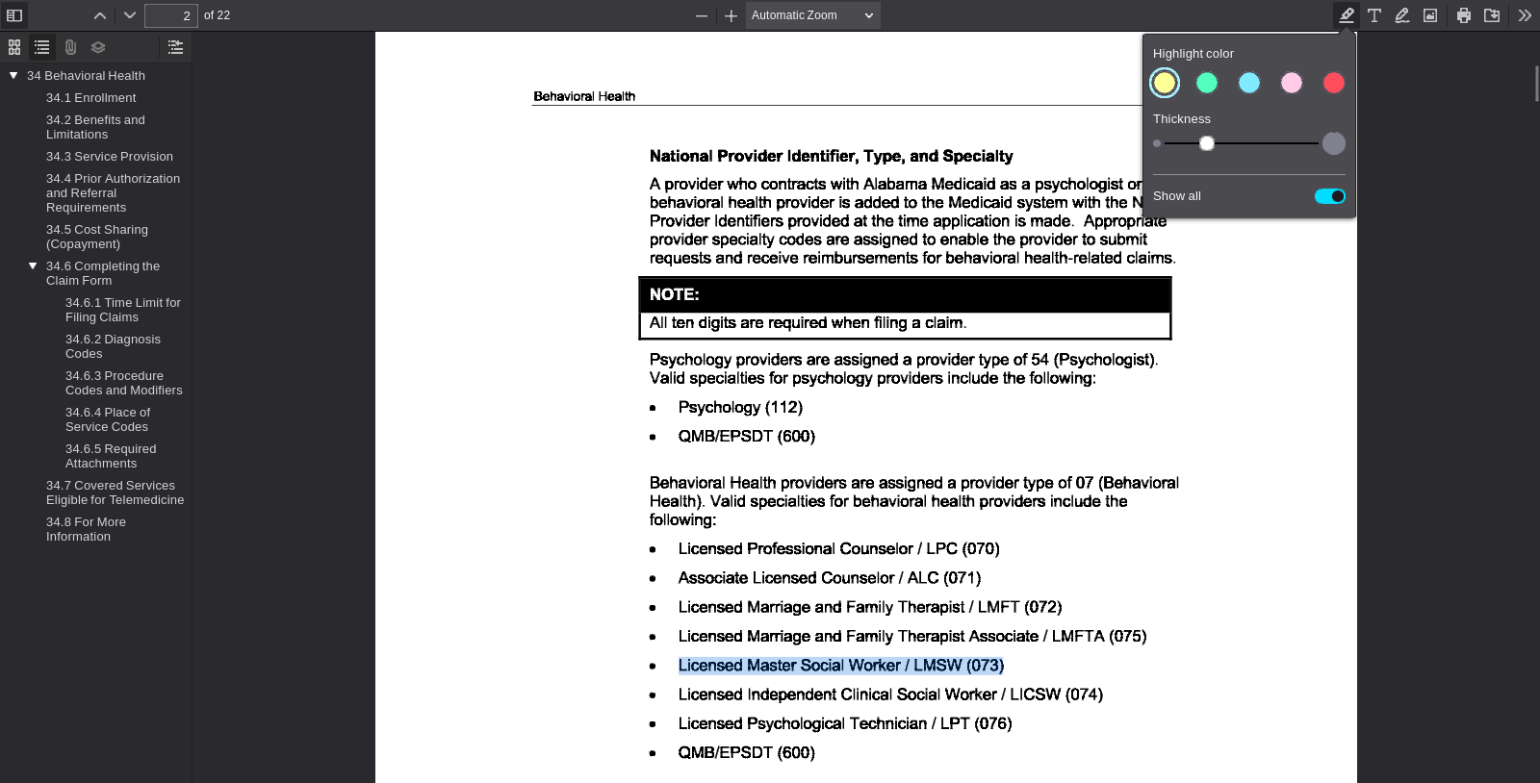
PDF viewer page 2 | Search anchor: Licensed Master Social Worker / LMSW (073)

SA-025 — Student-Authored Control Record
Independent source-grounded factual lookup item
Field | Completed record
Record ID | SA-025
Question | What specialty code is listed for a Licensed Independent Clinical Social Worker / LICSW.
Expected answer | Specialty code 074.
Question type | Answerable — source lookup
Exact supporting quote | Licensed Independent Clinical Social Worker / LICSW (074)
Source PDF | Jul26_34.pdf
PDF page | 2
Source URL | https://medicaid.alabama.gov/content/Gated/7.6.1G_Provider_Manuals/7.6.1.3G_July_2026/Jul26_34.pdf
Browser search anchor | Licensed Independent Clinical Social Worker / LICSW (074)
Source SHA-256 | 5d1a8052d80742b29fa8ba93ec2db5ff427507a8fed00488d2b99ce9488b56cf
Snapshot date | 2026-09-14
Authorship | Student-authored final wording supplied by the student.
Training exclusion | Excluded from training data and answer-key generation.
Browser verification | Verified in the PDF viewer; source-search evidence is included below.
Post-freeze factual scoring | To be scored after the control set is locked, alongside the generated evaluation set.
Browser source evidence
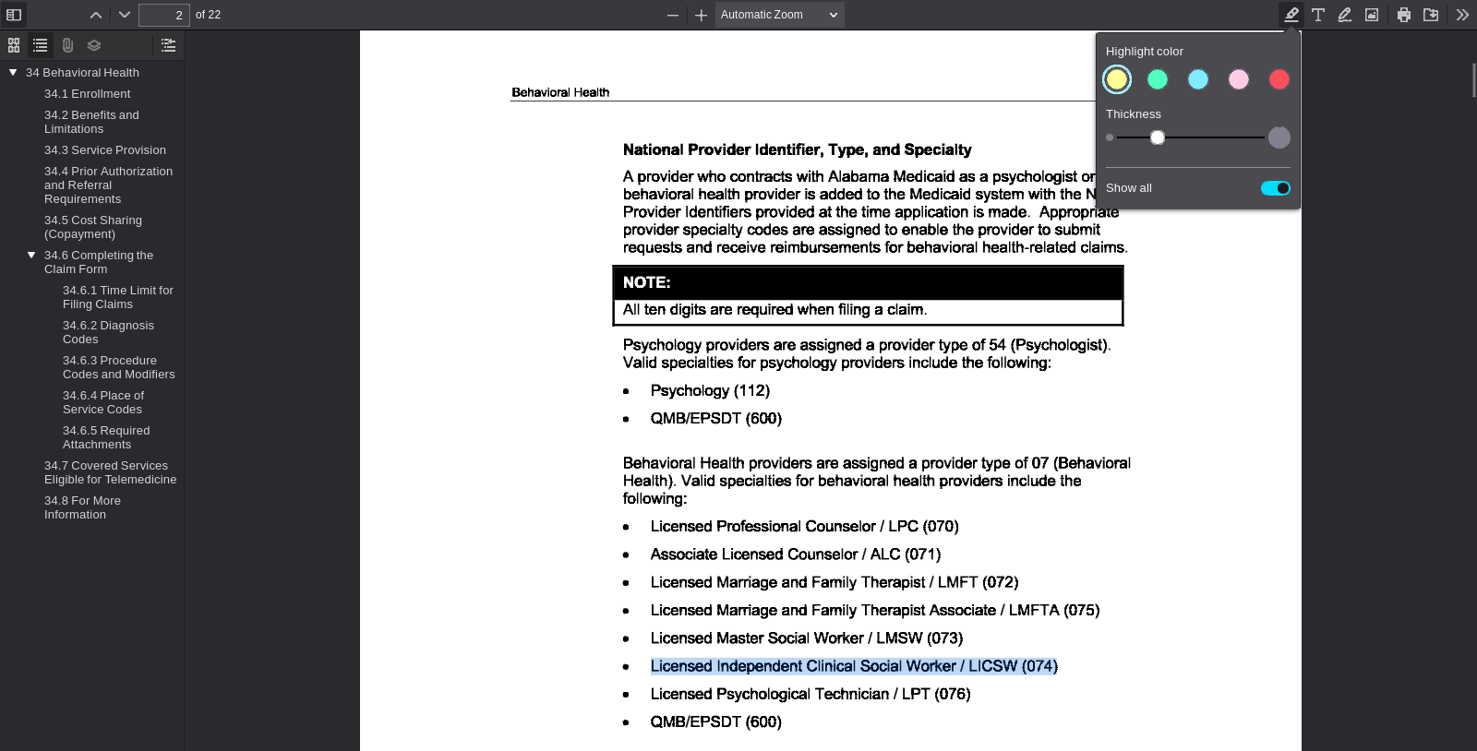
PDF viewer page 2 | Search anchor: Licensed Independent Clinical Social Worker / LICSW (074)

SA-026 — Student-Authored Control Record
Independent source-grounded factual lookup item
Field | Completed record
Record ID | SA-026
Question | What specialty code is listed for a Licensed Psychological Technician / LPT?
Expected answer | Specialty code 076.
Question type | Answerable — source lookup
Exact supporting quote | Licensed Psychological Technician / LPT (076)
Source PDF | Jul26_34.pdf
PDF page | 2
Source URL | https://medicaid.alabama.gov/content/Gated/7.6.1G_Provider_Manuals/7.6.1.3G_July_2026/Jul26_34.pdf
Browser search anchor | Licensed Psychological Technician / LPT (076)
Source SHA-256 | 5d1a8052d80742b29fa8ba93ec2db5ff427507a8fed00488d2b99ce9488b56cf
Snapshot date | 2026-09-14
Authorship | Student-authored final wording supplied by the student.
Training exclusion | Excluded from training data and answer-key generation.
Browser verification | Verified in the PDF viewer; source-search evidence is included below.
Post-freeze factual scoring | To be scored after the control set is locked, alongside the generated evaluation set.
Browser source evidence
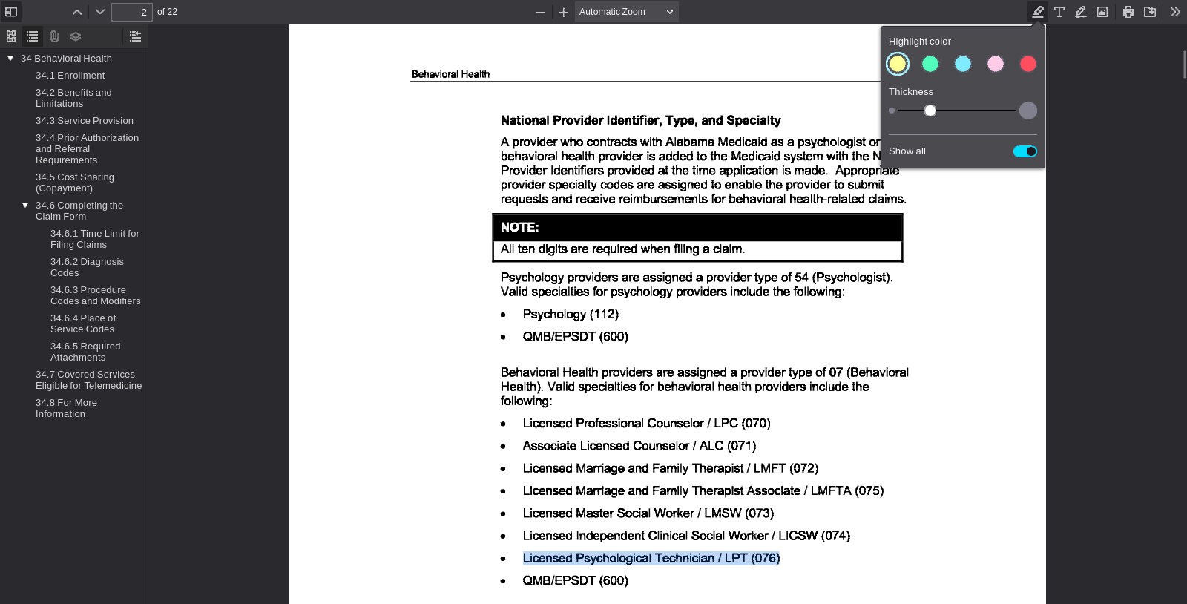
PDF viewer page 2 | Search anchor: Licensed Psychological Technician / LPT (076)

SA-027 — Student-Authored Control Record
Independent source-grounded factual lookup item
Field | Completed record
Record ID | SA-027
Question | What specialty code is listed for Preventive Health Education?
Expected answer | Specialty code 183.
Question type | Answerable — source lookup
Exact supporting quote | The valid specialty for preventive health education providers is Preventive Health Education (183).
Source PDF | Jul26_30.pdf
PDF page | 1
Source URL | https://medicaid.alabama.gov/content/Gated/7.6.1G_Provider_Manuals/7.6.1.3G_July_2026/Jul26_30.pdf
Browser search anchor | Preventive Health Education (183)
Source SHA-256 | eb21fa6f0eabfb878cdc053a14730b96bf8b3763ed00c2336c9f4795f56f295e
Snapshot date | 2026-09-14
Authorship | Student-authored final wording supplied by the student.
Training exclusion | Excluded from training data and answer-key generation.
Browser verification | Verified in the PDF viewer; source-search evidence is included below.
Post-freeze factual scoring | To be scored after the control set is locked, alongside the generated evaluation set.
Browser source evidence
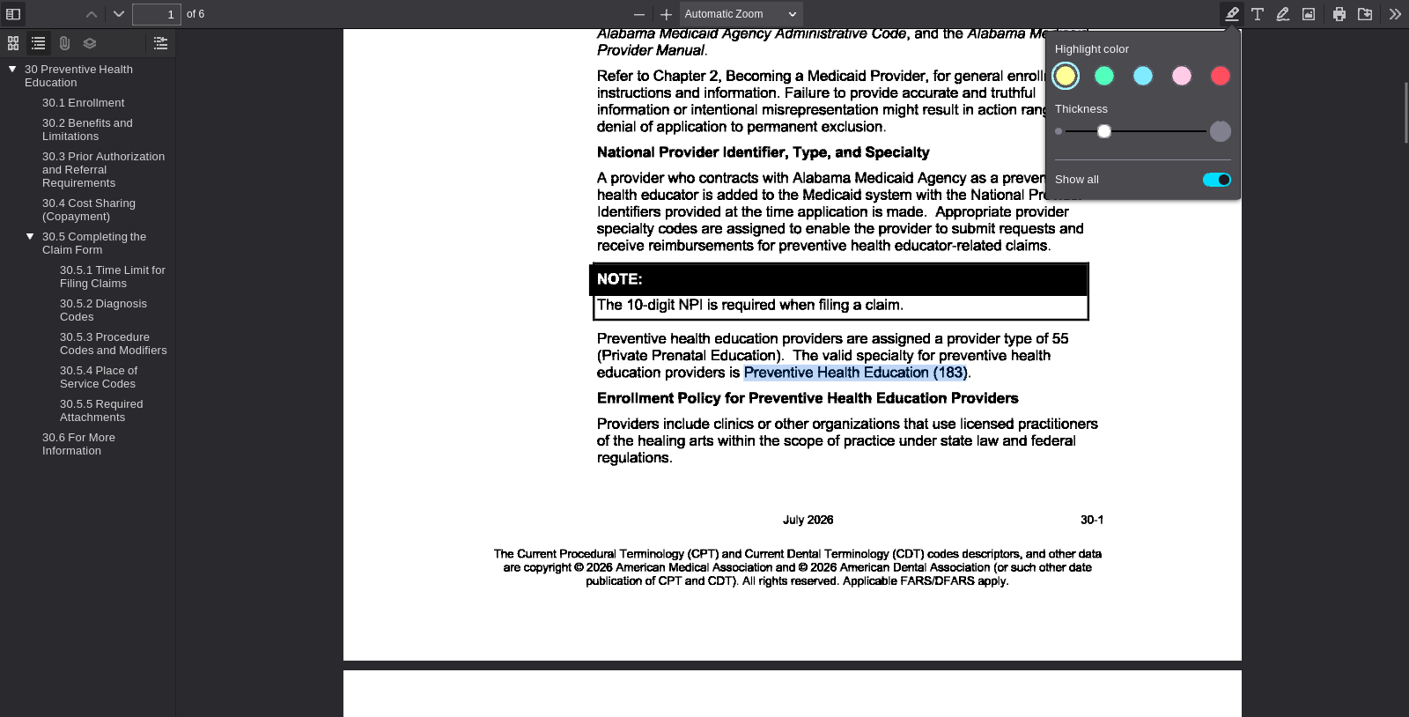
PDF viewer page 1 | Search anchor: Preventive Health Education (183)

SA-028 — Student-Authored Control Record
Independent source-grounded factual lookup item
Field | Completed record
Record ID | SA-028
Question | What specialty code is listed for EPSDT in the physician specialty table?
Expected answer | EPSDT code 560.
Question type | Answerable — source lookup
Exact supporting quote | EPSDT 560
Source PDF | Jul26_28.pdf
PDF page | 2
Source URL | https://medicaid.alabama.gov/content/Gated/7.6.1G_Provider_Manuals/7.6.1.3G_July_2026/Jul26_28.pdf
Browser search anchor | EPSDT
Source SHA-256 | 5816647d97b5acb0fc6d84fb6ded0f609aa3e7418072d8d93c35b3a442879d04
Snapshot date | 2026-09-14
Authorship | Student-authored final wording supplied by the student.
Training exclusion | Excluded from training data and answer-key generation.
Browser verification | Verified in the PDF viewer; source-search evidence is included below.
Post-freeze factual scoring | To be scored after the control set is locked, alongside the generated evaluation set.
Browser source evidence
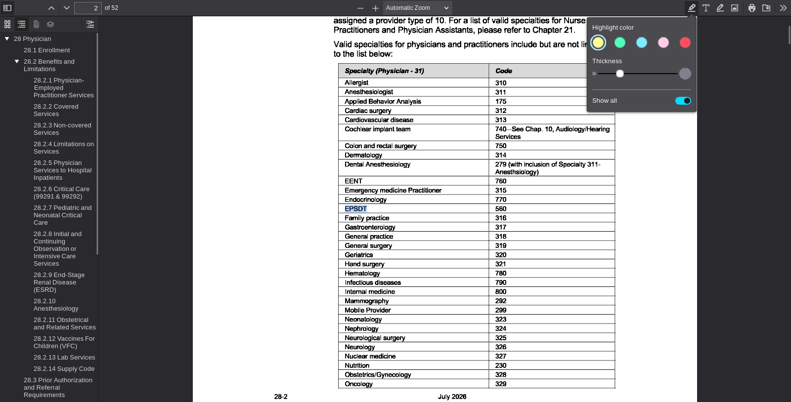
PDF viewer page 2 | Search anchor: EPSDT

SA-029 — Student-Authored Control Record
Independent source-grounded factual lookup item
Field | Completed record
Record ID | SA-029
Question | What specialty code is listed for Family Practice in the physician specialty table?
Expected answer | Family Practice code 316.
Question type | Answerable — source lookup
Exact supporting quote | Family practice 316
Source PDF | Jul26_28.pdf
PDF page | 2
Source URL | https://medicaid.alabama.gov/content/Gated/7.6.1G_Provider_Manuals/7.6.1.3G_July_2026/Jul26_28.pdf
Browser search anchor | Family practice
Source SHA-256 | 5816647d97b5acb0fc6d84fb6ded0f609aa3e7418072d8d93c35b3a442879d04
Snapshot date | 2026-09-14
Authorship | Student-authored final wording supplied by the student.
Training exclusion | Excluded from training data and answer-key generation.
Browser verification | Verified in the PDF viewer; source-search evidence is included below.
Post-freeze factual scoring | To be scored after the control set is locked, alongside the generated evaluation set.
Browser source evidence
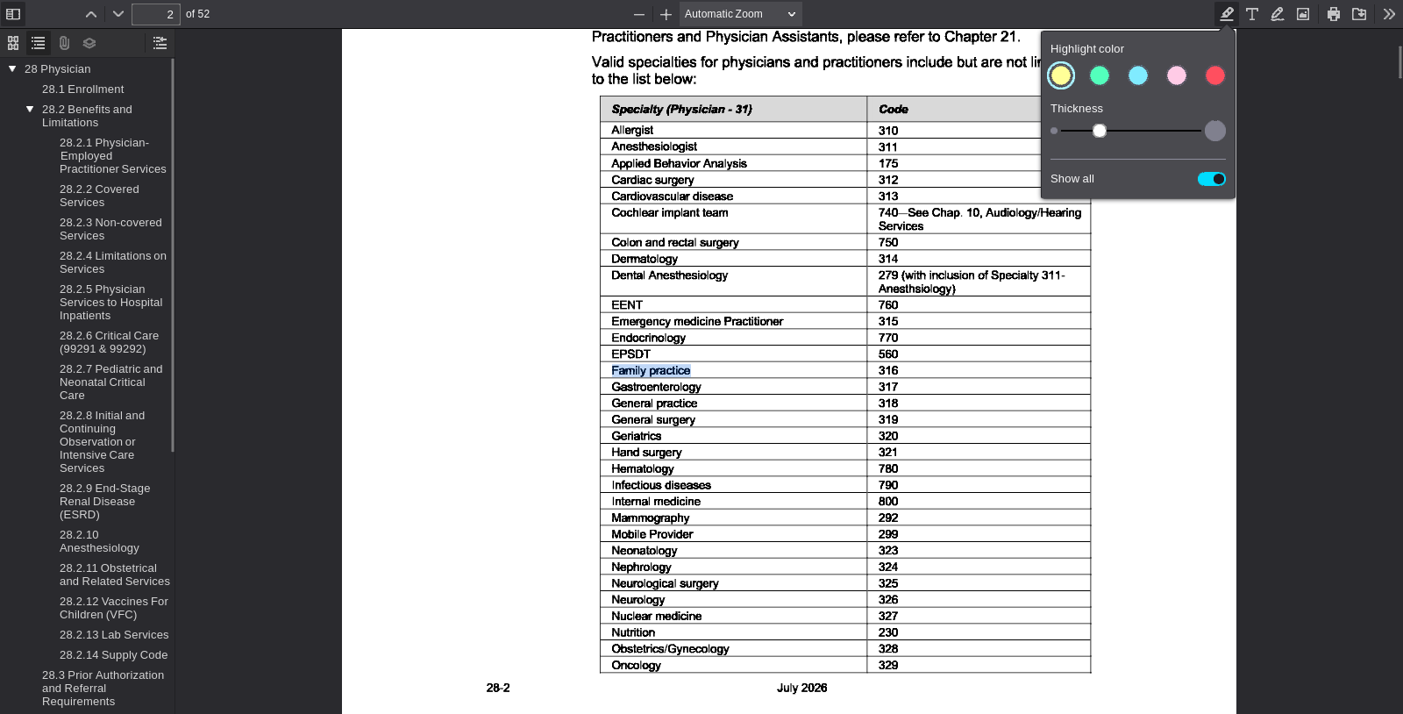
PDF viewer page 2 | Search anchor: Family practice

SA-030 — Student-Authored Control Record
Independent source-grounded factual lookup item
Field | Completed record
Record ID | SA-030
Question | What specialty code is listed for Cardiac Surgery in the physician specialty table?
Expected answer | Cardiac Surgery code 312.
Question type | Answerable — source lookup
Exact supporting quote | Cardiac surgery 312
Source PDF | Jul26_28.pdf
PDF page | 2
Source URL | https://medicaid.alabama.gov/content/Gated/7.6.1G_Provider_Manuals/7.6.1.3G_July_2026/Jul26_28.pdf
Browser search anchor | Cardiac surgery
Source SHA-256 | 5816647d97b5acb0fc6d84fb6ded0f609aa3e7418072d8d93c35b3a442879d04
Snapshot date | 2026-09-14
Authorship | Student-authored final wording supplied by the student.
Training exclusion | Excluded from training data and answer-key generation.
Browser verification | Verified in the PDF viewer; source-search evidence is included below.
Post-freeze factual scoring | To be scored after the control set is locked, alongside the generated evaluation set.
Browser source evidence
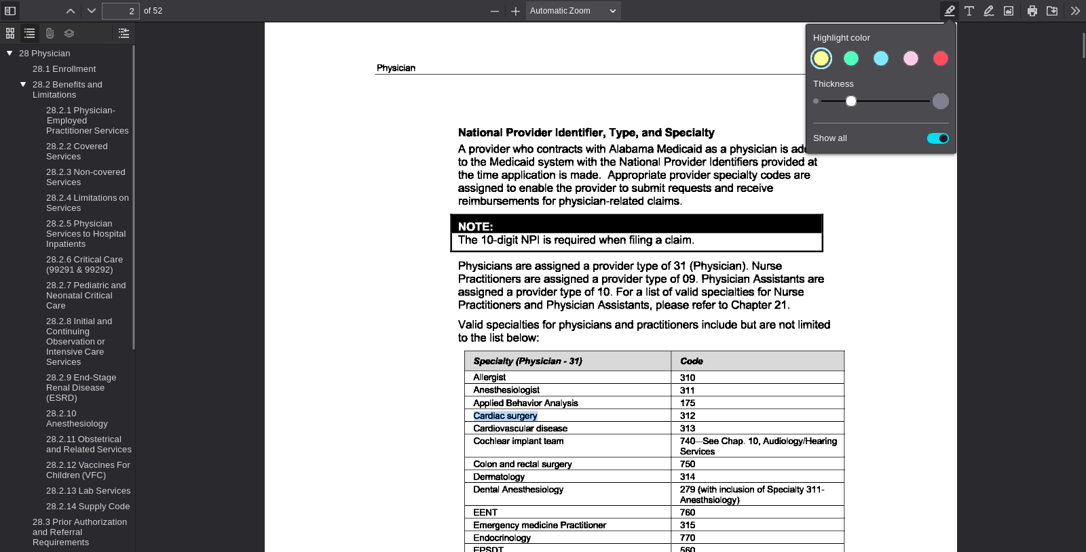
PDF viewer page 2 | Search anchor: Cardiac surgery

